

Postgraduate/Distance Learning
Assignment coversheet & feedback form

THIS SHEET MUST BE THE FIRST PAGE OF THE ASSIGNMENT YOU ARE SUBMITTING (DO NOT SEND AS A SEPARATE FILE)

For completion by the student:
Student Name: Maurane Gisiger
Student University Email: 2219166@student.uwtsd.ac.uk
Module code: HPCA7028  Module title: Sacred Skies | Student ID number:  2219166 |  |  | Educational support needs:  No
Assignment title: A Critical Examination of the Sky in Relation to Material Culture
Assignment due date: 4 May 2023
This assignment is for the 1st 2nd 3rd 4th 5th 6th module of the degree
I confirm that this is my original work and that I have adhered to the University policy on plagiarism.
Signed ………………GISIGER……………………………………………
Email submission: if you are submitting this form via email, please tick this box
(as a substitute for your signature) to confirm that you agree to the above declaration.
Assignment Mark
1st Marker’s Provisional mark
2nd Marker’s/Moderator’s provisional mark
External Examiner’s mark (if relevant)
Final Mark

NB. All marks are provisional until confirmed by the Final Examination Board.
For completion by Marker 1 :
Comments:

Marker’s signature: |  |  | Date:
For completion by Marker 2/Moderator:

Comments:

Marker’s Signature: |  | Date:
External Examiner’s comments (if relevant)

External Examiner’s Signature: |  | Date:

A Critical Examination of the Sky in Relation to Material Culture - A. Image-Based - DRAFT

Word Count: (4501 out of 4500 words (min 4275, max 4725))

Introduction (485/planned 450 words)

The desire to explore the universe has captivated humanity for centuries, driving scientists, artists, and writers alike to imagine the possibilities to travel to the Moon and beyond. As Professor Brycchan Carey highlights, the idea was particularly developed in “seventeenth-and eighteenth-century Moon voyage narratives” . This includes astronomer Johannes Kepler, who in 1608 wrote a book entitled Somnium (Latin for dream) which historian of science Gale Christianson describes as “a pioneering work of science fiction” . Image-based science-fiction artworks such as Georges Méliès’ famous Le Voyage dans la Lune movie from 1902 also reflect this fascination.
With technological advancements in the 20th century, the dream of a celestial voyage became a reality, and the Moon, as the closest celestial object to Earth, became the subject of numerous robotic and manned exploration missions, such as the “soft landers [which] provided the first hard information on the lunar surface in the years 1966 –1968” discussed by former President of the International Academy of Astronautics George Mueller. This culminated on the 20th of July 1969, date at which Neil Armstrong and Edwin “Buzz” Aldrin were the first humans to set foot on a celestial body other than Earth, as part of the National Aeronautics and Space Administration’s (NASA) Apollo 11 mission to the Moon. This historic event was transmitted for the public to witness, as Kerrie Dougherty notes, by “broadcasting to the world the lunar surface television from Apollo 11” .
The images of the Apollo 11 landing have had a profound impact on humanity's collective imagination, illuminating the evolving human relationship with the Moon and space exploration. This essay critically examines the sky's representation in relation to material culture through four artworks that capture different perspectives on the Moon landing of 1969.
The artworks considered in this essay are: A Man on the Moon, the photograph taken by Apollo 11 Commander Neil Armstrong during the Moon landing (see Figure 1a); First Men on the Moon, a 1971 painting by Robert McCall (Figure 2); the Moonwalk suite, silkscreen prints by Andy Warhol in 1987 (Figure 3); and First Men - Neil Armstrong, a 2007 painting by retired NASA astronaut Alan Bean (Figure 4). The first part of the essay focuses on the mythicised figure of the astronaut. The Man on the Moon photograph has become an icon of the 20th century and the image has been reproduced in various forms such as the other 3 artworks considered here. While reflecting each of their respective author's personal experience with the Moon and space, the artworks’ display of the figure of the astronaut serve to perpetuate the “myth” of the astronaut. The second part of the essay shifts the focus onto the artists’ intention, since all four artworks were created with a desire to transmit something to future generations. Overall, the essay investigates the cultural significance of these artworks and their ongoing impact on humanity’s collective imagination about the age-old dream of space travel.

The icon of the Man on the Moon and the mythicised figure of the astronaut
(2240/planned 2000 words)

In his research on what he qualifies as the “myth” surrounding astronauts, Roger Launius, an American historian and former chief historian of NASA, identifies five key components that contribute to the construction of the astronaut as a cultural figure . First, the astronaut is seen as an “everyman”, embodying the virtues of American citizens. In particular, the astronaut is also framed as a “defender of the nation” - as shall be discussed further in this section, this is particularly relevant in the context of the Space Race and the Cold War more generally. Third, the astronaut is depicted as a “fun-loving young man”, and fourth, as a “virile, masculine representative of the American ideal”; these two components can also be treated as extensions of the “American everyman”. Finally, Launius describes that the astronaut as a hero, a term by which he means a media celebrity. In his view, these five components work together to create in the person of the astronaut a powerful myth that is able to captivate the imagination of the public and contributes to the popular appeal of space exploration. In the following paragraphs, the values and virtues that are attributed to astronauts in the four artworks are analysed.

A Man on the Moon, captured during the Apollo 11 mission, has become one of the most recognizable images of the 20th century. The photograph however has a troubled history, which starts with the fact that Armstrong cropped the top of Aldrin’s suit; Eric Jones provides the official account of all the editing that took place from the original film to the commonly known picture (Figure 1b) . Much more ink has flown about this particular image, not least to defend the point of view that the Moon landings never happened; David Perlmutter and Nicole Smith-Dahmen find that “both sides of this controversy employ similar tools of visual analysis” , using details of the photograph to justify their claim.
While these scholars focus on the image's factual significance, an alternative way to look at the photograph is as an artwork, emphasising its artistic and aesthetic qualities. Modern art professor Gary Wells for instance observes that “the Apollo moon landings provided the first opportunity for humans to describe aesthetic experiences on an extraterrestrial landscape based on direct observation” and recalls the words of the first two men on the Moon: Armstrong described the moon’s surface as having “a stark beauty all its own” while Buzz Aldrin used “beautiful, beautiful,” and “magnificent desolation”. This emotional response, added to the unfamiliar environment with different gravity conditions, is a plausible explanation to legitimise the act of a spontaneous photograph that could be considered imperfect in its realisation, but actually perfectly humanises the astronaut which in turn enables a viewer to see him as an American everyman.
Another important consideration is the aesthetic of the astronaut himself. Against much of the literature she cites, feminist Maria Velasquez considers that “the portrait is very much a symbol of hegemonic masculinity” notably because the central figure occupies most of the space, and just like the name of the mission itself, Apollo. In a later paper, she points out that it is not coincidental that for its present-day Moon mission, NASA chose to include female astronauts and name the mission Artemis . Nevertheless, she fails to recognise what Sara Langston and Sarah Jane Pell demonstrated, which is that gendered terms had been “readily rejected in favour of the neutral term ‘astronaut’” by the time of the first Moon landing, so that in the collective imaginary the astronaut is a figure that both men and women could identify with. This is even more obvious when examining the suit, which, although it needs to be adapted to the morphology of the astronaut as highlighted for example by urologists Kimberly Maciolek and Sara Best , does not permit a viewer to see what gender the person who is inside has. Thus the “American ideal” represented by astronauts is not based on their sex, but on the character virtues that Launius suggests like their “everyman” humanity.

The three other artistic works studied in this essay postdate A Man on the Moon and a quick visual comparison exposes the photograph as the incontestable primary source of inspiration for the artists, although each of them included his own touch when illustrating the scene and highlighted different aspects of the astronaut’s character values. Having been authored by someone who has accomplished the dream of travelling to the Moon, First Men – Buzz Aldrin comes from the unique perspective of a man who, like the astronaut he portrays, has set foot on the Moon. Richard Taylor is one author who similarly describes Alan Bean as a unique astronaut, noting that he was the only one to “record what he saw on canvas and in paint” . Bean also created a First Men painting commemorating Neil Armstrong (see Figure 5), however the one at hand is visually closer to the original photograph, which can likely be explained by the fact that contrary to what is sometimes stated in popular publications, the photograph was taken by the Apollo 11 commander Neil Armstrong and shows fellow astronaut Buzz Aldrin (rather than vice-versa).
Bean describes his creative process as “almost as meticulous as the training for my own moon landing” . This can be seen in his attention to detail, such as in the reflection in Aldrin’s helmet which is stunningly similar to that in the Man on the Moon photograph, with elements like the position of Aldrin’s hands, the clearly recognisable Eagle lunar lander and shadow of the photographer ... His dedication to precision goes as far as editing paintings after they were completed to achieve an even greater historical accuracy, as evidenced by this quote on Bean’s website: “I found out several months after I had completed First Men that Neil had taken off his watch and left it attached to the AOT (because of a timer failure in the LM) when he went for his historic moonwalk. I took Neil off the wall, out of the frame, removed the varnish and painted the watch out”. In this way, he manifests this thoroughness in the figure he portrays, too, as the viewer admires the attention to detail and reflects on the intricacies of space exploration, including the astronaut’s work.
In his statement, a key aspect besides astronauts’ conscientiousness is that Bean refers to both the man and the subject represented in the painting as “Neil”. On one hand, this camaraderie experienced by members of the astronaut corps is a psychological motivator for astronaut, as documented by psychologists like Peter Suedfeld . At the same time, Suedfeld emphasises that cohesion is a common response to the isolation experienced by space travellers, if not a necessary one for the success of the mission. The solitary nature of space travel and otherworldly nature of the destination is visible in both Armstrong’s photograph and Bean’s painting where the grey, desolate lunar expanse that takes up most of the canvas is only visited by two people, one of whom is only visible after a more careful look at the reflections in the helmet visor. Unlike what can be captured in a photograph however, Bean could incorporate texture, achieved through the inclusion of his own “pieces of the American flag, name tag, and NASA and Apollo 12 mission emblems” and the use of lunar exploration tools. The most visually striking example of this is the overlay of footprints made by Moon-boots. Since in the lunar environment the footprints have a very long lifetime, they are often referenced in studies of the preservation of humanity’s cultural heritage on the Moon, such as Spennemann or Bohdan’s , who emphasise their status as records of the historical event. This is also not least thanks to Armstrong’s triumphant first phrase when stepping onto the lunar surface “That’s one small step for a man, one giant leap for mankind”, which has been interpreted by many scholars like diplomats Foy Kohler and Dodd Harvey in conjunction with the Apollo 11 plaque left behind which reads “We came in peace for all mankind” as a symbol of “man generally—as distinct from men of one nation, or of one political alignment, or one social system” . Thus, the astronaut is not only a national ideal and hero, but is presented as a virtuous character to which the viewers of the landing (and subsequent paintings re-capturing the scene) world-wide can aspire, becoming a symbol of unity and success.

In the other two artworks however, the American flag takes a much more visually prevalent role. The flag is another object featuring in the Moon landing photographs that sceptics of the Moon landings have used to dispute the veracity of the event. Former NASA employee Anne Platoff addresses this point, also raised by Perlmutter and Smith-Dahmen, by detailing how the flag could be moving despite there being no atmosphere, and hence no wind, on the lunar surface. However, the American flag also has a deeper meaning in the context of the Apollo missions as Platoff explains in another paper: the use of the American flag as a “national identifier” is key in the context of the Space Race and Cold War with the Soviet Union, still ongoing at the time of the production of McCall’s First Men on the Moon and Warhol’s Moonwalk series, and puts the astronaut in the position of a “national defender” identified by Launius.
Warhol used a silkscreen printing technique to reproduce an image of the Man on the Moon together with the American flag, while McCall paints a scene with one astronaut holding the American flag’s pole. Warhol trialled 66 different colours for Moonwalk (some of which are presented in Figures 6 a-3), an obstinacy that reflects the impact that seeing the images of the Moon landing and man’s first step on the Moon on TV had on Warhol. SUCH AS X note that Moonwalk was intended as part of a wider series of pop-art-works entitled “” dedicated to celebrating iconic moments broadcast in the 20th century . Furthermore, a NASA history website references his participation in the NASA Arts Program , through which he would have gained knowledge about the Apollo missions, which in turns could explain why he seems to have been inspired to combine A Man on the Moon and another iconic image that shows Buzz Aldrin saluting the American flag (see Figure 7), as highlighted by the gallery that owns the hot pink and yellow editions shown in Figure 2 .
Likewise, McCall took part in the Arts Program and his artwork echoes both Apollo 11 photographs showing the flag and the lunar lander, and another famous picture from the Apollo program, Earthrise (see Figure 8). He took additional artistic licenses firstly with the item held by the foreground astronaut, strongly reminiscent of the golf club held by Alan Shephard during the Apollo 14 landing of 1971 just a few months before McCall painted First Men on the Moon, which according to a comment in the Institute of Physics journal was “a stunt to keep that flagging interest [in the Moon] alive” . The addition of this element to the painting could thus be seen as a way to present the astronaut as a “fun-loving” “everyman”. Secondly and more noticeably, he took liberties with the other elements in the sky background. While one of the visual elements decried by Moon landing sceptics is that no stars can be seen in A Man on the Moon, which can easily be explained through the settings of the lunar camera, McCall replaces the sky experienced by astronauts on the Moon in its rightful place. Both this and the reference to Earthrise could be interpreted as attempts to represent the “overview effect” in his artwork, which Deana Weibel defines as the “cognitive shift resulting from seeing the Earth from space that increases some astronauts’ sense of connection to humanity, God, or other powerful forces” , an overwhelming emotion much like that of seeing the lunar surface mentioned earlier. McCall hence depicts what could be described as a wider scene, where the lunar surface does not take up about ¾ of the background space like it does in the other artworks but is limited to about ¼, and these additional elements are represented. In reality, the size of the canvas (7 by 9 feet) implies that the foreground astronaut would also be about 1 meter tall, very similarly to his size in Bean and Warhol’s artworks, yet illustrating celestial objects like the Earth, comet, stars and nebulae in a much more ornate way than what the astronauts would have experienced draws attention to the fact that the Apollo missions were not just about putting men on the Moon, they were also a scientific and astronomical endeavour, or as phrased by space investor Chad Anderson, “awe-inspiring accomplishments of NASA, pushing the boundaries of new frontiers and driving research at the limits of human knowledge” - while often being profoundly influenced personally by their unique vantage point on celestial object, the American astronauts are also the most prominent achievers of NASA’s goal by being ones to physically travel to previously unexplored places to push scientific boundaries.

In summary, there are elements in the artworks that support Launius’ view that astronauts are American everymen embodying American values, especially as seen with the representation of the American flag for the artists who were part of the NASA Arts Program. At the same time, there are many features which are instead in favour of saying that astronauts personify a number of universal values, from unity and camaraderie to scientific exploration and accuracy, which the astronaut-artists Armstrong and Bean seem to recognise more strongly.

The role of the space artist
(1340/planned 1500 words)

The previous section already shed some light on the reasons that pushed the artists to create the artworks considered in this essay, such as their involvement in the NASA Arts Program. By examining the NASA Arts Program’s purpose in more detail, as well as taking general considerations about the role of space art and space artists, this part of the essay will present the significance that the 4 artworks hold beyond their perpetuation of the myth of the astronaut as a virtuous and heroic figure and supports Pell’s claim that “Every space project needs an artist” , or even multiple.

NASA’s Arts Program was established in 1962 to provide a visual record of the agency's activities and achievements, and invited artists to collaborate with NASA personnel and to create works of art that captured the spirit of space exploration. In a press release shortly after inaugurating the program, former NASA Administrator James Webb states that “an artistic record of this nation’s program of space exploration will have great value for future generations and may make a significant contribution to the history of American art” . The emphasis on the national nature of the project is not present in the words of Bert Ulrich, curator of the Art Program, who finds that “That’s the beauty of art, […] that it reaches people in different ways. The idea is that art is another way to inspire people” . James Dean, who first implemented the program, highlights that “The biggest event for the program was the Apollo 11 mission in July 1969 […] The first time humans would walk on the Moon would be one of the most historic moments in history” . Collectively, these testimonies about the goal of the NASA Art Program raise two major roles of the space artist: firstly, as one who captures a specific event in human history for posterity to remember, and secondly, as one who uses a medium he or she is an expert in to communicate about NASA activities to the general public, particularly to inspire future generations, whether nationally or world-wide.
McCall confirms that the latter is also his own intention in a 2000 interview for the NASA Oral History Project, where he describes his motivation as being “all part of a continuing effort to somehow communicate my passion for these things [science and technology] to other people” . He moreover uses the word “future” over 20 times, indicating that the dream of space and lunar travel is an ongoing endeavour. The balance is much more tipped towards memorialisation in Warhol’s case, since it was intended as part of a wider collection recalling iconic televised moments, as previously mentioned. John Sandberg explains that by being realistic, but not naturalistic nor conventional, and original, but rooted in American tradition, Pop Art was able to become an extremely popular artform ; by being the most prominent figure of this artistic movement, Warhol reaches a wide audience and likely a different one to artists using more traditional artforms. The Moonwalk prints thus impacted millions of viewers’ imagination about space exploration, and continues to do so as demonstrated by the fact that trial proofs regularly re-appear on the art market.
The case is very similar for retired astronaut Alan Bean, who incorporates pieces of his own Moon voyage into his paintings: memorialisation takes a more important role than for McCall, although he does not forget the inspirational aspect. In the “story” tab next to First Men – Buzz Aldrin image on his website, he writes “Here is my memory” and sets out to describe the background of the Apollo Moon missions. Additionally, the “Message” section on the same website concludes with the words “Our generation will be remembered for many achievements, and one of the greatest will be our movement off the Earth, from its gravitational pull, to begin our future generations' exploration of the universe. My paintings record the beginnings of a quest never to end, our journey out among the stars” , where the idea of future generations carrying on the torch of exploration reappears. Even more explicitly, he writes that he seeks to “capture what I saw and felt, and bring it back to earth to share with generations to come” .
In another NASA Article about the Arts Program, the painter Honoré Daumier is quoted on “It is the emotional impact, interpretation and hidden significance of these events which lie within the scope of the artist’s vision” and photographs are reduced to factual record. In the first part of the essay however, it was shown that A Man on the Moon inspired many artists and was used as a model for artworks even decades after it was taken. It was concluded that it displays the astronaut as a human, relatable character; through the Apollo 11 pictures and their words, and their media presence during and after the event, the astronauts were seen by millions of people. To emphasize this, which Launius calls the “hero” component, Langston and Pell note that the duty of the astronaut includes sometimes being an entertainer and an educator , so that the photographic artwork discussed here functions to memorialise and inspire just like the two paintings and the series of screenprints.

It is relevant to study the use of the paintings to estimate whether the artists’ intentions for their artworks were fulfilled. In the broadest terms, Philip Corneille wrote in his column for the Communicating Astronomy to the Public journal - edited by the International Astronomical Union (IAU) and European Southern Observatory (ESO) – that “by pairing our natural love of art with exciting science, we can create an engaged public and capture their imaginations. It is one of the most exciting ways of bringing astronomical science closer to the people” . There are many more scholarly articles that examine the role that space art can play for outreach to the general public or formal science education at school-level, such as Amelia Ortiz-Gil and Miquel Gomez-Collado who parallel Ulrich’s words when they recognise that “The power of inspiration of art is a wonderful way to excite children’s imagination while communicating astronomical concepts” . Additionally, both in this and the IAU/ESO paper, reference is made to children or the public taking a first step in space exploration by engaging with the sky by producing their own artworks, an ongoing example is ESA’s monthly Space for Kids drawing competition. The participatory aspect is crucial; it is mentioned in numerous studies on education , including research on the scientific attitudes held by participants in citizens science projects , and is well-summarised by Stacy Olitsky and Catherine Milne in the statement that “It is a prevalent understanding among teachers, curriculum writers and education researchers that students need to be engaged in order to learn science” . The inspirational dimension of space art can lead to positive outcomes even for professionals: while they are not looking at art about the Moon landing, during investigations conducted for the European Space Agency’s (ESA) Topical Team in Arts and Science, Sarah Pell and Angelo Vermeulen formulate the hypothesis that “Artists can introduce a meta- perspective (taking a step back and inquiring into the practice of research), a historical, conceptual or aesthetic view, all of which can invite those who are researchers, engineers and inventors toward new insight and discovery” .

Overall, the four artworks under consideration demonstrate the important role of the space artist in capturing the experience of space exploration and providing a means of memorialisation and transmission. In particular, the NASA Art Program recognised the value of art in conveying the significance of their space program, including Apollo, and invited artists to collaborate with NASA personnel and be immersed in the daily running of NASA activities to create works of art that reflected their personal experience with the space sector to present it to the greatest numbers in an intelligible manner. This inspirational aspect continues to this day with specific applications, which are not limited to mass communication but appear in formal education and even professional scientists, and serve to influence young and old’s attitudes towards science, specifically their perception of space exploration.

Conclusion (436/planned 450 words)

In conclusion, the four artworks discussed in this essay serve as testaments to humanity's ongoing desire to explore new places and push the limits of its understanding of the Universe, through the particular example of the Moon landing. A Man on the Moon, First Men on the Moon, the Moonwalk suite, and First Men – Buzz Aldrin each capture different perspectives on the Moon landing of 1969, yet all contributed to build humanity's collective imagination about the age-old dream of space travel, especially in its embodiment in the figure of the astronaut.
The key figure in the historic event of 1969 is indeed the astronaut, as can be established from studying the iconic image A Man on the Moon as an artwork and conducting a visual inspection of the paintings and prints that were subsequently produced to commemorate Armstrong and Aldrin’s first steps. Many components that contribute to the construction of what Launius describes as the myth of the astronaut are displayed in the artworks: the virtue of being an “everyman” (in a gender-neutral meaning of the term) in the original Man on the Moon photograph, a symbol of both personal and world-wide success, as well as a demonstration of values like hard-work and meticulousness, in Bean’s painting, patriotism with the flags in Warhol’s and McCall’s works as well as scientific and technology boundary-pushing in McCall’s painting ...
While the artworks capture their respective artists’ own perspectives on and experiences of space exploration, they all ultimately serve to perpetuate this myth of the astronaut as both a virtuous “everyman” and media hero. Furthermore, as art curator Anne Collins Goodyear suggests in her comprehensive study of the relationship of art to science and technology around the time of the Apollo program, studying the NASA Arts Program “provides insight not only into how NASA wished to portray itself, but perhaps even more importantly, into American attitudes toward technology and space exploration during this period” . In the second half of the essay, the artists’ motivation were presented and it transpire that a major driver was the transmit of something meaningful, such as astronauts’ virtues, to future generations, at the same time reminding them of the historic technological achievement of NASA’s space exploration program culminating in the 1969 Apollo 11 landing, and encouraging these future generations to develop scientific attitudes, continue to engage with the sky and pursue manned space exploration. Throughout the decades since the Eagle touched down, the Moon landing has continued to serve as an inspiration for generations to become astronauts, space scientists, or rocket engineers, and fulfil their predecessors’ dream of travelling to the Moon and beyond.

Bibliography

To be finalised

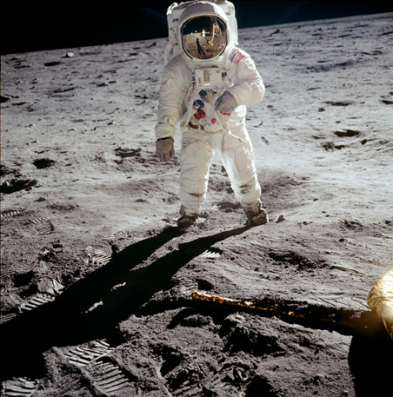
Appendix: Figures
Figure 1a: Neil Armstrong (1930-2012), Astronaut Edwin Aldrin walks on lunar surface near leg of Lunar Module, 1969, Scan from the original film of AS11-40-5903. Image: NASA Image and Video Library (https://images.nasa.gov/details/as11-40-5903).
Figure 1b: In 2004, an edited version of this image was published as the “NASA Image of the Day” under the title A Man on the Moon which is the name used in this essay for convenience: https://www.nasa.gov/multimedia/imagegallery/image_feature_196.html.

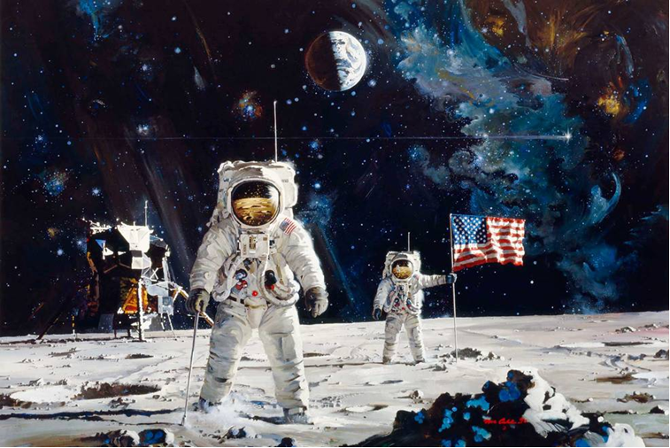
Figure 2 : Robert McCall (1919-2010), First Men on the Moon, 1971, Oil on Canvas, 7 x 9 ft (about 213 x 274 cm), Broadway National Bank, San Antonio, Texas. Image: Author’s own website (https://www.mccallstudios.com/a-new-dawn/).

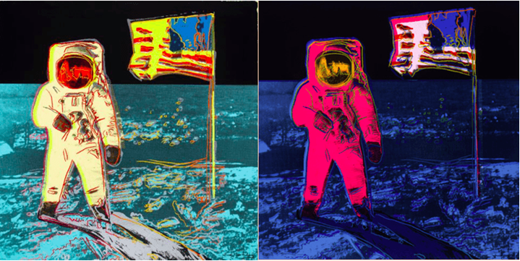
Figure 3 : Andy Warhol (1928-1987), part of the Moonwalk suite, 1987, Silkscreen prints on Lenox Museum board, 38.5 x 38.5 in (about 97 x 97 cm), Revolver Gallery, Santa Monica, California. Image: Revolver Gallery website (https://revolverwarholgallery.com/)

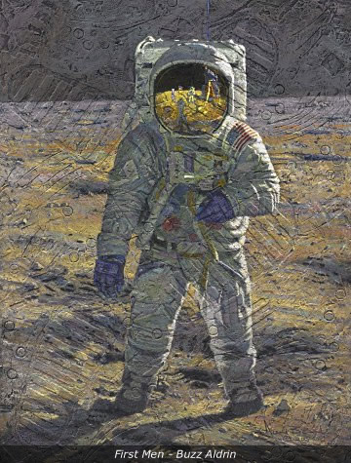
Figure 4 : Alan Bean (1932 -2018), First Men – Buzz Aldrin, 2007, Textured acrylic with Moondust on aircraft plywood, 40 x 30 in (about 102 x 76 cm), private collection. Image: artist’s own website (https://www.alanbean.com/gallery1.cfm)

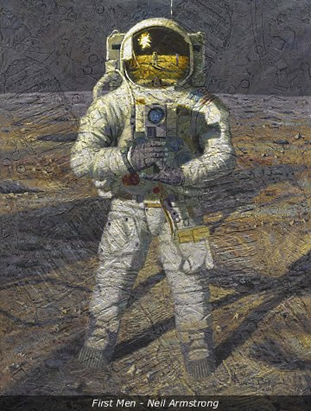
Figure 5 : Alan Bean (1932 -2018), First Men – Neil Armstrong, 2007, Textured acrylic with Moondust on aircraft plywood, 40 x 30 in (about 102 x 76 cm), private collection. Image: artist’s own website (https://www.alanbean.com/gallery1.cfm)

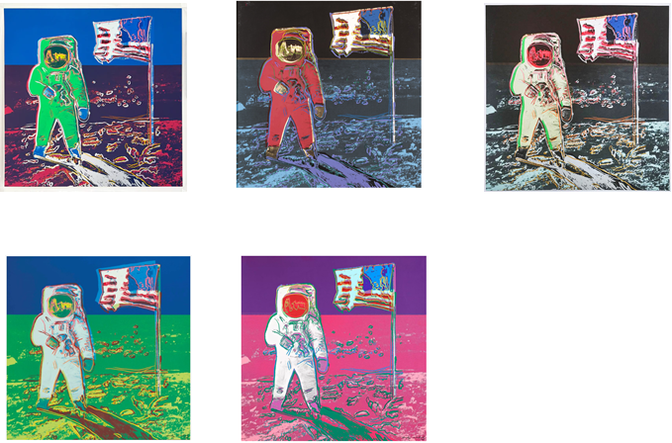
Figure 6 a-e: Andy Warhol (1928-1987), Trial proofs of the Moonwalk suite (top row, left-right: 13, 47, 61; bottom row, left-right: 9, 43), 1987, Silkscreen prints on Lenox Museum board, 38.5 x 38.5 in (about 97 x 97 cm), private collections/selected galleries. Images: selected galleries (see Trial Proof 13, Trial Proof 47, Trial Proof 61 , Trial Proof 9, Trial Proof 43)

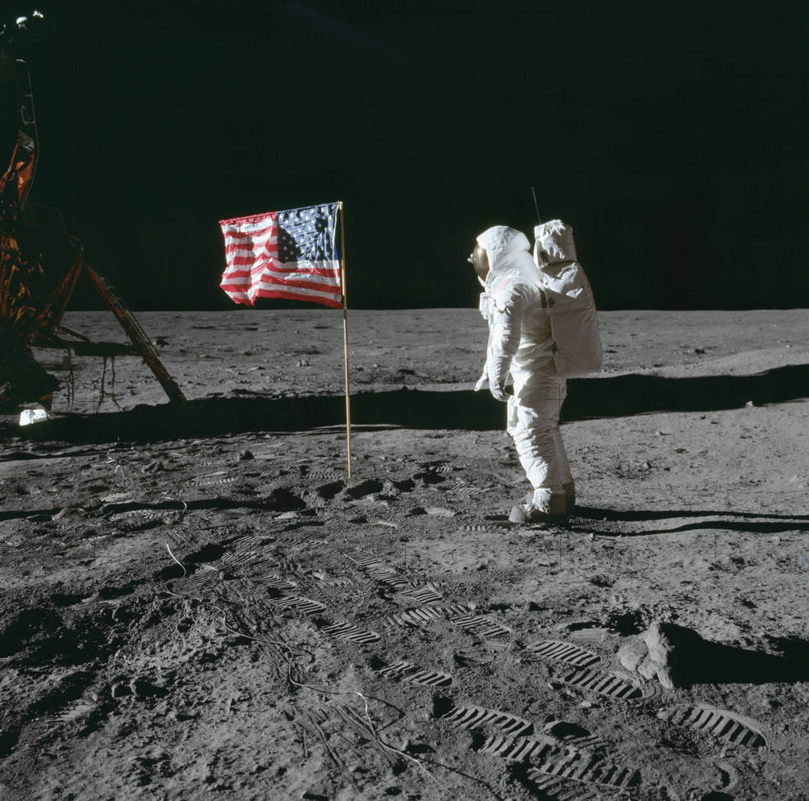
Figure 7 : Neil Armstrong (1930-2012), Buzz Aldrin saluting the US flag, 1969, Scan from the original film of AS11-40-5875. Image: NASA Image and Video Library (https://images.nasa.gov/details/as11-40-5875).

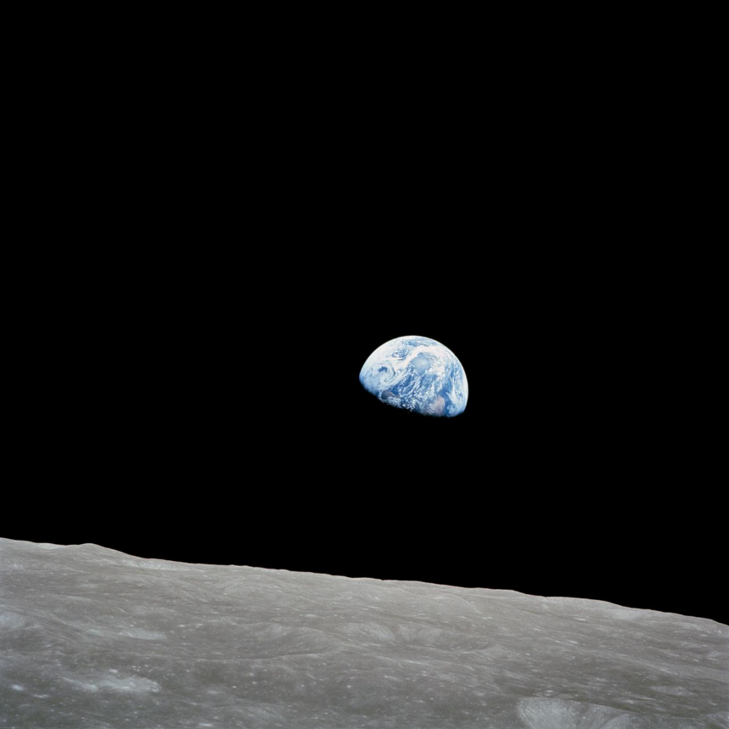
Figure 8 : Bill Anders (1933- ), Earth over the horizon of the moon (Earthrise), 1968, Cropped and coloured from the original film of AS08-14-2383. Image: NASA Image and Video Library (https://images.nasa.gov/details/as08-14-2383).

Carey, Brycchan. 2016. ““A new discovery of a new world”: The Moon and America in Seventeenth-and Eighteenth-Century European Literature” in “Literature in the Age of Celestial Discovery”. Palgrave Studies in Literature, Science and Medicine pp. 167-183
Christianson, Gale. 1976. “Kepler's Somnium: Science Fiction and the Renaissance Scientist”. Science Fiction Studies. 3.1. pp. 79-90
Dougherty, Kerrie. 2019. “The role of the ACT in the Apollo 11 Lunar landing”. Canberra Historical Journal 83. pp.6-13
Launius, Roger. 2008. “Heroes in a vacuum: The Apollo Astronaut as Cultural Icon”. The Florida Historical Quarterly. 87.2. pp. 174-209
https://history.nasa.gov/alsj/a11/a11-5903history.html
See e.g.,

