Module Name: Data Handling and Business Intelligence
Module Code: LCBB5000

Student name: Ivana Desevova
Student ID:2027510

Word Count: 3112
Table of Contents
Part 1: Analysis on Ice Cream Data 4
1. Introduction 4
2. Description of Ice Cream Data 5
3. Relationship/correlation Analysis 8
4. Analysis Conclusion 12
Part 2: Data Analysis on COVID-19 Cases 15
1. Introduction 15
2. Description of COVID-19 Cases Data 16
3. COVID-19 data Analysis 17
Overall Descriptive Statistics of the cases of each Continent 17
Cases statistics of Asia 17
Cases statistics of Europe 17
Cases statistics of America 17
Overall Descriptive Statistics of the Deaths of each Continent 18
Death statistics of Asia 18
Death statistics of Europe 18
Death statistics of America 18
Highest and lowest death rate 19
Deaths sum value of each continent with Histogram 19
Deaths percentage of each continent with Pie Chart 19
Correlations result of America Cases and Death 21
4. Methods of text mining 22
5. Evaluation of Excel and SPSS with conclusion 23

Part 1: Analysis of Ice Cream Data

1. Introduction
This report aims to discuss and analyse the use of Excel in business data processing, analysing and visualisation of business performances with successive business insights. Here, the discussion would be followed up by the demonstration of the numerical data concerning the data from the 200 students who have participated in the survey regarding their favourite ice cream flavour and scoring in the video play games including video and puzzle games (Jin & Kim, 2018). To show the relationship between the data measures and outcome of the student's most favourite ice cream flavours and scoring in the two different games, excel tools including IF function, Graphs, Charts, Trendline and Pie charts have been used and effectively added in the main body (Fedushko et al., 2020). The later discussion will develop the discussion on how modern business enterprises can use Excel in the data processing and analysing techniques.

2. Description of Ice Cream Data
In this section, the description regarding the set of data in the Ice Cream Excel file has been given. In the Ice Cream Data set, the data of 200 students have shown their responses towards the favourite ice cream flavour which they prefer in having the ice cream their choice. Besides, it also collected data on the scores in two different games which have been played by these students (Kuz'mina et al., 2020). In the case of Ice Cream data, these students have been given the choice of 3 different flavours including Vanilla, Chocolate and Strawberry. Based on the given choice, they have been asked to mark their favourite one. With the convenience of the data collection, these three flavours have been denoted as the 1, 2 and 3 respectively for Vanilla, Chocolate and Strawberry (Purba & Bimantara, 2020). In the case of collecting the data regarding the scores which have been counted in the manner of two games including Video Game and Puzzle Game have been played by the students where their highest scores have been collected and presented along with their respondent ID.
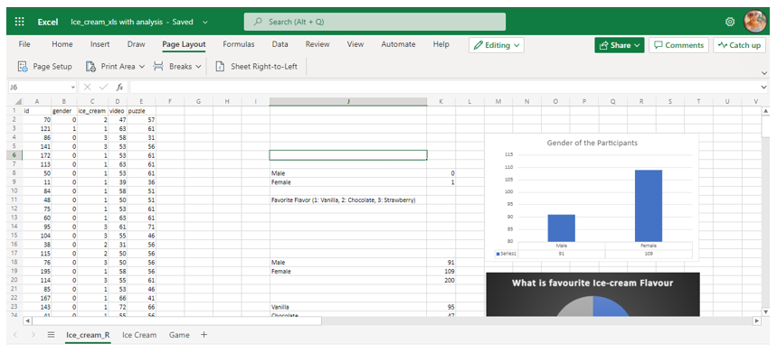

Figure: Gender of the Participants
The above figure has indicated that among the 200 participants in the data set, the number of male and female respondents respectively are 91 and 109 persons. As a result, the number of female respondents is essentially higher than the number of male respondents in the Ice Cream Data Set.

Figure: Favourite Ice-cream Flavour
In the case of knowing the favourite Ice Cream Flavour of the students who participated in the survey, the above pie has indicated that about 47% of the students prefer to have their ice cream with Vanilla Flavour while about 29% of the students have marked that Strawberry is their most favourite Ice-Cream Flavour. Thus, the remaining 24% of the students have marked Chocolate as their favourite Ice-cream Flavour. Therefore, the data set indicated that students with Vanilla Flavour preference are in the highest category group.

Figure: The trend line of the Game scores of the students
In the case of Playing the Video and Puzzle games by the students, the above trend line chart has indicated that the scores which have been obtained in these two games are higher in the case of Playing Puzzle games than Video games as the Average score in the Video game is 0.40 lower than the Puzzle game (Tuzunkan, 2018). In the case of the Video game, the Maximum score obtained by the students is 74 while the maximum score for the Puzzle Game is 71. Regarding the Minimum score of the two games, students have incurred the same 26 points in both games.

3. Relationship/correlation Analysis
Analysis of the Relationship between different Ice Cream Flavours and Gender
In the following figure, the pie charts have been used to reflect the relation between the male students and their favourite Ice Cream Flavour. In the case of Male students, the pie chart indicated that more than half of the male students or 52% of the male students prefer Vanilla as their Ice Cream Flavour while 32% of the male students prefer Strawberry flavour (Dul, 2019). In this regard, the relation between the Chocolate Flavour and Male students, the analysis has indicated that the remaining 16% of the male students have marked Chocolate as their favourite Ice Cream Flavour.
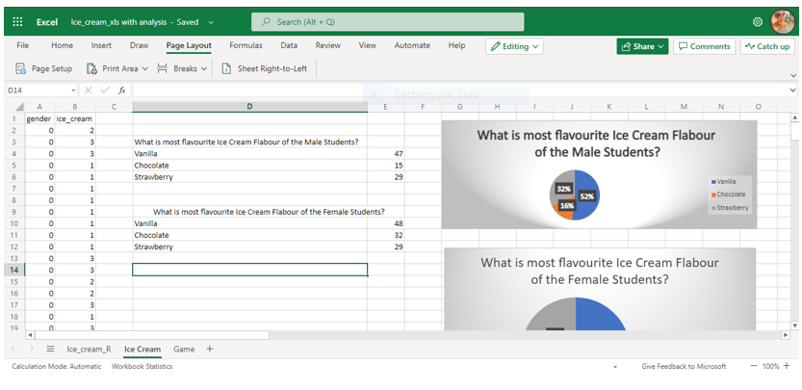

Figure: What is most favourite Ice Cream Flavour of the Male Students?
The following Pie Chart figure has been developed using the Excel tool to find the relation between the Female students and their favourite Ice Cream Flavour (GS et al., 2019). Concerning this figure, 44% of the female students have indicated that they prefer to have Vanilla as their favourite Ice Cream Flavour while 29% of the female students have marked Chocolate as their favourite Ice Cream Flavour. Thus, the remaining 27% have indicated that their favourite Ice Cream Flavour is Strawberry.

Figure: What is most favourite Ice Cream Flavour of the Female Students?
Analysis of the Relationship between Gaming scores and Gender
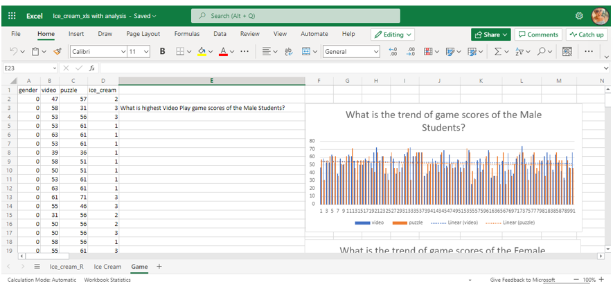

Figure: What is the trend of game scores of the Male Students?
The above figure has indicated that both Video and Puzzle Gaming scores have been concentrated in the manner of decreasing patterns in the trend line. Here, the decreasing trend line has also reflected that as the number of students is increasing, the average score of both games is decreasing (Bartosik-Purgat & Ratajczak-Mrożek, 2018). Besides, the overall score line for the Video game is higher upward than the Puzzle game. It indicated that concerning the male students and gaming scores, the male students are doing well in the video game than in the puzzle game where the highest and lowest score of the video game for male students are 74 and 26 points respectively. In the case of the Puzzle game, these scores are 71 and 26 for the highest and lowest levels.

Contrary to the male students, the trend line of the gaming scores of the female students has indicated that puzzle scores are higher upward than the video game scores for the female students. Thus, both of the gaming score lines are decreasing as the number of female students decreases over time (Kumar et al., 2021). In the case of doing well in the Puzzle game than in the Video game the female students, the highest and lowest scores in the Video game are 69 and 29 points while these scores are counted for Puzzle game as 71 and 26 points for Highest and Lowest level.

4. Analysis Conclusion
In the conclusion of the analysis section, it can be substantiated that most of the male students prefer Vanilla and Strawberry as their favourite Ice cream flavours while the contrary situation and findings have been found concerning female students who prefer mostly Vanilla and Chocolate in their Ice Cream. In this regard, the analysis has shown that Vanilla and Chocolate Ice cream flavours can be sold easily or had by female students. In the case of taking the consideration of the Gaming Scores into the analysis, the relationship between the gaming scores with its trend line with the male and female students, it has been found that female students did well in Puzzle gaming with a higher upward trend while the male students did well in the Video gaming with the highest scores.
5. MS Excel Evaluation and Conclusion
According to Sahoo (2021), Excel is the most commonly used statistical software which is used for the data analysis and presentation of the data with good insights and presentation tools. In the case of business management, the managers from different operations and departments such as marketing, finance, sales and production are using the Excel application in their computer operating system as an easy and quick way of data collection, pre-processing, analysis and visualisation.
Pre-processing
According to Sestino et al. (2020), Pre-processing includes the data extraction in a formatted and structured manner which can easily define the data into the information for effective data collection and analysis. Here, the business management can be helped and assisted with the collection of the data which are organised. For example, pre-processing can be used in the sales department where the big data from several locations including the sales figures of the different product categories can be transferred to the sorted and organised data using the pre-processing tools (Wang et al., 2020). In this regard, before data analysis, the managers can use the Auto sum, sorting, ascending, descending and conditional formatting for making these huge figures into the regional data set for taking the business decision for next year's product sales improvement.
Analysis
According to Li et al. (2020), Data Analysis involves the development of the hypothesis or the statistical model with the scientific method of calculation to reach the solutions which can be justified for the given problem or data query in the given set. In the case of analysis in Excel, the business managers can be facilitated by the tools concerning the correlation, regression, mean, mode and max in the excel function which allow the managers to know the actual set of data and its results with interpretation (Lim et al., 2019). For example, the Marketing department of an organisation can work on the hypothesis regarding whether social media marketing is positively related to increased sales with the collection of the sales data and customer's responses in the survey on Facebook using the Correlation and Regression analysis tool of the Excel.
Visualisation
According to Kalogiannidis (2021), Data visualisation involves a set of tools such as charts, pies, bars and graphs generated in Excel which helps the data analyser demonstrate and show the data in a structured and organised manner. In the case of visualising the data, the business managers use automated graphs and charts using the bar and trend line which help them to demonstrate the yearly or monthly sales performances or the expenditure level of the company. In this regard, they also use the Pie chart using the command of the Pivot table for showing the percentage of sales to the Board of Directors (Liang & Liu, 2018).
In the conclusion, it can be substantiated that business managers from different areas and departments can use Excel sheets for the data pre-processing, analysis and visualisation which helps the business to learn the scopes of the easy and quick data presentation. Besides, the easy and prompt tools of Excel can facilitate the manager to take quick decisions based on the charts, pivot tables, statistical commands and trend lines of the sales and expenditure.

Part 2: Data Analysis on COVID-19 Cases

Introduction
This part aims to discuss and analyse the Covid-19 cases in the manner of calculating the descriptive statistics using the SPSS application where the covid cases of the three continents including Europe, Asia and America will be used (Christa & Kristinae, 2021). The following discussion would include the summary of the data set and SPSS demonstrations with the Highest cases, lowest cases and correlation between the cases and deaths. The later discussion would add the importance of the most common mining methods of the text and the advantages and disadvantages of using the SPSS application for a business need.

2. Description of COVID-19 Cases Data
In the given set of Covid-19 data, there are three continents have been added and shown with the filtered tools where both cases and death data of Asia, Europe and America have been shown. In the case of the data set, other columns have indicated the date, countries, country code, year and month data which have been omitted in the final file after the pre-processing of the data for data analysis convenience (Einhorn et al., 2019). In the case of using this data set in the SPSS, the command of exporting the data of excel file has been used which automatically transformed the data into the appropriate structure and organisation.
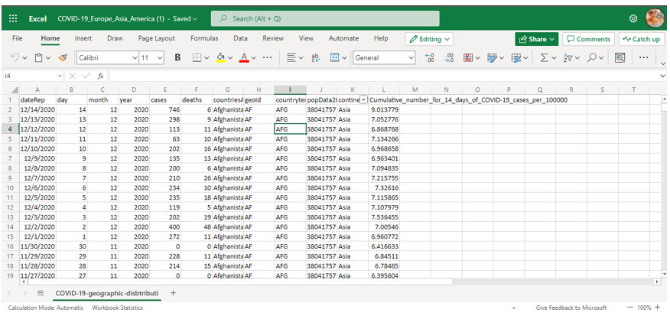
Variable View of Used data set
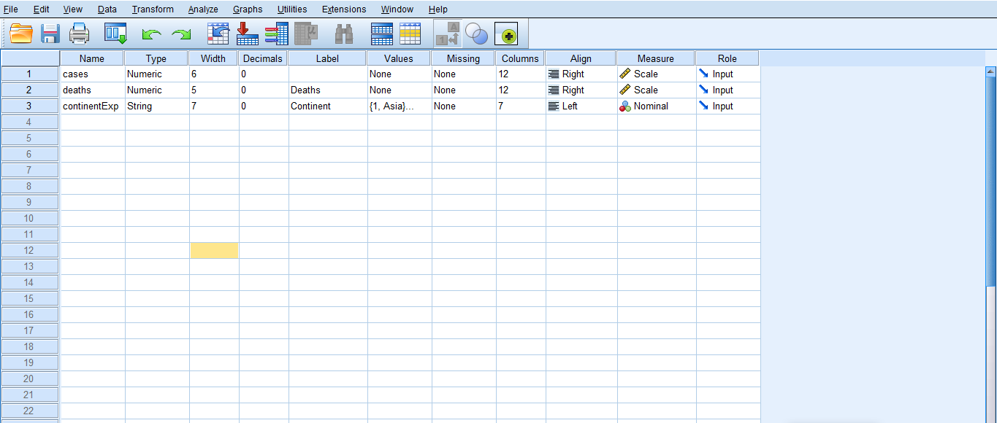

3. COVID-19 Data Analysis

Overall Descriptive Statistics of the cases of each Continent

Cases statistics in Asia
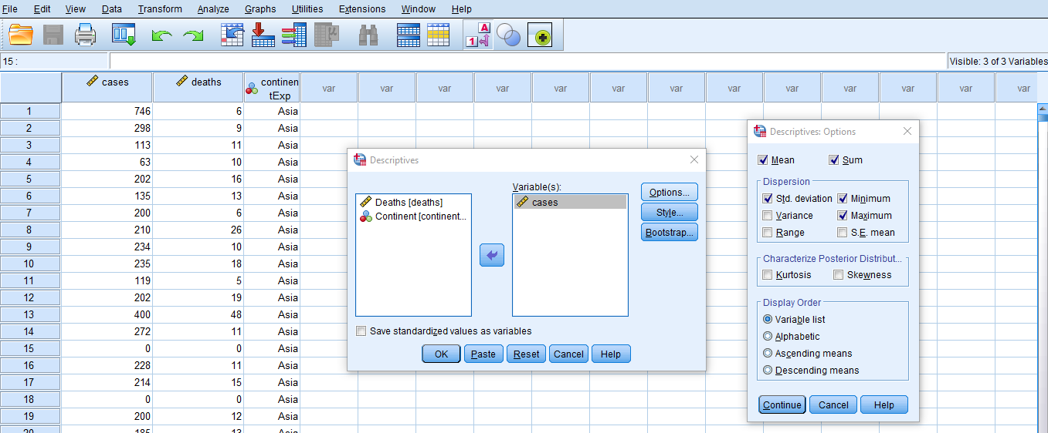
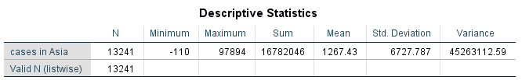
The above table has indicated that Asia has been reported with a total value of 1,67,82,046 as the Covid-19 reported cases.

Cases statistics of Europe
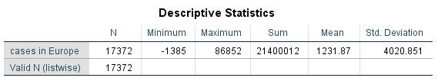
The above table has indicated that Europe has been reported with a total value of 2,14,00012 as the Covid-19 reported cases.

Cases statistics of America
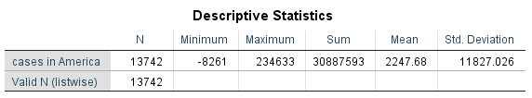
The above table has indicated that America has been reported with a total value of 30,88,7593 as the Covid-19 reported cases.
Based on the above three tables, the sum value of the daily cases can be known where the total cases of Asia, Europe and America have been counted respectively as 1,67,82,046, 2,14,00012 and 30,88,7593. In the case of calculating the sum value of the total cases, the analysis has shown that America has the highest Covid-19 cases reported to the authority.

Overall Descriptive Statistics of the Deaths of each Continent
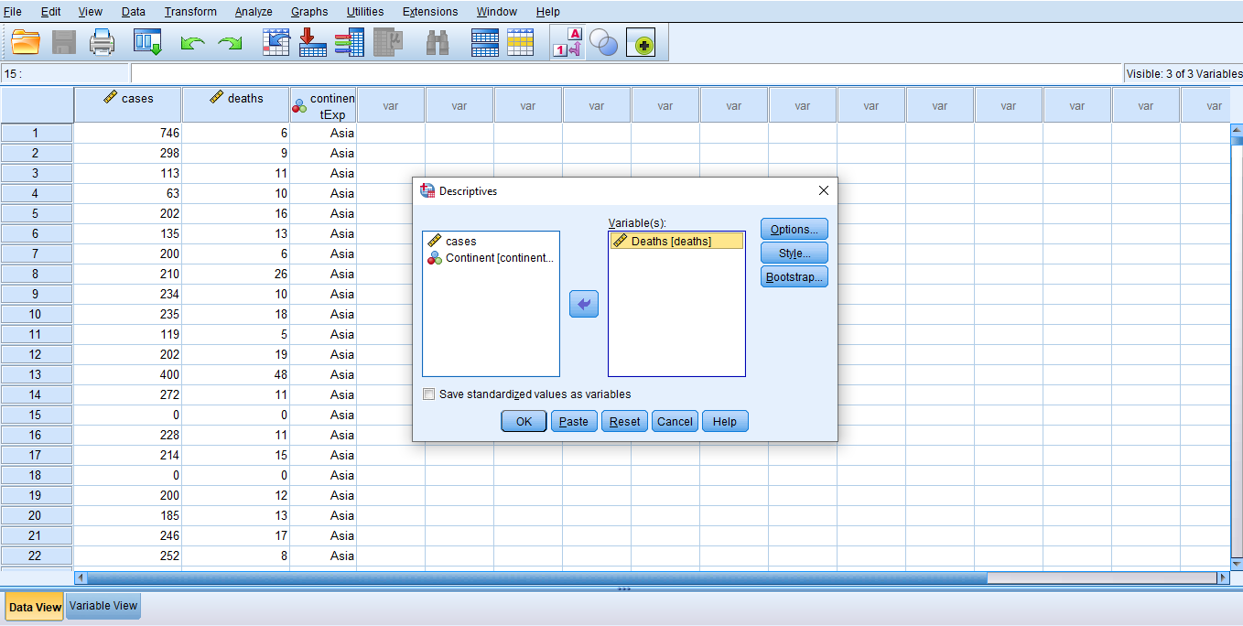

Death statistics of Asia
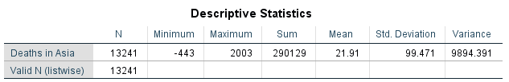
The above figure has shown that the total sum value of the death due to the Covid-19 has been reported with 2,90,129 in the case of Asia.

Death statistics of Europe

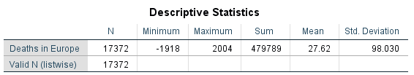
The total value of the death due to Covid-19 in Europe as a continent in the data set has shown 4,79,789 deaths.

Death statistics of America
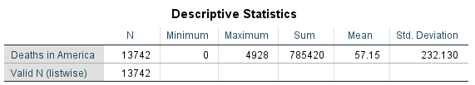
The above table has incorporated the calculation of the total death value in America which shows a total of 7,85, 420 deaths in America due to Covid-19.

Highest and lowest death rate
In the following figures, both histograms and pie charts have been used to know which content has the highest death rate and which one has been incorporated with the lowest death rate among the three continents.

The deaths sum value of each continent with a Histogram
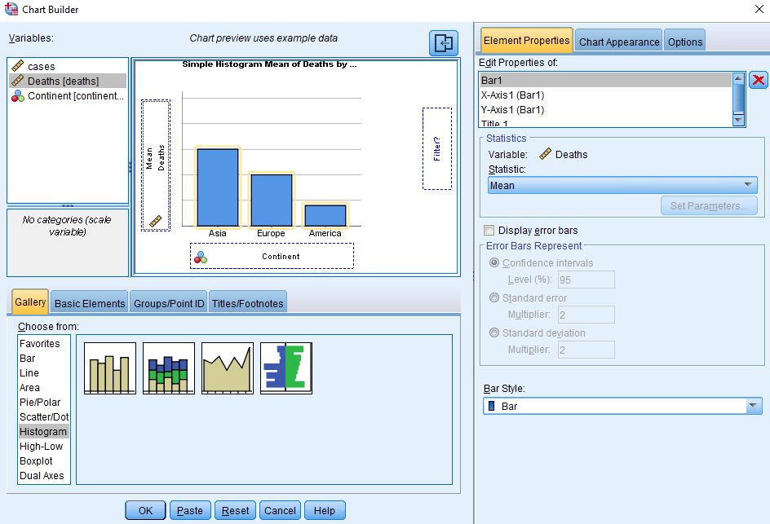
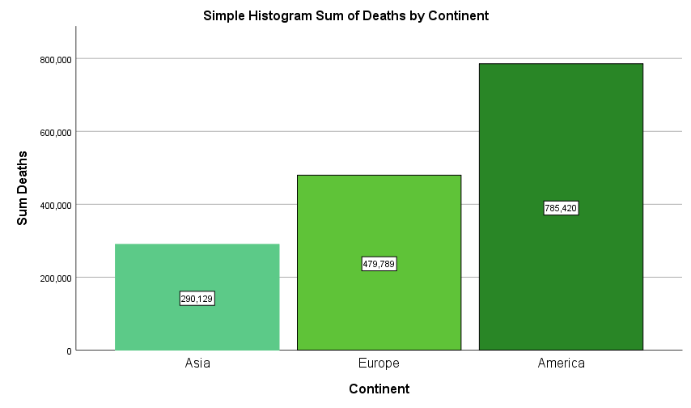
The histogram has incorporated the death figure of Asia, Europe and America with the value of 2,90,129, 4,79,789 and 7,85,420 respectively which has indicated that Asia has the lowest death sum value while the highest sum value of death America indicated the highest death rate has been incurred in America.

Deaths percentage of each continent with Pie Chart
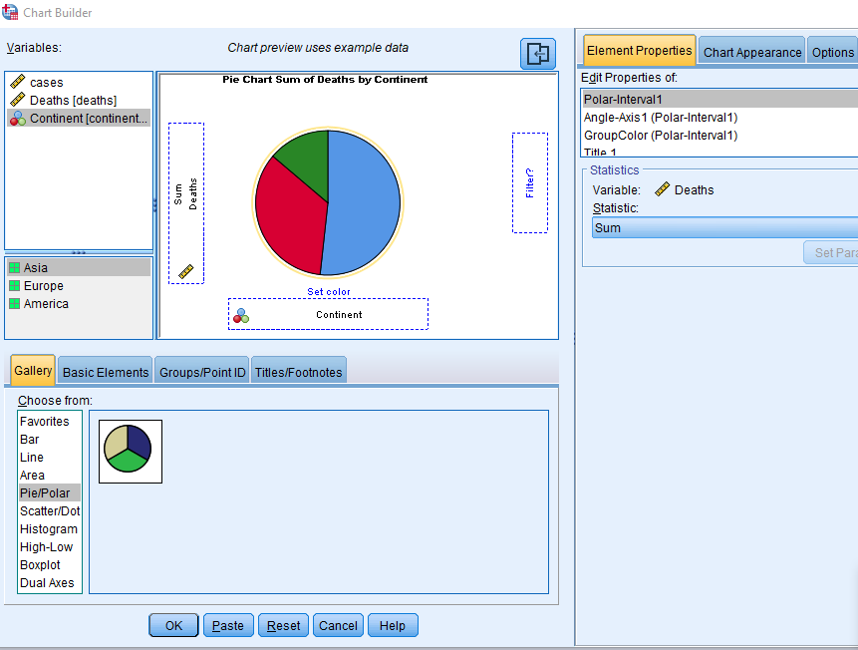

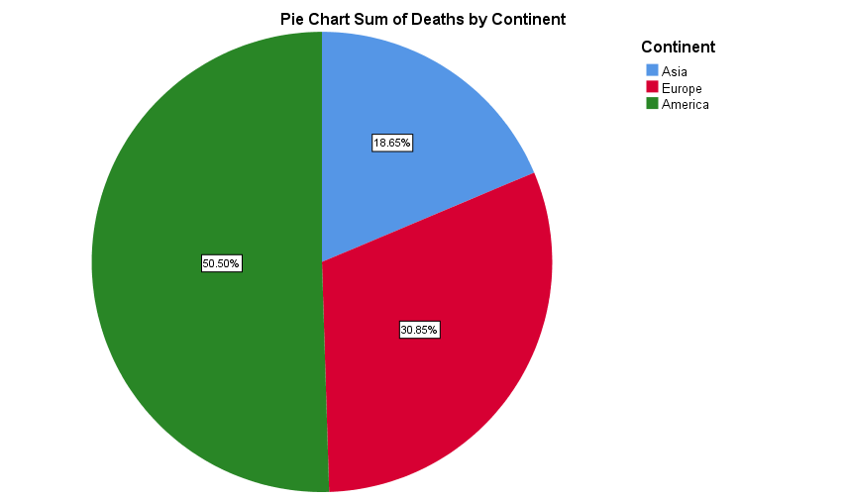
In the case of presenting the data with the Percentage rate, the death rate of the three continents including Asia, Europe and America where Asia has accounted for the 18.85% of the total deaths in the data set is the lowest rate while the 30.85% have been counted as death percentage of Europe. The highest death has been accounted for in America with a rate of 50.50% rate in the overall data set.

Correlations result between America Cases and Death
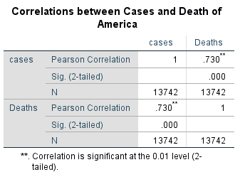
The above figure has calculated the Pearson Correlation value by taking the two variables including Cases and Deaths in the SPSS correlation command. The results have been counted with the level of significance of 0.01 which shows that cases of covid-19 and deaths are strongly correlated with the correlation value of 0.730 which is statistically significant with the α value of 0.000. Therefore, it can be concluded that covid-19 cases and deaths are positively correlated and have a positive linear relationship. Therefore, as the cases due to covid-19 increase in America, the rate of death will be increased with a linear relationship.

4. Methods of text mining
According to Ghimire et al. (2020), Text mining is the association of the process where the texts are organised and structured by following the standard data grouping and processing aspects to transform the text data into useful information. There are four main types of methods of text mining that are generally used in the Text Mining process.
Term focused Method
In this method, the data of the documents and huge texts are efficiently used as the term where the use of different terms are considered suitable commands for the data analysis and computation (Sardo et al., 2018). For example, machine learning has been developed and effectively used in several construction businesses in the UK using the Term based Method which lowered the time of execution in site engineering.
Phrase focused Method
This method involves a set of phrases which provide more semantic advantages to the users and less ambiguity. Compared to the Text-based method, the phrases are sophisticated and provide more efficiency (Jin & Kim, 2018). For example, customer care managers usually use phrases to help remind the customers regarding their complaint categories over the phone.
Concept focused Method
This text mining method uses the natural language-based attributes with the clustering features where the different words, texts and phrases are combined to create the sub-group of the data which can be varied with conceptual understanding (Fedushko et al., 2020). For example, a group of customers with the same complaint category can be sub-grouped for the effective conceptualisation of a problem statement in the sales department.
Pattern Taxonomy
The pattern taxonomy method is a rule-defined and relational text mining method where a sequential and structured process of text identification, coding and frequency identifications are adopted (Kuz'mina et al., 2020). For example, in the case of finding out the impacts of Covid-19 on the price of the stock market, a sequential pattern of daily price reduction rate is followed based on the given texts.

5. Evaluation of Excel and SPSS with the conclusion
SPSS and Excel applications are mostly used statistical tools and software in the current business world. In the case of using Excel, the easiness and convenient features require less time for understanding the process of calculations. For example, the manager from the public relation can easily use the command of Mean, Mode, Median and Sum by only selecting the commands (Purba & Bimantara, 2020). Besides, the quick and customisable columns and rows of the Excel sheet provide more scopes for the business manager to organise and group the sales data. Thus, the same excel commands are difficult to understand as this application provide no helping wizard to help user to know the process of data calculation.
Besides, the managers of the sales department can send the manipulated data to the production manager which impedes the organisation to take the correct production decision. The SPSS application is useful in the case of handling a large amount of sales data of several store locations while it also facilitates the easy user interface (Kumar et al., 2021). Thus, the advanced tools of descriptive statistics and regression analysis create the complexity to find the relation between the sales data and customer populations.
In conclusion, this part has summarised that America has the highest number of death and rate in Covid-19 cases while the correlation of 0.73 between the cases and deaths have provided a strong relationship. The later discussion has indicated the text mining methods while the Excel and SPSS have been evaluated with easiness and convenience in business management.

References
Bartosik-Purgat, M. and Ratajczak-Mrożek, M., (2018). Big data analysis as a source of companies’ competitive advantage: A review. Entrepreneurial Business and Economics Review, 6(4), p.197.
Christa, U. and Kristinae, V., (2021). The effect of product innovation on business performance during COVID 19 pandemic. Uncertain Supply Chain Management, 9(1), pp.151-158.
Dul, J., (2019). Conducting necessary condition analysis for business and management students. Sage.
Einhorn, F., Marnewick, C. and Meredith, J., (2019). Achieving strategic benefits from business IT projects: The critical importance of using the business case across the entire project lifetime. International Journal of Project Management, 37(8), pp.989-1002.
Fedushko, S., Ustyianovych, T., Syerov, Y. and Peracek, T., (2020). User-engagement score and SLIs/SLOs/SLAs measurements correlation of e-business projects through big data analysis. Applied Sciences, 10(24), p.9112.
Ghimire, A., Thapa, S., Jha, A.K., Adhikari, S. and Kumar, A., (2020). Accelerating business growth with big data and artificial intelligence. In 2020 Fourth International Conference on I-SMAC (IoT in Social, Mobile, Analytics and Cloud)(I-SMAC) (pp. 441-448). IEEE.
GS, A., Kurniasih, N., Reni, A., Istanti, E., Zuhroh, D. and Qomariah, N., (2019). The effect of business sphere on competitive advantage and business performance of SMEs. Management Science Letters, 9(8), pp.1153-1160.
Jin, D.H. and Kim, H.J., (2018). Integrated understanding of big data, big data analysis, and business intelligence: A case study of logistics. Sustainability, 10(10), p.3778.
Kalogiannidis, S., (2021). Business Trust and Communication as Predictors of Business Growth. WSEAS Transactions on Business and Economics, 18, pp.1512-1522.
Kumar, S., Sureka, R., Lim, W.M., Kumar Mangla, S. and Goyal, N., (2021). What do we know about business strategy and environmental research? Insights from Business Strategy and the Environment. Business Strategy and the Environment, 30(8), pp.3454-3469.
Kuz'mina, E.V., P'yankova, N.G., Tret'yakova, N.Y.V. and Botsoeva, A.V., (2020). Using Data Analysis Methodology to Foster Professional Competencies in Business Informaticians. European Journal of Contemporary Education, 9(1), pp.54-66.
Li, D., Gong, Y., Ren, M. and Li, D., (2020). The research and design of trust business management and analysis system based on big data technology. In 2020 5th IEEE International Conference on Big Data Analytics (ICBDA) (pp. 68-72). IEEE.
Liang, T.P. and Liu, Y.H., (2018). Research landscape of business intelligence and big data analytics: A bibliometrics study. Expert Systems with Applications, 111, pp.2-10.
Lim, W.M., Ahmed, P.K. and Ali, M.Y., (2019). Data and resource maximization in business-to-business marketing experiments: Methodological insights from data partitioning. Industrial Marketing Management, 76, pp.136-143.
Purba, J.H.V. and Bimantara, D., (2020). The influence of asset management on financial performance, with panel data analysis. In 2nd International Seminar on Business, Economics, Social Science and Technology (ISBEST 2019) (pp. 150-155). Atlantis Press.
Sahoo, S., (2021). Big data analytics in manufacturing: a bibliometric analysis of research in the field of business management. International Journal of Production Research, pp.1-29.
Sardo, F., Serrasqueiro, Z. and Alves, H., (2018). On the relationship between intellectual capital and financial performance: A panel data analysis on SME hotels. International Journal of Hospitality Management, 75, pp.67-74.
Sestino, A., Prete, M.I., Piper, L. and Guido, G., (2020). Internet of Things and Big Data as enablers for business digitalization strategies. Technovation, 98, p.102173.
Tuzunkan, D., (2018). Customer relationship management in business-to-business marketing: Example of tourism sector. GeoJournal of Tourism & Geosites, 22(2).
Wang, Z., Wang, N., Su, X. and Ge, S., (2020). An empirical study on business analytics affordances enhancing the management of cloud computing data security. International Journal of Information Management, 50, pp.387-394.

