VASILE ENE
1817171

THE GLOBAL BUSINESS ENVIRONMENT

ELECTRIC VEHICLE

Assesment 1

Dr. Kenny Tang

Introduction

What is the business environment?
The term ‘business environment’ means the sum total of all individuals, institutions and other forces that are outside the control of a business enterprise but that may affect its performance. Thus, the economic, social, political, technological and other forces which operate outside a business enterprise are part of its environment.[1]
The combination of internal and external factors that influence a company's operating situation. The business environment can include factors such as: clients and suppliers; its competition and owners; improvements in technology; laws and government activities; and market, social and economic trends.[2]
What Is Globalization?
Globalization is the spread of products, technology, information, and jobs across national borders and cultures. In economic terms, it describes an interdependence of nations around the globe fostered through free trade. Globalization motives are idealistic, as well as opportunistic, but the development of a global free market has benefited large corporations based in the Western world. Its impact remains mixed for workers, cultures, and small businesses around the globe, in both developed and emerging nations.[3]
Environmental degradation and climate change…
Greenhouse gases emitted by human activities alter Earth’s energy balance and thus its climate. Humans also affect climate by changing the nature of the land surfaces and through the emission of pollutants that affect the amount and type of particles in the atmosphere. Scientists have determined that, when all human and natural factors are considered, Earth’s climate balance has been altered towards warming, with the biggest contributor being increases in CO2.[4]
Human activities are changing the climate
Rigorous analysis of all data and lines of evidence shows that most of the observed global warming over the past 50 years or so cannot be explained by natural causes and instead requires a significant role for the influence of human activities.[5]
External forces
As the global economy has expanded there is the wider range of companies and countries engaged in global business. More over state and state related organisation are playing increasingly active role. We highlight two cross-cutting views of the international environment. The first is the differing dimensions of the environment, including economic, cultural, political, legal, financial, ecological and technological. The second is that of spheres, from the local through to the national, regional and global.[6]
PESTLE analysis is a structure for planning, presenting, and report writing, it is also an analytical tool to consider external factors and help in the analysis of the impacts. Basically, PESTLE is mainly used to identify and summarize environmental influences on an organization to help it assess actual and future strategic contexts [7]. PESTLE helps organization adapt proactively to ever changing environment and allows forward thinking so that issues are anticipated in advance [8]. PESTLE analysis can help to take advantages of the opportunities and minimize the threats. PESTLE can help to avoid strategies that may be doomed to failure for reasons beyond control.
Electric Vehicle Industry – PESTLE analysis
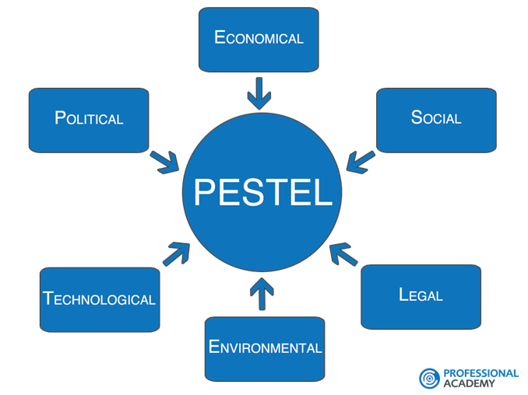Taken from: http://www.professionalacademy.com/blogs-and-advice/marketing-theories---pestel-analysis
Political factor refers to the impact of the decisions taken by the various government authorities and the broad policies followed by the government of a country. While a positive policy can help a business grow, a negative business strategy might adversely affect the industry. In the countries with tradition in the field of the motor vehicle industry, various policies at state or regional level are supported by the creation of various social facilities or by the adoption of laws directly related to this industry and environmental protection.
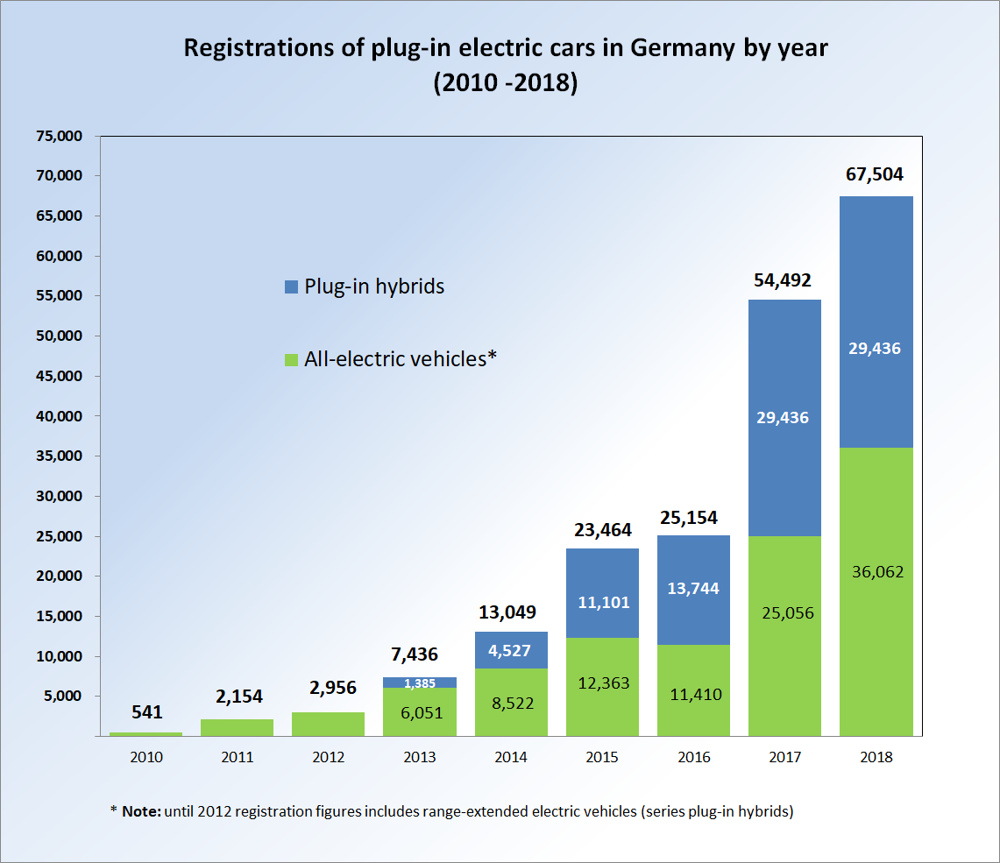
https://upload.wikimedia.org/wikipedia/commons/thumb/9/96/PEV_Registrations_Germany_2010_2014.png/300px-PEV_Registrations_Germany_2010_2014.png
In May 2010, under its National Platform for Electric Mobility, Chancellor Angela Merkel set the goal to bring one million electric vehicles on German roads by 2020.[9][10] Following the policies followed by many other European countries, the German government too has a positive policy for the BEV industry. German industry gives tax reductions and exemptions for the manufactures of BEVs in Germany (ACEA 2014).
The Plug-in Car Grant (PICG) programme started on 1 January 2011 and is available across the UK. The adoption of plug-in electric vehicles in the United Kingdom is actively supported by the British government through the plug-in car and van grants schemes and other incentives.[11]
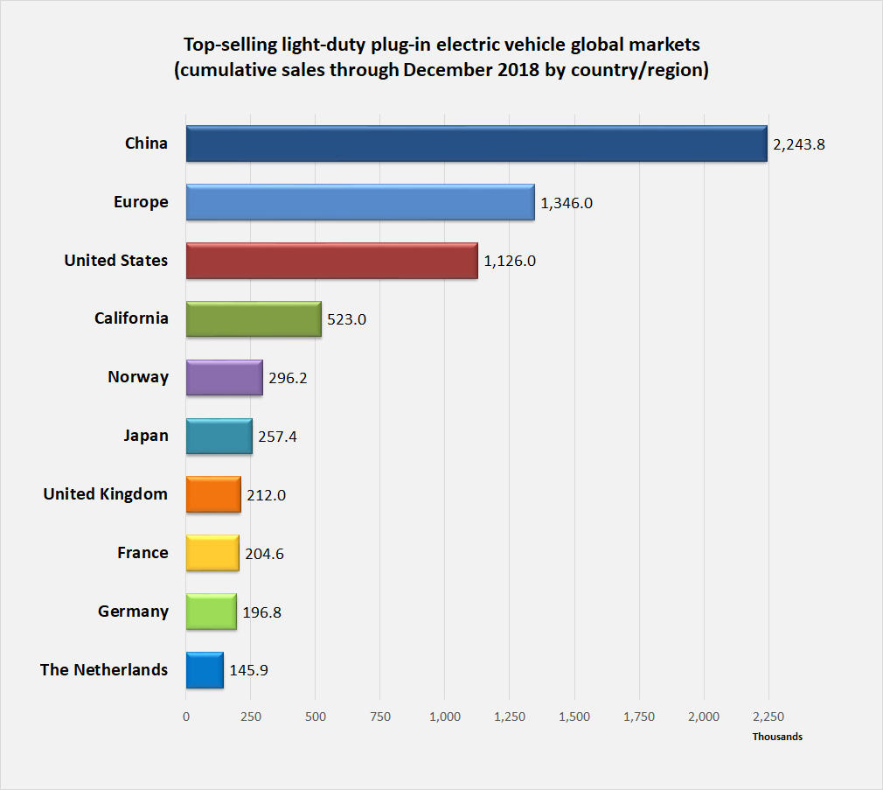
https://upload.wikimedia.org/wikipedia/commons/f/fa/Top_PEV_global_markets_stock_2017_final_with_California.png

The Chinese government adopted in 2009 a plan to leapfrog current automotive technology, and seize the growing new energy vehicle (NEV) market to become of the world leaders in manufacturing of all-electric and hybrid vehicles’
The American stock represented about 25% of the global plug-in car stock in 2017,[12] and the U.S. had the world's third largest stock of plug-in passenger cars after China and Europe.[13]
A 2016 study conducted by researchers from the University of California, Davis found that the federal tax credit was the reason behind more than 30% of the plug-in electric sales.
Economic factors are important in the development of this industry. Local, national or global economic growth leads to faster growth, if low growth rates have an impact on unemployment, bank interest rates can ease or hinder the spending capacity of consumers and organizations that lead to economic growth negative impact on the development of the industry in the field. For example, the crisis period after 2008 has led to a worsening and stagnation of the business environment regarding the electric vehicles. Nowadays, US market is most attractive for Electric Vehicle, because of the economic growth. In addition, financial elements incorporate monetary development in the option vitality commercial ventures and increment in the expense of utilizing the autos for the most part because of the ascent in technical service costs in the brief period. Accordingly, the interest for more-proficient autos is higher than it used to be.[14]
Social factor can positively or negatively influence the trade or production of electric vehicles. Due to globalization or developed areas through the road infrastructure achieved through the economic development of the respective region, this has led to a demand for the transportation of persons. The development of the purchase level, the development of environmental awareness, the awareness that driving an electric car is less polluting, this helps to reduce the carbon footprint. The maintenance costs of such a vehicle are lower compared to the classic vehicles, thus the owners of electric vehicles manage to save significant costs.
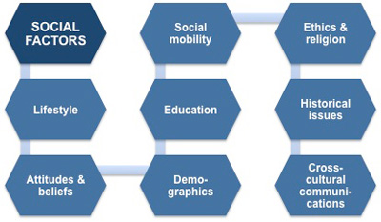http://www.free-management-ebooks.com/images/stpa0501.jpg
In general, electric car is an advance technology that used to reduce pollution and balance the environment. All of these will lead us to healthy life for human being.
Technological factors
Based on the history of the automobile vehicle, car reflects an evolution. Automobiles starting with the first steam, electrical, and gasoline engine cars. Need innovation and new technology to be invented to replace the conventional automobile vehicle. New ideas and innovation for the vehicles need to be introduced in order to improve and make the vehicles become safer and more efficient. Thus, hibrid car is introduced [15][16]. Electric cars completely operate with the power stored in their batteries. Batteries need to be charged by connecting them to external power sources. No internal combustion engines are used to charge the batteries of electric cars.[17]
Environmental factors
Normally, the fuel-powered cars will emit pollution gas, such as carbon monoxide, carbon dioxide and hydrocarbons. According to CNET, there is over 19 pound of carbon dioxide gets released into our earth’s ozone layer each time a car uses one gallon of gasoline. The most obvious consequence of this greenhouse gases emission is global warming and impacts the earth’s climate negatively [18]. This is where Tesla’s biggest strength lies. The cars are marketed as environmentally friendly because it uses electricity more than gas. Tesla vehicles abide by many environmental regulations and barely impact carbon emissions (compared to traditional cars). By focusing on the environment, Tesla has made a name for itself where few can compare.
Legal factors refer to the impact of the legal environment such as the laws and statutes have on the performance of a business or industry. The EU’s Clean Fuel Directive, as proposed in January 2013 and being discussed in EU Parliament in March 2014, sets a target of 800,000 publicly accessible EV charging stations to be installed throughout Europe by 2020 – with individual targets being set for each member state.[19] For the year 2014, the German government has injected fresh funds to the tune of € 500 million for research in electrical vehicle technologies.[20]
Porter’s 5 Forces
Michael Porter developed the Five Forces Model in 1980. Michael Porter's Five Forces is a powerful competitive analysis tool to determine the principal competitive influence in a market. It is a broadly used model in business that refers to the five important factors that drive a firm's competitive position within an industry. By thinking through how each force affects you, and by identifying the strength and direction of each force, you can quickly assess the strength of the position and your ability to make a sustained profit in the industry. Thus Five Forces analysis helps you stay competitive by:
• Knowing the strength of these five forces, you can develop strategies that help their businesses be more competitive and profitable.
• Looking at opportunities, you can to strengthen their organization's position compared to the other players for reducing the competitive pressure as well as generate competitive advantage.
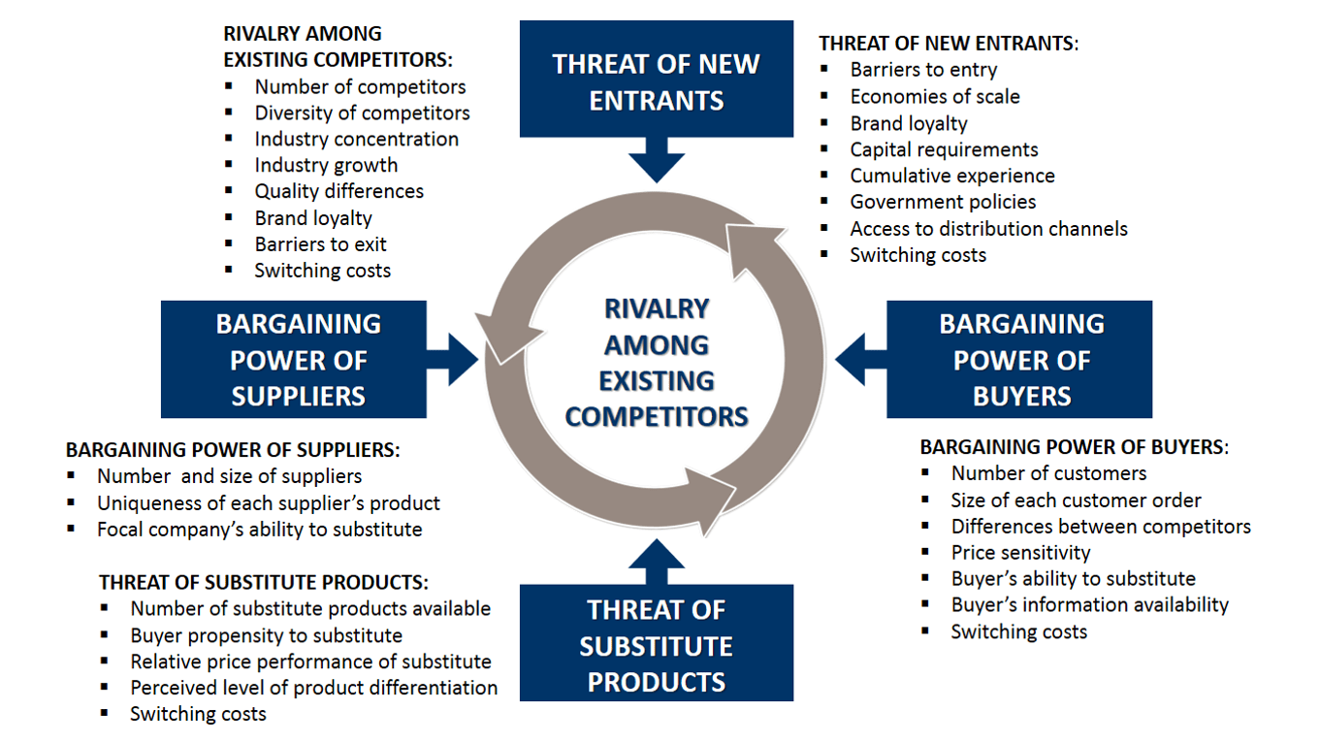
https://i2.wp.com/www.business-to-you.com/wp-content/uploads/2017/04/Five-Forces-Model-Porter.png
Bargaining power of suppliers: How can suppliers influence the production price of the product? A larger number of suppliers leads to a lower cost of production due to the competition of the prices offered by the suppliers. When the number of suppliers is small or in the market niche are only a limited number of suppliers then their bargaining power is higher and results in high costs to find another supplier, it is difficult to find an alternative product.
Bargaining Power of Buyers: The production of electric vehicles has been diversified especially in the last decade, involving all the major car manufacturers, as this is the next step in this industry. High fuel cost, environmental damage are just some of the reasons that have led to the spread of electric vehicles and yet this branch is still at the beginning of the road. The low maintenance costs, the advantages offered by the companies, Tesla selling its products directly without being involved with the car dealers, favors maintaining the sale price of the company. Websites, as well as social websites, present the electric vehicle and facilitate access to information. Car sites offer a range of assistance to car buyers in the form of buyer assistance in negotiations for discounts, cheaper insurance and comparing different alternatives available on the market.
Threat of Substitutes: the industry in the field is at the beginning but with the evidence of the American company Tesla is on the rise, Tesla has managed to overcome the recession and is currently growing and developing the company with new models. Tesla brand is one of the topiary competing companies in the industry trying to cope with this company. The Nissan-Renault Group is a direct threat to the success of the Nissan Leaf product, but there are other companies that have launched competing products BMW, Volvo, Ford, Honda, Toyota. China, an economic colossus, develops and launches products that compete with those on the market, but also diversifies the offer of vehicles that address a certain sector of the market by offering "low speed electric vehicle".
Threat of New Entrants: New entrants in a sector can pose a threat to the status quo and impact the sales of existing players. The Global automobile industry is well entrenched all over the world with most of the sales coming from the highly competitive eastern markets like China. A lot of Chinese automobile manufacturers are now improving the quality of their products and expanding globally. Reiterating its commitment to the Paris Agreement, the Government of India has plans to make a major shift to electric vehicles by 2030.
Competitive rivalry: in highly competitive industries, firms can exercise little or no control on the prices of the goods and services. In contrast, when the industry is a monopolistic competition or monopoly, businesses can fully control the prices of goods and services. Rivalry between existing players is likely to be high when:
Players are the same size.
Players have comparable strategies.
Little or no differentiation between players and their products leading to price competition.
Low market growth rates.
Barriers for exit are high.
Strategy consultants occasionally use Porter's five forces framework when making a qualitative evaluation of a firm's strategic position. However, for most consultants, the framework is only a starting point and value chain analysis or another type of analysis may be used in conjunction with this model.[21]
Organisational changes
Organizational change is about the process of changing an organization's strategies, processes, procedures, technologies, and culture, as well as the effect of such changes on the organization.
With organizational change strategies, companies can avoid stagnation while minimizing disruption as much as possible. Preparation is integral for success, especially during a change effort. However, one can’t prepare without knowing what type of change is occurring.
Types of Organizational Change. There are three main categories of change: business process re-engineering, technological change, and incremental change.
The construction of electric vehicles is relatively new, even though over time there have been attempts to produce an electric vehicle whose production was limited by the dependence on an energy supply system. Due to the development of new technologies, the innovations that have been made in recent years have made it possible to develop a competitive product and to be able to successfully replace the classic vehicle. Digitization, artificial intelligence, the development of a new generation of batteries with a longer life and a greater capacity of energy storage have facilitated the construction of efficient electric vehicles. It is true that at the beginning of production the cost of a vehicle was quite high.
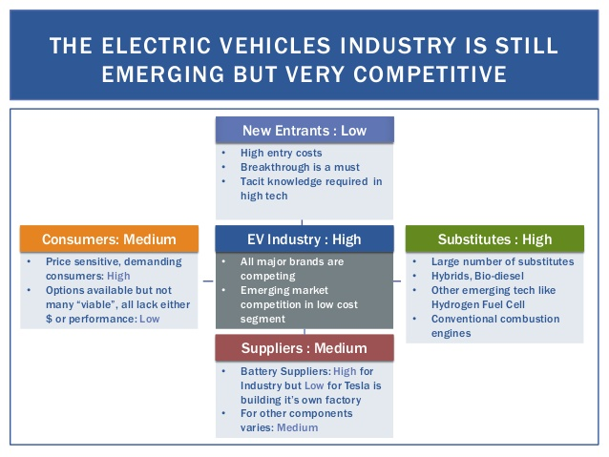
https://image.slidesharecdn.com/valuechainconfigurationforteslamotorsinbrazil-150917103225-lva1-app6891/95/value-chain-configuration-for-tesla-motors-in-brazil-3-638.jpg?cb=1442503704

A value chain is a model of looking at all of your business processes and figuring out how to gain a competitive advantage by focusing on developing maximum value in your product or service, while keeping your profit margins in the green at the same time. The term “value chain” refers to all of the business processes that combine to produce the desired product or service. In order to build a value chain model of a business, you perform a value chain analysis. These techniques fall under the umbrella of value based management.
Originally, the concept of a value chain was introduced by Michael E. Porter in his book Competitive Advantage: Creating and Sustaining Superior Performance (Free Press, 1998).
“Competitive advantage cannot be understood by looking at a firm as a whole […] It stems from the many discrete activities a firm performs in designing, producing, marketing, delivering and supporting its product” – Michael Porter, Competitive Advantage: Creating and Sustaining Superior Performance
Simply put, his value chain framework highlighted the importance of maximizing value at each stage of an organization’s processes. In order to differentiate their brand Tesla Motors attempts to manufacture superior products and exclusive technology. The core competencies of the company are conveyed through the accomplishments in their value chain, which builds customer value. In the process of clarifying the available information, it has categorized in actual value development.
The company has applied most of their value chain parts by implicating design, manufacturing and sales. Basic machineries are manufactured and transported from numerous suppliers, and most important machineries Tesla produces in-house (Bowman, 2010). Also, Gigafactory will provide considerable scale advantages and the manufacture will be vertically integrated (Tesla Motors, 2014). Also, the price of automobiles is non negotiable, that’s why the company implement the vertical integration on selling. The Gigafactory will help to construct the Gen3 with 200 miles assortment.
The distribution channel of Tesla Motors comprises their own stores in 18 countries. The stores are located in visible areas in shopping malls and high foot traffic streets in order to involve the clients when they are open-minded and create brand awareness (Tesla Motors, 2014). For instance, some celebrities, such as Morgan Freeman and George Clooney etc. have a big influence on popularity and fashionable brand image of Tesla. Tesla motors applies new multi channel model for acquiring vehicles, which includes online stores and retail outlets. The online purchasing helps potential customer to buy a car online in a suitable way.
The noticeable competitive advantage of Tesla is supercharger networks. The company have 110 public free charging stations in North America and Europe and one station in China (Tesla Motor, 2016).
With the exchange of electric vehicles or urgent requirements, it is necessary, therefore, the national and international networks for raising batteries with care are built, equipped with vehicles, stations for public use or home. In order to have a higher number of batteries, as well as increased efficiency, a greater amount of overcoming, it can create solutions for achieving better and stronger batteries. Artificial intelligence can come if it can be successfully applied in the fields of industry, the creation of new systems of safety, prevention, digitization of products intended for these branches for industry. Replacing classic cars with electric care vehicles are more environmentally friendly and creates a wide range of business diversification opportunities. From the manufacturer itself, from the designer, the creator of the vehicle's shape, from the software to the care of the cell, the product business opportunity will come countless. Trade in electric vehicles is growing, worldwide is steadily increasing or increasing interest in non-polluting vehicles.
The future is with vehicles and not only in domestic transport, public transport, buses, use of transport, etc.
References
[1] Martin Hoelz. (2009). Deloitte Touche Tohmatsu. A New Era Accelerating toward 2020- An automotive industry transformed. Retrieved November 23, 2011 from http://www.deloitte.com/assets/Dcom,Global/Local%20Assets/Documents/A%20New%20Era_Online_final.pdf.
[2] http://www.businessdictionary.com/definition/business-environment.html
[3] Globalization, By CAROL KOPP, Updated May 9, 2019 from https://www.investopedia.com/terms/g/globalization.asp
[4], [5] The Basics of Climate Change from https://royalsociety.org/topics-policy/projects/climate-change-evidence-causes/basics-of-climate-change/
[6] Morrison, J (2016) The Global Business Environment, Challenges and Responsibilities, 4th Edition, Palgrave.
[7] Williams, B.; Figueiredo, J.; , “Strategy and technology management: An innovation-leader case study,” Technology Management Conference (ITMC), 2011 IEEE International , vol., no., pp.806-811, 27-30 June 2011
[8] Simon Teague LLP, “The Ultimate Leadership Guide – Secrets to success”, Simon Teague LLP 2009, Buckland Press, Dover, Kent, UK, pg 13 – 14.
[9] John Blau (2010-05-03). "Berlin plugs in electric mobility strategy". Deutsche Welle. Retrieved 2014-08-24.
[10] Barbara Praetorius (2011). "E-Mobility in Germany: A research agenda for studying the diffusion of innovative mobility concepts" (PDF). ECEEE. Archived from the original (PDF) on 2014-08-26. Retrieved 2014-08-24.
[11]Society of Motor Manufacturers and Traders (SMMT) (6 January 2012). "December 2011 –EV and AFV registrations". SMMT. Retrieved 14 January 2012.
[12]International Energy Agency (IEA), Clean Energy Ministerial, and Electric Vehicles Initiative (EVI) (May 2018). "Global EV Outlook 2017: 3 million and counting" (PDF). IEA Publications. Retrieved 2018-10-22. See pp. 9–10, 19–23, 29–28, and Statistical annex, pp. 107–113.
[13] Cobb, Jeff (2017-01-16). "The World Just Bought Its Two-Millionth Plug-in Car". HybridCars.com. Retrieved 2017-01-17.
[14] BBC News, (2014).Petrol price reaches record high. [online] Available at http://www.bbc.co.uk/news/business-17490088
[15]Mary Bellis. (n.d.). About.com Inventors. Automobile History the History of Cars and Engines. Retrieved November 23, 2011 from http://inventors.about.com/od/cstartinventions/a/Car_History.htm.
[16] Discovery Communications, Inc (n.d.). Discovery Channel. History of Cars Timeline. Retrieved November 23, 2011 from http://www.yourdiscovery.com/cars/timeline/.
[17] Reynolds, C, & Kandilkar, M 2007, How hybrid-electric vehicles are different from conventional vehicles: The effect of weight and power on fuel consumption. Environmental Research Letters, vol. 2, no. 1, pp. 20-32.
[18] Sadie Bell. (November 26, 2011). LiveStrong.com. What are the benefits of the environment?.Retrieved November 22, 2011 from http://www.livestrong.com /article/129150-benefits-hybrid-cars- environment/
[19] Case Study - Electric vehicles in Europe Gearing up for a new phase
[20] World watch Institute (2014), Germany Boosts Electric Vehicle Development, Available: http://www.worldwatch.org/node/6251
[21] Tang, David (21 October 2014). "Introduction to Strategy Development and Strategy Execution". Flevy. Retrieved 2 November 2014.
[22] Tesla Motors, Inc., (2014).Form 10-K Annual Report. Palo Alto, California,[online]Available at: http://ir.teslamotors.com/secfiling.cfm?filingID=1193125-14-69681&CIK=1318605

