David Veater (2520276)

Assignment 2 Academic skills

Contents Table
- Introduction
- Presentation skills and Reflection
2.1 4 screenshots from the initial presentation presented by the student
  - Aspects that could be improved to enhance future presentation
- Self Evaluation and progression
3.1 Self evaluation
3.2 Strengths/Weaknesses and SMART guidelines
- Action Plans and Gantt charts
4.1 Action Plan
4.2 Demonstration of completing action plan
5. Tools used to enhance productivity
5.1 Tools
5.2 Using Excel spreadsheets
5.3 depicting data form graphs and tables
Introduction
This report will be discussing a student’s academic skills referencing the initial power point they delivered and things the student learnt whilst also feedback the student could use to improve upon. Next the report will be looking at a self-evaluation of the student and creating targets following smart guidelines that will allow the student to improve their weaknesses. This report will then look at action plans set for the student and Gantt charts. After this the report will be looking at the tools used by the student such as looking at their excel abilities, depicting data, and use of screengrabs.

Presentation skills and reflection

On the 14th of October the student needed to present an Icebreaker powerpoint presentation. An Icebreaker by Cambridge dictionary definition is “a game or activity that is used to introduce people to each other so that they feel more relaxed together” [1], researching Icebreakers first, the student set out to create an entertaining and enjoyable presentation while providing information about themself.
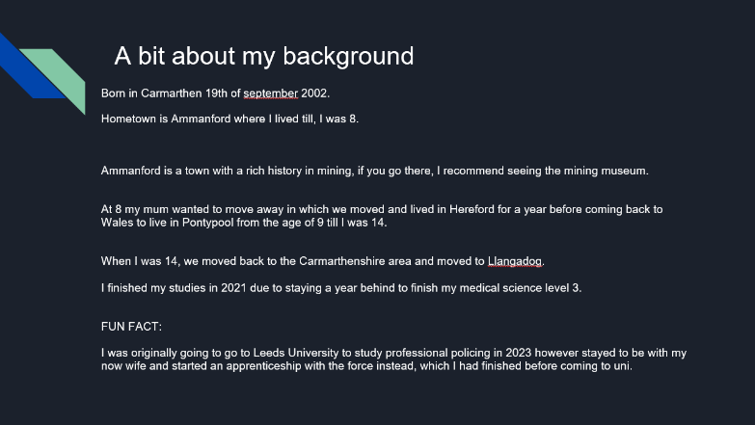
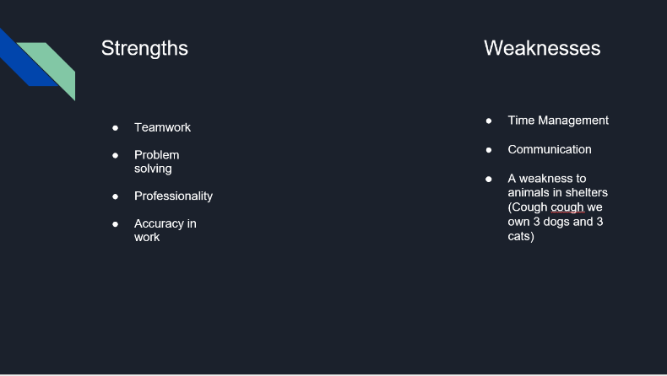

The below 4 screengrabs are from the students initial powerpoint.
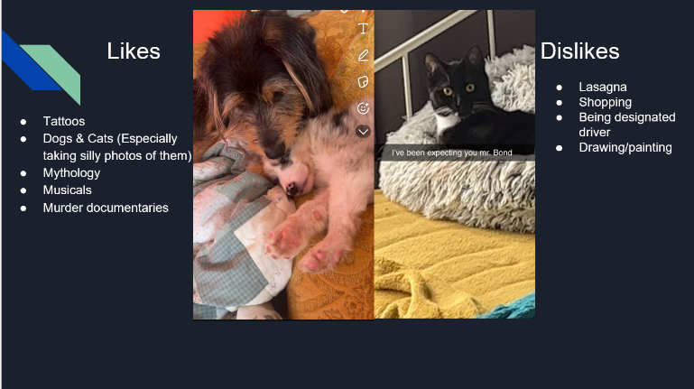
When trying to produce the powerpoint the student used a different software using Google Slides an online presentation app that allows you to collaborate with others in producing the slide [2], the student wished to learn how to use another power point software to develop their skills and gaining a mixed variety of knowledge on powerpoint software’s. Additionally, a skill learned during the process of creating the powerpoint was the skill of layout and designing the powerpoint using these to keep the interest of the audience and to show the key details I wanted put across to them. Lastly another skill the student developed and learn was confidence, confidence is highly important in presenting, stage fright being a struggle for presenters being able to maintain eye contact, engaging with audience and adding humour and questions keeps the audience’s attention on the presenter and maintains interest in the presentation.
Aspects that could be improved to enhance future presentations
Assessing and looking over the feedback provided by the audience the student has deemed these to be the areas that they will need to improve for future presentations.
First the presentations slides contained too many words, this will need to be in the future more simplified and instead fewer text with more just the subject and having notes on what to say for each section and not relying on the presentation. Another weakness to improve for the presentation is time management, the presentation went over the set time, in order to improve this more practise in presenting future PowerPoints and keeping track of time in each section of the presentation will need to be made.
Self-evaluation and progression
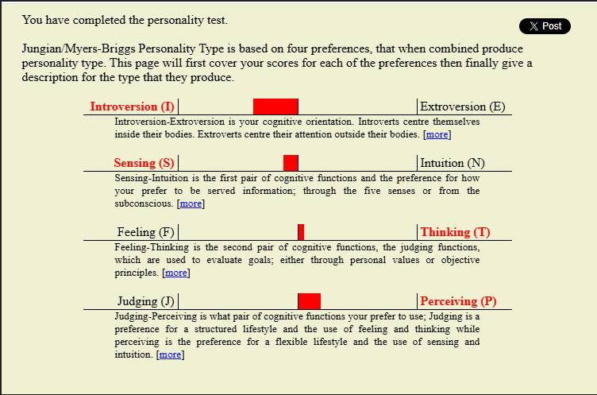
In order to evaluate the student, they were asked to complete the Holland Code test, a Jungian personality test, this test is based on four preferences that when combined creates a personality type (Jungian test), and the IPIP Big Five Factor test.
The results of these tests are the below.
[3]
As you can see in the Jungian test, the students result shows that they scored higher in introversion, sensing, thinking and perceiving, these results combined result in the student being an ISTP personality type. These types are known for their practicality and independence, and their personalities tend to be quieter and more observant, assessing environments and surroundings and analysing how things work [3]. Looking at these results, the student may find it easier to learn through kinaesthetic learning, this learning style is through the medium of a more practical, and hands on style of learning [4].

[5]
The big five personality traits are the most used and accepted model of personality tests in academic psychology; this test originates from the statistic study of responses to personality studies [5].
Looking at the results of the test the student is more extroverted rather than introverted, further the students’ results are high for emotional resulting in the student not showing signs of anxiety or depression within the results. the third factor in the students' results shows that they are more agreeable and cooperative rather than competitive and sceptical. These results also show that the student is conscientious showing they are more efficient and more self-disciplined compared to others who are impulsive and disorganised. And lastly the final factor student scored the highest in is intellect/imagination which shows the user has a high imagination and is open to new ideas and experiences compared to those who are more traditional and conservative [5].
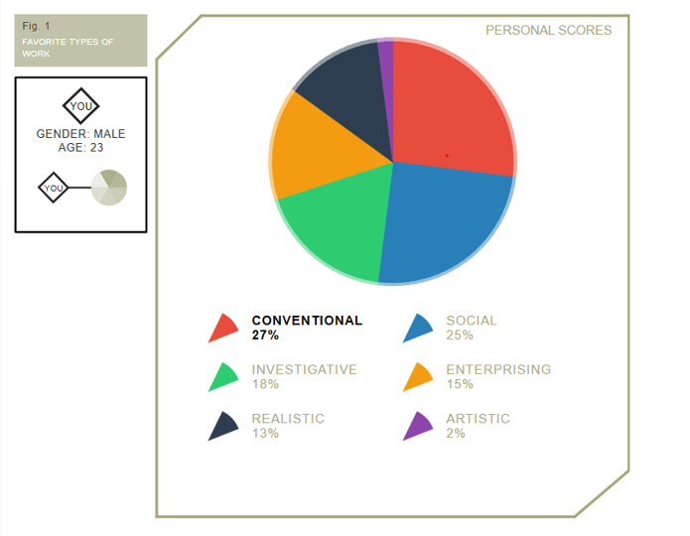
[6]
The next test the student completed is the career test using personality types and Holland Codes which resulted in the student's personality type being “CSIERA”, this showed that the student preferred career choices that followed a more conventional role followed then by social and investigative roles [6].
Due to the clash in the Jungian results and the “Big Five” test results the student looked over the results and found that they believed that the Jungian test was more accurate due to them feeling more introverted despite the result in the big five test and that they currently do have troubles with anxiety and depression, however despite these two errors in the results they do agree they are perceptive and conscientious of their work.

Strengths/Weaknesses and SMART guideline
Looking over the students reports and feedback from their presentation the student believes their strengths and weaknesses are the below.
Strengths | Weaknesses
Public speaking | Time management
Conscientious of work helping accuracy | Communication
Problem Solving | Adaptability
Creativity | Being overly self-critical
Work Ethic | Being disorganised

The student looking over the above table chose two weaknesses they wish to improve these being time management and communication in which the student created action plans following SMART goals, these being.
Specific, a specific goal that answers questions such as, what will be accomplished from this [7].
Measurable, making your goal be able to be measured and tracked as the student completes the action plan [7].
Achievable, this guideline assesses whether the goal is realistic, and the student will be able to carry out this [7].
Relevant, this guideline assesses whether the goals that are set and achieving the goal is relevant and necessary for the student [7].
Time-bound, this guideline assures that when creating the action plan there is an end date and time for the student to achieve their goals [7].

Following these guidelines the students’ specific goals will be to improve their time management skills and their communication skills, the time management goal will be measured through time logs, which will show how the student spends their time and how much the student spends their time on non-productive tasks. [8] The communication goal will be measured through self and peer assessments, the self-assessments will be completed by reflecting on the students’ current skills against their desired goal for communication skills, the peer assessment will be completed through constant feedback from other students and teachers [9]. Looking through the other guidelines, the student feels that these goals are achievable, and relevant towards their student life and course, whilst also being relevant to their desired future career in secondary school teaching. The two goals the student wishes to achieve will have a deadline of the end of the student’s foundation year on the 30th of June.
Based on these guidelines the student will be able to self-reflect using their measurements and feedback from peers or the student themself, taken throughout the time-period and see how they have progressed in their goal, and whether they have achieved them or not.
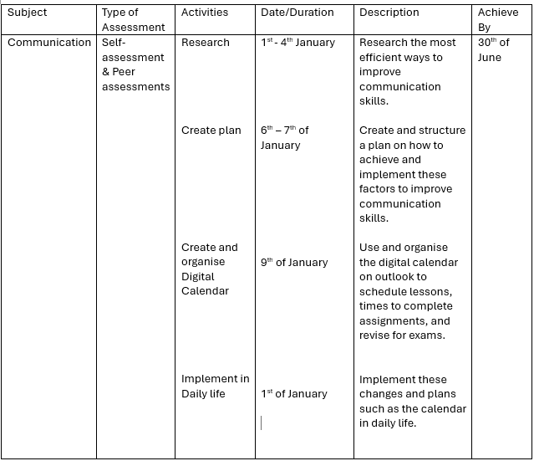
Action Plans
The below images are the created action plan and Gantt chart for improving time management skills.

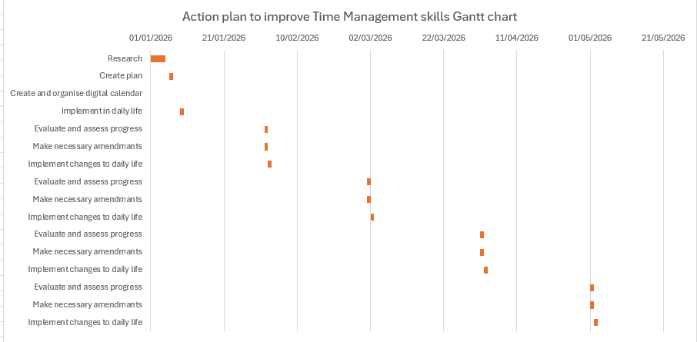
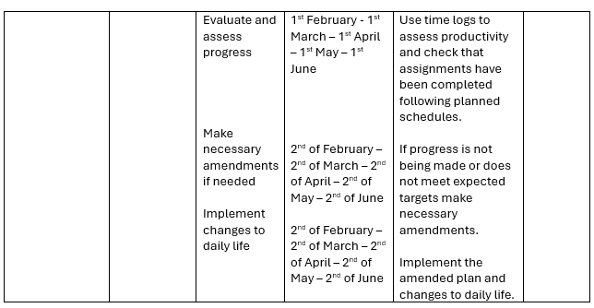
Screengrab of Gantt chart, created by author using Excel software

Using multiple sites such as Skillcast [8] for researching ways to improve time management skills is simple, it is the implementation and consistency of using the recommended suggestions that will be completed this is why in the action plan it has been set up that the student will assess and review how the plan is going and to measure their progress and development at the start of every month, so that they can implement and make adjustments. The important tools implanted into this action plan will using and organising the Calendar provided by the university on Outlook and the time log these two tools will be crucial to manage the students time and will help balancing studying and assessments along with normal daily activities. One of the difficulties found using this action plan was the implementation and organising the students' schedule such as organising revision times and times to complete assessments to work around days in university this is due to the travel time between their home and the university being over an hour long, due to this it is imperative to set out a realistic timetable and to work around the days the student would return home late.

Demonstration of completing action plan

In this demonstration the student has created the below action plan and Gantt chart to show the step-by-step process of completing Assessment 2 of their academic skills course. In this plan and Gantt chart they have implemented learned elements of their goals in improving their time management skills and used the action plan and Gantt chart to continue developing in their goal of improving their time management skills.
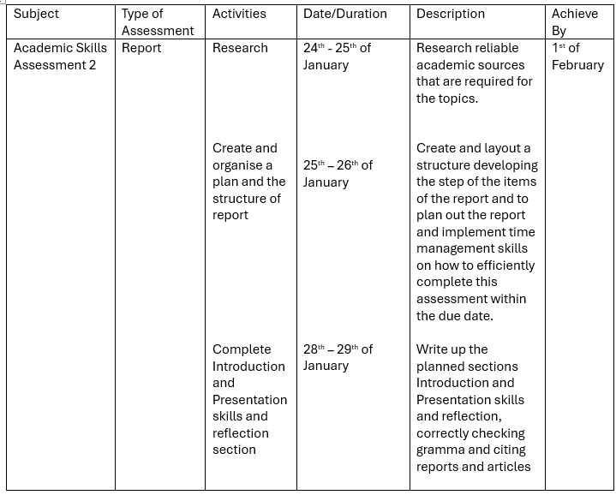

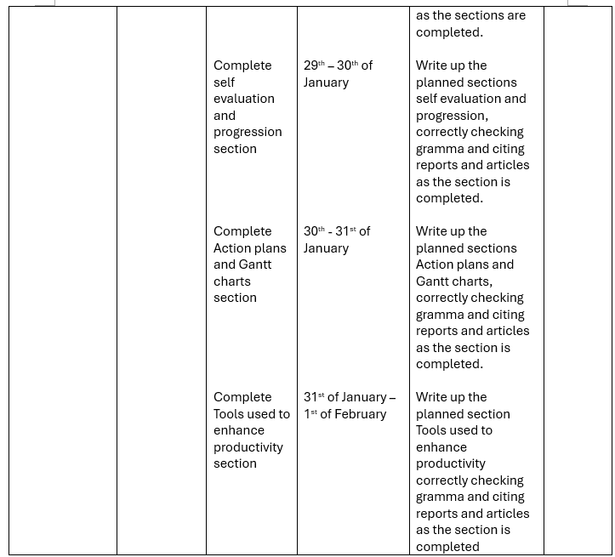
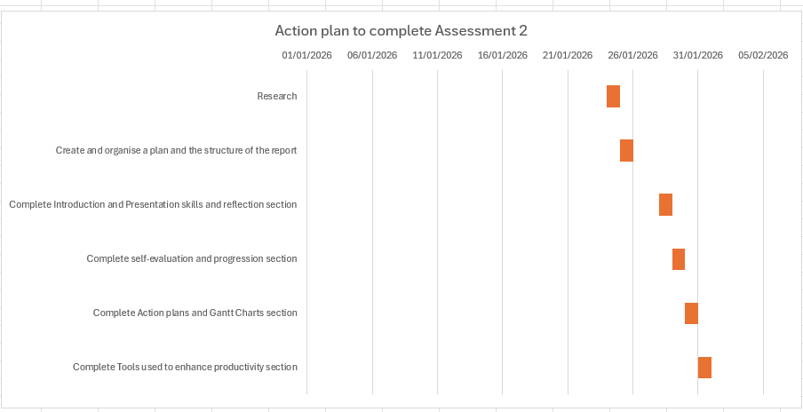
Screengrab of Gantt chart, created by author using Excel software

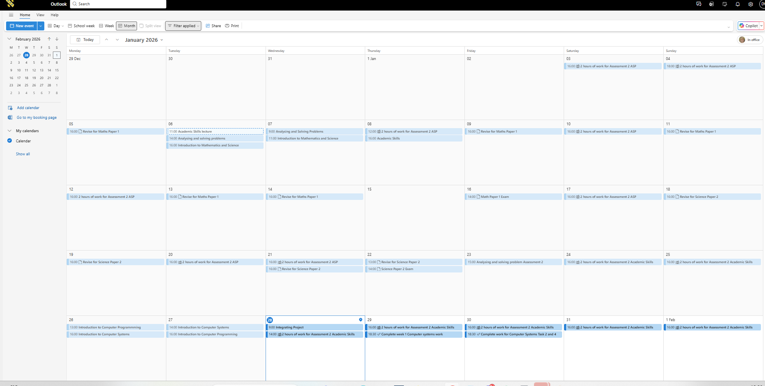
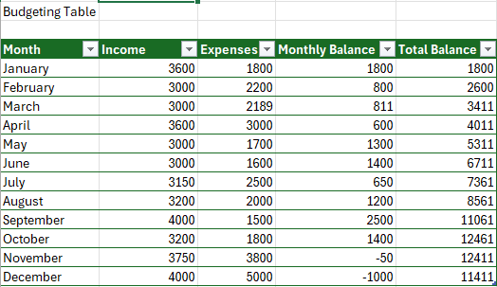
Use of tools to enhance productivity
In order to meet the objectives and the students goals in improving their time management they used their Student outlook calendar to create the below arrangements following certain criteria such as using days without lessons to study for the exams or complete assessments, and the hour travel back and forth from the university to study after or before lessons and exams.
Using University account on Microsoft Outlook for managing time.
The student uses Outlooks calendar as it allows them to manage and organise their schedule while also allowing for collaboration in creating group schedules which will support the student in their independent project when working in a group. [10]
Furthermore, additional tools that the student has added to their repertoire to improve their productivity is learning how to use the excel software. Excel software allows the user to create and organise a vast amount of data efficiently whether it’s numbers or text. Using Excel, it enables you to add or subtract your data, sort and filter your data, put your data into tables with a varied styles and themes, and then import the data into different charts. [11] The student used the Excel software to create the Gantt charts within this report.
Additionally, using the Excel software’s formulas such as “=sum B2+/-C2” these will allow you to subtract or add the two data numbers and import it into another box, For example the below budgeting table uses the formula “B2-C2” to calculate the monthly balance for January [11]. The below are examples of the author using the Excel software to organise and manage their finances and depicting the data from table and charts.

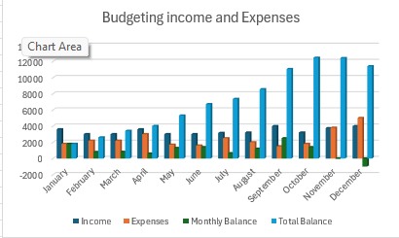
Created by author using Excel software
Created by author using Excel software

Created by author using Excel software
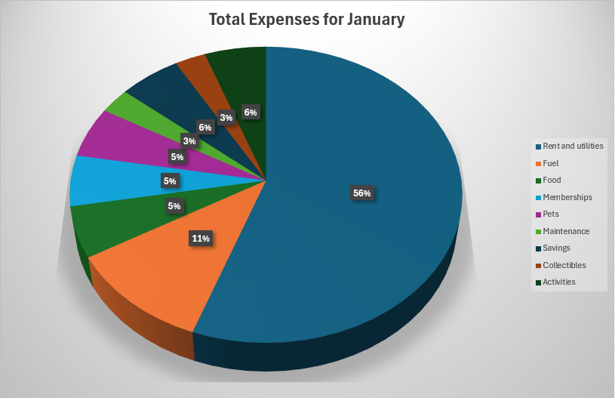

Bibliography

[1] | Cambridge University Press, “Cambridge University,” Cambridge University Press, [Online]. Available: https://dictionary.cambridge.org/dictionary/english/ice-breaker. [Accessed 26 January 2026].
[2] | Google slides, “Build Beautiful slides together,” Google , [Online]. Available: https://workspace.google.com/intl/en_uk/products/slides/. [Accessed 26 January 2026].
[3] | Open-psychometrics, “Open Extended Jungian Type Scales 1.2,” Open-psychometrics, 15 October 2019. [Online]. Available: https://openpsychometrics.org/tests/OEJTS/. [Accessed 15 January 2026].
[4] | Bay Atlantic University , “8 Types of Learning Styles,” Bay Atlantic University, 7 March 2024. [Online]. Available: https://bau.edu/blog/types-of-learning-styles/. [Accessed 26 January 2026].
[5] | Open-psychometrics, “Big Five Personality test,” Open-Psychometrics, 2 August 2019. [Online]. Available: https://openpsychometrics.org/tests/IPIP-BFFM/. [Accessed 15 January 2026].
[6] | 123Test team, “Career test,” 123Test, 17 May 2024. [Online]. Available: https://www.123test.com/career-test/. [Accessed 15 January 2026].
[7] | Atlassian, “How-to-write-smart-goals,” Atlassian, [Online]. Available: https://www.atlassian.com/blog/productivity/how-to-write-smart-goals%20967. [Accessed 22 January 2026].
[8] | skillcast, “10 ways to improve your Time Management skills,” skillcast, 15 September 2025. [Online]. Available: https://www.skillcast.com/blog/10-ways-improve-time-management-skills. [Accessed 27 January 2026].
[9] | Corporate English Solutions, “Measuring the hard-to-measure: assessing communication skills,” British Council, 25 November 2025. [Online]. Available: https://corporate.britishcouncil.org/insights/measuring-the-hard-to-measure-assessing-communication-skills. [Accessed 28 January 2026].
[10] | Microsoft, “Introduction to the Outlook Calendar,” Microsoft, [Online]. Available: https://support.microsoft.com/en-gb/office/introduction-to-the-outlook-calendar-d94c5203-77c7-48ec-90a5-2e2bc10bd6f8. [Accessed 07 January 2026].
[11] | Microsoft, “Basic tasks in Excel,” Microsoft, [Online]. Available: https://support.microsoft.com/en-gb/office/basic-tasks-in-excel-dc775dd1-fa52-430f-9c3c-d998d1735fca. [Accessed 20 January 2026].

