  Component One: Student Journal (learning log) 750 words +/- 10%  Contribution to Overall Module Assessment: 25% | Student No: | 2242243
 | Module Title: | Operating Hotel Facilities
 | Module Code: | BMIH4006
 | Lecturer: | Scott James
In this reflective journal, I will explore my conversation with the housekeeping manager at Delta Hotel by Marriot to gain insights into their housekeeping procedures. Although I did not directly participate in housekeeping tasks because of the rota given to me, the discussion provided me with valuable information about their practices, including the frequency of full service, light service, the average cleaning time per room, health and safety protocols, chemical usage, and the role of an agency like Omni Facilities Management at Delta Hotels by Marriot Liverpool.
During the chat with the housekeeping manager, I found out that the hotel does a full cleaning of a guest’s room every three days. This means they change the bed lines, clean the bathroom, dust the furniture, and refill supplies. Guests can also ask for light cleaning every day where the room is tidied up and supplies are replaced. I was told that it takes about 28 minutes to clean one room. The cleaning process starts with gathering cleaning supplies and fresh lines before entering the room. The housekeeping staff follow a step-by-step method to make sure the room is clean and tidy. Before cleaning the room turn on the lights, and open the curtains and the windows. I learned that preparing the bedroom is the first step, then the bathroom, shower, sink, and bathroom toilet. I also learned that the PPE should be changed before moving to the next job. Moreover, The housekeeping manager emphasized the importance of the health and safety procedures during cleaning tasks. This included using PPE, following proper lifting techniques to prevent injuries, and adhering to guidelines for handling and disposing of chemicals safely. In terms of chemical usage, I have learned that the housekeeping staff are trained to use cleaning products effectively and responsibly. Additionally, I discovered that Delta Hotels by Marriot Liverpool partners with an agency called Omni Facilities Management for housekeeping services. I have also learned that when the guests leave something in the hotel room after checking out, inform the supervisor immediately and all found should be logged and stored properly.
At first, I felt unsure about reflecting on the cleaning process without doing it myself. However, talking to the housekeeping manager gave me a new perspective on the hard work and attention to detail needed to keep guest rooms clean and cozy.
The conversation with the housekeeping manager made me realize the effort and care the staff put into their work. The structured approach to cleaning, along with offering different levels of service to guests, shows how much the hotel values making guests feel comfortable and happy and by partnering with a reputable agency like Omni, the hotel can ensure high-quality housekeeping services that meet the industry standards.
The insights from the housekeeping manager showed me how important it is to have efficient processes and teamwork in providing top-notch cleaning services. Balancing full and quick cleanings helps meet guests’ needs while making the best use of time and resources. Also, the integration of grooming standards, health and safety procedures, and proper chemical usage into housekeeping practices demonstrates a holistic approach to maintaining cleanliness and guest satisfaction. Adhering to these standards not only enhances the guest experience but also contributes to a safe and healthy work environment.
My talk with the housekeeping manager gave me a better understanding of the detailed cleaning methods and dedication required to keep guest rooms clean and inviting. Even though I did not physically help with cleaning, I now appreciate the hard work and attention to detail that goes into this vital part of the hotel’s service. Also, my conversation with the housekeeping manager provided valuable insights into the essential aspects of housekeeping including health and safety protocols and the role of external agencies. Understanding these practices deepened my awareness of the dedication and professionalism required to uphold cleanliness standards in the hospitality industry.
Going forward, I plan to observe the housekeeping staff in action and maybe even try my hand at cleaning a room if I am given a chance to do so. I believe that this hands-on experience will help me learn more about the effort and care that goes into maintaining a welcoming and hygienic environment for guests.

Component Two: Health and Safety Guide
Contribution to Overall Module Assessment: 25%
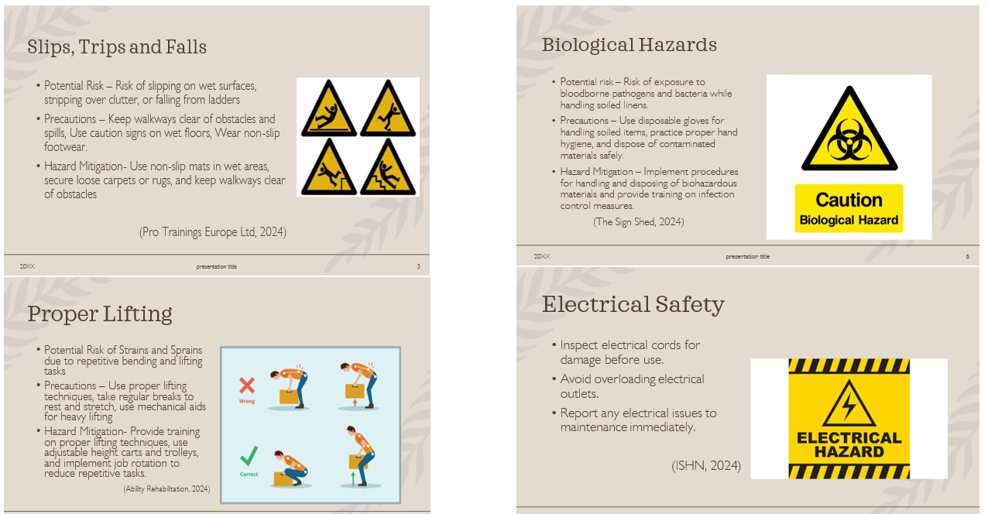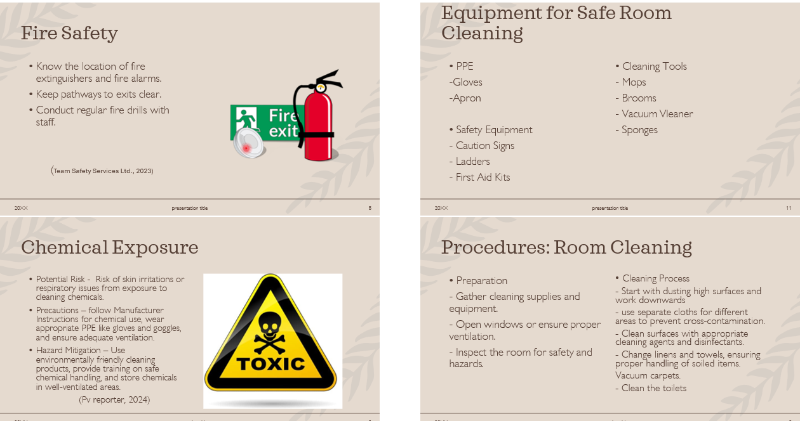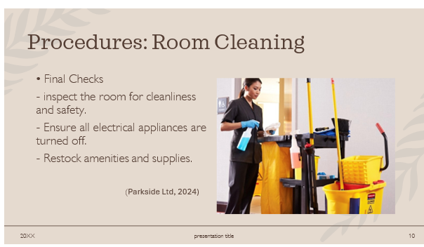(Hotel Cleaning Services, 2024)

Reference List

Pro Trainings Europe Ltd., 2024
Available at: https://www.protrainings.uk/wiki/slips-trips-and-falls/
Ability Rehabilitation,
Available at: https://abilityrehabilitation.com/news/safe-lifting-practices/
PV Reporter, 2024
Available at: https://www.pvreporter.com/occupational-and-chemical-exposure-that-may-cause-mpns-along-with-familial-clustering/
The Sign Shed, 2024
Available at: https://www.thesignshed.co.uk/products/biological-hazard-sign-1
ISHN, 2024
Available at: https://www.ishn.com/articles/103868-electrical-hazards-harm-thousands-annually
Team Safety Services Ltd., 2023
Available at: https://teamsafetyservices.com/fire-safety-training/
Parkside Ltd, 2024
Available at: https://www.parksideirl.com/house-keeping/
Hotel Cleaning Services, 2024
https://hotelcleaningservices.com/hotel-cleaning-2020-guide/

