

Assessment 2

Student name:​ Dewan Ashrafi
Student ID: ​1916230
Module name: Mental Disorders and Psychopathology​
Module code: BMHP6006
Lecturer name: Bianca Sanfilippo ​
Date: 29/04/2022

Contents
Page
Introduction 3
General anxiety disorder 3
Schizophrenia 10
Autism 18
Conclusion 23
References 23
Appendix 34

Introduction
Over the last few years, the number of people with mental health problems has gone up. (Mind UK, 2020) Mental health is as vital to total well-being as physical health since it affects cognition, perception, and behaviour. (CDC, 2021) Mental diseases are responsible for 14.3% of worldwide mortality, or approximately 8 million deaths annually, with around 22,589 in England and Wales. (Walker et al, 2015) (Statista, 2022) In the UK, the Mental act 1983 defines ‘Mental Disorder’ as ‘Any disorder or disability of the mind’. (Legislation.gov.uk, 1983) In 2017, 792 million or 10.7% of the world population, suffered from various mental illnesses. (Ritchie et al, 2018) Mental disorders affect 1 in 4 persons in the UK, costing the economy about £118 billion, or 5% of GDP. (Mind UK, 2020) (LSE, 2022)
This report critically analyses the categorisation, diagnosis, treatment, and rehabilitation assessments for three major mental diseases from the ICD-10 (WHO); General Anxiety Disorder, Schizophrenia, and Autism.

General Anxiety Disorder (GAD)



Definition

General anxiety disorder is a mental illness distinguished by extreme, constant, and unreasonable concern over minor matters affecting the physical, mental and social well being. (Munir and Takov, 2019)
Classification
WHO in ICD-10 recognised General Anxiety Disorder in F40-F48 as a ‘Neurotic, Stress-related and Somatoform disorder’. The Code for GAD is F41.1. (WHO, 2010)

Facts and Statistics
GAD is among the most prevalent mental illnesses globally and in the UK. (Ritchie, Roser and Dattani, 2018) (NICE, 2011) It impacts 3-6% of adults and 5% of children and adolescents globally. (Strawn et al., 2018) GAD affects women twice as frequently as men. (Geddes et al., 2012) It is also common in those who are separated, divorced, unemployed, widowed, uneducated, and from low socioeconomic backgrounds. (Ansseau et al, 2008)
(NHS, 2016)

(NHS, 2016)

(NHS, 2016)

- Nearly 5% of the UK population suffers from GAD. (NHS, 2018)
- GAD affects 12.5% of non-parents. 11.5% of jobless or economically inactive people and 31.5% among people receiving employment and assistance allowance have GAD. Only 4.6 per cent of nonsmokers have GAD, compared to 13.8 per cent of smokers (those who smoke 15 or more). (NHS, 2016)

- Children are less affected by this disorder; only 0.70% suffer from it. (NHS, 2018)

- The COVID-19 risk group had higher levels of stress, anxiety, and depression, ranging from 7% to 14%. (Jia et al., 2020)

Aetiology

The specific aetiology of GAD is uncertain; however, a mix of variables is probably responsible. (NHS, 2018)

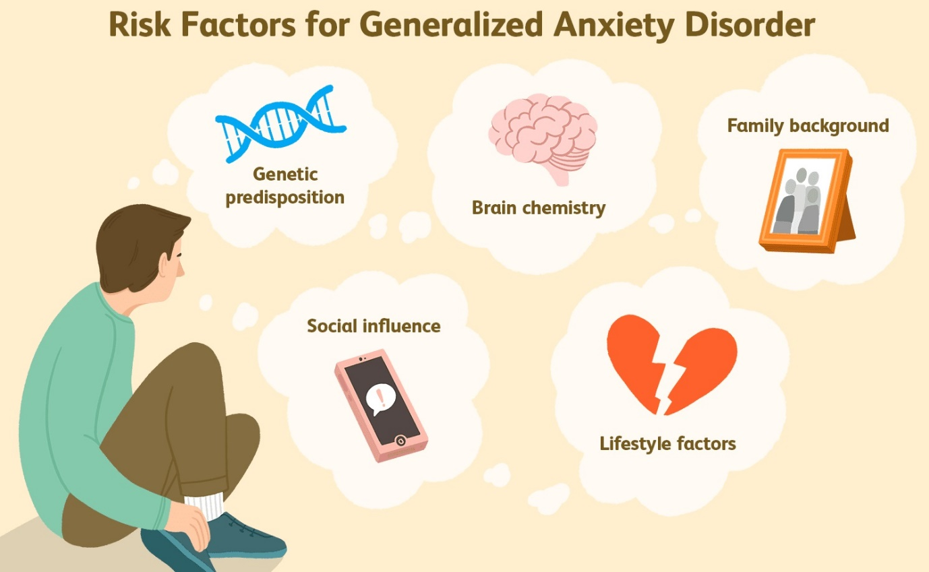
(Meek, 2021)

Genetics: People who have first relatives with GAD are more vulnerable to this disorder. The inherited connection to developing anxiety disorders (including GAD) is around 30%-40%. (Hettema et al, 2001)(Stern et al., 2016, pp.1–1200)
Brain Structure: The fear and emotion processing centres and other brain areas are related to general anxiety disorder. (Etkin et al., 2009)
Life Experience: Childhood trauma, abuse, neglect, loss of a loved one, desertion, divorce, or loneliness, and incorrect or excessive use of social media may all contribute to GAD.. (Fryers and Brugha, 2013) (Vytal et al., 2013). A child with an anxious parent or caregiver may exhibit the same behaviour. (Burstein and Ginsburg, 2010)
Lifestyle: Consumption of stress-inducing substances, including alcohol, narcotics, and coffee, work or job-related stress, dangerous, stressful, and terrifying personal relationships can be root factors of GAD. (Richards and Smith, 2015) (NHS, 2018). (Ströhle et al, 2018) (Wang, 2006)
Medical Condition: A chronic medical condition’s pain or suffering may cause GAD. (Aquin et al., 2017)

Symptoms

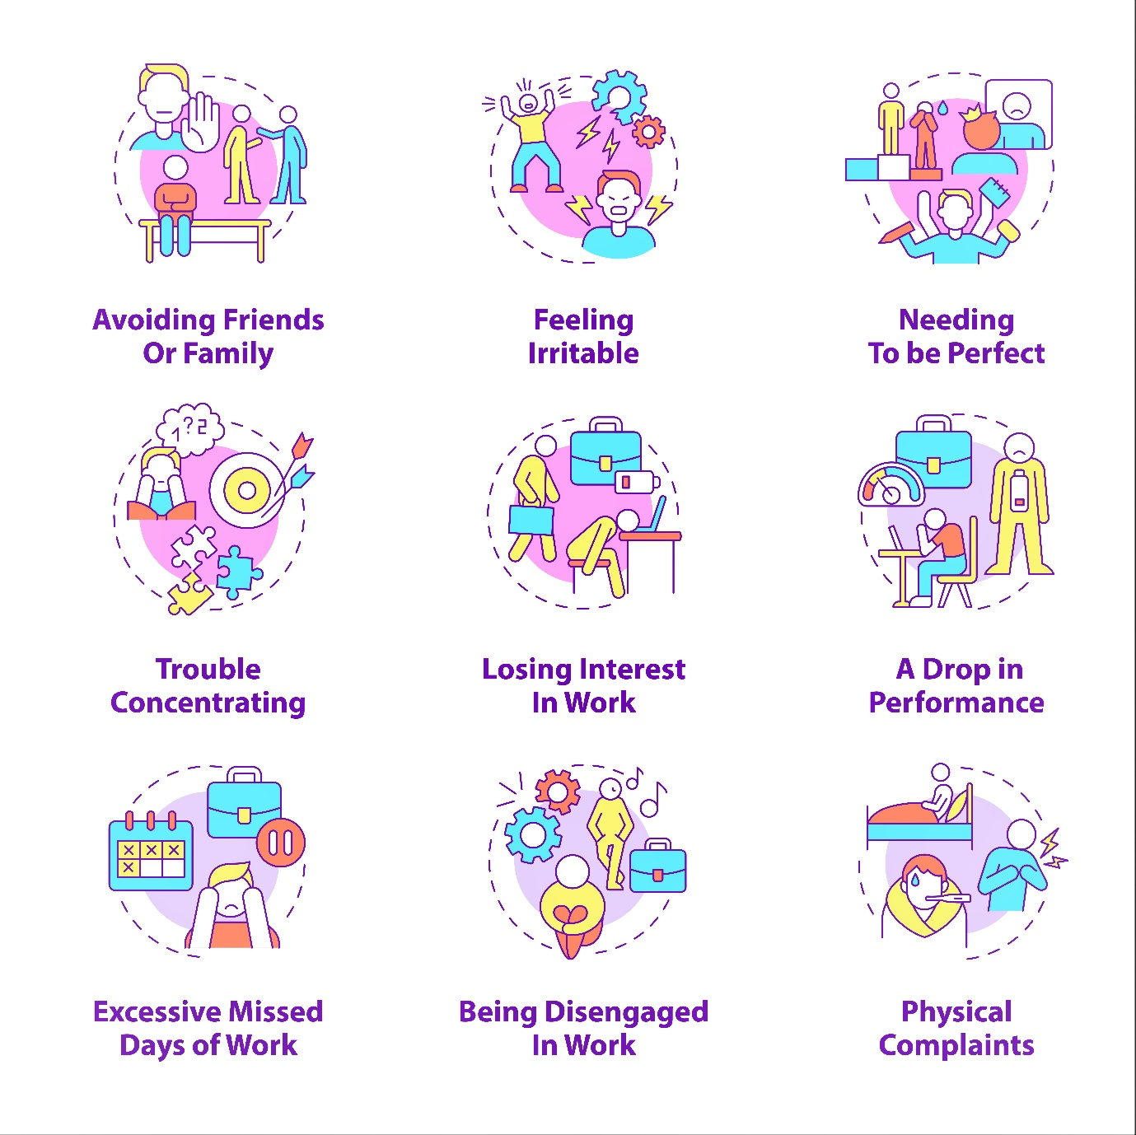

Symptoms of generalised anxiety disorder might differ from person to person. (Mayo Clinic, 2017)
Physical signs and symptoms are(Mayo Clinic, 2017) (John Hopkins Medicine, 2019):
- Fatigue
- Sleeping problems
- Headache
- Muscular spasms or pains are common symptoms of muscle strain.
- Trembling and Twitchy.
- Stiff muscle
- Sweating
- Irritable bowel syndrome,
- Nausea or diarrhoea
- Irritability
- Palpitations
- Urinating more than usual
- Lump in neck
- Dry Mouth
- Vertigo
- Sudden hot flush
- Dizziness
Psychological symptoms are (NHS, 2018) (Mayo Clinic, 2017) (John Hopkins Medicine, 2019):
- Worrying or concerned over minor issues
- Overcomplicating thoughts
- Scared of making the incorrect choice and indecisiveness
- Inability leave thoughts of unfavourable events
- Inability to relax
- Lack of Concentration

Diagnosis

GP or mental health practitioner may conduct the following to assist in the diagnosis of GAD(NICE, 2022) (NHS, 2021) (Bandelow et al., 2013):
- Examine for evidence of medication or medical anxiety. The doctor may prescribe blood or urine testing.
- May investigate into symptoms and medical history.
- GAD is simpler to diagnose after six months of symptoms.
- The anxiety Disorder Measurement (ADSM) questionnaire can diagnose and determine a rehabilitation plan, and assessment tools like the Generalised Anxiety Disorder questionnaire (GAD-7) can help diagnose GAD.

Treatment

The two major treatments for GAD are Psychotherapy and medication. (Mayo Clinic, 2017)
A GP or a psychologist may recommend a self-help course to develop anxiety coping abilities. (NICE, 2011)

Psychotherapy
Assume the self-help course does not benefit the patient. As a result, Cognitive Behavioral Therapy (CBT) may be a highly successful short-term treatment that offers specific strategies to regulate anxiety and ultimately return to activities that the patient abandoned due to fear. ‘Applied Relaxation’ is another option. It helps relax muscles during stressful situations. (NHS, 2018)

Medication

GAD is treated using the medications indicated below(NICE, 2011)(NHS, 2018)(Mayo Clinic, 2017):

Antidepressants: Anxiety-related depression is treated with antidepressants like Selective serotonin reuptake inhibitors(SSRIs) and Serotonin and norepinephrine reuptake inhibitors (SNRI). Atypical GAD antidepressants include escitalopram, duloxetine, venlafaxine, and paroxetine (Paxil, Pexeva). Other popular medicines are Pregabalin, Buspirone, and Benzodiazepines. However, these medications may cause nausea, headaches, vertigo, dry mouth, weight gain, decreased sex desire, sleepiness, constipation, impaired vision, and sweating. (NHS, 2018) Other experts suggested that psychotherapy has drawbacks such as guilt, humiliation, emotional eruptions, family and friend estrangement, breakups, and suicidality. (Schermuly-Haupt et al, 2018)

Principles of care

NICE (The National Institute for Health and Care Excellence UK) has developed GAD care principles. Carers and any associate professionals dealing with GAD should (NICE, 2011):
- Be non-judgemental and informative, and comprehend the patient’s level of understanding.
- Understand the patient’s concern about GAD’s influence.
- Explore therapy options and make decisions with the patient.
- Inform about local and national-level self-help and support organisations.
- Respect the illness’s sensitivity and confidentiality.
- Give written and spoken information about GAD, such as how families and caregivers may help.
- Consider alternatives for those with mild learning disabilities or dementia. However, if they have serious difficulties, a specialist can be consulted.
Recommendations
The following lifestyle choices and therapies may be beneficial To preventing and curing General Anxiety Disorder:
- Quitting smoking and cutting back on alcohol and caffeine may help the patient feel less anxious. (Temple et al, 2017) (Ferreira et al, 2019)

- A healthy and balanced diet, regular physical exercise, plenty of sleep, and drinking enough water can help reduce anxiety. (Kris-Etherton et al, 2020) (HSS, 2018)(Ben Simon et al, 2019) (Haghighatdoost et al, 2018)

- Massage, relaxation training, yoga, music, and meditation have proved to reduce anxiety. (Qin et al., 2020)(NCCIH, 2020) (NCCIH, 2016)

Schizophrenia
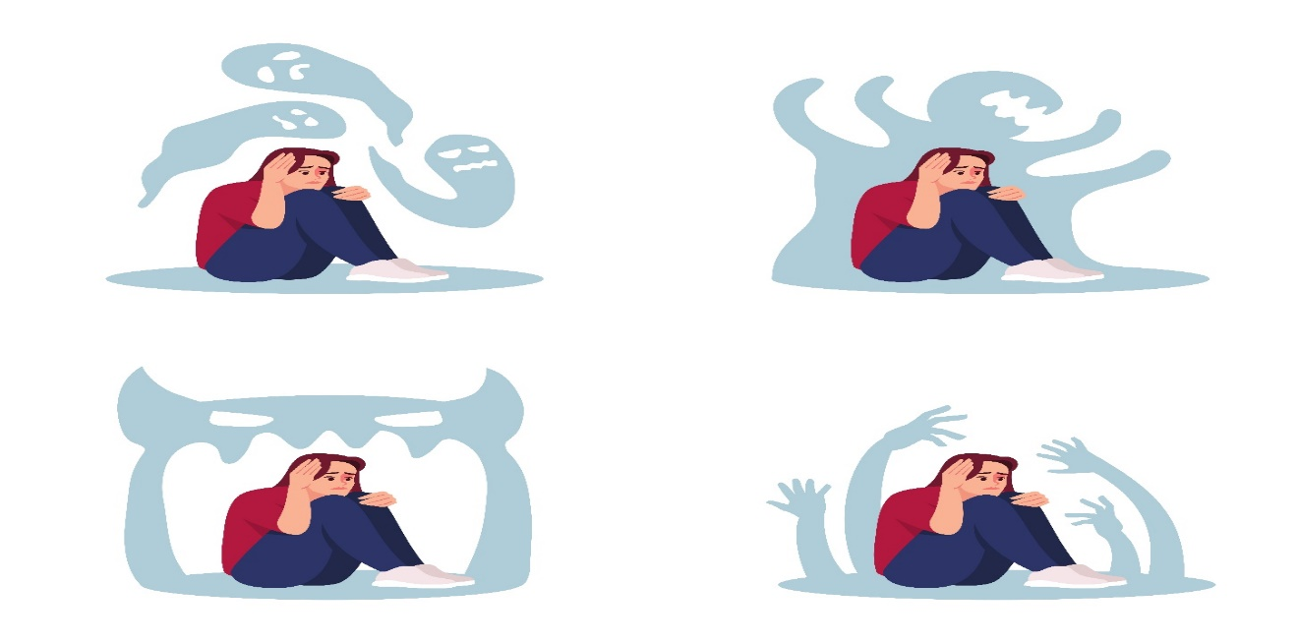
Definition
According to the NIMH (National Institute of Mental Health of the USA), ‘Schizophrenia is a chronic mental illness marked by abnormalities in cognition, perception, emotional reactivity, and social relationships’. (NIMH, 2018) On 24 April 1908, Swiss psychiatrist Professor Bleuler first coined the term’ Schizophrenia’ from Greek skhizein (to split) + phrēn (heart, mind) (Yeragani et al, 2012).

Classification

Schizophrenia was classified as a mental disorder by the WHO in ICD-10 section V (Mental and behavioural disorders) in group F20-F29 (Schizophrenia, schizotypal, and delusory disorders), with the code F20. (WHO, 2010)
Facts and Stats
Number of People who have Schizophrenia, 2019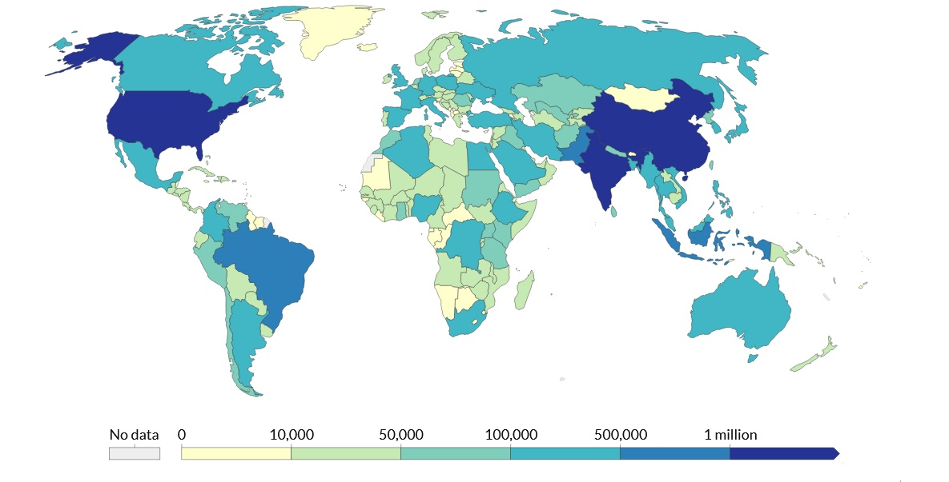

Schizophrenia affects around 24 million individuals, or 0.32% globally, and adults have a rate of 1 in 222 (0.45%). The risk of premature death is higher with people with this disorder, 2 to 3 times more than the average population. (WHO 2022) In 2019, approximately 0.28% ( of females and 0.32% of men were diagnosed with Schizophrenia in adults. (Statista, 2022)

People with Schizophrenia in the UK BY Age, 2019
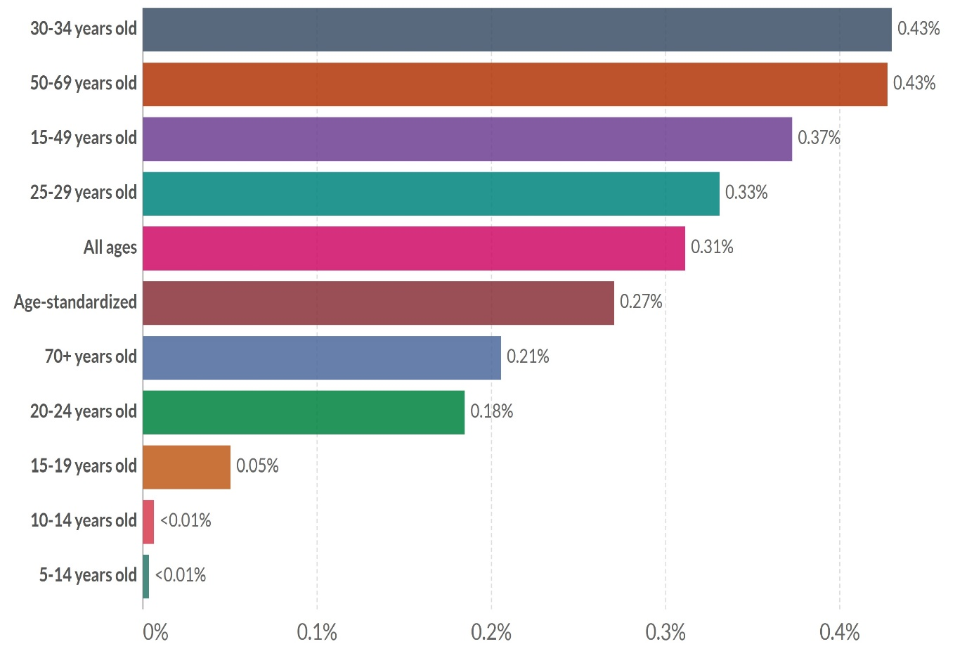
(Ritchie and Roser, 2018)

(Ritchie and Roser, 2018)

- The lifetime prevalence of Schizophrenia and associated illnesses in the UK is 14.5 per 1000 persons. (NICE, 2022)
- In 2019 196,953 people had Schizophrenia; 94,535 were female and 102418 were male. (Ritchie and Roser, 2018)
- People in urban lifestyles are more vulnerable to this disorder. (Fett et al, 2019)
- It seldom occurs before the age of 15 but typically appears between 15 and 35. (RsPsych, 2019)

Causes
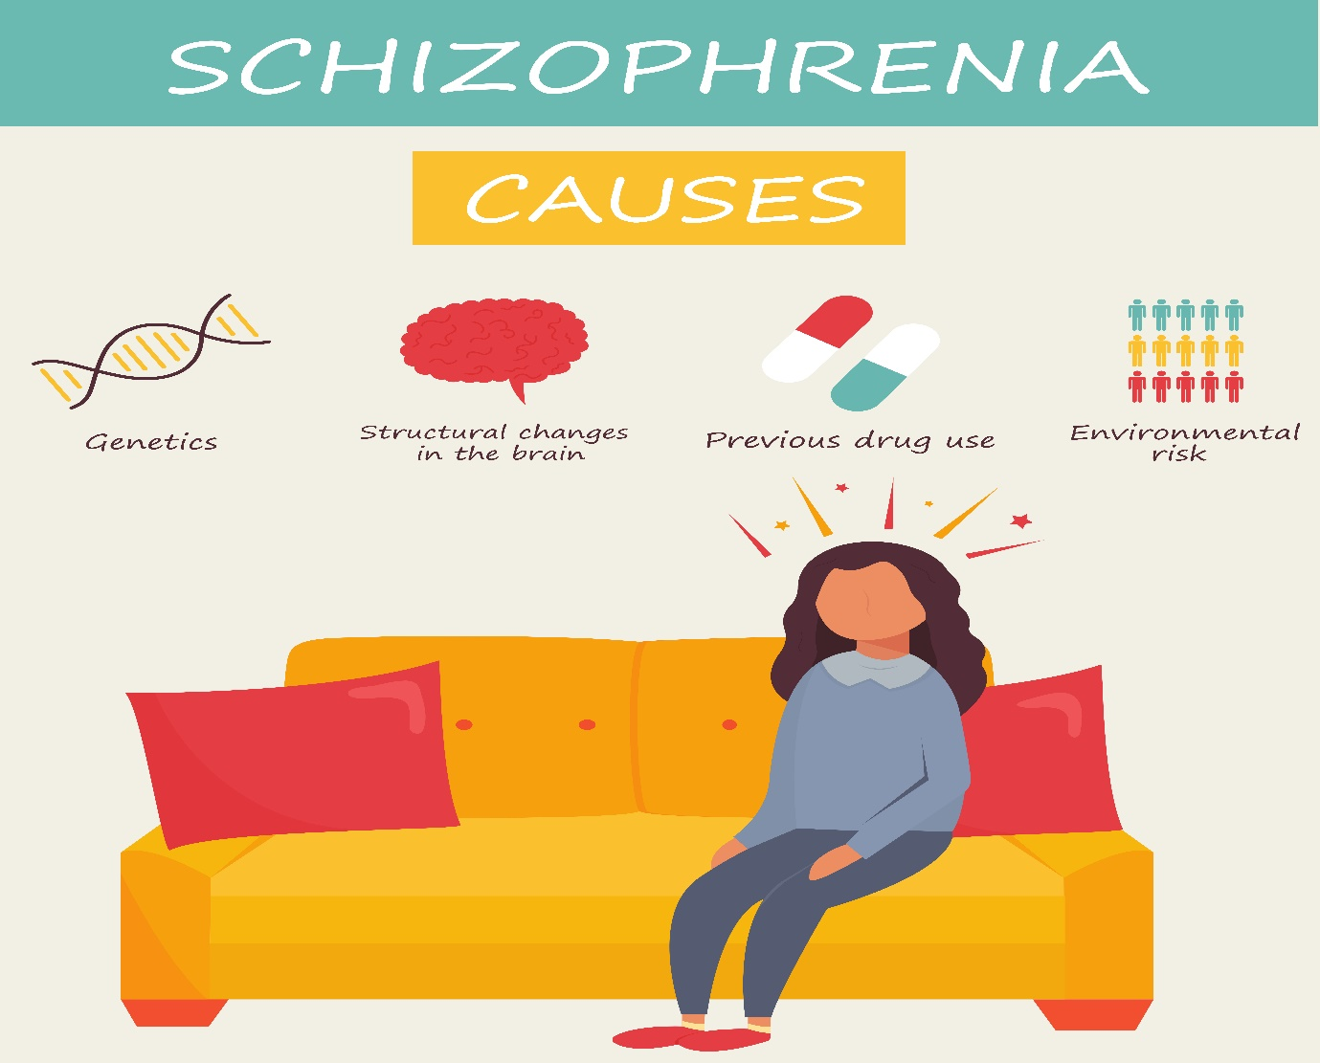

There is no specific cause of Schizophrenia that has been found by research. (WHO, 2022) The general causes may include (Mind, 2020):

- Stressful life events
- Use of drugs and alcohol
- Inheritance of genes
- Imaging tests performed on persons with Schizophrenia revealed anomalies in specific brain areas. (Wright et al., 2000)
- Abnormalities in the brain may produce many of the symptoms of Schizophrenia. (Sedvall and Farde, 1995)

Signs and Symptoms
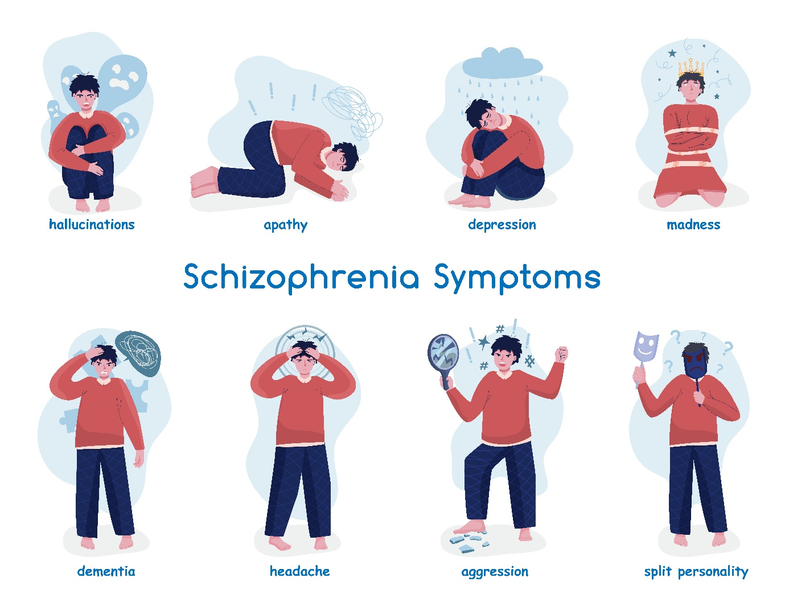
Schizophrenia symptoms may be classified into three groups (NIMH, 2022).
- Positive Symptoms:

Hallucinations are sensory illusions that seem real but are not. In Schizophrenia, the patient hears voices, sees people or things, tastes or smells, and feels. (NIMH, 2022)
Delusions are ideas that are not true. They are, nonetheless, entirely normal to the person experiencing them. Delusional theories are developed to explain hallucinations. Their actions may be described by voices, leading them to suspect surveillance. Paranoid delusions sufferers believe they are being tortured, followed, watched, plotted against, or poisoned. (NHS, 2019) (NIMH, 2022)
A movement disorder occurs when a person’s movements are abnormal; patients may find themselves repeating identical motions. (NIMH, 2022)

- Negative Symptoms:

It includes extreme agitation or slowing of movements, keeping of atypical postures, minimal speech, constrained encounter and emotional expression, inability to perceive interest or pleasure, and social disengagement. (WHO, 2022)
- Cognitive Symptoms:
These symptoms may impair communication and memory. Cognitive ability is a significant predictor of everyday functioning. Possible symptoms are (NIMH, 2022):
Having problems making judgments based on information
Applying information instantaneously
Inability to focus

Diagnosis

There is no one test for Schizophrenia, and it is typically diagnosed by a mental health professional. The initial step of diagnosis is to consult with a health care physician or a psychiatrist. (NHS, 2019) Tests (Urine, blood) can also be ordered by the doctor to ensure that alcohol or drug usage is not causing the symptoms. MRI and CT scans, which scan and photograph the body and brain, may also rule out other abnormalities, such as a brain tumour. They will also administer tests to determine how the patient comprehends (these may be cognitive tests), personality tests, and open-ended exams such as the Rorschach test. (Jennifer Casarella, 2021)

Treatment
A combination of Psychotherapy (counselling) and medications is often used to treat Schizophrenia. Community Health teams consisting, Psychiatrists, psychologists, psychotherapists, and counsellors are usually available to help persons with Schizophrenia. (NHS, 2019)
Psychotherapy: Cognitive behavioural therapy (CBT) is the primary talking treatment recommended for treating Schizophrenia. Delusions or voices, relaxation, medication side effects, and concerns like social anxiety and despair that persons with Schizophrenia may confront are addressed in this treatment. (Mind, 2020)
Medicine: Doctors utilise antipsychotic medications (neuroleptics or powerful tranquillisers) to treat Schizophrenia.
Nevertheless, many of these drugs have side effects. Dizziness, trembling, loss of sexual desire, impaired eyesight, constipation, dry mouth, and muscular spasms are common symptoms. (Stępnicki, Kondej and Kaczor, 2018) (NHS, 2019)

People with severe mental illnesses frequently undergo a care programme approach (CPA) with four stages; assessment, care plan, and necessary worker appointment (Usually a social worker or nurse) and review. (NHS, 2019)
Psychological Interventions: Psychosocial interventions are another option for people with Schizophrenia. An individual’s counsellor may assist with stress, illness, and social skills. (Higuera, 2022)

Measurements of Rehabilitation
Complex psychosis and severe mental illnesses can have special needs, impacting rehabilitation and recovery. Therefore, it is necessary to measure the effectiveness of care and therapy to prevent self-harm, suicide, drug misuse, neglect and self-neglect, loss of dignity, and human rights abuses. (NICE, 2020) The QuIRC-SA is the first standardised assessment to measure the quality of care for long-term mental diseases like Schizophrenia. (UCL, 2022)

Principles of Care
Effective treatment of psychosis, Schizophrenia and related illnesses require adherence to certain principles. (NICE, 2014) (NICE, 2018)(NICE, 2011) (NICE, 2013)

For Adult care:
- Service to everyone without judgement or discrimination.
- Assessing risk factors may ensure patient and family safety.
- Discuss therapy options with the patient and family.
- Respect and safeguard patient confidentiality.
- Create a treatment plan based on the patient’s needs.
For Children’s care:
- Acquire parent’s and young person’s (12-18) consent before treatment.
- Consistently follow the Mental Capacity Act 2005, Mental Health Act 1983, and the Children Act 1989.

- If required, employ child-friendly information (Information) to include children and their families.

- Develop relationships with children and their caregivers.
Recommendations

The lifestyle habits and treatments listed below may be helpful to Scizophrernia prevention and treatment:

- Research suggests that Folic acid supplementation may help alleviate both positive and negative symptoms of Schizophrenia. Vitamins C, E, and B (particularly B12 and B6) also helped manage symptoms of Schizophrenia. (Ganguly et al, 2018)
- According to the National Alliance on Mental Illness, stress may aggravate hallucinations and delusions in people with Schizophrenia. Therefore, to reduce stress, medication, Yoga, Exercise, a balanced diet, regular sleep pattern, recognising stress triggers, and an organised daily routine can be helpful. (NAMI, 2020)
- Research proved ketogenic diets showed promise as a treatment for Schizophrenia. (Sarnyai et al, 2019)

Autism

Definition
Autism, often known as ‘autism spectrum disorder’ (ASD), is a group of conditions characterised by difficulties with social skills, repetitive activities, speech, and nonverbal communication. (Autism Speaks, 2021)

Classification

WHO identified autism as a group of psychological development disorders in ICD-10.

Facts and Data

Number of People with Autism (Global)
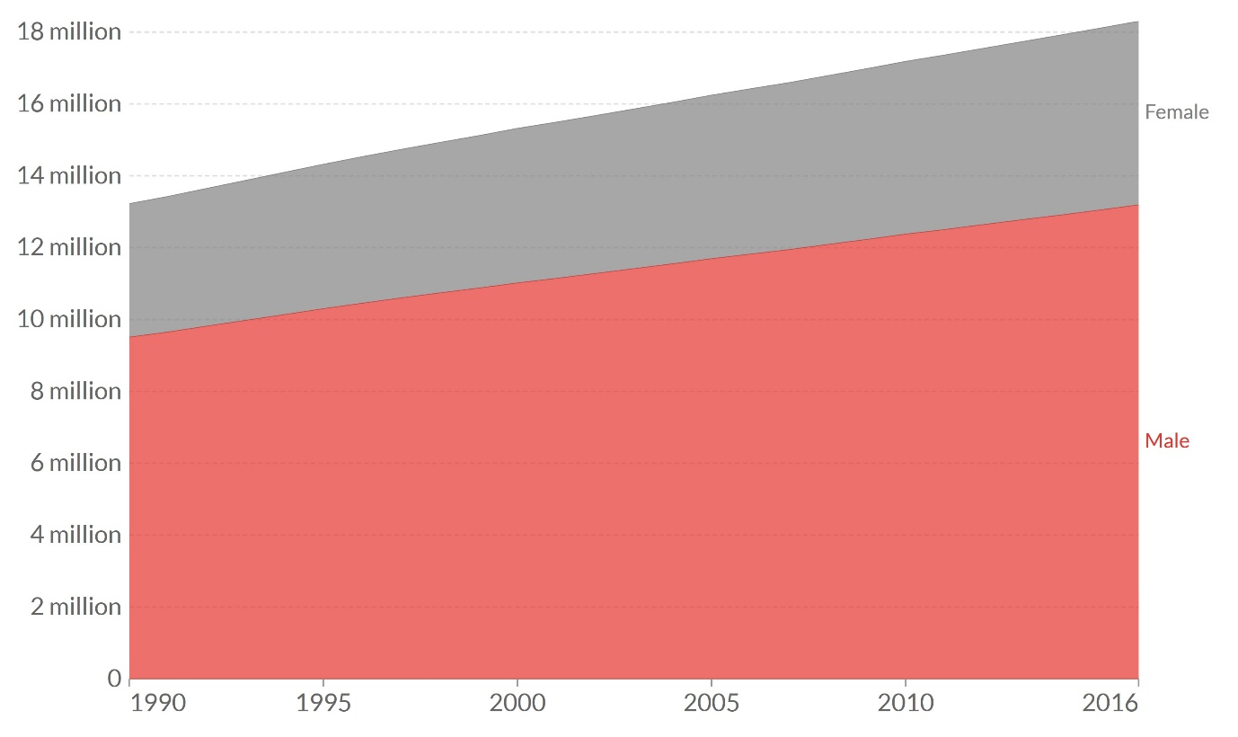

- 18.3m people who have autism; 13.19m males and 5.11 females. (Our World in Data, 2022)
- Autism affects around one out of every 100 children globally. (WHO, 2021)
- An estimated 700,000 autistic adults and children in the UK, accounting for around 1% of the population. (HM Government, 2021)
- Autisms are more common in men than in women, impacting 4 times as many men as women. (Werling and Geschwind, 2013)

Causes

ASD has no recognised cause. Recent studies show not just one reason. However, several factors may be identified as causes of autism. These are (NIH, 2022) (Rylaarsdam and Guemez-Gamboa, 2019) (Cherney, 2018)

Genetic: It is believed that genetic factors account for 40 to 80 per cent of autism risk. Having close family members with autism and genetic mutation can increase the possibility of having autism.

Environmental risk factors: Parental age, birth difficulties, metabolic inconsistencies, metal and environmental contaminant exposure, and background of viral diseases in the mother may contribute to autism.

Signs and Symptoms

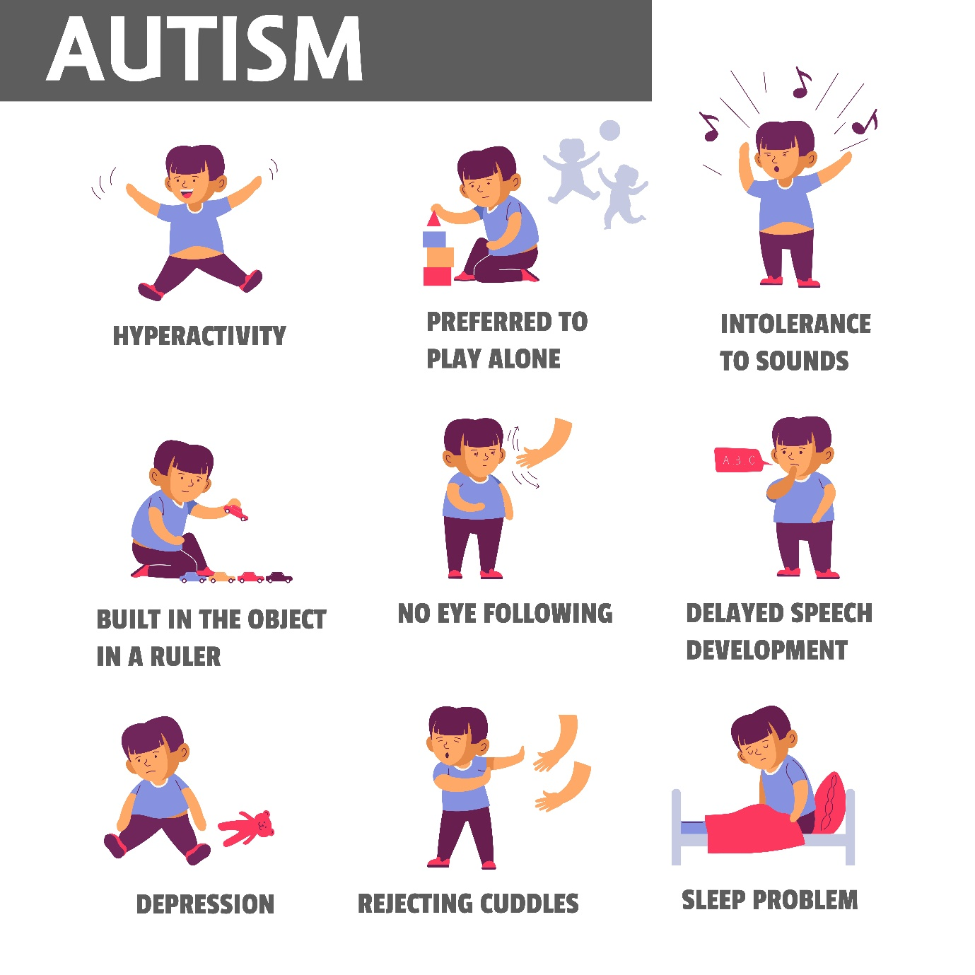

Some of the more prevalent symptoms that a person may have autism include (CDC, 2019):

- Avoiding direct eye contact
- Speech and communication abilities are delayed.
- reliance on rituals and rules
- Being irritated by tiny changes
- Unanticipated reactions to noises, tastes, sights, touch, and fragrances that are
- Difficulty comprehending the feelings of others
- concentrating on or getting obsessed with a particular set of interests or items
- Repetitive activity, such as waving hands or rocking
- Children who have not responded to their name by the age of 12 months
- By 14 months, children are not pointing at distant things.

Diagnosis
Adult patient or patients (Child) family can contact their GP or a health visitor (for children under 5), any other doctor or therapist you or your child sees special educational needs (SENCO) workers for an autism evaluation. Autism experts asses to confirm autism. An autism evaluation confirms any form of autism. An assessment team may: enquire about patients’ difficulties; observe how they interact with others—relatives, friends, GP, or child’s teachers. (NHS, 2019) The Autism Diagnostic Interview-Revised (ADI-R) is a clinical diagnostic tool for children and adults with autism. The ICD-10 and DSM-IV manuals illustrate how the information acquired from the ADI-R may be utilised in a diagnostic algorithm for autism. (National Autistic Society, 2022)

Contamperoray Treatment
Current therapies aim to lessen symptoms that affect daily functional abilities and ensure the quality of life. Although some therapies require more than one strategy, these treatments may typically be divided into the following categories (CDC, 2022):
Behavioural Approaches: It concentrates on changing behaviour through knowing what occurs before and after the act. The best evidence for treating ASD symptoms is behavioural.
Development Approaches: These methods concentrate on increasing individual developmental skills, such as linguistic or physical capabilities, or on a larger spectrum of interrelated developmental abilities. Behavioural techniques are often coupled with developmental approaches.
Educational Approaches: In a classroom context, educational therapies are administered. These approaches are based on the fact that persons with autism benefit from consistency and visual learning.

Social-Relational Approaches: These work on social skills and emotional ties. Parents or peer mentors can participate in this therapy.

Pharmacological Approaches: There are no drugs available to address the primary symptoms of autism. Some drugs treat co-occurring symptoms, which may improve the functioning of persons.

Psychological Approaches: Anxiety, sadness, and other mental health concerns may be addressed psychologically. It focuses on discovering the links between ideas, emotions, and actions.

Measurements of Rehabilitation
Autism Rating Scale CARS: It evaluates people of various ages and abilities. Simple, objective and quantitative judgments based on direct observation of behaviour There is a clear, substantial, positive link between scores and autism diagnosis. (Schopler et al., 2010)
Autism Diagnostic Observation Schedule (ADOS): The ADOS is a standardised diagnostic test for autism. It is the gold standard for diagnosing ASD (ASD). The examiner and the individual being assessed engage in organised and semi-structured social interactions in the procedure. (Hus and Lord, 2014)

Principles of Care
The followings are the guidelines and principles of care given by the National Institute for Health and Care Excellence (NICE, 2022):

- Confirm access to mental health treatments for all autistic children and adults regardless of their intellectual level or comorbid diagnoses.
- Local autism teams should offer (or coordinate) interventions and care for autistic children and adults with special needs.
- Autism teams should play an essential role in providing and coordinating services.
- Autism awareness and management training should be provided to all health and social care workers dealing with autistic people.
- Be non-judgemental and non-discriminatory.
- According to their requirements and developmental stage, provide continuing assistance and provide all relevant information to autistic people, their families, and caregivers.
Recommendations
Here are some of the recommendations given by the experts:
- Early detection of developmental abnormalities is crucial to children’s and families’ well-being. It is a primary care medical home role and a duty of all paediatric health care providers. (CDC, 2017)

- Complementary and alternative therapies are often utilised in conjunction with more standard treatments. Some examples are special diets, herbal supplements, chiropractic treatment, animal therapy, arts therapy, mindfulness, and relaxation therapies. However, a doctor must be consulted before using these. (CDC, 2022)

- An effective treatment plan should be planned considering the patient’s interest. Communication and bonding with a child with ASD might be difficult without talking or touching. The parents can communicate by looking at them, talking to them, and touching them. Even if they never talk, he or she is still communicating. Parents and carers have to learn their language. (Smith et al, 2019)

Conclusion
Human rights are fundamental rights that we all have, representing principles such as justice, decency, equality, and respect. They safeguard us all, particularly those suffering from mental disorders who may experience abuse, neglect, or solitude. Most significantly, these rights empower people to speak out and confront mistreatment. Ensuring human rights and understanding and acknowledging disruptions and adverse effects in all mental disorders will benefit patients, enhance therapy, or minimise attrition. In the same way, measurement-based assessment of clinical performance would benefit patients. Also, more importance should be given to the Person-centered care approach as it recognises patients’ individuality, assists patients in receiving more appropriate treatment and feeling more fully cared for as human beings.

Reference list
Ansseau, M., Fischler, B., Dierick, M., Albert, A., Leyman, S. and Mignon, A. (2008). Socioeconomic Correlates of Generalized Anxiety Disorder and Major Depression in Primary care: the GADIS II Study (Generalized Anxiety and Depression Impact Survey II). Depression and Anxiety, 25(6), pp.506–513.
Aquin, J.P., El-Gabalawy, R., Sala, T. and Sareen, J. (2017). Anxiety Disorders and General Medical Conditions: Current Research and Future Directions. Focus (American Psychiatric Publishing), 15(2), pp.173–181.
Autism Speaks (2021). What Is Autism? | Autism Speaks. [online] Autism Speaks. Available at: https://www.autismspeaks.org/what-autism [Accessed 27 Apr. 2022].
Bandelow, B., Boerner, R.J., Kasper, S., Linden, M., Wittchen, H.-U. and Möller, H.-J. (2013). The Diagnosis and Treatment of Generalized Anxiety Disorder. Deutsches Aerzteblatt Online, 110(17).
Ben Simon, E., Rossi, A., Harvey, A.G. and Walker, M.P. (2019). Overanxious and Underslept. Nature Human Behaviour, 4(1), pp.100–110.
Burstein, M. and Ginsburg, G.S. (2010). The Effect of Parental Modeling of Anxious Behaviors and Cognitions in school-aged children: an Experimental Pilot Study. Behaviour Research and Therapy, 48(6), pp.506–515.
CDC-Centers for Disease Control and Prevention (2017). Recommendations & Guidelines. [online] Centers for Disease Control and Prevention. Available at: https://www.cdc.gov/ncbddd/autism/hcp-recommendations.html [Accessed 29 Apr. 2022].
CDC-Centers for Disease Control and Prevention (2019). Signs and Symptoms of Autism Spectrum Disorders. [online] Centers for Disease Control and Prevention. Available at: https://www.cdc.gov/ncbddd/autism/signs.html [Accessed 29 Apr. 2022].
CDC-Centers for Disease Control and Prevention (2021). About Mental Health. [online] Centers for Disease Control and Prevention. Available at: https://www.cdc.gov/mentalhealth/learn/index.htm [Accessed 18 Apr. 2022].
CDC-Centers for Disease Control and Prevention (2022). Treatment | Autism Spectrum Disorder (ASD) | NCBDDD | CDC. [online] Centers for Disease Control and Prevention. Available at: https://www.cdc.gov/ncbddd/autism/treatment.html#ref1 [Accessed 29 Apr. 2022].
Cherney, K. (2018). Everything You Need to Know About Autism. [online] Healthline. Available at: https://www.healthline.com/health/autism#causes [Accessed 29 Apr. 2022].
Craske, M.G. and Stein, M.B. (2016). Anxiety. The Lancet, 388(10063), pp.3048–3059.
Etkin, A., Prater, K.E., Schatzberg, A.F., Menon, V. and Greicius, M.D. (2009). Disrupted Amygdalar Subregion Functional Connectivity and Evidence of a Compensatory Network in Generalized Anxiety Disorder. Archives of General Psychiatry, 66(12), pp.1361–1372.
Ferreira, V.R., Jardim, T.V., Sousa, A.L.L., Rosa, B.M.C. and Jardim, P.C.V. (2019). Smoking, Alcohol Consumption and Mental health: Data from the Brazilian Study of Cardiovascular Risks in Adolescents (ERICA). Addictive Behaviors Reports, 9, p.100147.
Fett, A.-K.J., Lemmers-Jansen, I.L.J. and Krabbendam, L. (2019). Psychosis and Urbanicity. Current Opinion in Psychiatry, 32(3), pp.232–241.
Fryers, T. and Brugha, T. (2013). Childhood Determinants of Adult Psychiatric Disorder. Clinical Practice & Epidemiology in Mental Health, 9(1), pp.1–50.
Ganguly, P., Soliman, A. and Moustafa, A.A. (2018). Holistic Management of Schizophrenia Symptoms Using Pharmacological and Non-pharmacological Treatment. Frontiers in Public Health, 6(166).
Geddes, J., Price, J., Mcknight, R. and Gelder, M.G. (2012). Psychiatry. 4th ed. Oxford ; New York: Oxford University Press.
Haghighatdoost, F., Feizi, A., Esmaillzadeh, A., Rashidi-Pourfard, N., Keshteli, A.H., Roohafza, H. and Adibi, P. (2018). Drinking Plain Water Is Associated with Decreased Risk of Depression and Anxiety in adults: Results from a Large cross-sectional Study. World Journal of Psychiatry, 8(3), pp.88–96.
Hettema, J.M., Neale, M.C. and Kendler, K.S. (2001). A Review and Meta-Analysis of the Genetic Epidemiology of Anxiety Disorders. American Journal of Psychiatry, 158(10), pp.1568–1578.
HHS-U.S. Department of Health and Human Services (2018). Physical Activity Guidelines for Americans 2nd Edition. [online] health.gov, pp.1–118. Available at: https://health.gov/sites/default/files/2019-09/Physical_Activity_Guidelines_2nd_edition.pdf [Accessed 23 Apr. 2022].
Higuera, V. (2022). Schizophrenia: Symptoms, Causes, Treatment, and Prognosis. [online] Healthline. Available at: https://www.healthline.com/health/schizophrenia#in-children [Accessed 27 Apr. 2022].
HM Government (2021). The National Strategy for Autistic children, Young People and adults: 2021 to 2026. pp.1–43.
Hus, V. and Lord, C. (2014). The Autism Diagnostic Observation Schedule, Module 4: Revised Algorithm and Standardized Severity Scores. Journal of Autism and Developmental Disorders, 44(8), pp.1996–2012.
Jennifer Casarella (2021). Schizophrenia Diagnosis & Tests: How Doctors Know If Someone Has It. [online] WebMD. Available at: https://www.webmd.com/schizophrenia/schizophrenia-tests [Accessed 26 Apr. 2022].
Jia, R., Ayling, K., Chalder, T., Massey, A., Broadbent, E., Coupland, C. and Vedhara, K. (2020). Mental Health in the UK during the COVID-19 pandemic: cross-sectional Analyses from a Community Cohort Study. BMJ Open, 10(9), p.e040620.
John Hopkins Medicine (2019). Generalized Anxiety Disorder (GAD). [online] Hopkins Medicine. Available at: https://www.hopkinsmedicine.org/health/conditions-and-diseases/generalized-anxiety-disorder [Accessed 20 Apr. 2022].
Kessler, R.C., Petukhova, M., Sampson, N.A., Zaslavsky, A.M. and Wittchen, H.-U. (2012). Twelve-month and Lifetime Prevalence and Lifetime Morbid Risk of Anxiety and Mood Disorders in the United States. International Journal of Methods in Psychiatric Research, 21(3), pp.169–184.
Kris-Etherton, P.M., Petersen, K.S., Hibbeln, J.R., Hurley, D., Kolick, V., Peoples, S., Rodriguez, N. and Woodward-Lopez, G. (2020). Nutrition and Behavioral Health disorders: Depression and Anxiety. Nutrition Reviews, 79(3).
Legislation.gov.uk (1983). Mental Health Act 1983. [online] Legislation.gov.uk. Available at: https://www.legislation.gov.uk/ukpga/1983/20/contents [Accessed 19 Apr. 2022].
LSE-London School of Economics and Political Science (2022). Mental Health Problems Cost UK Economy at Least £118 Billion a Year - New Research. [online] London School of Economics and Political Science. Available at: https://www.lse.ac.uk/News/Latest-news-from-LSE/2022/c-Mar-22/Mental-health-problems-cost-UK-economy-at-least-118-billion-a-year-new-research [Accessed 19 Apr. 2022].
Mayo Clinic (2017). Generalized Anxiety Disorder - Diagnosis and Treatment - Mayo Clinic. [online] Mayoclinic.org. Available at: https://www.mayoclinic.org/diseases-conditions/generalized-anxiety-disorder/diagnosis-treatment/drc-20361045 [Accessed 20 Apr. 2022].
Meek, W. (2021). What Could Cause Generalized Anxiety Disorder? [online] Verywell Mind. Available at: https://www.verywellmind.com/gad-causes-risk-factors-1392982#toc-genetics [Accessed 23 Apr. 2022].
Mind (2020). Causes. [online] www.mind.org.uk. Available at: https://www.mind.org.uk/information-support/types-of-mental-health-problems/schizophrenia/causes/ [Accessed 26 Apr. 2022].
Mind UK (2020). How Common Are Mental Health problems? [online] Mind.org.uk. Available at: https://www.mind.org.uk/information-support/types-of-mental-health-problems/statistics-and-facts-about-mental-health/how-common-are-mental-health-problems/ [Accessed 18 Apr. 2022].
Munir, S. and Takov, V. (2019). Anxiety, Generalized Anxiety Disorder (GAD). [online] Nih.gov. Available at: https://www.ncbi.nlm.nih.gov/books/NBK441870/ [Accessed 19 Apr. 2022].
NAMI-National Alliance on Mental Illness (2020). Managing Stress | NAMI: National Alliance on Mental Illness. [online] Nami.org. Available at: https://www.nami.org/Your-Journey/Individuals-with-Mental-Illness/Taking-Care-of-Your-Body/Managing-Stress [Accessed 29 Apr. 2022].
National Autistic Society (2022). Diagnostic tools - a guide for all audiences. [online] www.autism.org.uk. Available at: https://www.autism.org.uk/advice-and-guidance/topics/diagnosis/diagnostic-tools/all-audiences [Accessed 29 Apr. 2022].
NCCIH-National Center for Complementary and Integrative Health (2016). Meditation: In Depth. [online] NCCIH. Available at: https://www.nccih.nih.gov/health/meditation-in-depth [Accessed 26 Apr. 2022].
NCCIH-National Center for Complementary and Integrative Health (2020). Mind and Body Approaches for Stress and Anxiety: What the Science Says. [online] NCCIH. Available at: https://www.nccih.nih.gov/health/providers/digest/mind-and-body-approaches-for-stress-science [Accessed 25 Apr. 2022].
NHS (2018). Treatment - Generalised Anxiety Disorder in Adults. [online] nhs.uk. Available at: https://www.nhs.uk/mental-health/conditions/generalised-anxiety-disorder/treatment/ [Accessed 20 Apr. 2022].
NHS-National Health Service (2016). Mental Health and Wellbeing in England. [online] NHS Digital, pp.1–405. Available at: https://files.digital.nhs.uk/pdf/q/3/mental_health_and_wellbeing_in_england_full_report.pdf [Accessed 20 Apr. 2022].
NHS-National Health Service (2018a). Mental Health of Children and Young People in England, 2017 [PAS] - NHS Digital. [online] NHS Digital. Available at: https://digital.nhs.uk/data-and-information/publications/statistical/mental-health-of-children-and-young-people-in-england/2017/2017 [Accessed 22 Apr. 2022].
NHS-National Health Service (2018b). Overview - Generalised Anxiety Disorder in Adults. [online] nhs.uk. Available at: https://www.nhs.uk/mental-health/conditions/generalised-anxiety-disorder/overview/ [Accessed 21 Apr. 2022].
NHS-National Health Service (2019a). Diagnosis - Schizophrenia. [online] nhs.uk. Available at: https://www.nhs.uk/mental-health/conditions/schizophrenia/diagnosis/ [Accessed 25 Apr. 2022].
NHS-National Health Service (2019b). How to Get Diagnosed With Autism. [online] nhs.uk. Available at: https://www.nhs.uk/conditions/autism/getting-diagnosed/how-to-get-diagnosed/ [Accessed 29 Apr. 2022].
NHS-National Health Service (2019c). Symptoms - Schizophrenia. [online] nhs.uk. Available at: https://www.nhs.uk/mental-health/conditions/schizophrenia/symptoms/ [Accessed 25 Apr. 2022].
NHS-National Health Service (2019d). Treatment - Schizophrenia. [online] nhs.uk. Available at: https://www.nhs.uk/mental-health/conditions/schizophrenia/treatment/ [Accessed 27 Apr. 2022].
NHS-National Health Service (2021). Diagnosis - Generalised Anxiety Disorder in Adults. [online] nhs.uk. Available at: https://www.nhs.uk/mental-health/conditions/generalised-anxiety-disorder/diagnosis/ [Accessed 19 Apr. 2022].
NICE-National Institute for Health and Care Excellence (2011a). Common mental health problems | Information for the public | Common mental health problems: identification and pathways to care | Guidance | NICE. [online] Nice.org.uk. Available at: https://www.nice.org.uk/guidance/cg123/ifp/chapter/Common-mental-health-problems [Accessed 20 Apr. 2022].
NICE-National Institute for Health and Care Excellence (2011b). Recommendations | Generalised Anxiety Disorder and Panic Disorder in adults: Management | Guidance | NICE. [online] www.nice.org.uk. Available at: https://www.nice.org.uk/guidance/cg113/chapter/Recommendations#principles-of-care-for-people-with-generalised-anxiety-disorder-gad.
NICE-National Institute for Health and Care Excellence (2013). Recommendations | Psychosis and schizophrenia in children and young people: recognition and management | Guidance | NICE. [online] Nice.org.uk. Available at: https://www.nice.org.uk/guidance/cg155/chapter/recommendations [Accessed 29 Apr. 2022].
NICE-National Institute for Health and Care Excellence (2014). 1 Recommendations | Psychosis and Schizophrenia in adults: Prevention and Management | Guidance | NICE. [online] Nice.org.uk. Available at: https://www.nice.org.uk/guidance/cg178/chapter/1-recommendations.
NICE-National Institute for Health and Care Excellence (2020a). National Institute for Health and Care Excellence Draft for Consultation. [online] Available at: https://www.nice.org.uk/guidance/ng181/documents/evidence-review-6 [Accessed 29 Apr. 2022].
NICE-National Institute for Health and Care Excellence (2020b). Overview | Rehabilitation for adults with complex psychosis | Guidance | NICE. [online] www.nice.org.uk. Available at: https://www.nice.org.uk/guidance/NG181 [Accessed 29 Apr. 2022].
NICE-National Institute for Health and Care Excellence (2022a). Generalized Anxiety disorder: When Should I Suspect Generalized Anxiety disorder? [online] NICE. Available at: https://cks.nice.org.uk/topics/generalized-anxiety-disorder/diagnosis/diagnosis/ [Accessed 22 Apr. 2022].
NICE-National Institute for Health and Care Excellence (2022b). Recommendations | Autism spectrum disorder in under 19s: support and management | Guidance | NICE. [online] www.nice.org.uk. Available at: https://www.nice.org.uk/guidance/cg170/chapter/Recommendations#general-principles-of-care [Accessed 29 Apr. 2022].
NICE-National Institute for Health and Care Excellence, N. (2018). Recommendations | Decision-making and mental capacity | Guidance | NICE. [online] Nice.org.uk. Available at: https://www.nice.org.uk/guidance/ng108/chapter/Recommendations [Accessed 29 Apr. 2022].
NICE-NATIONAL INSTITUTE FOR HEALTH AND CLINICAL EXCELLENCE (2022). Psychosis and Schizophrenia in Children and Young people: Final Scope 1 NATIONAL INSTITUTE FOR HEALTH AND CLINICAL EXCELLENCE SCOPE 1 Guideline Title Psychosis and Schizophrenia in Children and Young people: Recognition and Management.
NIH-National Institutes of Health (2022). Autism spectrum disorder: MedlinePlus Genetics. [online] medlineplus.gov. Available at: https://medlineplus.gov/genetics/condition/autism-spectrum-disorder/.
NIMH-National Institute of Mental Health (2018). NIMH» Schizophrenia. [online] www.nimh.nih.gov. Available at: https://www.nimh.nih.gov/health/statistics/schizophrenia.
NIMH-National Institute of Mental Health (2022). Schizophrenia. [online] National Institute of Mental Health (NIMH). Available at: https://www.nimh.nih.gov/health/publications/schizophrenia#part_6324 [Accessed 29 Apr. 2022].
Our World in Data (2022). Number of People with Autism. [online] Our World in Data. Available at: https://ourworldindata.org/grapher/number-of-people-with-autism?country=~OWID_WRL [Accessed 29 Apr. 2022].
Qin, S., Xiao, Y., Chi, Z., Zhu, D., Cheng, P., Yu, T., Li, H. and Jiao, L. (2020). Effectiveness and Safety of Massage in the Treatment of Anxiety and Depression in Patients with Cancer. Medicine, 99(39), p.e22262.
Richards, G. and Smith, A. (2015). Caffeine Consumption and self-assessed stress, anxiety, and Depression in Secondary School Children. Journal of Psychopharmacology, 29(12), pp.1236–1247.
Ritchie, H. and Roser, M. (2018). Mental Health. [online] Our World in Data. Available at: https://ourworldindata.org/mental-health# [Accessed 26 Apr. 2022].
Ritchie, H., Roser, M. and Dattani, S. (2018). Mental Health. [online] Our World in Data. Available at: https://ourworldindata.org/mental-health [Accessed 19 Apr. 2022].
Royal College of Psychiatrists (2019). Schizophrenia. [online] RC PSYCH ROYAL COLLEGE OF PSYCHIATRISTS. Available at: https://www.rcpsych.ac.uk/mental-health/problems-disorders/schizophrenia [Accessed 26 Apr. 2022].
Rylaarsdam, L. and Guemez-Gamboa, A. (2019). Genetic Causes and Modifiers of Autism Spectrum Disorder. Frontiers in Cellular Neuroscience, 13.
Sarnyai, Z., Kraeuter, A.-K. and Palmer, C.M. (2019). Ketogenic diet for schizophrenia. Current Opinion in Psychiatry, 32(5), pp.394–401.
Schermuly-Haupt, M.-L., Linden, M. and Rush, A.J. (2018). Unwanted Events and Side Effects in Cognitive Behavior Therapy. Cognitive Therapy and Research, 42(3), pp.219–229.
Schopler, E., Elizabeth, M., Love, S.R. and G Janette Wellman (2010). Childhood Autism Rating Scale : CARS 2. Los Angeles: Western Psychological Services (Wps.
Sedvall, G. and Farde, L. (1995). Chemical brain anatomy in schizophrenia. The Lancet, 346(8977), pp.743–749.
Smith, M., Segal, J. and Hutman, T. (2019). Helping Your Child with Autism Thrive. [online] HelpGuide.org. Available at: https://www.helpguide.org/articles/autism-learning-disabilities/helping-your-child-with-autism-thrive.htm [Accessed 29 Apr. 2022].
Statista (2022a). Deaths Due to Mental Disorders 2019 by gender/age. [online] Statista. Available at: https://www.statista.com/statistics/381282/deaths-caused-by-mental-disorders-by-gender-and-age-in-england-wales/ [Accessed 18 Apr. 2022].
Statista (2022b). Schizophrenia in Worldwide by Gender 2019. [online] Statista. Available at: https://www.statista.com/statistics/1035195/schizophrenia-worldwide-share-of-population-by-gender/ [Accessed 28 Apr. 2022].
Stępnicki, P., Kondej, M. and Kaczor, A.A. (2018). Current Concepts and Treatments of Schizophrenia. Molecules, 23(8), p.2087.
Stern, T.A., Fava, M., Wilens, T.E., Rosenbaum, J.F. and Massachusetts General Hospital (2016). Massachusetts General Hospital Comprehensive Clinical Psychiatry. 2nd ed. London: Elsevier, pp.1–1200.
Strawn, J.R., Geracioti, L., Rajdev, N., Clemenza, K. and Levine, A. (2018). Pharmacotherapy for Generalized Anxiety Disorder in Adult and Pediatric patients: an evidence-based Treatment Review. Expert Opinion on Pharmacotherapy, 19(10), pp.1057–1070.
Ströhle, A., Gensichen, J. and Domschke, K. (2018). The Diagnosis and Treatment of Anxiety Disorders. Deutsches Aerzteblatt Online, 115(37).
Telles-Correia, D., Saraiva, S. and Gonçalves, J. (2018). Mental Disorder—The Need for an Accurate Definition. Frontiers in Psychiatry, 9(64), pp.1–5.
Temple, J.L., Bernard, C., Lipshultz, S.E., Czachor, J.D., Westphal, J.A. and Mestre, M.A. (2017). The Safety of Ingested Caffeine: a Comprehensive Review. Frontiers in Psychiatry, 8(80).
UCL-University College London (2022). UCL : QUIRC-SA. [online] quirc.eu. Available at: https://quirc.eu/quirc-sa/.
Vytal, K.E., Cornwell, B.R., Letkiewicz, A.M., Arkin, N.E. and Grillon, C. (2013). The Complex Interaction between Anxiety and cognition: Insight from Spatial and Verbal Working Memory. Frontiers in Human Neuroscience, 7.
Walker, E.R., McGee, R.E. and Druss, B.G. (2015). Mortality in Mental Disorders and Global Disease Burden Implications. JAMA Psychiatry, 72(4), p.334.
Wang, J.L. (2006). Perceived Work stress, Imbalance between Work and family/personal lives, and Mental Disorders. Social Psychiatry and Psychiatric Epidemiology, 41(7), pp.541–548.
Werling, D.M. and Geschwind, D.H. (2013). Sex differences in autism spectrum disorders. Current Opinion in Neurology, 26(2), pp.146–153.
WHO-World Health Organisation (2010a). ICD-10 Version:2010. [online] icd.who.int. Available at: https://icd.who.int/browse10/2010/en#/F41.1 [Accessed 18 Apr. 2022].

WHO-World Health Organisation (2010b). ICD-10 Version:2010. [online] icd.who.int. Available at: https://icd.who.int/browse10/2016/en#/F20-F29 [Accessed 26 Apr. 2022].

WHO-World Health Organisation (2021). Autism Spectrum Disorders. [online] Who.int. Available at: https://www.who.int/news-room/fact-sheets/detail/autism-spectrum-disorders [Accessed 28 Apr. 2022].

WHO-World Health Organisation (2022). Schizophrenia. [online] Who.int. Available at: https://www.who.int/news-room/fact-sheets/detail/schizophrenia [Accessed 24 Apr. 2022].
Wright, I.C., Rabe-Hesketh, S., Woodruff, P.W.R., David, A.S., Murray, R.M. and Bullmore, E.T. (2000). Meta-Analysis of Regional Brain Volumes in Schizophrenia. American Journal of Psychiatry, 157(1), pp.16–25.

Yeragani, V., Ashok, A. and Baugh, J. (2012). Paul Eugen Bleuler and the Origin of the Term Schizophrenia (SCHIZOPRENIEGRUPPE). Indian Journal of Psychiatry, 54(1), p.95.

Appendix


