

Postgraduate/Distance Learning
Assignment coversheet & feedback form

THIS SHEET MUST BE THE FIRST PAGE OF THE ASSIGNMENT YOU ARE SUBMITTING (DO NOT SEND AS A SEPARATE FILE)

For completion by the student:
Student Name: Luke Collin

Student University Email: 2307915@student.uwtsd.ac.uk
Module code: HPCA7015  Module title: Foundations in Cultural Astronomy and Astrology | Student ID number:  2307915 |  |  | Educational support needs:  No
Assignment title: Essay based on a Sky Journal

Assignment due date: 28th November 2024
This assignment is for the 1st 2nd 3rd x 4th 5th 6th module of the degree
I confirm that this is my original work and that I have adhered to the University policy on plagiarism.
Signed ……………………L.Collin………………………………………
Email submission:if you are submitting this form via email, please tick this box □
(as a substitute for your signature) to confirm that you agree to the above declaration.
Assignment Mark
1st Marker’s Provisional mark
2nd Marker’s/Moderator’s provisional mark
External Examiner’s mark (if relevant)
Final Mark

NB. All marks are provisional until confirmed by the Final Examination Board.

For completion by Marker 1 :
Comments:

Marker’s signature: |  |  | Date:
For completion by Marker 2/Moderator:

Comments:

Marker’s Signature: |  | Date:
External Examiner’s comments (if relevant)

External Examiner’s Signature: |  | Date:

HPCA7015: Assignment two

Luke Collin

Essay based on a Sky Journal

Introduction

In 1888, Vincent Van Gogh sent a letter to his brother Theo Van Gogh and within it, contained an interesting line “Be clearly aware of the stars and infinity on high. Then life seems almost enchanted after all”. Throughout this personal sky journal, this quote will be used as a foundation for my own observations of the sky over the duration of a month. The focus of this project will be around sunsets and the accompanying themes of ‘nature’, ‘colour’ and ‘visibility’. To accomplish this, a methodology outlines how this journal was made possible including the equipment required. This will then be followed by the diary entries along with the sunset photographs that will analyse the findings of this project and how they reflect on Van Gogh’s quote and the required themes. Lastly, a conclusion will be given that will summarise this journal in its entirety and attempt to define my own personal interpretation of Van Gogh’s quote.

Methodology

The sunset and its related themes of ‘nature’, ‘colour’ and ‘visibility’ were observed throughout the months of September and October while I pondered the quote by Van Gogh as addressed in the introduction. I began to document my observations within a sky journal on the day of the Autumnal equinox on September 22nd and this was purposely chosen as the Sun enters the astrological sign of Libra, a state of balance within nature. To capture the sunsets, I used my iPhone 13 as its practical and pocket size. Meanwhile, I wrote my notes after photographing the sky on my phone’s notes application. These were then written up in full upon reflection when I returned home in my sky journal. This journal uses a phenomenological approach but specifically, the reflective practice. This is a practice which according to Donald Schon “is the ability to reflect ones’ actions so as to engage in a process of continuous learning” and “a dialogue of thinking and doing through which one becomes more skilful”. The journal became a way to document not only the varying sunsets within September and October but to also document my own internal responses and feelings to the sunsets and the environment too. For this purpose, five diary entries have been chosen for this essay as I feel they are most appropriate.

Context

Humans have been fascinated with the sky above them since early prehistory and because of Van Gogh’s insomnia, it is likely that he became fascinated with the night sky. This can be seen in his works such as The Starry Night in 1889 (Appendix A) for example, however he was also fond of sunsets as many examples can be seen within his art such as Landscape at Sunset in 1885 (Appendix B), Sunset at Montmajour in 1888 (Appendix C), and Willows at Sunset in 1888 (Appendix D). Van Goghs artworks each provoke a different interpretation of the sunset due to the choice of colour, brush stroke and environment. These factors create an obvious contrast in the mood and perspective that the individual artworks intended to portray. This can be witnessed in his Landscape at Sunset, being unsettling, atmospheric and apocalyptic (see Appendix B) and the complete opposite in Sunset at Montmajour being serene and calming (see Appendix C). The audience reaction is aligned with the reflective approach due to the emotions and thoughts that they portray externally which can therefore reflect the internal mind. The human experience is forever changing daily, and it was stated by Bonfert that sunsets too, are special because one will not be the same as the previous. The psychologist Zena Burgess suggests that “a sunset can connect us with something bigger than ourselves”. This quote not only connects with Van Gogh’s statement but also highlights a psychological impact that sun sets can have upon people. Although the sun provides many physical health benefits and essential vitamins such as vitamin d and the prevention of cancer, it is believed that watching sunsets as a form of meditation can reduce stress levels and offer healing. It is interesting to observe the effects that the Sun has on us as individuals.

Journal entries

Man’s Best Friend – 22nd September 2024 19:10pm

I can see the sense of happiness and fulfilment radiating from my dog Benny, after he has exerted his energy from chasing his ball across the field. Behind him is the last light of the day, as the Sun has given us his energy in order for us to have our Wednesday. I guess in some sense, we have all given our energy, whether it was a long day at work or a meeting with friends. It makes me think about how witnessing a sunset in the earliest chapters of our human history made people feel, was it a sense of fear that the sun may not return or that the impending darkness will bring with it danger of predators.

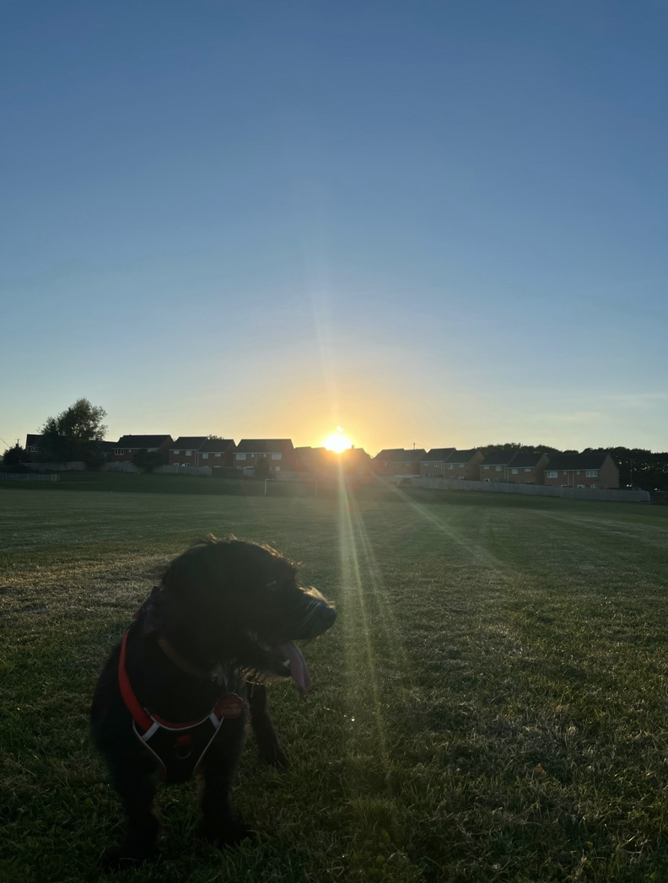

Figure 1: Man’s Best Friend, 22nd September 2024 19:10pm. Image: Luke Collin.

Sunset through the Trees – 23rd September 2024 19:01pm

Trying to find a nice spot in this nature reserve to capture the sunset was proving difficult as there was no gap within the tree line due to the foliage. I began to continue along the track way in hopes to find a gap. Meanwhile, I began to think about Van Gogh’s quote “Be clearly aware of the stars and infinity on high. Then life seems almost enchanted after all”. I thought to myself “what does he mean?”, “can this be subjective?”. I realised that the answer was not presenting itself to me directly but in fact, indirectly, as I found a gap in the treeline where I could capture the beautiful rays of a sunset. I find that the dark silhouette of the trees in contrast with the tones of green leaves and the light blue sky may just be a conclusion on Van Goghs quote after all. Beauty is indeed subjective, and life is what we make of it.

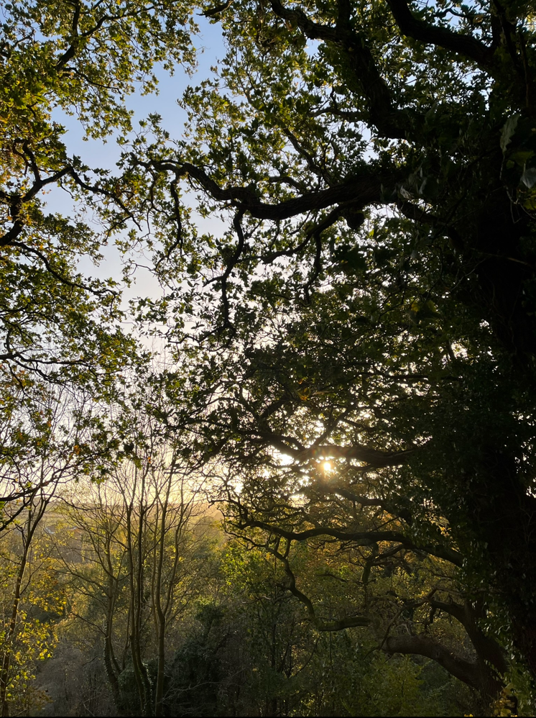

Figure 2: Sunset through the trees, 23rd September 2024 19:01pm. Image: Luke Collin.

The Colour of Nature - 2nd October 17:43pm

Throughout my recent walks with my dog, I have noticed the slow change of the colour of the tree leaves and, on this occasion, I decided to pick one up. When the leaves have just turned, the colour is much brighter like this one for instance (see fig.4). The contrast between this leaf and the dark green trees behind it are striking and nice to see. It is amazing how we can see colour, but I believe that we take this for granted as there are many animals that cannot like my dog Benny, for instance. If we only saw through a limited colour scope such as shades of black and white, then it would change our entire perspective.

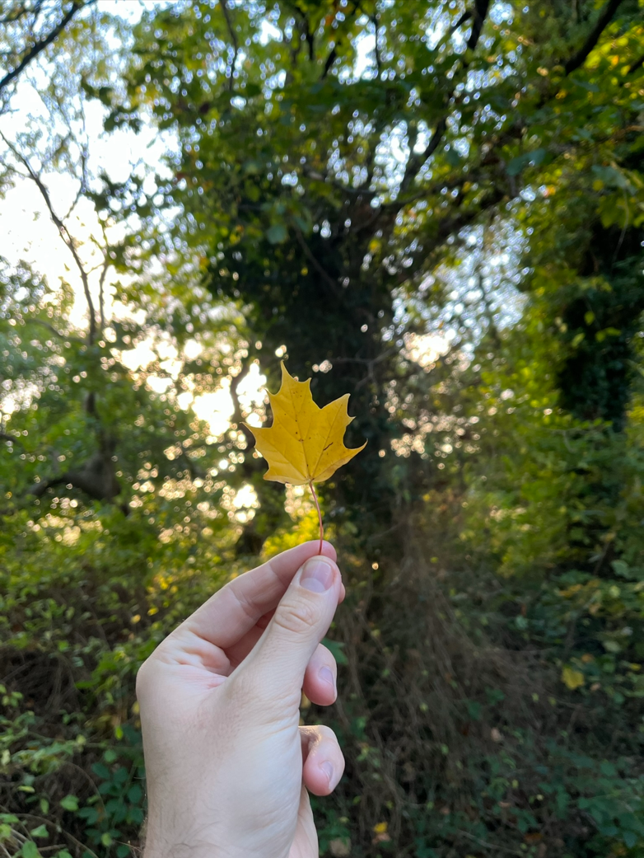

Figure 4: The Colour of Nature, 2nd October 18:01pm. Image: Luke Collin

Sunset at the Workplace - 10th October 18:26pm

I am halfway through my shift at work, and I see the Moon watching me from a distance. She is reflecting the Sun’s light from the west and I too, am stood upon reflection as I am about to take on a new position within this workplace. At this time, the moon was positioned at 8 degrees of Capricorn and according to Taylor, the moon positioned in the sign of Capricorn is linked with the workplace and career. This is very fitting for that moment I am in, although my thoughts appear heavy, the clear blue sky and the birds chirping all around me provides a sense of relief. I find that the natural environment around you is always calmer and realising this can certainly aid you.

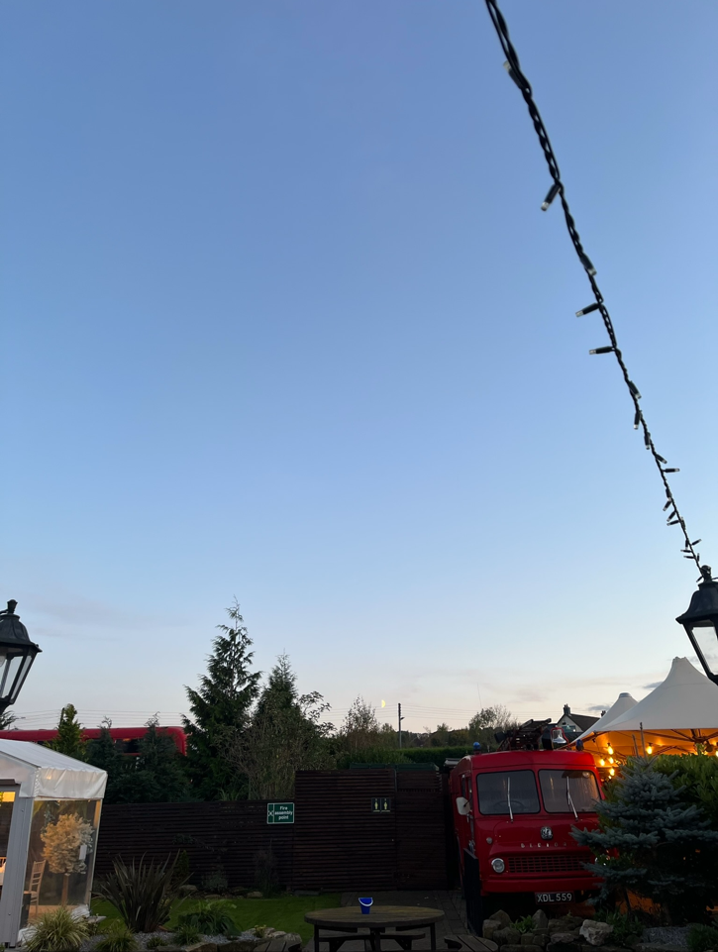

Figure 3: Sunset at the workplace, 10th October 18:26. Image: Luke Collin.

A Walk in Colour - 12th October 18:18pm

I was walking by the coast listening to the slow stream of traffic pass by with my phone in hand, replying to some text messages. It was when I looked up to the sky that I noticed something amazing. It was the vibrant colour of the sunset (see fig.5). Sometimes I think people get addicted to the mindless scrolling on social media that they neglect the true beauty above them. It disconnects us with not only our environment but the rest of humanity in its own way. What I found interesting about this moment is that the natural light of the sun has been replaced by artificial light from the streetlamps. There was not only beauty in the sky but also in the surrounding environment with the Georgian buildings and the vintage streetlights.

I found that so far, this encounter has brought me closer to understanding exactly what Van Gogh meant by “Be clearly aware of the stars and infinity on high. Then life seems almost enchanted after all”. My interpretation at this moment in time is that he is saying that we must look up more and admire what is there and that there is more to life than what is occurring on the ground level or surface.

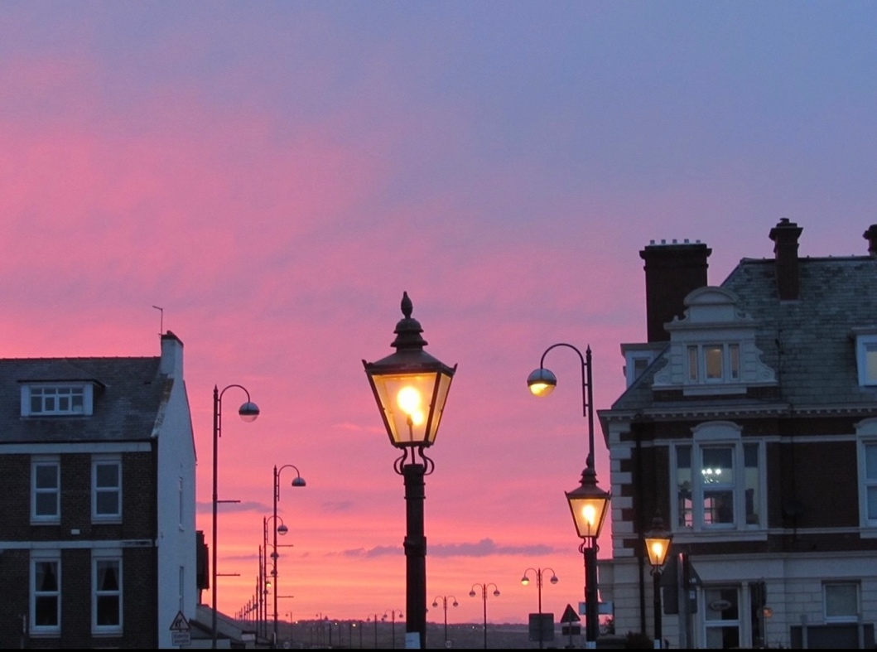

Figure 5: A Walk in Colour, 12th October 18:18pm. Image: Luke Collin.

Conclusion

This essay set out to capture the sunset and the surrounding nature over the course of one month in the Northeast of England using five entries from my sky journal. While using a quote by Van Gogh “Be clearly aware of the stars and infinity on high. Then life seems almost enchanted after all” as a basis for this study, my aim was to connect the theme of sunsets, colour and nature to this. The journal entries provided a chronological pattern to my thinking as through each entry, I began to form my own subjective understanding of the quote as evident within the entry of fig.5.

It was witnessing the sunsets and the surrounding nature whilst maintaining a reflective practice and a phenomenological approach that brought to my attention my own thoughts and how heavily they sometimes weighed as I became more conscious of them. Becoming aware of the nature and colours around you during a sunset felt physically and mentally peaceful, especially within fig.3. In the Context, I addressed how sunsets can reduce stress levels and promote healing. To revaluate this point, although I am unsure if my health has increased, I can however say with certainty that it offered stress relief. Of course, this may have been psychological but nonetheless, it occurred. I previously stated how sunsets are different from one another, I found this to be true as they were never the same which was due to the colour of the sky, and likely my mindset. I also mentioned that sunsets were also used in conjunction with meditations, I now believe that journaling offers the same contentment that meditation does. I believe that Van Gogh’s fascination with the sky led him to have such profound thoughts of what appears to be a sense of personal clarity and relief, and I too experienced this. To conclude this essay, it has been an interesting experience and sky journaling was never something I considered doing before now, but it will be something that I will continue to do with different themes and topics.

Bibliography

ABC News, Why watching sunsets and sending time in nature could be good for you. (2024] https://psychology.org.au/insights/why-watching-sunsets-and-spending-time-in-nature-c [accessed 8th November].

Atlihan, L. The Autumn Equinox: A Reflection on Balance (2024) https://www.yinovacenter.com/blog/the-autumn-equinox/#:~:text=Unlike%20the%20solstices%2C%20which%20are,that%20envelops%20the%20whole%20globe. [accessed 10th November 2024].

Benwell, M. Reclaim Your Brain: why it’s time to stop scrolling our lives away. (2024) https://www.theguardian.com/lifeandstyle/ng-interactive/2024/jan/01/is-it-time-to-reclaim-our-brains [accessed 10th November 2024].

Bockover, M. I. ‘The Emotions’, in Humboldt Journal of Social Relations, vol.18 (2), (Berlin: Humboldt State University, 1992), pp.45-56.

Bonfert, A. The Magic of a Sunset: The story behind the beauty of sunrise and sunset. (2020) https://medium.com/live-your-life-on-purpose/the-magic-of-a-sunset-608b539fed88 [accessed 8th November 2024].

Campion, N. The Dawn of Astrology: A Cultural History of Western Astrology: The Ancient and Classical Worlds, (London: Continuum Books, 2008).

Kroller-Muller Museum, Willows at Sunset (2024) https://krollermuller.nl/en/vincent-van-gogh-pollard-willows-at-sunset [accessed 10th November 2024].

Kryger, H. M. ‘Vincent van Gogh’s sleep’, in Sleep Health Journal of the National Sleep Foundation, vol.9 (5), (Washington D.C: National Sleep Foundation, 2023).

Mills, J. Views of the Universe from Van Gogh to the Hubble Telescope: A Comparative Study of Sublime Beauty. (2017) https://janicemillsfineartist.wordpress.com/2017/02/21/views-of-the-universe-from-van-gogh-to-the-hubble-telescope-a-comparative-study-of-sublime-beauty/ [accessed 8th November 2024].

Schon, A. D. The Reflective Practitioner: How Professionals Think in Action (New York: Routledge, 1991).

Sejpal, V. Change Is the Only Constant – 5 Principles of Human Change (online) https://www.practo.com/healthfeed/change-is-the-only-constant-5-principles-of-human-change-40474/post#:~:text=We%20experience%20change%20on%20a,Others%20are%20negative. [accessed 25th November 2024].

Shehadi, L. Sunset at Montmajour (2013) https://www.apollo-magazine.com/drawing-sunset/ [Accessed 10th November 2024].

Simmons, L. Libra Season 2024 Will Affect Each Zodiac Sign (& Bring Soulmates Together) (Online) https://stylecaster.com/lists/libra-season-2024-affect-zodiac-sign/ [accessed 10th November 2024].

Stokes, V. and Clark, C. What is Sun Gazing Meditation and Does it have Health Benefits? (2022) https://www.healthline.com/health/mind-body/sun-gazing [accessed 5 November 2024].

Taylor, S. The Impact of the Moon’s Transit Through Each Zodiac sign (2024) https://my.astrofame.com/astrology/article/moon-transit-zodiac-impact [accessed 8th November 2024].

The Metropolitan Museum of Art, The Starry Night (2024) https://www.metmuseum.org/art/collection/search/828514 [accessed 10th November 2024].

The Vincent van Gogh Gallery, Landscape at Sunset (2024) http://www.vggallery.com/painting/p_0079.htm [accessed 10th November 2024].

Tristan, F. J. ‘Do Animals See things as We Do?’ in Scientific American, vol.109 (3), (New York: Springer Nature, 1913).

Van der Rhee, H. et al. ‘Sunlight, Vitamin D and the Prevention of Cancer: A Systematic Review of Epidemiological Studies’, in European Journal of Cancer Prevention, vol.18 (6), (Philadelphia: Lippincott Williams & Wilkins, 2009).

Van Gogh, V. and de Leeuw, R. The Letters of Vincent Van Gogh. London: Penguin Books, 1997, p.392.

Appendices

Appendix A

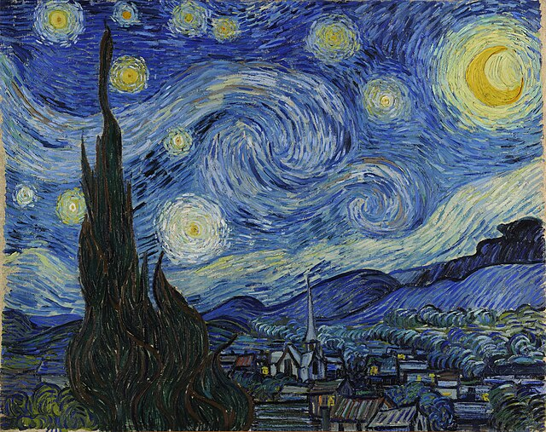

Appendix A: Vincent Van Gogh, The Starry Night (1889), Oil on canvas, 73.7 x 92.1 cm, The Museum of Modern Art. Image: The Metropolitan Museum of Art.

Appendix B

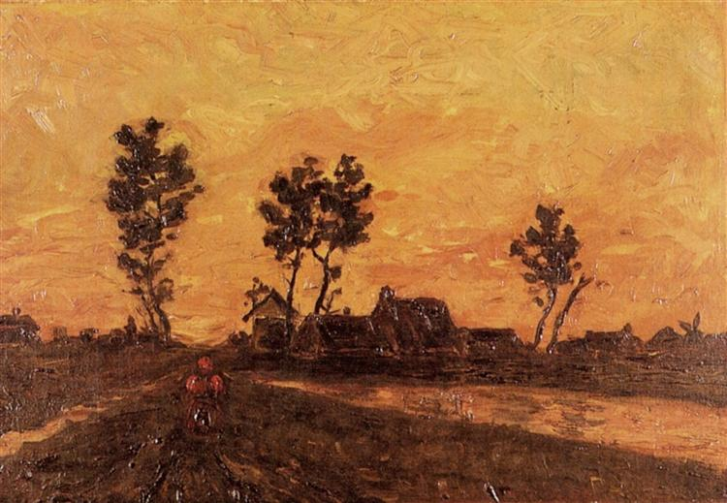

Appendix B: Vincent Van Gogh, Landscape at Sunset (1885), Oil on canvas, 27.5 x 41.5cm, private collection, Image: The Vincent van Gogh Gallery.

Appendix C

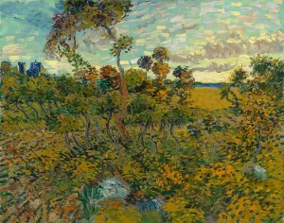

Appendix C: Vincent van Gogh, Sunset at Montmajour (1888), Oil on canvas, 73.3 x 93.3cm, private collection, Image: Lemma Shehadi.

Appendix D

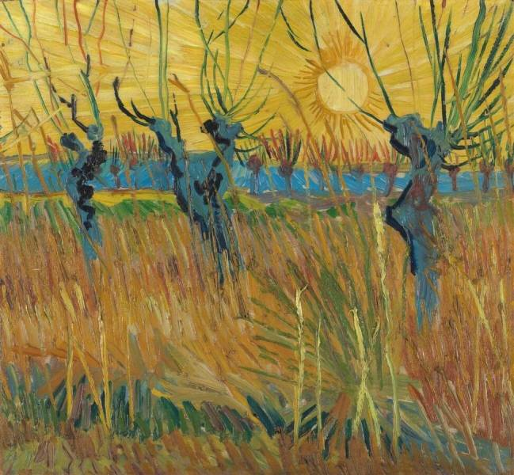

Appendix D: Vincent van Gogh, Willows at Sunset (1888), Oil on canvas, 31.6 x 34.3cm, Riiksmuseum Kroller-Muller, Image: Kroller-Muller Museum.

Vincent van Gogh, and Ronald de Leeuw, The Letters of Vincent Van Gogh. London: Penguin Books, 1997, p.392.
Liz Simmons, Libra Season 2024 Will Affect Each Zodiac Sign (& Bring Soulmates Together) (Online) https://stylecaster.com/lists/libra-season-2024-affect-zodiac-sign/ [accessed 10th November 2024].
Lillianne Atlihan, The Autumn Equinox: A Reflection on Balance (2024) https://www.yinovacenter.com/blog/the-autumn-equinox/#:~:text=Unlike%20the%20solstices%2C%20which%20are,that%20envelops%20the%20whole%20globe. [accessed 10th November 2024].
Donald, A. Schon, The Reflective Practitioner: How Professionals Think in Action (New York: Routledge, 1991). p.56.
Nicholas Campion, The Dawn of Astrology: A Cultural History of Western Astrology: The Ancient and Classical Worlds, (London: Continuum Books, 2008). Pp.2-14.
Meir, H. Kryger, ‘Vincent van Gogh’s sleep’, in Sleep Health Journal of the National Sleep Foundation, vol.9 (5), (Washington D.C: National Sleep Foundation, 2023), p.568.
Janice Mills, Views of the Universe from Van Gogh to the Hubble Telescope: A Comparative Study of Sublime Beauty. (2017) https://janicemillsfineartist.wordpress.com/2017/02/21/views-of-the-universe-from-van-gogh-to-the-hubble-telescope-a-comparative-study-of-sublime-beauty/ [accessed 8th November 2024].
Mary I. Bockover, ‘The Emotions’, in Humboldt Journal of Social Relations, vol.18 (2), (Berlin: Humboldt State University, 1992), pp.45-56.
Vijal Sejpal, Change Is the Only Constant – 5 Principles of Human Change (online) https://www.practo.com/healthfeed/change-is-the-only-constant-5-principles-of-human-change-40474/post#:~:text=We%20experience%20change%20on%20a,Others%20are%20negative. [accessed 25th November 2024].
Anne Bonfert, The Magic of a Sunset: The story behind the beauty of sunrise and sunset. (2020) https://medium.com/live-your-life-on-purpose/the-magic-of-a-sunset-608b539fed88 [accessed 8th November 2024].
ABC News, Why watching sunsets and sending time in nature could be good for you. (2024] https://psychology.org.au/insights/why-watching-sunsets-and-spending-time-in-nature-c [accessed 8th November].
Han van der Rhee, et al. ‘Sunlight, Vitamin D and the Prevention of Cancer: A Systematic Review of Epidemiological Studies’, in European Journal of Cancer Prevention, vol.18 (6), (Philadelphia: Lippincott Williams & Wilkins, 2009), pp.458-75.
Victoria Stokes and Catherine Clark, What is Sun Gazing Meditation and Does it have Health Benefits? (2022) https://www.healthline.com/health/mind-body/sun-gazing [accessed 5 November 2024].
Vincent van Gogh, and Ronald de Leeuw, The Letters of Vincent Van Gogh. London: Penguin Books, 1997, p.392.
Jose, F. Tristan, ‘Do Animals See things as We Do?’ in Scientific American, vol.109 (3), (New York: Springer Nature, 1913), p.54.
Susan Taylor, The Impact of the Moon’s Transit Through Each Zodiac sign (2024) https://my.astrofame.com/astrology/article/moon-transit-zodiac-impact [accessed 8th November 2024].
Max Benwell, Reclaim Your Brain: why it’s time to stop scrolling our lives away. (2024) https://www.theguardian.com/lifeandstyle/ng-interactive/2024/jan/01/is-it-time-to-reclaim-our-brains [accessed 10th November 2024].
Vincent van Gogh, and Ronald de Leeuw, The Letters of Vincent Van Gogh. London: Penguin Books, 1997, p.392.

