reflective fieldwork management plan for Dinefwr Park

Will Roberts (2100809)
[Email address]
BMOE6003; Landscape and sustainable recreation; Anthony Burns
Reflective fieldwork management plan for chosen recreational area.
A management plan for Dinefwr Park
Contents
Executive summary 2
Introduction 2
Conceptual Frameworks 3
Carrying capacity: 3
Limits of acceptable standards 4
Indicators of standards of quality 4
Threefold framework of outdoor recreation 5
Recreation opportunity spectrum 5
Problems and Impacts 6
Soil Erosions 6
Vandalism of bird hides 6
Solutions and management 7
Soil erosion management 7
Vandalism of bird hides 7
Theft of dead and live wood 8
Conclusion 9
References 10
Appendices 12
Appendix 1: shows the matrix for management for hardening the resources and experience. 12
Appendix 2: shows the matrix for management practices for limiting use. 12
Appendix 3 shows the matrix for management for reducing the impact of use. 13
Appendix 4: shows the matrix for management for the increase of supply. 13

Figure 1: limits of acceptable standards. (Manning, et al., 2017) 3
Figure 2 The threefold framework of outdoor recreation (Manning, et al., 2017) 4
Figure 3: Recreation opportunity spectrum. 5

Executive summary
Outdoor recreation has a range of effects on the environment in which we roam. This can change ecosystems and the natural beauty of the surrounding area. However, through management it can be maintained so that both human beings and animals can live harmoniously. Dinefwr Park, that lies within the Carmarthenshire landscape is home to Newton House, that dates back from the 17th century, also home to Dinefwr Castle. The land surrounding has a deer park that has a herd of fallow deer and ancient woodland that dates back more than 400 years. This landscape attracts people from local and afar, however this has meant that a variety of issues, such as depreciative behaviour leading to path erosions and vandalism of structures, has occurred. The use of conceptual frameworks such as carrying capacities, limits of acceptable change and indicators of quality standards will help protect the landscape and visitor experience at Dinefwr Park. These indicators will help guide strategies such as improved education, zoning, and visitor control; this will help to improve and protect the landscape so that generations to come can benefit from Dinefwr Park and its surrounding landscapes.

Introduction
Since COVID-19 visitor levels to natural landscapes have been on the increase (Panjwani, 2023); this has been apparent at Dinefwr Park as they have experienced a 66% increase in visitor level post-COVID-19. This increase has had an impact on their ability to keep up with maintenance, and to sustain ecology and the wildlife within the landscape. Through landscape restoration, that utilises naturally regenerative techniques to restore ecological characteristics and functions within a landscape (Iternational Fund for Animal Welfare, 2023); has helped with subtle management techniques. But with this increase of visitor numbers, it is sometimes become necessary for parks to introduce harder management plans; both of these techniques are visible at Dinefwr Park.
Dinefwr Park is a Site of Specific Scientific Interest (SSSI) due to its rare species of lichen and invertebrate assemblages (Windle & Douglass, 2023). With Dinefwr Park as a National Trust site, it must manage their dual mission to protect this SSSI site, but to also provide education through visitor participation yet still able to finance the management of the site (Litke, 1998). Hardin (1968) states that environmental problems and issues can be describe as the issues of the ‘commons’, these can be ultimately mitigated through ‘mutual coercion, [which is] mutually agreed upon’.
This report will underline and present recommendations through a management plan that will address the main problems Dinefwr Park has been facing. Such problems like depreciative behaviour, such as causing vandalism to bird hides (defacing with graffiti and smashing wooden panels), has caused there to be a divide in the people who use the park. Concerning bird watchers, it is difficult to use these hides effectively if there is light coming through the back face (Park, 2010). Another problem is theft of way markers and signs, this has had an effect of visitors going off-track, thus causing damage to lichens and invertebrates, that come specifically under the protection of the SSSI. The last problem to be addressed in this report concerns people taking firewood from the forests of Dinefwr Park and its surrounds, this has an effect to the invertebrate assemblages that thrives on dead wood and once more protected under the SSSI.

Conceptual Frameworks

Carrying capacity:
As Malthus (1798) posits in his essay on the principle of population, he suggests that population is limited to what the landscape affords us, such as the supply of food and other vital resources. The essay goes onto state that if this limit is not respected, Malthus describes as the ‘vice and misery’ on human population and the environment around us. Carrying capacity can then be defined as limits and standards that are not to be succeeded to protect the landscape (Sommer, 2015). This is an important consideration in this management plan, as if the carry capacity of the park is succeeded it can cause path erosions, noise pollution and the subsequent loss of habitat (Long, et al., 2022). However, carrying capacity can be seen as not inclusive, as it can be implemented through the increase of ticket sale prices into restricted landscape areas; this is especially pertinent in a time of social economic instability (Butler, 2024).

Limits of acceptable standards
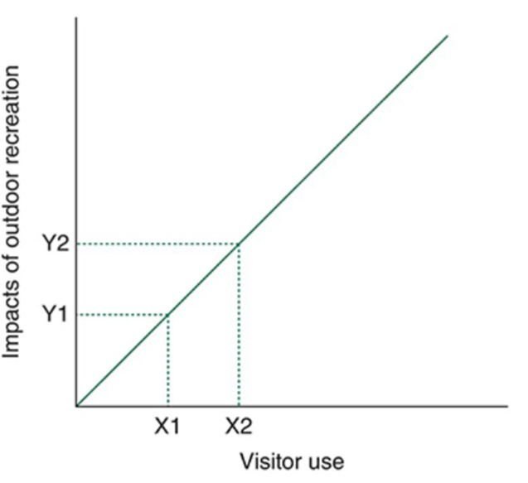

Figure 1: limits of acceptable standards. (Manning, et al., 2017)

Linking on from the carrying capacity of Dinefwr Park, this report needs to understand to what point is it damaging the landscape. Figure 1 shows that the increase of visitor numbers impacts upon outdoor recreation and the landscape that they are in. Regarding carrying capacity, to make Figure 1 more descriptive, the use of variables can show a distinguishment between X1-Y1 and X2-Y2. For example, the difference between ‘visitor use’ and ‘trampling in a specific area’ can then give an indicator to when upon the graph it is not at an acceptable level (Manning, et al., 2017; Stankey, et al., 1986). To clarify this matter, any increase in visitor levels at a specific natural venue, such as Dinefwr Park, will ultimately result in a widening impact to the landscape and surrounding flora and fauna.

Indicators of standards of quality
Creating objectives through management is important so that there are clear indicators for standards of quality. These indicators should follow guidelines which include being specific, objective, reliable and repeatable, sensitive, efficient, and manageable. These variables, that have been identified by designated individuals/groups such as wardens, managers and rangers, will enable specific authorities to keep track on the limits of acceptable change. Notably, if the impacts of change are becoming increasingly prevalent, which then will allow time for specific protocols to be administered regarding management techniques (Sarbanes, 2012). These variables will also mitigate against the limitations of subjectivity that this conceptual framework may fall under. Manning, et al (2017) give the example of indicators for soil erosion or plant trampling this would include what is the minimum path erosion depth and what is the minimum of trampling of flora and fora is aloud.

Threefold framework of outdoor recreation

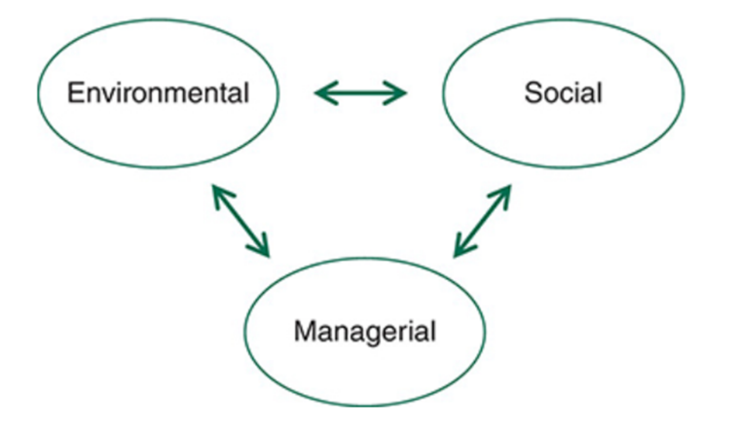
Figure 2 The threefold framework of outdoor recreation (Manning, et al., 2017)

Manning et al (2017) describes that outdoor recreation can be described through three components, these being: ‘resources (e.g. soil, vegetation, water, and wildlife), experiences (e.g. crowding, conflict) and management (e.g. visitor education, rules, and regulations)’ (Manning, et al., 2017, p. 6). This framework was developed from Wagar (1964) who argued that the increase of visitors will affect the quality of the recreation experience. As Figure 2 highlights, the inter-relationship that the environment and social and managerial position has is imperative, and if they do not work together the landscape will depreciate, along with visitor numbers.

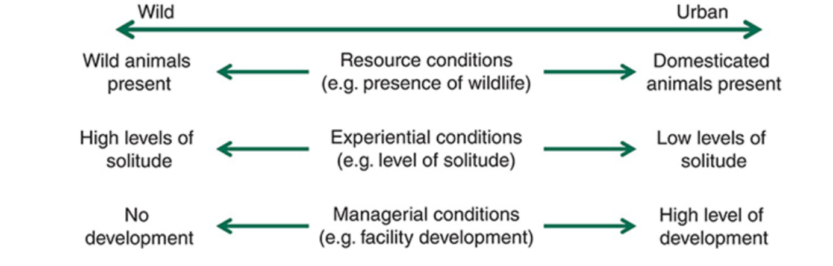
Recreation opportunity spectrum
Figure 3: Recreation opportunity spectrum.
This spectrum helps those who are implementing management techniques to make sure that we have a balance of diversity in outdoor recreational areas (Manning, et al., 2017). Clark & Stankey, (1979, p. 1) defines recreation opportunity ‘as the combination of physical, biological, social and managerial conditions that gives value to a place’. Figure 3 therefore shows the trade-off when developing a recreational area. These trade-offs will have to be considered whenever developing the site, in order to enable a fair level of acceptable standards. This spectrum is also designed to encourage management to not provide every type of experience to the visitor but draw focus on one or two elements, this is dependent upon the park, the demographic of visitors and the wider landscape (Driver & Brown, 1978). In Dinefwr Park’s case, the main demographic they receive is local residents, dog walkers and families from surrounding areas; this means that developments can focus on ’solitude’ and preserving the wildlife that is present.

Problems and Impacts

Soil Erosions
During the site visit one of the main problems that Dinefwr Park estate faces is soil erosion due visitors going off trail and trampling vegetation; this causes paths to widen, destroys habitats, plus the compaction of soil and related muddiness (Manning, et al., 2017). This compaction and loss of vegetation leaves the land more susceptible to erosion due to water run off not being able to dissipate into the ground, thus causing the creation of channels and troughs (David & Rhodes, 1999; Salesa & Cerda, 2020). This is especially a problem for Dinefwr Park, as the grounds come under SSSI status, due to there being rare lichens and invertebrate assemblages. This has been caused because of way markings and signs being stolen or vandalised and this has had an effect on people wandering off dedicated trails. Visitors have also been seen to go off the path purposefully to engage in detrimental behaviour, this has included the lighting of fires and cutting and moving dead wood. The community of saproxylic (dead wood) invertebrates, that are mostly beetles that can be found in Dinefwr Park, is part of the reason for its status for an SSSI; this means that the removal of dead wood has a knock-on effect to this species and if not controlled can see the removal of the species entirely (Countryside council for Wales, 1999).

Vandalism of bird hides
Dinefwr Park has a rich variety of wildlife that the public like to enjoy and visit, especially the birds that roam around the oxbow lakes, wetlands, and woodlands that the Park has to offer. This is enjoyed by local bird watchers using the bird hides that have been built on the estate, in order to draw more diverse foot fall into the park. However, these hides have been subjected to damaging behaviours such as littering, graffiti and alteration/destroying the hides; the key demographic that was highlighted for these incidents were adolescents using hides as a ‘den’ for social smoking and drinking activities. As a result of this they have taken the back of the hides out making it less effective for camouflage as light can pass through more freely, thus giving potential birdwatchers’ position away and subsequently scaring off birds.
In a more general perspective at Dinefwr Park, depreciative behaviour has always been a problem with the constant battle of vandalism and littering. Depreciative behaviour is often mitigated through signage and education; however, this is not always effective as Yang (2024) states, that one individual breaking the rules can stimulate others will follow. However, their study did find that punitive warning signs are more effective that positive educational signs along with signs with colder backgrounds, like blue, are more effective than warmer (red) signs.

Solutions and management

Soil erosion management
Using the matrix shown in Appendix 1 from Manning, et al., (2017), and the relating key, notably looking at ‘Information/Education’, it suggests that information can be given on current soil conditions to inform visitors to use correct paths; this can also be utilised as a rotational system so that the same paths get used all the time. As in Appendix 1, Manning, et al. (2017, p.203) suggests (6b) the utilisation of stepping stones and board walks, Dinefwr Park already has 500m of accessible board walk; however, this needs constant maintaining so other resources like stepping stones may be useful in areas for longevity. Within Appendix 2, for practices of limiting use zoning (5a), this may be an acceptable method, so that different parts of the site get used at different times. This is also supported (73b), where having different paths open for different seasons can dissipate footfall (Manning, et al., 2017, p.177-186).

Vandalism of bird hides
Utilising Appendix 3, notably the ‘Reducing the Impact of Use’ matrix from Manning, et al., (2017, p.193-202), it suggests through ‘Information/Education’ (61b,c), informing visitors of what is acceptable and unacceptable behaviour, in relation to littering and treatment of structures, is important when informing visitors and the effects of their behaviours. This can then be further enforced by ‘Rules/Regulations’ (63) and then law enforcement (64a,b); this being in the form of a uniformed ranger and sanctions if persons are found caught performing depreciative behaviour; outcomes can be in the form of warnings and fines (Manning, et al., 2017, p.193-202).

Theft of dead and live wood
The theft of wood in Dinefwr Park is a big problem, as this is the preferred habitat for invertebrates that are protected under the SSSI. The theft of wood is usually used for setting unauthorised fires that also scar the ground because of this. With the assistance of Manning, et al., (2017, p.190), see Appendix 4, (61a), specifically the ‘Increase of supply’, they suggest that education about the landscape is important; in Dinefwr Park’s case it would be providing further information on how the action of moving and destroying dead wood on the floor impacts the wider ecosystem. Under Appendix 4, concerning ‘wildlife’, within the matrix for management for the increase of supply, Manning, et al., (2017, p.188) suggest regulations for promoting good behaviour when around these habitats; also, under ‘Limit use’ in Appendix 2, setting capacities for the specific parts of the park will allow breaks for other areas (20f) (Manning, et al., 2017, p.179).
However, education and promoting rules and regulations can only go so far as the theories such as Kohlberg’s six stages of moral development which centres around three main subheadings: pre-conventional mortality; conventional mortality and post-conventional mortality and under these there are two stages each (Kohlberg, 1971). This theory is relevant when looking in recreation management as people like to make the rules flexible around them if it does not directly line up with their perspective. This is prevalent in stage 5: ‘social contact orientation’ and stage 6: ‘universal ethical principle orientation’ (Sanders, 2024). So, when developing educational signs and regulations in order to mange the landscape you must consider that this may entice people to bend the rules.

Conclusion
Through looking at conceptual frameworks and the use of Manning et al (2017) matrix for management practices, this report has been able to conclude that education, regulations, and zoning will be the most effective methods of management of Dinefwr Park. As Dinefwr is a SSSI it is always a priority to safeguard the rare species that are to be found there. Through education it will develop a visitor’s sense of place to the environment/landscape that surrounds them, this will then intern intrinsically change a person’s morals to abide to the regulations of the park. It is important to note that for combating soil erosion it is important to post and educate about different routes and paths for different times of year so that the land can recuperate. This report was reluctant to suggest any fees to access the land that surrounds the house as the opportunities it affords to visitors from any social-economic background can benefit from the landscape for enhancing their health and wellbeing, especially in a place of huge historical and cultural influence for Wales.

Word count: 2466

References
Butler, R., 2024. Issues in applyingcarrying capacity concepts: example from the United Kingdom, Gulidford: WWF.
Clark, R. & Stankey, G., 1979. The Recreation Opportunity Spectrum: A Framework for Planning, Management, and Research. s.l.:US. Departemnt of Agriculture Forest Service.
Countryside council for Wales, 1999. Site of special scentific iterest citation Carmarthenshire Dinefwr Estate, s.l.: Countryside council for Wales.
David, A. & Rhodes, W., 1999. Recreation, Ecological Impacts. Recreation, Ecological Impacts, Volume 356, pp. 506-508.
Driver, B. & Brown, P., 1978. The Opportunity Spectrum Concept and Behavioral Information in Outdoor Recreation Resourse Supply Inventories: A Rationale. In: G. Lund, V. LaBau, P. Ffollitt & D. Robinson, eds. Integrated Inventories of Renewable Natural Resources: Proceedings of the Workshop. Tucson, Arizona: U.S. Department of Argriculture, pp. 24-31.
Hardin, G., 1948. The tragedy of the commons. Science, Volume 162, pp. 1243-1248.
Iternational Fund for Animal Welfare, 2023. What is landscape restoration?. [Online]
Available at: https://www.ifaw.org/initiative/climate-change/what-is-landscape-restoration#:~:text=Landscape%20restoration%20is%20one%20of,landscape%20using%20naturally%20regenerative%20techniques.
[Accessed 19 04 2024].
Kohlberg, L., 1971. Chapter 1: Stages of moral development as a basis for moral education. In: L. Kohlberg, ed. Moral Education. Toronto: University of Toronto Press, pp. 23-92.
Litke, S., 1998. National Parks: Their Origins & Development, Cambridge: Brecon Beacons National Park Authority.
Long, C. et al., 2022. Tourism environmental carrying capacity review, hotspot, issue, and prospect. Int J Environ Res Public Health, 19(24).
Malthus, T., 1798. An Essay on the Principle of Poulation. New York: W.W. Norton & Co.
Manning, R., Anderson, L. & Pettengill, P., 2017. Managing Outdoor Recreation Case studies in the national parks. 2nd ed. Wallingford: Cabi.
Panjwani, A., 2023. Tourism: Statistics and policy, London: House of Commons Libary.
Park, K., 2010. Hides and Camouflage. [Online]
Available at: http://www.photographers-resource.co.uk/wildlife/photographing/hides_and_camouflage.htm
[Accessed 03 May 2024].
Salesa & Cerda, 2020. Soil erosion on mountain trails as a consequence of recreational activities. A comprehensive review of the scientific literature. Journal of Environmental Management, 271(1).
Sanders, C., 2024. Britannica: Lawrence Kohlberg's stages of moral development. [Online]
Available at: https://www.britannica.com/science/Lawrence-Kohlbergs-stages-of-moral-development
[Accessed 3 May 2024].
Sarbanes, P., 2012. Using Indicators and Standards of Quality to Guide Transportation Management in Parks and Public Lands:A Best Practices Manual, s.l.: s.n.
Sommer, A., 2015. Carrying Capacity in PARKS & BENIFITS ppatner protected areas, s.l.: Parks & Benefits Baltic protected areas and tourism.
Stankey, et al., 1986. The limits of acceptable change (LAC) system for wilderness planning. general technical report INT-176, s.l.: USDA forest service.
Wagar, J., 1968. The carrying capacity of wild lands for creation lands, Washington DC: Society of American Foresters .
Windle, A. & Douglass, J., 2023. Lichen Survey of Dinefwr NNR (VC 44 Carmarthenshire) including re-monitoring the 2013 baseline and comments on air polution and Ash Dieback, Bangor: National Resources Wales.
Yang, T., 2024. The effectiveness of information signs in deterring visitor vandalism. Journal of Ooutdoor Recreation and Tourism, Volume 45.

Appendices

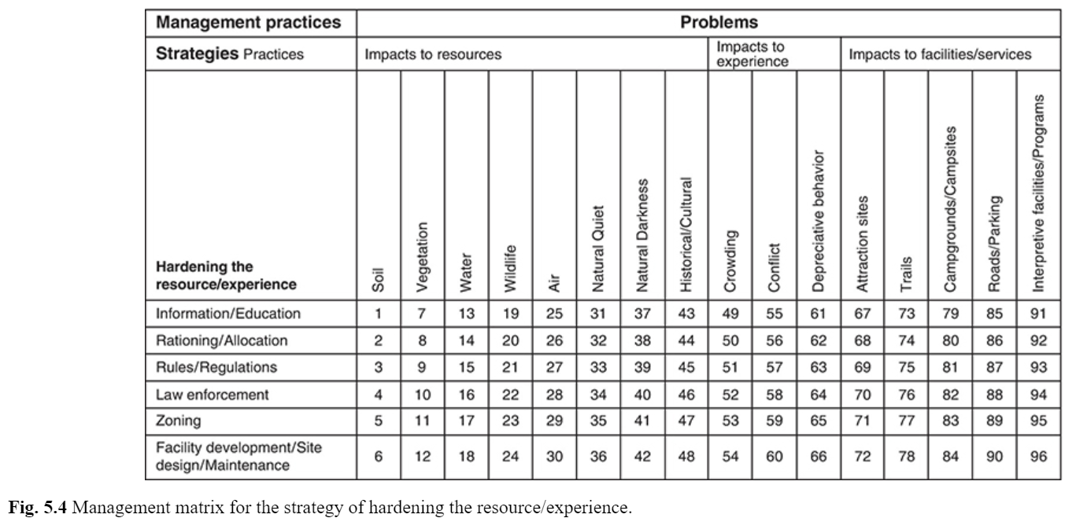
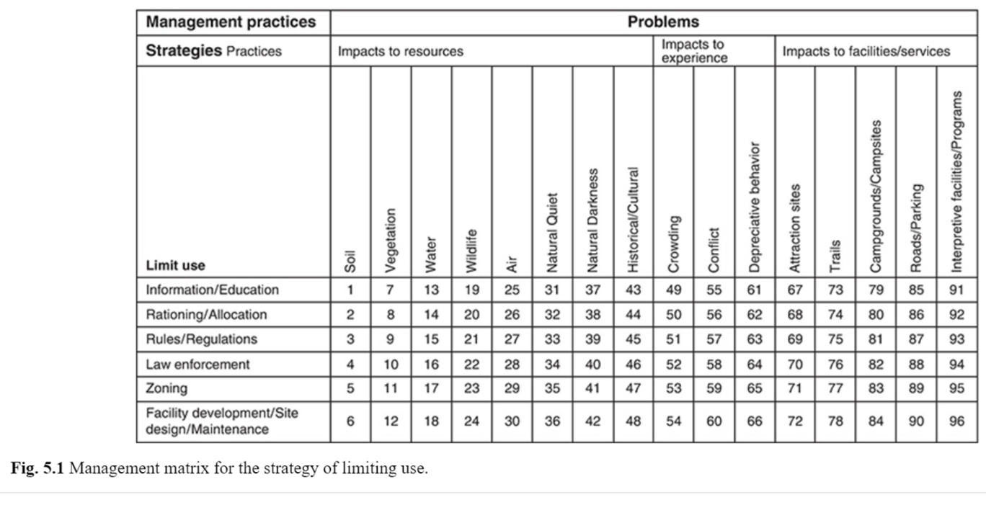
Appendix 1: shows the matrix for management for hardening the resources and experience.

Appendix 2: shows the matrix for management practices for limiting use.

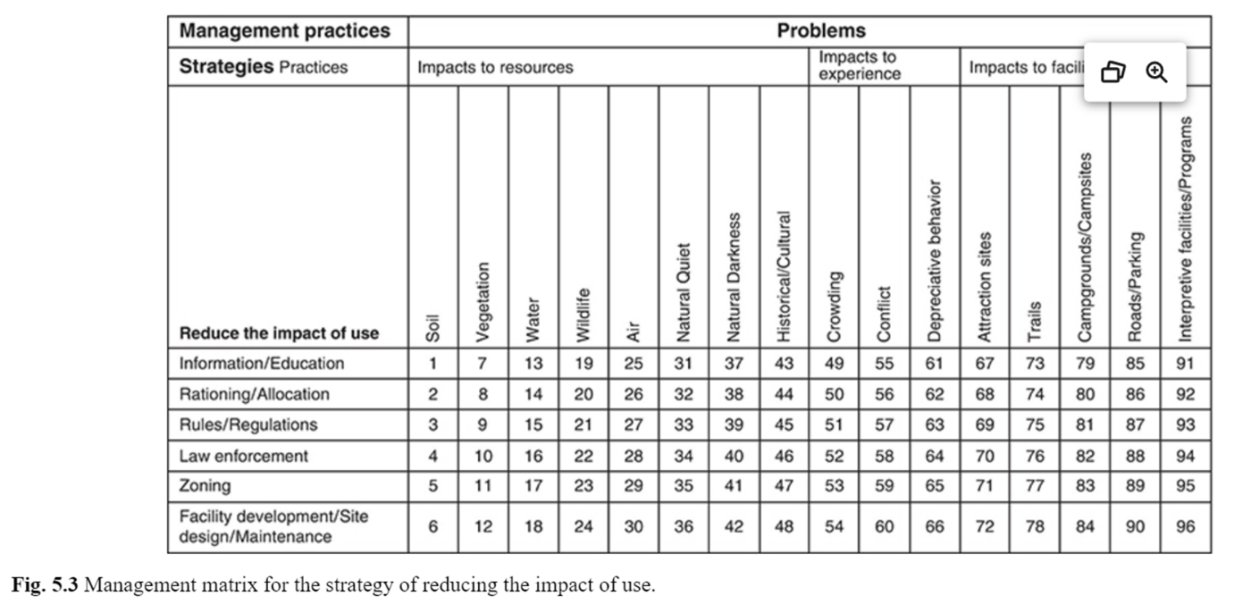
Appendix 3 shows the matrix for management for reducing the impact of use.

Appendix 4: shows the matrix for management for the increase of supply.


