

Cover Page
Aminah Haseen
2407621
BMHP5015
Component 1 Portfolio

Task 1 – Personal Brand
My personal brand will be created on the basis of kindness, reliability, professionalism, and commitment to serving other people. Since I am a student of a health and social care program, it is essential for me to be viewed as a person who respects others and pays due attention to their needs and preferences. Such characteristics are critical in the health and social care environment because customers have to be treated with dignity, respect, and safety. My main employment objective is related to becoming a healthcare professional, namely a healthcare assistant.
Personal branding will make it easier for an employer to understand what I can offer and whether I can fit into the organisation. As per the guidelines set by the NHS England, health professionals must give compassionate, respectful, and person-centred care. All these qualities make up my personal brand. My personal brand would be reflected in me through punctuality, respectful communication, confidentiality, and willingness to learn from feedback.
In order to enhance my personal branding, I will ensure that I improve my communication skills, teamwork skills and confidence. I will participate in training, obtain certification like the Care Certificate, and gain experience through volunteering or placement. In addition, I will ensure that I update my CV and prepare case studies demonstrating my skills, such as helping other people, problem-solving, and responsibility.
A professional presence online is also very significant. My social media postings will always be appropriate and not have a negative impact on how my potential employers will view me. Through being compassionate, reliable, and having a good attitude, I can develop an admirable personal brand.

Task 2 - Network Map and Rationale
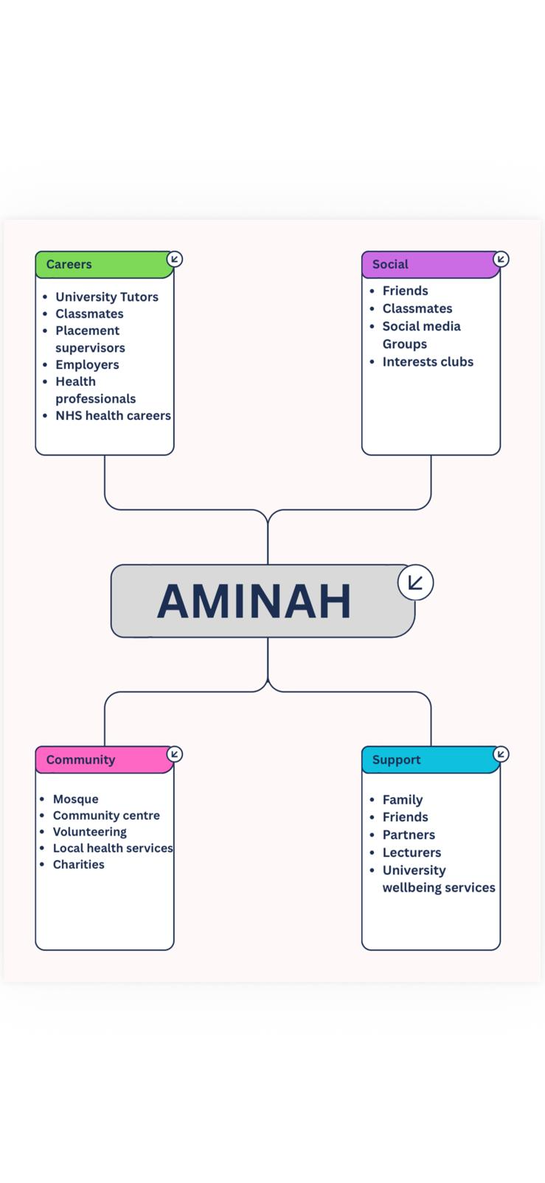

My personal network comprises individuals, groups, and organisations who will assist me in my personal development, academic growth, and career growth. This network is categorised into four distinct sections, including career, support, social, and community, due to the different kinds of assistance they offer. It is essential to have a good network since it will offer advice, motivation, opportunities and helpful information.
In the career network category, there are university tutors, fellow students, placement tutors and health professionals. They can play a vital role in helping me towards achieving my aim of working in the health and social care field, as they will help in developing knowledge, confidence and professionalism. University tutors will offer academic guidance, while the placement tutors will help in giving feedback on practical skills and professionalism. Health professionals might help me in getting information concerning job opportunities, training and what employers are looking for from the employees. NHS England states that healthcare professionals must collaborate with other people and provide person-centred and compassionate care.
My family, friends and partners act as my source of encouragement during times when I am under pressure, as well as helping me find a proper balance between studies at the university and other tasks, encouraging me to move forward in my plans. The social network consisting of friends and classmates also plays an important role as it helps me establish contacts and exchange ideas and opinions.
Community organisations, which include community organisations, volunteering options and health charities, are part of my network. Volunteering may contribute to my professional experience, my ability to communicate with people, and my dedication. At the same time, I realise that my network should consist of professional contacts as well, and I am going to attend career fairs and discuss various issues with professionals during placements and use them for that purpose. It is shown that networking could help enhance the employability of graduates as it would increase their access to information, advice, and resources (Tymon and Batistic, 2016). Networking could also contribute to career success as it would provide an individual with helpful contacts (Seibert, Kraimer and Liden, 2001).

Task 3- Blog
Waiting For Treatment: How NHS Waiting Times May Affect Mental Wellbeing
It is quite stressful to wait for treatment when you already feel pain, have mental wellbeing problems or have problems coping with everyday activities. Waiting times are one of the biggest challenges in the UK health and social care sector since there are many people who wait for their appointments, tests, surgeries, and mental health services. Despite the efforts of healthcare workers to provide safe services, waiting times are capable of affecting patients and their relatives greatly.
Waiting for many patients means not only waiting for the appointment. It means having problems for a longer period of time, worrying about possible outcomes and uncertainty of when help would come. Uncertainty affects patients' mental well-being. The patients feel anxious, frustrated or ignored by healthcare systems.
Waiting periods can also have an impact on the family members or carers. In the case when an individual requires treatment due to having mobility issues or suffering from psychological disorders, then they will require more support from their family members at home. This may be difficult for a carer, especially in the case when they are also working or studying. Therefore, communication plays a vital role. The patients must know about their treatment status, whom to contact in case their conditions get worse and the kind of help they will receive during the waiting periods.
It is crucial to bear in mind that not all individuals face waiting periods equally. For instance, elderly patients, disabled individuals, chronic patients, as well as individuals who have less support, can be adversely impacted by waiting periods. The health and social care providers should consider individual requirements rather than treating everybody in the same manner.
There are several means by which patients can feel more supported while waiting. These include contacting their \GP or healthcare professionals when their symptoms have deteriorated, asking for information about cancellations, accessing reputable wellbeing sources and talking to their families or friends. Nevertheless, the onus must not be solely on the patients. Services must have sufficient staffing, proper communication systems and collaboration within health and social care sectors.
Waiting times are not just a question of numbers. There is always a human being behind each appointment, who might feel anxious, ill or distressed. Improved communication and support while waiting can humanise the healthcare service.
Task 4- NHS Equality, Diversity and Inclusion Quiz
- What is the primary goal of the NHS Equality, Diversity, and Inclusion Improvement Plan?
The primary objective is the improvement of the working environment for all members of staff in the NHS and equal opportunities. Making sure that staff from all backgrounds are respected, supported and able to progress.

- How does the NHS EDI Improvement Plan propose to tackle the gender pay gap?
The goal of the plan is to narrow down the gender pay gap through the improvement of fair recruitment, promotion, and pay practices. Also advocates for organisations to utilise information in identifying cases of inequality and taking action.

- What is meant by the term ‘intersectionality’ as used in the NHS EDI Improvement Plan?
intersectionality refers to the experience of discrimination or inequality from different dimensions of an individual's identity, including gender, race, disability, religion or sexual orientation.

- Why is it important for the NHS to create a psychologically safe work environment?
So employees feel safe and comfortable in raising issues, asking questions and bringing any problems that arise without fear of victimisation, bullying, or impacts on their careers.

- How does the NHS EDI Improvement Plan suggest improving the experience of internationally recruited staff?
Improving the experience for the internationally recruited staff member by offering induction support, pastoral care, mentoring and support in integrating into the UK workplace environment.

- What role does leadership play in advancing EDI objectives according to the NHS Improvement Plan?
Leadership is a critical role since leaders define the standards of fair treatment, respect and inclusivity in the workplace. The NHS leaders should confront all kinds of discrimination.

- Identify one way the NHS EDI Improvement Plan aims to reduce health inequalities within the workforce.
One way in which the action plan will reduce health inequalities is through improving wellbeing provision for the workers of the organisation and ensuring that all workers have access to occupational health services.

- Why does the NHS EDI Improvement Plan emphasise the importance of collecting and analysing data on protected characteristics?
The data on protected characteristics will allow the NHS to better understand those categories of people who are prone to discrimination, pay inequality and restricted access to career development.

- Explain how flexible working policies can contribute to equality and inclusion in the NHS workforce.
Flexible working arrangements can be useful for workers who care for their families or have physical or mental disabilities, health issues or religious considerations.

- What is one strategy mentioned in the NHS EDI Improvement Plan to combat bullying and harassment in the workplace?
A solution would be for organisations to have a defined zero tolerance policy for bullying and harassment, as well as channels for employees to anonymously report instances.

Task 5- A Letter to Yourself

To Younger Me,

I know that Year 6 is particularly hard for you since you are being bullied. You are bound to be hurt, alone, and wonder why this is happening to you. You may start to become anxious about attending school and feel that you need to keep everything bottled up inside. I want you to know that you deserve to feel safe, respected, and included in your schooling environment.
In this situation, emotional intelligence would have been helpful as it would have helped you acknowledge and control the emotions that come from being bullied. You will most likely experience anger, sadness or embarrassment, and these are all normal emotions. Instead of keeping these emotions to yourself, you should have acknowledged your emotions and told an adult, whether a parent, teacher or relative.
Resilience would have also helped. Resilience is not about pretending that the bullying did not hurt or coping with everything on your own. Resilience is coping with a tough situation, seeking help and maintaining self-belief. You could have thought of your strengths, spent time with supportive people and participated in activities which would have boosted your confidence.
If I could talk to you then, I would have suggested not to blame yourself for the way other people act. Being a victim of bullying does not make you the way you are. You are an honest person, you're competent enough, and you deserve good friends. Although it was a hard time, it would be helpful for understanding the importance of being a kind, empathic and vocal person.
As you are getting older, emotional intelligence and resilience will become very useful for studying, working and building relationships. As a healthcare professional, you will need these traits to understand how other people feel and provide them with appropriate assistance.

From Older Me.

Task 6- GANTT Chart (200 words equivalent)
Tasks to achieve employment goal | Jul-Sep 2026 | Oct-Dec 2026 | Jan-Mar 2027 | Apr-Jun 2027 | Jul-Sep 2027 | Oct-Dec 2027
Complete university modules | ■ | ■ | ■ | ■
Improve communication and teamwork skills | ■ | ■ | ■ | ■ | ■ | ■
Research healthcare assistant roles and requirements | ■
Create and update CV and cover letter | ■ | ■
Gain experience through volunteering and placement |  | ■ | ■ | ■
Apply for healthcare assistant jobs and prepare for interviews |  |  |  | ■ | ■
Start work and continue professional development |  |  |  |  |  | ■

The following Gantt chart represents how I will need to proceed to meet my future career goal of being a Healthcare Assistant. For the first few months, I will concentrate on finishing my work at the university, finding out the necessary information concerning jobs and working on my CV. Then, I will get some practical skills from training or volunteering. Getting experience will allow me to gain some self-confidence, good communication skills, and awareness of what is expected from a professional.
Task 7- Making Changes- Report
Introducing A Daily Resident Check-In.
One measure that I would put in place as a manager of the care home would be to have a resident well-being check-in on a daily basis. In this, there will be discussions between the staff members and the residents on a daily basis. In the discussion, the residents will be asked how they are feeling and whether there are any issues that need to be addressed.
The steps that I will take to implement the change in practice include explaining the idea to both the staff, resident and their families. There will be a meeting where the benefits of doing a well-being check-in will be explained, and how this will help in communication. Staff members will get advice on how to pose open questions and listen to what the residents have to say. There will be a simple well-being form that can be used to log any concerns raised by the residents.
A change model by Lewin can be applied here to achieve success in this case. The first step, which is unfreezing, requires the explanation of why the change is needed and encouraging the staff to see the advantages. The second step, which is changing, will require introducing the check-in and providing relevant training. The last step is that of refreezing, which would entail incorporation of the check-ins into the daily activities and evaluating its effectiveness. (Kallen, 1951)
The skills that are crucial for success are communication, leadership, teamwork, empathy and organisation. Staff will have to communicate properly with the residents and cooperate to exchange the relevant information. As a manager, I will have to demonstrate leadership and listen to the feedback from the staff.
Potential barriers might be staff shortages, lack of time and staff resistance due to the feeling that it causes additional workload. These barriers can be avoided by maintaining the check-in process as short as possible. Integrating it into the current care process and soliciting feedback from the staff members. CQC suggests that good care must be person-centred and responsive to people's needs, and this initiative will promote quality care. (CQC, 2015)
Thus, daily well-being check-ins can contribute to enhancing residents' experience and improving communication.

Reference List
Task 1:
England, N. (2026). NHS England. https://www.england.nhs.uk/. (Accessed: 2 July 2026).
Healthcare assistant | Health Careers (no date). https://www.healthcareers.nhs.uk/explore-roles/healthcare-support-worker/roles-healthcare-support-worker/healthcare-assistant. (Accessed: 2 July 2026).
Task 2:
Seibert, S.E., Kraimer, M.L. and Liden, R.C. (2001) “A Social Capital Theory of Career Success,” Academy of Management Journal, 44(2), pp. 219–237. Available at: https://doi.org/10.5465/3069452.
Batistic, S. and Tymon, A. (2017) “Networking behaviour, graduate employability: a social capital perspective,” Education & training (London), 59(4), pp. 374–388. Available at: https://doi.org/10.1108/ET-06-2016-0100.
Task 7:
Care Quality Commission (2015) Guidance for providers on meeting the regulations. https://www.cqc.org.uk/sites/default/files/20150324_guidance_providers_meeting_regulations_01.pdf. (Accessed: 2 July 2026)
England, N. (2023) NHS England » The NHS Patient Safety Strategy. https://www.england.nhs.uk/patient-safety/the-nhs-patient-safety-strategy/. (Accessed: 2 July 2026)
Kallen, H.M. (1951) “LEWIN, KURT, ‘Field Theory in Social Science: Selected Theoretical Papers’ (Book Review),” Social research. Camden, N. J: New School for Social Research, Graduate Faculty of Political and Social Science, pp. 522–522.

