

Assessment 1 – Reading Task Template
PART 1: Upload your photo of your A3 in-class notes here:
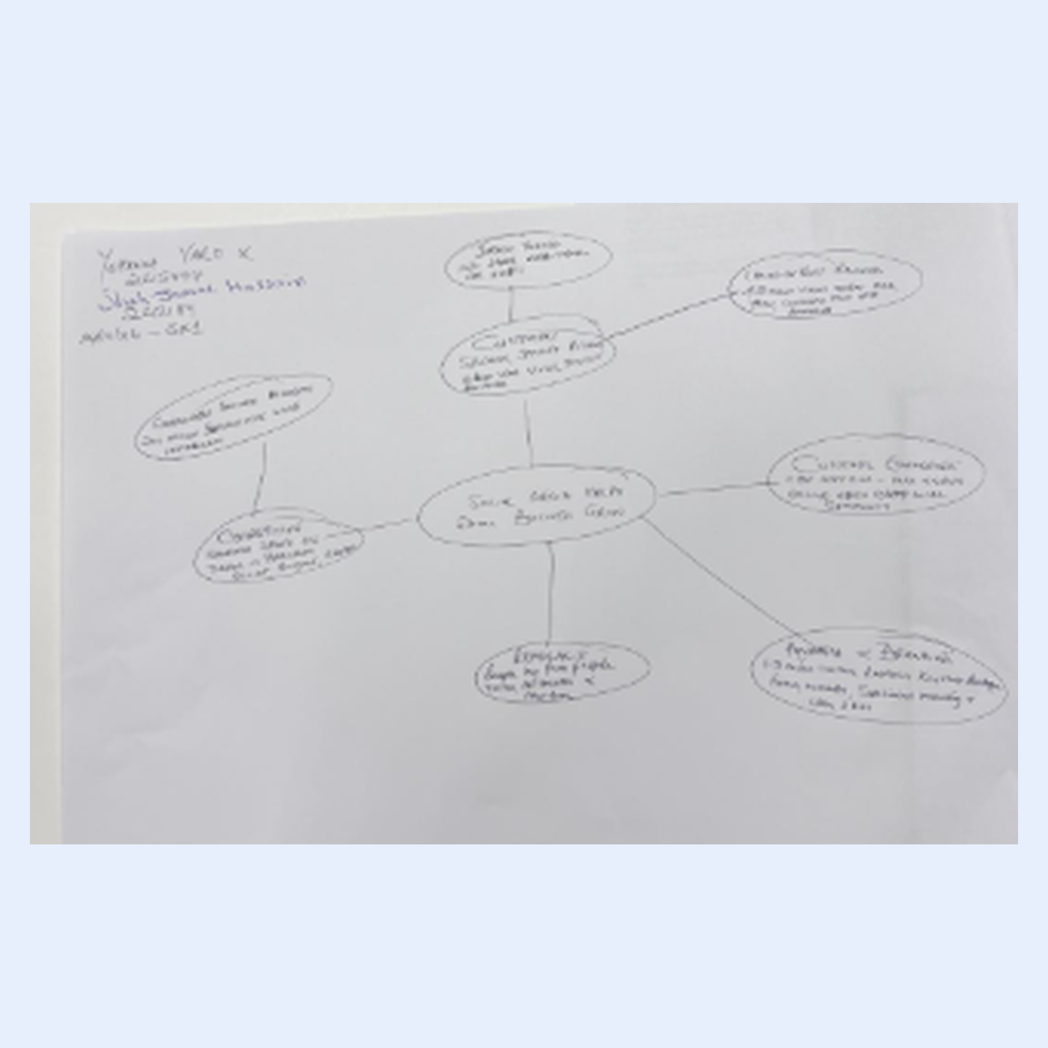

PART 2:
- Answer every question below in 1-3 full sentences.
- Use your own words. Do not use generative AI to answer these questions.
- Include a specific detail from the text when asked.
REMINDER
- The main idea is the overall message of the whole text.
- A key point helps to explain the main idea.
- A specific detail or example from the text shows that the key point is true.

- What is the main idea of the whole text?

The main idea of the text is mainly about how social media helps small businesses grow. It shows how platforms like TikTok and Instagram can bring in more customers and help businesses make more sales.

- What is one key point that supports the main idea, and which specific example from the text shows this?
One key point is that social media helps businesses attract customers from different places. For example, some people travelled three hours to try a chicken burger at Honywood Sandwich Shop after seeing posts about it online. This shows the power of social media and the impact it has on people's choices.

- What is a different key point that supports the main idea, and which specific example from the text shows this?

Another important point is that social media helps small businesses reach more customers and build their brand. For example, Linda Hunter used Instagram to promote her clothing business and now sells clothes online to customers across the UK and even Australia. This shows how promoting on social media can reach more people around the world than just having a physical shop which also cuts costs and saves money.

- Which part of the text do you think is most important, and why?
I think the most important part is the story about Honywood Sandwich Shop. It shows how customers sharing videos online can make a small business popular and encourage people to travel a long way to visit it

Reflection:
- What did you find difficult in this task (including in-class components), and why was it difficult?
I found it challenging to identify the main points in the article because there were several different businesses and examples mentioned. At first, I struggled to decide which information was most important and how to organise it clearly in my mind map.

- What helped you with this difficulty, and how did it help you?
Reading the article more than once and creating my mind map helped me understand the information better. Breaking the text into smaller points made it easier to see how the different examples connected to the main idea of social media helping small businesses grow.

