21/1/2019
Practical Lab Report
Science M3X01513
Nathan Myer 1801800

1: Rationale

The purpose of this experiment was twofold. First, to explore the relationships between 3 forces in equilibrium; the elastic force of two springs and the weight of different masses. Second, to provide experience collecting, processing, and analyzing data from a relatively simple procedure so that the experimenters may familiarize themselves with the process.

2: Set Up

Experimenters built the apparatus using a spirit level, a meter stick, two identical springs, a roll of line, tape, a holding stand for the meter stick, and a mass hanger with masses incrementing at 50 grams.
- Springs were attached to the meter stick at 20cm and 80cm by tying loops of line through one end loop of each spring and then around the meter stick, taping the line in place such that the spring was allowed to swing freely
- A single length of line was tied between the hanging end loops of both springs such that with no mass attached, the springs were not stretched and the line had negligible sag
- It is recommended that for further experiments, the center of the connecting line be marked to ensure consistency
- The middle of the meter stick was mounted to the stand such that the meter stick was firmly held and level
- The maximum mass to be tested was hung from the center of the connecting line to check both that it would not reach the tabletop and that it would not bring the meter stick out of level

3: Procedure

For the experiment, a ruler and a protractor accurate to 1mm and 1° respectively were used to collect data. Measurements L1, L2, Θ1, and Θ2 were taken for each mass M.
- L1 is the entire length (end loops included) of the spring at the 20cm mark
- L2 is the entire length (end loops included) of the spring at the 80cm mark
- Θ1 is the angle between the two halves of line on either side of the mass hanger with the protractor zeroed on the half leading to the L2 spring
- Θ2 is the angle between the two halves of line on either side of the mass hanger with the protractor zeroed on the half leading to the L1 spring
Starting at 0g, measurements were taken every 50g up to 600g. After removing and replacing the 600g hanging mass, a second trial was done in reverse order, with measurements taken every 50g from 600g to 0g. Further trials may be done to increase data volume if desired. All data was recorded in a table (table 1) made before the experiment.
To ensure data quality:
- Measurements were only be taken once the springs had stopped oscillating
- The ruler and protractor were held as close to the apparatus as possible without touching it
- Measurements were taken at eye level to the component being measured
- The center of the protractor was on the point where the hanging mass attached to the line
- The experimenter rested their elbows on the table and used any other viable means to steady their hands, including grabbing the meter stick with one hand while being careful not to bring it out of level
- The experimenter was careful to record only what measurements were observed and not what measurements were expected, especially in the second and any further trials
- Between trials and at random points during the experiment, the apparatus was checked to ensure it was not out of level

4: Results

Table 1: Raw experiment data
The results from the experiment are displayed in table 1. In the Processed Data section, Lm is the mean length of both springs across both trails and Θm is the mean angle of both measurements across both trials. The rightmost column was given by the formula $\frac{M}{\cos\left(\frac{θm}{2}\right)}$ [Equation 1], where M is mass and Θm is the mean angle previously mentioned. Uncertainties and percentage uncertainties for Lm and Θm at each mass are displayed in table 2. Uncertainties were calculated using data from both trials.
Table 2: Probable and percentage error
In both trials, L2 was consistently larger than L1 across nearly all masses, as is more clearly illustrated in figure 1. Figure 2 shows the relationship between mass and average angle, and in figure 3 average length is plotted against the data derived from equation 1, with a line of best fit.
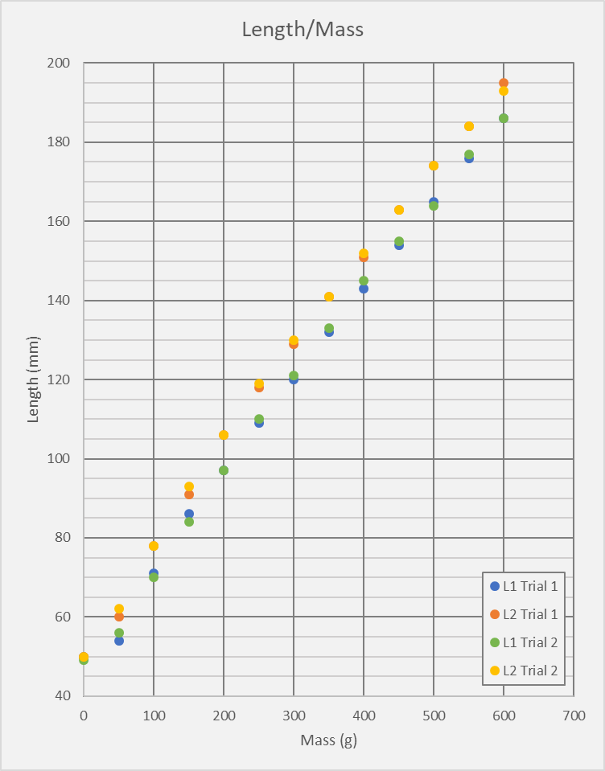
Figure 1: L1 and L2 spring discrepancies
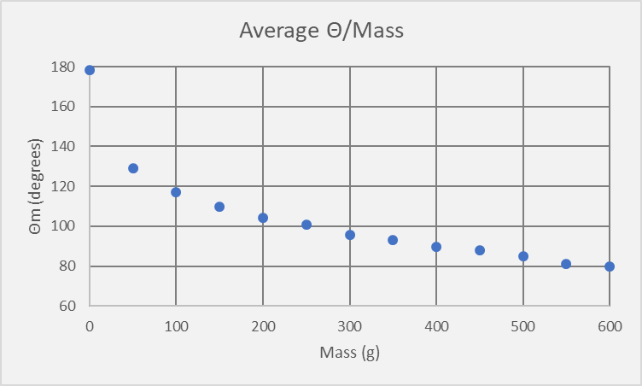
Figure 2: As mass increments, change in Θm decreases

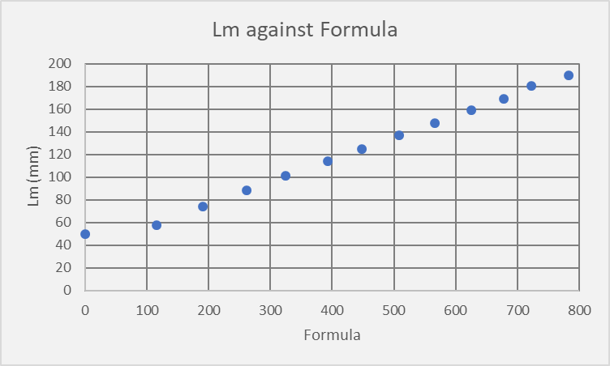
Figure 3: Length plotted against values derived from equation 1

5: Conclusions

5.1: Data Reliability and Quality

As mentioned previously, the data across both trials shows L2 consistently higher than L1. This is reflected by the uncertainties in table 2, where it can be seen the probable error is as much as 5mm in some cases, caused by the large range of values between L1 and L2 measurements. This discrepancy between the two springs can be interpreted either as systematic error or as a difference in elasticity between the L1 and L2 springs. As the same level of variance is present in both trials, it is likely that the cause is a difference in elasticity. Had there been time during the experiment, this could have been tested for by switching the L1 and L2 springs and seeing if the discrepancy also reversed.
Assuming the large range is caused by differences in spring elasticity and not systematic error, it can then be corrected for by measuring the probable error of each spring individually. The results, in table 3, show a drastically decreased error for both springs. However, it is important to note that this does not discount systematic error, as the dataset would yield these results no matter the cause of the L1/L2 discrepancy.
Table 3: L1 and L2 corrected error
If the cause truly is a difference in spring elasticity, then the corrected results make the L1 and L2 results very reliable, however the process by which the corrected results are obtained necessarily halves the data volume used to derive L1 and L2 mean values, which is less than ideal. By contrast, the uncorrected results return percentage error as high as 7%, making them less reliable, although the mean values are derived from a larger volume of data. Either way, the data collected for L1 and L2 have limited quality.
The data collected for mean angle, however, has a maximum percentage error of 3%, making this section of data quite reliable. As the mean values were both taken from a large volume of data and are also reliable, they are of good quality.

5.2: Discussion

As seen in figure 1, mass and spring length share a linear relationship, which may be approximated by the equation $Y=\frac{1}{5}X+58$ [Equation 2]. From this it can be determined that each spring has consistent elasticity across a wide range of tensions. Similarly, average length plotted against formula-derived data in figure 3 also has a linear relationship. This can be approximated by the equation $Y=\frac{1}{6}X+41$ [Equation 3]. Both equations share similar gradients; this might result from the fact that in both cases average length is plotted against Mass or a function of Mass. In either case, it seems that the length of the springs increases somewhere between 1/6th and 1/5th of the increase in Mass and Mass-related values.
The initial point in figure 3 appears to be erroneous. This abnormal amount of change between 0g and 50g mass points may indicate an initial range of low elasticity from the springs as they began to stretch, which was quickly passed through as successive masses were added. As seen in figure 1, the transition from 0g to 50g mass was also where the lengths of the L1 and L2 springs diverged, which seems to support the idea that this was a particularly transient phase in the springs’ elasticity, thus the related data may not conform with the rest of the set.
Figure 2 does not contain a linear relationship, and suggests instead an inverse one. It can be clearly seen that as mass increases, the change in angle decreases, and will presumably approach a minimum value. These results make sense considering how the experiment was set up; with the springs set 60cm apart, the line connecting them will never reach 0° around the point at which the hanging mass is attached, instead approaching a minimum angle determined by the maximum length the springs may be stretched—in other words, how far from the meter stick the center of the line may be pulled. In this case, the minimum angle may lie somewhere about 70° or 75°, estimating from the data shown in figure 2.
Especially in the higher mass range of the dataset, it can be seen that change in angle varies noticeably outside the expected curve. This is likely due to human error during data collection; as the hanging mass approached the table, it became more difficult for the experimenter to properly brace their arms, resulting in less reliable measurements. A different measuring strategy or perhaps a higher stand may be necessary in further trials to reduce this problem.

6: Given Data (coursework section 2)

The following pages are copied directly from documents provided on Moodle, with answers and additions by the experimenter in blue font.
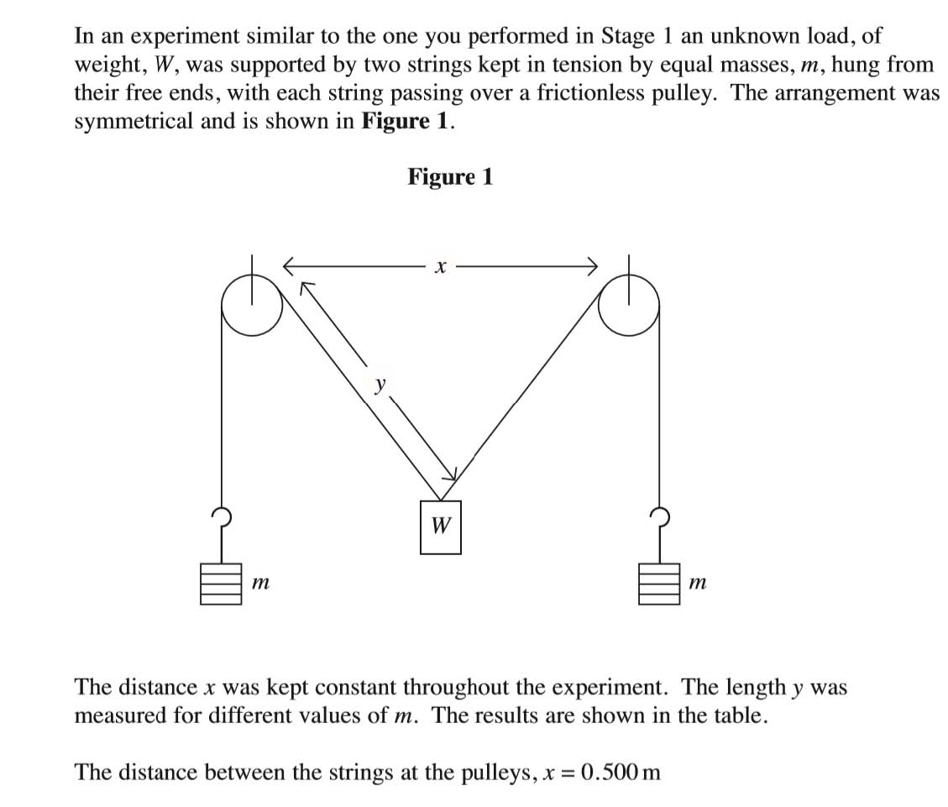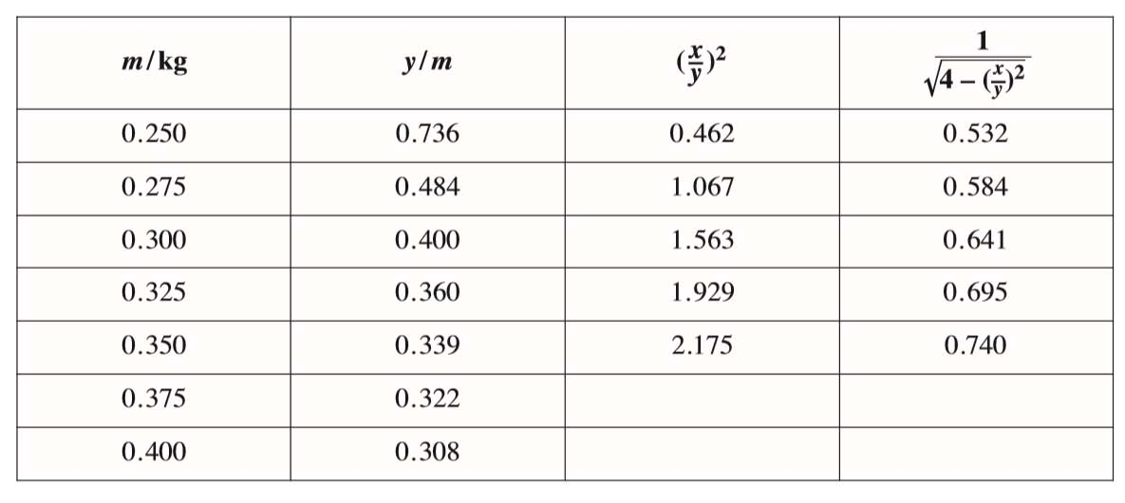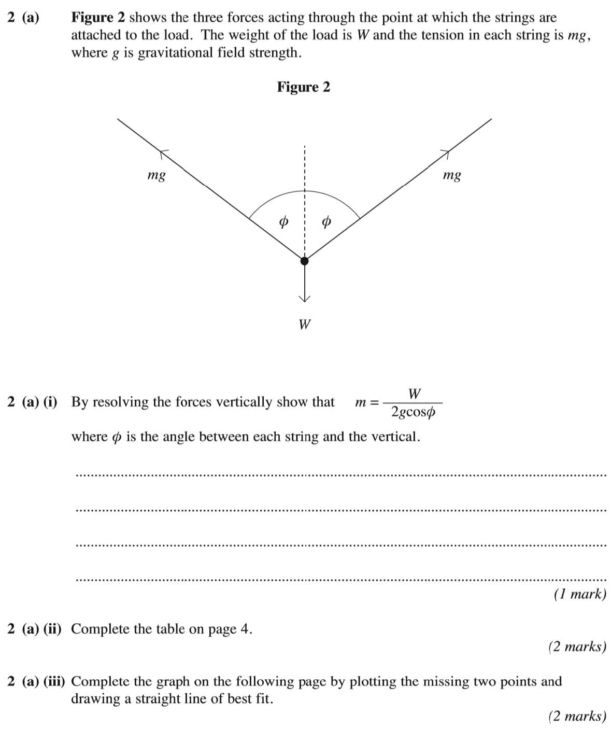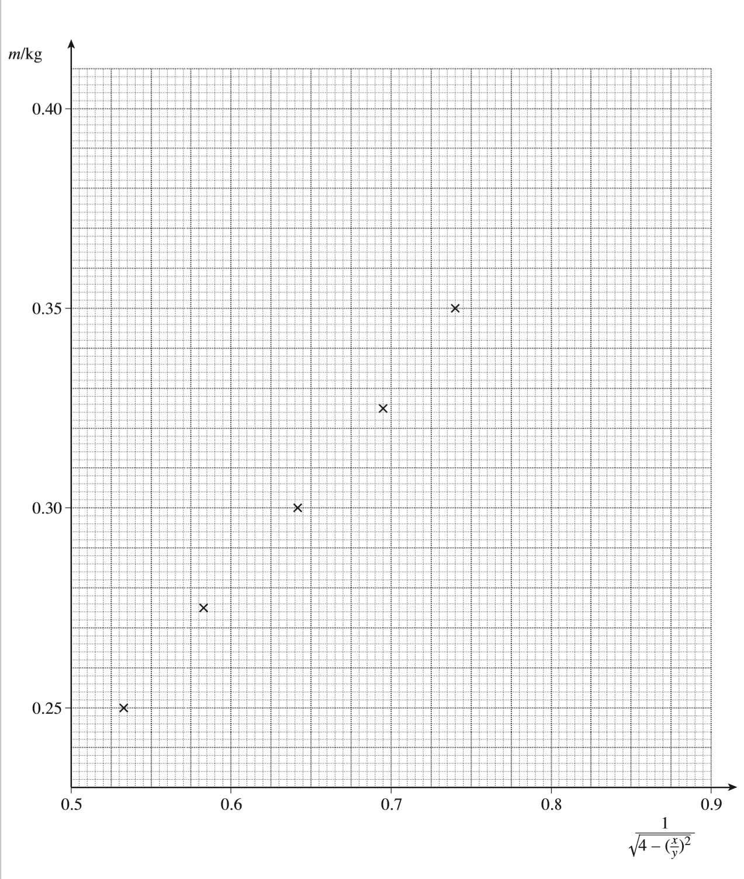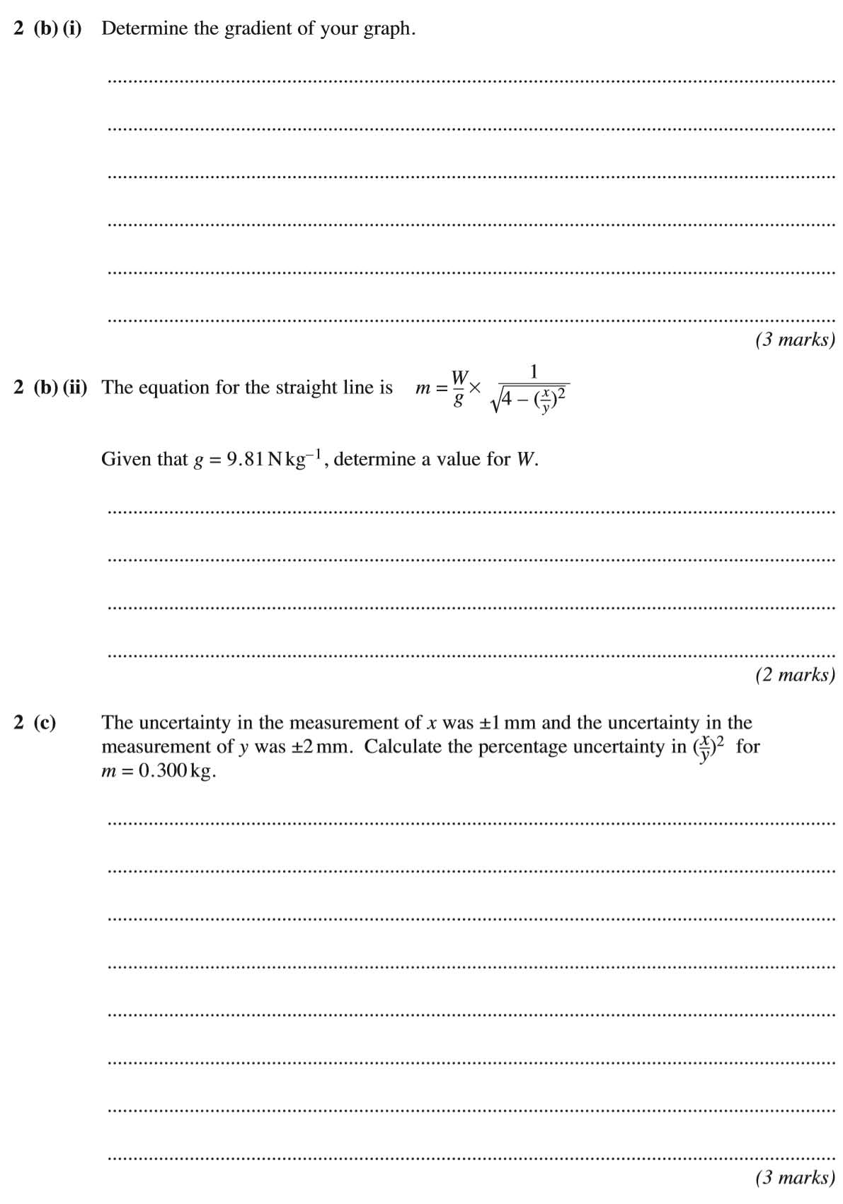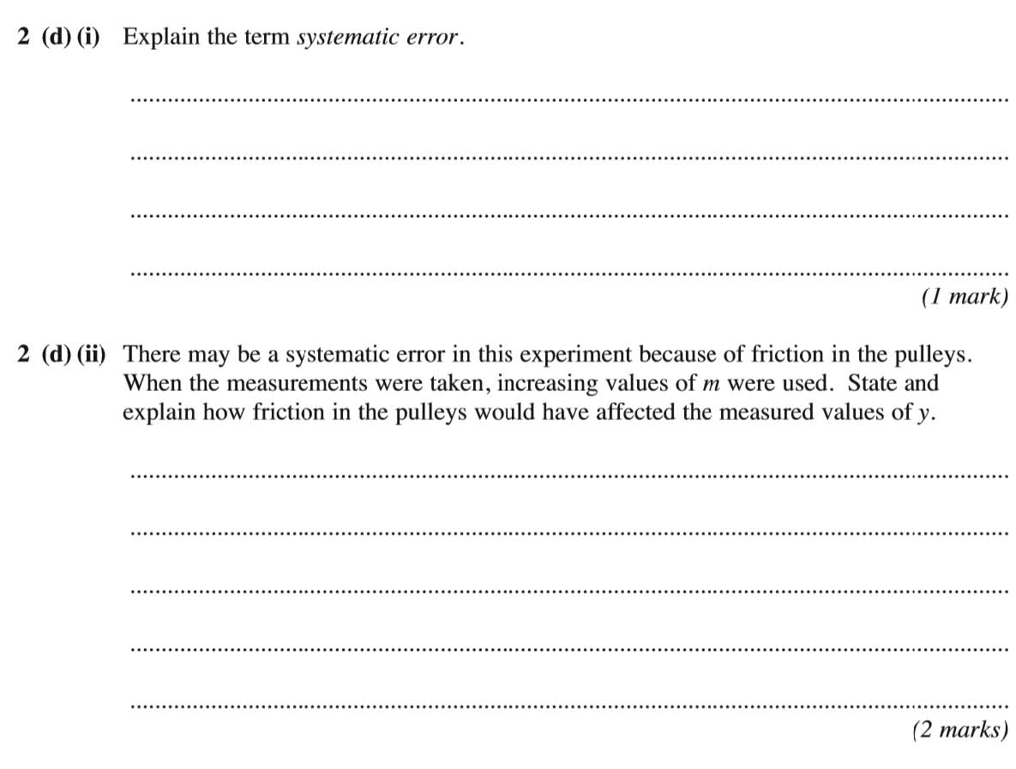
0.856
0.793
2.635
2.411
In equilibrium: Fm = W
$$m=\frac{W}{2gcosφ}$$
$$\frac{1}{m}=\frac{2gcosφ}{W}$$
$$W=2mgcosφ$$
$$Fm=mgcosφ+mgcosφ$$
Fm
(0.750, 0.352)
(0.565, 0.266)
x
x
$$0.7×2=1.4$$
$$0.2+0.5=0.7$$
$${\left(\frac{500±0.2\%}{400±0.5\%}\right)}^{2}={\left(1.25±0.7\%\right)}^{2}=1.563±1.4\%$$
$$\frac{1}{500}=0.002=0.2\%$$
$$x=500±1$$
$$\frac{2}{400}=0.005=0.5\%$$
$y=400±2$
$$W=\frac{2.943}{0.641}=4.591$$
$$W=\frac{0.300×9.81}{0.641}$$
$$0.300=\frac{W}{9.81}×0.641$$
$$M=\frac{86}{185}=0.465$$
$$M=\frac{0.086}{0.185}$$
$$M=\frac{0.352-0.266}{0.750-0.565}$$
Friction in the pulleys will have made Y values increasingly longer than they should have been as m increased. With more mass hanging from the pulleys, the bearings experienced more friction, meaning the pulleys gave increasing rotational resistance that did not allow the middle load to rise as much as it would have in a frictionless system, making y values increasingly longer than they should have been.
Systematic error is when measurements differ from their true value according to a trend or pattern, e.g. a group of length measurements are consistently 5mm shorter than the true length value because the measuring tool was incorrectly calibrated.

