

Databases and Application Development
(ACCA5026)

Component 1
Report Documentation

Name: David Nyadu Larbi
Student ID: 2407275
Course: BSc (Honours) Applied Computing

Table of Contents

Introduction 3
Database Design - Entity Relationship Diagram 3
Database Implementation 4
Data Definition Language (DDL) 7
Data Manipulation Language (DML) 9
Stored Procedure 11
Triggers 11
Indexing 12
Performance Tuning 12
Conclusions and Reflection 12
References 12

Introduction
MedAssist Clinic, a healthcare provider in the UK, aims to modernize its operations by developing a centralized relational database. This system will manage patient records, doctor details, departments, appointments, treatments, and feedback, supporting efficient, secure, and consistent data handling. The design emphasizes normalization to reduce redundancy, maintain data integrity, and optimize query performance. The following report details the database schema, normalization process, sample data, stored procedures, triggers, and indexing strategies.

Database Design - Entity Relationship Diagram
An Entity Relationship Diagram (ERD) is a basic modelling tool employed in the analysis and design of organized information systems, especially within business environments. It consists of identifying entities and their connections, serving as the conceptual basis for creating databases and developing systems.[1].

In this project, the core entities include Patients, Doctors, Departments, Appointments, Treatments, and Feedback. The relationships among these entities are designed to support the clinic's operations such as scheduling, treatment documentation, and feedback collection.
Entity Descriptions

The Patient entity maintains personal and health-related information, while the Doctor entity contains professional details linked to a specific department. The Department entity represents various medical specialties, and the Appointment entity records scheduled consultations between patients and healthcare providers. The Treatment entity documents diagnoses and prescribed therapies, and the Feedback entity collects patient reviews regarding their experiences.

Bellow is the Entity Relationship Diagram

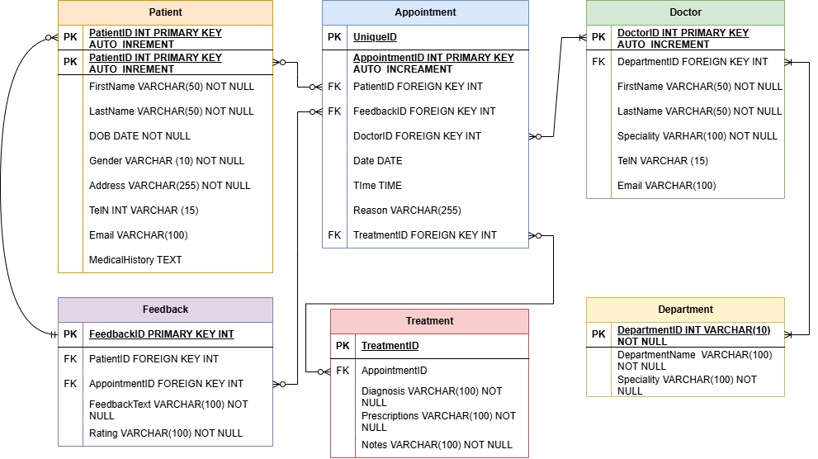

Figure 1 Image of the Entity Relationship Diagram

Database Implementation

Database implementation involves development, and deployment of a database system that efficiently manages data storage, retrieval, and manipulation to fulfil the requirements of a specific request[2].
This can be achieved using data manipulation software such as Structured Query Language (SQL), which is a standard language for managing and manipulating relational databases. Additionally, NoSQL databases like MongoDB (which stands for "Not Only SQL"), Cassandra, and CouchDB provide flexible, schema less data storage solutions that are well-suited for handling large-scale and unstructured data. NewSQL databases, such as VoltDB (a high-performance in-memory database) and NuoDB, combine the scalability of NoSQL systems with traditional SQL features.
Graph databases like Neo4j (which stands for "Graph Database" for managing highly connected data) and Amazon Neptune are optimized for handling interconnected data and complex relationships efficiently. In this project, Structured Query Language(SQL) software it used.

SQL commands are employed to implement the Entity Relationship Diagram (ERD) outlined above, typically involving a series of instructions to establish the necessary database structure. This process includes defining tables that correspond to each entity identified in the Entity Relationship Diagram, ensuring that each table accurately represents the data attributes and characteristics of the respective entity.

Additionally, relationships between entities are established by setting primary keys within each table, which uniquely identify individual records. These primary keys are then referenced as foreign keys in related tables to enforce referential integrity and accurately model the associations depicted in the ERD. This methodology ensures that, the database structure aligns with the conceptual design, promoting efficient data management and maintaining data integrity.[3].

The images bellow from Fig.2 to Fig.7 displays all the SQL statements used to implement the Entity Relationship Diagram.

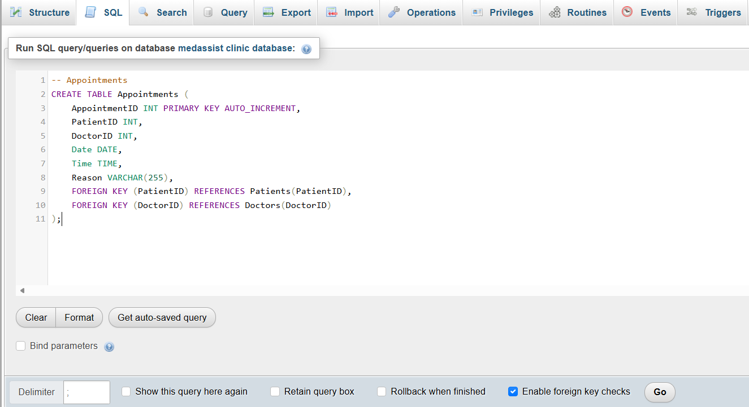

Figure 2 Implementation of appointment table and linking it to Patients and Doctors table

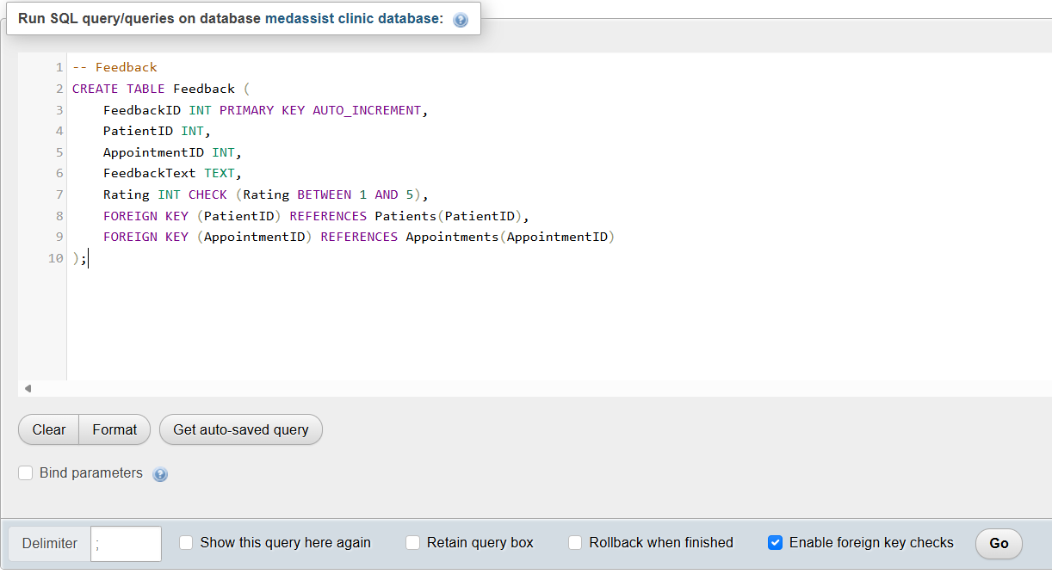
Figure 3 Implementation of feedback table linking it to patients and appointment table
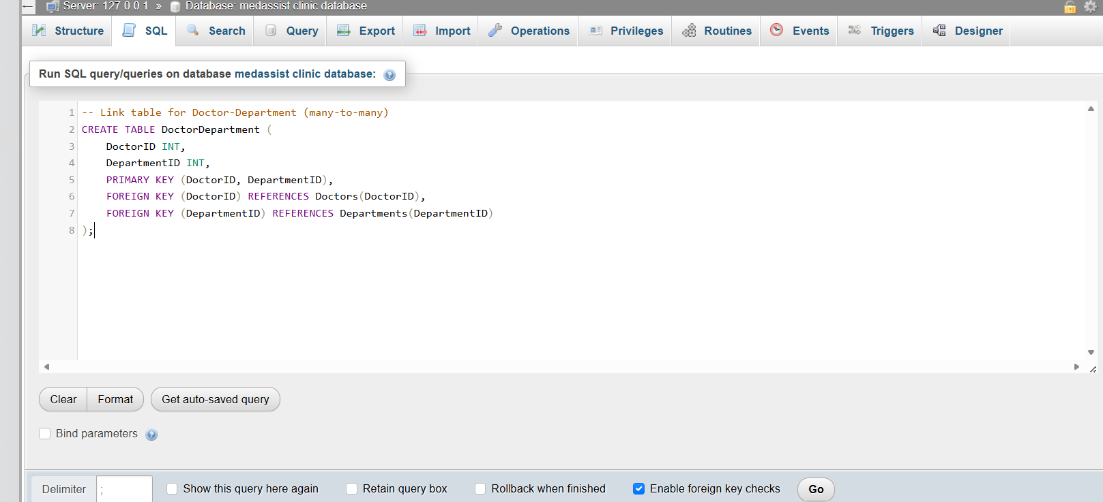

Figure 4 Implementation of department table linking it to doctors and department table

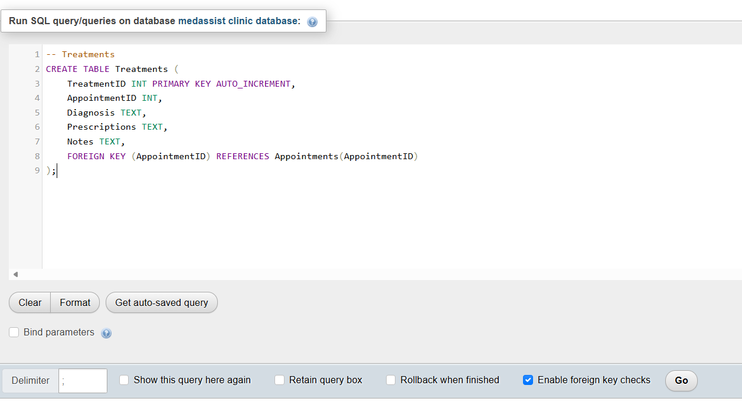
Figure 5 Implementation of Treatments table linking it to appointment table
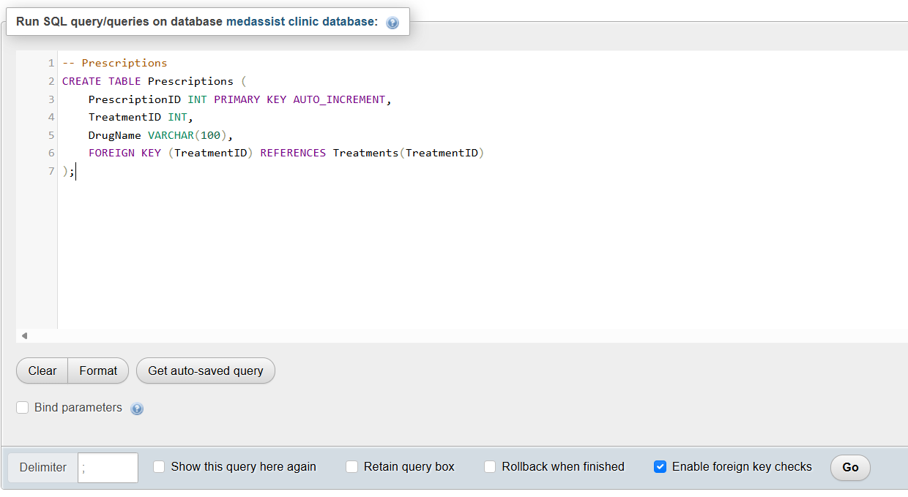
Figure 6 Implementation of Prescriptions table
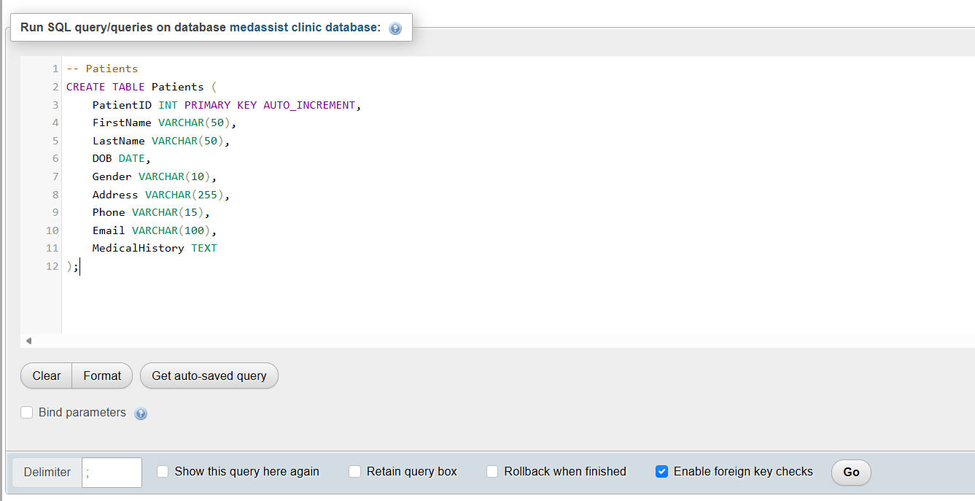
Figure 7 Implementation of the Patients table

Data Definition Language (DDL)

Data Definition Language (DDL) is used for defining and managing database schemas. It includes statements that enable the creation, modification, and deletion of database structures such as tables and schemas. Data Definition Language (DDL) is essential for establishing the internal schema of a database, specifying how data is organized and stored[4].
Bellow are all the Data Definition Language (DDL) scripts used to create the tables that represent the Entity Relationship Diagram (ERD).

-- Departments
CREATE TABLE Departments (
DepartmentID INT PRIMARY KEY AUTO_INCREMENT,
DepartmentName VARCHAR(100),
Specialty VARCHAR(100)
);

-- Doctors
CREATE TABLE Doctors (
DoctorID INT PRIMARY KEY AUTO_INCREMENT,
FirstName VARCHAR(50),
LastName VARCHAR(50),
Phone VARCHAR(15),
Email VARCHAR(100)
);

-- Link table for Doctors and Departments (Many-to-Many)
CREATE TABLE DoctorDepartment (
DoctorID INT,
DepartmentID INT,
PRIMARY KEY (DoctorID, DepartmentID),
FOREIGN KEY (DoctorID) REFERENCES Doctors(DoctorID),
FOREIGN KEY (DepartmentID) REFERENCES Departments(DepartmentID)
);
CREATE TABLE Patients (
PatientID INT PRIMARY KEY AUTO_INCREMENT,
FirstName VARCHAR(50),
LastName VARCHAR(50),
DOB DATE,
Gender VARCHAR(10),
Address VARCHAR(255),
Phone VARCHAR(15),
Email VARCHAR(100),
MedicalHistory TEXT
);

CREATE TABLE Appointments (
AppointmentID INT PRIMARY KEY AUTO_INCREMENT,
PatientID INT,
DoctorID INT,
Date DATE,
Time TIME,
Reason VARCHAR(255),
FOREIGN KEY (PatientID) REFERENCES Patients(PatientID),
FOREIGN KEY (DoctorID) REFERENCES Doctors(DoctorID)
);

CREATE TABLE Treatments (
TreatmentID INT PRIMARY KEY AUTO_INCREMENT,
AppointmentID INT,
Diagnosis TEXT,
Prescriptions TEXT,
Notes TEXT,
FOREIGN KEY (AppointmentID) REFERENCES Appointments(AppointmentID)
);

CREATE TABLE Prescriptions (
PrescriptionID INT PRIMARY KEY AUTO_INCREMENT,
TreatmentID INT,
DrugName VARCHAR(100),
FOREIGN KEY (TreatmentID) REFERENCES Treatments(TreatmentID)
);

CREATE TABLE Feedback (
FeedbackID INT PRIMARY KEY AUTO_INCREMENT,
PatientID INT,
AppointmentID INT,
FeedbackText TEXT,
Rating INT CHECK (Rating BETWEEN 1 AND 5),
FOREIGN KEY (PatientID) REFERENCES Patients(PatientID),
FOREIGN KEY (AppointmentID) REFERENCES Appointments(AppointmentID)
);

Data Manipulation Language (DML)

Data Manipulation Language (DML) consists of a subset of SQL commands designed to handle and modify data in database tables. It mainly involves actions like fetching, adding, deleting, and updating data. These functions enable users to insert new records, change existing data directly without moving data over the network, and delete data that is no longer required[5].
Below are the Data Manipulation Language (DML) used in this project to manipulate date.

INSERT INTO Departments (DepartmentName, Specialty) VALUES
('General Medicine', 'General Physician'),
('Dermatology', 'Dermatologist'),
('Pediatrics', 'Pediatrician'),
('Cardiology', 'Cardiologist'),
('Neurology', 'Neurologist'),
('Orthopedics', 'Orthopedic Surgeon'),
('Ophthalmology', 'Ophthalmologist'),
('Gynecology', 'Gynecologist'),
('Psychiatry', 'Psychiatrist');

INSERT INTO Doctors (FirstName, LastName, Phone, Email) VALUES
('John', 'Doe', '1111111111', 'john.doe@gmail.com'),
('Jane', 'Smith', '2222222222', 'jane.smith@hotmail.com'),
('Emily', 'Johnson', '3333333333', 'emily.johnson@hotmail.com'),
('Michael', 'Brown', '4444444444', 'michael.brown@gmail.com.com'),
('Sarah', 'Davis', '5555555555', 'sarah.davis@hotmail.com'),
('William', 'Miller', '6666666666', 'william.miller@gmail.com'),
('Olivia', 'Wilson', '7777777777', 'olivia.wilson@hotmail.com'),
('Liam', 'Moore', '8888888888', 'liam.moore@gmail.com.com'),
('Ava', 'Taylor', '9999999999', 'ava.taylor@gmail.com');

INSERT INTO DoctorDepartment (DoctorID, DepartmentID) VALUES
(1, 1), -- John Doe -> General Medicine
(2, 2), -- Jane Smith -> Dermatology
(3, 3), -- Emily Johnson -> Pediatrics
(4, 4), -- Michael Brown -> Cardiology
(5, 5), -- Sarah Davis -> Neurology
(6, 6), -- William Miller -> Orthopedics
(7, 7), -- Olivia Wilson -> Ophthalmology
(8, 8), -- Liam Moore -> Gynecology
(9, 9); -- Ava Taylor -> Psychiatry

INSERT INTO Patients (FirstName, LastName, DOB, Gender, Address, Phone, Email, MedicalHistory) VALUES
('Alice', 'Smith', '1985-02-20', 'Female', '123 Elm St', '1010101010', 'alice.smith@gmail.co.uk', 'No allergies'),
('Bob', 'Johnson', '1978-11-05', 'Male', '456 Oak St', '1020202020', 'bob.johnson@gmail.co.uk', 'Diabetic'),
('Carol', 'Williams', '1992-07-12', 'Female', '789 Pine St', '1030303030', 'carol.williams@gmail.co.uk', 'Asthma'),
('David', 'Brown', '1980-03-30', 'Male', '321 Maple St', '1040404040', 'david.brown@example.com', 'Hypertension'),
('Eva', 'Davis', '1995-09-17', 'Female', '654 Spruce St', '1050505050', 'No significant history'),
('Frank', 'Miller', '1965-01-25', 'Male', '987 Birch St', '1060606060', 'Heart condition'),
('Grace', 'Wilson', '1990-04-22', 'Female', '159 Cedar St', '1070707070', 'Allergic to penicillin'),
('Henry', 'Moore', '1975-12-15', 'Male', '753 Walnut St', '1080808080', 'Cholesterol issues'),
('Isabella', 'Taylor', '1988-06-09', 'Female', '852 Cherry St', '1090909090', 'Pregnant'),
('Jack', 'Anderson', '1993-08-30', 'Male', '951 Poplar St', '1101010101', 'No known issues');

INSERT INTO Appointments (PatientID, DoctorID, Date, Time, Reason) VALUES
(1, 1, '2024-07-01', '09:00', 'Routine check-up'),
(2, 2, '2024-07-02', '10:30', 'Skin rash'),
(3, 3, '2024-07-03', '11:00', 'Child vaccination'),
(4, 4, '2024-07-04', '14:00', 'Heart issue follow-up'),
(5, 5, '2024-07-05', '15:30', 'Migraine consultation'),
(6, 6, '2024-07-06', '09:00', 'Knee pain'),
(7, 7, '2024-07-07', '10:15', 'Vision test'),
(8, 8, '2024-07-08', '11:45', 'Pregnancy check'),
(9, 9, '2024-07-09', '13:00', 'Mental health assessment');

INSERT INTO Treatments (AppointmentID, Diagnosis, Prescriptions, Notes) VALUES
(1, 'Healthy', NULL, 'No treatment needed'),
(2, 'Dermatitis', NULL, 'Prescribed topical ointment'),
(3, 'Normal', NULL, 'Routine vaccination'),
(4, 'Hypertension', NULL, 'Prescribed medication'),
(5, 'Migraine', NULL, 'Prescribed painkillers'),
(6, 'Knee ligament strain', NULL, 'Rest and physiotherapy'),
(7, 'Refractive error', NULL, 'Eyeglasses prescribed'),
(8, 'Pregnancy', NULL, 'Regular prenatal checkups'),
(9, 'Anxiety', NULL, 'Counseling recommended');

Stored Procedure
Stored procedures in SQL are predefined routines saved within a database server that applications can call, usually in a client-server setup. They offer a comprehensive language for creating and executing SQL modules and routines, such as functions and procedures. These routines are organized into blocks, featuring local variables, condition handlers, and SQL commands, enabling modular, reusable code that runs directly within the database[6].

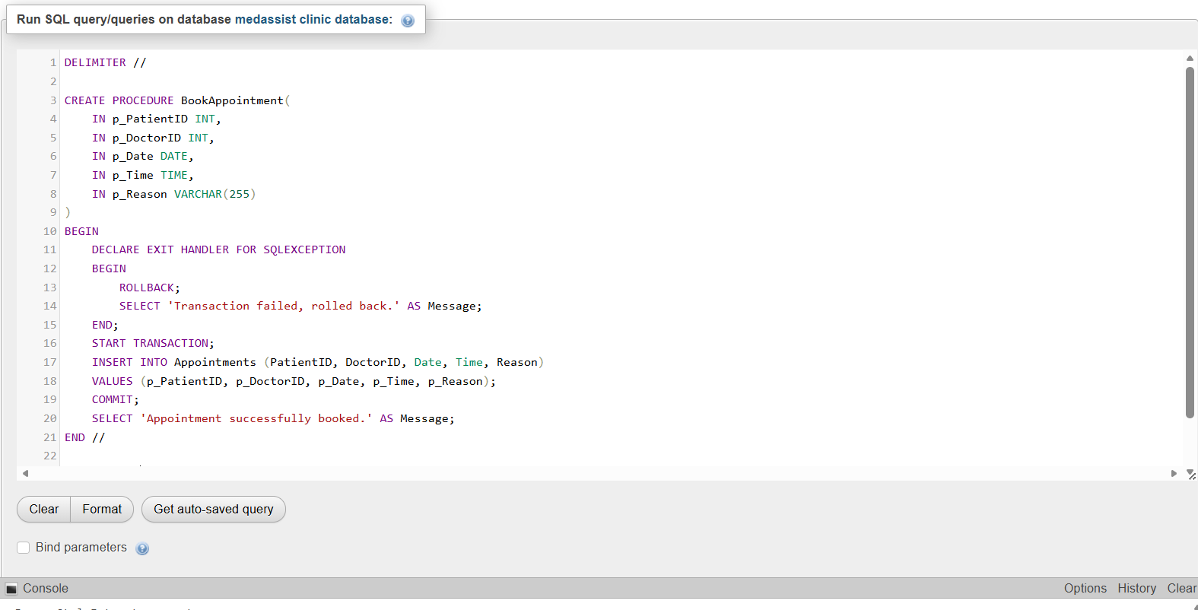
Figure 8 Implementation of procedures in SQL
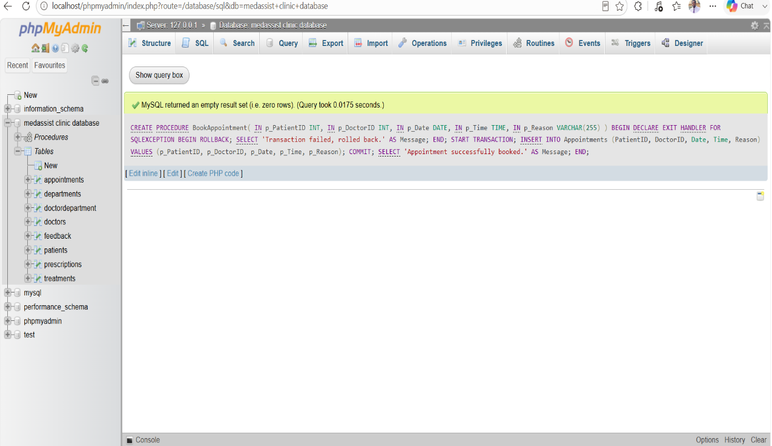
Figure 9 Prove of implementation of procedures in phpMyAdmin
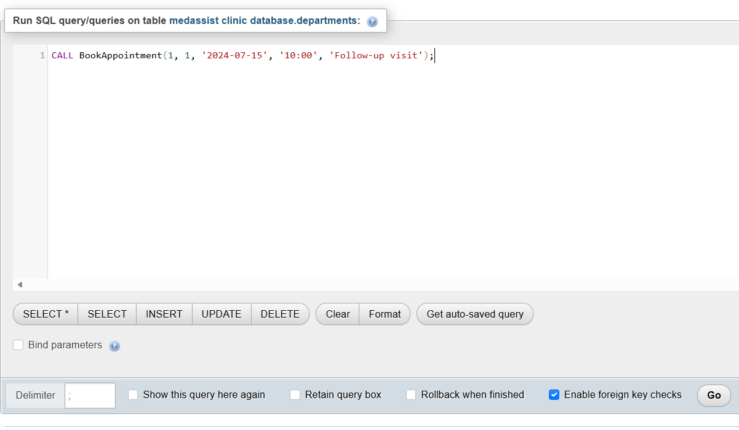
Figure 10 Using data manipulation language 'CALL' for BookAppointment table

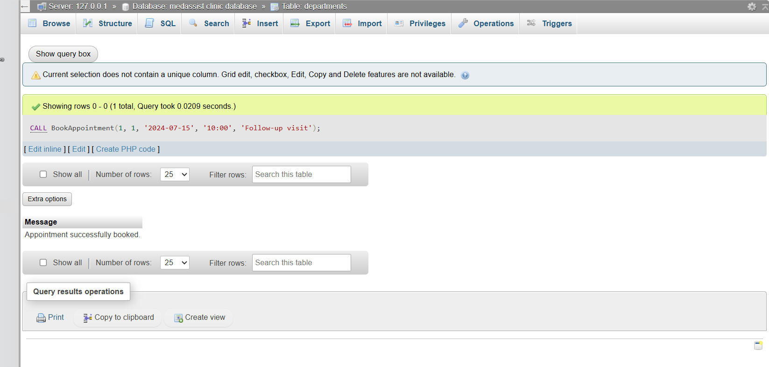
Figure 11 The result of the CALL command used

Bellow is a procedure language used for BookAppointment. The ‘BookAppointment’ stored procedure automates the process of scheduling a new appointment in a healthcare database. It takes the patient's ID, doctor's ID, appointment date, time, and the reason for the visit as input parameters.
The procedure starts a transaction to ensure data integrity, then inserts a new record into the ‘Appointments’ table with the provided details. If any SQL error occurs during this process, an exception handler rolls back the transaction and returns a message indicating that the transaction failed and was reversed. If the insertion is successful, the transaction is committed, and a confirmation message is returned, indicating that the appointment was successfully booked. This approach ensures that appointments are added reliably and errors are handled gracefully to maintain the consistency of the database.

DELIMITER //

CREATE PROCEDURE BookAppointment(
IN p_PatientID INT,
IN p_DoctorID INT,
IN p_Date DATE,
IN p_Time TIME,
IN p_Reason VARCHAR(255)
)
BEGIN
DECLARE EXIT HANDLER FOR SQLEXCEPTION
BEGIN
ROLLBACK;
SELECT 'Transaction failed, rolled back.' AS Message;
END;
START TRANSACTION;
INSERT INTO Appointments (PatientID, DoctorID, Date, Time, Reason)
VALUES (p_PatientID, p_DoctorID, p_Date, p_Time, p_Reason);
COMMIT;
SELECT 'Appointment successfully booked.' AS Message;
END //

DELIMITER ;

Triggers
Triggers in databases are tools that facilitate automatic, real-time processing by executing predefined actions whenever certain events occur within the database system. They work on an event-condition-action model, meaning an event activates the trigger, the condition is evaluated, and if it is true, a specific action is carried out. These events usually involve modifications to the database, such as inserting, updating, or deleting data, but can also include calling procedures or responding to system-generated events like clock signals[7].

The code below defines two main parts, a table and a trigger, used for auditing changes in a database.First, it creates an ‘AuditLog’ table designed to record details about specific operations. The table includes columns such as ‘LogID’, which uniquely identifies each log entry and auto-increments with each new record; ‘TableName’, indicating the name of the table where the change occurred; ‘OperationType’, specifying the type of operation (such as UPDATE); ‘ChangedBy’, capturing the user who made the change; ‘ChangeTime’, timestamping when the change happened, defaulting to the current time; and ‘OldData’ and ‘NewData’, storing the previous and updated data respectively in text format.

Next, the code sets up a trigger named ‘trg_Patients_AfterUpdate’ that activates after any update operation on the ‘Patients’ table. For each row updated, the trigger executes and inserts a new record into the ‘AuditLog’ table. This record logs the table name (‘Patients’), the operation type (‘UPDATE’), the user who performed the change (‘USER()’), and concatenates relevant data from the old and new states of the record specifically, the patient ID and name before and after the update. This mechanism helps track and audit changes made to patient records, providing a history of modifications for accountability and review.

CREATE TABLE AuditLog (
LogID INT PRIMARY KEY AUTO_INCREMENT,
TableName VARCHAR(50),
OperationType VARCHAR(10),
ChangedBy VARCHAR(50),
ChangeTime TIMESTAMP DEFAULT CURRENT_TIMESTAMP,
OldData TEXT,
NewData TEXT
);

DELIMITER //

CREATE TRIGGER trg_Patients_AfterUpdate
AFTER UPDATE ON Patients
FOR EACH ROW
BEGIN
INSERT INTO AuditLog (TableName, OperationType, ChangedBy, OldData, NewData)
VALUES (
'Patients',
'UPDATE',
USER(),
CONCAT('PatientID: ', OLD.PatientID, ', Name: ', OLD.FirstName, ' ', OLD.LastName),
CONCAT('PatientID: ', NEW.PatientID, ', Name: ', NEW.FirstName, ' ', NEW.LastName)
);
END //

DELIMITER ;

Indexing
Indexing in databases is a technique used to enhance query performance by creating efficient routes to access data. It involves arranging data in a structured manner that speeds up data retrieval, particularly when handling large datasets. Without effective indexing, even basic queries can become significantly slower as the amount of data increases[3].

CREATE INDEX idx_Patient_LastName ON Patients(LastName);
CREATE INDEX idx_Doctor_Department ON DoctorDepartment(DepartmentID);
CREATE INDEX idx_Appointments_Date ON Appointments(Date);

Performance Tuning
Performance tuning in SQL databases involves enhancing the efficiency and speed of SQL queries and overall database functions to sustain or boost system performance as the database expands. It encompasses multiple techniques focused on optimizing query design and how the database engine executes them, which helps minimize resource usage like CPU and I/O operations[1].
Example instead of doing this
INSERT INTO Departments (DepartmentName, Specialty) VALUES ('General Medicine', 'General Physician');
INSERT INTO Departments (DepartmentName, Specialty) VALUES ('Dermatology', 'Dermatologist');

This done in this project to increase the speed and accuracy.
INSERT INTO Departments (DepartmentName, Specialty) VALUES
('General Medicine', 'General Physician'),
('Dermatology', 'Dermatologist');

Conclusions and Reflection

Conclusion

This project successfully demonstrates the design, implementation, and optimization of a centralized relational database for MedAssist Clinic, a healthcare provider. By carefully developing an Entity Relationship Diagram (ERD), translating it into an efficient database schema, and employing best practices such as normalization, indexing, stored procedures, and triggers, the system ensures data integrity, security, and improved performance.

The process of normalization minimized redundancy and maintained data consistency across entities like Patients, Doctors, Departments, and Appointments. The use of SQL scripts for creating tables, relationships, and constraints provided a solid foundation for reliable data management. Implementing stored procedures, such as the appointment booking routine, enhanced transactional integrity and streamlined operational workflows. Additionally, the use of triggers for auditing changes increased accountability and facilitated tracking modifications, which is crucial in healthcare environments.

Performance optimization techniques, including indexing and query tuning, played a vital role in ensuring the system remains responsive as data volume grows. These strategies collectively contribute to a scalable, secure, and maintainable database system that can support the clinic’s operational needs effectively.

Reflection

Undertaking this project has deepened my understanding of database design principles, especially the importance of normalization, referential integrity, and indexing in building efficient systems. I have gained practical experience in translating conceptual ERDs into real SQL code, managing complex relationships, and implementing advanced features like stored procedures and triggers.

This hands on experience highlighted the significance of performance tuning and data security in real-world applications, especially in sensitive sectors like healthcare. Moving forward, I recognize the importance of continuous monitoring and optimization to adapt to evolving data needs and ensure system robustness. Overall, this project has enhanced my technical skills and appreciation for the critical role databases play in supporting organizational operations and decision-making.

References
[1] Anon. “,” , 2014. https://doi.org/10.21512/comtech.v5i1.2577
[2] Anon. “,” 1, 2007. https://doi.org/10.1561/1900000002
[3] Anon. “,” , 2025. https://doi.org/10.48550/arxiv.2510.16388
[4] Anon. “,” , 41–86). John Wiley & Sons, 2023. https://doi.org/10.1002/9781394277094.ch3
[5] Anon. “,” , n.d..
[6] Anon. “,” , 1995. https://doi.org/10.1145/211990.212024
[7] Anon. “,” , 2011.

