

BMHP5014 Changemakers; Creativity and value creation

Assignment Tittle;
Component -1 Online Portfolio of set Exercises

Student Name; Duwage Varuni Perera

Student Number; 240713

Tutors Details; Parese Ahmed

Task 1 – Concept Map
Create a concept map that outlines the relationship between creativity, value creation, and health and social care improvement. Within the concept map explain how these concepts interact in a health and social care context (250 words).

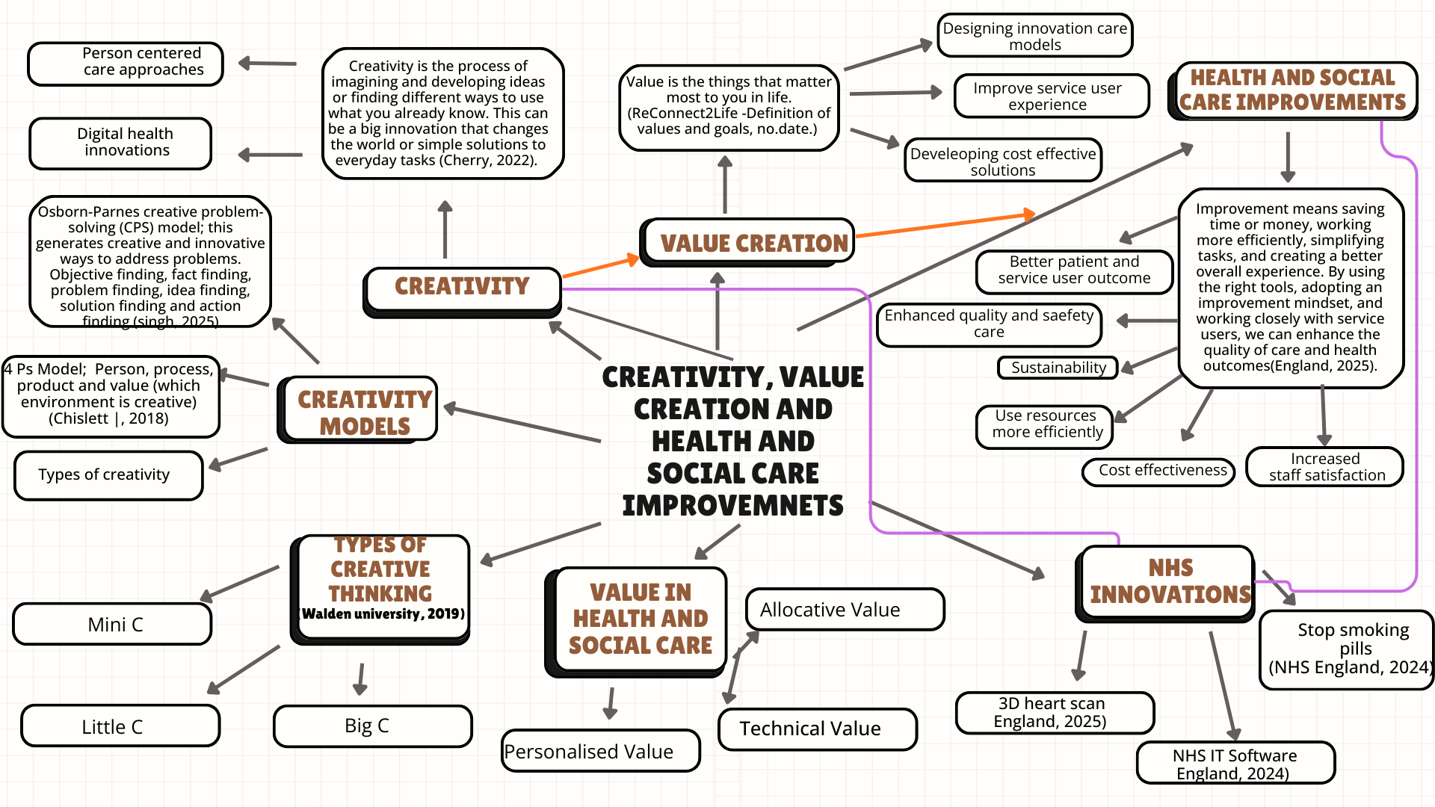

Task 2 - Self-Reflection of Group Activity
Complete a self-Reflection on the Convergent/Divergent paperclip thinking class activity using a reflective model (250 words, 1 source)
Self – Reflection using a Gibbs Model (McLeod, 2025)
Description
During a learning activity on convergent and divergent thinking activities, the lecturer divided students into groups of three to four. Each group received paper clips and generated many possible uses through divergent thinking. Our group created over 15 ideas. Following this, we applied convergent thinking to evaluate and narrow down our options. Ultimately, selecting the use of a paper clip to tie back straps as the best option (Team Asana, 2025).
Feeling
At the beginning of the activity, I felt confident because I already knew several practical uses of paper clips. This encouraged me to share my ideas with the group. I enjoyed learning how one object could have many functions. However, choosing only one idea was challenging, as many were creative. Despite this, agreeing on a final option as a group was a positive and rewarding experience.
Evaluating
Overall, the activity was effective in promoting creativity, teamwork, and communication. The positive part of the activity was that there were no limits during brainstorming, which encouraged everyone to contribute without restriction. Presenting our final idea to the class also helped improve my confidence and public speaking skills. One limitation was the difficulty in evaluating ideas, as some were creative but impractical or unsafe, such as using a paper clip as a toothpick.
Conclusion
This activity demonstrated that divergent and convergent thinking are most effective when used together. It also highlighted the importance of collaboration and critical evaluation in problem-solving.
Action plan
In the future, I will use divergent thinking to generate a variety of ideas before making decisions. After brainstorming, I will use convergent thinking to select the most appropriate and practical solution. I will also work on improving my communication and collaboration with group members.

Task 3 - Case Study of a UK innovation
Write a concise case study analysis of an innovative project or initiative within the NHS or UK social care. Focus on how creativity was used to drive change and the value it created for patients or service users (400 words, 2 sources
Case Study: NHS rolls out new multiple sclerosis jab that cuts hospital treatment time by 90% (NHS England, 2024).
The latest estimates show that over 150,000 people now live with multiple sclerosis in the UK, compared to around 130,000 in 2019 (Multiple Sclerosis Society UK, 2024) In 2024, NHS England introduced a 10-minute injection of ocrelizumab, replacing the traditional IV infusion that required hospital stays of up to four hours. The innovation addressed long treatment times, improving patient convenience, and reducing pressure on NHS staff and resources. Key stakeholders included MS patients, healthcare professionals, and NHS administrators.
Creativity played a key role in this innovation by encouraging the NHS to rethink how the treatment was provided rather than focusing only on developing new medicines. By thinking creatively, the NHS moved away from hospital-based IV infusion and developed a quicker and more patient-focused injection. The main creative approach was service redesign, supported by clinical evidence and patient feedback to improve existing practice. This transformed MS treatment from a lengthy hospital procedure into a quick and efficient service. This reduced treatment time manages staff workload while maintaining high-quality care.
This innovation uses creative approaches such as new technology, redesigned service, and collaborative partnerships. Firstly, new technology was used to create a version of Ocrelizumab that can be given as a quick injection instead of an IV infusion. Secondly, the NHS redesigned how MS care is delivered, moving from hospital treatment to a quicker and more patient-friendly approach. Finally working in partnership with NHS England, regulatory organisations NICE and Roche supported fast approval and use safely across the NHS. Together, these helped care for patients and made services more efficient.
Creativity creation from this innovation can be seen through both tangible and intangible benefits for patients and health care systems. Tangible benefits for patients include reducing treatment time, fewer hospital visits, and making care more convenient and accessible. Intangible benefits include higher patient satisfaction and reduced anxiety. This innovation improved MS care by replacing long hospital treatments with a quick ten-minute injection. For example, patients like Nin Sambi (in the case study) highlighted how shorter treatment makes it easier to manage childcare and family responsibilities. Clinical trials showed that the injection is just as effective as the IV treatment, meaning patients continue to receive high-quality care with a better experience. For example, 97% of patients had no relapses or any new brain changes over 48 weeks, which means care quality was maintained. This led to cost and efficiency benefits by freeing staff time and reducing service pressure.
Overall, the initiative improved the patient’s quality of life and made the health care system more effective.

Task 4 - Research Task
Identify a current issue in health and social care (e.g. e.g., mental health stigma, access to care for vulnerable populations). Find two pieces of academic research (journal articles) that explain the reason for this problem. Paraphrase the findings of each article (300 words, 2 sources).

Mental Health Crisis in Children and Young People
Introduction
Children and young people are experiencing increasing mental health problems such as anxiety, stress, and depression. Demand services exceed capacity, causing delays and leaving many young people without proper support.
King’s Fund article (Gilburt and Mallorie, 2024)
The King’s Fund highlights that mental health services for children and young people cannot keep up with rising demand. Although referrals have increased, fewer than half of the estimated 1.4 million children with mental health problems receive support from NHS-funded services, leaving many without appropriate care. This gap between need and service capacity results in long and uneven waiting times, with some children waiting months or even years, depending on where they live. Many children whose problems are too complex for early intervention but below the threshold for specialist NHS services miss out on support. Limited inpatient beds and a lack of suitable alternatives mean some children cannot access the care they need, sometimes ending up in inappropriate settings. In addition, services vary across regions, creating inequalities in access. These factors together show why the mental health system is struggling to meet the needs of children and young people, contributing to the ongoing crisis.

Care Before Crisis -Mind (Mind, 2019)
According to the Care Before Crisis report, the mental health services for children and young people in England cannot keep up with the growing demand. The report highlights that mental health difficulties are becoming more common in young people, rising from one in nine in 2017 to one in five now. The main reason for the crisis is that children cannot get mental health help quickly. By July 2025, over 500,000 referrals were waiting, many for over a year. Limited staff and strict rules mean many children do not get help until their problems become severe or not at all. The report highlights social and economic factors that harm young people’s mental health. Poverty, rising costs, bullying, racism, and pressure to perform well at school can all increase anxiety and low mood. The report notes that time spent on social media can affect young people’s mental health. This may lead to anxiety and stress because of cyberbullying and pressure to compare themselves to others.

Task 5 - Podcast
Record a two-minute Podcast introducing your idea for component 2 using https://www.rev.com/onlinevoicerecorder The MP3 audio must be downloaded and embedded as a file (see guidance video on how to do this here: https://www.youtube.com/watch?v=D21isId0agw) or an accessible OneDrive link if using a chromebook (make accessibility – anybody) before inserting into your portfolio. Check the accessibility of the link before submitting.

https://uowtsd-my.sharepoint.com/:u:/g/personal/2407132_student_uwtsd_ac_uk/IQAKvSh1k3bYS5vX3NyZ2z6rASJb8nfUM-MLsPaxhZRnejg?nav=eyJyZWZlcnJhbEluZm8iOnsicmVmZXJyYWxBcHAiOiJPbmVEcml2ZUZvckJ1c2luZXNzIiwicmVmZXJyYWxBcHBQbGF0Zm9ybSI6IldlYiIsInJlZmVycmFsTW9kZSI6InZpZXciLCJyZWZlcnJhbFZpZXciOiJNeUZpbGVzTGlua0NvcHkifX0&e=ojpHLB

my-recording (6).mp3

Task 6 - NHS Leadership Framework Analysis
Write a short summary (200 words) explaining the key components of the NHS Leadership Framework. Then, choose one component and describe (150 words) how a leader might use it to encourage creativity and improve care in the NHS (2 sources).
The NHS Leadership Framework outlines the key behaviors and qualities expected from leaders at all levels to ensure high-quality patient care. It emphasises that leadership is not confined to managerial roles; rather, all staff members share the responsibility for promoting learning, openness, and patient-focused care within the National Health Service. The framework highlights that leadership can be developed by staff at every level, enabling everyone to build their leadership skills regardless of their job role. Staff can develop leadership qualities through self-reflection, continuous learning, and participating in training and professional development programs provided by the NHS.

The leadership framework is structured around seven domains, each representing an important area of leadership practice. These are demonstrating personal qualities, working with others, managing services, improving services, setting direction, creating the vision, and delivering the strategy. Within each domain, there are four elements, and each element includes four descriptors. These descriptors explain leadership behaviours that staff should demonstrate. The framework shows how leadership behaviours develop from the individual level and extend to influence teams, organisations and the wider healthcare system (Leadership Academy Leadership Framework, no.date.).

Improving Services
One key component of the NHS Leadership Framework is Improving Services, which aims to continuously improve the quality, safety, and effectiveness of healthcare delivery. Leaders are expected to make a meaningful impact on patient care by maintaining high standards and identifying ways to improve healthcare services. To achieve this, leaders should focus on several key practices. First, they must ensure patient safety by creating systems and processes that reduce risks and protect patients. Additionally, leaders should critically evaluate services by reviewing performance, analysing data, and learning from feedback to identify areas needing improvement. Moreover, effective leaders promote improvement and innovation by encouraging staff to share new ideas and supporting creative solutions to healthcare challenges. They also facilitate organisational transformation by guiding teams through periods of change and helping organisations implement practices that enhance the quality and efficiency of care (Hardacre et al., 2010

.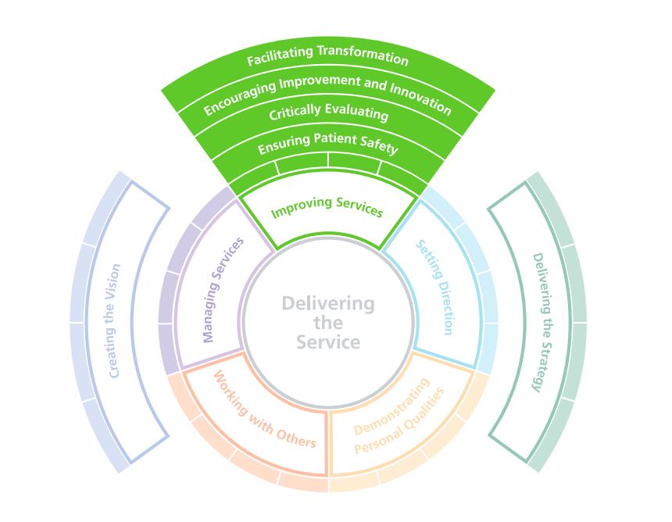

Task 7 - Self-Reflection Journal Entry
Write a short journal entry about what you learned in this module. Focus on how your understanding of creativity and value creation withing H&SC has changed and how it has informed your professional practice (200 words).
This module helped me understand how creativity can be applied in health and social care to create value. Before studying this module, I thought creativity was mainly related to art or design. However, I now realise that creativity plays a crucial role in improving services, solving problems, and supporting people’s well-being in health and social care settings. Throughout the module, I learned about the connection between creativity and well-being, examined various creativity models, and explored different thinking approaches, such as divergent and convergent thinking. These concepts enhanced my understanding of how new ideas are generated and refined into practical solutions. I also investigated innovation in the UK health and social care sector and how creative approaches can enhance patient care and service delivery. Another significant aspect of the module was learning about health campaigns, including their importance and the various types used to raise awareness and promote healthier lifestyles. I developed creative and ethical leadership skills and learned about the challenges that leaders may face in this sector. By participating in practical activities such as developing a podcast, creating a poster, and pitching innovative ideas, I improved my communication and presentation skills. Overall, this module deepened my understanding of the importance of creativity in fostering better professional practice and promoting positive developments in health and social care.

Reference List
Cherry, K. (2022). The Components and Psychological Study of Creativity. [online] Verywell Mind. Available at: https://www.verywellmind.com/what-is-creativity-p2-3986725. [Accessed 18 Jan. 2026].

Chislett |, D. (2018). The 4 Ps of Creativity • David Chislett Keynote Speaker. [online] David Chislett Keynote Speaker. Available at: https://davidchislett.com/the-4-ps-of-creativity/. [Accessed 15 Feb. 2026].

England, N. (2025). NHS England» What is improvement? [online] England.nhs.uk. Available at: https://www.england.nhs.uk/nhsimpact/what-is-improvement/ [Accessed 15 Jan. 2026].

England, N. (2025). NHS England» Futuristic 3D heart scans on NHS speed up diagnosis and save millions. [online] England.nhs.uk. Available at: https://www.england.nhs.uk/2025/05/futuristic-3d-heart-scans-speed-up-diagnosis-and-save-millions/ [Accessed 17 Jan. 2026].

NHS England (2024). NHS England» NHS Rolls out ‘stop-smoking’ Pill to Help Tens of Thousands Quit. [online] England.nhs.uk. Available at: https://www.england.nhs.uk/2024/11/nhs-rolls-out-stop-smoking-pill-to-help-tens-of-thousands-quit/. [Accessed 18 Jan. 2026].

England, N. (2024). NHS England» Millions of patients benefitting from improved care as new NHS IT software rolled out. [online] England.nhs.uk. Available at: https://www.england.nhs.uk/2024/11/millions-of-patients-benefitting-from-improved-care-as-new-nhs-it-software-rolled-out/. [Accessed 20 Jan. 2026].

England, N. (2024). NHS England» NHS rolls out new multiple sclerosis jab that cuts hospital treatment time by 90%. [online] England.nhs.uk. Available at: https://www.england.nhs.uk/2024/07/nhs-rolls-out-new-multiple-sclerosis-jab-that-cuts-hospital-treatment-time-by-ninety-per-cent/. [Accessed 13 Feb. 2026].

Gilburt, H. and Mallorie, S. (2024). Mental Health 360 | Children and Young People. [online] The King’s Fund. Available at: https://www.kingsfund.org.uk/insight-and-analysis/long-reads/mental-health-360-services-children-young-people. [Accessed 17 Feb. 2026].

Hardacre, J., Cragg, R., Flanagan, H., Spurgeon, P. and Shapiro, J. (2010). Exploring links between NHS leadership and improvement. International Journal of Leadership in Public Services, 6(3), pp.26–38. doi:https://doi.org/10.5042/ijlps.2010.0515. [Accessed 7 March. 2026].

Leadership Academy Leadership Framework. (n.d.). Available at: https://www.nwpgmd.nhs.uk/sites/default/files/NHSLeadership-Framework.pdf [Accessed 7 March. 2026].

McLeod, S. (2025). Gibbs Reflective Cycle. [online] Simply Psychology. Available at: https://www.simplypsychology.org/gibbs-reflective-cycle.html. [Accessed 10 Feb. 2026].

Mind.org.uk. (2019). Care Before Crisis: our report on young people’s mental health. [online] Available at: https://www.mind.org.uk/news-campaigns/campaigns/children-and-young-peoples-mental-health/care-before-crisis-our-report-on-young-peoples-mental-health/. [Accessed 17 Feb. 2026].

Multiple Sclerosis Society UK. (2024). Number of people living with MS in UK increases. [online] Available at: https://www.mssociety.org.uk/research/news/number-people-living-ms-uk-increases?utm_source=chatgpt.com. [Accessed 13 Feb. 2026].

ReConnect2Life -Definition of values and goals. (n.d.). Available at: https://www.torbayandsouthdevon.nhs.uk/uploads/definition-of-values-and-goals.pdf. [Accessed 18 Jan. 2026].

singh, K. (2025). 1. The Osborn Parnes Creative Problem. [online] Scribd. Available at: https://www.scribd.com/document/859428134/1-The-Osborn-Parnes-Creative-Problem. [Accessed 13 Feb. 2026].

Team Asana (2025). Convergent vs. Divergent Thinking: Finding the Right Balance • Asana. [online] Asana. Available at: https://asana.com/resources/convergent-vs-divergent. [Accessed 12 Feb. 2026].
Walden University (2019). The Four C Model of Creativity | Walden University. [online] Waldenu.edu. Available at: https://www.waldenu.edu/online-masters-programs/ms-in-education/resource/the-four-c-model-of-creativity. [Accessed 10 Feb. 2026].

‌

‌
‌

‌

‌
.

‌
‌

‌
‌

