
A Comparison of The Marketing Methods of Two Multinational Hotel Brands
Student Name: George Andrei Codrianu
ID: 2210052
Marketing Essentials
BMIH4005
Gayathri Senanayake Mudiyanselge


In the current highly competitive global hospitality sector, multinational hotel corporations implement a range of promotional methods to attract new customers and maintain strong relationships with their existing clientele. This allows multinational hotel corporations to stay ahead of the competition and retain strong relationships with their existing clientele. The purpose of this study is to analyse and compare the marketing approaches utilised by Premier Inn and Hilton Hotel Hotels, both of which are well-known hotel chains on an international scale. The purpose of this comparison is to ascertain which of the two firms has the marketing tactics that are more successful.
It is noteworthy that both Premier Inn and Hilton Hotel target different demographic subsets of customers, each of which has the ability to gain from the other's offerings of services due to the fact that both cater to the same market. This comparative analysis aims to shed light on the similarities and differences between the marketing strategies used by these two firms by comparing and contrasting such methods. During this study, various aspects will be taken into consideration, including promotional methods, brand positioning tactics, the choice of the target audience, and the efficacy of the marketing in its entirety (IHG, 2023).
During the course of the inquiry, a significant amount of focus and attention will be directed towards doing an analysis of the brand positioning methods utilised by both companies. The aforementioned component is essential due to the fact that it offers useful insight into the distinctive identity and perception that each hotel chain creates in the minds of customers, consequently affecting the decisions that customers make regarding their purchases (Inn, 2019).
The pillars of Premier Inn's marketing strategy are product, price, location, and promotion (sometimes known as the "PPPP" structure). The Premier Inn takes great pride in providing an exceptional level of service, which is demonstrated by the fact that its accommodations are of a high standard while remaining affordable. They have an advantage over their competitors thanks to their extensive availability in a number of easily accessible areas. In addition, they adopt an all-encompassing strategy to advertising, which is demonstrated by the fact that their website was just recently redesigned and that they make considerable use of social media and strategic collaborations.
Hilton Hotel, a global hospitality firm known for its remote resorts, uses a framework for its marketing activities that closely mimics the "PPPP" strategy: product, price, place, and promotion. This framework consists of product, price, and location, as well as promotion. Ray (2019) asserts that the focus of Hilton Hotel to provide high-quality products and services in private and luxury surroundings sets the company apart from its rivals (Ray, 2019).
Individuals who have achieved financial success, place high importance on ethics and sustainability, and are open to spending more money on their vacations are Hilton Hotel' ideal customers. Due to the fact that this is one of the key focuses of the organisation, each of the Hilton Hotel hotels is often situated in very visible places. Hilton Hotel increases consumer awareness of its brand and products by increasing its use of content marketing, social media, and strategic alliances (DePino, 2023).
The PESTEL framework is a useful tool for determining how vulnerable an organisation is to the dangers posed by the environment. Hotel Hilton Hotel gives preference to locations in nations that have stable governments, powerful economies, cutting-edge scientific advances, and pristine natural surroundings. The hotel not only complies with all necessary local, state, and federal requirements, but it also makes environmental consciousness, visitor safety, and economic opportunity its top priorities (Frue, 2019). This examination places primary emphasis on the political and economic stability of the Premier Inn, as well as on economic and social aspects, as well as technological and legal advancements (Peterdy, 2023).
The strengths and weaknesses of the scenario are taken into consideration in the SWOT analysis. The hotel provides a number of different features, such as luxury marketing, environmentally responsible operations, and customised treatment for each guest who stays there. According to Garg Kumar (2021) research, the absence of a well-known brand name may be to blame for the product's steep price tag (Garg & Kumar, 2021).
Opportunities can be found in both the rapidly expanding ecotourism market and the strong hotel industry competition currently taking place. Premier Inn has a reputation for not being lavish, and the quality of its lodgings can vary, but it makes up for this by having a vast number of locations and customer-loyalty programmes. Premier Inn has a large number of locations. It may be challenging to appeal to such a wide clientele due to the fluidity of customer tastes and the intense competition in the pricing sector (Unbound, 2023).
Two of the key methods that Hilton Hotel utilises to disseminate information regarding the company and its products are articles and social media (Ezee, 2022). Premier Inn, on the other hand, is working towards expanding its customer base by establishing new alliances and launching a brand-new website. These hotels have began delivering diversity, equality, and inclusion training to each and every one of their staff as a direct response to the racial justice movement and new safety laws. This tactic entails using contactless check-in as well as cleaning guests' rooms on a more regular basis (Balaji, et al., 2023).
In order to bring in tourists, both Hilton Hotel and Premier Inn rely heavily on a variety of means of advertising. Tourists make up the majority of their customer base. It is sourced from every conceivable region on the planet. This idea is illustrated in "Bowman's Strategy Clock", which can be found in that publication (TH, 2023).
Premier Inn appeals to individuals with more limited financial resources who place a premium on ease and accessibility in the lodging options they select, whereas Hilton Hotel appeals to those with more discretionary income who place a premium on privacy, grandeur, and the protection of the natural environment in which they are staying. On the other hand, Premier Inn is geared towards the wealthy, who are able to pay for the hotel chain's more opulent and environmentally conscious services. According to Bowman & Faulkner (2023), the marketing strategies that both businesses want to implement will involve segmentation, targeting, and positioning (Bowman & Faulkner, 2023).
We put the safety of our guests as our top priority and do everything in our power to ensure that they are satisfied with our services. The fight for racial justice is one example of how the challenges of the modern period spurred these shifts in society's attitudes and practices. Both Hilton Hotel and Premier Inn have suffered losses as a result of political challenges, which include the modification of rules and the fallout from international conflicts. In order for these hotels to keep up with the competition and maintain good service standards, they need to be able to adapt to political events, new regulations, and disruptions (AD, 2017).
When comparing the marketing techniques of Hilton Hotel and Premier Inn, it is important to keep in mind that each brand caters to a different demographic of consumers. Affluent people who have a desire for environmentally responsible luxury travel appear to make up the majority of Hilton Hotel' target market, as depicted in Figure 2 of the supplemental materials. The promotion of the company's eco-friendly and healthful products can be found on social media as well as through content marketing. On the other side, individuals who place a premium on cost-effectiveness without compromising on comfort or convenience will feel right at home at the Premier Inn. The company is developing a brand-new website and forming connections with online travel agents. These actions are being taken in an effort to attract more clients who are sensitive of their financial situations (Inn, 2023).
The two different hotel chains have each built their very unique one-of-a-kind brand promotion plans by drawing on the information acquired from their own individual SWOT analysis. By utilising a perceptual map (see Diagram 2 in the appendix), the study exhibits that Hilton Hotel has a powerful brand positioning in the eyes of its target market as a result of the one-of-a-kind and ecologically responsible services that it provides. The unique combination of benefits offered by Hilton Hotel sets it apart from other products in its category. In the not-too-distant future, the corporation plans to make use of this as a marketing tool. It positions itself as the superior choice that will be to the benefit of the globe and the people who live in it. Because of its convenient location and reasonable room prices, Premier Inn is the hotel of choice for a large number of tourists on a tight budget. The choice made by Hilton Hotel to establish this programme demonstrates the company's dedication to the implementation of environmentally friendly business practices (Hilton, 2023).
According to recent reports, customers have gotten more outspoken in recent years, which has led to businesses being forced to take sides in contentious debates. The way in which brands connect with their respective target audiences has been fundamentally altered by the advent of digital and social media marketing. Businesses now have the ability to engage in two-way dialogues with their customers by utilising social media platforms such as Facebook, Twitter, Instagram, and LinkedIn. The goal of these conversations is to convince potential customers to buy the items offered by the business (Inn, 2019).
It is imperative for Hilton Hotel to place a high priority on content marketing and social media in order to preserve its standing as a reputable and trustworthy service provider. If the company had stronger relationships to the leaders of the tourism sector, it is possible that the company's brand would have a higher domination in the market. It may be possible to improve the Premier Inn website by making its user interface more intuitive and by including additional visual depictions of the hotel's goods and services. Balaji et al. suggest that passengers who are interested in saving money get in touch with an online travel agency (Balaji, et al., 2023).
In conclusion, the digital marketing endeavours of the two organisations were successful because each company selected a different strategy to reach their separate primary client bases. This allowed the companies to effectively promote their products and services to their target audiences. This result was achieved in spite of the fact that numerous organisations employed a wide variety of approaches in order to accomplish this. In contrast to Hilton Hotel, Premier Inn has not made influencer marketing via social media and other channels a top priority in their marketing strategy. In each and every piece of marketing collateral that they produce, companies place a strong focus on their care for the environment and their commitment to the preservation of natural resources. According to the findings, Hilton Hotel ought to keep its advertising spend at its current level in order to both keep and increase the number of customers it serves. Either the company will seek substantial presence on trip registration platforms or it will develop agreements with airlines and travel suppliers as a means of expanding its business.

References
AD, 2017. 4 Ways Hotels Can Benefit from Social Media. [Online]
Available at: https://absolutdata.infogain.com/blog/4-ways-hotels-can-benefit-from-social-media/
Balaji, M. et al., 2023. Effectiveness of B2B social media marketing: The effect of message source and message content on social media engagement. Science Direct, pp. 243-257.
Bowman, C. & Faulkner, D., 2023. Bowman’s Strategic Clock: Give Your Product the Market Position it deserves. [Online]
Available at: https://bstrategyhub.com/bowmans-strategic-clock-give-your-product-the-market-position-it-deserves/
DePino, F., 2023. Social Media for Hotels – Top 6 Platforms for Your Hospitality Business. [Online]
Available at: https://mediaboom.com/news/social-media-for-hotels/
Ezee, 2022. 9 Excellent Hotel Social Media Marketing Strategies for 2023. [Online]
Available at: https://www.ezeeabsolute.com/blog/hotel-social-media-marketing/
Frue, K., 2019. PESTLE Analysis for Hotel Industry. [Online]
Available at: https://pestleanalysis.com/pestle-analysis-for-hotel-industry/
Garg, A. & Kumar, J., 2021. Social media marketing influence on Boutique Hotel customers’ purchase intention in Malaysia. [Online]
Available at: https://www.tmstudies.net/index.php/ectms/article/view/1502
Hilton, 2023. Where will you stay next? Choose from top destinations.. [Online]
Available at: https://www.hilton.com/en/?WT.mc_id=zINDA0EMEA1MB2PSH3GGL4INTCRB5dkt6MULTIBR7_121127646_1003528_p17961983772&ads_rl=7695469998&&gclid=Cj0KCQjw4bipBhCyARIsAFsieCyAPZleQBuMgSmM30HSGIt8yDb0luR4Hy8rVR6MtalvVYTMp0MaOKUaAoxmEALw_wcB&gclsrc=aw.ds
IHG, 2023. Always there with just what you need. [Online]
Available at: https://www.ihg.com/holidayinn/hotels/us/en/reservation
Inn, P., 2019. Buy the brand-new and exclusive. [Online]
Available at: https://www.premierinnbed.co.uk/
Inn, P., 2023. Time for a new adventure? Get started from one of our 800+ hotels. [Online]
Available at: https://www.premierinn.com/gb/en/home.html
Peterdy, K., 2023. PESTEL Analysis. [Online]
Available at: https://corporatefinanceinstitute.com/resources/management/pestel-analysis/
Ray, L., 2019. Google’s algorithm undergoes enormous shifts to prioritise content focused on expertise, authoritativeness and trustworthiness. Journal of Digital & Social Media Marketing, pp. pp. 128-136.
TH, 2023. Bowman Strategy Clock. [Online]
Available at: https://www.toolshero.com/strategy/bowman-strategy-clock/
Unbound, 2023. What Will Be The Impact of Social Media On B2B Marketing In 2023. [Online]
Available at: https://www.unboundb2b.com/blog/impact-of-social-media-on-b2b-marketing/

Appendix
- 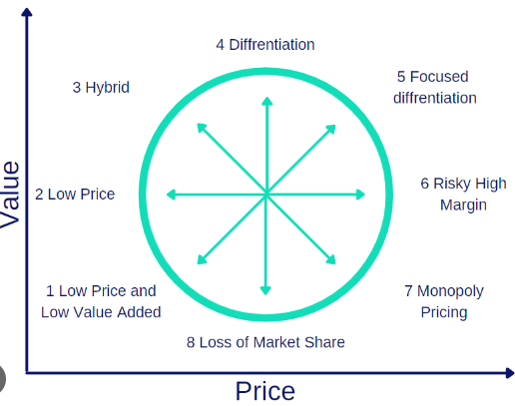
Premier Inn
Hilton Hotel
- 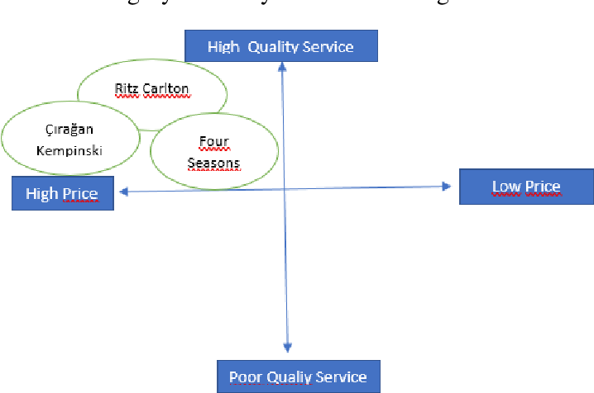
Premier Inn
Hilton Hotel
- 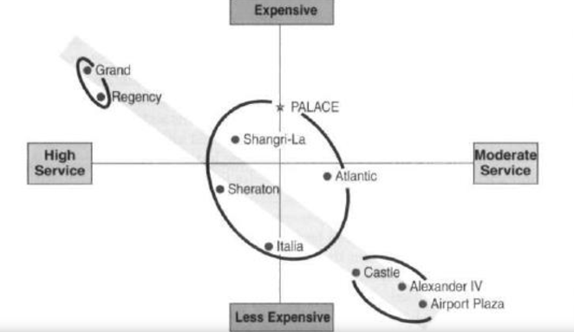
Premier Inn
Hilton Hotel
- 
 

