
MODULE NAME: DATA HANDLING & BUSINESS INTELLIGENCE

MODULE CODE: LCBB5000

TOPIC: WRITTEN REPORT EXPLAINING AT LEAST 5 CURRENT BUSINESS INTELLIGENCE TRENDS (1250words)

STUDENT: MARTINA CHORLOVA

STUDENT NUMBER: 2028046

LECTURER NAME: AMITAVE BANIK

DATE: 02/09/2022
TABLE OF CONTENTS

1. INTRODUCTION......................................................3|page

2. BUSINESS INTELLIGENCE TRENDS...........................3|page

2.1 DATA DISCOVERY….………………………………………………………………...3|page
2.2 AUGMENTED ANALYTIC.…………………………………….…………………...4|page
2.3 BUSINESS ACTIVITY MONITORING…………………………………………...4|page
2.4 CLOUD ANALYTICS……………………………………………………….………….5|page
2.5 DATA SECURITY……………………………………………………………………....6|page

3.CONCLUSION…………………………………………………….….7|page

- REFERENCES..........................................................8|page

- INTRODUCTION
Business Intelligence (BI) is a collection of processes, architecture, and technologies that run raw data into useful knowledge. Driving business behaviours to turn data into actionable knowledge it is a suite of tools and services (Sharda, Delen & Truban, 2018). Business Intelligence can be defined as a set of theories, methodologies, systems and technologies that support business decisions making with valuable data, information and knowledge (Llave,2018). Jin & Kim (2018) argue that the concept of Business Intelligence has been growing according to the applications and technologies, that support firm’s gather, store, analyse, and access data more effectively. From the definitions of the researchers, Business Intelligence is a goal for better decisions, faster and easier. In this research provide a comprehensive view of Business Intelligence, that is more than a technology, affects organisational culture, convert businesses to data-driven organisations and most notably enable organisation to create new innovative products and business models. Also, analysis of why Business Intelligence is so important and how plays its role in the real business. Business Intelligence applications have a broad range of industries from health care, marketing, accounting, sales, inventory departments, airlines to major IT and telecommunication firms.

- BUSINESS INTELLIGENCE TRENDS
Covid-19 has made long-term changes in the current practice of the organisations. In this fast-changing environment, business intelligence is the solution that respond of the needs in the modern organisations. Now the organisations need intelligent solutions that respond quickly in problem solving and decision-making process. There are two main reasons why Business Intelligence is becoming more and more considerable investment strategy for some enterprises, and organizations are investing huge amount of money in BI tools. Business Intelligence is the most important technical priority and increases the use of information. Another reason is that increasingly crucial role of data, BI clarify business information and create data-based action plans. BI direct the past and present patterns and trends, taking advantages of the information to make better decision to day-to-day business operations. Collect problems from organization or businesses, then answer and track, and determines which actions to take to reach their goals (Zhao,2021). People can create performance benchmarks, spot market trends, increase compliance, and improve business. For helping the unexpected changes, there are five main trends that lead and influence businesses at present, which are Data Discovery, Augmented Analytics, Business Activity Monitoring, Cloud Analytics and Data Security.

  - DATA DISCOVERY
Data Discovery is the process of collecting data from internal or external sources. Data discovery helps to business users to discover trends, patterns and clusters. The data must relate to wide range of sources, to be clean and shape for data sets. Data discovery has many applications, can enhance many aspects of business planning. Prospecting for new clients and understanding needs and interests of potential targets. Data discovery is ideally for fraud prevention, for both external threats, like phishing emails and internal issues with employee errors. Data discovery can be used to speed up the collection and processing of insurance claims data. Also, can help in social media analysis with spotting customer issues quickly or behavioural trends in real time before becoming bigger issues. Data discovery allows businesses to turn this intelligence into a competitive advantage, whether in better customer experiences or product innovation. After Covid-19 and increased volume of remote working, businesses adapted in the cloud where they share and storage files. The data is placed in different shared files, applications and data bases. The business must be sure there are appropriate controls and secure practices. To avoid any financial and reputational loss, the data should be protected with encryption, access control, cloud data security and data loss prevention. Data analysing process is shown in the figure below.
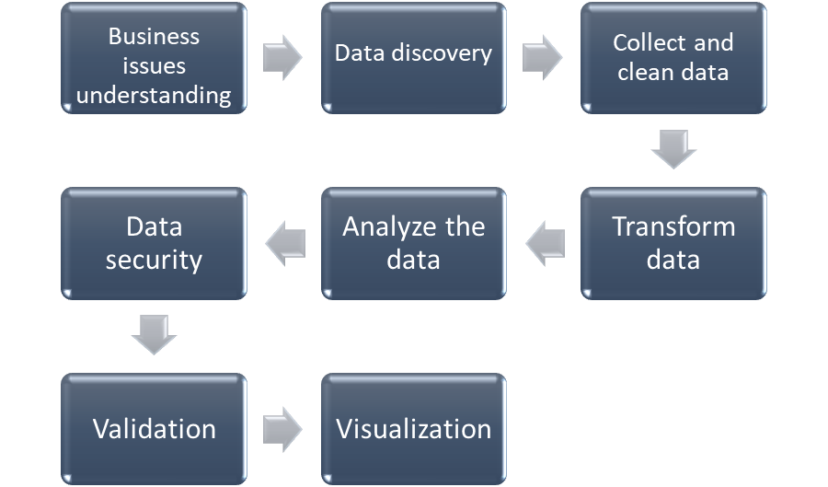
Fig. 1. Data analysing process (Research from all)

  - AUGMENTED ANALYTICS
Augmented Analytics is a unique platform that process data far faster than a human. Augmented Analytics solutions are with models, algorithms and solutions, that do not need to be developed by data specialist. This technology transforming data in clean, analysed and ready to use with minimal specialist human supervision. That can be use by smaller businesses which are with reduced capital for lower costs. Augmented Analytics can help to investigate trends from sales team, IT departments to uncover the drivers in servers and system usage. Data analysist can use it to clean, shape and prepare data faster. Also, can be applied in travel and hospitality for personalised offers. In marketing to explore the effectiveness of campaigns and find hidden data. Supply chain management can use it to understand why certain locations delivering products not at the expected rate.

  - BUSINESS ACTIVITY MONITORING
Business Activity Monitoring (BAM) is a way to improve business process performance. Using analytic software to improve processes by identifying areas for optimization. It takes real-time data about current and past processes and turn it in meaningful information with visual insights, like charts, tables and reports. The information is accessible with dashboards and include overview of business-related data. With business activity monitoring owners and managers can identify trends and pattern to be used for optimization.
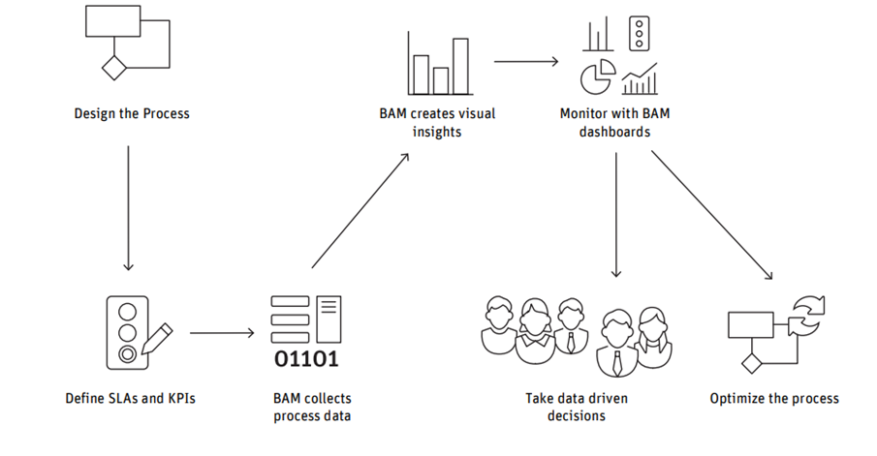
Fig.2 Business Activity Monitoring experience (Appway,2017)

Before any organisation start to work with Business Activity Monitoring must to consider some challenges. First the management must be committed to monitoring the processes and identifying critical situations. Second, must be performed timely analysis and define which business indicators should be considered. Third, reducing time process duration to increase revenue. Fourth, investment in training to all parties involved to ensure the main goal of increasing efficiency of the organisation. Fifth, to consider security, to be used software or cloud service for protection of the data. BAM can be applied in banking to identify automatically anomalies such as large cash withdrawals, loan requests from companies or over a certain amount. Also, can be used in manufacturing for optimizing the processes, reduce operational costs, identifying opportunities and threats for the business to react.

  - CLOUD ANALYTICS
The right data platform, that is built for cloud bond all components of the technology to produce positive experience with your data. Allow to use all applications that you need with reduce cost to add more infrastructure to manage such software. Cloud Analytics automates everything from data storage, data transactions and data security. Analytic team spend more time with data not to managing infrastructure. Reduce costs with the payment only for storage and compute resources, not for capacity. Modern cloud data platforms employ a multi-cluster, shared data architecture and make it easy to add capacity in infinite resources of the cloud. All business can use different cloud platform that works best for them unique business needs. These data platforms give you access data from multiple clouds and securely share data. There are some industries that can be benefited from the cloud platform like automotive industry, education, financial sector, healthcare, insurance sales, hospitality, manufacturing, real estate industry and non-profit organizations.

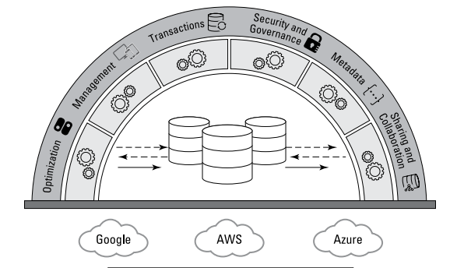
Fig.3 Architecture of a Cloud Data Platform (Baum,2021)

  - DATA SECURITY
Data Security is challenge in Business Intelligence tools as they need to offer secure products for their clients. If any data is leave unattended can cause enough damage to the business or any organisation. There must be a secure system to keep secure especially sensitive data which is always under attack from cybercriminals. If the data is stolen, the cybercriminals have the key for the whole process and can be damaged. First option which is cost-effective is cloud providers, that have established safeguard of data. Second option is encrypting, the data must be encrypted before stored or sent to someone else. That allows encrypt of massive data quickly and stored save. Third one is authenticated permission and access, powerful tool that gives limited access and data is shared to the correct person. Other security practices are – secure coding, input source authorization, distributed framework, corruption free software, cryptographic protocol, Hadoop encryption and backup.
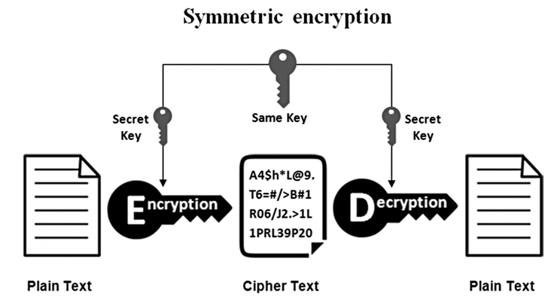
Fig. 4. Cryptography as encryption and decryption (Koley, 2019)
- CONCLUSION
From this research can be conclude that, every business needs faster insight into growing volumes of data in real time to help for the organizations to view the past and future. In this increasingly data-rich business environment, data discovery is the bridge between customer needs and business priorities. The trends of Business Intelligence are more than a technology, they change the organizational culture to become data driven. They are helping for creating new business models and entirely new innovative products. Improving security is another key for the success of the business. The future seems to be more automated, with quickly evolving model for the progression of the modern business. In this rapidly changing modernized technological world, so many new trends will come out.

- REFERENCES
Appway, (2017) “A 6 step guide to enterprise Business Activity Monitoring (BAM)” https://www.appway.com/filesystem/bfdfef710e817fb13e7a3747a76710a6-d638c072c1251c0e06191a85847e4c1b3fdb7993262352de77c87ce122bc0e5c5f49371c54123459b650c024f5d056a5ad2adfc8a92186b05392e762ecd5b155/Whitepaper_BAM.pdf (accessed on 30/07/2022)
Azevedo, Ana and Santos, Manuel. (2021) “Integration Challenges for Analytics, Business Intelligence, and Data Mining, IGI Global https://books.google.co.uk/books?hl=en&lr=&id=6DULEAAAQBAJ&oi=fnd&pg=PR1&dq=Integration+Challenges++for+Analytics,+Business++Intelligence,+and+Data++Mining+Ana+Azevedo&ots=e1jYBuiVTI&sig=fAI8RTjFHgbmRDpYWqMEqnCuzyU#v=onepage&q=Integration%20Challenges%20%20for%20Analytics%2C%20Business%20%20Intelligence%2C%20and%20Data%20%20Mining%20Ana%20Azevedo&f=false (accessed on 27/07/2022)
BARC Research Study, Data, BI and Analytics Trend Monitor 2022 https://www.infozoom.com/download/PDF/Data,%20BI%20and%20Analytics%20Trend%20Monitor%202022_InfoZoom.pdf (accessed on 27/07/2022)
Baum, David (2021) “Cloud Data Analytics for Dummies” https://www.snowflake.com/wp-content/uploads/2020/11/Cloud-Data-Analytics-for-Dummies.pdf (accessed on 27/07/2022)
Boldosova, V. (2020) ‘telling stories that sell: The role of storytelling and big data analytics in smart service sales’, Industrial marketing management, 86, pp. 122–134. Telling stories that sell: The role of storytelling and big data analytics in smart service sales - ScienceDirect (uwtsd.ac.uk) (accessed on 27/07/2022)
Divatia, A. S., Tikoria, J. and Lakdawala, S. (2021) ‘Emerging trends and impact of business intelligence & analytics in organizations: Case studies from India’, Business Information Review, 38(1), pp. 40–52. doi: 10.1177/0266382120969265.
GUARDA, T., BALSECA, J., GARCÍA, K., GONZÁLEZ, J., YAGUAL, F. and CASTILLO-BELTRAN, H., 2021. Digital Transformation Trends and Innovation. IOP Conference Series. Materials Science and Engineering, 1099(1),
HENRY, F.N., 2019. Big Data and Business Analytics: Trends, Platforms, Success Factors and Applications. Big Data and Cognitive Computing, 3(2),. Big Data and Business Analytics: Trends, Platforms, Success Factors and Applications - ProQuest (uwtsd.ac.uk) (accessed on 28/07/2022)
Janiesch, C. and Matzner, M. (2019) ‘BAMN: a modeling method for business activity monitoring systems’, Journal of decision systems, 28(3), pp. 185–223. doi:10.1080/12460125.2019.1631682 Full article: BAMN: a modeling method for business activity monitoring systems (uwtsd.ac.uk) (accessed on 29/07/2022)
LaPlante,Alice.(2019)”What is Augmented Analytics? Report” (https://www.oracle.com/oce/dc/assets/CONTA196820E5A344A2DA3FE13B2A6269410/native/oreilly-augmented-analytics-ebook.pdf?elqTrackId=b817af5b70214383af0677038c17d6f5&elqaid=84622&elqat=2 (accessed on 28/07/2022)
MULLINS, C.S., 2021. The Limitless Applications of Analytics. Big Data Quarterly. The Limitless Applications of Analytics - ProQuest (uwtsd.ac.uk) (accessed on 29/07/2022)
Olszak, C. M. (2021) Business intelligence and big data: drivers of organizational success. Boca Raton, Florida; CRC Press.
Prat, Nicolas. (2019) “Augmented Analytics” https://core.ac.uk/download/pdf/301379732.pdf (accessed on 28/07/2022)
Shibakali Gupta, Indradip Banerjee and Siddhartha Bhattacharyya (2019) Big Data Security. Berlin: De Gruyter (De Gruyter Frontiers in Computational Intelligence). Available at: https://search-ebscohost-com.ezproxy.uwtsd.ac.uk/login.aspx?direct=true&db=e001mww&AN=2330583&site=ehost-live (Accessed 01/08/2022).
Splunk, (2022) The state of Security 2022 https://www.splunk.com/en_us/pdfs/resources/e-book/state-of-security-2022.pdf (accessed on 01/08/2022)
ZHAO, Y., 2021. Transformation of Business Analytics from Business Intelligence. Les Ulis: EDP Sciences. Transformation of Business Analytics from Business Intelligence - ProQuest (uwtsd.ac.uk) (accessed on 30/07/2022)

