EFFECTIVE TEAMWORK AND COMMUNICATION
BMSW 4002

Student name: Joselyn Castillo Cabral
Student ID: 2121046

Table of Contents
1.0 Introduction 1
2.0 Models of Communication 2
2.1 Communication Model of Shannon and Weaver 2
2.2 The Schramm Model 4
2.3 Berlo’s SMCR Model 5
3.0 Communication Skills 7
3.1 Verbal Communication 7
3.2 Non-Verbal Communication 7
3.3 Listening Skills 8
4.0 Advantages and Disadvantages of Technology in Communication 8
4.1 Advantages of Communication Technology 9
4.2 Disadvantages of Communication Technology 9
5.0 Conclusion 11
References 12
Appendix 13

1.0 Introduction
Communication refers to the act of exchanging and sharing facts, information, opinions, emotions, or ideas from one individual or group to another. It is simply a process through which information is transferred among individuals by using a common system of signs, symbols, or behaviour (Luhmann, 2012). No two-way communication can occur without a "sender," "information," and "receiver". Communication is a skill that requires a lot of nuances to master, despite appearances to the contrary. Interference with a message in transit can be caused by many factors. Remoteness, way of life, mode of communication, and people's emotional states are all examples of such factors (Rani, 2016). Companies throughout the globe place a premium on candidates who can communicate precisely, efficiently, and clearly. Every communication encompasses three parties: the originator, the information itself, and the respondent. The communication is encrypted by the intended recipient, who may use any number of techniques, including vocal and behavioural clues. Because of the many ways in which data can be communicated, some receivers may get somewhat distinct traits from others. When communicating with numerous people, it's important to remember that each may interpret the very same set of cues differently. They might also be at different levels of understanding.
In this paper, different models of communication have been discussed, considering the case study of Pedro and Maria. The report also includes a discussion on different communication skills and the pros and cons of technology in communication.

2.0 Models of Communication

2.1 Communication Model of Shannon and Weaver
There are six elements involved in the communication model of Shannon and Weaver, which are:
Information Source: The sender or someone who originated the information or message. In the Case study, Maria is the one who transmitted data in an unreadable way.
Transmitter: Encoder, the thing that converts the information or messages into signals
Channel: The medium by which information is transmitted from sender to receiver. Maria used her cellphone as the medium by which she transmitted the data.
Reception: The decoder, the place at which the signal is received and where it is transformed into a message (Narula, 2006). Pedro is at the receiving end of the given case study.
Destination: The receiver of the information
Noise: Through a channel, messages are transmitted from encoder to decoder. Throughout this process, the messages can get influenced or distracted by different physical noises, such as thunder, crowd noise, and horn sounds, or by encoded signals in the transmission channel, which may disrupt the communication flow or prevent the receiver from receiving or understanding the message accurately (Shannon, 1948). In the case study, Pedro works on a building site that is bound to have severe noises from machines and many other external sources.
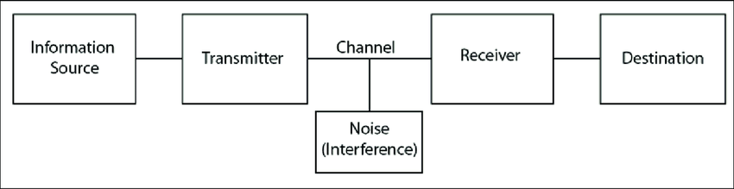
Figure: Shannon and Weaver Model (Al-Fedaghi, 2012)
This concept of this model is intended to foster efficient communication between the sender and the receiver. Shannon and Weaver identified a variable known as "Noise" that influences the process of communication. This model of Shannon and Weaver addresses only external sounds that alter messages or signals originating from outside sources (Al-Fedaghi, 2012).
The miscommunication in both Pedro and Maria can be explained by using the conceptual framework developed by Shannon and Weaver. Maria casually communicated with Pedro via a technological device, surely a cell phone, and delivered the information in an unreadable form. Exchanged communications were sent and received using cell phones, exchanging encrypted replies. First, Pedro had to figure out what the message meant before attempting to comprehend it. As a decoder, the cell phone also worked as a convenient calculator. Pedro failed to understand the transmissions because of the interference on the channels.

2.2 The Schramm Model
Schramm's communication model includes five elements: sender, receiver, massage, feedback, and noise. He proposed that communication is a cyclical, continuous, and two-way process in which the senders and receivers alternate sending and receiving information or messages (Schram, 1954). He claimed that the information flow of this cycle could be sustained and maintained properly only when both parties comprehend the other’s messages. Communication breaks down when the recipient does not understand what is being said. Till the sender receives confirmation or feedback from the recipient that the message was understood, the communication cycle is not complete (Rubtcova and Pavenkov, 2021). As per Berlo's model, Internal noise can be caused due to the difference between the sender and receiver in terms of communication skills like listening, speaking, reading or language differences, attitude suchlike Bored or assumptions, and knowledge differences, which are when the sender chooses difficult words to convey the message it becomes difficult for the receivers to comprehend the message.
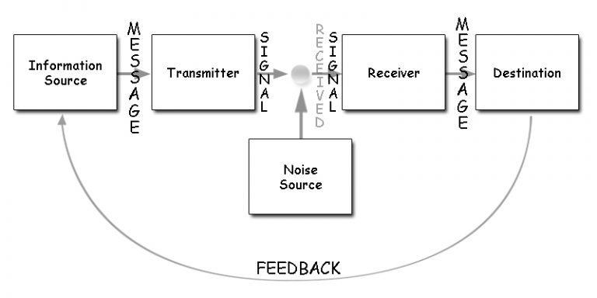
Figure: The Schramm’s Model (Rubtcova and Pavenkov, 2021)
Schramm's model differs from the model of Shannon and Weaver in terms of Schramm's model, which includes the element called feedback which is not included in the S & W model. Noise can be both external and internal, whereas Shannon and Weaver’s model only deals with external sources of noise.
In the case study, the misunderstanding between Pedro and Maria could have been avoided by using this element, feedback. When Pedro and Maria work together to verify that the message was received and understood, they reduce the likelihood of misunderstandings occurring.

2.3 Berlo’s SMCR Model
The most fundamental type of modern communication is the SMCR (sender-message-channel-receiver) model, which is also known as Berlo’s model. It is less of a model and more of a breakdown of what makes up communication. According to Berlo's model, efficient communication is possible only when senders and receivers are of the same level. If the message sender and the recipient of the message are too different from each other, the message may not achieve the desired effect. The ability to listen carefully on the receiving end is also crucial. As per Berlo, communication is the sending and receiving of any kind of information (Narula, 2006). The model claims internal noise can be caused due to the difference between the sender and receiver in terms of communication skills like listening, speaking, reading or language differences, attitude suchlike Bored or assumptions, and knowledge differences when the sender chooses difficult words to convey the message it becomes difficult for the receivers to comprehend the message.
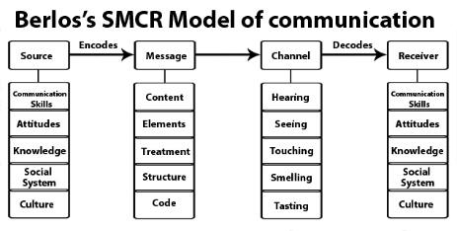
Figure: Berlo’s SMCR Model (Narula, 2006)
A brief overview of the four main parts of this concept is provided below:
Source: Whenever individuals refer to a message's "source," they're talking about the person or thing responsible for sending it. Berlo lists five source-related factors, including competence in interactions, attitude, comprehension, background, and custom.
Message: The term "message" is used to describe the main point that the originator of a communication hopes to make to the receiver. Beyond the sender and the receiver, Berlo proposed an additional five criteria linked to the communication itself. Included in this category are the content, modules, therapy, format, and methodology.
Channel: Messages are transmitted from Transmitter to Transceiver via channels. Berlo argued that the five senses (hearing, viewing, feeling, tasting, and inhaling) are equally crucial for effective communication.
Receiver: The final step in any conversation is reception. Berlo uses criteria likeability, conviction, cultural heritage, and customs for both the information originator and the receiver. When the transmitter and recipient exchange content, perspectives, and abilities, the conversation becomes successful.
As a result of applying Berlo's paradigm of communication, the confusion between Pedro and Maria can get resolved. Proper communication, according to Berlo's theory, requires that both the transmitter and the recipient share a common theoretical foundation. The only way to have meaningful dialogue is if both parties are open to hearing each other out. Therefore, it's imperative that the communicating parties get along well. If Maria is an amazing speaker, then Pedro must be attentive. If Pedro and Maria had already been standing at an identical height, they might not have misunderstood each other.

3.0 Communication Skills
Communication skills refer to the competency or capability of conveying one's thoughts and feelings effectively to another. Communication skills are very important for communicating effectively. Communication skills cover a wide range of facets, including communication, observation, and empathy (Tongue and Forese, 2005).

3.1 Verbal Communication
The ability to convey a message through one's use of words is referred to as verbal communication skills. This includes the manner in which one writes as well as the manner in which one speaks. The most important objective of this communication is to rely on or deliver information in a way that is both clear and succinct through the use of language.
In written communication, information and ideas are conveyed by using written language. On the other hand, in spoken communication which is also called oral communication, messages are conveyed through the utilisation of spoken language. Verbal communication also includes aspects like the choice of words, tone, and pitch (Ellison, 2015).
Tone addresses the overall attitude of the sender of the message toward the information which is communicated. For instance, in business communications, the speaker is supposed to strive for a formal, professional, serious, and engaged tone. Here, serious tone simply refers to the speaker's need to use language that is neutral, clear, and direct. The tone of communication depends on the context and situation. Word choice is also very crucial in verbal communication since the wrong word choice can deliver the message in a completely wrong way, making it impossible for the receiver to comprehend the actual meaning.

3.2 Non-Verbal Communication
Nonverbal communication refers to the transmission of messages, information, or signals by using nonverbal platforms like facial expressions, posture, gestures, body language, etc.
A person's vocal range, facial expressions, body movements, and overall body language all contribute to the overall context of the conversation (Key, 2011). Maintaining eye contact shows that you're paying interest to the other individual and the conversation. Staring at someone can make them uncomfortable. Watch how everyone else around each other reacts with their bodies while you talk to them. One's emotions can be deduced from their body language.
According to the proxemics concept of communication, persons control how strongly they affect others by varying the travel time between themselves and other people (Brown, 2001). Proxemics is a branch of non-verbal communication which emphasises the importance of bodily gestures and other forms of contact between communicators. This helps to explain why as well as how individuals construct their atmospheres to disseminate information regarding their ease and belongingness in the world.

3.3 Listening Skills
Listening skill denotes The capability of paying attention to as well as efficiently interpreting the message of the speaker. It includes skills like active listening, empathetic listening, etc. Active listening needs the audience to listen to a speaker very attentively, comprehend what his message is, and give responses and feedback on the things that have been spoken. It also includes retaining the information for the future. Active Listening helps both the speaker and the audience remain engaged in the conversation. This listening form conveys an understanding which is mutual between the sender and receiver of the information. Active listening is the practice that mainly involves paying attention, showing that the listener is Listening, providing feedback when necessary, deferring judgment, and responding accordingly and appropriately (Rost and Wilson, 2013).
An effective listening process involves simply absorbing the words being spoken. Being an active listener requires introspection. Through introspection, individuals gain control over how they take in and make sense of data. When people hear the words of others, they filter them through their own preconceived notions. When presented with evidence that runs counter to their existing views, it's human nature to go on the combative and cease listening to additional info. By understanding and managing their emotions, self-aware people are better able to communicate, form strong relationships, and take charge in any situation.

4.0 Advantages and Disadvantages of Technology in Communication
The term "communication technology" refers to any electronic system that facilitates two-way conversation. The ability to communicate with people who aren't in the same place at the same time is made possible by advancements in communication technology (Rogers, 2016). The technology used in communication has both advantages and disadvantages, Which are discussed below.

4.1 Advantages of Communication Technology
Efficient: It also helps businesses to gain feedback, ask questions, and deliver information instantly, which saves resources like time and manpower, making the communication process more efficient and effective in the long term (Diaz and Boswell, 2012).
Real-time Communication: Technology allows people to communicate in real time via email, messaging, social media, and other means, allowing them to initiate communication promptly and conveniently.
Economical: Technology has made the communication process Economical. Through the use of video conferencing technology in communication, travel expenses and time can be reduced.
Speed: There is no longer any need to worry about a delay in getting in touch with someone because a phone call, text message, or email is always just a click away. New means of instantaneous communication have been made possible by technological advancements in times of crisis or emergencies.
Dissemination: it has become more effective to disseminate information, broadcast news, and share knowledge now that social media has become such a pervasive and easily accessible platform for communication.
Clarity: Clarity in communication has been aided by the availability of high-megapixel video and images as well as high-quality sound systems, especially in long-distance communication.

4.2 Disadvantages of Communication Technology
Lack of Human Connection: Because of its immediacy and lack of capacity for nuanced expression, technology limits the depth of human connection that can be achieved through face-to-face conversation or physical communication. Since technological communication is so quick and immediate, it often distorts the original meaning of the message (Rogers, 2016). As a result of technological advancements, we are now able to communicate with one another in short. But these brief and carefully edited words and phrases often lack intimacy as well as eliminate the contextual clues which are delivered through body language and tone of voice.
Potential for Misunderstanding: When communication is done using modern technological devices like cell phones, computers, or any other gadget, both parties lose the nuances that are offered through voice inflexion and body language. At times, the intended meaning and tone of digital communication can be misread, and there are chances that the word of the message might be misconstrued. Also. Clarification can be made easily and immediately a face-to-face or physical communication.
Challenging for the Older Generation: Communication Technology is difficult for the older generation to use. Therefore, technology in communication often reduces the effectiveness of their Communication, and more miscommunications occur (Diaz and Boswell, 2012).

5.0 Conclusion
Communication is a significant part of life. Without proper communication skills, the message or information conveyed can be misunderstood and misinterpreted. Various barriers make the communication process complicated and reduce the effectiveness of communication. Regardless of the type of communication, whether it is verbal or nonverbal, written or oral, communication faces different barriers. Due to the advancement of technology, the communication process has become easier, but it also has some drawbacks. There are several models, like Schramm’s model, Berlo’s SMCR model, the communication model of Shannon and Weaver, etc., that demonstrates and discusses the communication process and different aspects related to it.

References
Al-Fedaghi, S., 2012. A conceptual foundation for the Shannon-Weaver model of communication. International journal of soft computing, 7(1), pp.12-19.
Ali, M., 2018. Communication skills 3: non-verbal communication. Nursing times, 114(2), pp.41-42.
Diaz, I., Chiaburu, D.S., Zimmerman, R.D. and Boswell, W.R., 2012. Communication technology: Pros and cons of constant connection to work. Journal of Vocational Behavior, 80(2), pp.500-508.
Ellison, D., 2015. Communication skills. Nursing Clinics, 50(1), pp.45-57.
Luhmann, N., 2012. What is communication?. Communication theory, 2(3), pp.251-259.
Narula, U., 2006. Communication models. Atlantic Publishers & Dist.
Rani, K.U., 2016. Communication barriers. Journal of English language and literature, 3(2), pp.74-76.
Rogers, E.M., 2016. Communication technology. Simon and Schuster.
Rost, M. and Wilson, J.J., 2013. Active listening. Routledge.
Rubtcova, M. and Pavenkov, O., 2021, August. Lasswell and Osgood-Schramm models of mass communication. In the 3rd World Conference on Social Sciences on the (pp. 3-5).
Schram, W.E., 1954. The process and effects of mass communication.
Shannon, C.E., 1948. A mathematical theory of communication. The Bell system technical journal, 27(3), pp.379-423.
Tongue, J.R., Epps, H.R. and Forese, L.L., 2005. Communication skills. Instructional course lectures, 54, pp.3-9.

Appendix
Case Study: MARIA and PEDRO
Pedro works on a building site, and Maria is his wife.
One day Maria phoned Pedro.
‘Hello, Pedro, when you’re coming home, see if you can get me a chicken.’
‘Okay,’ replied Pedro.
When he got home, Pedro took off his boots and coat and went into the kitchen.
‘Maria, where are you?’ He said.
‘Here – in the sitting room,’ she said.
When Pedro went into the sitting room, Maria said, ‘Where is the chicken?’
‘What Chicken?’ Asked Pedro.
The one I asked you to get on your way home.’
Oh, no! I thought you said I would see you in the kitchen when I come home!

