Handbook for Early Years Practitioners during childhood transitions.

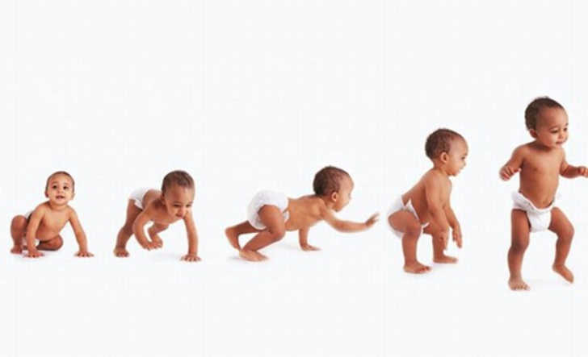

Contents

An introduction to transition Page 3

The Needs of the child Page 4 – 6

The Role of the adult. Page 7 – p8

Partnerships Page 9

Interventions Page 10 – 12

Outcomes Page 13

Reference List Page 14

Introduction

This handbook is an introduction to help with the transition from a home setting into a nursery setting. Helping you to understand what happens and the impact it has on the child. While giving some useful information on how to help them.

Transition – a process of change/changing from one form or condition to another (Oxford School Dictionary)

What is Transition and what impact does this have on the child?
This is a movement children make from their home to either a nursery or a early years setting, then from there to a primary school setting, from primary to secondary, even going from secondary onto further education and then beyond this into their adulthood. Everybody at some point during their lifetime will go through Transitions. (Parentzone Scotland)

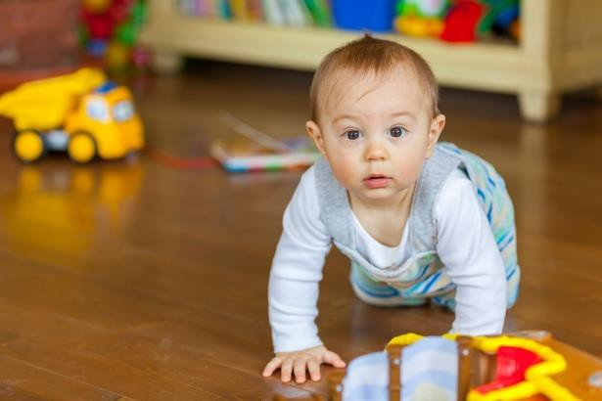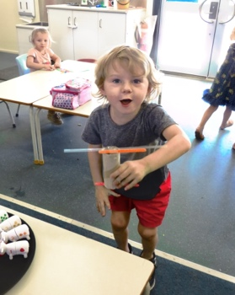
This Photo by Unknown Author is licensed under CC BY-NC-ND
This Photo by Unknown Author is licensed under CC BY
This Photo by Unknown Author is licensed under CC BY

Dowling (2014) believes adults and children feel most safe with the people they know and also being in familiar surroundings which they are used to being in. Dowling also suggests that the different values we put onto ourselves can be affected by how secure and safe we feel within ourselves.
For children beginning their journey to school in an early year’s setting, there will be many new experiences, new faces and new environments, for them to face. It can even be intimidating to the children who come across as confident starting in a new group setting. All children’s early transitions and experiences will help to shape all future abilities with the dealings of new experiences, Dowling (2010).

The needs of the child

When you are thinking about a child’s needs in particular their development, you as practitioners should try to be aware of the different theories of a child development that have so far informed our modern practice and society (Lindon, 2010).
Lindon believes that good practice can be an holistic view of children and how they develop, also children as a whole should always be kept in your mind in order for you to be an effective practitioner.
Winnicott (1964) theory puts a great significance towards the role of the mother, or whomever is the primary carer. A baby would not be able survive without someone there to look after them. Winnicott (1964) believes care and nurture can provide a loving and even a supportive home for the infant whom at this time is totally dependent on the adult. This home environment should then be shared with carefulness to the childcare provider whom should then receive it with great confidence. The care provided should be no less caring here.
Pikler’s theory approaches on how new bonds can be formed between ta child and their teacher through tender and affectionate daily care given. By meeting the basic needs of the child in a focused, kind and even an interactive way the child will then grow to secure and even loved the child’s confidence will then grow in their new relationship with yourself. (Weber, 2010).
Maslow’s most famous work is that of the ‘Hierarchy of Needs’ where he suggests an individuals response towards learning can be dominated at any moment by a need that has priority.
Maslow’s Hierarchy of Needs (1943) was divided in to two phases. The bottom or lower needs are related to the safety aspects and the physiological aspects of their learning. Maslow also argued that to progress to the higher/top levels you need to have meet the needs of the lower ones first.
.
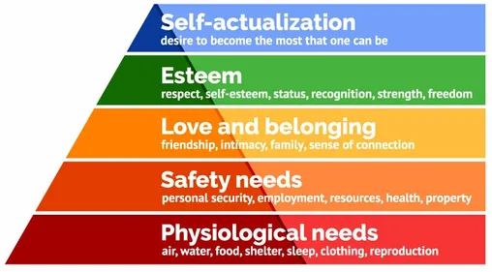
https://www.simplypsychology.org/maslow.html

The physiological needs of the child
There are 3 physiological needs included are those that are vital to your survival. Here are some examples of the physiological need these include:
Breathing
Food
Water
Also in addition to these basic needs of air, nutrition and temperature regulation, the physiological needs included are also clothing and shelter.

The need of the child’s Safety and Security
On the second tier of Maslow’s hierarchy (1943), the child’s needs start becoming a slightly more complex. This level, the needs for the child’s safety and security become the primary. People need and also want control and an order in their lives. These are some of the basic safety and security needs:
Safety against accidents and injury
Financial security
Health and wellness
Finding a job, putting money into a savings account, also moving to a safer area are some examples of the actions that are motivated by the need for safety and security.
These together, the physiological and the safety levels of Maslow's hierarchy of needs (1943), are often referred to as "the basic needs."
The Social Needs
There are also social needs in Maslow’s hierarchy, these include love, belonging and also acceptance. When at this level, the child and adults need for an emotional relationship drives their human behaviour. Some of the things that helps this need include:
Family relationships
Friendships
Romantic attachments
Community groups
Churches and religious organizations
It is important for people to feel loved and accepted by others, in order to avoid loneliness, anxiety and depression. Their personal relationships with family, friends and lovers also play an important part, as well as groups—like sports teams, religious groups, book clubs, along with many other group activities Maslow (1943)

The Esteem Needs
On the fourth level, Maslow (1943) states the need for respect and appreciation by all. Once every need on the bottom three levels have been completed, then their esteem needs start to have a more prominent role in their motivating behaviours. It is then at this level, it starts to become increasingly important to start to gain the respect and appreciation from others. Some people have the need to accomplish different things and then have their efforts noticed and even recognized. Some people need a sense that they are respected by others. Also that they are making a some sort of contribution to the world. Maslow (1943) states participation in team sports or activities, and personal hobbies can help with the fulfilling of the self-esteem needs. People can satisfy their esteem needs by achieving recognition from others, which in turn can help them to feel confident in their different abilities. All together, these esteem and social levels of Maslow’s hierarchy make up the part known as the "psychological needs"
Self-Actualization Needs
At the very top of Maslow’s hierarchy (1943) is the self-actualization needs. Self-actualizing are people who are self-aware, can be concerned with their personal growth and can be less concerned with other people’s opinions, they are interested in fulfilling their full potential. Maslow’s said of self-actualization: "It may be loosely described as the full use and exploitation of talents, capabilities, potentialities, etc. Such people seem to be fulfilling themselves and to be doing the best that they are capable of doing. They are people who have developed or are developing to the full stature of which they capable."


This Photo by Unknown Author is licensed under CC BY

The role of the adult

Every early year’s practitioner has to make sure that every child is always fully supported throughout the whole transition process and has to accommodate and plan for each one appropriately. Every need of each child must be, firstly identified and then met in order to help encourage their independence and also their confidence, this will then help the child with settling into what will be their new surroundings and routine. You as the practitioner has the responsibility to help every child when they come to move onto their next steps, for example when transitioning from, home to nursery, nursery in to the reception class. The child’s family have also got to be supported while this process is happening. When it comes to the process of the child leaving their home environment to attend the school system, this time can and is a very emotional and anxious time for everyone, therefore the transition process has to be managed in a sensitive and effective way by the setting to where the child is going to be attending. (Croneri, 2018)

Bronfenbrenner’s model (1976) believed that you should look at a child in the wider environment and not just in their immediate one. There are 4 parts to his theory.

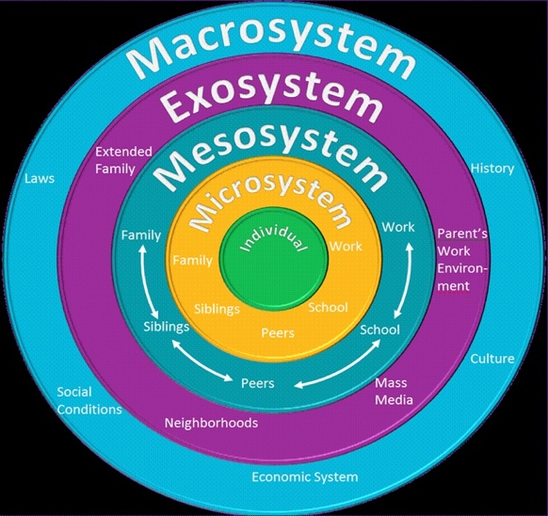
This Photo by Unknown Author is licensed under CC BY-NC-ND
The microsystem – Bronfenbrenner (1977) believed this environment is the closest part to the child, this being the home and classroom as the most common environments for them. Within these environments the child is provided with interactions from their parents, other family members, their teachers, friends and even neighbours can be seen as direct social influences on the child. Bronfenbrenner (1976) also believed that it is at this level the child learns quite early the rules of behaviour and social situations.
The mesosystem – Bronfenbrenner (1977) stated that relationships that are formed between all the different parts within the microsystem and the frequency and quality of the interactions between them. Bronfenbrenner (1977) advocated that all children’s developments were optimised when links between the mesosystem and microsystem were strong and well developed. As an example the child’s educational achievement would increase if there was good effective communications between the parents and the teachers. But on the other hand if the parent was to show a bad attitude towards the teacher or school due to them not having a good experience then this in turn could then go on to affect the child’s development within the school.
The exosystem – this part is where Bronfenbrenner (1977) believed that the child’s environment to which they may not be a direct part of can still influence how they develop. Bronfenbrenner (1977) also saw this part of his theory as a possible extension to the second part, which is the macrosystem., which could possibly include the neighbour hood they grow up in, the communication they have access to, government agencies, also world media. However Paquette and Ryan (2001) believed that this layer does have an impact on children because it has interactions with parts of the mesosystem. As a example some children can be either negatively or positively be impacted by their parents work schedules.
The macrosystem – this is the part that forms which would be know as the outermost layer to a child’s development. Bronfenbrenner (1977) went onto explain how this system was different to all the other layers as it does not refer to specific circumstances which can affect the life of certain people, but to the different prototypes, different cultures that then go on to set a pattern for activities that occur at a concrete level. Bronfenbrenner (1977) believed this could include cultural values, customs and laws of the society wherever the child grows up in. These can then have a impact (direct or indirect) to the interactions that are within the other different layers in the theory. Bronfenbrenner (1977) theory parallels and even complements other theorists such as Bowlby and Ainsworth.


Partnerships


This Photo by Unknown Author is licensed under CC BY
This Photo by Unknown Author is licensed under CC BY-SA


This Photo by Unknown Author is licensed under CC BY-SA-NC

Multiagency

You should always remember you must have parental permission when you are working with any type of multiagency, such as speech and language therapists, the health visitor and even support assistants. The multiagency approach is an important proactive part and whomever is involved with that particular child should come together and communicate in partnership with each other to improve the child’s chances. The areas of their learning development delays should be identified through different assessments. This then helps the keyworkers to then inform parents/carers of their findings and also any other multiagency, for example speech and language, social services, physio and who else should to be involved with it. There should be strong links made between the child and the keyworker, this when they help the chid build secure and happy attachments which will help them to settle in with their new routine as smoothly and confidently as possible. Communication is vital, whether it be through non-verbal or verbal strategies, as well as also responding to them appropriately and also showing an interest in the child and what their doing or saying. (Daly, Byers, Taylor, 2004).
Interventions

To start the whole process of transition, the teacher and whomever is involved must try to arrange a visit to the child’s home, so a meeting can then take place in their home environment in which you can then gather any relevant information to the family and most importantly the child’s needs.

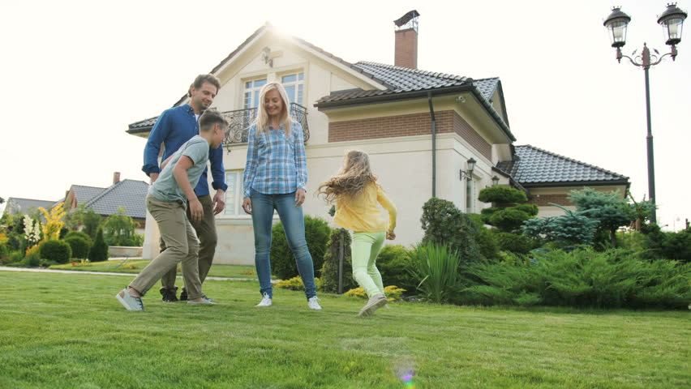

This is where an ‘all about me’ booklet can be completed, and any relevant paperwork needed can be done during the visit. This first contact then helps to start the whole transition process, during this visit families are then given the opportunity to be able to talk to and ask questions to the teacher which in turn starts to build a relationship with the staff within the setting. It can also help staff to collect any background information needed with regards to any disability needs , cultural needs or even any vulnerabilities the child may have. The setting may find it difficult to start providing high-quality services, without knowing the child’s information which is essential. Welsh Government (2000).


This Photo by Unknown Author is licensed under CC BY-SA

Allowing visits to the school or nursey are always encouraged prior to the child’s start date to help the child become familiar with the classroom staff and how the daily routine works, this will also help the parents/ carers to. The policy for the child’s settling in should always be clear and accessible to parents / carers at any time. Welsh Government (2000).

This Photo by Unknown Author is licensed under CC BY-SA

As the child then starts to gradually settle in, you as the keyworker always has to remember your role, this includes:
To safeguard and support the child and the family, be a good role model, always be sensitive and reassure both the child and their parent/ carer. Provide a high quality of care, within a welcoming environment.
Remembering to maintain your observations, to help with your assessments and your planning. Welsh government (2000)
To meet all their emotional social and physical needs.
To respect and values the child and also their families
Always have effective communication, this can be by always keeping parents/carers informed.
Have activities that could reflect the culture and home life, this can be with activities initiated by the child. Welsh Government (2000).

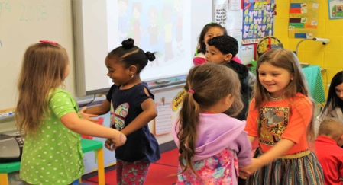
This Photo by Unknown Author is licensed under CC BY-ND

When it comes to the end of the session you should do an informal handover with whomever collects the child whether this be the parents or carers, this then is a good opportunity for you to discuss if you have any concerns or issues from that day. All the information that is then gathered from the handovers will then go on to help yourself plan any activities which will then support the child (Collins, 2010, p. 234).

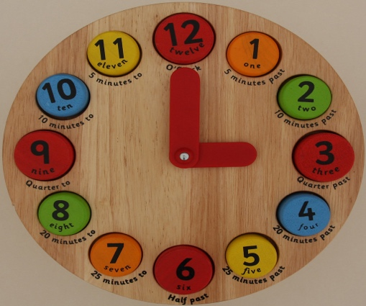
This Photo by Unknown Author is licensed under CC BY-SA-NC

The principles outlined here, good practices and pedagogy will go onto provide a successful and even smooth transition for every child and their families and can also improve the child’s outcome long term. (Daly, Byers, Taylor, 2004).

Outcomes

Laevers (1994) believes children’s development and learning can be assed by using two different tools. First being the emotional well-being, this can be grouped by how receptive and open they are, by how assertive and flexible and they can be, and also by how confident and relaxed they are in the setting. Second being their involvement, this is done by looking at how good a child’s concentration is, their persistence, energy, even their expressions and also their satisfaction plays a part. However, Martland (2020) goes on to discusses that observations of children in that moment will go onto build a clearer picture of the child’s development and journey. The records you keep whether it be in the form of Learning Journals, which would contain the child’s work, assessment data, observations, the input from the parent or carer will help to provide useful information to then assess their progress as the grow.
The observations you make will allow anybody to be able respond to any child’s needs which will then provide different opportunities to help develop onto the next steps. This will then tie in with the theory of ‘sustained shared thinking’ which always happens during the child adult interaction in the environment. Martland (2020)
Also there is holistic assessment this is also there to help support the child in that moment, it connects a child within the setting, with the child that is at home and helps facilitate the planning for their next step. It also enables practitioners to set them up for their future, and to acquire the confidence and skills for their different transitions throughout their lifetime. (Brooker, 2008)

Reference List

Aubrey, K and Riley, A. (2019). Understanding and using educational theories. 2nd Ed. London: Sage publications.

Bates, B. (2019). Learning Theories Simplified. 2nd Ed. London: Sage publications.

Brooker, L. (2008). Supporting Transitions in the Early years. Maidenhead:Open University Press.

Collins, S (2010) ‘Thinking through the uses of observation and documentation’ in Moyles, J. (ed) Thinking about play. Berkshire: Open University Press.

Croneri. Managing transitions. Available at: https://app.croneri.co.uk/feature-articles/managing-transitions-early-years-provisions https://www.verywellmind.com/what-is-maslows-hierarchy-of-needs-4136760 Accessed: November 2022

Daly, M. and Byers, E. and Taylor,W. (2009) Early years management in practice. 2nd Ed. Essex: Heinmann, Pearson Education Limited.

Dowling, M. (2010) Young Children’s Personal, Social and Emotional Development. 3rd Ed. London: Sage.

Dunlop, A.W. and Fabian, H. (2006) Informing transitions in the early years. United Kingdom: McGraw-Hill Education

Henry, M. (1996) Young Children, Parents and Professionals. London: Routledge.

https://www.simplypsychology.org/maslow.html [photo] Accessed: November (2022)

Laevers, F. (1994) Defining and assessing quality in early childhood education. Leuven: Leuven University Press.

Lindon, J. (2010) Understanding Child Development 2nd Ed. London: Hodder Education.

Martland, R., (2020) Kinderly Webinar In the Moment Planning Available at https://learn.kinderly.co.uk/courses/in-the-moment-planning-webinar/#/page/5e2f1966244030384232c6fb

Maslow. (2022) Higher achy of needs theory. Available at: https://www.verywellmind.com/search?q=maslow

Oxford school dictionary (2002) Oxford

Photos: Bing, Accessed: 2022

Weber, S. (2010) ‘The Work of Dr Emmi Pikler’. Research Bulletin, Autumn/Winter 2010. Available at:https://docplayer.net/84484676-Susan-weber-the-work-of-emmi-pikler-research-bulletin-autumn-winter-2010-volume-15-2.html

Welsh Government. (2018) Available at: https://www.cymru.gov.uk
Winnicott, D. (1964) The Child, The Family and The Outside world. Penguin:London

