Student name:
Agnieszka Janina Wilkosz
Student ID number: 2115098
Programme: BA Leadership and Management
Module: Developing workplace critical thinking
Module code: BMSW 5102

Lecturer:
Zahida Khan
Assignment Title:
Developing relationships and workplace achievement.

Table of Contents
Introduction 2
Employee Motivation base of Wiggle 2
Employee engagement base of Wiggle 4
Reward base on Wiggle 7
Personal Development Plan 10
Conclusion 12
Reference list 12

Introduction

Wiggle is a global online sports shop selling bikes, accessories, and sportswear.
In 1920, Wiggle started out as Butler Cycles, a small independent bicycle shop. In 1999, Butler Cycles launched online with the launch of Wiggle. It has become one of the largest online sports stores.
2021 Wiggle employed about 670 people in Portsmouth, Newtownabbey, Belfast and
Wolverhampton (Wiggle.2022).
The following report is structured in two parts. The first will present the motivation, engagement of employees and how reward makes an impact on organizational performance. All report elements will be drawn up based on the company-Wiggle. In the second part, the Personal Development Plan will be presented.

Employee Motivation base of Wiggle
In the 21st century, organisations need efficient and motivated employees to overcome obstacles and achieve goals. Motivation is a significant factor in organisation (Asaari, 2019). Motivation is "a pleasurable or positive emotional state resulting from the appraisal of one's job experiences" (Badubi, 2017, p. 45). Employee motivation is essential and increase their productivity and enable employees to accept change. To a large extent, companies success depends on employee’s willingness to use their creativity, skills, and hard work for the company's benefit. It is the responsibility of the organisation to encourage and nurture this positive attitude in the employee by implementing an effective incentive system.
Highly motivated employees are more productive, efficient, willing to work, and the organisation's success can only be achieved through the contribution of employees (Asaari, 2019).
Wiggle sports equipment warehouse in Wolverhampton has employees in various departments and positions. This report will focus on employee motivation in the position of warehouse operator. The task of such an employee is to have a performance of at least 80%, not to make mistakes and follow the rules of health and safety. The company motivates its employees with 25 days of holiday + 8 Bank Holidays and working hours: 37.5 hours per week. Company Bonus Scheme, Staff discount, pension, and Healthcare. It sounds good, but when people work for several years, is it enough to generate a sufficient level of motivation. When the company noticed a drop in motivation, reflecting a lower performance, the company introduced extra money for the best employees with the highest target That had positive inpact on organization performance. Wiggle applied the Taylor principle; workers must work more to earn more. Piece rate for the payroll system (Mukhopadhyay, 2020). The company abandoned this system after three months without providing any explanations. The employees those who received extra money for their hard work, were demotivated. It should be considered whether money motivates people at all. In a literature review, some argue that money is motivated. Money satisfies the need for survival and security. They can also satisfy the need for their worth and status. Herzberg argued that a lack of money could cause dissatisfaction, but money is not satisfactory (Armstrong, 2007). At Wiggle, people have a constant hourly rate that increases every year. This year, when after April 1, employees still did not receive information, they slowed down with work. When the managers noticed this, the next day, they informed about the amount of the increase, and people stopped being demotivated but also not motivated. Herzberg's sentence confirms this perfectly.
According to Herzberg, there are two types of motivation (Armstrong, 2007). As show below picture.
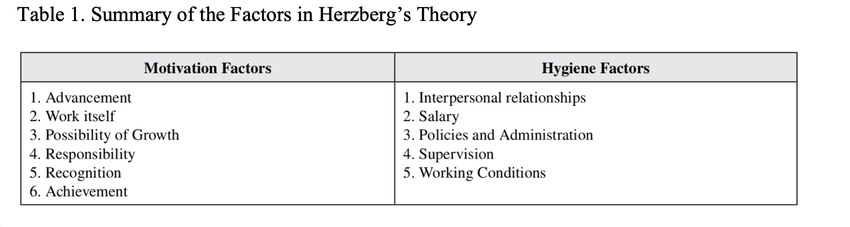
(Source: Mukhopadhyay, 2020)

Wiggle provides a salary more than the minimum wage, which attracts new employees, but no motivates. Two years ago, the company paid a bonus to its employees, which greatly motivated the employees, while a year later, when the company did not pay annual bonus, all employees were disappointed. The company ensures the extension of Maslow’s theory to meet all needs, the need physiologically pay for the work performed and the need for security - it provides a safe place. Social needs people work together in teams. Respect for the needs- the manager or team leader, praises the high target but also asks what went wrong when there is no 80% and the last need for self-fulfilment, allows participating in courses but does not offer flexible hours in the case of studies. It is demotivating and prevents employees from growing (Badubi, 2017).
Following Herzberg's theory, Wiggle meets the Hygiene factors and has many Motivation Factors. The work in the warehouse itself is monotonous, and the only goal is 80% of the target. The company is aware of this, allowing its employees to work on other departments, and conducts training. Wiggle organizes additional projects in which ordinary employees can participate, such as changing the shift pattern and suggestions in which one employee with the best idea wins. Wiggle tries to motivate employees in various ways while inhibiting personal development due to the lack of flexible working hours. It certainly strongly influenced the lack of employee motivation and was often associated with leaving the company.

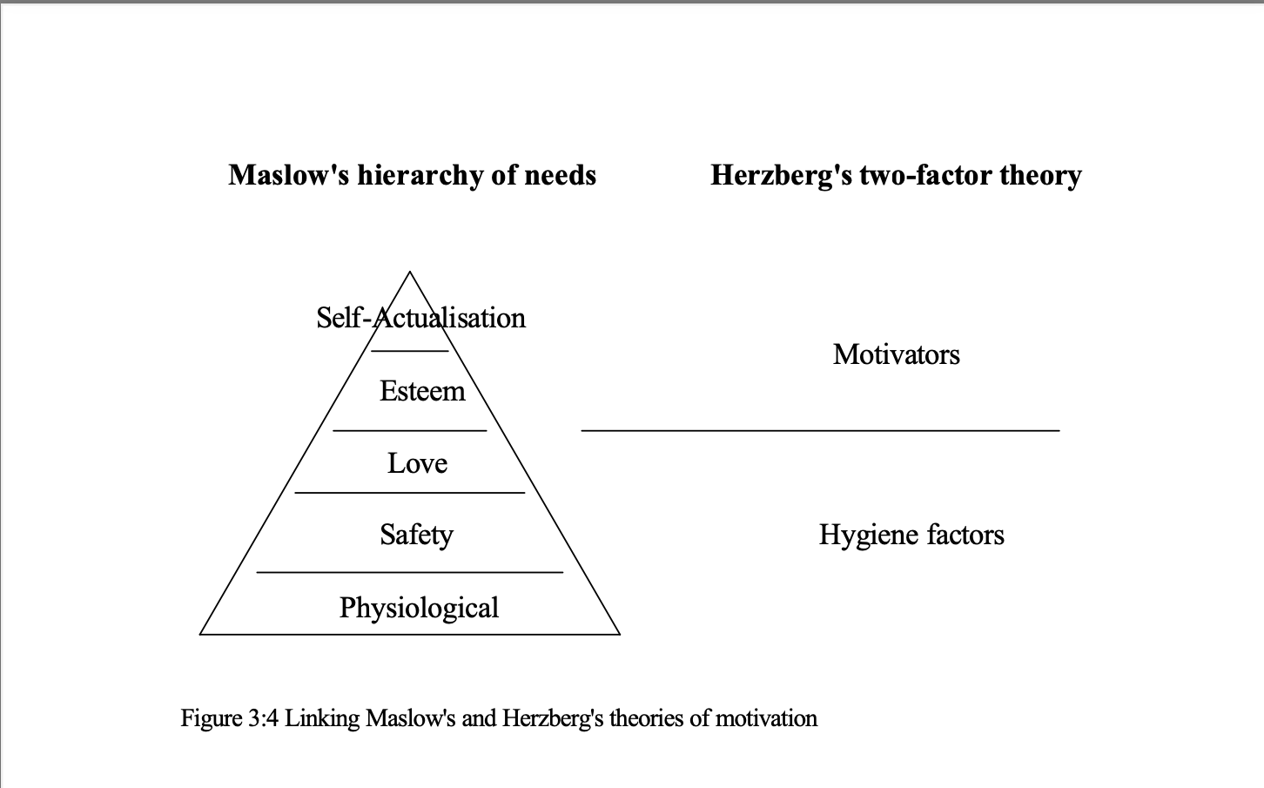
(Source: Porter, 2003)

Employee engagement base of Wiggle
In today's competitive business environment, organizations need active employees who are quick to adapt, responsive and engage (Uddin, 2019). Employees have a decisive influence on innovation, efficiency, competitiveness, and success (Bakker, 2008). There is no universal definition of employee engagement in the literature (Kular, 2008). "The concept of employee engagement as the integration of various behavioural components such as commitment (cognitive, affective and behavioural), commitment, attachment (rational and emotional), discretionary effort, deep connection, energy, positive attitude and psychological presence (attention and absorption), which leads the employee's potential to his results and is positively related to the success of the organization" (Gupta, 2016, p. 50). In short, "Commitment is a condition for employees to be intellectually and psychologically involved in the organization" (Azmy, 2019, p. 187). Employee engagement is a positive mental state related to work. Such an employee is characterized by vigour, dedication, preoccupation with work and organization. This behaviour goes beyond the demands (Uddin, 2019). Engagement is a two-way process in which an organization must put extra effort into employee engagement, and in return, engaged employees voluntarily commit effort to the organization's goals and values (Gupta, 2016). Highly engaged employees effectively invest their emotional, behavioural, and cognitive resources into the task (Balwant, 2019).
At Wiggle, many factors influence employee engagement. Support from superiors is a form of actively and proactively motivating employees to engage and improve performance in the form of commitment to work (Azmy, 2019). Leadership plays a key role. Each shift has a manager, team leaders and coordinators. Despite many superiors, work could have been more organized. Engagement decreases when they see chaos and a lack of logic (Azmy, 2019). The manager listens to employees and makes them feel important, which leads to employee engagement. Any employee can talk to the manager and express their opinion. It often ends with promises, not deeds. Employees make significantly less important decisions, such as where the Christmas Eve party will take place. One of the most critical issues in which employees had a voice was the change in the work schedule. Employees felt involved because their voices mattered. With the departure of the operations manager from the company, the idea of changing working hours was forgotten by managers (Gupta, 2016)
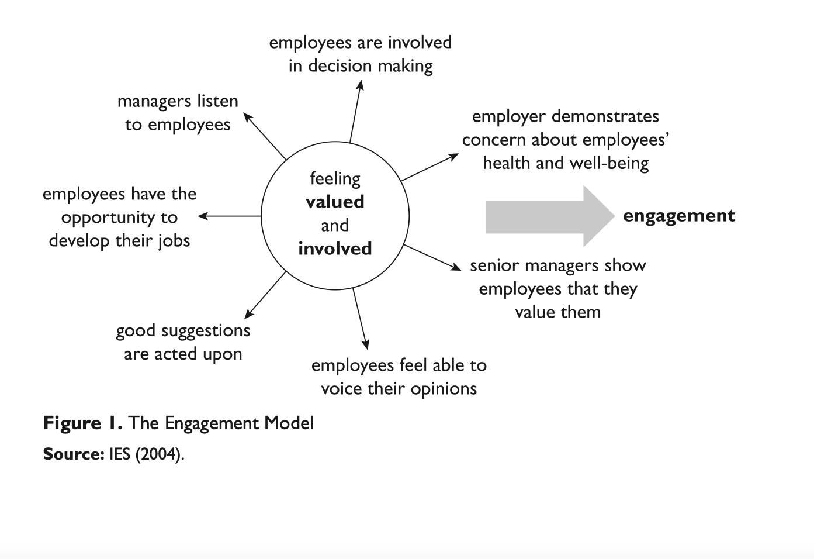
(Source: Gupta, 2016)
Wiggle provides training but is mostly still confined to the warehouse operator role. Sometimes it is nice to get away from what employee does every day, and it could be more developmental. The worker can be promoted, and two years ago, it was noticeable when a picker or packer became a coordinator but now company started reducing management. As a result, the involvement of employees has been strongly weakened because they need to see the possibility of development. Employees should achieve a performance 80% every day. Every time they have the required minimum or more, the manager or team leader praises them verbally, and when the employee does not have the required minimum must explain why. The superiors understand and try to help. It improves commitment because when workers get help, they try harder. There is also an annual appraisal where the employee is assessed, and a career path is planned but workers saw neither the grade nor what they wanted to achieve mattered. Unfortunately, the lack of communication is the main problem. Only three times per year at a meeting of all employees, it is presented what company have achieved, what want to achieve and what changes will be made. This makes more rumours than truth and certainly does not improve employee engagement. All employees are treated equally, but there are situations where one employee is allowed to do something, and another is not allowed. In such situations, employee engagement decreases. Wiggle stands out because the hourly wage pays more than the minimum and has many benefits, such as a private gym, pension, free hot and cold drinks, party, gifts, and cash bonuses. It strongly affects the involvement of employees because the conditions are good. Health and safety conditions are at a high level and employees feel safe. If an accident occurs, employees are informed about what has happened, and all information on how to improve safety at work is given. This improves engagement. The company is average family friendliness and work-life balance. Wiggle works in strict hours from 6-23 seven days a week. It is impossible to have flexible working hours, so reconciling work and studies is impossible because days off are movable. As a result of this engagement drops sharply, and workers often must choose between work or education. Wiggle also engages its employees by giving them shares. The company has many factors that positively affect the involvement of employees, but many still need to be worked on so that employees are satisfied with their work, have a high level of commitment, can develop, and thus do not want to leave the organization (Gupta, 2016).

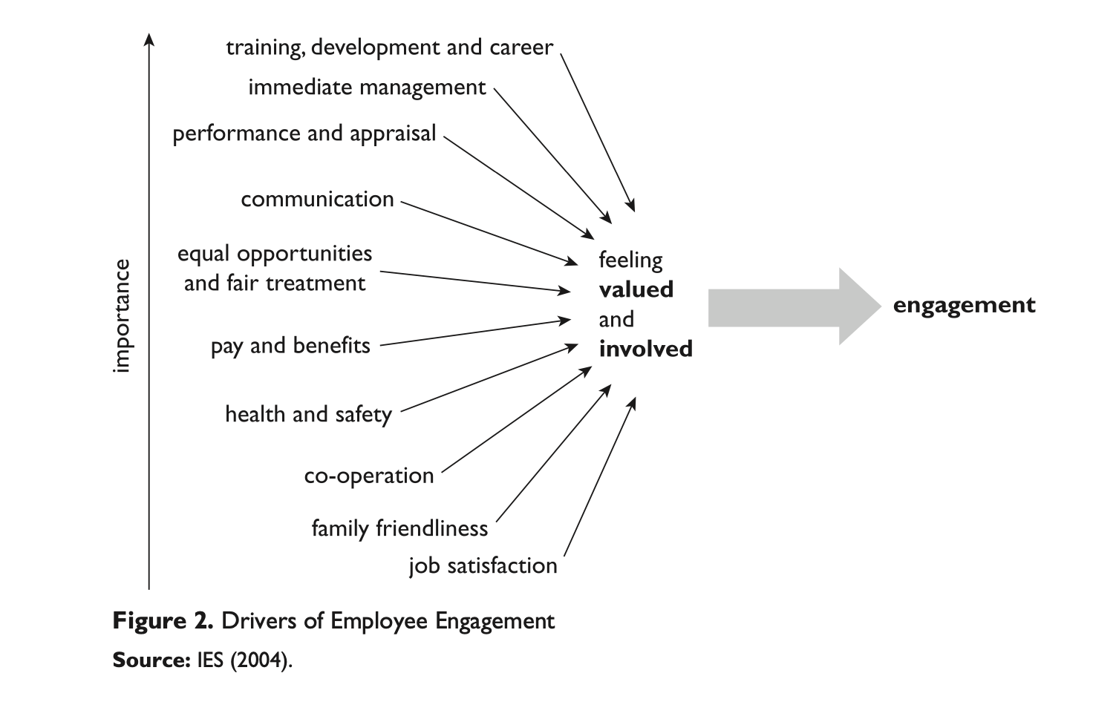
(Source: Gupta, 2016)

Reward base on Wiggle
Rewards play a paramount role in improving performance. A carefully designed reward system can significantly increase organisational performance (Akafo,2015). The reward is the total aggregate amount of monetary and non-monetary remuneration (Akafo, 2015). "Successful reward policies make a material difference to the performance of an organisation” (Armstrong, 2010, p11). In all organisations, rewards play an essential role in creating and sustaining effective engagement that leads to improved performance and job stability (Hadžiahmetović, 2017).

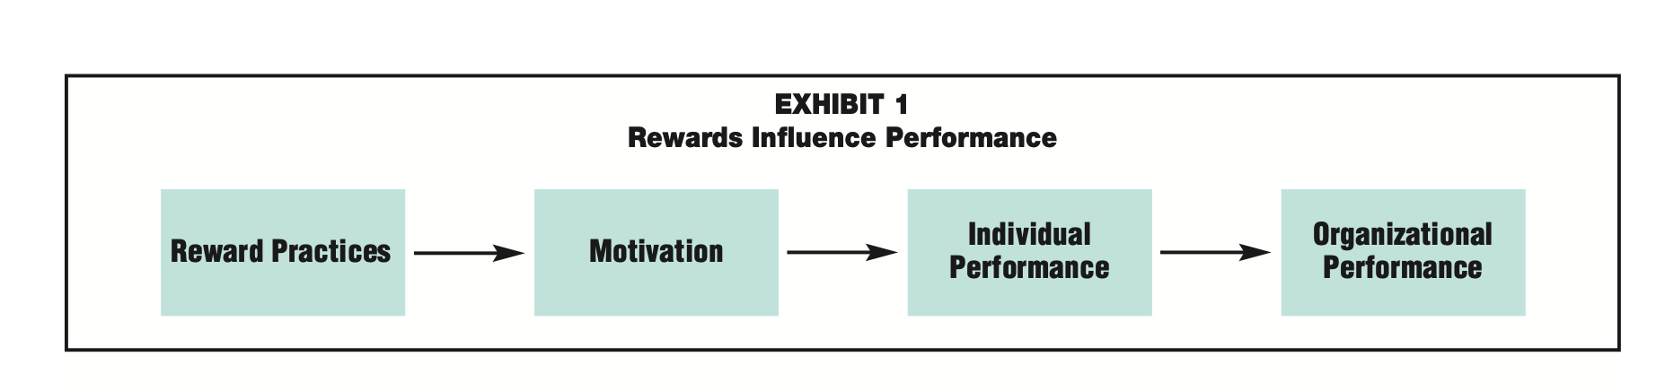
(Source: Allen, 2001)

Organizational rewards fall into three categories: organizational reward, social reward, and intrinsic rewards (Hadžiahmetović, 2017).
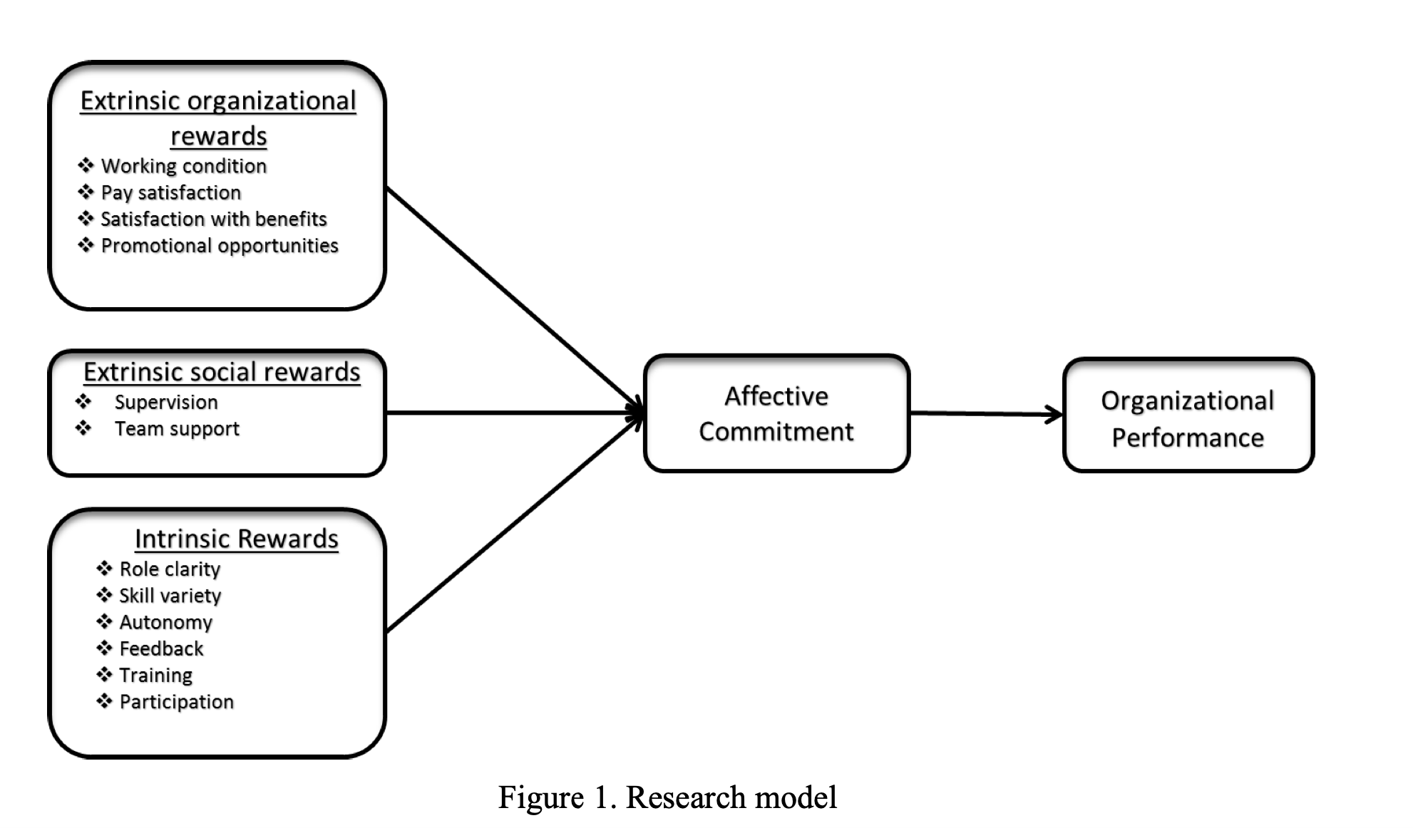
(Source: Hadžiahmetović, 2017)

Reward systems are essential for an organisation because each employee's performance is important. Employees need encouragement. (Allen, 2001).
Rewards also affect Wiggle's performance. The company's employees earn more than the minimum wage, which increases yearly. When workers were not informed of the amount of the raise on April 1, their productivity declined. During the lockdown, when stores were closed, Wiggle saw a significant increase in orders. As a reward for those who worked overtime, there was an extra cash bonus for each day worked. Back then, employees were more willing to work overtime, and the company could ship orders to all customers. Also, during this period, the company had huge profits, and each employee received a cash reward in exchange for hard work. It positively affected employees, but when the company did not pay any bonuses a year later, employees were disappointed and less motivated to work. It was reflected in individual results that had an impact on the performance of the organisation. Money is often only one of many rewards a person seeks through employment. (Francis, 2011). In Wiggle, two years ago, there was a real chance for promotion, but this year, with the reduction of employees, this chance is much smaller. The best employees with the highest results, good behaviour and low absenteeism as a reward cannot count on promotion. Employees who feel they cannot develop themselves often decide to leave. It can be said that non-financial rewards, such as training and development programs, increase the organisation's performance (Francis, 2011). Wiggle for high-performing employees provides training in other departments. However, in practice, it looks like the employee received training as a reward, but he is rarely sent to another job because it is hard to replace them. A piece-rate wage system where pay is mechanically linked to performance. It would bring a high degree of labour productivity and invariably significantly increase efficiency (Francis, 2011). Wiggle used this method for a short time. Employees certainly worked harder because they could earn more. However, the company withdrew from it without giving any explanation. The peer review method can be used in employee reward, where the employee evaluates his or her colleague (Francis, 2011). In the company, this was used and positively impacted because such an employee received a gift, and everyone had the right to vote.
Employees' positive perception of the reward strategy influences their attitude towards the organisation. The rewards system plays an essential role in stimulating employees to innovate. The best way to ensure the continued profitability of companies in challenging economic conditions is to focus on rewards management and organisational performance (De Waal, 2013). Therefore, reward systems are essential for organisations. Although reward systems can attract the right employee, retain them, and constantly motivate them to achieve the desired results, a poorly structured reward system can result in high employee turnover and low productivity and thus affect the performance organisation (Ngwa, 2019)

Personal Development Plan
PDP is used to control the development of employees' competences in the company. Employees should educate, develop, and improve their competences by using PDP as a reflection tool (Beausaert, 2013).
Personal development plan for an employee in the position of a warehouse operator. The main goal is to become a shift manager in 2028-2030, but before that, the table below shows the career path. To become a manager, worker must have the appropriate skills, knowledge, and experience.

OBJECKT | TIME | ACTIVITIS | Skills and knowledge CRITERRIA | RESOURCES
SHORT TERM
University graduation- Business and Management. | September 2021-September 2024 | Attending classes, performing homework, activities, assessments, preparing for written exams, tests, interviews, reading literature related to studies. | Completion of levels 4, 5 and 6 with a minimum Merit score, awarding a diploma. Gaining theoretical knowledge - business and management | Laptop, internet, access to the library, access to programs such as Microsoft office.
Applying for trainer position. | December 2022- March 2023 | Applying for the position of a trainer by completing the application and submitting CV created for the position, preparing for an interview. | Participating in a job interview, getting a job, collect experience such as teaching, mange people | Laptop, internet, access to a program for creating CV
Excel course | January 2023- July 2023 | Learn advanced excel, Finish Excel Training Courses on Systematix | Learning advanced Excel and obtaining a certificate, then refresh knowledge each month | Using access to In learning at the university, laptop, internet, purchase of a course on Systematix
Applying for coordinator position. | October 2023-May 2024 | Applying for the position of coordinator by completing the application and improving CV through the experience gained as a trainer and completing the Excel course | Participating in a job interview, getting a job. Collect experience manage job, time, people. Cerates excel reports. Simple solve problems, talk to workers. | Laptop, internet, access to a program for creating CV
LONG TERM
Master's degree business and management | January 2025-Janiary 2026 | Attending classes, performing homework, activities, assessments, preparing for written exams, tests, interviews, reading literature related to studies. | Completion of Master with a minimum Merit grate, awarding a diploma. Gaining theoretical knowledge - business and management | Laptop, internet, access to the library, access to programs such as Microsoft office, participation in additional courses.
Applying for team leader positions. | January 2025-January 2026 | Applying for the position of team lieder by completing the application and improving CV through the experience gained as a trainer, coordinator, diploma BA, Master and completing Excel course | Participating in a job interview, getting a job. Collect experience menage people, solve problems,  organizing work, communication skills, delegating task and motivation workers. | Laptop, internet, access to a program for creating CV, Diploma, certificate Excel course

Conclusion
Motivating, engaging, and rewarding employees is important nowadays. Without these three things, a company cannot achieve performance because employees are the most important thing in an organization. There is no organization without employees. The wiggle company in the above-mentioned aspects still has a lot to improve, but also has many aspects that positively affect its employees.
The created PDP shows the career path that must be followed to become a manager in the company in the future.

Reference list

- Akafo, V. and Boateng, P.A., 2015. Impact of reward and recognition on job satisfaction and motivation. European Journal of Business and Management, 7(24), pp.112-124
- Allen, R.S. and Helms, M.M., 2001. Reward practices and organizational performance. Compensation & Benefits Review, 33(4), pp.74-80.
- Anku, J.S., Amewugah, B.K. and Glover, M.K., 2018. Concept of reward management, reward system and corporate efficiency. International Journal of Economics, Commerce and Management, 6(2), pp.621-637.
- Armstrong, M. (2007) A handbook of employee reward management and practice [electronic resource]. 2nd ed. Philadelphia:; London ;, Kogan Page.
- Armstrong, M., Brown, D. and Reilly, P., 2010. Evidence-based reward management: Creating measurable business impact from your pay and reward practices. Kogan Page Publishers.
- Asaari, M.H.A.H., Desa, N.M. and Subramaniam, L., 2019. Influence of salary, promotion, and recognition toward work motivation among government trade agency employees. International Journal of Business and Management, 14(4), pp.48-59.
- Azmy, A., 2019. Employee engagement factors in a higher education institution. Binus Business Review, 10(3), pp.187-200.
- Badubi, R.M., 2017. Theories of motivation and their application in organizations: A risk analysis. International Journal of Innovation and Economic Development, 3(3), pp.44-51.
- Bakker, A.B. and Schaufeli, W.B., 2008. Positive organizational behavior: Engaged employees in flourishing organizations. Journal of Organizational Behavior: The International Journal of Industrial, Occupational and Organizational Psychology and Behavior, 29(2), pp.147-154
- Balwant, P., 2019. Stay close! The role of leader distance in the relationship between transformational leadership, work engagement, and performance in undergraduate project teams. Journal of Education for Business, 94(6), pp.369-380.
- Beausaert, S., Segers, M., Fouarge, D. and Gijselaers, W., 2013. Effect of using a personal development plan on learning and development. Journal of Workplace Learning.
- De Waal, A. and Jansen, P., 2013, April. The bonus as hygiene factor: the role of reward systems in the high-performance organization. In Evidence-Based HRM: A Global Forum for Empirical Scholarship. Emerald Group Publishing Limited.
- Francis, A.O., 2011. Reward economics and organisation: The issue of effectiveness. African Journal of Business Management, 5(4), pp.1115-1123.
- Gupta, N. and Sharma, V., 2016. Exploring employee engagement—A way to better business performance. Global Business Review, 17(3_suppl), pp.45S-63S.
- Hadžiahmetović, N. and Dinç, M.S., 2017. The mediating role of affective commitment in the organizational rewards–organizational performance relationship. International Journal ofHuman Resource Studies, 7(3), pp.105-130.
- Kular, S., Gatenby, M., Rees, C., Soane, E. and Truss, K., 2008. Employee engagement: A literature review.
- Mukhopadhyay, B.R. and Chatwin, C.R., 2020. The significance of Herzberg and taylor for the gig economy of China: Evaluating gigger incentives for Meituan and Ele. Me. International Journal of Applied Behavioral Economics (IJABE), 9(4), pp.1-17.
- Ngwa, W.T., Adeleke, B.S., Agbaeze, E.K., Ghasi, N.C. and Imhanrenialena, B.O., 2019. Effect of reward system on employee performance among selected manufacturing firms in the Litoral region of Cameroon. Academy of Strategic Management Journal, 18(3), pp.1-16.
- Porter, L.W., Bigley, G.A. and Steers, R.M., 2003. Motivation and work behavior.
- Uddin, M.A., Mahmood, M. & Fan, L. (2019) Why individual employee engagement matters for team performance?: Mediating effects of employee commitment and organizational citizenship behaviour. Team performance management. 25 (1/2), 47–68. doi:10.1108/TPM-12-2017-0078.

