The interrelation of Autism, Art and Glitch Photography.

Gwilym Rhys Morris P146267
Submitted in partial fulfilment of the requirements
for the degree of BA (Hons) Photography in the Arts

University of Wales Trinity Saint David, Swansea

Dissertation Supervisor: Ryan Moule

Table of Contents

Synopsis 4

Chapter 1: What is Autism? 5-7

Chapter 2: The Link between DNA, Genetics and Autism 8-10

Chapter 3: The Correlation between the Artistic Mind and Autism 11-13

Chapter 4: Art Movements 14-16

Chapter 5: Glitch and Autistic Photography 17-24

Chapter 6: My Own Body of Work 25-39

Chapter 7: Conclusion 40-45

Appendix 1: Computer Code Comparison Tables 46-47

Bibliography 48-63

List of Illustrations

Figure 1: Autistic Spectrum Disorders 5
Figure 2: Characteristics of Autism/Asperger Syndrome 6
Figure 3: From series Mountain Tour, 2010. 17
Figure 4: From series Mountain Tour, 2010. 18
Figure 5: From series Mountain Tour, 2010. 18
Figure 6: From the series City of Vapors, 2015. 19
Figure 7: From the series The Inner Resonance of Things, 2011-2015. 20
Figure 8: From the series City of Vapors, 2015. 20
Figure 9: Wood Mouse Exploring, 2015-2017. 21
Figure 10: Land of the Lowering Sunset, 2015-2017. 22
Figure 11: Emotional Edge, 2015-2017. 22
Figure 12: Space Rainbow, 2015-2017. 23
Figure 13: Untitled, 2010-2013. 24
Figure 14: Untitled 1, 2017. 26
Figure 15: Untitled 2, 2017. 26
Figure 16: Untitled 3, 2017. 30
Figure 17: Untitled 4, 2017. 30
Figure 18: Untitled 5, 2017. 31
Figure 19: Untitled 6, 2017. 31
Figure 20: Obscured, 2017. 34
Figure 21: Erased, 2017. 34
Figure 22: Vision, 2017. 35
Figure 23: Eerie, 2017. 35
Figure 24: Overloaded, 2017. 36
Figure 25: Ghost, 2017. 36
Figure 26: Digitalised, 2017. 37
Figure 27: Eccentricity, 2017. 38
Figure 28: Fragmented, 2017. 38
Figure 29: Gaps, 2017. 39
Figure 30: Numeral systems conversion table, 2017. 46
Figure 31: ASCII control characters, 2017. 47
Summary: Synopsis

I plan within this dissertation to consider the relationship between autism and art, especially glitch art, being an autistic photographer interested in glitch photography. This dissertation will take a first person perspective from an auto-enthnographic position. I will provide insight into the nature of autism including potential genetic and other factors before considering the art movements that underpin autistic art. I will then focus on glitch and autistic photographers and conclude with my own body of work and evaluate the results.

Chapter 1: What is Autism?

Autism originally only included Kanner Syndrome, (classic autism) after Leo Kanner, (1896-1981). Typical Kanner characteristics are communication issues, general intellectual delay, little eye-contact, minimal social interaction and ritualistic/compulsive behaviour. Today classic autism is at the extreme end of an autistic spectrum of disorders (ASD) as shown in the diagram below.

(Fig.1) Autism as interpreted today – A Spectrum of Disorders

An individual classed as PDD has autistic tendencies, Brett’s Disorder affects girls while Asperger’s Syndrome is similar to Autistic Disorder but without language delay.

The autistic spectrum is vast and mysterious thus no-one understands it properly. Current understanding is a fragmented amalgamation of different theories but an autistic diagnosis requires a person to have difficulties with social skills, communication and show repetitive behaviour/interests. An autistic individual may also have - fine motor skill and behavioural problems, over activity, lack of empathy, speech problems, sensory sensitivity, dyslexia, dyspraxia and/or ADHD. The impact of Autism can differ greatly between being mildly and very severely affected.

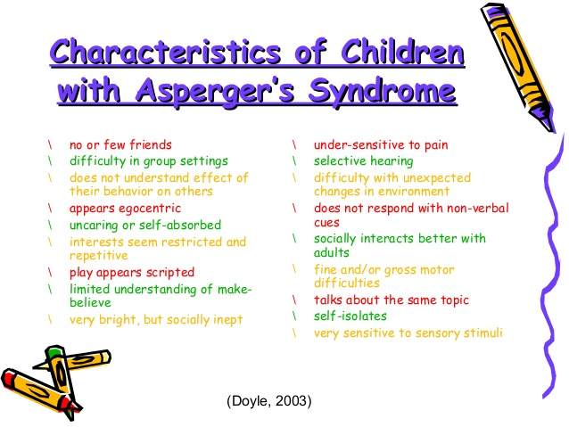

(Fig 2) Autism Spectrum Disorder in the Classroom

Autism is often seen as a disability, partially justifiable since autism can impede an individual from doing things others might take for granted. However autism encompasses such a huge array of characteristics that to fit all autistic people under one single "disabled" label is too simplistic. Furthermore, although some characteristics of Autism are disabling, others are advantageous including having an unorthodox, unique outlook on life. I think whether or not it is a disability ultimately depends on how badly it affects the individual concerned.
When you think of someone with autism....it might be someone with a special set of talents or unique skills – such as natural artistic ability or a remarkable memory.... enhanced abilities in engineering or mathematics, or an increased focus on detail.... people with autism spectrum conditions bring a whole range of valued skills and talents – both technical and social – to the workplace and beyond. Penny Spikins; (The Conversation, 2017).

I hadn’t given much thought to being autistic previously. I've had it all my life; it's my normality. On questioning others, I found they felt I had the following difficulties:
- Fine motor skills and writing problems
- Over-activity
- Inability to remain still easily
- Concentration difficulties
- Issues with staying awake in lectures and on buses
- Immaturity, playing around more than others
- Difficulty with elocution, weak language and verbal communication skills. Although my vocabulary is extensive, I can struggle with framing thoughts and ideas coherently. I also find talking on the phone problematic and struggle to initiate conversations.
- Inadequate social skills which leads to difficulty in making close friends.
- Some repetitive and obsessive behaviour although this can be advantageous for anime and gaming.
The above characteristics are all obvious but others are subtler. I sense I'm unlike others but I'm not sure how. I consider this valuable since I believe I have a unique, creative perspective, an opinion developed through feedback from lecturers.
Chapter 2: The Link between DNA, Genetics and Autism

Autism and its causes is ambiguous but there’s strong evidence that there are associated genetic and environmental factors although "researchers disagree on the relative contributions of genes and environment." (Zeliadt, 2017)

Genetically autism occurs because of variations within our DNA. Although it’s argued that some cases of autism are due to ‘genetic mistakes’, most cases are hereditary. My own half brother and sister have autism. "Researchers have known that genes contribute to autism since the 1970s, when a team found that identical twins often share the condition". (Zeliadt, 2017) There’s no specific autistic genes but “the list of genes implicated in autism is growing. Researchers have tallied 65 genes they consider strongly linked to autism, and more than 200 others that have weaker ties. Many of these genes are important for communication between neurons or control the expression of other genes." (Zeliadt, 2017)

According to The Dna Dilemma, Why Science wants your Genome, the smallest variations in genetic code can mean the difference being autistic or otherwise. Understanding genetics "may eliminate genetic mutations and cure disease.” (The Globe and Mail. 2017).

Such developments could have implications for treating or preventing autism, however autistic traits such as exceptional memory and heightened senses can be advantageous. “All human evolution was driven by slightly autistic Asperger’s and autistic people. The human race would still be sitting around in caves chattering to each other if it were not for them.” (The Conversation. 2017).

There are obvious ethical concerns about ‘playing god’. Genetic Modification can cause discrimination. Treating some genetic structures as superior might lead to 'designer babies' altered for desirable genetic characteristics. We also lack understanding of its long-term implications. I believe we should look at the positive characteristics of autism rather than thinking about fixing it or eradicating it.

According to an article in the Independent titled Autism Genes Conserved during Human Evolution to make us Smarter say Scientists; a 5000 case study found that autism genes help make us smarter and are linked to brain and intellectual performance . The Centre of Disease Control (CDC) suggests that ASD gene inheritance is actually a positive process of natural selection. "Accordingly, we hypothesize that certain ASD risk alleles were under positive selection during human evolution due to their involvement in neurogenesis and cognitive ability”.(Cdc.gov, 2016)

Indeed, Juan Enriques, a Harvard scholar and geneticist argues that technology reveals that with autism "rapid evolution may be under way". (Enriques, 2012). He notes that there’s been a 78% increase in autism diagnoses between 2000–2008, only half being due to improved detection and awareness, the rest ascribable to a real growth in the number people with autism.

Enriques maintains that this growth is the result of rapid evolutionary changes due to the need to adapt to excessive stimulation in today’s society. He believes this means we are in the process of evolving into a brand new species. (Washington Post 2014)

Chapter 3: The correlation between the artistic mind and autism

From personal experience and research art has special appeal for many autistic people. There are organisations supporting and encouraging autistic artists such as Create Arts for Autism which "aims to dispel the myth that people with autism cannot be creative and to show that art can significantly improve their quality of life, facilitating experiential-based learning and instilling life-long skills." (Art for Autism 2017)

Art for autistic people can be a tool for communication; we struggle with words and phrases. Art allows us to express feelings about ourselves and the world. “Art gives me a way to speak deeply with other people without using words”. (Mullin, p24) Art is a way of 'talking' and helps alleviate the intense frustration of not being able to make ourselves understood. It can keep us calm and happy in the face of sensory overload, providing a way to open ourselves up to the world in general and to ourselves in particular.

Autistic people struggle to understand the rules of society but this can be freeing for our artwork. We aren't tied down by conventions or what is popular. Autistic art tends to be either ultra realistic due to our good memory skills and special interests, or it’s perplexing, colourful, and chaotic.

Art can be a way of sharing our divergence while highlighting that difference as beautiful. A way of showing that we are creative and unique and that it's actually good. Autism gives me freedom. Being less aware of 'normality' means I don't feel driven to conform. It’s also a medium to bring “hope and confidence and joy and encouragement to all those with autism and disabilities.” (Mullin, 2016, p111)

I value being a bit chaotic and eccentric and enjoy showing this within my photography. This may be why I have an interest in Glitch Art which is exciting as the result is unpredictable. Experimenting with code is interesting since it can easily destroy an image but it might also create something wonderful, with convoluted patterns and colour combinations.

I believe Glitch Art is especially representative of autism, our vision is different rather than erroneous. We see things in a way that others would struggle to understand and consider distorted and strange. I believe the closer one looks at Glitch Art the more it tells us about the artist and autism. It may reflect a strong interest in pattern, repetition and shape, typical autistic traits. It shows the subject matter in a strange, fragmented yet wonderful way which may provide some insight into what it's like being autistic.

According to the ‘Thompson Centre for Autism and Neurodevelopmental Disorders’ (Autism Speaks,2017) "in order to truly understand the perspective of young people with ASD, who struggle with limited communication and fears, we needed to think outside the box to help them share their stories. Giving them cameras so they could tell their stories through images allowed us to determine what these young adults thought and felt." (Autism Speaks 2017) This project is called Photovoice.

Having given a brief introduction to why art benefits autistic individuals, I will look at artistic movements that have underpinned the work of autistic artists.
Chapter 4: Art Movements

Art has always been a way to share not only feelings and interests but also ideas on such subjects as religion, politics and culture, interpreted according to personal perspectives. Art has changed throughout history, with new movements born and new fashions and ideas emerging.

Initially, art focused on historical and religious scenes or portraits of important people displayed in their best clothes, all painted in the studio over a long period of time.

In the 19th century the focus shifted to realism expressed in as detailed a way as possible. The impressionist movement concentrated on capturing the real life of ordinary people at a given moment, painting outdoors for a truer representation of life both in the countryside and town. They used small dabs of different coloured paint to imitate reality and their reactionary use of light and colour makes their images seem true to nature.

Over time however it was felt that this style did not capture the feeling of the 'modern' industrial age. This emphasis on progressive thinking gave rise to Modernism in the 1850s. Artists experimented with modern formats, techniques and materials. They despised what they deemed romantic fantasies and tried to show true reality through the use of shapes, colour, lighting and structure.

In the 1960s abstract art became popular. The aim was to give an impression of the object, rather than a copy. At first, this object was still recognisable because the distortion was slight. However, under Cubism, blocks were used to represent different perspectives, deconstructing reality to show all elements of the subject. The finished art has little resemblance to the original scene or object.

Abstract art eventually evolved until the subject was no longer recognisable. This art depends on the effective use of materials, shape, lighting and colour to impact our senses, thoughts and emotions. Minimalism belongs to this subject-less genre as its art is composed solely of simple shapes made of modern materials.

The Postmodern era, from the 1960s onwards, is freer, with its underlying principle that 'anything goes'. It's based on the theory that the world is complex and cannot be easily defined or explained. There are no set rules, no universal truths. “Modernist devised new windows on the world, postmodernists offered a shattered mirror." (Adamson G and Pavitt J). It recognises that art doesn't need a purpose or function. It can be appreciated simply for being funny, pretty, ugly or outlandish. Art can simply be art. Postmodernism is especially suited to my work since I value freedom. Restricting art with set rules is counterproductive, Glitch art is fundamentally Postmodern.

“Anti-authoritarian by nature, postmodernism refused to recognise the authority of any single style or definition of what art should be. It collapsed the distinction between high culture and mass or popular culture, between art and everyday life. Because postmodernism broke the established rules about style, it introduced a new era of freedom and a sense that ‘anything goes’. Often funny, tongue-in-cheek or ludicrous; it can be confrontational and controversial, challenging the boundaries of taste; but most crucially, it reflects a self-awareness of style itself. Often mixing different artistic and popular styles and media, postmodernist art can also consciously and self-consciously borrow from or ironically comment on a range of styles from the past”. (Tate,2017

Photography is not rarefied, being open to everyone, but there’s a difference between snapshots and photographic art. Cameras were originally valued for reproducing exact copies of a subject, over time they become increasingly capable, encouraging photographers to experiment thus creating beautiful, unusual and surreal images. This pushed the boundaries of photography.

Today it's even easier to be creative since most cameras are digital. Everyone can manipulate images in the editing process. One example is glitch photography where images are distorted to form abstract photographs. Glitch photographs can be created through Data Bending either by Reinterpretation (file conversion to a new format), Sonification (non-musical to musical file conversion), Forced Errors (corrupting/breaking images for unusual effects) and Incorrect Editing (modifying files using programmes designed for a different file format e.g. JPEG into Word).

Digital editing provides huge levels of freedom and possibilities for creativity and expressiveness but the focus on realism is still important to photography.

Chapter 5: Glitch and Autistic Photography

GLITCH PHOTOGRAPHERS

Kim Asendorf (MA) (1981-) is a renowned German Multimedia Artist. He studied Media & Social Hacking, Net.art, New Media Art and Creative Coding at the Kassel School of Art and Design and invented Pixel Sorting, an image-altering algorithmic system. Kim likes Glitch Photography for its experimental, subversive nature, combining technology and aesthetics to create intense colour combinations and unusual patterns. His 'Mountain' Series (2012), presents abstract and strikingly beautiful photographs of untouched, serene, and majestic mountain ranges. They look magical, unearthly and alien through distortion, strange colour combinations and unusual patterning.
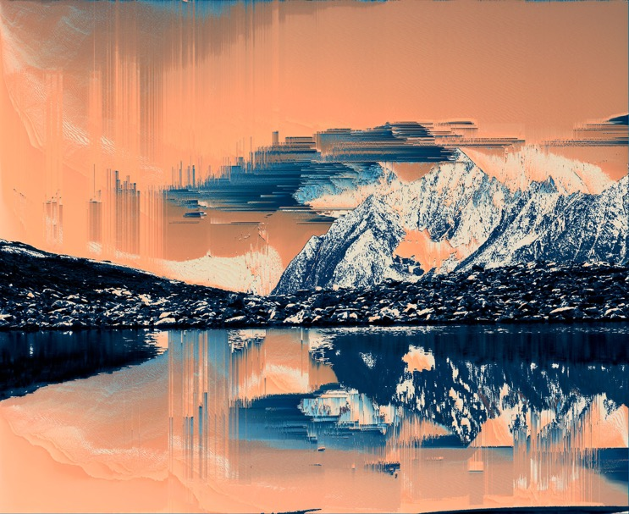
(Fig 3) Asendorf, K. (2010) from series Mountain Tour
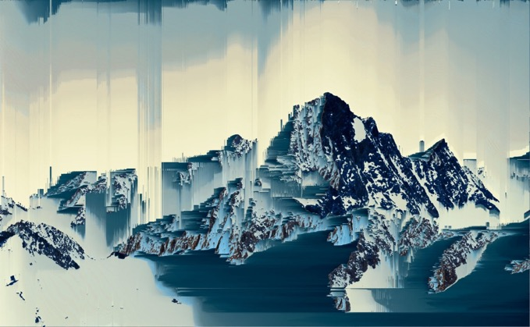
(Fig 4) Asendorf, K. (2010) from series Mountain Tour, 2010
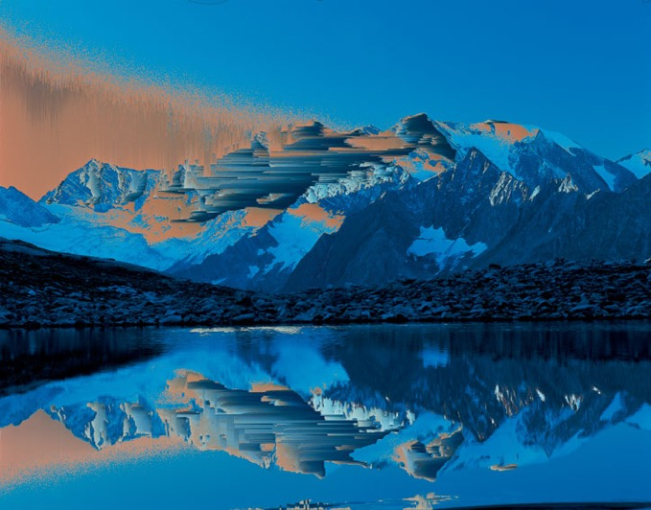
(Fig 5) Asendorf, K. (2010) from series Mountain Tour, 2010

Sabato Visconti (1985-) is a Brazilian multimedia artist living in America. He likes glitch art for its unpredictability and the excitement of creating something new and beautiful through destruction, deconstructing traditional concepts of beauty to push the boundaries of what's acceptable. He believes glitch photography reveals the underlying coded logic behind reality. He experiments with different, constantly evolving glitch techniques.

His work is sombre, focusing on issues like death, destruction, heartbreak and lost innocence. The photographs are striking, some grotesque and others beautiful, with chaotic, intricate, surreal and atmospheric scenes built from jagged lines, fluid organic shapes and a brilliant interplay of colour, tone and lighting.
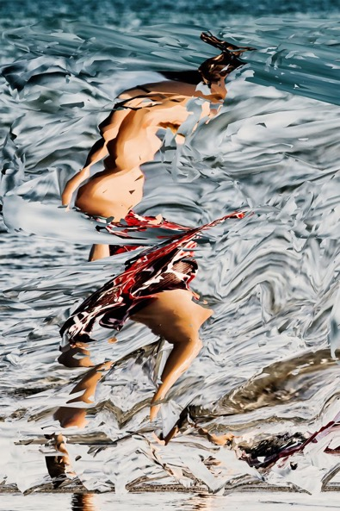
(Fig 6) Visconti, S. (2015) from the series City of Vapors,

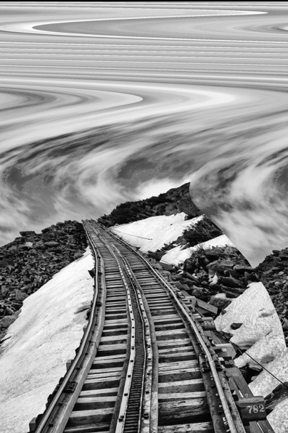
(Fig 7) Visconti, S. (2015) from the series The Inner Resonance of Things

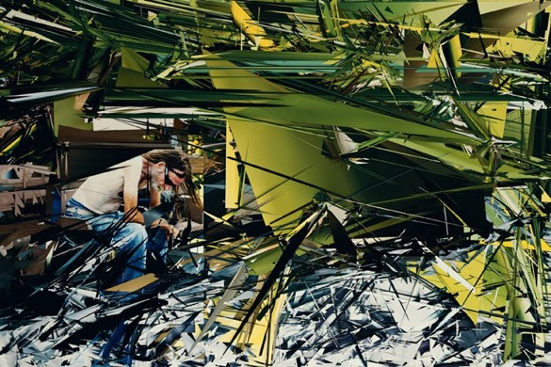
(Fig 8) Visconti, S. (2015) from the series City of Vapors
AUTISTIC PHOGRAPHERS

Reuben Brewer is a British autistic photographer who specialises in nature and landscape photography. He has Asperger’s Syndrome with the associated difficulties with communication and social skills and is therefore uncomfortable photographing people. He’s restricted in his subject matter being unable to travel far from home. He finds photography therapeutic in controlling the information or sensory overload. “When I'm in a safe zone, using my camera and going out in the garden to take photographs, or down to my local lake, I can improve my skills, and try my best to relax.” (Barnes,2014)

His animal and flower images are exceptional in their detail and his landscape photography is evocative. His photographs are atmospheric and colourful with interesting subject matter and effective composition.
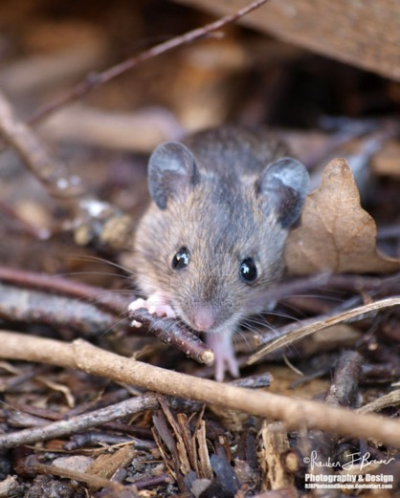
(Fig 9) Brewer, R. (2015) Wood Mouse Exploring,
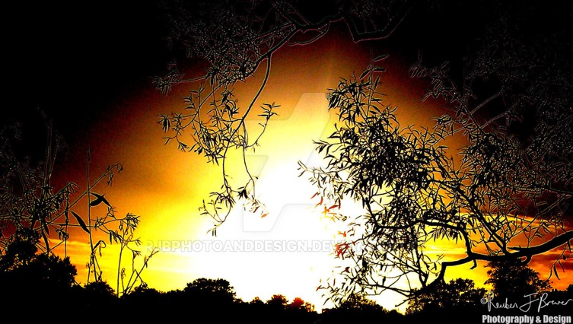
(Fig10) Brewer, R. (2015) Land of the Lowering Sunset, 2015

He also experiments with digital technology, generating glitch-like abstract effects. These photographs are beautiful, multi-hued, colourful and vibrant with strong definition and dramatic patterns.
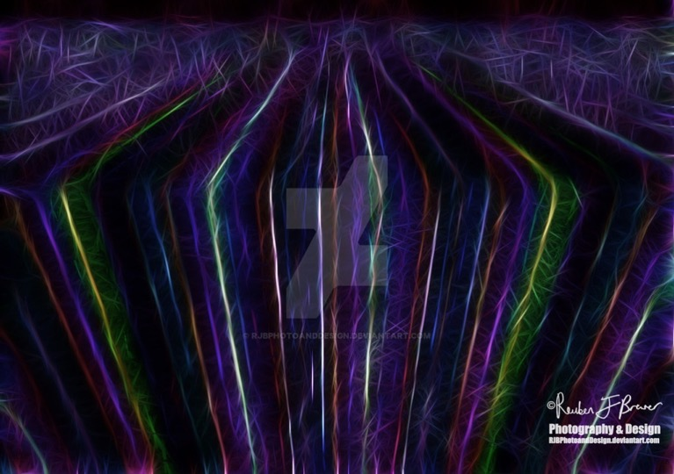
(Fig 11) Brewer, R. (2015) Emotional Edge 2015-2017
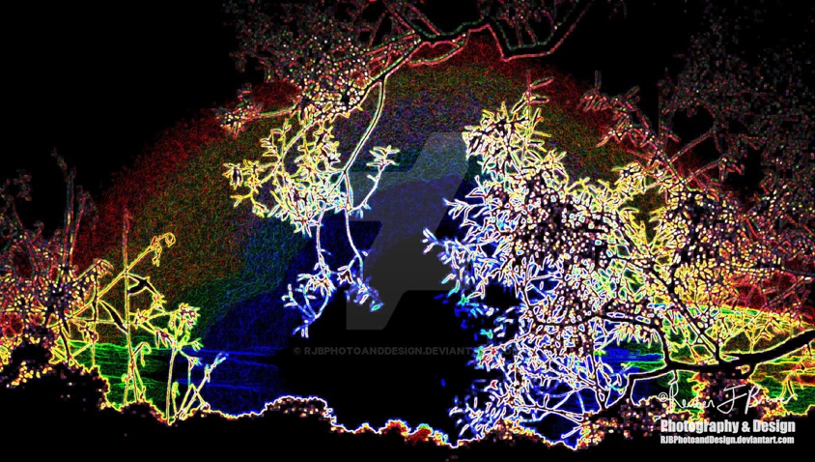
(Fig 12) Brewer, R. (2015) Space Rainbow, 2015-2017

Shauna Phoon is an Australian autistic photographer. She realised she was different from others but didn't understand how or why until she was diagnosed as autistic in her early 20s. This made her understand herself better and ended the feeling of isolation through knowing there were others like her. She's interested in the science of autism and had an MRI scan which showed that autistic people have inconsistent brain activity patterns. Her photographs highlight what being autistic is like, showing the vastness of the autistic spectrum with all its variations. She challenges autistic stereotypes and emphasises there’s no autistic 'norm' since everyone is unique. Her most notable series is The Absence of Normal – Faces of Autism.

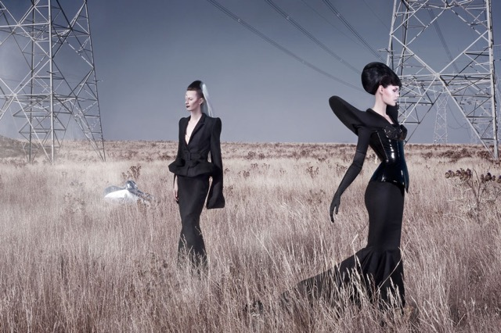
(Fig 13) Phoon, S. (2010) Untitled,

Her work is especially interesting since I'm researching the connection between art and autism. The above photograph is dramatic, surreal, melancholic and wonderful. It emphasises how autistic people can be physically close to others but still feel disconnected.

Chapter 6: My own body of work

I decided to continue a project I undertook last year focusing on the interrelation between autism and art. The aims were twofold as I hoped to learn more about myself while sharing my understanding of autism and my world through photography. It made me consider autism in a way I had never done before, making me realise how autism affected me and other artists and how much we differed from non-autistic people.

I wanted my images to show these differences as effectively as possible and saw glitch photography as the best option. Glitched self-photographs are appropriate since they show that I’m different and that I see the world around me in a unique way. Glitch art is experimental and ever-changing with unpredictable results.

The dissertation is subjective, taken from my own perspective as an autistic artist. Glitched self-portraits seem most appropriate for this very personal theme. They help show that I look at the world in a fragmented, unusual way due to my autism. I decided that a revealing base self-portrait was needed, showing not only my appearance but also indicating my habits and nature. I would then distort and fragment this image to create a range of photographs illustrating the interrelation of autism and art/glitch art.

In common with many autistic people, my problems with communication make it difficult for me to take photographs of people. I had asked a fellow student to take my base photograph for a previous project, but decided to take my own for this exercise. I took some 40 photographs before I was sufficiently happy with two of them.
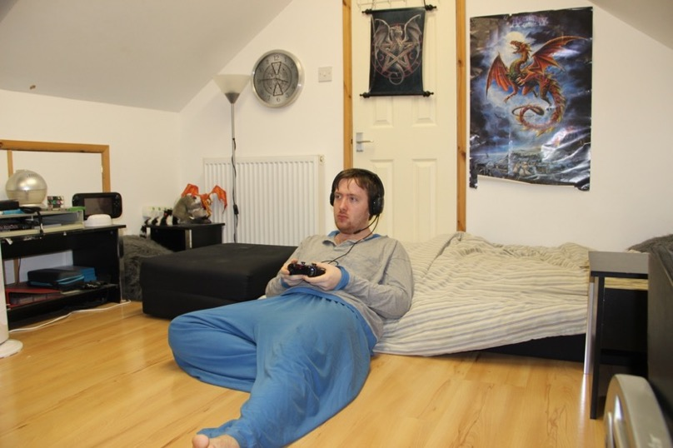
(Fig 14) untitled 1, 2017
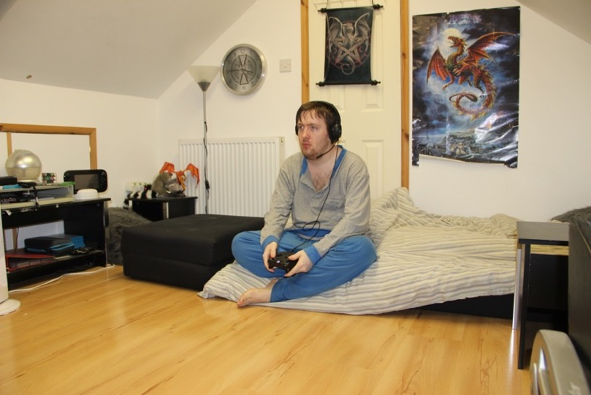
(Fig 15) untitled 2, 2017
I wanted the photographs to be true and honest self-portrayals, warts and all, thus was determined to pose as naturally as possible. My expression and posture are typical representations of me at home. The images show something of my character and nature. I look slightly dazed and tired, a normal state given that my sleep habits are bad. My normal expression is as shown – unsmiling and dispassionate. I dislike bathing or shaving so my hair is greasy and unkempt and I have facial stubble. Incidentally, people with autism tend neither to care about appearance nor how others see them since they don't relate to others in the same way. I tend to live in my own world and I struggle to see or care how others view me.

The photographs were taken in the loft, my retreat, a place of safety belonging only to me. This is my habitual place to be when home as the peace and solitude appeals to me. Socializing isn't easy for autistic individuals and I often need to be alone up there-usually relaxing cross-legged or sprawling on my sofa playing video games as shown. I have always had all-absorbing interests from an early age, in common with most autistic individuals, the most recent being dragons as seen from the poster on the wall and the ornaments in the background.

I’m wearing pyjamas since I enjoy the comfort they represent and I change into them as soon as I get home. People with autism have problems with sensory input, particularly sound, touch and taste, and one manifestation of this is my fussiness about clothes. I hate having my neck restricted so clothes must be baggy around the neckline or v-necked.

The headphones block out exterior sounds to prevent distraction and to enrich the experience I’m immersed in. They also suggest that my preferred interactions with people are online rather than face to face. I don't like going into crowded places, clubs or pubs. Communication is an issue for me and the headset makes the viewer think about communication and sound.

With these source images I planned to glitch them; distort them unpredictably representing how autism affects my personality, what I understand and do. The glitched images provide a visual representation of how other people view me, or how I think they do. The images also represent how my vision may be difficult for others to comprehend, appearing deformed, fragmented and bizarre.

My image in the photograph, obscured by the alterations created by the glitches, may reflect the fact that not everyone can understand me, including myself. I am somewhat hidden from the world, behind the barrier of autism, with a screen between me and others. I can still be identified since I’m still there, alive, real and fundamentally the same, but I'm superficially distorted and obscured. This is very effective, suggesting a block between me and the outside world.

Glitch art was my medium of choice both because I appreciate its unpredictability and because autism can make a person appear glitched to outsiders. Personally, I don’t consider myself glitched if that means there is something wrong with me; I think I’m just different. I do however accept that others might believe otherwise. It's a matter of perception and opinion. Glitching gives results that are exciting, surprising, mysterious and colourful with interesting patterns and effects.
For the editing process my first thought was to use TextEdit. With TextEdit, a photograph is converted into coding which is displayed on screen and this can be manipulated to create glitch effects either through moving code around, adding code or deleting it. "TextEdit is the simple and easy to use text editor for Windows that allows you view and edit HTML, CSS, JavaScript, PHP, PERL, SQL, Delphi, C, C++, and other languages source code". (Download.com, 2008)

Although the glitch effects were interesting, the resulting images all started to look the same so I searched for new solutions.

Through research I learnt that by altering the file format for an image to be TextEdited, this would alter the glitch effects. "Different files yield different results. Try playing with .PSD, .JPG, .GIF, .PNG, and other image files to see the different effects. " (Doc Pop's Blog, 2014) I decided to experiment and learnt that some formats were more effective than others, with TIFF, JPEG and JPF image files being highly compatible with glitching.

Glitching images in TIFF format caused the image to be divided into horizontal segments that were distorted, with colours changing or segments shifting. Interesting but a bit too basic. The colour change is dramatic and alien but bright, implying that the autistic world looks very different, but vibrant.
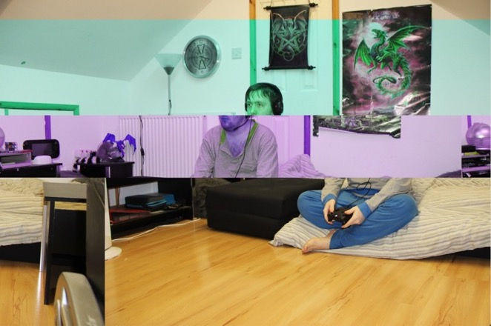
(Fig 16) Morris, G. untitled 3, 2017
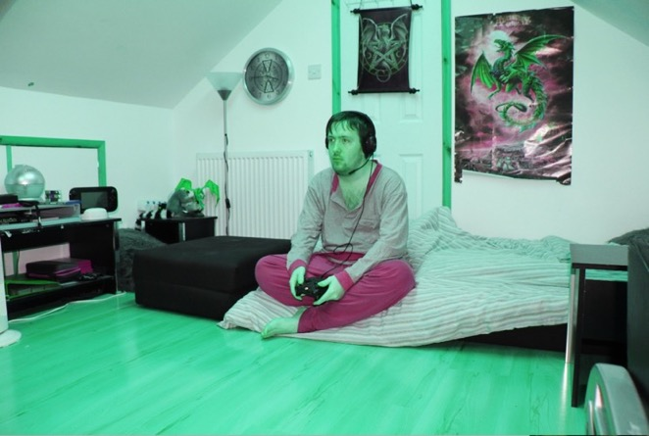
(Fig 17) Morris, G. untitled 4, 2017
The Jpeg format generated multi-hued horizontal lines that look very colourful, wild and interesting. These lines obscure me, separating me from the world, protecting me..
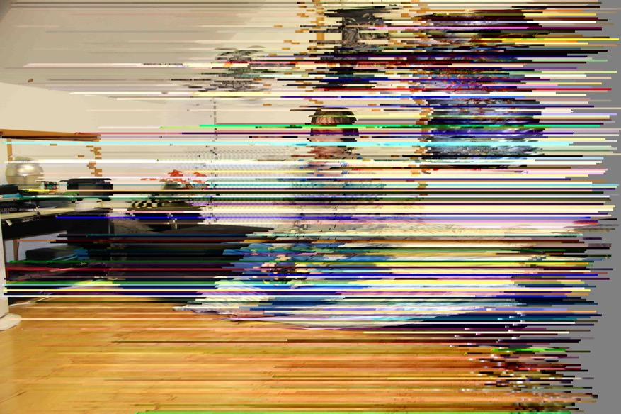
(Fig 18) Morris, G. untitled 5, 2017

Glitching JPF files always had an effect, dividing the image into a square lattice, any combination of which might be distorted and/or inverted, with the texture or colour altered. The distortion could be intense, creating a patchwork of bizarre, striking and interesting effects. Glitching effects are unpredictable, reflecting accurately my world as being wild, wonderful and free, full of pattern, texture and colour.
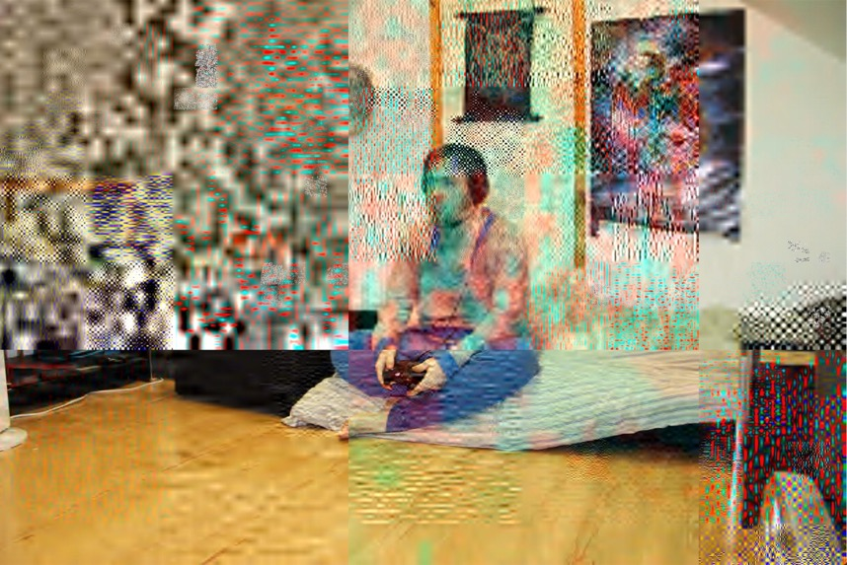
(Fig 19) Morris, G. untitled 6, 2017
Having experimented with TextEdit, I decided to try other editing programs to see their effects. I tried Audacity, an audio editing program which can be used to modify images. (Doc Pop's Blog, 2014) I didn't like it, maybe due to unfamiliarity with audio formats.

I then tried HexFiend, similar to TextEdit but using Hexadecimal code. HexFiend is amazing, offering extensive control over the glitching process including easy monitoring of glitch effects.

HexFiend struggles with large files: the glitching process can slow, the program can shut down, the computer processing speed can get reduced and the computer can crash! Conversely, large file types when edited have higher quality, so balance is needed. Another issue is the image can also get too distorted - not appropriate as I do wish the subject to be discernible. I need to show something of my autistic self with a filter between my world and that of others, not a total block!

I was pleased with Hexfiend. By using this, I was able to create many different, interesting, colourful results that seemed appropriate to the theme of my dissertation. They not only portrayed me but also showed what it's like being autistic. The overall glitch effects are similar to TextEdit but more consistent and intense.

I positioned the photographs in a 9 horizontal by 9 vertical slot grid, marking failures as an F within the grid. This was for the purpose of monitoring the photographs more effectively. I created 252 images that seem acceptable, some better than others with reference to their relevance to the dissertation and personal preference.
I include ten photographs, chosen as they best display the bright, colourful world in which I live while also emphasising that it’s separate from other peoples’. I’m separated from the viewer by a screen of distortion, thus suggesting a degree of miscommunication and isolation. It depicts my hidden world. I’m obscured but present within. The intense colour combinations and the juxtaposition of random repetitive patterns highlight that my world is bright and free but has underlying stability and predictability.

I’ve chosen the name "FACES" for my work because this has multiple connotations:
- The faces of autism
- To face myself
- To face the world
- The difficulty autistic people have interpreting facial expressions

(Fig 20) Morris, G. Obscured, 2017
I’m concealed behind a barrier of multi-hued lines reflecting the autistic appreciation of repetition, colour and shape. I’m also protected and obscured from the outside world.
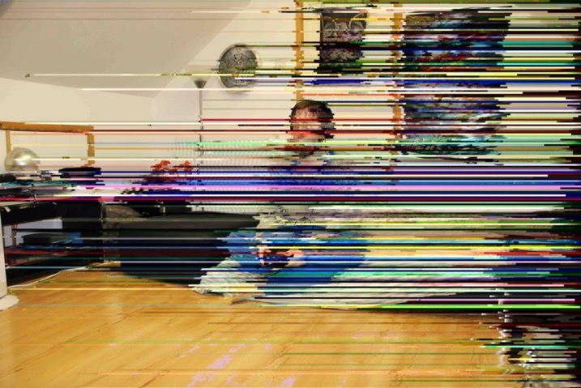
(Fig 21) Morris, G. Erased, 2017
This image creates an impression of being painted over as if to conceal or erase me, either done by myself or others, suggesting the desire to ignore autism and disability.
(Fig 22) Morris, G. Vision, 2017
Although I feel that my vision is unhindered this is deceptive since the world that I see is different from that of others. My face remains largely undistorted and the strange colours are ‘normal’ to me.
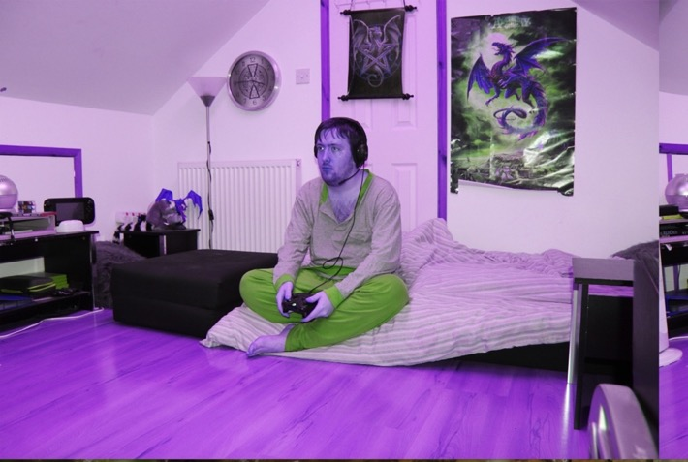
(Fig 23) Morris, G. Eerie, 2017
This photograph is slightly unsettling and eerie, a creepy image reflecting how people can sometimes feel disturbed and frightened of autistic people.
(Fig 24) Morris, G. Overloaded, 2017
Autism is associated with difficulty in coping with sensory overload. In this image I’m surrounded and covered by a variety of different textures and shapes that engulf me, indicating that I can’t cope and am trying to cut myself off.
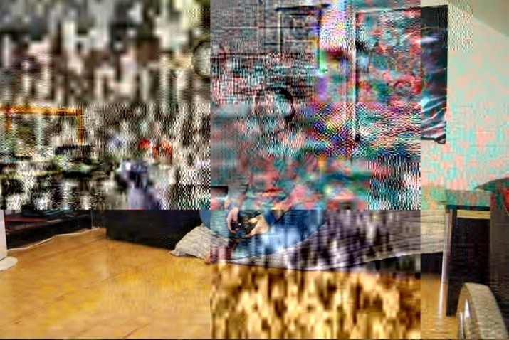
(Fig 25) Morris, G. Ghost, 2017
Autism can isolate people within their own unique worlds as if they are ghosts, present but separate, unseen and overlooked. I’m present within the image but am barely noticeable.
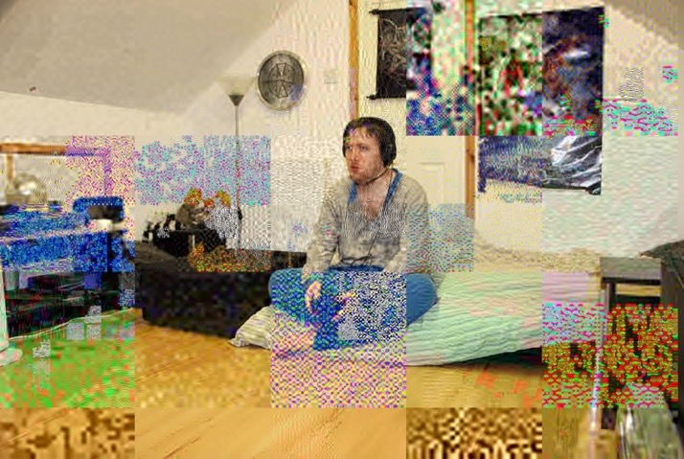
(Fig 26) Morris, G. Digitalized, 2017

This photograph is reminiscent of a motherboard with the dotted squares representing electronic chips. This is appropriate given my Iiking for digital art and the fact that autistic individuals are often attracted to technology. Also our responses are sometimes considered robotic and inexpressive.

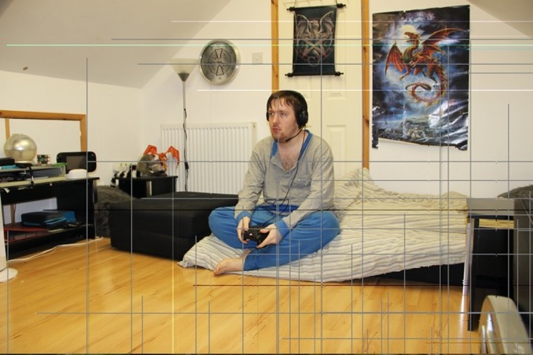
(Fig 27) Morris, G. Eccentricity, 2017
This photograph highlights that the impact of autism can be subtle, slight and hardly noticeable. The distortion barely affects the clarity of the image, suggesting eccentricity rather than disability.
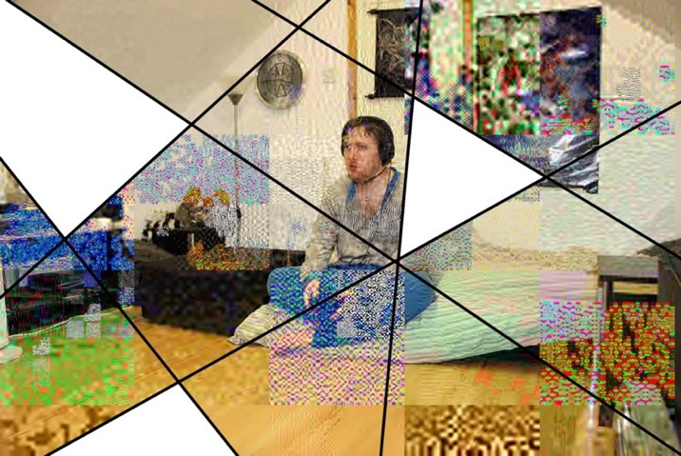
(Fig 28) Morris, G. Fragmented,2017
Current understanding of Autism is fragmented, a miss-match of theories from numerous sources that combine to create an incomplete picture represented by the missing segments within this image.
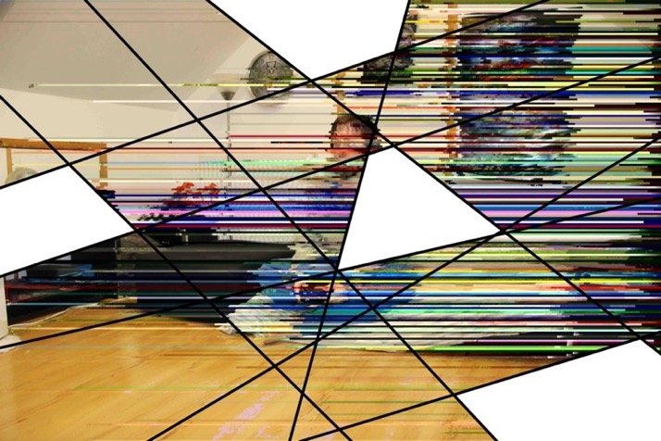
(Fig 29) Morris, G. Gaps, 2017
This reflects that there are gaps in my self-knowledge and abilities, for instance communication and social skills. This is represented by a distorted image of myself with missing segments.
Chapter 7: Conclusion

Researching Autism has been invaluable. Investigating the triad of communication, social skills and repetitive behaviour difficulties has enabled me to better understand autism and myself. I was especially interested in the debate of whether autism is a disability.

I considered within the main body of the dissertation the relationship between genetics and autism. It has been increasingly recognised that though certain genes are commonly associated with autism, there are no autism-specific ones. Future research may identify such genes and further our understanding of the causes of autism.

However, increasing understanding of genes leads to the controversial possibility of erasing autism through genetic modification. I’m uneasy about this since autism is integral to my identity and should not be something to be fixed. Genetic modification is a dilemma calling for judgements on what is ethically acceptable. To me, it seems acceptable to modify genes to eliminate diseases such as cancer but not to alter personality and identity since this would involve deciding what are desirable and undesirable personality traits.

Currently there is no definitive medical test to diagnose Autism. It is known that having autism affects brain patterns of individuals which can be recognised by MRI scans. Far more development is needed so that simple tests can be carried out.

Autistic cases are increasing, partly due to improved diagnosis and awareness, but also it can be read as a sign of evolutionary genetic change with more people being born with autism. I agree with the argument that this genetic adaptation is at least partially triggered by a dramatic increase in the level of stimulation we experience in the everyday, an environment that is overstimulating our senses and causing overload. This seems realistic given the strong association between sensory stimulation and autism evidenced by the fact we struggle to handle sensory overload.

Evolution is based on the selection of positive survival traits and the likelihood that autism is growing indicates that it is something desirable and necessary for human survival with many valuable traits including advanced memory skills. It might also mean that autistic individuals are the prototypes of an evolved new human species better suited to the tumultuous, over-populated modern age.

There’s a proven link between autism and art. Some autistic individuals, including some with the most severe form of autism, are artistic and some are artistic savants born with a special talent. These artists create brilliant, vibrant work in this postmodern era where the rules for art are less confining.

An artistic talent is an adaptation to help cope with the complexity of autism. It aids problems with communication, social interaction and mindfulness. It gives the autistic artist a voice, a platform to interact, a way to communicate. A way to connect with the world around them and a way to escape that same world and not to mention a way to create and show their own world. Autistic born traits such as clarity and good memory which lends itself well to any artistic medium, giving autistic people a unique comprehension of colour, patterns, the love for repetition and other factors are fundamental to our art.

Autistic art has increased awareness of autism and helped reduce prejudice, enabling improved connection with the world. The work we create is a voice to communicate with others, to open-up our world and increase understanding. People who are different can feel isolated and this is true of autistic people who struggle with communication and interaction. Art helps us communicate, enabling a connection with others and creating a feeling of community.

Art helps the artist become more self-aware. Through this artistic project I learnt far more about being autistic. Since art is a voice, the more art I looked at, the more voices by autistic people I heard and the more I learnt about autism, myself and society. Some things I learnt were positives that I was glad to recognise such as autistic perspectives are individual, creative and unique, yet, sadly I also learnt that autistic people can feel isolated and sad or angry, facts visible within their artworks.

Art is liberating, providing a role to help the artist feel connected and able to fit in, whilst also making others value the artist more easily as a contributing member of society. According to Amanda Lamunyon in the book Drawing Autism “[Art] caused people to look at me differently and accept me more even though I was a little different” (Mullin, 2016, p82).

The digital art movement has helped autistic art flourish. Autism can be linked with fine motor skills issues and digital editing means that we can overcome this difficulty, enabling us to create beautiful, intricate and complex works. The digital world has opened a new platform of creativity. Autistic art is modern because the digital world is modern.

The digital world can be compared to genetics in that digital code has similarities to DNA codes. Computer processes are governed by operating binary language in the same way that humans are governed by their DNA code. I believe that glitch art is also comparable to genetic code in that it symbolises how accidents in our genetic code can trigger huge, unexpected changes with dramatic, visible results.

Glitch art is created by manipulation resulting in accidental effects that are unexpected and sometimes chaotic, imbued with colour and strong patterns reminiscent of autistic characteristics. I think that combining technology and aesthetics is symbolic of the present day where computers have become so fundamental to each of us.

Glitch art seems an appropriate medium when we are dependent on technology. It’s representative of the fact that our world today is distorted, that we are separated from reality by a screen of digital data. The digital world is a facsimile of reality, just as the autistic world is a version of the ‘real’ world, often brighter and more colourful than its counterpart.

I enjoyed the freedom of creating glitch art as I dislike any form of restriction. Being autistic tends to mean seeing things differently and not being restricted by how others see the world or by opinions on what is the right way to be.

I found modifying photographs to produce an array of diverse effects effective in providing insight into aspects of autism with intense, unexpected colours, strange patterns, repetition or unintelligible images. The images being distorted represent the fact that our world is not quite ‘normal’ but still worthwhile. The degree of distortion varies, to represent the difference between the visions of autistic individuals. The glitches also warp the colour scheme, making the images seem strange but beautiful which is how I think of the autistic world.

In some images the glitches seem to create a screen between me, hidden behind the glitches, and the viewer, with the level of distortion varying between mild and severe. This I find sad but realistic since a difficulty with communication and social skills plus seeing the world differently can isolate us and can often mean people can’t understand us at all.

Autism itself can be recognised as a glitch in the DNA coding and this lies in parallel with glitch art which is distorted art created by a glitch in the digital coding. Glitch art can be seen in many ways as representative of autism. Each image is unique, presenting a distorted view definitely, but the level of distortion is dependent on the amount that has changed with the DNA. Sometimes completely unreadable, a damaged photo, other times an altered view. However each one changes a person’s perception and understanding firstly of the art but when taken in comparison, surely of autism also? Unpredictable, just as autism is, glitch art allows me a window to show others how I see the world.

In these glitched images I believe I have successfully shown something of my autistic world and of myself as an autistic artist. The glitches resemble digital patterns which bear some similarity to DNA strands within our genetic makeup. Consequently I feel that the images in particular and the dissertation in general have successfully fulfilled the stated aim of the dissertation by showing the correlation between Art, Autism and Genetics.

Appendix : Comparison Tables for Different Computer Codes

Decimal  Base-10 | Binary  Base-2 | Octal  Base-8 | Hexadecimal  Base-16
0 | 0 | 0 | 0
1 | 1 | 1 | 1
2 | 10 | 2 | 2
3 | 11 | 3 | 3
4 | 100 | 4 | 4
5 | 101 | 5 | 5
6 | 110 | 6 | 6
7 | 111 | 7 | 7
8 | 1000 | 10 | 8
9 | 1001 | 11 | 9
10 | 1010 | 12 | A
11 | 1011 | 13 | B
12 | 1100 | 14 | C
13 | 1101 | 15 | D
14 | 1110 | 16 | E
15 | 1111 | 17 | F
16 | 10000 | 20 | 10
17 | 10001 | 21 | 11
18 | 10010 | 22 | 12
19 | 10011 | 23 | 13
20 | 10100 | 24 | 14
21 | 10101 | 25 | 15
22 | 10110 | 26 | 16
23 | 10111 | 27 | 17
24 | 11000 | 30 | 18
25 | 11001 | 31 | 19
26 | 11010 | 32 | 1A
27 | 11011 | 33 | 1B
28 | 11100 | 34 | 1C
29 | 11101 | 35 | 1D
30 | 11110 | 36 | 1E
31 | 11111 | 37 | 1F
32 | 100000 | 40 | 20

(Fig 30) Numeral systems conversion table, 2017

Comparison of Decimal, Binary, Octal and Hexadecimal Code.

Dec | Hex | Binary | Character | Description
0 | 00 | 00000000 | NUL | Null
1 | 01 | 00000001 | SOH | start of header
2 | 02 | 00000010 | STX | start of text
3 | 03 | 00000011 | ETX | end of text
4 | 04 | 00000100 | EOT | end of transmission
5 | 05 | 00000101 | ENQ | Enquiry
6 | 06 | 00000110 | ACK | acknowledge
7 | 07 | 00000111 | BEL | Bell
8 | 08 | 00001000 | BS | Backspace
9 | 09 | 00001001 | HT | horizontal tab
10 | 0A | 00001010 | LF | line feed
11 | 0B | 00001011 | VT | vertical tab
12 | 0C | 00001100 | FF | form feed
13 | 0D | 00001101 | CR | enter / carriage return
14 | 0E | 00001110 | SO | shift out
15 | 0F | 00001111 | SI | shift in
16 | 10 | 00010000 | DLE | data link escape
17 | 11 | 00010001 | DC1 | device control 1
18 | 12 | 00010010 | DC2 | device control 2
19 | 13 | 00010011 | DC3 | device control 3
20 | 14 | 00010100 | DC4 | device control 4
21 | 15 | 00010101 | NAK | negative acknowledge
22 | 16 | 00010110 | SYN | Synchronize
23 | 17 | 00010111 | ETB | end of trans. block
24 | 18 | 00011000 | CAN | Cancel
25 | 19 | 00011001 | EM | end of medium
26 | 1A | 00011010 | SUB | Substitute
27 | 1B | 00011011 | ESC | Escape
28 | 1C | 00011100 | FS | file separator
29 | 1D | 00011101 | GS | group separator
30 | 1E | 00011110 | RS | record separator
31 | 1F | 00011111 | US | unit separator
127 | 7F | 01111111 | DEL | Delete

(Fig 31) ASCII control characters, 2017

Comparison of decimal, Hexadecimal and Ascii codes.

Bibliography

Adamson, G., Pavitt, J. & Antonelli, P. 2011. Postmodernism: style and subversion, 1970-1990, London: V & A Pub.

Attwood, T., 2015. The Complete Guide to Asperger’s Syndrome. London: Jessica Kingsley Publishers.

Bogdashina, O., 2006. Theory of mind and the triad of perspectives on autism and Asperger syndrome. London [u.a.]: Jessica Kingsley Publications.

Donaldson, M., 1995. Children with Language Impairments-An Introduction. London: Jessica Kingsley Publications.

Law J and Elias J., 1996. Trouble Talking-A Guide for the Parents of Children with Speech and Language Difficulties. London: Jessica Kingsley Publications.

Legge, B., 2002. Can't Eat, Won't Eat-Dietary Difficulties and Autistic Spectrum Disorders. London: Jessica Kingsley Publications.

Mullin J., 2016. Drawing Autism. London: Lom Art an imprint of Michael O’Mara Books Ltd.

Pacelli, T., 2012. 100 Lessons to Understand How Autistic People See Life. Washington: Pacelli Publishing.

Online Sources

- Abbas, A. (2017). Disabled Artist With there Art- Maria Iliou - Amazing Art. [online] Lifeblog79.blogspot.co.uk. Available at: http://lifeblog79.blogspot.co.uk/2012/03/this-world-is-full-of-artistic-peoples.html [Accessed 15 Nov. 2017].
- Amidi, A. (2017). Supreme Sunlight by Kim Asendorf. [online] Cartoon Brew. Available at: http://www.cartoonbrew.com/music-videos/supreme-sunlight-by-kim-asendorf-47329.html [Accessed 18 Nov. 2017].
- Anon, (2017). [online] Available at: ; http://www.creativeapplications.net/other/glitch-textiles-phillip-stearns-uses-short-circuited-cameras-to-create-blanket-patterns/ [Accessed 11 Nov. 2017].
- Anon, (2017). [online] Available at: http://download.cnet.com/TextEdit/3000-2351_4-10842593.html [Accessed 25 Nov. 2017].
- Anon, (2017). [online] Available at: http://yearoftheglitch.tumblr.com/ https://phillipstearns.wordpress.com/about/ [Accessed 3 Dec. 2017].
- Asciitable.com. (2017). Ascii Table - ASCII character codes and html, octal, hex and decimal chart conversion. [online] Available at: http://www.asciitable.com/ [Accessed 23 Nov. 2017].
- Asendorf, K. (2017). First animated GIF sent into Deep Space, Kim Asendorf, 2013. [online] KIMASENDORF.COM. Available at: http://kimasendorf.com/first-gif-sent-into-deep-space/ [Accessed 13 Nov. 2017].

- Autism Speaks. (2017). Photography gives voice to teens participating in autism research. [online] Available at: https://www.autismspeaks.org/blog/2016/08/16/photography-gives-voice-teens-participating-autism-research [Accessed 10 Nov. 2017].
- Autism Speaks. (2017). What Is Autism? [online] Available at: https://www.autismspeaks.org/what-autism [Accessed 2017].
- Autism.org.uk. (n.d.). Related conditions - NAS. [online] Available at: http://www.autism.org.uk/about/what-is/related-conditions.aspx [Accessed 2017].
- Basulto, D. (2014). We need a better explanation for the surge in autism. [online] Washington Post. Available at: https://www.washingtonpost.com/news/innovations/wp/2014/04/10/we-need-a-better-explanation-for-the-surge-in-autism/?utm_term=.e24be01703f6 [Accessed 18 Nov. 2017].
- Binaryhexconverter.com. (2017). Hexadecimal to Decimal Converter. [online] Available at: http://www.binaryhexconverter.com/hex-to-decimal-converter [Accessed 6 Nov. 2017].
- Bored Panda. (2017). 5-Year-Old With Autism Paints Stunning Masterpieces. [online] Available at: http://www.boredpanda.com/5-year-old-painter-autism-iris-grace/ [Accessed 12 Nov. 2017].
- BuzzFeed. 2014. 19 Secrets Autistic People Will Never Tell You. [online] Available at: https://www.buzzfeed.com/nicholasf4e25a6fa9/secrets-autistc-people-will-never-tell-you-110m1?utm_term=.ptzEDGnWK#.koElOZkLa [Accessed 23 Nov. 2017].
- Cdc.gov. (2016). CDC | Data and Statistics | Autism Spectrum Disorder (ASD) | NCBDDD. [online] Available at: http://www.cdc.gov/ncbddd/autism/data.html [Accessed 11 Oct. 2017].
- Co.Design. (2017). Text(ile) Messages: Cozy Up To Glitch Art. [online] Available at: http://www.fastcodesign.com/1673063/textile-messages-cozy-up-to-glitch-art [Accessed 2 Dec. 2017].
- Connor, R. (2017). Six-year-old Iris raises awareness of autism through her amazing paintings - now she has her own book. [online] The Independent. Available at: http://www.independent.co.uk/arts-entertainment/books/iris-grace-mother-of-six-year-old-girl-acclaimed-for-her-beautiful-paintings-on-new-book-about-a6905151.html [Accessed 14 Dec. 2017].
- Cook, D. (2017). Converting Between Binary, Octal, Decimal, and Hexadecimal Number Systems - Robot Room. [online] Robotroom.com. Available at: http://www.robotroom.com/NumberSystems.html [Accessed 12 Dec. 2017].
- Cosslett, R. (2017). 'This was my form of language': the artist who draws cities from memory. [online] the Guardian. Available at: https://www.theguardian.com/cities/2017/may/04/artist-draws-cities-memory-stephen-wiltshire [Accessed 1 Dec. 2017].
- Createartforautism.com. (n.d.). Create! Art For Autism 2014. [online] Available at: http://www.createartforautism.com/ [Accessed 14 Nov. 2017].
- Critique Collective. (2017). Tutorial on Databending and Glitch Art. [online] Available at: https://critiquecollective.com/2014/03/13/tutorial-on-databending-and-glitch-art/ [Accessed 1 Dec. 2017].
- Design, W. and Design, M. (2017). 25 Breathtaking Artworks by Artists with Cognitive Disability. [online] Designmantic.com. Available at: https://www.designmantic.com/community/artists-with-cognitive-disability.php [Accessed 14 Nov. 2017].
- Disabledartistsguild.com. (2017). Maria Iliou - Disabled Artists Guild. [online] Available at: http://www.disabledartistsguild.com/mariailiou/ [Accessed 14 Dec. 2017].
- Displaced Replaced. (2017). About. [online] Available at: http://www.displacedreplaced.com/about [Accessed 17 Nov. 2017].
- Doc Pop's Blog. (2017). A Glitch Tutorial: How to databend images with text editors. [online] Available at: https://docpop.org/2014/01/a-glitch-primer-editing-image-files-with-text-editors/ [Accessed 27 Nov. 2017].
- En.wikipedia.org. (2017). Computer number format. [online] Available at: https://en.wikipedia.org/wiki/Computer_number_format [Accessed 4 Dec. 2017].
- Enriquez, J. (n.d.). Juan Enriquez | Speaker | TED. [online] Ted.com. Available at: https://www.ted.com/speakers/juan_enriquez [Accessed 5 Oct. 2017].
- Enriquez, J. 2012. Will our kids be a different species?. [online] Ted.com. Available at: https://www.ted.com/talks/juan_enriquez_will_our_kids_be_a_different_species [Accessed 5 Oct. 2017].
- Experimentwithnature.com. (2017). Glitch Textiles. [online] Available at: http://experimentwithnature.com/03-found/glitch-textiles/#.VyPmIvkrLIU [Accessed 10 Nov. 2017].
- Facebook.com. (2017). Displaced/Replaced. [online] Available at: https://www.facebook.com/displacedreplaced/ [Accessed 17 Nov. 2017].
- Facebook.com. (2017). Shauna Phoon (clandestine-wishes) Photography. [online] Available at: https://www.facebook.com/shaunaphoonphotography/ [Accessed 10 Nov. 2017].
- File.org. (2017). JPF File - What is it and how do I open it?. [online] Available at: https://file.org/extension/jpf [Accessed 7 Nov. 2017].
- Forbes.com. (2017). Forbes Welcome. [online] Available at: https://www.forbes.com/sites/rachelhennessey/2012/09/10/how-autistic-artist-stephen-wiltshire-made-it-big/#190cdb424cd5 [Accessed 1 Dec. 2017].
- Gambino, M. (2017). Ask an Expert: What is the Difference Between Modern and Postmodern Art? [online] Smithsonian. Available at: https://www.smithsonianmag.com/arts-culture/ask-an-expert-what-is-the-difference-between-modern-and-postmodern-art-87883230/ [Accessed 1 Dec. 2017].
- Genetics.thetech.org. (2013). Autism and genetics | Understanding Genetics. [online] Available at: http://genetics.thetech.org/original_news/news49 [Accessed 2 Oct. 2017].
- Glitch Art, Photography, and Illustrations by Sabato Visconti. (2017). Glitch Art, Photography, and Illustrations by Sabato Visconti - エコー ザ ドルフィン C a t a c l y s m. [online] Available at: http://www.sabatobox.com/ecco-the-dolphin-ride-the-cataclysm [Accessed 6 Dec. 2017].
- Glitchtextiles.tumblr.com. (2017). Glitch Textiles. [online] Available at: http://glitchtextiles.tumblr.com/ [Accessed 13 Dec. 2017].
- Iris Grace. (2017). Iris Grace. [online] Available at: https://irisgracepainting.com [Accessed 13 Nov. 2017].
- It’s Nice That. (2017). Emerging net artists Kim Asendorf and Emilio Gomariz unite on many meta-levels to be Maadonna. [online] Available at: https://www.itsnicethat.com/articles/maadonna [Accessed 12 Nov. 2017].
- Jeremysvision.com. (2017). About | Jeremy's Vision. [online] Available at: http://www.jeremysvision.com/about/ [Accessed 12 Nov. 2017].
- Journal.fashionspyder.com. (2017). TEXTILE TECHNOLOGY - SEASON OF THE GLITCH | Fashion Spyder. [online] Available at: http://journal.fashionspyder.com/textech-glitch/ [Accessed 13 Dec. 2017].
- Juxtapoz.com. (2017). Glitch Art Textiles by Phillip Stearns. [online] Available at: http://www.juxtapoz.com/news/glitch-art-textiles-by-phillip-stearns/ [Accessed 10 Dec. 2017].
- Kang, M. (2017). Once shut in by autism, photographer Forrest Sargent shares world through camera lens | Quirksee. [online] Quirksee.org. Available at: http://www.quirksee.org/2013/09/03/forrest-sargent-autism-letterboard-rapid-prompting-method/ [Accessed 19 Nov. 2017].
- Kimasendorf.com. (2017). KIM ASENDORF. [online] Available at: http://kimasendorf.com/www/ [Accessed 20 Nov. 2017].
- Life-Styled.Net. (2017). Glitch: An Inspiring Interview with Phillip Stearns of GlitchTextiles. [online] Available at: http://www.life-styled.net/glitch-textiles/ [Accessed 5 Nov. 2017].
- Lifewire. (2017). JPG & JPEG Files: How to Open & Convert Them. [online] Available at: https://www.lifewire.com/jpg-jpeg-file-4139913 [Accessed 26 Nov. 2017].
- Lifewire. (2017). TIF and TIFF Files: What They Are, and How to Open and Convert Them. [online] Available at: https://www.lifewire.com/tif-tiff-file-2622393 [Accessed 9 Nov. 2017].
- Lucarelli, F. (2017). Fragmented Memory: Glitch Textiles by Phillip Stearns (2013). [online] SOCKS. Available at: http://socks-studio.com/2015/07/22/fragmented-memory-glitch-textile-by-phillip-stearns-2013/ [Accessed 10 Dec. 2017].
- Lynch, E. (2017). Glitch Textiles, Blankets with Abstract Designs Based on Glitched Digital Files. [online] Laughing Squid. Available at: https://laughingsquid.com/glitch-textiles-blankets-with-abstract-designs-based-on-glitched-digital-files/ [Accessed 5 Nov. 2017].
- Macho Zapp. (2017). Profile of a Digital Artist: Sabato Visconti. [online] Available at: http://www.machozapp.com/blog0/2016/1/2/profile-of-a-digital-artist-sabato-visconti [Accessed 8 Dec. 2017].
- Misterlynch.com. (2017). Cite a Website - Cite This For Me. [online] Available at: https://www.misterlynch.com/ [Accessed 17 Nov. 2017].
- Mrrk.nl. (2017). The ink Storm collection. [online] Available at: http://www.mrrk.nl/site/gallery/inkstorm/ [Accessed 3 Dec. 2017].
- NeuroTribes. (2017). Hidden Light: The Visual Language of an Autistic Photographer | NeuroTribes. [online] Available at: http://blogs.plos.org/neurotribes/2011/02/09/hidden-light-the-visual-language-of-an-autistic-photographer/ [Accessed 10 Nov. 2017].
- Nhs.uk. (n.d.). Autism spectrum disorder (ASD). [online] Available at: http://www.nhs.uk/conditions/Autistic-spectrum-disorder/Pages/Introduction.aspx [Accessed 2017].
- Nimh.nih.gov. 2016. NIMH » Autism Spectrum Disorder. [online] Available at: https://www.nimh.nih.gov/health/topics/autism-spectrum-disorders-asd/index.shtml [Accessed 5 Nov. 2017].
- Nytimes.com. (2017). About New York - Artist Stephen Wiltshire Recreates New York From Memory - NYTimes.com. [online] Available at: http://www.nytimes.com/2009/10/28/nyregion/28about.html [Accessed 1 Dec. 2017].
- Phillip David Stearns. (2017). Glitch Textiles. [online] Available at: http://www.phillipstearns.com/glitchtextiles/blox2eerhhrt9plwj3vnmmfmy3qfm0 [Accessed 20 Nov. 2017].
- Phillip Stearns. (2017). Glitch Textiles. [online] Available at: https://phillipstearns.wordpress.com/glitch-textiles/ [Accessed 10 Nov. 2017].
- Phillip Stearns. (2017). Phillip Stearns. [online] Available at: https://phillipstearns.wordpress.com [Accessed 1 Nov. 2017].
- Priestman, C. (2017). Ecco the Dolphin glitch art is all your vaporwave dreams come true - Kill Screen. [online] Kill Screen. Available at: https://killscreen.com/articles/ecco-the-dolphin-glitch-art-is-all-your-vaporwave-dreams-come-true/ [Accessed 5 Dec. 2017].
- Prosthetic Knowledge. (2017). [online] Available at: http://prostheticknowledge.tumblr.com/post/30196185509/mountain-tour-2010-by-kim-asendorf-one-of-the [Accessed 19 Nov. 2017].
- Prosthetic Knowledge. (2017). [online] Available at: http://prostheticknowledge.tumblr.com/post/32963838252/kim-asendorfs-pixel-sorting-code-is-now [Accessed 11 Nov. 2017].
- Radowitz, J. (2017). Autism genes ‘conserved during human evolution to make us smarter’. [online] The Independent. Available at: http://www.independent.co.uk/life-style/health-and-families/health-news/autism-genes-conserved-human-evolution-make-smarter-health-news-a7602761.html [Accessed 20 Oct. 2017].
- Rawvision.com. (2017). Jessica Park | Raw Vision Magazine. [online] Available at: https://rawvision.com/articles/jessica-park [Accessed 23 Nov. 2017].
- SearchStorage. (2017). What is byte? - Definition from WhatIs.com. [online] Available at: http://searchstorage.techtarget.com/definition/byte [Accessed 19 Nov. 2017].
- Sony | Alpha Universe. (2017). Christopher Lynch. [online] Available at: https://alphauniverse.com/artisans/Lynch/ [Accessed 11 Nov. 2017].
- Spikins, P. 2017. How our autistic ancestors played an important role in human evolution. [online] The Conversation. Available at: http://theconversation.com/how-our-autistic-ancestors-played-an-important-role-in-human-evolution-73477 [Accessed 9 Nov. 2017].
- Stallio. (2008) Databending and Glitch Art Primer, Part 1: the Wordpad effect blog. Available at: http://blog.animalswithinanimals.com/2008/08/databending-and-glitch-art-primer-part.html [Accessed 14 Dec. 2017].
- Stephen Wiltshire. (2017). Stephen Wiltshire. [online] Available at: http://www.stephenwiltshire.co.uk [Accessed 14 Oct. 2017].
- Tate. (2017). Impressionism – Art Term | Tate. [online] Available at: http://www.tate.org.uk/art/art-terms/i/impressionism [Accessed 1 Dec. 2017].
- Tate. (2017). Impressionism – Art Term | Tate. [online] Available at: http://www.tate.org.uk/art/art-terms/i/impressionism [Accessed 14 Dec. 2017].
- Tate. (2017). Minimalism – Art Term | Tate. [online] Available at: http://www.tate.org.uk/art/art-terms/m/minimalism [Accessed 14 Dec. 2017].
- Tate. (2017). Postmodernism – Art Term | Tate. [online] Available at: http://www.tate.org.uk/art/art-terms/p/postmodernism [Accessed 1 Dec. 2017].
- Tate. (2017). Realism – Art Term | Tate. [online] Available at: http://www.tate.org.uk/art/art-terms/r/realism [Accessed 14 Dec. 2017].
- Tate. (2017). Significant form – Art Term | Tate. [online] Available at: http://www.tate.org.uk/art/art-terms/s/significant-form [Accessed 1 Dec. 2017].
- Tate. (n.d.). Modernism – Art Term | Tate. [online] Available at: http://www.tate.org.uk/art/art-terms/m/modernism [Accessed 3 Nov. 2017].
- Techwalla. (2017). What Is Digital Coding? | Techwalla.com. [online] Available at: https://www.techwalla.com/articles/what-is-digital-coding?ref=Track2&utm_source=IACB2B [Accessed 4 Dec. 2017].
- Telegraph.co.uk. (2017). Richard Wawro. [online] Available at: http://www.telegraph.co.uk/news/obituaries/1512657/Richard-Wawro.html [Accessed 14 Dec. 2017].
- Telegraph.co.uk. (2017). Stephen Wiltshire the human camera: autistic artist draws city skylines from memory. [online] Available at: http://www.telegraph.co.uk/culture/culturepicturegalleries/8359988/Stephen-Wiltshire-the-human-camera-autistic-artist-draws-city-skylines-from-memory.html [Accessed 1 Dec. 2017].

- The Art of Autism. (2017). Athena: Greek, abstract artist, photographer, actress, author, poet, and non-verbal #Autistic with limited language. [online] Available at: http://the-art-of-autism.com/athena-greek-abstract-artist-photographer-actress-author-poet-and-non-verbal-autistic-with-limited-language/ [Accessed 14 Dec. 2017].
- The Art of Autism. (2017). Jeremy Sicile-Kira paints his dreams – autistic painter dreams auras. [online] Available at: http://the-art-of-autism.com/jeremy-sicile-kira-paints-his-dreams/ [Accessed 12 Oct. 2017].
- The Art of Autism. (2017). Maria and Athena Iliou. [online] Available at: http://the-art-of-autism.com/poets/maria-and-athena-iliou/ [Accessed 16 Nov. 2017].
- The Art of Autism. (2017). Maria: Greek, Athenas mom, radio host, wise, poet, actress, photographer and #Autistic. [online] Available at: http://the-art-of-autism.com/maria-greek-radio-host-wise-poet-actress-photographer-and-autistic/ [Accessed 14 Nov. 2017].
- The Fox Is Black. (2017). The Glitched Out Art of Kim Asendorf. [online] Available at: http://thefoxisblack.com/2011/02/16/the-glitched-out-art-of-kim-asendorf/ [Accessed 20 Nov. 2017].
- The Globe and Mail. (2012). The DNA Dilemma: Why science wants your genome. [online] Available at: https://www.theglobeandmail.com/news/national/time-to-lead/the-dna-dilemma-why-science-wants-your-genome/article5921666/ [Accessed 28 Sep. 2017].
- The Mighty. (2015). 15 Things You Should Never Say to an Autistic. [online] Available at: https://themighty.com/2015/09/15-things-you-should-never-say-to-an-autistic/ [Accessed 2017].
- The Mighty. (2017). Autistic Photographer Captures the Perfectly Diverse 'Faces of Autism'. [online] Available at: https://themighty.com/2016/03/autistic-photographer-shauna-phoon-captures-the-perfectly-diverse-faces-of-autism/ [Accessed 14 Dec. 2017].
- The Periphery. (2017). The Periphery | Sabato Visconti. [online] Available at: http://www.theperipherymag.com/interview-sabato-visconti [Accessed 8 Dec. 2017].
- Theabsenceofnormal.tumblr.com. (2017). The Absence of Normal - Faces of Autism. [online] Available at: http://theabsenceofnormal.tumblr.com/ [Accessed 13 Nov. 2017].
- TheFreeDictionary.com. (n.d.). Kanner's syndrome. [online] Available at: https://medical-dictionary.thefreedictionary.com/Kanner%27s+syndrome [Accessed 11 Nov. 2017].
- TheProblemSite.com. (2017). Reference Pages. [online] Available at: https://www.theproblemsite.com/reference/mathematics/codes/hexadecimal- [Accessed 28 Dec. 2017].
- Thinkorsmile.com. (2017). Kim Asendorf's pixel sorting Mountain Tour | Think or Smile. [online] Available at: http://thinkorsmile.com/2010/08/11/kim-asendorfs-pixel-sorting-mountain-tour/ [Accessed 13 Nov. 2017].
- Times, T. (2017). American Dreamers: Sabato Visconti. [online] Nytimes.com. Available at: https://www.nytimes.com/interactive/projects/storywall/american-dreamers/stories/sabato-visconti [Accessed 11 Nov. 2017].
- Tumblr.glitchartistscollective.com. (2017). Glitch Artists Collective. [online] Available at: http://tumblr.glitchartistscollective.com [Accessed 8 Nov. 2017].
- Vimeo. (2017). a.d.l.r. - Supreme Sunlight. [online] Available at: https://vimeo.com/16800870 [Accessed 18 Nov. 2017].
- Washington Post (2014) We need a better explanation for the surge in Autism (online) Available at: https://www.washingtonpost.com/news/innovations/wp/2014/04/10/we-need-a-better-explanation-for-the-surge-in-autism/?utm_term=.0b0f753fb7f9.
- Wawro.net. (2017). Richard Wawro, Artist. [online] Available at: http://www.wawro.net/Richard_Wawro/About_Richard.html [Accessed 8 Nov. 2017].
- WebMd. (n.d.) What Are the Types of Autism Spectrum Disorders? [online] WebMD. Available at: http://www.webmd.com/brain/autism/autism-spectrum-disorders [Accessed 2017].
- Wisconsin Medical Society. (2017). Richard Wawro - An Amazing Artist - Wisconsin Medical Society. [online] Available at: https://www.wisconsinmedicalsociety.org/professional/savant-syndrome/profiles-and-videos/profiles/richard-wawro-an-amazing-artist/ [Accessed 6 Nov. 2017].
- YouTube. (2017). ArtCraft: Glitch Art. [online] Available at: https://www.youtube.com/watch?v=ypcV1UHRyP0 [Accessed 23 Nov. 2017].
- Zeliadt, N. (2017). Autism genetics, explained | Spectrum | Autism Research News. [online] Spectrum | Autism Research News. Available at: https://spectrumnews.org/news/autism-genetics-explained/ [Accessed 29 Sep. 2017].
Illustrations Reference List

- Asendorf, K. (2017). KIM ASENDORF - MOUNTAIN TOUR. [online] Kimasendorf.com. Available at: http://kimasendorf.com/mountain-tour/ [Accessed 14 Nov. 2017].
- AutisMag. (2014). Types of Autism - 5 Major Autism Spectrum Disorder Forms. [online] Available at: https://www.dealwithautism.com/types-of-autism/ [Accessed 2017].
- DeviantArt. (2017). RJBPhotoandDesign on DeviantArt. [online] Available at: https://rjbphotoanddesign.deviantart.com [Accessed 14 Dec. 2017].
- Morris, G. (2017) Digitalised. [photograph]
- Morris, G. (2017) Eccentricity. [photograph]
- Morris, G. (2017) Eerie. [photograph]
- Morris, G. (2017) Erased. [photograph]
- Morris, G. (2017) Fragmented. [photograph]
- Morris, G. (2017) Gaps. [photograph]
- Morris, G. (2017) Ghost. [photograph]
- Morris, G. (2017) Obscured. [photograph]
- Morris, G. (2017) Overloaded. [photograph]
- Morris, G. (2017) Untitled 1. [photograph]
- Morris, G. (2017) Untitled 2. [photograph]
- Morris, G. (2017) Untitled 3. [photograph]
- Morris, G. (2017) Untitled 4. [photograph]
- Morris, G. (2017) Untitled 5. [photograph]
- Morris, G. (2017) Untitled 6. [photograph]
- Morris, G. (2017) Vision. [photograph]
- Rapidtables.com. (2017). ASCII Table | ASCII character codes table. [online] Available at: https://www.rapidtables.com/code/text/ascii-table.html [Accessed 13 Dec. 2017].
- Rapidtables.com. (2017). Numeral Systems - Binary, Octal, Decimal, Hex. [online] Available at: https://www.rapidtables.com/math/number/Numeral_system.html [Accessed 3 Dec. 2017].
- Shaunaphoon. (2017). Shauna Phoon - Portfolio of Projects. [online] Available at: https://www.shaunaphoon.com [Accessed 10 Nov. 2017].
- Slideshare.net. (2010). Autism Spectrum Disorder in the Classroom. [online] Available at: https://www.slideshare.net/marina761/autism-spectrum-disorder-in-the-classroom [Accessed 2017].
- Yatzer. (2017). Compelling Photographic Glitch Art by Sabato Visconti | Yatzer. [online] Available at: https://www.yatzer.com/sabato-visconti [Accessed 15 Oct. 2017].

