Feasibility Plan
Edible Drinking Straws Conference

Student name: Madalina Andreea Iordache
Student ID Number: 2119156
International Meetings Management for the Hotel Industry - BMIH6007
Lecturer’s name: Kathryn Flynn

Link to the video on Microsoft Stream/Teams:
Madalina Iordache Group B IMM Assign 1 Presentation Recording-20240208_204156-Meeting Recording.mp4 (sharepoint.com)

PowerPoint Presentation:

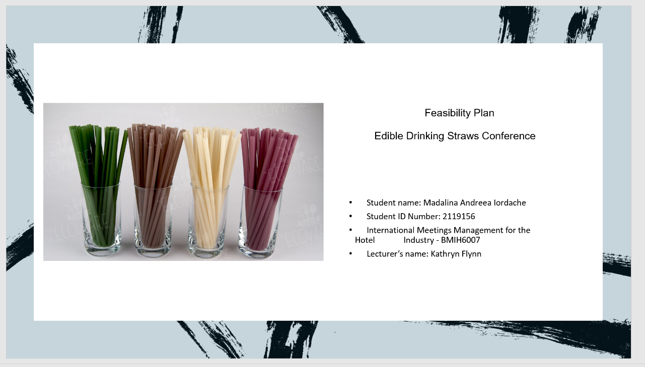
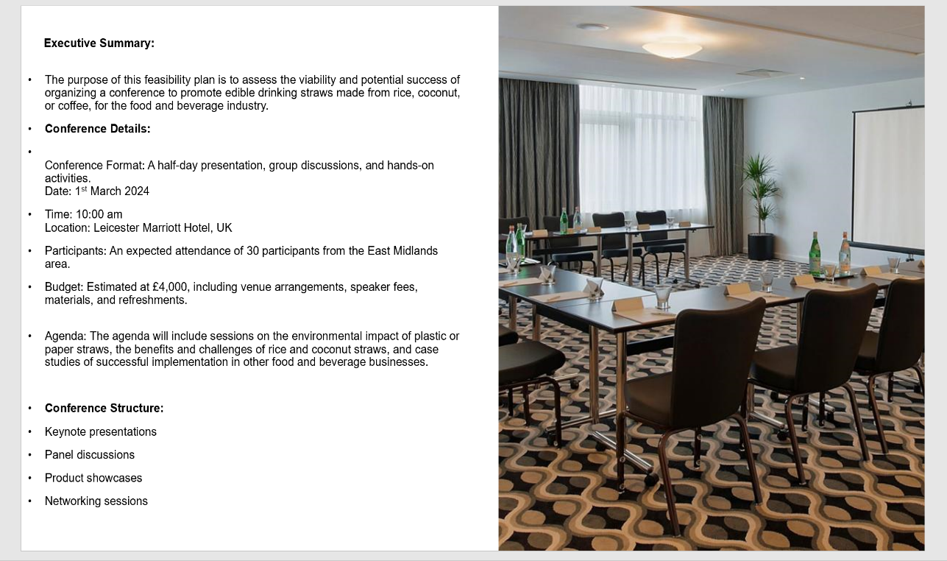
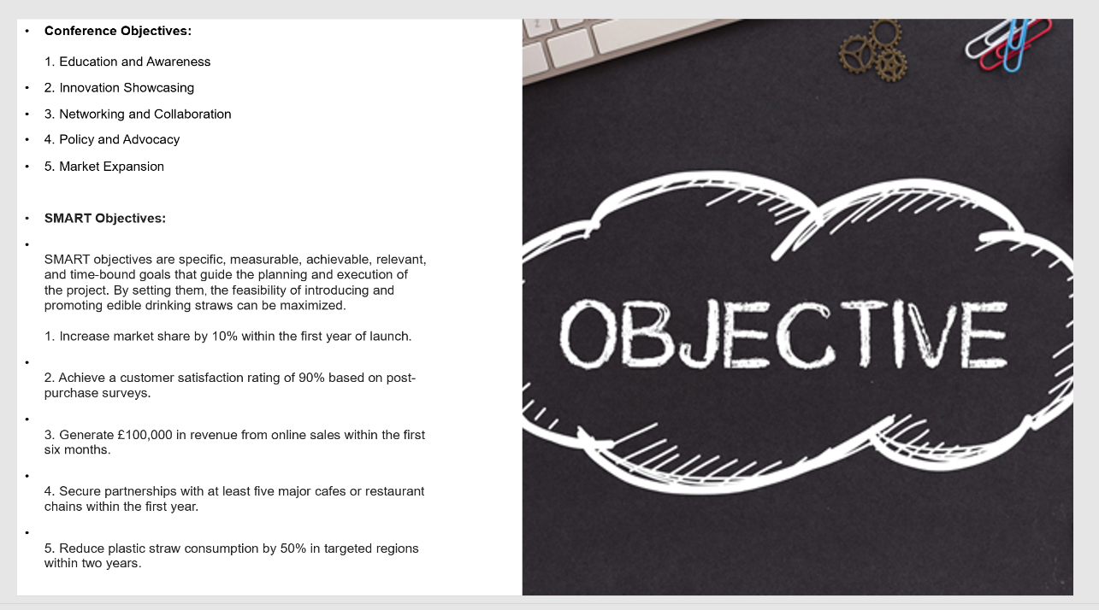
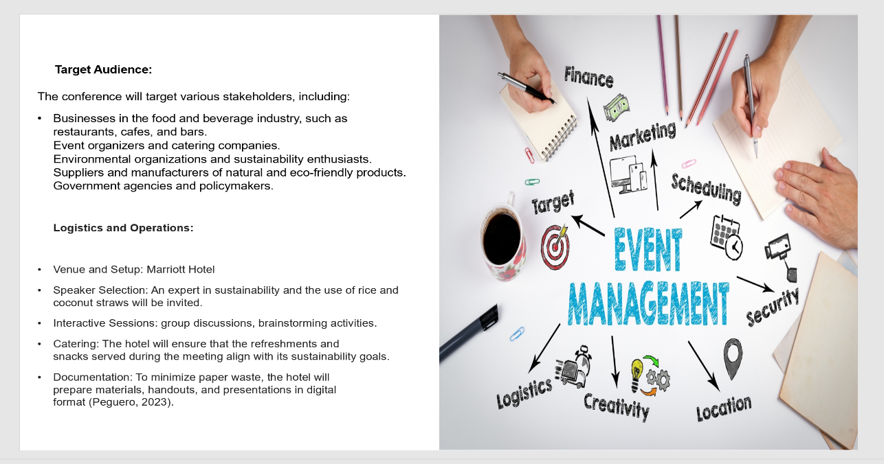

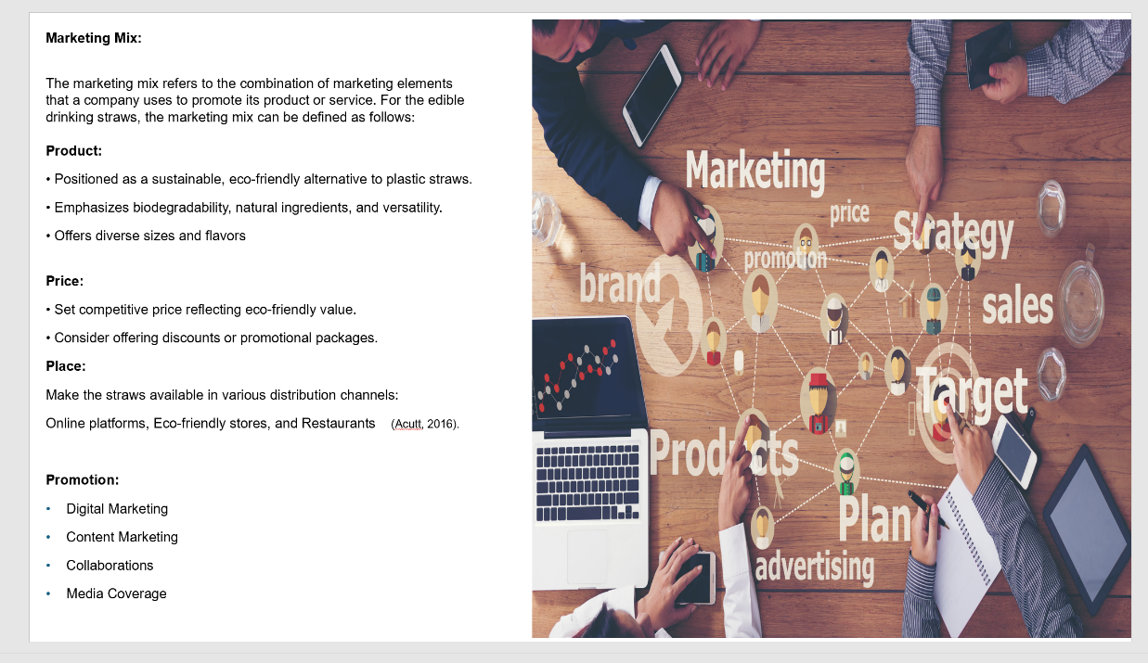

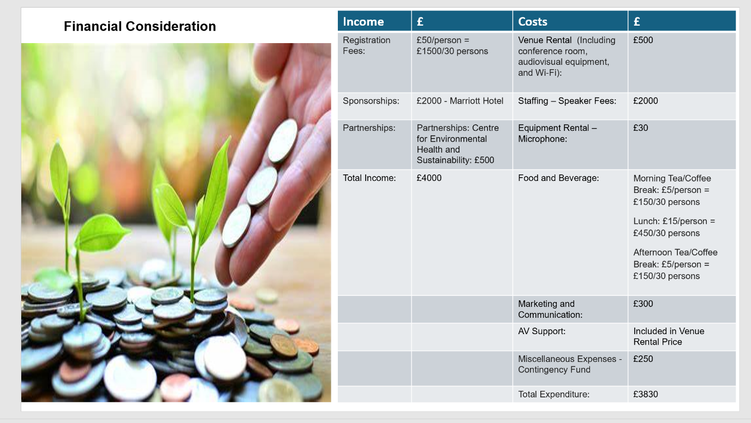

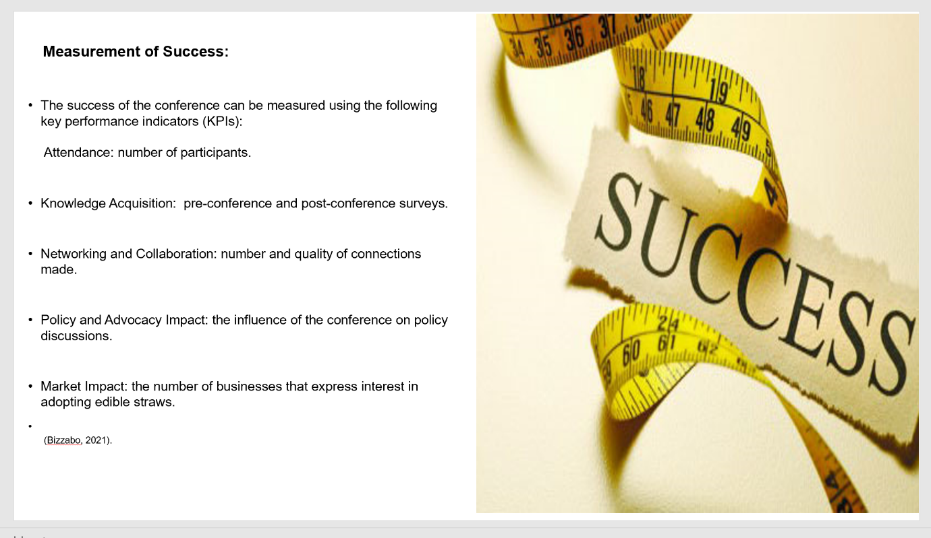

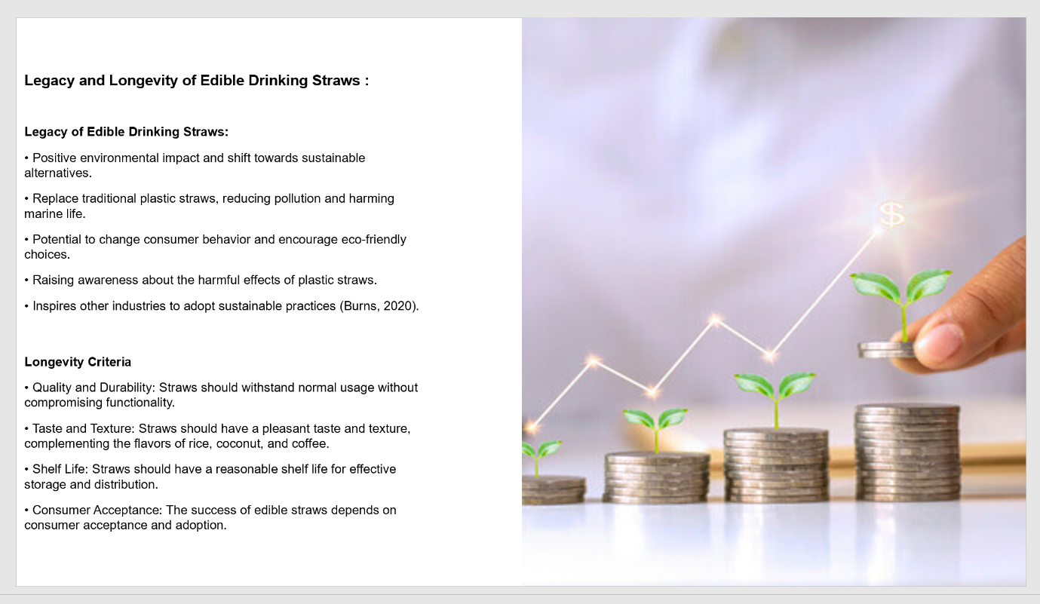

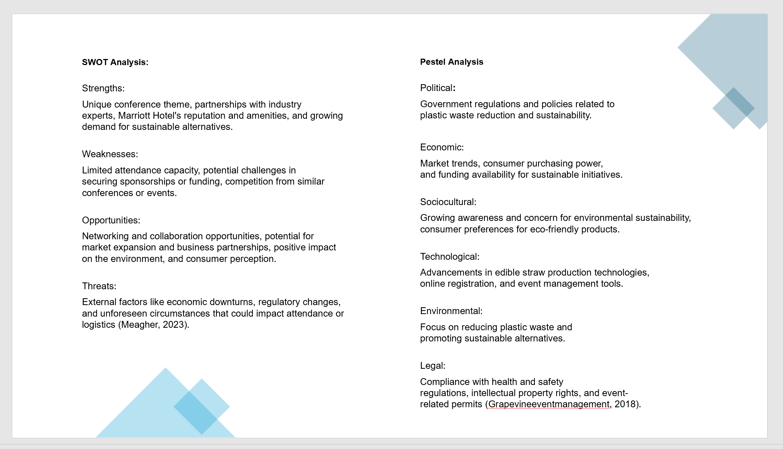

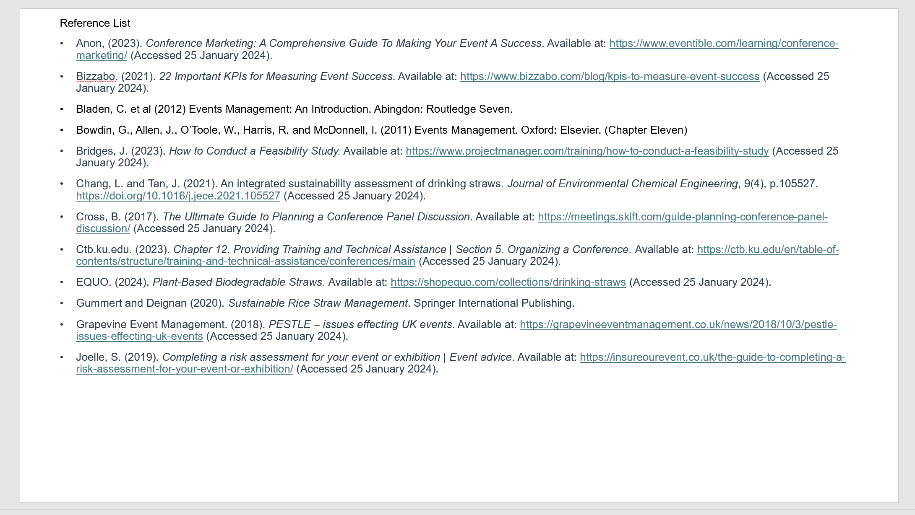

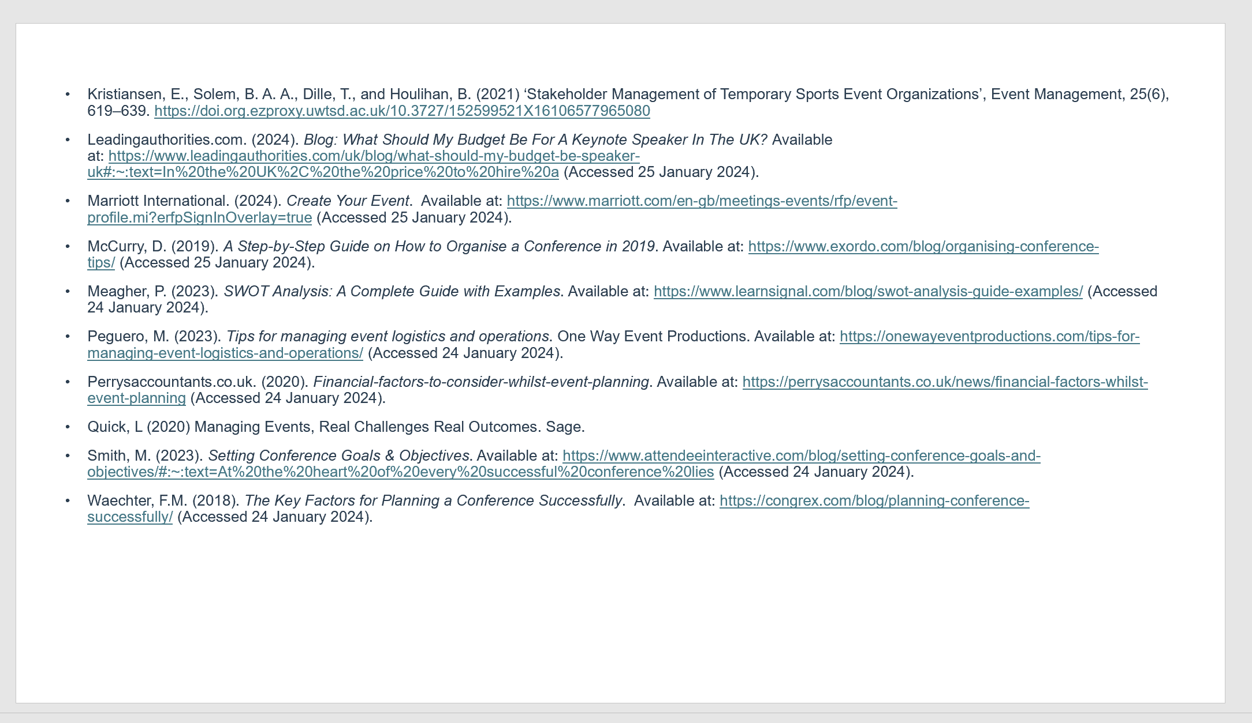

Reference list:

Acutt, M. (2016). The Marketing Mix. Available at: https://marketingmix.co.uk/. (Accessed 06 February 2024).

Anon, (2023). Conference Marketing: A Comprehensive Guide To Making Your Event A Success. Available at: https://www.eventible.com/learning/conference-marketing/ (Accessed 25 January 2024).

Bizzabo. (2021). 22 Important KPIs for Measuring Event Success. Available at: https://www.bizzabo.com/blog/kpis-to-measure-event-success (Accessed 25 January 2024).

Bladen, C. et al (2012) Events Management: An Introduction. Abingdon: Routledge Seven.

Bowdin, G., Allen, J., O’Toole, W., Harris, R. and McDonnell, I. (2011) Events Management. Oxford: Elsevier. (Chapter Eleven)

Bridges, J. (2023). How to Conduct a Feasibility Study. Available at: https://www.projectmanager.com/training/how-to-conduct-a-feasibility-study (Accessed 25 January 2024).

Burns, S. (2020). How To Build A Legacy For Your Business. Available at: https://www.forbes.com/sites/stephanieburns/2020/05/24/how-to-build-a-legacy-for-your-business/ (Accessed 25 January 2024).

Chang, L. and Tan, J. (2021). An integrated sustainability assessment of drinking straws. Journal of Environmental Chemical Engineering, 9(4), p.105527. https://doi.org/10.1016/j.jece.2021.105527 (Accessed 25 January 2024).
Cross, B. (2017). The Ultimate Guide to Planning a Conference Panel Discussion. Available at: https://meetings.skift.com/guide-planning-conference-panel-discussion/ (Accessed 25 January 2024).

Ctb.ku.edu. (2023). Chapter 12. Providing Training and Technical Assistance | Section 5. Organizing a Conference. Available at: https://ctb.ku.edu/en/table-of-contents/structure/training-and-technical-assistance/conferences/main (Accessed 25 January 2024).

EQUO. (2024). Plant-Based Biodegradable Straws. Available at: https://shopequo.com/collections/drinking-straws (Accessed 25 January 2024).

Gummert and Deignan (2020). Sustainable Rice Straw Management. Springer International Publishing.

Grapevine Event Management. (2018). PESTLE – issues effecting UK events. Available at: https://grapevineeventmanagement.co.uk/news/2018/10/3/pestle-issues-effecting-uk-events (Accessed 25 January 2024).

Joelle, S. (2019). Completing a risk assessment for your event or exhibition | Event advice. Available at: https://insureourevent.co.uk/the-guide-to-completing-a-risk-assessment-for-your-event-or-exhibition/ (Accessed 25 January 2024).

Kristiansen, E., Solem, B. A. A., Dille, T., and Houlihan, B. (2021) ‘Stakeholder Management of Temporary Sports Event Organizations’, Event Management, 25(6), 619–639. https://doi.org.ezproxy.uwtsd.ac.uk/10.3727/152599521X16106577965080

Leadingauthorities.com. (2024). Blog: What Should My Budget Be For A Keynote Speaker In The UK? Available at: https://www.leadingauthorities.com/uk/blog/what-should-my-budget-be-speaker-uk#:~:text=In%20the%20UK%2C%20the%20price%20to%20hire%20a (Accessed 25 January 2024).

Marriott International. (2024). Create Your Event. Available at: https://www.marriott.com/en-gb/meetings-events/rfp/event-profile.mi?erfpSignInOverlay=true (Accessed 25 January 2024).

McCurry, D. (2019). A Step-by-Step Guide on How to Organise a Conference in 2019. Available at: https://www.exordo.com/blog/organising-conference-tips/ (Accessed 25 January 2024).

Meagher, P. (2023). SWOT Analysis: A Complete Guide with Examples. Available at: https://www.learnsignal.com/blog/swot-analysis-guide-examples/ (Accessed 24 January 2024).

Peguero, M. (2023). Tips for managing event logistics and operations. One Way Event Productions. Available at: https://onewayeventproductions.com/tips-for-managing-event-logistics-and-operations/ (Accessed 24 January 2024).

Perrysaccountants.co.uk. (2020). Financial-factors-to-consider-whilst-event-planning. Available at: https://perrysaccountants.co.uk/news/financial-factors-whilst-event-planning (Accessed 24 January 2024).

Quick, L (2020) Managing Events, Real Challenges Real Outcomes. Sage.

Smith, M. (2023). Setting Conference Goals & Objectives. Available at: https://www.attendeeinteractive.com/blog/setting-conference-goals-and-objectives/#:~:text=At%20the%20heart%20of%20every%20successful%20conference%20lies (Accessed 24 January 2024).

Waechter, F.M. (2018). The Key Factors for Planning a Conference Successfully. Available at: https://congrex.com/blog/planning-conference-successfully/ (Accessed 24 January 2024).

