Community Engagement Assessment 1

Student Name: Dominica Doinita Stan
Student Number: 2007931
Lecturer’s Name: Dr. Molly Jack
Module Code : LCBB4002

Executive Summary
The report shall discuss the role of an organization “Cargill” and their practice regarding community engagement as well its benefits on the society. It shall discuss how the organization uses different social media platforms to engage the stakeholders. The organization has evolved gradually from the perspective of community engagement, in the previous era they only focused on selling healthy foods and engaged in offline advertisements wherein, in the present time they have engaged themselves in engaging the community and organizing both offline and online campaigns to aware the mass regarding the positive consequence of eating healthy. The report shall also discuss regarding the training facilities and how technical communication training, training of increasing the skills of empathy, listing and explaining and other skills are required for community engagement. It shall conclude by recommending certain features to further strengthen the community engagement.

Table of Contents
Executive Summary 2
Introduction 4
Relationship and methods of engagement with the stakeholders 4
Evolution of community engagement by the organization 6
Use of social media platforms 9
Training and development for the employees 9
Conclusion 10
Reference 11

Introduction
The purpose of this report is to discuss an UK based organization “Cargill” that invests and supports the local communities. The report shall discuss regarding the organizational practices of community engagement as well as stakeholder’s participation. They both work in partnerships or alone and offer corporate support to several NGOs that support the community. It has been traced that in underdeveloped and developing countries, still a huge population is unaware regarding the dangerous consequences of malnutrition as well as are unaware regarding food securities moreover, in advanced countries such as in the UK, a vast population still engulfs unhealthy lifestyle and consumes alcohol and other harmful edibles that lacks nutritious content (Kumar, 2019). Likewise, Cargill focuses to aware the community regarding the benefits of eating healthy and also distributes healthy foods. Having their networks in different countries they are able to connect with people of various income groups and help them to stay healthy. They collaborate with sponsors and build relations with community leaders and such collaborative works results in strengthening the local community by making them healthier. They have been witnessed to help around 15% children and women by making them aware regarding the necessity of nutrition, active lifestyle and healthy eating (Dolce, 2019).

Relationship and methods of engagement with the stakeholders
It has been traced that Cargill is a business organization that sells food grains, coffee, molasses, pulses, eggs and various other food items. In the last few years, they have put their efforts in social causes. Their primary stakeholders are their employees, suppliers, sponsors and partners and secondary stakeholders are the community leaders and the local peoples. It has been identified that by reflecting excellent Corporate Social Responsibilities (CSR) they have expanded their value and reputation in the market as well as in front of the stakeholders (Mehra, 2020). Offering flexible working hours, appropriate wage rates, health insurance as well as offering adequate training facilities to the employee has brought them closer to the organization. Low employee’s turnover rate of the organization proves the attachment of the employees with the organization. The organization offers appropriate rates to the suppliers and sources their raw materials sustainability and that has developed trustable relationships with the suppliers as compared to the competitors (Mayo, 2020). Due to previous social works and their positive impact on the community the partners, sponsors and community leaders remain eager to collaborate with Cargill. Moreover, the organization has a trustable reputation among the community.
They mainly use social media platforms to engage with the stakeholders. Reports have revealed that stakeholders use several types of social media platforms. Facebook has 1.11 billion users, twitter embraces 55 million, billions of people visit several pages on YouTube as well as LinkedIn’s have around 225 million users (Pine, 2020). It is quite certain that the stakeholders are using at least one of those social media platforms. Thus, the statistics confirm that the audiences are present in social media wherein, Cargill uses the social media platform wisely to inform, collaborate and consult with the stakeholders. The organization maintains pertinent present on popular social media platforms. They initiate by creating social media accounts and contact with different stakeholders. For the cause of using clean water and eating healthy, the organization tries to find the stakeholders in LinkedIn that includes partners, doctors, suppliers, consultants, emergency service providers, contacting local authorities and so on (Lowe, 2019).
One of the major benefits of having a social media page is that the stakeholders could easily follow the project by liking the official page. They could comment in that page and it gives enormous scope for future collaboration on social causes. Next the organization searches for stakeholder’s conversation. Some audience members talk bad as well as good regarding the campaigns wherein, the organization comment in the page to solve such issues. Increased conversation in the social media platforms showcases the content more and more to the followers and it successfully reaches a larger audience (Dolce, 2019).
The organization targets the stakeholders by identifying their interest. Nowadays it is easy to trace the potential stakeholders in social media by searching keywords such as place, events, service, name and other relevant things. Likewise, a valuable network could be built including the local audience, community leaders and sponsors are targeted. The organization shares videos of the campaigns to attract the shareholders.

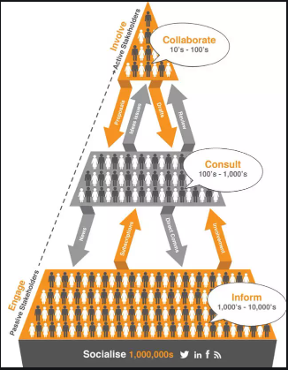
Figure: Showing stakeholder’s engagement
Likewise, through social media platforms, Cargill inform about their work to thousands of people, consult with hundreds of people and ultimately collaborate with few effective stakeholders.

Evolution of community engagement by the organization
Community engagement is termed as the process of collaborative working involving different groups of individuals affiliated by special interest, geographic proximity, or those within similar situations to fight against similar issues that are affecting the society (Medina, 2019).
Cargill was established as a grain warehouse in 1865 by William Wallace Cargill, in 1870 Cargill established the headquarters in Albert Lea. In 1880, the business was expanded beyond grains and including other items such as coal, flour, seeds, lumber and also investing in water irrigation, farms, land and so on. In 1923, Cargill acquired a grain merchandise firm “Taylor & Bournique” and the new technologies that came along with the new firm gave Cargill competitive advantages over their rivals. In 1930 the organization started their global expansion and spread their arms in Holland, Argentina and in various other parts of the world. In 1953, they expanded in Asian markets. In 1955, the organization included a scientific method of business and included a centralized R&D sector for feed developments (Pakiding, 2020). Till that time all the employees, leaders and managers were only focused on offline campaigns and advertisements for community engagement. The employees at that time have excellent verbal presentation and communication skills as well as skills of making offline posters for community engagement regarding the issues of eating healthy. In 2009 after achieving more than US $25 billion, they stated helping people and engaging themselves more in community engagement. They gradually started showcasing their corporate social responsibilities (Maher, 2019).
After evolution, the organization requires more complex strategies to carry out their responsibilities. They have already involved community planning services, negotiating with the community leaders, supporting the people to learn together and to stay healthy together however; still they are required to design inclusive ways of working.
Some of their strategies that they have evolved for community engagement are that, in 2009, Cargill has partnered with Fare share that is a charity organization that fights against hunger, Cargill has funded over £600000, the employees have volunteered their expertise and time for food distribution and to aware the children and women. In 2017, a joint venture with Fare Share distributed chicken every week to the needy at free of cost (McMuller et al., 2020). The investment for community engagement has expanded as well as the technical skills and online presence has now been given more importance.

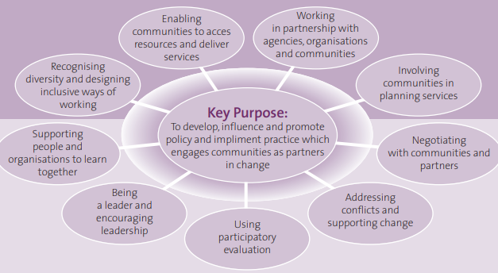
Figure: Showing the strategies of community engagement
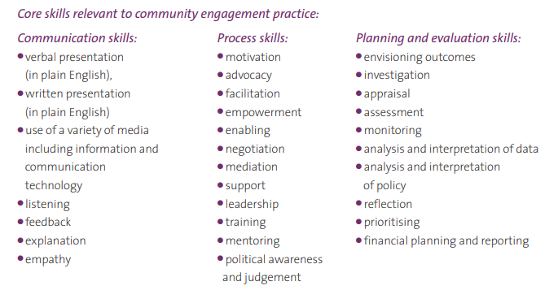
Figure: Showing the skills required for community engagement
Previously the leaders had communication skills that were applicable to communicate the required data in offline modes wherein, the skills had been evolved to give verbal presentation in front of the community in both offline and online modes moreover, the employees require the skill of explaining, listening and having empathy as well as giving feedbacks to the community in social media platforms regarding the necessity of healthy eating (Kumar, 2020). Such communication skills have been proved to be effective for community engagement. Moreover, the employees have evolved the skills of negotiation that are required for bargaining with the suppliers or sponsors as well as with the community leaders they require the skills of motivation, advocacy and empowerment. They are also required to be politically aware as community engagement is needed to be conducted under the rule of local government as in the present days the government rules have become more complex.

Use of social media platforms
Robert Reich, owner of Stanford center on “philanthropy and civil society” said that around 70% individuals get involved in charity work because they are asked by people to do so. Likewise, the organization initially selects a doable task that is measurable and effective and they reach out to the community. Then they share their story. Their causes have inspired a lot of people to join the campaign. Effective creativity and innovative skills help the employees to develop their content in social media effectively that reach close to the heart of the people (Mehra and Mayo, 2019). Efficient Research and Development department of the organization and the ability of the employees to develop videos and content regarding the harmful consequences of eating unhealthy shakes the community and they understand the need of eating health. Next, they invite friends and known persons for sponsorships. They choose the correct social media platforms, such as the most popular platforms including Facebook. Furthermore, the organization keeps a track of the visitors on their page and sends emails to those audiences to join the program.
One of the most exciting moves of the organization is that they update videos regularly on their official pages showcasing the harmful impacts of eating unhealthily and depending on drugs or alcohol. They also strategically promote their healthy food through the campaigns. Through effective technical communication skills, the employees communicate their message with the community and aware the members and also engage with the stakeholders.

Training and development for the employees
To work for social causes, one of the most important moves is to rebuild and re-shape the employees, to sharpen their skills and to motivate them to give their efforts for social causes. Likewise, the employees shall be trained effectively to improve their communication skills. The training shall be quite different from normal communication training that is required for normal corporate sector, in social causes the employees shall be trained to communicate effective in both offline and offline campaigns and shall have for effective technical communication skills so that they could reach easily through social media platforms to their target audience (Dolce, 2019). They shall be trained with the help of modern technologies and shall have expertise in digital technologies and web designing skills to be innovative and creative in developing their contents so that the social cause and the necessity of the campaigns reach to the audience. Moreover, they shall consult with social media influencers to learn how to influence the audience to participate in social causes (Kumar, 2020). Moreover, they shall be trained to increase their listening skills and explain skills. Empathy refers to the ability of understanding the feelings of another person. It is a skill and shall be trained in the workplace. The leaders shall be effective to develop the skill of empathy in every employee to increase their social awareness. For several years the organization has tried to develop a diverse workplace as diversity brings in creativity as well as innovations, however diversity also might result in internal conflicts. Thus, empathy is required to understand each other’s cultural background, experience, political beliefs and so on.
Their processing skills including their motivation power shall be increased; experts shall be consulted to sharpen such skills. Last but not the least the employees shall have the planning and evaluation skills to plan the program effectively in such a way so that the communities understand the necessity of the program and participate whole heartedly. Employees shall be trained to minimize language barriers and give training of multiple languages so that they could reach out to the peoples from various cultures (Mayo, 2020).

Conclusion
Thus, in a nutshell it shall be concluded that, organizations shall have corporate social responsibility and shall remain aware socially. To do so, they shall engage with the community and stakeholders shall participate to support the cause. The values and training of the employees shall be modified in such a way so that they can support the community engagement. Using social media platforms, the stakeholders shall be communicated and technical communicative skills such as verbal and written presentation skills, listening, explaining powers and empathy shall be gained by the employees. Furthermore, collaborating with government agencies and other giant organizations shall remain recommended that helps in community engagement by giving financial support.

Reference
Di Napoli, I., Dolce, P. and Arcidiacono, C., 2019. Community trust: A social indicator related to community Engagement. Social Indicators Research, 145(2), pp.551-579.
Durbeej, N., Abrahamsson, N., Papadopoulos, F.C., Beijer, K., Salari, R. and Sarkadi, A., 2019. Outside the norm: Mental health, school adjustment and community engagement in non-binary youth. Scandinavian journal of public health, p.1403494819890994.
Esmaeilpour Arabi, N., Yigitcanlar, T., Kamruzzaman, M. and Guaralda, M., 2020. How can an enhanced community engagement with innovation districts be established? Evidence from Sydney, Melbourne and Brisbane. Cities, 96, p.102430.
Kumar, J. and Kumar, V., 2020. Drivers of brand community engagement. Journal of Retailing and Consumer Services, 54, p.101949.
Lowe, K., Harrison, N., Tennent, C., Guenther, J., Vass, G. and Moodie, N., 2019. Factors affecting the development of school and Indigenous community engagement: A systematic review. The Australian Educational Researcher, 46(2), pp.253-271.
Maher, R., 2019. Squeezing psychological freedom in corporate–community engagement. Journal of Business Ethics, 160(4), pp.1047-1066.
Mayo, P., 2019. Higher education in a globalising world: Community engagement and lifelong learning.
McMullen, J.M., George, M., Ingman, B.C., Pulling Kuhn, A., Graham, D.J. and Carson, R.L., 2020. A systematic review of community engagement outcomes research in school‐based health interventions. Journal of School Health, 90(12), pp.985-994.
Medina, M.A., Cosby, G. and Grim, J., 2019. Community engagement through partnerships: Lessons learned from a decade of full-service community school implementation. Journal of Education for Students Placed at Risk (JESPAR), 24(3), pp.272-287.
Mehra, B., Sikes, E.S. and Singh, V., 2020. Scenarios of technology used to promote community engagement: Overcoming marginalization and bridging digital divides in the Southern and Central Appalachian rural libraries. Information Processing & Management, 57(3), p.102129.
Pakiding, F., Zohar, K., Allo, A.Y., Keroman, S., Lontoh, D., Dutton, P.H. and Tiwari, M., 2020. Community Engagement: An Integral Component of a Multifaceted Conservation Approach for the Transboundary Western Pacific Leatherback. Frontiers in Marine Science, 7, p.756.
Pecl, G.T., Stuart-Smith, J., Walsh, P., Bray, D., Brians, M., Burgess, M., Frusher, S.D., Gledhill, D., George, O., Jackson, G. and Keane, J., 2019. Redmap Australia: challenges and successes with a large-scale citizen science-based approach to ecological monitoring and community engagement on climate change. Frontiers in Marine Science, 6, p.349.
Pine, K.H., Hinrichs, M.M., Wang, J., Lewis, D. and Johnston, E., 2020. For impactful community engagement: check your role. Communications of the ACM, 63(7), pp.26-28.

