Streaming killed the physical star.
BMTY7004 – Essay
New Technology in Music and Creative Entertainment
Word count –

Isabella Coakley

Table of Contents
Executive summary 3
Introduction 4
The Physical industry 4
A change in format and a step toward digital 5
Web 2.0 piracy 6
Streaming domination 6
Conclusion 8
Bibliography 9

Executive summary

The music industry has since its conception been a physical lead industry with services running through parts of its offerings. As formats and technology developed to meet consumer desires the industry was led to make drastic changes to its main revenue source that being physical products to providing a digital service. Exploring the climate that led to this drastic shift shows that not only had consumers pushed for a change long before the digital revolution but that if the music industry wasn’t willing to change consumers other industries would still make the change.

Introduction

Before the time of the phonograph in the late 19th Century all music was considered Service-based, as whether in private homes or public auditoriums composers, instrumentalists and singers were giving the audience an intangible product. With the invention of permanent sound recordings came the development of the ‘Music business’ as a product industry. The music business was from its conception a product-based industry through the creation of products for consumers to purchase and enjoy.
The 20th century was a time of great invention and technological development in all industries, for the Music industry it started with the mass production of record players and records, then transferred from ‘wind up’ to electronic. It continued into the second half of the century with the use of new materials for discs and equipment and the invention of new recording methods and storage.

The Physical industry

The industry was keen to adapt, mass production led to mass purchasing by the consumer and small affordable record players were found in almost every home. Consumers ‘were keen to spend’ , particularly in America (PBS, n.d.) . Many had adopted the modern view of buying short-life products, ‘The cardinal features of this culture were acquisition and consumption as the means of achieving happiness;’ (Beal, 1994). This consumer attitude embraced new technology, wanting the latest development, the latest product and the latest artist recordings.
It was during this adoption that radio was also dominating the lives of everyday consumers as the physical sales of records climbed consumers looked for ways to find new music and so turned on the radio. The radio becoming a domineering force in the industry servicing listener with new music
alongside a parasocial relationship. The strength of radio climbed to the point which record labels were clamouring to have new artists featured on large stations with payola becoming commonplace. Though the consumer was buying into a physical industry they were using the service side to dictate their choice of purchase.
As technology was developed the Music Industry as a whole appeared to adapt and adopt, but in the 1960s new technology started to change the relationship between industry and consumer. Cassette tapes were at first all pre-recorded like records but quickly consumers became able to home record as well, and shortly after from small portable devices. This allowed the consumer to record live music or broadcasted music and was the first small step towards the change to a service lead industry .‘The cassette enabled the first personal mobile music experience’ (Skågeby, 2011). As a commodity, the cassette player became and still is an iconic item, from the cheapest import to the coveted ‘Walkman’ it was a symbol of youth that was used by all generations. Through the 1970s and 1980s advertising for any item marketing to the youth, the market would usually include a walkman in the background symbolising affluence, desirability and cultural status.
With this new technology, the consumer used this opportunity to bring the service they had enjoyed from the radio into their own lives. With tape decks or with other means of recording reel-to-reel the consumer began curating their own listening experience similar to that they would find on radio and relatively new music television programming. The experience of curating this playlist had not been an opportunity the average consumer had been afforded to this point with the nearest being compilation vinyl records that labels would release. This was the first inkling of the consumer wanting to take more control and curation over their music consumption which would only grow as technology developed.
Whilst the music industry profited from the sales of cassettes and players it was unhappy that the public could record sound without paying for the recording, an issue that was highly debated at the time. Eventually, the American Congress voted in a bill in 1985 that the public could not profit from copying tapes they could only be for personal use (99th Congress, 1985) these personal tapes, often eclectic mixes of artists and genres are fondly remembered as ‘mix tapes’, often gifted to friends and loved ones. The mix tapes were the first possible portable individual personalisation of music listening available to consumers, which is why I am identifying this as the first step towards the service industry of the 21st Century.
As the sales of cassette tapes rose and records dropped the industry fear that tape-to-tape copying would mean fewer sales was proven wrong as shown in the New York Times article of 1985, sales of pre-recorded cassettes outstripped that of blanks and records alike (Pareles, 1985)

A change in format and a step toward digital

A few years later the next development excited the market, the Compact Disc and players bringing a better quality sound recording than had been previously possible on home or portable players. Digital audio recording on CDs meant greater storage abilities than had been on vinyl or cassette, this also leads to better sound quality depending on player capability and eventually became compatible with personal computers replacing floppy discs again enabling home recording (discwizards, n.d.).
Consumers who had only recently invested in portable cassette players once again invested in the latest thing, often buying up repeat copies of the music they had on cassette or vinyl in the new CD format. The Music Industry was getting involved in all aspects of technological development, embracing the changes, particularly the major companies such as Sony and Phillips who had led the way with CD production. In 1986 records were outsold for the first time by another recording product, the CD. ‘A case study of the Music Industry’.
However, this change of format did not change the consumer's wants to create their own listening experience with the ripping of CDs becoming rampant. A store selling blank Cds became a major play in the market as consumers flocked to create their own mix tapes for all reasons and occasions with the format was able to store more data than the previous cassettes with this CD mix tapes became a staple in youth lives. Youths began taking over the service roles that radio DJs and TV presenters held as they individually would distribute their mis-tapes.
Up until this point, the music industry could be seen to have understood, utilised and profited from new technology. Consumer spending was at an all-time high in the late 1990’s reaching 21.5 billion dollars. It was a strong industry with three main divisions, the recording, licensing and promotion of music either all done in house by major labels or outsourced through smaller specialist companies. It was in the main a hierarchically structured industry using linear models with the core focus of creating and profiting from end products of physical music recordings. All areas and genres of the business had profited from developmental changes, so the question is why did it not embrace and invest in the development of the Internet? The main consideration for this is probably the virtual concept of the new technology, as the music industry was developed around physical products, and the internet offered end-user concepts that were non-tangible. Having a product that you could not hold in your hand was alien to the music industry and understanding how to make a profit from a customer who no longer needed to purchase your product was a major obstacle for the investment decision-makers to overcome.

Web 2.0 piracy

As early as 1994 when Aerosmiths ‘Headfirst’ could be digitally downloaded the evidence was there to demonstrate the possibilities around standard music production and free download releases E. Buskirk 2008 (BUSKIRK, 2008). At this point, IUMA had been offering a downloadable music service from the University of California since 1993, but it was not followed by the Music Industry until Sony Japan launched the digital music store Bitmusic in 1999. The majority of the Music Industry as a whole had gone from being innovators to followers, this left open opportunities for new entrepreneurial gambits such as Napstar who launched the file sharing site in 1999. This site was so controversial for not paying for the use of music even consumers were unsure of the legalities of using the site. This did not stop its popularity and it quickly gained customers over the 2-year period before it was shut down it is thought to have had over 80 million users. The main reason behind the closure was the weight of legal challenges around the non-payment of fees to artists and rights holders of the music that was offered (Lamont, 2013).
While the music industry’s legal teams were working on shutting down file-sharing opportunities the management teams were waking up to the profit loss and how to overcome the issues. Production teams tried installing software locks (DRM) to protect property rights and Universal and Sony combined to create ‘Pressplay’ digital sharing, but it would never be enough with the wider international public uptake of Web 2.0. In the meantime Tech giant Apple released the iPod portable player, the first portable download ‘product’ for consumers to purchase, and they needed to purchase it if they wanted to use the Apple music service iTunes away from home. It was also the first professional example of consumer payment for downloads giving the industry a chance to see revenue opportunities that could work for the industry and the artist.
The music industry companies themselves responded with personal MP3 players and started to invest in the internet music opportunities such as Spotify and Youtube. In some cases simply through purchasing shares and in others exchanging shares or licensing deals as Sony, Warner and Universal have with YouTube.

Streaming domination

During these legal and technical battles, consumer habits were speedily changing, consumers no longer expected or needed to pay to listen to or view music and video, and consumers had not previously had so much choice or so much offered freely. Many consumers were happy to listen to or view advertising if that meant their consumption was free of payment. The streaming services increasingly offered subscription options involving regular payments from consumers for advertising-free service, podcasts, tailored listening and special events. So the public was once again spending on their music consumption, but by individual choice and getting far more for their money than previously. However what they got was mainly virtual, if they switched services then they mostly lost stored information so customer loyalty became a key part of the subscription services.
Development within the physical format has continued with electronic equipment such as head/earphones, digital speakers, MP3 updates and the incorporation of music and visuals within mobile phones. Recorded music has continued with the market for vinyl going through a strong surge, and new formats such as Khino Kits being offered.
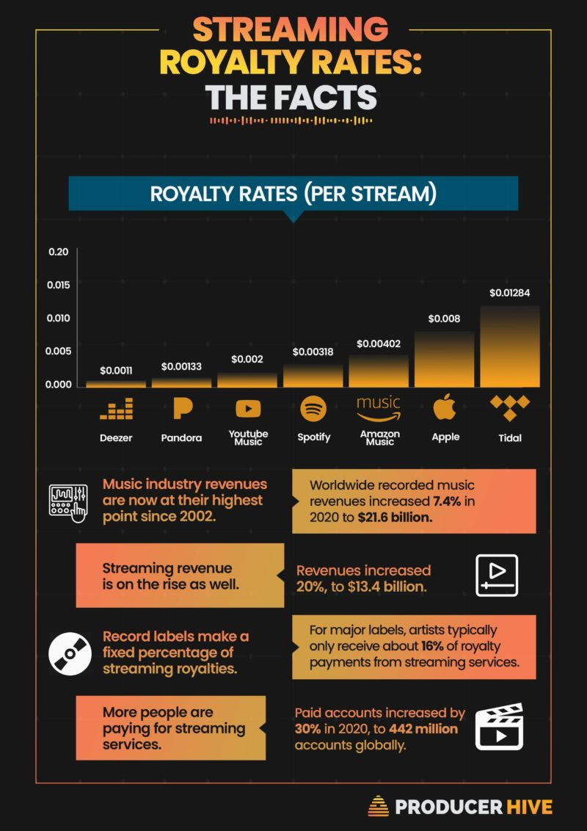
For the Artist, performance and distribution changed, if you were an unknown musician you no longer have to produce physical samples to give out to Record Company executives in the hope that they would listen and like you. Instead, you can freely record from home with the most basic equipment and your art can be uploaded and downloaded instantly almost worldwide, this has created huge opportunities for exposure for new talent. It is no longer necessary for artists to sign a contract to receive payment for their work, if enough people show interest through the internet money is paid directly to them as the content loader. More recently artists are turning to Digital aggregators such as AWAl and CD baby, paying a fee to get their music played by services like Spotify and iTunes, so these digital aggregators are playing a similar role to the previous intermediary management or talent scouts of the old product lead music industry. The difference being that they are a service charging a flat fee, not a person taking a percentage of any future contract, the importance of these services is now growing to the extent that the major record labels are ‘seeking ownership links’ with them (Galuszka, 2015).
Figure 1 Streaming royalties (FITZJOHN, n.d.)
Whilst these initiatives are all very helpful for new artists, for established artists it is very different. The income they would previously have earned after negotiating a recording and publishing contract was dependent on what the volume of physical recordings containing their music would sell. So previously a popular artist was in a strong position to negotiate a high percentage contract in their own favour and gain a good income. With the diminished record sales that income was gone and in the beginning of free downloads their income was not being replaced by anything else. Artists
around the world protested the use of their copyrights without re-numeration and as the internet services developed the likes of Spotify and Apple Music started paying out, the current figures for Apple are 125 streams per dollar as artist income and Spotify is 314 streams per dollar income, this compared to record sales seems shocking and the disparity between platforms rates is also an issue.
Many artists have complained about Spotify’s rates and withdrawn their work from the platform some permanently some coming back after renegotiation. Some artists also withdraw from platforms for other reasons such as supporting or disagreeing with a political issue, which happened with the ‘Artists against Spotify’ who withdrew because they felt Spotify broadcast misinformation in 2022 regarding the Covid pandemic.
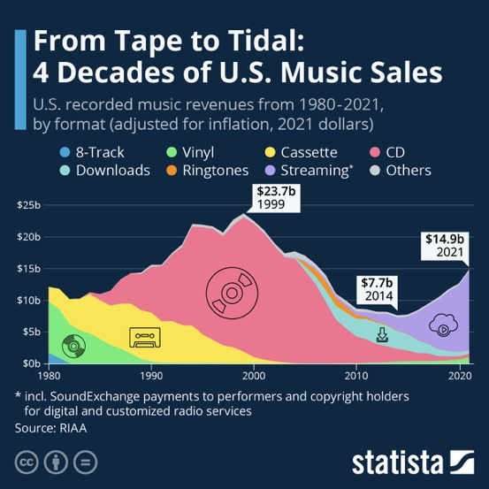
Pre-internet streaming the Record companies organised and encouraged artists to tour to promote their records, often adding a tour commitment for each album to an artist's contract. Exposure for an artist on a radio or television show or tour meant increased sales if the consumer liked the music, at that time the revenue from the record sales was seen as far more important and profitable than any profit the tour may or not make, hence the old adage ‘you tour to promote the record’.
Figure 2 Music sales by format (Richter, 2022)
Since the internet streaming services conception, the industry’s role has developed into one of servitisation. Record companies now work with artists to create the biggest and the most spectacular live performance shows they possibly can. Live events have become even more popular than before the millennium and are seen as a major revenue source, often the publicity for newly released music leads up to event marketing, a complete reverse of the previous practice.
Over a twenty-year period from the launch of the internet, the music industry as a whole has re-prioritised, created new divisions and downsized dramatically product production, ending up with far fewer products that had become almost ‘niche’ such as cassette tapes and vinyl releases. The music industry has become a service industry, discovering and nurturing new talent, producing, marketing and hosting for consumer consumption. This shift from ‘content providers to distributors’ has settled and become a standard business practice throughout the industry and where well managed is providing good profit margins.

Conclusion

The music industry though building its monetary value and power acquisition from artists via the market created around physical distribution much of its growth was driven by service lead sectors. The live sector running throughout all these changes alongside radio DJs and services as simple as the store clerk in a music shop giving the customer a recommendation. The rise of physical and its mass consumption was heralded by these services. The consumer made it clear to the industry as soon as they had the opportunity that they wanted more power over what they listened to. As such though the means of consumption have drastically changed alongside how the sector is defined it has been driven by a natural progression in technology and consumer behaviour. Had the industry been more willing to adapt to consumer wants before the tide changed and technology-based services companies took on the role perhaps the means by which the music industry provides the current service may look different however it is clear that the industry would of inevitably still become a service industry.

Bibliography
99th Congress, 1985. All Information (Except Text) for H.R.2911 - Home Audio Recording Act. DC: congress.gov.
artsites, n.d. Computer Music (So Far). [Online]
Available at: http://artsites.ucsc.edu/EMS/Music/equipment/computers/history/history.html
[Accessed 16 02 2023].
Beal, T. D., 1994. Reviewed Work: Land of Desire: Merchants, Power, and the Rise of a New American Culture by William Leach. The Business History Review, 68(1), pp. 168-170.
BUSKIRK, E. V., 2008. First Free Download. [Online]
Available at: https://www.wired.com/2008/03/the-first-free/
[Accessed 02 03 2023].
discwizards, n.d. The history and evolution of the compact disc. [Online]
Available at: https://www.discwizards.com/history-of-the-cd.htm
[Accessed 11 03 2023].
FITZJOHN, S., n.d. STREAMING PAYOUTS PER PLATFORM & ROYALTIES CALCULATOR. [Online]
Available at: https://producerhive.com/music-marketing-tips/streaming-royalties-breakdown/
[Accessed 15 03 2023].
Galuszka, P., 2015. Music Aggregators and Intermediation of the Digital Music Market. International Journal of Communication, Volume 9.
Lamont, T., 2013. Napster: the day the music was set free. [Online]
Available at: https://www.theguardian.com/music/2013/feb/24/napster-music-free-file-sharing
[Accessed 05 03 2023].
Lavengood, R. A. S. 0. 2. W. M. I. S. ’. T. Y. D. E. P. S. M., 2019. What Makes It Sound ’80s?: The Yamaha DX7 Electric Piano Sound. Journal of Popular Music Studies, 31(3), pp. 73-94.
Pareles, J., 1985. ISSUE AND DEBATE; ROYALTIES ON RECORDERS AND BLANK AUDIO TAPES. The New York Times, 21 November, p. 34.
PBS, n.d. The Rise of American Consumerism. [Online]
Available at: https://www.pbs.org/wgbh/americanexperience/features/tupperware-consumer/#:~:text=Television%20and%20automobile%20sales%20skyrocketed,of%20five%20million%20a%20year
[Accessed 20 02 2023].
Richter, F., 2022. From Tape to Tidal: 4 Decades of U.S. Music Sales. [Online]
Available at: https://www.statista.com/chart/17244/us-music-revenue-by-format/
[Accessed 24 02 2023].
Skågeby, J., 2011. Slow and fast music media: comparing values of cassettes and playlists. TRANSFORMATIONS Journal of Media & Culture, Issue 20.

