Student No. 2303869 Acting for Musical Theatre module code: ADPA5023

Introduction
This reflective essay aims to evaluate various techniques introduced and practised throughout the module. I will apply the Gibbs reflective cycle (Gibbs,1988) to support my reflection and learning process, demonstrating the relevance of research in supporting the development of practical skills.

Main body
One technique that proved influential within the module was ‘Character Exercises’. This involved focusing on information relating to characters within a musical, based on a set of questions, rather than from an emotional perspective. Alfred (2007) reminds an actor of the benefits of preparation. It is “to arm yourself with (a) knowledge of the material (‘This is what I know so far’) and (b) possible ways of structuring the rehearsals
(‘This is how we might approach the work’)” (Alfred, 2007, p. 75). At the time I was very confused as the chosen scene and song did not provide adequate facts to build on my character. This resulted in evaluating the lines and lyrics of the character, which proved unnecessary, as the key information was gleaned from the song alone. Although this process involved energy and time, it was beneficial in terms of gaining a deeper understanding of the character analysis. Alfred (2007, p. 75) advises that an actor “might consider the preparation in a totally different light, one in which you gather all the information you can glean from your material until you’re sufficiently primed to begin exploring it together with the actors in rehearsal. Only then will you be ready to discover what the production might be like.”

I learned that using factual information within a script can further help me to develop my character. Alfred (2007, p. 76) explains, “Because you’re trying to become one with the material rather than doing something to it, you develop an intimacy with it, you learn to breathe with it, so that in time it organically releases its buried associations. It must be more productive to collaborate with what is there, rather than deny, distort or fight it.” I applied this technique beyond the class when auditioning for ‘I Love You, You're Perfect, Now Change.’ Baron (2021) advocates this technique as it allows for “The actions and emotions that you plan can seem to seamlessly come from inside of you without any sense of performing or acting.”

Alfed (2007, p. 143) discusses the benefits of gathering a bank of “transformational techniques to help actors towards characterisation” with the view of being helpful “as alternative languages or tools to help the actor towards the creation of a role, especially in breaking them of patterns and ingrained habits.” However, he explains that “These techniques may not all work for every role or every play, and some may stimulate some actors’ imaginations more than others.” However, he advocates their usefulness for actors "as part of their battery of technical skills and as aids to creative work.” Indeed, he believes they can “broaden the range of an actor’s expressiveness.”

Another technique that I found helpful within the module was Meisner repetition exercises. This technique was applied at the beginning of a scene to help us improvise and convey “…natural, instinctual, and emotionally connected performances” (Lemon, no date). In turn, this technique “fosters a dynamic interplay between actors, making scenes feel vibrant and alive” (Lemon, no date). Andrasik and Krcmarova (2025, p. 1) agree and explain how the Meisner technique encourages actors to “respond spontaneously and truthfully to scene partners, rather than relying on preconceived notions or scripted responses.”

Practising the technique allowed for a greater understanding and a deeper appreciation of the application. However, the technique involved time dedicated to the practice at the beginning of a scene, and again before improvisation, resulting in less rehearsal time for the actual piece. Nonetheless, as a less experienced actor than my peers, this is the one technique that has helped me to improvise and provide a “…natural, instinctual, and emotionally connected performance” and avoid planning out the movement and characteristics of a character in my head (Lemon, no date) as Andrasik and Krcmarova (2025) analyse that “ it is deeply rooted in the belief that genuine emotional reactions, presence, attention, and quality of contact with the stage partner create the most compelling performances.” I foresee that this technique will be particularly helpful within my career.

Uta Hagen’s ‘object exercise’ is another technique I learnt during the module. It involved testing my ability to re-create two minutes of my life and “bringing it to presentation as if for the first time” (Hagen, 2009, p. 91). I chose feeding the dog in the morning as the focus for my basic exercise. This involved addressing key questions (as shown in Table 1).
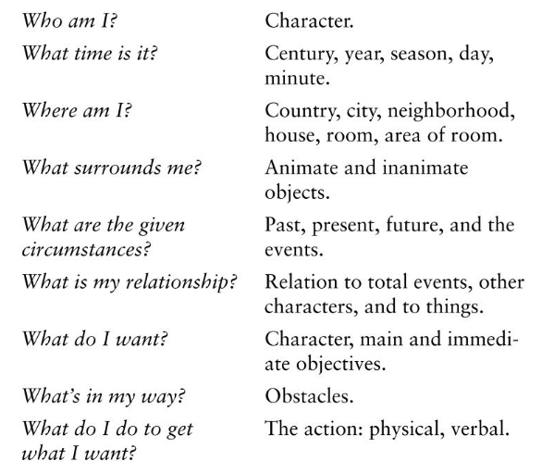
Table 1: Uta Hagen’s 9 Questions (Hagen, 2009, p. 82).

Within the two-minute exercise, I worked through the activity with the support of the above questions, whilst also seeing the pictures of the environment and pinpointing “all of the physical and psychological sensations inherent” to the scene, and made “a layout of the action for the two minutes” to “test all aspects mentioned” (Hagen, 2009, p. 85). I noticed that this technique did not resonate with my skill set, as I found it difficult to reach a level of subconsciousness to fully apply this technique. One challenge I encountered was the fast pace and high intensity of the exercise. Trying to fit so many components into just two minutes left me feeling hurried rather than concentrated. Instead of strengthening my engagement with the action, the strict time limit pushed me to focus on ‘getting through it’ rather than truly experiencing it. Consequently, the work felt more robotic than lived‑in. Reflecting on the experience made it clear why the two‑minute exercise didn’t fit with my processing. The need to work both quickly and subconsciously limited my ability to respond in a genuine way. Although the technique has value, it doesn’t currently match how I access honest action. This realisation helps me move forward with a better understanding of my own approach and the methods that support my connection to the work.

Conclusion
Reflecting on the techniques explored throughout this module has highlighted how each method has contributed differently to my development as an actor. Using Gibbs’ (1988) reflective cycle allowed me to evaluate not only what I learned, but how these experiences will shape my future practice. ‘Character Exercises’ proved particularly valuable, demonstrating the importance of grounding performance in factual material rather than relying solely on emotional instinct. Although initially challenging, this process strengthened my analytical skills and deepened my understanding of character construction. In contrast, Meisner repetition offered a more instinctive pathway, enabling me to respond truthfully and spontaneously in the moment (Andrasik and Krcmarova, 2025). Despite the time it required, this technique significantly enhanced my confidence in improvisation and will remain a key tool in my ongoing training. Hagen’s (2009) object exercise, while insightful, revealed the importance of recognising which methods align with my natural process. Acknowledging its limitations for my practice was itself a meaningful learning outcome, reinforcing the need to adapt techniques to suit individual working styles and learning needs. Overall, the module has broadened my technical and reflective abilities, equipping me with a more versatile toolkit and a clearer understanding of how to continue developing as an actor.

Reference List
Alfreds, M. (2007) Different Every Night : Freeing the Actor. Nick Hern Books.

Andrášik, T. and Krčmářová, B. (2025) 'Meisner Repetition Exercises as a Tool for Deliberate Practice in Psychotherapy: A Gestalt Therapy Exploration', The Journal of Humanistic Counseling, pp. 1-13. Available at:
https://onlinelibrary.wiley.com/doi/epdf/10.1002/johc.70022 (Accessed: 4 January 2025).

Baron, J. (2021) Why character analysis and interpretation is so important. Available at: https://www.backstage.com/magazine/article/the-importance-of-character-analysis-interpretation-70997/I (Accessed: 2 January 2026).

Gibbs, G. (1988) Learning by Doing: A guide to teaching and learning methods. Oxford Polytechnic.

Hagen, U. (2009) Respect for Acting. Wiley Blackwell Publication.

Lemon, D (no date) The Actress Forge- Truth acting: Meisner technique. Available at: https://www.theactorsforge.com/resources/11-truth-acting-the-meisner-technique (Accessed: 2 January 2026).

