UNIVERSITY OF WALES:  TRINITY SAINT DAVID |  |  | PRIFYSGOL CYMRU:  Y DRINDOD DEWI SANT
LOCATION: LAMPETER |  | LLEOLIAD: LLAMBED
LEVEL 5 |  | LEFEL 5
November 2019 |  | Tachwedd 2019

HPAH5037
Murder, Mayhem and Megalomania: The Life and Times of the Emperor Nero

QUIZ 4

Write your name here:
Write your Student number here:

TIME: 20 minutes

ATTEMPT TO ANSWER ALL OF THE FOLLOWING 20 QUESTIONS:

In the case of multiple-choice questions indicate your answer by circling either A, B, C or D (as you think is correct). Giving more than one answer to a question will result in a zero mark (if you wish to change your answer make this clear). For other questions write your answer.

1) From what film does this still image come from?
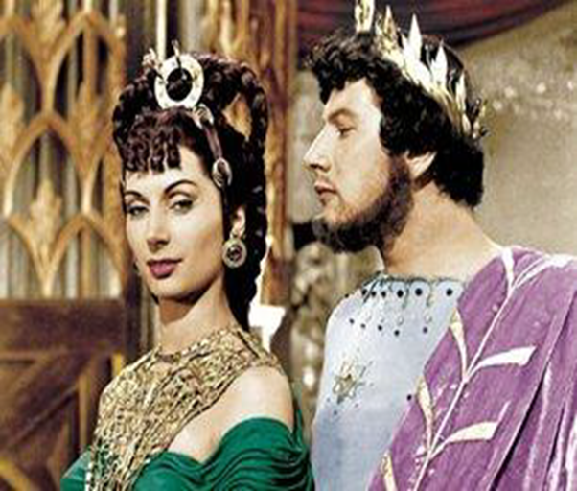
A – Mel Brook’s History of the World: Part I
B – Emperor Nero on the Warpath
C – The Sign of the Cross
D – Quo Vadis

2) To what gens does Nero belong to on his (biological) father’s side?
A – Licinia
B – Cornelia
C – Domitia
D – Rubellia

3) Tacitus draws on a number of earlier sources – which of these is one of the authors that he does not draw upon?
A – Cluvius Rufus
B – Pliny the Elder
C – Fabius Rusticus
D – Flavius Vopiscus

4) Who is the authors of this (translated) passage?
“Even now his subjects wish he were still alive, and most men believe that he is…”
A – Dio Chrysostom
B – Josephus
C – Marcian of Heraclea
D – Diogenes Laërtius

6) To which year does the “Year of the Four Emperors” refer?
A – 67 CE
B – 68 CE
C – 69 CE
D – 70 CE

6) Which of these figures was not an emperor during the “Year of the Four Emperors”?
A – Domitian
B – Galba
C – Otho
D – Vespasian

7) Who is the author of the following (translated) passage?
“…The Flavii, admittedly an obscure family, none of whose members had ever enjoyed high office, at last brought stable government to the empire… Titus Flavius Petro, a citizen of Reate, who fought for Pompey in the civil war as a centurion or perhaps a reservist… secured an honourable discharge and took up debt collecting… his son Sabinus… became a customs supervisor in Asia, where several cities honoured him with statues inscribed “To an Honest Customs Officer”. He later turned banker among the Helvetii, and there died leaving a wife, Vespasia Polla, and two sons, Sabinus and Vespasian…”
A – Josephus
B – Tacitus
C – Suetonius
D – Plutarch

8) From which work does the following (translated) passage come from?
“Very soon, the houses of the citizens shall fall a prey to the conflagrations which I will set going! Fire, utter ruin, shall weigh down this hateful mob, extreme privations, bitter starvation with weeping and sorrow!”
A – Troades
B – Medea
C – Thyestes
D – Octavia

9) What is the name of the Neronian themed tragedy written by Jean Racine in 1669?
A – Nero: An Historical Play
B – Britannicus
C – La Mort de Nerón
D – Othello

10) Which medieval author accuses Nero of having his belly become swollen from anal sex?
A – John, Bishop of Nikiu
B – Arrigo Boito
C – Juliana of Norwich
D – Jean Racine

11) Who is the female figure represented on the reverse of this coin?
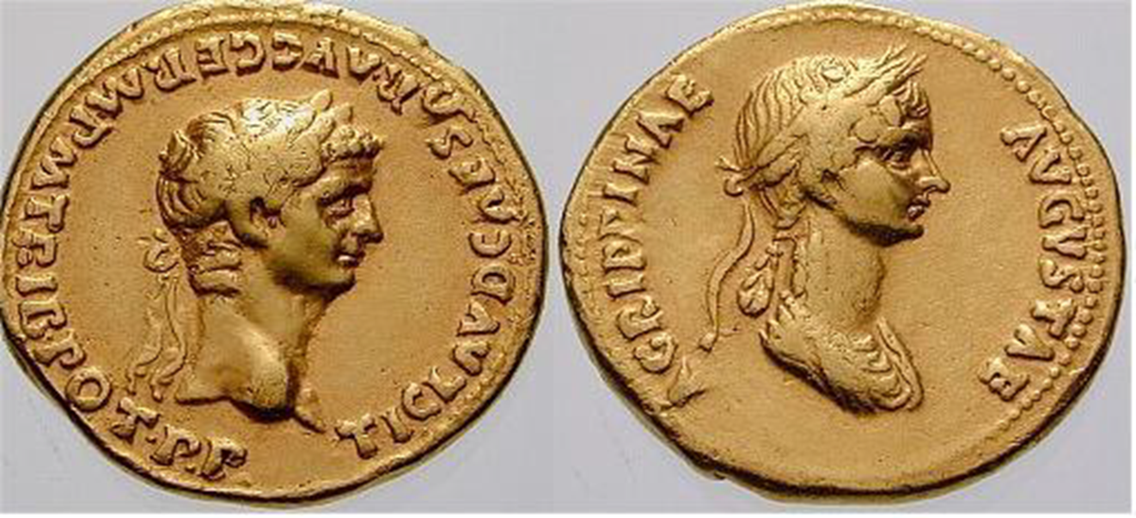
A – Lollia Paulina
B – Aelia Paetina
C – Poppaea Sabina
D – Agrippina the Younger

12) Under which emperor was this coin minted?
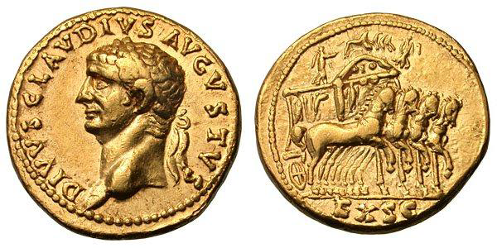
A – Caligula
B – Claudius
C – Nero
D – Galba

13) Which of these games did Nero not attend/participate in?
A – Isthmian
B – Pythian
C – Olympian
D – Ephesia

14) Who is the author of this (translated) passage?
“For his processional entry into Rome he chose the chariot race which Augustus had used in his triumph nearly a hundred years previously, and wore a Greek mantle spangled with gold stars over a purple robe. The Olympian wreath was on his head, the Pythian wreath in his right hand, and others were carried before him, with placards explaining where and against whom he had won them, what songs he had sung, and in what plays he had acted. Nero‘s chariot was followed by his regular claque, who shouted that they were Augustiani and the soldiers of his triumph.”
A – Josephus
B – Philo
C – Suetonius
D – Statius

15) What is the conventional name for head-gear worn hear by Nero on this Tetradrachm?
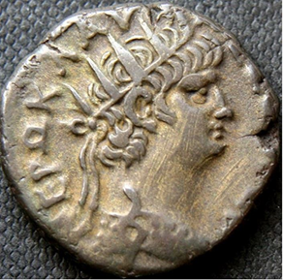
A – Atef
B – Deshret
C – radiate crown
D – corona civica

16) What is the name of the territory that Nero’s client king Polemon II was compelled to abdicate from?
A – Pontus-Cilicia
B – Cottian Alps
C – Moesia Inferior
D – Nabataea

17) Who is the author of this (translated) passage?
“Nero, though angry at him, did not sail against him, nor yet against the Ethiopians or the Caspian Gates, as he had intended. He did, indeed, among other things, send spies to both places, but seeing that the subjugation of these regions demanded time and labour, he hoped that they would submit to him of their own accord.”
A – Cassius Dio
B – Suetonius
C – Tacitus
D – Plutarch

18) What is the name of Nero’s third wife?
A – Statilia Messalina
B – Poppaea Sabina
C – Claudia Octavia
D – Claudia Antonia

19) In what year was Tiridates of Armenia crowned in Rome by Nero?
A – 64 CE
B – 65 CE
C – 66 CE
D – 67 CE

20) What is the name of the procurator whose aggressive demands for repayment of Claudian era loans was one of the underlying causes of the Boudiccan rebellion according to Cassius Dio?
A – Corbulo
B – Catus Decianus
C – Gessius Florus
D – Cestius Gallus

