Luke MacDonald (2100654)

EnerPHit Retrofit Assessment of Underwood Cottage Using PHPP Methodology
Module: ACBA5026

Table of Contents
Introduction 2
Existing Building Assessment 3
PHPP Baseline Model 6
Proposed EnerPHit Retrofit Strategy 7
Evaluation of Retrofit Interventions 11
Comfort and Health 11
Operational Carbon and Energy Reduction 11
Embodied Carbon and Material Selection 12
Financial Savings 12
Conclusion 13
References 14

Introduction
The built environment is responsible for a significant amount of global energy consumption and carbon emissions; therefore, the retrofit of existing buildings has become an essential strategy in reaching national and international decarbonisation targets. While new-build standards continue to improve, a lot of the existing housing stock remains energy inefficient, particularly traditional solid wall properties which usually experience high heat losses, poor airtightness and raised operational energy demand. Retrofitting these buildings presents unique challenges due to limitations related with existing construction methods, moisture behaviour and heritage considerations.
The EnerPHit standard, developed by the Passive House Institute (Passive House Institute, 2025), provides a solid framework for the deep energy retrofit of existing buildings. Unlike full Passive House certification, EnerPHit recognises the practical problems associated with refurbishment projects while still targeting large reductions in operational energy demand, improved occupant comfort and improved indoor environmental quality. The standard assesses factors including space heating demand, airtightness, thermal bridge reduction and primary energy consumption through the Passive House Planning Package (PHPP) methodology.
This report evaluates the existing performance of Underwood, a traditional stone cottage located in Parkmill, Gower, Wales, and investigates retrofit interventions aimed to improve the building to meet EnerPHit performance levels. Existing building fabric, energy consumption and mechanical and electrical services are assessed using available survey data, utility information, airtightness testing and PHPP modelling. Retrofit strategies including fabric insulation upgrades, airtightness improvements, thermal bridge mitigation and ventilation improvements are then analysed within the PHPP model to find their effectiveness. Finally, the proposed interventions are evaluated regarding occupant comfort and health, operational and embodied carbon reduction, and potential financial savings.

Existing Building Assessment
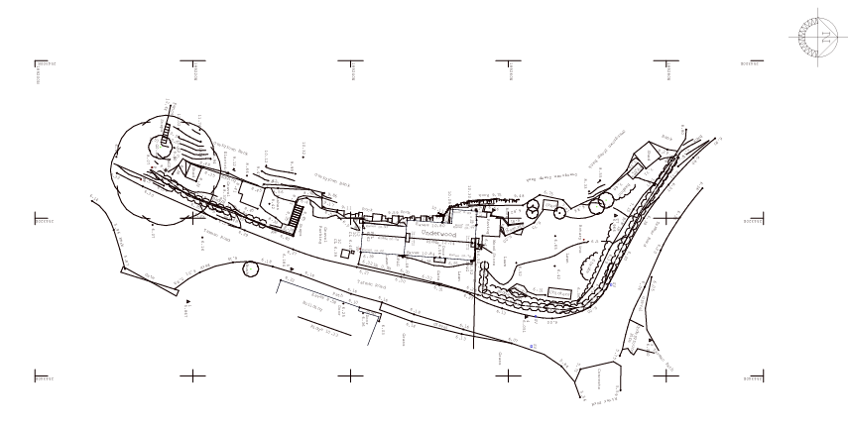
Underwood is a traditional detached stone cottage located in Parkmill, Gower, Swansea.

Figure 9: Existing site plan of Underwood cottage, Parkmill, showing orientation, access and surrounding topography.
The property consists of a two-storey dwelling with a reported gross internal floor area of approximately 106 m² (Green ROOM homes, 2025) and is constructed using traditional solid masonry walls with pitched slate roofing. Existing drawings and survey information show a compact built form with relatively limited glazing areas, although the building still has significant heat loss due to the thermal performance of the original construction.
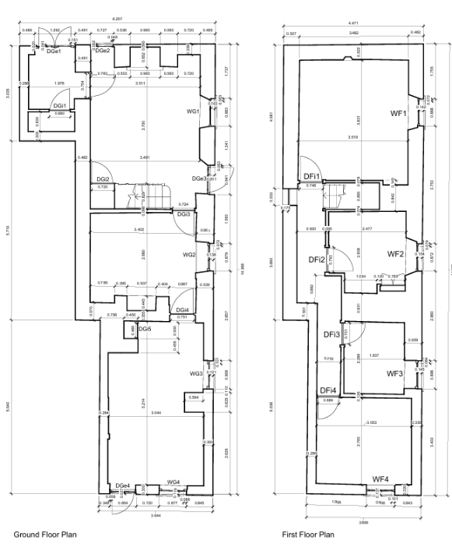

Figure 1: Existing ground and first floor plans of Underwood cottage, Parkmill.

The existing external walls are assumed to consist mainly of solid stone masonry construction finished with render externally and plaster internally. Due to the age and traditional construction methods of the property, the walls are likely to have poor thermal resistance and significant thermal bridging at floor junctions, openings and roof connections. The ground floor appears to use a solid floor construction with underfloor heating installed during previous refurbishment works, while the upper floor consists of suspended timber joists. The roof is a pitched slate roof with limited existing insulation levels when compared to EnerPHit requirements. Existing windows appear to be double glazed replacement units rather than original single glazing; however, their performance remains massively below Passivhaus standards.
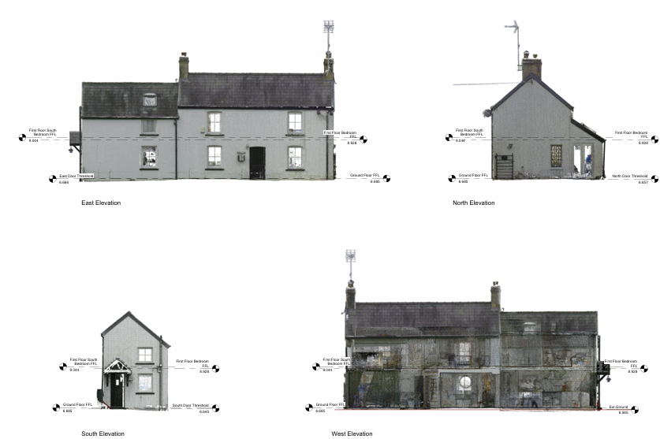

Figure 2: Existing elevations of Underwood cottage illustrating the traditional masonry construction, glazing arrangement and roof form.
The building is heated using an LPG-fired central heating system. Given documentation proves installation of a Worcester Bosch Greenstar 30i LPG boiler (Worcester Bosch, 2024) serving underfloor heating at ground floor level and radiators at first floor level. Although the boiler is relatively modern and efficient compared to older fossil fuel systems, the dwelling remains largely reliant on LPG consumption due to high fabric heat losses and poor airtightness performance.
Operational energy data shows the large energy demand associated with the existing building. LPG consumption records between December 2023 and March 2025 show an annual heating demand of approximately 34,350 kWh/year, equivalent to approximately 381.7 kWh/m²a (Underwood LPG Usage Data, 2025). This massively exceeds EnerPHit performance targets and highlights the inefficiency of the existing building envelope. Electricity usage records further show relatively high energy consumption, with total electricity demand recorded at 6,405.61 kWh during 2023 and 5,029.56 kWh during 2024 (OVO Energy, 2024).

Figure 3: Recorded annual operational energy consumption for Underwood based on LPG and electricity usage data.
Airtightness testing also uncovered large uncontrolled air leakage within the building envelope. Pulse testing undertaken in March 2025 recorded an air permeability value of 10.53 m³/m²h at 50 Pa and an air change rate of 12.54 ACH at 50 Pa (Pulse Airtightness Test, 2025). These results are massively above EnerPHit airtightness requirements and show considerable breaches through junctions, openings and traditional construction interfaces. Excessive breaching contributes directly to increased heating demand, reduced thermal comfort and raised risk of condensation due to uncontrolled moisture transport.
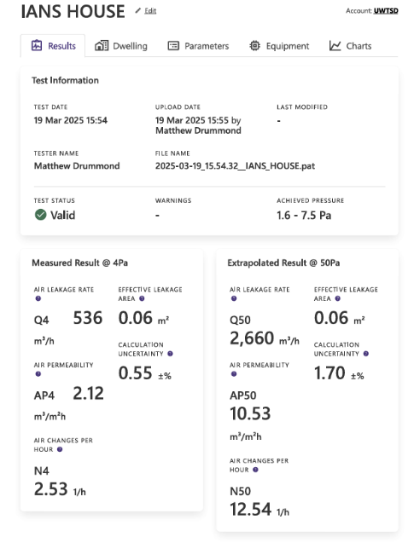

Figure 4: Pulse airtightness test results showing measured air permeability of 10.53 m³/m²h at 50 Pa.
Table 1: Summary of Existing Building Characteristics
Source: Author using project survey and energy assessment data.
Element | Existing Condition
Building Type | Traditional detached stone cottage
External Walls | Solid stone masonry construction
Roof | Pitched slate roof
Ground Flor | Solid floor with underfloor heating
Upper Floor | Suspended timber floor
Heating System | Worcester Bosch Greenstar 30i LPG boiler
Ventilation | Natural ventilation
Airtightness | 10.53 m³/m²h @50Pa
A summary of the existing building characteristics is provided in Table 1. The existing building therefore uncovers several characteristics usually related to traditional solid wall dwellings: poor thermal performance, high operational energy demand, large air leakage and significant thermal bridging. However, the compact form of the property and previous refurbishment works provide a good basis for implementing a deep energy retrofit strategy aimed at approaching EnerPHit performance levels.

PHPP Baseline Model
A baseline energy model of Underwood was created using the Passive House Planning Package (PHPP) methodology (Passive House Institute, 2025) to evaluate the existing thermal performance of the building and identify the main causes of excessive energy demand. The model included measured building geometry, construction assumptions, utility consumption data, airtightness test results and thermal bridge assessments from the available survey documentation.
The building geometry entered PHPP was based on the floor plans provided, elevations and section drawings. The dwelling has a compact two-storey form with a treated floor area of approximately 106 m². Openings were modelled according to the measured window and door dimensions shown in the survey drawings. Orientation and surrounding site conditions were also considered using the site plan information to account for solar gains and shading effects.
Baseline thermal performance values were assigned using the U-value worksheets provided alongside assumptions for traditional solid masonry construction. The external walls were modelled as uninsulated solid stone walls with relatively high U-values compared to modern standards, while the roof and floor constructions were assumed to have only mediocre levels of insulation. Existing glazing systems were modelled as standard double-glazed units with higher heat losses and lower surface temperatures than Passivhaus-certified glazing systems. Thermal bridging effects at wall-to-floor and wall-to-roof junctions were included using the available THERM outputs.
Ventilation and infiltration losses created a significant proportion of the modelled heating demand. The measured airtightness result of 10.53 m³/m²h at 50 Pa was entered into the PHPP model to represent the existing building condition. This level of breaching is massively above EnerPHit recommendations and results in major heat losses due to uncontrolled air movement through the building fabric. The absence of mechanical ventilation with heat recovery (MVHR) within the existing dwelling contributes further to ventilation-related heat loss and inconsistent indoor air quality.
The baseline model outputs concluded that the building performs significantly below EnerPHit requirements. High transmission heat losses through the solid masonry walls, along with with uncontrolled infiltration and thermal bridging, resulted in excessive annual space heating demand. This is supported by the recorded operational energy consumption, particularly the annualised LPG usage of approximately 34,350 kWh/year. Therefore, the model confirmed that large retrofit intervention would be required to lower operational energy demand to a level appropriate for EnerPHit performance standards.
The baseline PHPP assessment also identified the external walls and airtightness performance as the most critical areas requiring improvement. As a result, the retrofit strategy prioritised improved insulation, airtightness reduction, thermal bridge mitigation and ventilation improvements to achieve large reductions in space heating demand and improve occupant comfort.

Proposed EnerPHit Retrofit Strategy
To reduce the operational energy demand of Underwood and move the building closer to EnerPHit performance levels, a series of fabric and mechanical retrofit interventions were incorporated within the PHPP model. The proposed strategy focused on reducing transmission heat losses, improving airtightness, minimising thermal bridging and improving indoor environmental quality while staying appropriate for a traditional solid wall building.
The main intervention proposed was the installation of external wall insulation (EWI) to the existing solid stone walls. Due to the poor thermal performance of traditional masonry construction, the walls represented one of the largest contributors to overall heat loss within the model. External insulation was preferred to internal wall insulation because it allows the already existing masonry structure to stay within the thermal envelope, therefore reducing condensation risk and improving thermal continuity around junctions. In addition, EWI minimises interruption to internal floor area and protects the exposed internal stone features present within parts of the dwelling.
Two external insulation approaches were considered within the analysis: EPS insulation and wood fibre insulation. WUFI hygrothermal simulations showed that the existing wall construction presented increasing moisture accumulation (WUFI Pro Simulator, 2025) over time, showing a higher long-term moisture risk within the untreated structure.

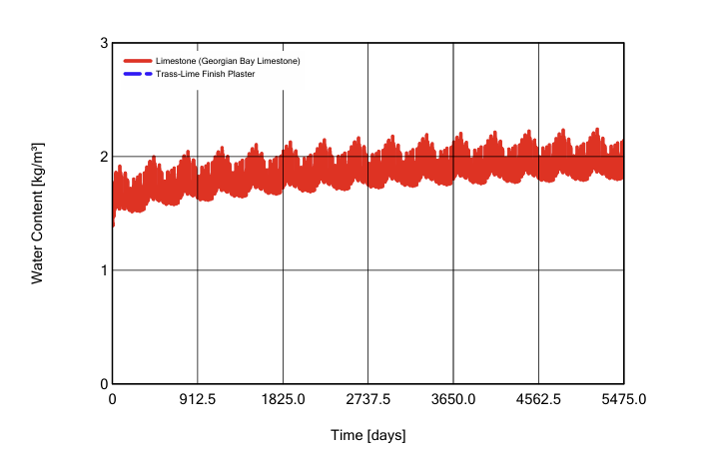

Figure 5: WUFI simulation showing moisture accumulation within the untreated existing wall construction over time.
Both proposed EWI systems improved the moisture behaviour of the wall by reducing exposure to external temperature fluctuations and moisture. However, the wood fibre system proved superior vapour permeability and drying potential (WUFI Pro Simulator, 2025) compared to EPS insulation.
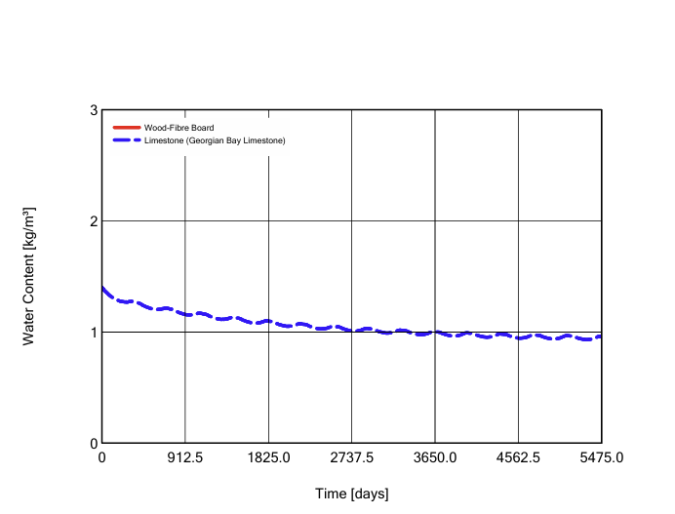

Figure 6: WUFI simulation demonstrating improved drying potential and moisture stability using wood fibre external wall insulation.
In contrast, while the EPS system largely reduced moisture content within the masonry, its lower vapour permeability may restrict drying within traditional solid wall construction. Consequently, the wood fibre solution was considered more compatible with the breathability requirements of the existing stone structure and more appropriate from a building protection perspective.
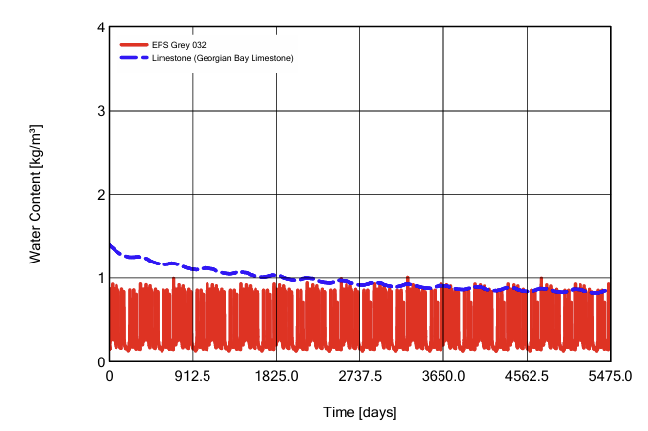

Figure 7: WUFI simulation demonstrating moisture performance of the proposed EPS external wall insulation system.
Additional insulation upgrades were proposed to the roof and floor constructions to reduce transmission losses further. The pitched roof was upgraded with high-performance insulation positioned at the rafter level to significantly improve the thermal resistance of the building envelope. Improvements to the ground floor insulation were more restricted due to the existing underfloor heating system and traditional construction, however additional insulation was assumed where possible without large disruption to the existing fabric.
The replacement of the existing double-glazed windows with high-performance triple-glazed units was also proposed. Existing glazing systems contribute to heat loss due to poor U-values and lowered internal surface temperatures. Triple glazing improves thermal performance while also increasing occupant comfort by reducing cold draughts and improving mean radiant temperatures bordering openings. Careful installation within the insulation layer would also assist in reducing thermal bridging around junctions.
Airtightness improvements formed another important aspect of the retrofit strategy. The measured air permeability result of 10.53 m³/m²h at 50 Pa highlighted significant uncontrolled infiltration throughout the existing building envelope. Therefore, the retrofit proposal included aa airtightness strategy involving sealing at junctions, penetrations, window interfaces and roof connections. Improving airtightness massively reduces ventilation heat losses and is essential in allowing the successful operation of mechanical ventilation with heat recovery (MVHR) systems.
The introduction of MVHR was proposed to provide controlled fresh air ventilation while recovering heat from extracted air. This system improves indoor air quality and reduces the risk of condensation and mould growth while massively lowering ventilation-related heat losses. For a highly insulated and increasingly airtight building envelope, MVHR becomes essential in maintaining good indoor conditions without negatively affecting energy efficiency.
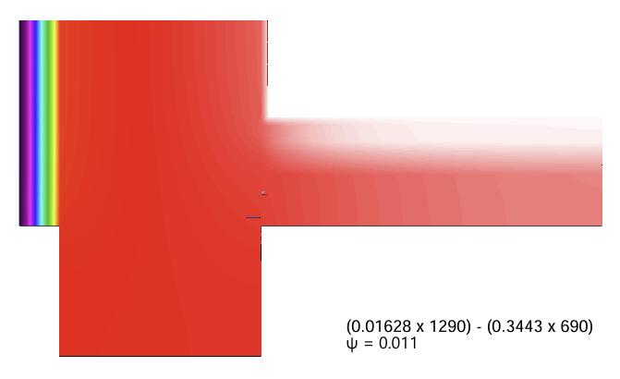

Figure 8: THERM analysis of proposed insulated stone wall junction demonstrating reduced thermal bridging with ψ = 0.011 W/mK.

Table 2: Proposed EnerPHit Retrofit Interventions
Source: Author based on PHPP, WUFI and THERM retrofit analysis.
Building Element | Proposed Retrofit Measure
External Walls | Wood fibre external wall insulation
Roof | Increased high-performance roof insulation
Ground Floor | Improved floor insulation where feasible
Windows | Triple-glazed high-performance units
Airtightness | Continuous airtightness layer and junction sealing
Ventilation | Mechanical ventilation with heat recovery (MVHR)
Thermal Bridges | Improved insulated junction detailing
Heating Systems | Retained efficient LPG boiler with reduced demand
Moisture Management | Vapour-open wall construction strategy
The proposed retrofit interventions included within the PHPP model are summarised in Table 2. Thermal bridge mitigation was also included within the retrofit design. Existing junctions within traditional buildings usually create cold spots and increased heat losses which can contribute to condensation risk and discomfort for occupants. THERM analysis showed relatively low ψ-values for the proposed insulated junction details, with the full stone wall detail getting a ψ-value of 0.011 W/mK (THERM Simulation, 2025) and the partial stone wall detail getting 0.059 W/mK. These results show that the proposed EWI strategy largely improves thermal continuity and reduces thermal transmittance at important junctions.
Collectively, the proposed interventions significantly improved the thermal performance of the building within the PHPP model. By combining improved insulation, improved airtightness, reduced thermal bridging and efficient ventilation systems, the retrofit strategy aimed to massively reduce space heating demand all while improving occupant comfort and long-term durability.

Evaluation of Retrofit Interventions
The proposed retrofit interventions showed large improvements in the predicted performance of the building when assessed through the PHPP model. Although achieving a full EnerPHit certification within a traditional solid wall property presents practical challenges, the proposed measures largely reduced energy demand while improving thermal comfort, indoor environmental quality and long-term building performance.

Comfort and Health
One of the most significant benefits of the retrofit strategy is the improvement in occupant comfort. The baseline building showed characteristics usually associated with traditional masonry dwellings, including cold internal surface temperatures, draughts and fluctuating indoor conditions caused by poor insulation and high infiltration rates. The introduction of continuous external insulation largely increases internal surface temperatures, reducing heat loss from occupants and creating a more stable internal condition throughout the year.
Improved airtightness enhances thermal comfort further by eliminating uncontrolled draughts and cold air infiltration. However, reducing infiltration without providing good ventilation can negatively affect the indoor air quality and increase the risk of moisture. The proposed MVHR system addresses this issue by supplying controlled fresh air while also extracting stale air and recovering heat that would otherwise be lost. This creates a healthier indoor environment with more consistent humidity levels and reduced likelihood of condensation and mould growth (Passivhaus Trust, 2023).
The WUFI simulations also showed improved moisture performance within the upgraded wall. The untreated wall construction showed evidence of increased moisture accumulation over time, which may contribute to long-term deterioration of the building fabric. Both EWI systems reduced this risk; however, the wood fibre insulation system showed improved drying potential due to its vapour permeability. This makes the proposed solution particularly suitable for traditional stone construction where moisture movement through the fabric must be managed carefully.

Operational Carbon and Energy Reduction
The proposed retrofit measures significantly reduce operational energy demand by lowering transmission and ventilation heat losses. The baseline building showed extremely high annual heating demand, supported by LPG consumption figures of around 34,350 kWh/year (Underwood LPG Usage Data, 2025). These levels of energy demand result in massive carbon emissions due to the reliance on fossil fuel heating systems.
By improving wall, roof and floor insulation, upgrading glazing and reducing infiltration, the PHPP model predicts a large reduction in space heating demand. Thermal bridge mitigation contributes to reduced heat losses further and improves overall building efficiency. The reduction in heating demand also allows the existing heating system to operate more efficiently with lower energy input requirements.

Although the existing Worcester Bosch LPG boiler is relatively modern, the reduction in overall heating demand would create opportunities for future transition towards lower-carbon heating technologies such as heat pumps. Retrofitting the building fabric first is essential before introducing low-carbon heating systems, as highly efficient fabric performance reduces peak heating loads and improves the feasibility of renewable technologies.

Embodied Carbon and Material Selection
Embodied carbon considerations created an important aspect of the retrofit strategy. Retaining and upgrading the existing building fabric already shows a significant embodied carbon saving compared with demolition and complete reconstruction. The reuse of the existing structure preserves embodied energy already within the building materials while reducing construction waste and resource consumption.
Material selection within the retrofit strategy also influences embodied carbon performance. While EPS insulation gives strong thermal performance and relatively low heat losses, it is a product with higher embodied carbon and lower vapour permeability. In comparison, wood fibre insulation is from renewable biological materials and stores carbon throughout its service life (Passivhaus Trust, 2023). Additionally, its hygroscopic and vapour permeable properties make it more compatible with traditional stone wall construction.
Consequently, although wood fibre insulation may involve higher initial costs and increased wall thicknesses, it gives advantages in terms of environmental sustainability, moisture management and long-term durability. This shows the importance of balancing operational carbon reduction with embodied carbon impacts when designing deep retrofit strategies.

Financial Savings
The retrofit interventions also provide the potential for significant long-term financial savings through reduced energy consumption. Existing LPG and electricity costs show the high operational expense associated with the current building condition, with LPG costs alone averaging around £237 per month over the recorded period. Reducing space heating demand through improved building fabric performance would massively lower fuel consumption and protect occupants from future energy price rises.
However, achieving EnerPHit-level retrofit standards includes massive upfront investment due to the cost of insulation systems, glazing replacement, airtightness works and MVHR installation. Some measures, particularly vapour-open natural insulation systems, may have longer payback periods when compared purely on operational energy savings. Nevertheless, the financial assessment should also consider non-monetary benefits such as improved comfort, healthier indoor environments, reduced maintenance risks and increased property value.
Overall, the retrofit strategy shows that massive reductions in energy demand and carbon emissions can be achieved within a traditional stone dwelling while also improving occupant comfort, building durability and long-term sustainability.

Conclusion
This report evaluated the existing performance of Underwood, a traditional stone cottage located in Parkmill, Gower, and investigated retrofit interventions aimed to improve the building towards EnerPHit performance standards using PHPP methodology. The baseline assessment identified several important performance problems, including poor thermal insulation, large air leakage, large thermal bridging and extremely high operational energy demand. Existing data and airtightness testing confirmed that the dwelling performs substantially below low-energy building standards.
A series of retrofit interventions were implemented within the PHPP model to reduce space heating demand and improve overall building performance. The proposed strategy focused on external wall insulation, upgraded roof and floor insulation, triple-glazed windows, airtightness improvements, thermal bridge mitigation and the installation of mechanical ventilation with heat recovery. Together, these measures significantly reduced transmission and ventilation heat losses while improving internal comfort conditions and indoor air quality.
The analysis shows that external wall insulation represents one of the most effective interventions due to the poor thermal performance of the existing solid masonry walls. WUFI simulations highlighted the importance of selecting moisture-compatible materials within traditional construction further, with wood fibre insulation showing improved vapour permeability and drying potential when compared with EPS systems. Thermal bridge calculations also confirmed improved junction performance through the proposed retrofit details.
Although achieving full EnerPHit certification within an existing traditional property may stay challenging due to practical and heritage constraints, the proposed retrofit strategy shows that large reductions in operational energy demand and carbon emissions are achievable. The interventions also provide important benefits in relation to occupant comfort, indoor environmental quality, moisture safety and long-term building durability.
Overall, the project shows the importance of applying a whole-building approach to retrofit design. By combining fabric-first improvements with appropriate ventilation and moisture management strategies, traditional buildings such as Underwood can be successfully adapted to meet significantly higher environmental performance standards while preserving the existing building fabric and extending its long-term usable life.

References
CIBSE (2021) TM54: Evaluating Operational Energy Performance of Buildings. London: Chartered Institution of Building Services Engineers.
Green Room Homes (2025) Underwood, Parkmill Estate Agent Particulars. Project document.
OVO Energy (2024) Underwood Electricity Usage Data 2023–2024. Project document.
Passive House Institute (2025) EnerPHit Standard and PHPP Methodology. Darmstadt: Passive House Institute.
Passivhaus Trust (2023) Retrofit and EnerPHit Guidance. Available at: Home
(Accessed: 8 May 2026).
Pulse Airtightness Test (2025) Underwood Airtightness Test Results. Project document.
THERM Simulation (2025) EWI Thermal Bridge Modelling Outputs. Project document.
Underwood LPG Usage Data (2025) LPG Consumption Records December 2023–March 2025. Project document.
WUFI Pro Simulation (2025) External Wall Hygrothermal Simulation Outputs. Project document.
Worcester Bosch (2024) Greenstar 30i LPG Boiler Registration Documentation. Project document.

