Using a Research Approach in Human Resources

Report Title: Using a Research Approach in HR (5CIHR)
Using a Research Approach in HR – Activity 2
Undertake research into an area of HR and write a business report for identified stakeholders. Within your report you should:
1. Assess a range of primary and secondary data sources suitable for the area investigated;
2. Explain how you collected and analysed the data, justifying the methodology adopted;
3. Draw conclusions and make recommendations based on the data.

Name: Rebekah Thomas

CIPD Membership Number:

Date: Wednesday 7th July 2021

Word count: 2490

By signing below, I confirm that the work/evidence presented is my own, unaided work. I understand the regulations pertaining to candidate malpractice and the action that may be taken as a result.

Signed: R A THOMAS
Date: 07/07/2021

Executive Summary
This research report has been completed for key stakeholders within Capita including line managers, the Recruiting Operations Manager and other senior executives. It has produced to analyse and explore working from home and whether the coronavirus pandemic has changed the world of work within the organisation.
The literature review was completed parallel to the report’s objectives to stay on track and relevant. A wide range of reliable research was collected and considered from various sources such as the CIPD, People Management and the Guardian online in order to further understand the topic and to identify any key trends and behaviours. The primary research collected consists of a quantitative questionnaire and qualitative discussion notes gathered via email. A mixed method approach to the research was chosen in order to allow room to explore the advantages of both quantitative and qualitative data. Primary research was needed in order to focus on the organisation, to comprehend the situation for colleagues and what will happen post pandemic. It was discovered that colleagues at Capita have had to work from home as a result of COVID-19 and performance along with productivity levels have either excelled or stayed the same. The majority of staff would like to continue to work from home as well as returning to the office by adopting a hybrid approach, which means the ability and option to do both. The report has found that the coronavirus pandemic is still a phenomenon, so organisations are still strategically planning how and when to return to the office. Capita have implemented a hybrid approach for now with the intention of returning to the office full time when able to do so.
The following recommendations have been proposed:
- Discoveries have shown the majority of colleagues want to follow a hybrid approach, but this may not be the case for everyone so it may be beneficial to conduct further research into this.
- Assuming that everyone is willing to go back to the office would be unrealistic. Capita may lose colleagues, which would have detrimental effect to the business. This is something the organisation needs to appreciate.
- In order to work from home successfully, employees must be provided with the correct equipment. Appendix D gives an estimated cost to deliver equipment from the office, but this is a rough quote and will be dependent on the office location.
There were a few obstacles to overcome while conducting the research report. Time limits and working from home were the two biggest concerns. Working from home in the sense that it was more difficult to contact colleagues and conduct research in a timely manner. If more time was given, the qualitative discussion notes could have been a lot more detailed, or a focus group could have been arranged in order to collect more valuable input. The response rate to the quantitative questionnaire was a lot lower than expected and the success of this research depended on both the responses and authenticity of responses. However, lessons have been learnt for future research reports.
Contents
Executive Summary………………………………………………………………………………….2
1. Introduction…………………………………………………………………………………………4
2. Literature Review…………………………………………………………………………………..4
- 2.1 To investigate if working from home always been possible…………………………….4
- 2.2 Has performance been affected by working from home and COVID-19?.……………4
- 2.3 Working from home - momentary or here to stay?......................................................5
- 2.4 Where do we go from here?........................................................................................5
3. Methodology………………………………………………………………………………………..6
4. Findings…………….……………………………………………………………………………….7
5. Conclusion………………………………………………………………………………………...11
6. Recommendations…………………………………………………………………………….…11
7. Limitations…………………………………………………………………………………………12
References…………………………………………………………………………………………..13
Appendices………………………………………………………………………………………..…17
- Appendix A Copy of email sent to staff regarding taking part in research……………….17
- Appendix B Further results from the quantitative questionnaire…………………………....18
- Appendix C Further qualitative discussion notes……………………………………………19
- Appendix D Estimated cost implications for organisation………………………………….20
- Appendix E UWTSD Ethics approval form…………………………………………………..21

1. Introduction
The aim of this research report is to explore working from home and whether COVID-19 has changed the world of work, specifically within Capita. This will be investigated through objectives set below. This research report has focused exclusively on the organisation, Capita and how they have adapted to COVID-19 restrictions. Concentrating on performance levels and productivity as a result of the pandemic while working from home rather than other factors of COVID-19 such as wellbeing. The reason for the chosen topic and why it is exclusive to Capita is to inform key stakeholders within the organisation such as management and headquarters that working practices have transformed due to COVID-19 for the better.
Aim: To determine whether COVID-19 has altered the working practices at Capita forever?
Objectives:
1. Look into the history of working from home through Capita, was it an option prior to COVID-19 or has it only now been introduced due to the pandemic?
2. Find out how working from home has affected performance at Capita by comparing the advantages and disadvantages.
3. Establish if this is something that will be continue post COVID-19 for staff at Capita, such as the option to work from home or flexible working.
4. To make recommendations exclusively for Capita: Determine whether we are more productive working from home and whether working from home will continue post pandemic.
2. Literature Review
Literature has been collected and analysed from reliable sources such as the CIPD, People Management and the Guardian online. I have assessed key themes and focused on particular areas in order to cover the set objectives. The focus on the report has been the pandemic therefore not all literature reviewed has been included in order to stay relevant.
1. To investigate if working from home always been possible.
A report by the CIPD (2019) found that flexible working has always been available, and flexitime is the most popular form used in the UK compared to the rest of the EU. Another CIPD (2020) report confirmed that 5% of people generally worked from home prior to the pandemic to which Brown and Serle (2020) state rocketed to over 60% during lockdown. This implies that even though some employees had the opportunity to work remotely before COVID-19 they have chosen not to. It is important to understand that working remotely and working from home as a result of COVID-19 are very different. April and Dasgupta (2020) verify that Finland are pioneers with their approach to flexible working, but it’s impossible to establish whether the UK will follow suit. According to Brown and Serle (2020) organisations were forced into a new way of working practically overnight and even though we have adapted well considering the circumstances, there are still outstanding factors.
2. Has performance been affected by working from home and COVID-19?
It is difficult to assess productivity levels of those working from home according to the CIPD (2020) as there are many various kinds of work, where some roles are suited to remote settings better than others. Data available from Office for National Statistics (2020a) indicates that home working opportunities are often only available to those in roles where qualifications and salary are high-ranking in comparison to manual roles. April and Dasgupta (2020) argue that a detriment of working from home is reduced productivity levels and low performance. Osborne (2021) suggests there is evidence that those working from home clock more hours too, whether it is powering through a lunch break and staying online for longer in order to get the task done. The CIPD (2020) echo this by referring to work intensification as a regular side effect by working from home. According to Bloom, Nicholas, et al (2021) one of the reasons why working from home will be utilised more often post COVID-19 is because performance levels have generally risen. When corroborating whether we are more productive working from home, roles need to be taken into consideration as data collected from the Office for National Statistics (2020b) advises not all jobs can be done remotely.
3. Working from home - momentary or here to stay?
There will be the option to continue to work from home after pandemic according to a report from the CIPD (2020). Their survey suggests more than three quarters of people working from home currently and expect to be able to continue working from home after the pandemic. Bloom, Nicholas, et al (2021) agrees with this report as their data discloses people working from home in the UK want to preserve this arrangement for at least two days a week. Free (2020) deliberates if people are to continue to work from home, then organisations need to make reasonable amendments such as advertising flexible roles and ensuring the company has fully adapted to this new way of working. Cosslett, R L. (2020) adds that working from home has shown some people positive benefits such as a better work life balance. There is plenty of evidence that people working from home want to continue doing so but there are also people who cannot wait to get back to the office. “It's been said of the pandemic that while we're all in the same storm, we are not all in the same boat. (Free, C. 2020, https://www.capita.com/our-thinking/are-we-at-risk-of-missing-the-point)”
4. Where do we go from here?
A report from the CIPD in September (2020) suggests a hybrid approach may be the best option for organisations. Sweney (2021) discloses Nationwide Building Society’s plans for their staff post pandemic which reveals the ability to work wherever they want. Some would disagree with this and find it unfair, as not all organisations are in the position to offer this. Another report from the CIPD (2020) suggests that although people are relatively happy to be working from home, some are not. The UK went homebased overnight and for some, working from home also means home schooling, childcare and caring duties. The hybrid approach will give employers and employees the best of both worlds, however Rambhai (2021) has found that only 20% of employees are happy with hybrid working. So, can we continue to work from home post pandemic? Ultimately, this question is still open as there are a lot of factors to consider and it is not a simple yes or no.
Literature Review Summary
The option to work from home has always been available. Flexible working is common in the UK but how flexible depends on the organisation and profession specifically. Whether performance levels have been affected by the pandemic remains unanswered because research shows a clear divide between employees and employers. A survey from Bloom, Nicholas, et al (2021) discovered that people do tend to be more efficient while working from home. However, research also indicated some organisations found performance lower than usual. Evidence suggests working from home will stay put post pandemic. Many organisations have demonstrated that working from home is possible. A survey from the BBC (2020) revealed that many companies do not plan to return to the office because it is cost saving but also has improved work-life balance.
The literature review has provided a wealth of information which is general to the UK working from home and COVID-19. In order to attempt to meet the set objectives, there now needs to be a focus solely on Capita.
3. Methodology
A cross-section approach has been followed in order to be effective. The primary research collected consists of a quantitative questionnaire and qualitative discussion notes gathered via email. A mixed method research route was chosen to allow room to explore the benefits of quantitative and qualitative data, to which Anderson (2013) mentions the triangulation process that allows the use of verifying results.
An email was sent to staff who would be later contacted to take part in the following research activities in accordance with ethical standards (Appendix A). A questionnaire was created via Google Forms and sent electronically in order to collect results swiftly and was sent to a total of 22 members of staff within the Region. It was sent regionally instead of nationally in order to remain pertinent. Staff were able to remain anonymous and were given the option to take part. It was hoped that by remaining anonymous, more would respond but out of 22, only 31% responded. The limited number of responses meant the results may be inadequate. Opie (2002) specifies questionnaire answers need to be measurable and closed question types should be avoided. The qualitative discussion started with a question sent to direct members of the team, it was unstructured, and the purpose was to uncover a greater understanding into how the team felt. Perkins and Woodhams (in Taylor and Woodhams 2016a) imply this is an advantageous way to identify any precise issues.
Investigation results have been analysed in order to identify trends, discover any areas for development and later to make recommendations. Other methods were considered. If there were no limitations and timescales on this project, it may have been advantageous to interview colleagues rather than sent a questionnaire. Denscombe (2017) suggests in comparison to a questionnaire, an interview provides more detail and flexibility.
4. Findings
Results from the quantitative questionnaire can be found at Appendix B and the qualitative discussion notes at Appendix C. These findings have been cross-referenced and organised by the initial literature review;
1. To investigate if working from home always been possible.
Findings from the questionnaire indicate that colleagues are aware of flexible working and the capability to request it. Colleagues worked from home during the pandemic and 71.4% of them worked from home previously as indicated in Figure 1. The CIPD (2020) proclaim that more people are working from home. The Office for National Statistics (2020a) also confirms that 86% of people working from home are because of the pandemic.
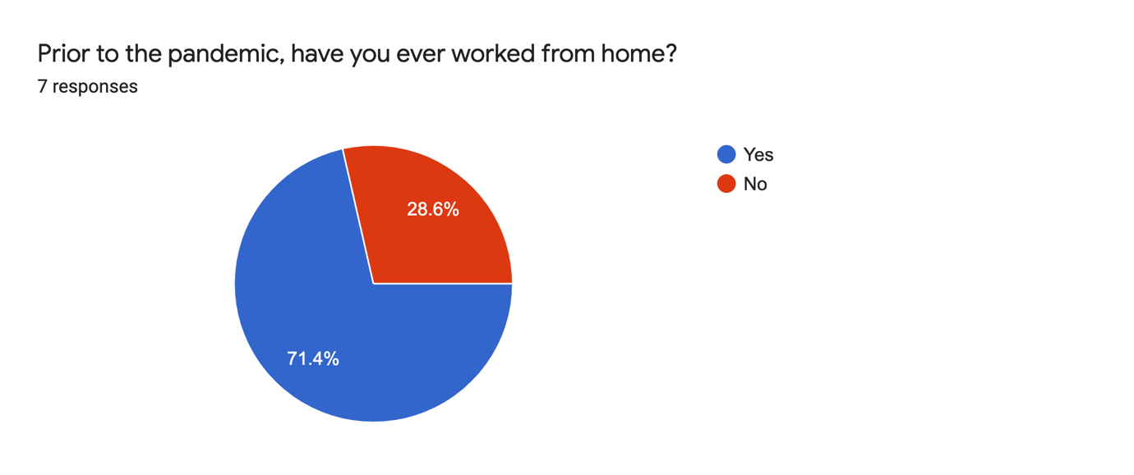
Figure 1
Haar (2020) suggests working from home is common and believes the normal 9-5 pattern will soon be a thing of the past. For Capita, working from home has always been a possibility so working from home will continue.
2. Has performance been affected by working from home and COVID-19?
The CIPD (2020) suggest performance levels of those working from home have risen. Although Bloom, Nicholas, et al (2021) believe many have noticed no change in their performance. It is clearly different for all organisations. According to Figure 2, colleagues believe they are more productive while working from home. Almost a third neither agree nor disagree, so there has been no change on performance due to the pandemic.
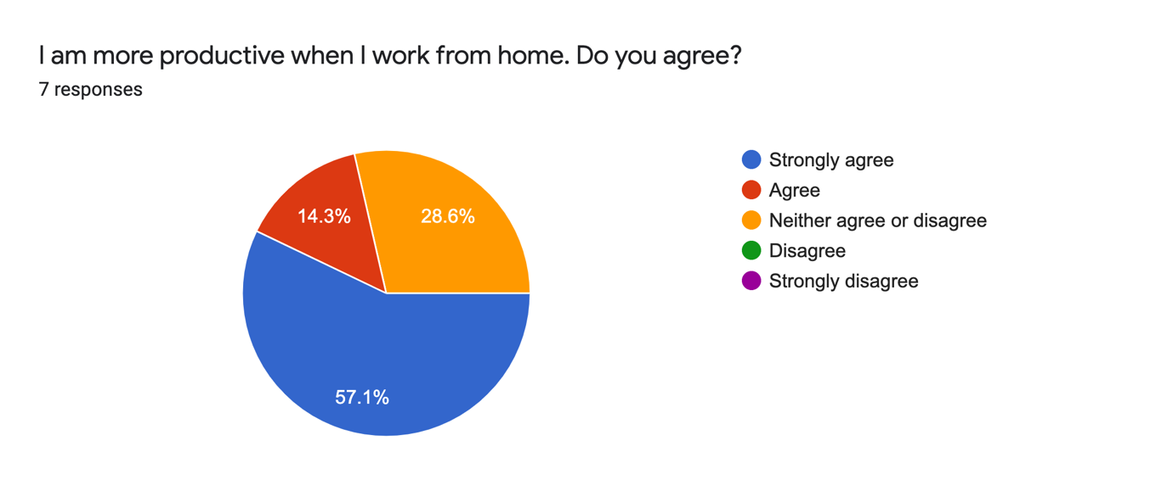
Figure 2
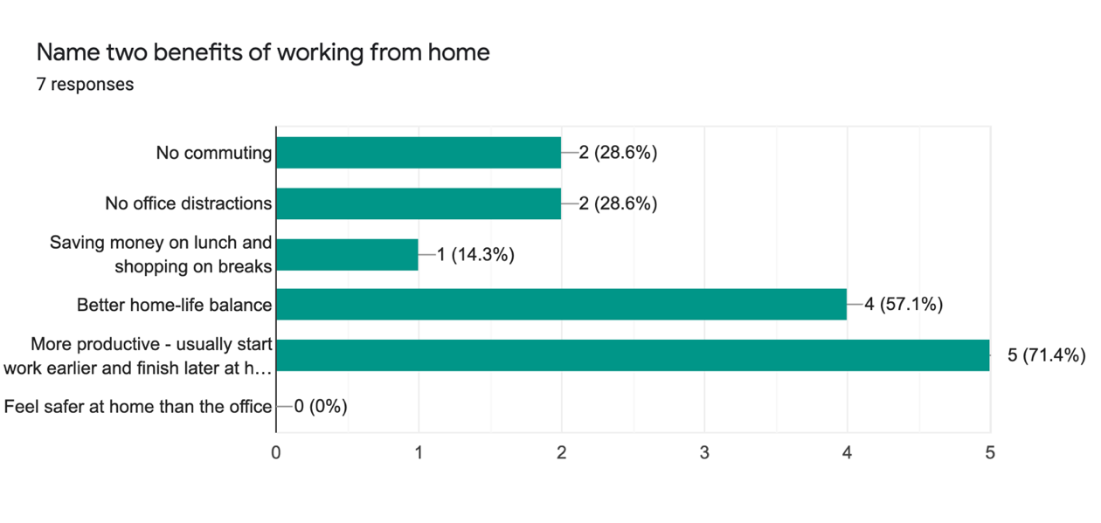
Figure 3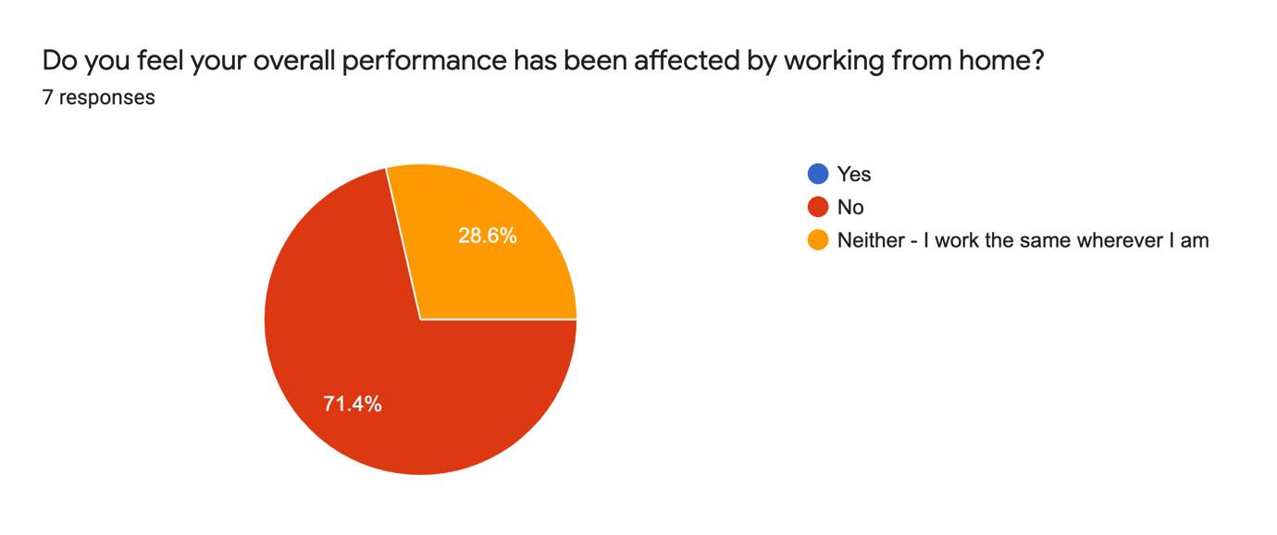Figure 4
Figure 3 indicates colleagues believe one of the benefits of working from home has been productivity, by starting work earlier or finishing later. Calnan (2017) implies that people working from home tend to put more effort in and Osborne (2021) adds that employees are spending more time at their desk at home. This amplifies the findings match the initial research. It shows that performance has been affected by the pandemic but in a positive way as shown in Figure 4.
3. Working from home - momentary or here to stay?
Colleagues within Capita want the flexibility to do both as revealed in Figure 5. This contradicts Churchill’s (2020b) impression that the majority of people want to continue working from home post lockdown. Staff want the best of both which Owen (2020b) reiterates.
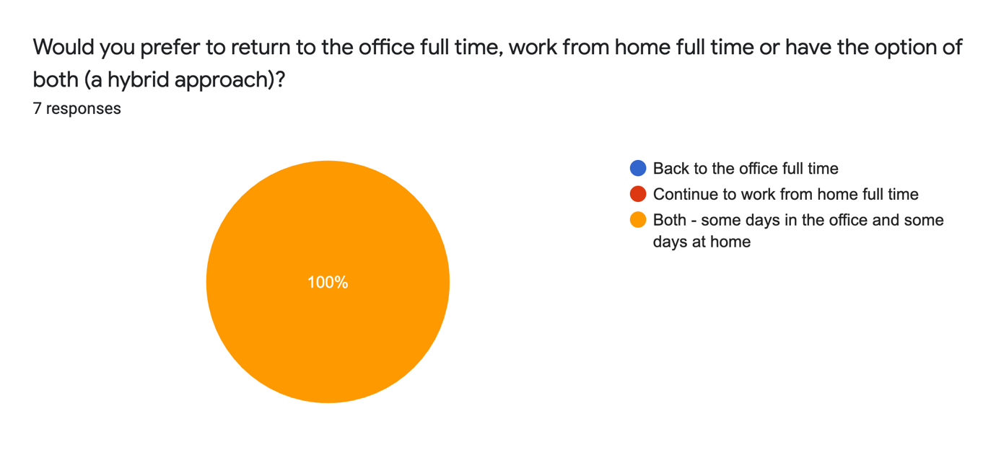
Figure 5
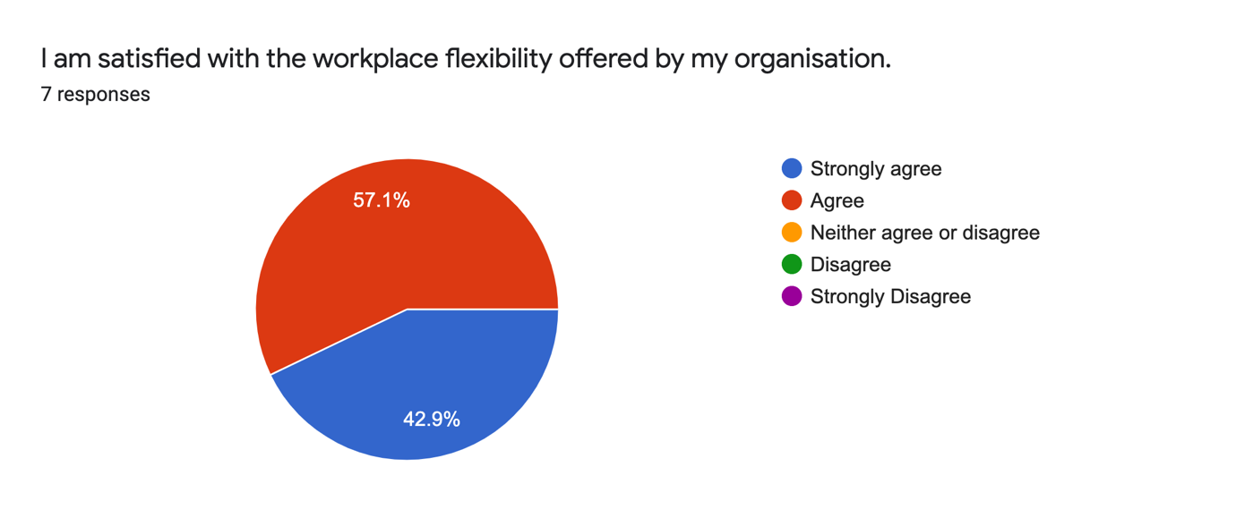
Figure 6
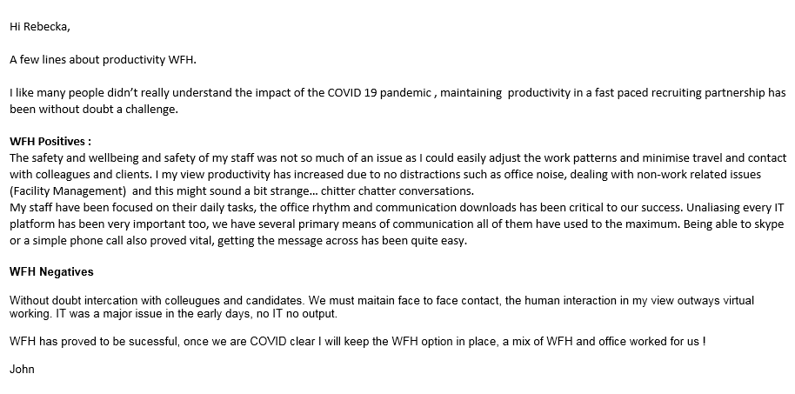
Figure 7
In Figure 6, colleagues are satisfised with the flexibility that is available as over 50% strongly agree. It compares well to Nationwide’s approach to flexible working, where Sweney (2021) discloses the organisation have listened to their staff’s needs. Figure 7 demonstrates working from home is here to stay.
4. Where do we go from here?
Figure 5 reveals colleagues want a hybrid approach to working. Rambhai (2021) declares more than half of those working from home because of COVID-19 will expect to continue in the future. However, one in seven wouldn’t request to work from home in future as shown in Figure 8. Although this could be for a number of reasons unrelated to COVID-19. 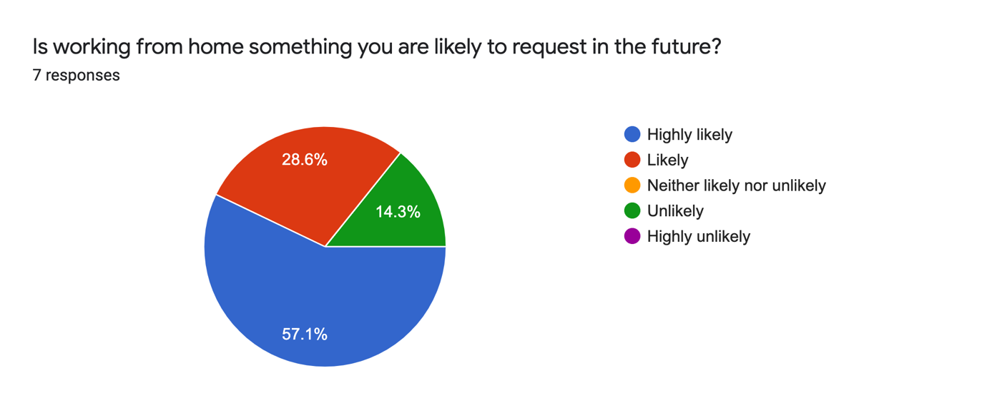
Figure 8
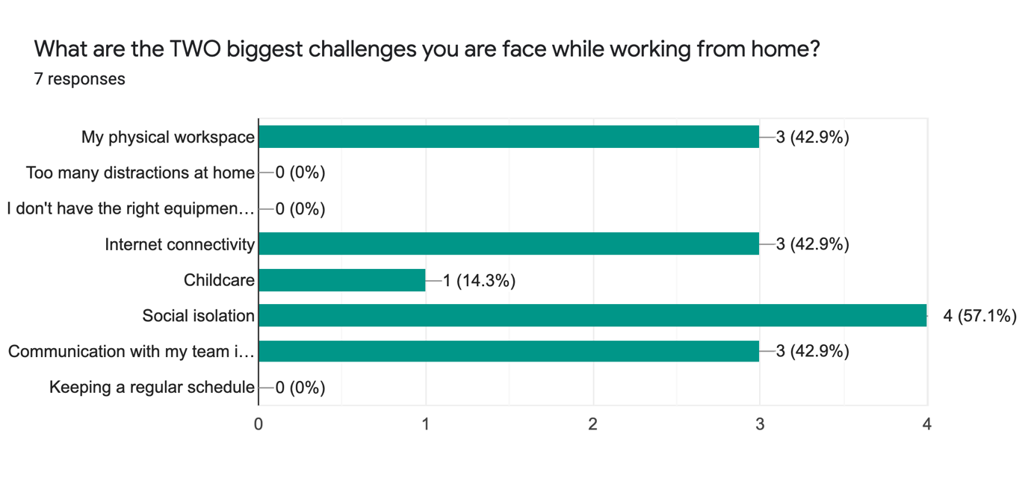
Figure 9
Challenges colleagues faced while working from home have been identified in Figure 9. These findings have been magnified by the CIPD’s (2020) predictions of social isolation and communication issues problems. Colleagues either agreed or strongly agreed that the COVID-19 has changed the future of the world of work. Views from the team collected through qualitative discussion notes attached to Appendix B show they believe are more productive at home and want the hybrid work method. They also identified risk factors, which only strengthens the findings from the questionnaire.
5. Conclusion
Working practices have transformed due to COVID-19 for the better with Capita. Staff working from home want to maintain the flexibility post pandemic by working both in the office and at home using a hybrid approach.
Performance has not been affected, staff either work the same or put more effort in. Senior managers are aware, and this may be why the option to continue working from home been planned. There are difficulties for staff as a result of working from home, but the majority are still content with ability to continue doing so.
COVID-19 has unquestionably altered the world of work. As lockdowns lift, it’s only a matter of time before organisations will ask staff to return to the office. Senior managers at Capita have proposed a timeline to return to the office in a staggered formation. This doesn’t mean returning to the office full-time, so where do we go from here?
6. Recommendations
Based on the findings from both the literature review and primary research, the following recommendations have been made:
- Discoveries have shown the majority of colleagues want to follow a hybrid approach, but this may not be the case for everyone so it may be beneficial to conduct further research into this.
- Assuming that everyone is willing to go back to the office would be unrealistic. Capita may lose colleagues, which would have detrimental effect to the business. This is something the organisation needs to appreciate.
- In order to work from home successfully, employees must be provided with the correct equipment. Appendix D shows the estimated cost to deliver equipment from the office.
7. Limitations
Time restraints and working from home were the two biggest concerns. Responses to the quantitative questionnaire was a lot lower than expected and the success of this research depended on both the responses and authenticity of responses according to Denscombe (2017). After distributing the quantitative questionnaire, the realisation that a lot of the questions were not worded correctly and types of questions such as open or closed were not fully thought through so findings were scarce. If more time was given, the qualitative discussion notes would be more detailed, or a focus group could have been arranged. Anderson (2013) points out the better the qualitative the easier to evaluate. This is something to consider in future research projects.

References & Bibliography List
Anderson, Val. (2013) Research Methods in Human Resource Management. 3rd Ed. London: CIPD.
April, M. & Dasgupta, P. (2020) Could the UK introduce the legal right to work from home? People Management. [Article] 20 May 2020. Available at: https://www.peoplemanagement.co.uk/experts/legal/could-the-uk-introduce-the-legal-right-to-work-from-home (Accessed 3 March 2021)
BBC (2020) Capita to close over a third of offices permanently. [Article] 30 August 2020. Available at: https://www.bbc.co.uk/news/business-53968213 (Accessed 3 March 2021)
Bell, J., & Opie, C. (2002) Learning from research: getting more from your data. 1st Ed. Buckingham. Open University Press.
Bloom, Nicholas, et al (2021) “How Has Working from Home Impacted Productivity? This UK Survey Has Answers.” [Article] 21 March 2021. World Economic Forum. Available at: www.weforum.org/agenda/2021/03/survey-what-are-uk-attitudes-to-working-from-home-in-the-new-normal?utm_source=facebook&utm_medium=social_scheduler&utm_term=Education (Accessed 6 April 2021)
Brown, J. & Serle, W. (2020) Overnight we went home – what will work look like after the crisis? Capita – our thinking. [Article] 15 June 2020. Available at: https://www.capita.com/our-thinking/what-will-work-look-like-after-crisis (Accessed 3 March 2021)
Calnan, M. (2017) Almost three-quarters of employees “put in more effort” when working from home. [Article] People Management. 5 October 2017. Available at: https://www.peoplemanagement.co.uk/news/articles/employees-more-effort-working-from-home (Accessed 30 March 2021)
‌Churchill, F. (2020a) Half working from home during lockdown are unhappy with work-life balance, survey finds. [Article] People Management. 7 April 2020. Available at: https://www.peoplemanagement.co.uk/news/articles/half-working-from-home-during-lockdown-unhappy-with-work-life-balance (Accessed 30 March 2021)
Churchill, F. (2020b) Majority of public in favour of continued working from home, poll finds. [Article] People Management. 28 August 2020. Available at: https://www.peoplemanagement.co.uk/news/articles/majority-public-favour-continued-working-from-home-poll-finds (Accessed 30 March 2021)
CIPD (2019) Flexible working in the UK. [Report] 12 June 2019. Available at: https://www.cipd.co.uk/knowledge/work/trends/flexible-working (Accessed 4 March 2021)
CIPD (2021) Flexible working practices. [Factsheet] 1 February 2021. Available at: https://www.cipd.co.uk/knowledge/fundamentals/relations/flexible-working/factsheet#gref (Accessed 28 March 2021)
CIPD (2020) Coronavirus (COVID-19): Flexible working during the pandemic and beyond. [Guide] 4 November 2020. Available at: https://www.cipd.co.uk/knowledge/fundamentals/relations/flexible-working/during-COVID-19-and-beyond (Accessed 4 March 2021)
CIPD (2020) Working from home: assessing the research evidence. [Report] 26 November 2020. Available at: https://www.cipd.co.uk/knowledge/fundamentals/relations/flexible-working/working-from-home-evidence-after-lockdown (Accessed 3 March 2021)
CIPD (2020) Coronavirus and the workforce: working from home in the ‘new normal’. [Thought Piece] 2 July 2020. Available at: https://www.cipd.co.uk/news-views/changing-work-views/future-work/thought-pieces/coronavirus-working-home (Accessed 3 March 2021)
CIPD (2020) Megatrends: Working from home – what’s driving the rise in remote working? [Report] 2 April 2020. Available at: https://www.cipd.co.uk/knowledge/work/trends/megatrends/working-home-rise (Accessed 3 March 2021)
CIPD (2020) Home working set to more than double compared to pre-pandemic levels once crises is over. [Survey] 16 July 2020. Available at: https://www.cipd.co.uk/about/media/press/home-working-increases (Accessed 3 March 2021)
CIPD (2020) Embedding new ways of working post-pandemic. [Report] 16 September 2020. Available at: https://www.cipd.co.uk/knowledge/work/trends/working-post-pandemic (Accessed 3 March 2021)
CIPD (2021) Planning for hybrid working. [Guide] 10 March 2021. Available at: https://www.cipd.co.uk/knowledge/fundamentals/relations/flexible-working/planning-hybrid-working (Accessed 4 May 2021)
Cosslett, R L. (2020) Working from home has offered people a glimpse of how things could be different. [Article] The Guardian Online. Wednesday 18 November 2020. Available at: https://www.theguardian.com/commentisfree/2020/nov/18/working-from-home-living-coronavirus-remote (Accessed 2 April 2021)
Denscombe, M. (2017) The Good Research Guide : for Small-Scale Social Research Projects. London: Open University Press
Haar, A. ter (2020) Making flexibility work in the “new normal.” [Article] People Management. 16 June 2020. Available at: https://www.peoplemanagement.co.uk/voices/comment/making-flexibility-work-in-the-new-normal (Accessed 30 March 2021)
Free, C. (2020) Are we at risk of missing the point? Capita – our thinking. [Article] 15 December 2020. Available at: https://www.capita.com/our-thinking/are-we-at-risk-of-missing-the-point (Accessed 3 March 2021)
GOV.UK (2012) Flexible working. [online] GOV.UK. Available at: https://www.gov.uk/flexible-working (Accessed 28 March 2021)
Legislation.gov.uk (1996). Employment Rights Act 1996. (Amended) [online] Legislation.gov.uk. Available at: https://www.legislation.gov.uk/ukpga/1996/18/contents (Accessed 28 March 2021)
Legislation.gov.uk (2014). The Flexible Working Regulations 2014. [online] www.legislation.gov.uk. Available at: https://www.legislation.gov.uk/uksi/2014/1398/made (Accessed 28 March 2021)
Marchington, M. & Wilkinson, A. (2012) Human resource management at work. 5th ed. London. CIPD
Office for National Statistics (2020a) Coronavirus and homeworking in the UK: April 2020 [Statistics] 8 July 2020. Available at: https://www.ons.gov.uk/employmentandlabourmarket/peopleinwork/employmentandemployeetypes/bulletins/coronavirusandhomeworkingintheuk/april2020 (Accessed 3 March 2021)
Office for National Statistics (2020b) Which jobs can be done from home? [Report] 21 July 2020. Available at: https://www.ons.gov.uk/employmentandlabourmarket/peopleinwork/employmentandemployeetypes/articles/whichjobscanbedonefromhome/2020-07-21 (Accessed 3 March 2021)
Osborne, H. (2021) Home works putting in more hours since Covid, research shows. [Article] Thursday 4 February 2021. The Guardian Online. Available at: https://www.theguardian.com/business/2021/feb/04/home-workers-putting-in-more-hours-since-covid-research (Accessed 2 April 2021)
Owen, J. (2020a) Home working boosts work-life balance, collaboration and focus, report finds. [Article] People Management. 17 September 2020. Available at: https://www.peoplemanagement.co.uk/news/articles/home-working-boosts-work-life-balance-collaboration-focus-report-finds (Accessed 30 March 2021)
Owen, J. (2020b) Majority of employees want to work from home for most of the week, research finds. [Article] People Management. 11 September 2020. Available at: https://www.peoplemanagement.co.uk/news/articles/majority-employees-want-work-home-most-week-research-finds (Accessed 30 March 2021)
Pakes, A. (2021) Staff must have a say in flexible working policies. [Article] Wednesday 31 March 2021. The Guardian Online. Available at: https://www.theguardian.com/money/2021/mar/31/staff-must-have-a-say-in-flexible-working-policies (Accessed 2 April 2021)
Partridge, J. (2021) Capita to close more offices as working from home options increase. [Article] Wednesday 17 March 2021. The Guardian Online. Available at: https://www.theguardian.com/business/2021/mar/17/capita-to-close-more-offices-as-working-from-home-options-increase-covid (Accessed 2 April 2021)
Rambhai, J. (2021) Many employers unprepared for hybrid working. [Research] 9 April 2021. Available at: https://www.peoplemanagement.co.uk/experts/research/many-employers-unprepared-for-hybrid-working (Accessed 4 May 2021)
Roper, J. (2020) Your new working normal questions – answered. [Article] People Management. 22 October 2020. Available at: https://www.peoplemanagement.co.uk/long-reads/articles/your-new-working-normal-questions-answered (Accessed 30 March 2021)
‌Sharman, J. (2020) Coronavirus: ‘Millions’ in Britain want permanent flexible working after lockdown, survey suggests – The Independent Online. [Article] 20 May 2020. Available at: https://www.independent.co.uk/independentpremium/uk-news/coronavirus-lockdown-flexible-working-uk-remote-wfh-home-office-a9524921.html (Accessed 4 March 2021)
Sweney, M. (2021) Nationwide office staff can work anywhere in the UK when lockdown ends. [Article] Thursday 25 March 2021. The Guardian Online. Available at: https://www.theguardian.com/business/2021/mar/25/nationwide-office-staff-can-work-anywhere-in-uk-when-lockdown-ends (Accessed 2 April 2021)
The Work Foundation. (2016) Working anywhere: a winning formula for good work. London: The Work Foundation.
Taylor, S. and Woodhams, C. (2016a) Studying Human Resource Management. 2nd Ed. London. CIPD
Taylor, S. and Woodhams, C. (2016b) Human Resource Management: People and Organisations. 2nd Ed. London. CIPD

Appendices
Appendix A
Copy of email sent to colleagues in accordance with ethical standards asking them to take part in the quantitative research questionnaire:
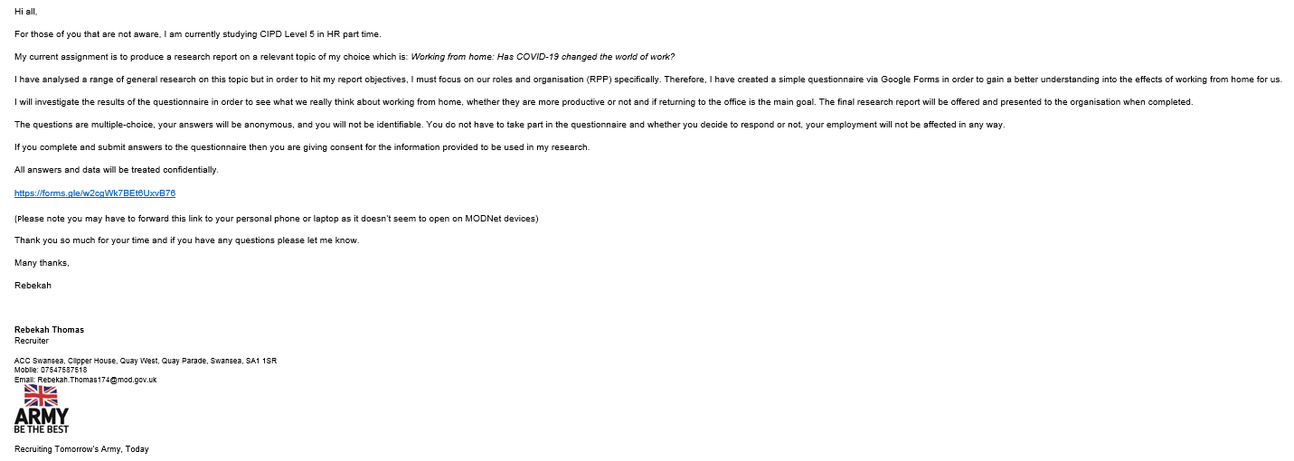

Appendix B
Results from the quantitative questionnaire which were not utilised in the main body of the report:
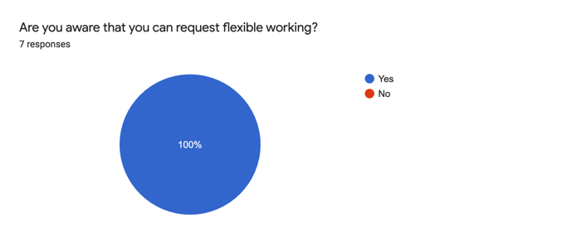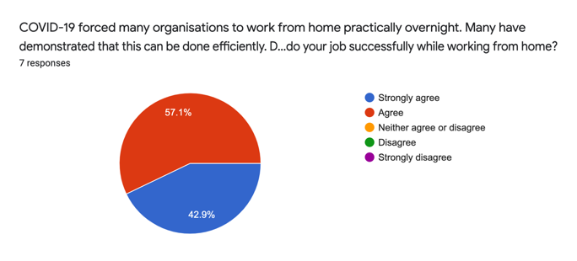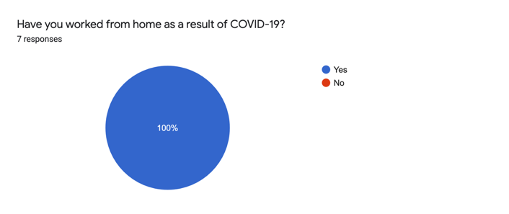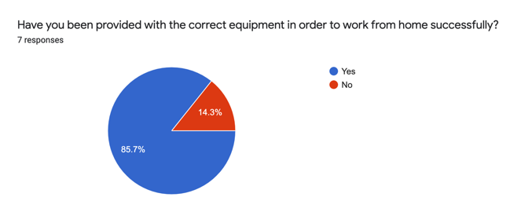
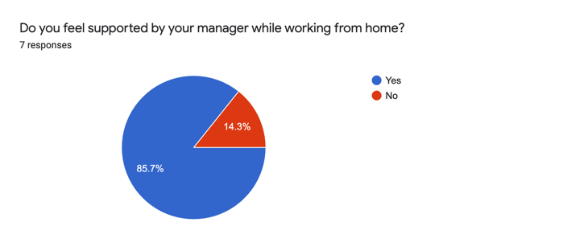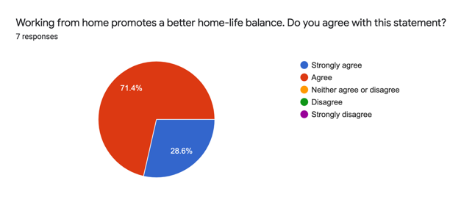

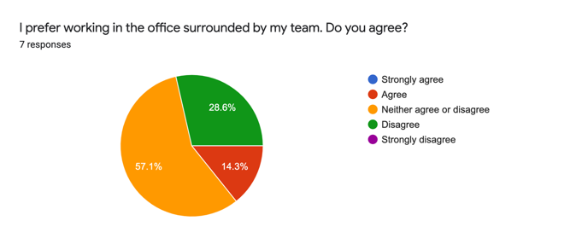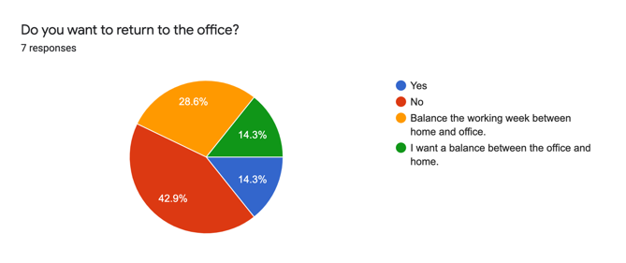

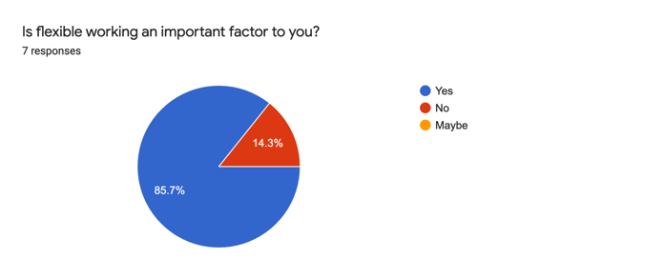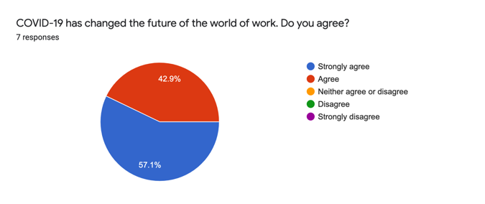
Appendix C
Further qualitative discussion notes which were not used in the main body of the report:
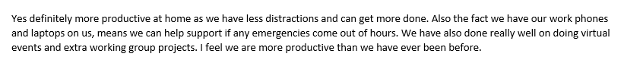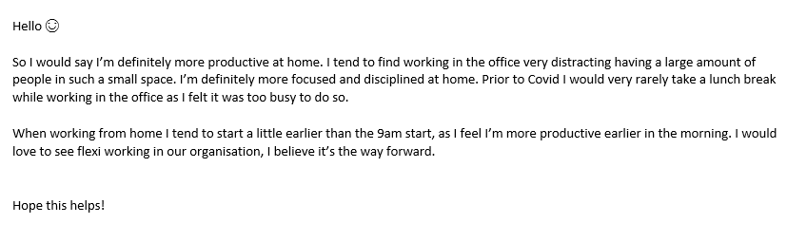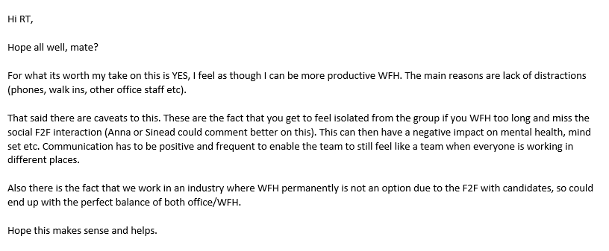
Appendix D
Estimated cost implications for organisation:
Research into the cost of moving office equipment such as a desk, computer chair and a filing cabinet from the office to home. Bearing in mind. This is a rough estimate of the cost. This would fluctuate across the region depending on location and what supplies are needed specifically from each individual. As an estimate, to move basic office supplies from the Swansea office to a home in Neath, it would £73.00. It may cost considerably more for those working in the Cardiff or Birmingham office.
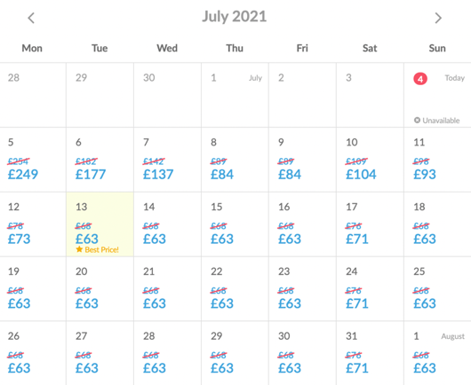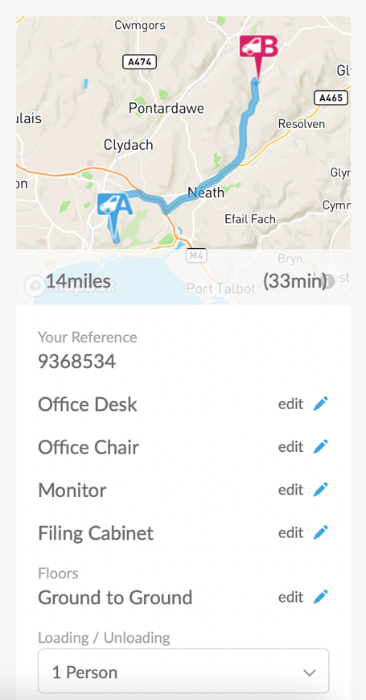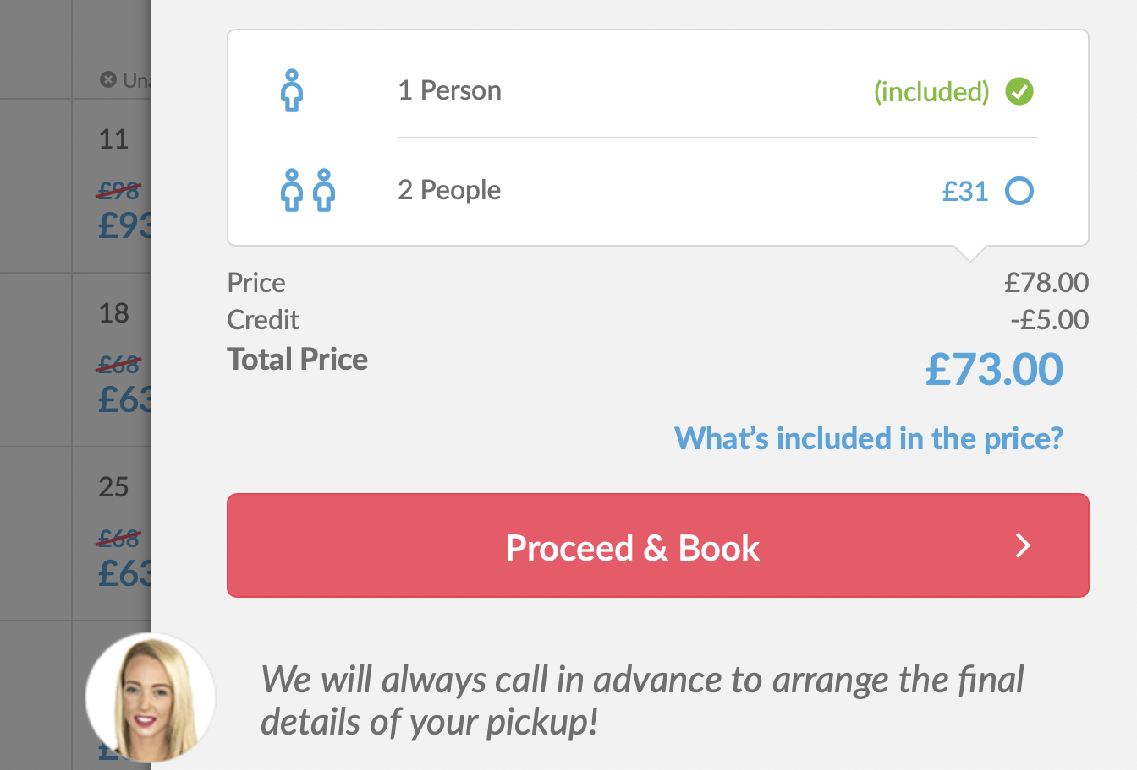
Appendix E
Copy of the UWTSD Ethical Approval Form:
APPLICATION FOR ETHICAL APPROVAL

In order for research to result in benefit and minimise risk of harm, it must be conducted ethically. A researcher may not be covered by the University’s insurance if ethical approval has not been obtained prior to commencement.

The University follows the OECD Frascati manual definition of research activity: “creative work undertaken on a systematic basis in order to increase the stock of knowledge, including knowledge of man, culture and society, and the use of this stock of knowledge to devise new applications”. As such this covers activities undertaken by members of staff, postgraduate research students, and both taught postgraduate and undergraduate students working on dissertations/projects.

The individual undertaking the research activity is known as the “principal researcher”.

Ethical approval is not required for routine audits, performance reviews, quality assurance studies, testing within normal educational requirements, and literary or artistic criticism.

Please read the notes for guidance before completing ALL sections of the form.

This form must be completed and approved prior to undertaking any research activity. Please see Checklist for details of process for different categories of application.

SECTION A: About You (Principal Researcher)

Full Name: |  |  | Rebekah Anne Thomas
Tick all boxes which apply:
Member of staff: | ☐ | Student: |  | X | Honorary research fellow: | ☐

Faculty/School/Centre: | Institute of Management and Health
Campus: | Carmarthen
E-mail address: | 2007852@student.uwtsd.ac.uk
Contact Telephone Number: | 07952 911 874
For students:
Student Number: | 2007852 | Undergraduate | ☐
Programme of Study: | CIPD Diploma in Applied Human Resources (Level 5) | Taught Postgraduate | ☐
Director of Studies/Supervisor: | Julie Thomas | Research | ☒

SECTION B: Approval for Research Activity

Has the research activity received approval in principle?  (please check the Guidance Notes as to the appropriate approval process for different levels of research by different categories of individual) |  | YES | ☒ | NO | ☐
 |  |  |  | Date
If Yes, please indicate source of approval (and date where known): | Research Degrees Committee |  | ☐
 | Faculty Research Committee |  | ☐
 | Other (write in) |  | ☒ | Approved by lecturer & work to go ahead with topic
Approval in principle must be obtained from the relevant source prior to seeking ethical approval.

SECTION C: External Ethical Guidance Materials

Please list the core ethical guidance documents that have been referred to during the completion of this form (including any discipline-specific codes of research ethics, and also any specific ethical guidance relating to the proposed methodology). Please tick to confirm that your research proposal adheres to these codes and guidelines.
University code of conduct | ☒
CIPD code of conduct | ☒
 | ☐

SECTION D: External Collaborative Research Activity

Does the research activity involve collaborators outside of the University? |  | YES | ☒ | NO | ☐
If Yes, please provide the name of the external organisation and name and contact details for the main contact person:
Institution | Capita – British Army
Contact person name | Anna Khan
Contact person e-mail address | Anna.Khan120@mod.gov.uk

Where research activity is carried out in collaboration with an external organisation
Does this organisation have its own ethics approval system? | YES | ☒ | NO | ☐
If Yes, please attach a copy of any final approval (or interim approval) from the organisation

SECTION E: Details of Research Activity

Indicative title: | Working from home: Has COVID-19 changed the world of work?
Proposed start date: | 30 January 2021 | Proposed end date: | 05 July 2021
Purpose of research activity (including aims and objectives)
Outline the purpose, aims and objectives of the research activity, including key research questions. Show briefly how existing research has informed the proposed activity and explain what the research activity will add and how it addresses an area of importance. (Maximum 300 words)
1. Look into the history of working from home, was it an option prior to COVID-19 or has it only now been introduced due to the pandemic?
2. Find out how working from home has affected performance – within my office and organisation specifically by comparing the advantages and disadvantages.
3. Establish if this is something that will be continued post COVID-19, such as the option to work from home or flexible working.
4. To make recommendations by determine whether we are more productive working from home.
I have selected this topic, as I believe it is of significant relevance. I have explored a number of other areas of interest such as the ‘gender pay gap’ and ‘progression within the workplace ‘I found there to be a lack of resources and no direct links to the subject. The subject I have chosen to research is one that is relevant to both my organisation and to myself, and one I find extremely interesting. As it is such a current topic, I should not face many issues with finding relevant information for my secondary research. Moreover, I have chosen this topic is because I believe COVID-19 really has changed the world of work, and it is something I would like to learn more about.

Proposed methods
Provide a brief summary of all the methods that may be used in the research activity, making it clear what specific techniques may be used. If methods other than those listed in this section are deemed appropriate later, additional ethical approval for those methods will be needed. (Maximum 600 words)
I will collect a range of data in order to fuel my report. Starting with secondary data, I will first look at existing data, such as articles and surveys on the current COVID-19 working from home situation, in order to gain a wider understanding. I will also look at information about working from home in general, to once again gain more insight about the subject, and in particular to see if this was a widely available option before the pandemic begun. I will then focus on my organisation: I will collect evidence from within my workplace to gain knowledge and understanding about the workers’ opinions and experiences of working from home and the implications this has.
As part of my primary research, I will seek answers and opinions from my work colleagues within the organisation. In particular I will produce a questionnaire or a survey to gather this information, and to find out if people prefer working from home or not. I also plan to interview specific colleagues who have had to work from home more permanently: I believe this interview material will enable me to understand their opinions about working from home. I understand I will have to approach management to gain a better understanding into the working from home situation, and to determine whether it will be continued in the future or not. From these research ideas I believe my research may be more qualitative than quantitative.

As mentioned previously, I hope to create and use a questionnaire to send to my colleagues to find out their opinions about the working from home situation: whether they prefer to work at home or in the office and where they feel more productive. I also hope to interview particular members of staff who have been working from home permanently since COVID-19 first begun in order to get a better understanding into their thoughts on the situation: for example, how it has really been to work from home and if they feel they would be able to continue this in future. These interviews could also be carried out in a focus group as I am aware there is more than one person within my organisation who is working from home permanently, so it may be interesting to compare their answers and to see if they agree or disagree on certain points. I also plan to approach management with either interviews or surveys to gain an insight into whether they believe staff are more productive while working from home and if this will be continued in the future, either by the option to work from home or even flexible working. I have chosen these research methods, as I believe they are best suited for my topic. The best way to find out if my colleagues prefer working from home or if they are more productive is to ask them through a questionnaire or survey. The interview approach will enable me to gather a large body of information and it will allow me to understand what the respondent is saying. I have not considered the participant observation method as this is not possible during the current climate, however I do believe this type of research report would be an excellent way to observe the relations of a situation first hand.

Location of research activity
Identify all locations where research activity will take place.
Research will take place while working from home.

Research activity outside of the UK
If research activity will take place overseas, you are responsible for ensuring that local ethical considerations are complied with and that the relevant permissions are sought. Specify any local guidelines (e.g. from local professional associations/learned societies/universities) that exist and whether these involve any ethical stipulations beyond those usual in the UK (provide details of any licenses or permissions required). Also specify whether there are any specific ethical issues raised by the local context in which the research activity is taking place, for example, particular cultural sensitivities or vulnerabilities of participants.
N/A

SECTION F: Scope of Research Activity

Will the research activity include: | YES | NO
Use of a questionnaire or similar research instrument? | ☒ | ☐
Use of interviews? | ☒ | ☐
Use of diaries? | ☒ | ☐
Participant observation with their knowledge? | ☒ | ☐
Participant observation without their knowledge? | ☐ | ☒
Use of video or audio recording? | ☐ | ☒
Access to personal or confidential information without the participants’ specific consent? | ☐ | ☒
Administration of any questions, test stimuli, presentation that may be experienced as physically, mentally or emotionally harmful / offensive? | ☐ | ☒
Performance of any acts which may cause embarrassment or affect self-esteem? | ☐ | ☒
Investigation of participants involved in illegal activities? | ☐ | ☒
Use of procedures that involve deception? | ☐ | ☒
Administration of any substance, agent or placebo? | ☐ | ☒
Working with live vertebrate animals? | ☐ | ☒
Other primary data collection methods, please explain in this box | ☐ | ☒

If NO to every question, then the research activity is (ethically) low risk and may be exempt from some of the following sections (please refer to Guidance Notes).

If YES to any question, then no research activity should be undertaken until full ethical approval has been obtained.

SECTION G: Intended Participants

Who are the intended participants: | YES | NO
Students or staff at the University? | ☐ | ☒
Adults (over the age of 18 and competent to give consent)? | ☒ | ☐
Vulnerable adults? | ☐ | ☒
Children under 18? | ☐ | ☒
Prisoners? | ☐ | ☒
Young offenders? | ☐ | ☒
Those who could be considered to have a particularly dependent relationship with the investigator or a gatekeeper? | ☐ | ☒
People engaged in illegal activities? | ☐ | ☒
Others (please identify): | ☐ | ☒

Participant numbers and source
Provide an estimate of the expected number of participants. How will you identify participants and how will they be recruited?
I will work with no more than 10 members of my organisation and will ask them to assist me in my studies.

Information for participants: | YES | NO | N/A
Will you describe the main research procedures to participants in advance, so that they are informed about what to expect? | ☒ | ☐ | ☐
Will you tell participants that their participation is voluntary? | ☒ | ☐ | ☐
Will you obtain written consent for participation? | ☒ | ☐ | ☐
Will you explain to participants that refusal to participate in the research will not affect their treatment or education (if relevant)? | ☐ | ☐ | ☒
If the research is observational, will you ask participants for their consent to being observed? | ☐ | ☐ | ☒
Will you tell participants that they may withdraw from the research at any time and for any reason? | ☒ | ☐ | ☐
With questionnaires, will you give participants the option of omitting questions they do not want to answer? | ☒ | ☐ | ☐
Will you tell participants that their data will be treated with full confidentiality and that, if published, it will not be identifiable as theirs? | ☒ | ☐ | ☐
Will you debrief participants at the end of their participation, in a way appropriate to the type of research undertaken? | ☒ | ☐ | ☐
If NO to any of above questions, please give an explanation
N/A

Information for participants: | YES | NO | N/A
Will participants be paid? | ☐ | ☒ | ☐
Is specialist electrical or other equipment to be used with participants? | ☐ | ☒ | ☐
Are there any financial or other interests to the investigator or University arising from this study? | ☐ | ☒ | ☐
Will the research activity involve deliberately misleading participants in any way, or the partial or full concealment of the specific study aims? | ☐ | ☒ | ☐
If YES to any question, please provide full details
N/A

SECTION H: Anticipated Risks

Outline any anticipated risks that may adversely affect any of the participants, the researchers and/or the University, and the steps that will be taken to address them.

If you have completed a full risk assessment (for example as required by a laboratory, or external research collaborator) you may append that to this form.

Full risk assessment completed and appended?

Yes ☒
No ☒

Risks to participants
For example: emotional distress, financial disclosure, physical harm, transfer of personal data, sensitive organisational information
N/A

If research activity may include sensitive, embarrassing or upsetting topics (e.g. sexual activity, drug use) or issues likely to disclose information requiring further action (e.g. criminal activity), give details of the procedures to deal with these issues, including any support/advice (e.g. helpline numbers) to be offered to participants. Note that where applicable, consent procedures should make it clear that if something potentially or actually illegal is discovered in the course of a project, it may need to be disclosed to the proper authorities
N/A

Risks to investigator
For example: personal safety, physical harm, emotional distress, risk of accusation of harm/impropriety, conflict of interest
N/A

University/institutional risks
For example: adverse publicity, financial loss, data protection
N/A

Adverse outcomes
List measures put in place to limit any adverse effects or outcomes of research activity where appropriate. Include any emergency protocols.
N/A

Disclosure and Barring Service
If the research activity involves children or vulnerable adults, a Disclosure and Barring Service (DBS) certificate must be obtained before any contact with such participants. | YES | NO | N/A
Has a DBS certificate been obtained? | ☐ | ☐ | ☒

SECTION I: Feedback, Consent and Confidentiality

Feedback
What feedback will be provided to participants, how will this be done and when?
Yes, I will provide a copy of my finished report to participants and management.

Informed consent
Describe the arrangements to inform potential participants, before providing consent, of what is involved in participating. Describe the arrangements for participants to provide full consent before data collection begins. If gaining consent in this way is inappropriate, explain how consent will be obtained and recorded.
I have already spoken to my organisation regarding this assignment, the report and what I plan to do. Once I start the project, I will again let my employer know so they are aware that I will be approaching them shortly and ask for consent officially.

Confidentiality / Anonymity
Set out how anonymity of participants and confidentiality will be ensured in any outputs. If anonymity is not being offered, explain why this is the case.
N/A

SECTION J: Data Protection and Storage

In completing this section refer to the University’s Research Data Management Policy and the extensive resources on the University’s Research Data Management web pages (http://uwtsd.ac.uk/library/research-data-management/).
 | YES | NO
Does the research activity involve personal data (as defined by the Data Protection Act)?  “personal data” means data which relate to a living individual who can be identified—  (a) from those data, or  (b) from those data and other information which is in the possession of, or is likely to come into the possession of, the data controller, and includes any expression of opinion about the individual and any indication of the intentions of the data controller or any other person in respect of the individual. | ☐ | ☒
If YES, provide a description of the data and explain why this data needs to be collected:
Does it involve sensitive personal data (as defined by the Data Protection Act)?  “Sensitive personal data” means personal data consisting of information as to –  (a) the racial or ethnic origin of the data subject,  (b) his political opinions,  (c) his religious beliefs or other beliefs of a similar nature,  (d) whether he is a member of a trade union (within the meaning of the Trade Union and Labour Relations (Consolidation) Act 1992),  (e) his physical or mental health or condition,  (f) his sexual life,  (g) the commission or alleged commission by him of any offence, or  (h) any proceedings for any offence committed or alleged to have been committed by him, the disposal of such proceedings or the sentence of any court in such proceedings. | ☐ | ☒
If YES, provide a description of the data and explain why this data needs to be collected:

Will the research activity involve storing personal data on one of the following: | YES | NO
Manual files (i.e. in paper form)? | ☐ | ☐
University computers? | ☐ | ☒
Private company computers? | ☐ | ☒
Home or other personal computers? | ☐ | ☒
Laptop computers/ CDs/ Portable disk-drives/ memory sticks? | ☒ | ☐
“Cloud” storage or websites? | ☐ | ☒
Other – specify: | ☐ | ☒
For all stored data, explain the measures in place to ensure data confidentiality, including details of password protection, encryption and anonymisation:
I will store all work on my personal laptop which password and touchpad protected.

Will the research activity involve any of the following activities: | YES | NO
Electronic transfer of data in any form? | ☒ | ☐
Sharing of data with others at the University? | ☐ | ☒
Sharing of data with other organisations? | ☐ | ☒
Export of data outside the European Union or importing of data from outside the UK? | ☐ | ☒
Use of personal addresses, postcodes, faxes, emails or telephone numbers? | ☐ | ☒
Publication of data that might allow identification of individuals? | ☐ | ☒
Use of data management system? | ☐ | ☒
Data archiving? | ☐ | ☒
If YES to any question, please provide full details, explaining how this will be conducted in accordance with the Data Protection Act (and/or any international equivalent):
I may transfer data when it comes to uploading the final assignment which I believe counts as transferring data but all persona information will be removed.

List all who will have access to the data generated by the research activity:
Line Manager – Anna Khan (who is working from home long term)
Recruiting Operations Manager, Head of Recruiting Operations Manager and Recruiting Operations Business Manager within my region. They will all be interested in the statistics in reference to performance levels while working from home. They may even forward this report on to see if it could make a difference in whether the business would consider the option to continue the working from home option.
I will reach out to other recruiters within the business to find out whether they prefer working from home or not, and to hear about their opinions on the subject.
My university lecturers will all have access to the report/data once I have submitted my report.

List who will have control of, and act as custodian(s) for, data generated by the research activity:
Myself.

Give details of data storage arrangements, including where data will be stored, how long for, and in what form. Will data be archived – if so how and if not why not.
I will collect data from January and throughout the project. Once the project has been submitted, I will wait six weeks before deleting research – in case I need to revisit any part of the report. All data will be stored on my personal laptop as already explained previously.

SECTION K: Declaration

The information which I have provided is correct and complete to the best of my knowledge. I have attempted to identify any risks and issues related to the research activity and acknowledge my obligations and the rights of the participants.

In submitting this application I hereby confirm that I undertake to ensure that the above named research activity will meet the University’s Research Ethics and Integrity Code of Practice
Signature of applicant: | R A THOMAS | Date: | 08/01/2021

For students:
Director of Studies/Supervisor: | Rachael Jones
Signature: | 
Date: | 4/3/2021

For staff:
Head of School/Assistant Dean:
Signature:
Date:

Checklist: Please complete the checklist below to ensure that you have completed the form according to the guidelines and attached any required documentation:
☐ | I have read the guidance notes supplied before completing the form.
☐ | I have completed ALL RELEVANT sections of the form in full.
☐ | I confirm that the research activity has received approval in principle
☐ | I have attached a copy of final/interim approval from external organisation (where appropriate)
☐ | I have attached a full risk assessment (and have NOT completed Section H of this form) (where appropriate)
☐ | I understand that it is my responsibility to ensure that the above named research activity will meet the University’s Research Ethics and Integrity Code of Practice.
☐ | I understand that before commencing data collection all documents aimed at respondents (including information sheets, consent forms, questionnaires, interview schedules etc.) must be confirmed by the DoS/Supervisor, module tutor or Head of School.

RESEARCH STUDENTS AND STAFF ONLY
All communications relating to this application during its processing must be in writing and emailed to pgresearch@uwtsd.ac.uk , with the title ‘Ethical Approval’ followed by your name.
You will be informed of the outcome of your claim by email; therefore it is important that you check your University and personal email accounts regularly.

STUDENTS ON UNDERGRADUATE OR TAUGHT MASTERS PROGRAMMES should submit this form (and receive the outcome) via systems explained to you by the supervisor/module leader.

This form is available electronically from the Academic Office web pages: http://www.uwtsd.ac.uk/academic-office/

Application Process

All staff research projects and all research students must submit the Ethical Approval Form to the University Ethics Committee via the Academic Office (pgresearch@uwtsd.ac.uk). Staff research directly in relation to personal study for taught undergraduate or Masters programmes should be submitted via the Faculty procedures explained below.

Taught masters and taught undergraduate research Ethical Approval Forms are considered within Faculties. Faculties will provide details of the specific processes for this. Where the Ethical issues within any single ethical application are of particular concern the Faculty will refer these to the University Ethics Committee. Any student activity that involves the collection of primary data needs to undergo Ethical approval, this includes assignment work as well as dissertations.

Notes for guidance in completion of this form

Section A: About You
Please complete all relevant sections

Section B: Approval for research activity
Research proposals must be approved in principle before applying for Ethical Approval. The proposal approval only becomes final when the ethical approval is received.

The process for proposal approval varies according the individual and programme of study:
- Research students, by application on form PG1 to the Research Degrees Committee
- Taught students by review of research proposal within Faculties (Faculties provide specific details of these processes)
- Staff, by agreement by the Head of School/Assistant Dean

Section C: External Ethical Guidance materials
Many discipline areas are required to operate with the discipline specific codes of research ethics (for example health, psychology, education etc.), any such codes must be listed and you must tick to confirm that you have consulted with these.

Section D: External Collaborative Research Activity
Provide details of the external collaborative partners, where appropriate you might want to submit a copy of the external collaboration agreement with the Ethical Approval Form. If the partner requires the research to be subject to its own internal Ethical approval process then please provide details of that process and a copy of any final (or interim) approvals received from the organisation.

Section E: Details of Research Activity
Remember that the individuals reviewing this Ethical Approval Form may not have seen your research proposal, and also may not be experts in the specific area of your research. The information provided should therefore be jargon free and clearly stated.
Indicative Title: please use the same title as used on the research proposal.
Purpose: the Ethical approval process will want to ensure that the methods you propose are adequate and appropriate to address the research aims and objectives. Excessive additional data collection can be seen as unethical.
Proposed Methods: the Ethical approval process seeks to ensure that you understand the methods that are intended, and that the implementation of those methods will be appropriate and without unnecessary impact on respondents. Please be specific.
Location: this needs to mention geographical location and also local situation (for example, within Local Authority Offices in Cardiff, using a private room but close to other individuals). If you are collecting data within an organisational setting then you need to explain the permissions that you have obtained to do this.
Research Activity outside of the UK: please complete this section in detail, and note any guidance you have received. Also describe your own familiarity (or not) with the location that you will be utilising.

Section F: Scope of Research Activity
Please tick ALL of the research activities that might be undertaken. If any additional types of activity are intended then please add an extra box and describe these.
If you have answered no to all questions in F then sections G and J do not need to be completed. Section H should be considered, and may be completed. Signatures are still required in section K.

Section G: Intended Participants
Please tick all categories that might apply.
Numbers & Source: if you are using a series of different methods or research activities please list numbers for each stage/phase. Be clear about how you will find respondents. Will you use intermediaries, and if so how? How will you ensure compliance with your sampling strategy?
Information for participants: all participants should be appropriately informed about the research, what is expected of them and what will happen to the information that they provide. The Ethical review process does not ask to see this documentation, but requires this to be reviewed and approved by the Director of Studies in the case of research students, the supervisor/module tutor in relation to students on taught programmes and the Head of School/Assistant Dean in relation to staff research.

Section H: Anticipate Risks
All research carries some level of risk. The answers you provide to questions in this section will be reviewed to ensure that you have an appropriate understanding of the type of risks involved and how you can mitigate against these risks. If you have completed a full risk assessment, as required for example for laboratory work, field work, clinical tests, diving operations, or by a collaborative partner, you may append that to this form. In that case, please tick the box indicating this has been provided. You will not then be required to complete Section H.
Risk to participants Think very carefully about how your actions/questions/discussions might affect the people you are involving as participants. You might identify the risk as small but it would still be a risk. Many types of question have the potential to make respondents less content with their life / job; you need to recognise and try to ameliorate any such effects
If these are business owners, time with you may reduce profit.
In some locations physical risk is very real to both participants and yourself, please consider this.
Risk to you, the researcher Think about where you will meet people, if there are any dangers involved in the location. If you are meeting people as individuals think about using a public place. In general do not visit people in their own homes or remote locations. If you are talking to individuals about certain issues think about how their responses might affect you emotionally. What about the risk of collecting insufficient data?
Risk to the University When undertaking your research, you are acting as a member of the University (student or staff). Professionalism is important, so it is important to be well organised and well prepared. Punctuality, clarity etc. are all part of this. What will you do to ensure this? You must ensure you do not harm the good name of the University in any way and do nothing to undermine the reputation of the research it conducts and sponsors. Upholding high standards of conduct and integrity are vital in this regard. You must also conduct the research in such a way to minimise the potential for claims of negligence made against the University, its researchers and any collaborating individual or organisation. In this respect you should always comply with ethical, legal and professional frameworks, obligations and standards as required by statutory and regulatory authorities, as well as the university’s Research Integrity and Ethics Code of Practice. Research misconduct in this respect can take many forms, including:
- fabrication: making up results or other outputs (eg, artefacts) and presenting them as if they were real
- falsification: manipulating research processes or changing or omitting data without good cause
- plagiarism: using other people’s material without giving proper credit
- failure to meet ethical, legal and professional obligations: for example failure to declare competing interests; misrepresentation of involvement or authorship; misrepresentation of interests; breach of confidentiality; lack of informed consent; misuse of personal data; and abuse of research subjects or material
- improper dealing with allegations of misconduct: failing to address possible infringements such as attempts to cover up misconduct and reprisals against whistle-blowers

Adverse Outcomes. Think carefully about the possibilities, and cover here

Section I: Feedback, Consent and Confidentiality
Feedback to participants: outline your approach. Will interview transcripts be shared with respondents to check accuracy? Will summaries of questionnaire analysis be made available to respondents in some way? Will an overview report be provided? How and when?
Informed consent: Draft letter / e-mail / or heading (or footer) section of questionnaire must be approved by DoS/supervisor (if research student), supervisor/module tutor if taught student, or Head of School / Assistant Dean if a member of staff.
Confidentiality/Anonymity. Explain clearly how you will ensure confidentiality and anonymity.

Section J: Data Protection and Storage
Before completing this section it is necessary to read the University’s Research Data Management information. The questions that follow are designed to ensure compliance with the Data Protection Act as well as established research protocols.

Many research activities will involve electronic transfer of data and use of data management systems in the summarisation and analysis of data. You will need to explain these in relation to compliance with the Data Protection Act.
Think carefully about who will have access to your data, this will include supervisors and examiners. Also that a thesis will be made available via the University library and the British Library system. If you are seeking an access bar for a period of time after completion then mention it here. If you will provide a copy of your findings, or intend to give a presentation, to a facilitating/ supporting/accessing organisation then explain that in this section. But also think about the general principle of data sharing, as explained in the Research Data Management information.
In terms of storage of data please ensure security, and also mitigate against loss of data.

Section K: Declaration
Ensure the appropriate countersignatures have been provided
Look carefully at the checklist and ensure that you comply with and tick all that are relevant to your research.

