
1

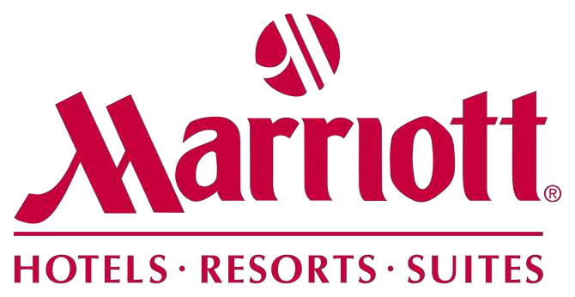

Human Resource Management in Diversity, Equity and Inclusion Developing for the future


Net income in million U.S. dollars

A LITTLE BIT OF BACKGROUND
2
- Marriott is a worldwide operator, licensor, and franchisor of hospitality properties under a wide range of different brands targeting different
customer segments (luxury, premium, select )


- Till 2021, Marriott ranks second as the leading hotel company in terms
of properties, and ranks at number one in terms of guestroom numbers
0
2,000 4,000 6,000 8,000 10,000
2,500
Wyndham Hotels & Resorts 8,941

Marriott International 7,662
2,000 1,907
Choice Hotels International
7,111
Hilton 6,619

IGH Hotels and Resorts 5,959
1,500
1,372
1,273
Best Western Hotels & Resorts
4,037
1,099
Radisson Hotel Group 1,615
1,000
859
G6 Hospitality 1,393
697
753
780
Aimbridge Hospitality
1,380
571 626
500
Hyatt Hotels Corp.
1,020
458
359
198
Westmont Hospitality Group 736
Red Roof 668 0
Extended Stay America 653
Highgate
366
-267
-500
-346
Apple Hospitality REIT 232

Figure 1. Leading hotels in terms of number of properties (left); net incomes of Marriott (right)

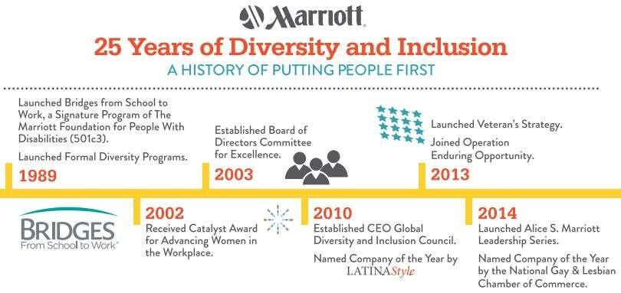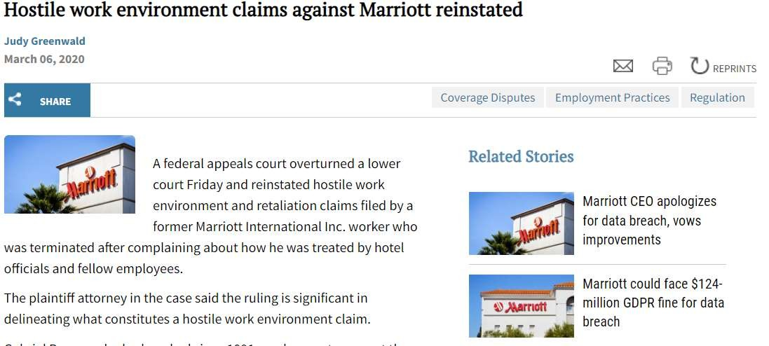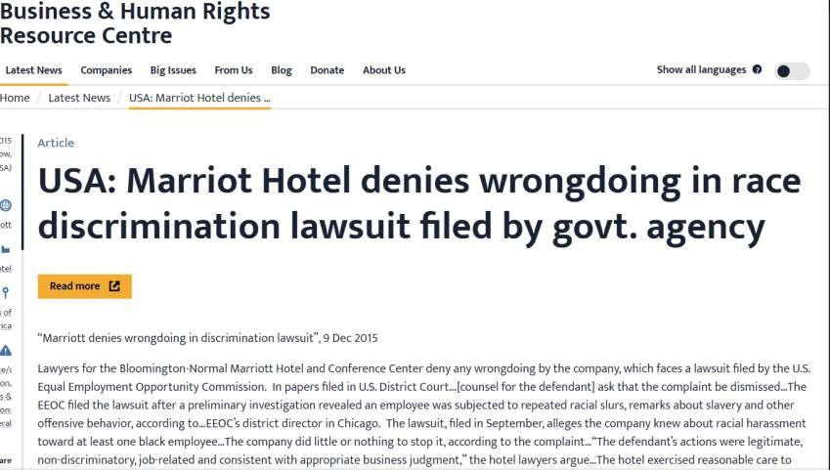
3

Diversity, equity, and inclusion in Marriott

- For the past decade, Marriott has pledged to diversity, equity, and inclusion. However, the expectations have deviated from reality, as it has ignored the equity and inclusion dimension but solely focus on
the diversity dimension.
- - Resulting in highly diversified labor, but continuously conflicts
and complaints in the workplace

Deviation



Diversity, equity, and inclusion in Marriott
4

Data technologies to uncover DE&I patterns
- The identification of demographical patterns in DE&I to make more informed decisions in key HRM decisions, such as recruitment, selection, promotion, etc.
- The use of data technologies to uncover DE&I patterns through the collection, analysis, and prediction based on massive and multi-dimensional data of employees

Data technologies to generate DE&I intelligence
-The continuous monitoring and benchmarking of DE&I through identifiable attributes of DE&I, such as work style and mindset of single individual, of specific working teams, of departments, of branches, of the company.
-The integration of employee voices ( from social media, from work forums, etc.) to integrate DE& intelligence generated by data technologies with primary feedback to propose DE&I initiatives and promote overall DE&I emotions.
-The use of data technologies (neurological analysis, artificial intelligence, etc.) to study the DE&I biases and get rid of some hidden underlying DE&I subjectivity and biases.

-

The development of technology proficiency
5

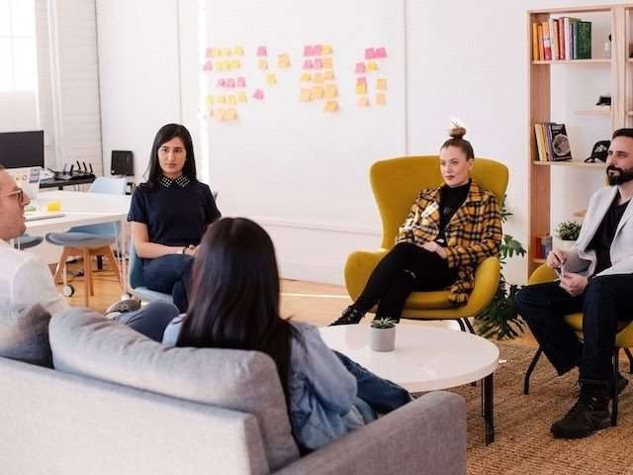The current status quo of HRM professionals

  - HRM professionals in Marriott Hotel have been specializing in the traditional six modules of basic HRM administration functions.
  - HRM professionals’ proficiency in data technology remained at the basic workplace software and HR management system. So far, there have been no specific data technologies being used in the DE&I issues
  - HRM professionals have low or even bare proficiency in relatively advanced data technologies, such as big data analytics, artificial intelligence, etc.
  - HRM professionals have a low understanding of how data technologies can be a potential facilitator in promoting DE&I

The development of technology proficiency
6

The development of technological awareness

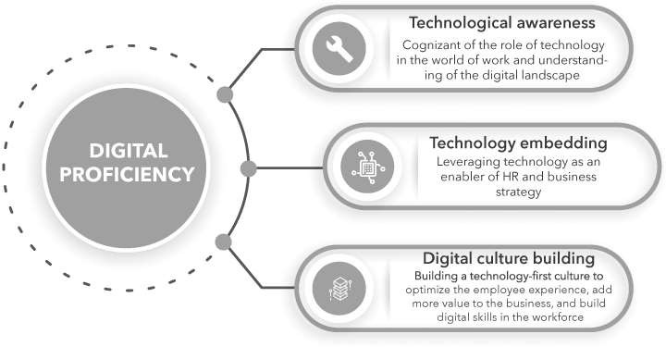
  - The development of digital and technological awareness of HRM professionals to perceive the necessity and significance of data technologies in DE&I management

The development of technological embedding
  - The digitalization of basic HRM functions to generate digital data sources for inputs, as well as the use of automation to promote HRM effectiveness and efficiency
  - The proficiency of people analytics to generate DE&I insights and intelligence developed through a wide spectrum of training and development initiatives, courses, webinars, seminars, on-the-job coaching, etc.

The development of digital culture
  - The development of a technology-first culture in the HRM to optimize DE&I experiences through engaging with employees and other departments

The development of virtual team working & Active listening
7

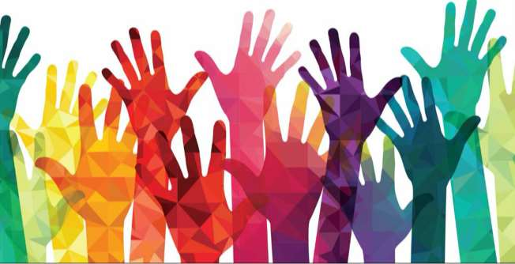

Cross-department collaboration
- The embeddedness of technologies in DE&I and other HRM functions requires cross-department collaboration and coordination in data collection, analysis, and data-facilitated decision-making.
- Interdepartmental alignment can ensure the overall embeddedness of data technologies in DE&I

Cross-market collaboration
- The geographical presence of Marriott requires the application and integration of data technologies across different branches of Marriott located in different places
- Developing cultural awareness and competencies in communication and coordination to fully leverage data technologies through a virtual team setting is required
Active listening
- Data technologies only provide insights and intelligence gained through the existing data, but do not reveal a comprehensive DE&I picture.
- HRM professionals should actively and proactively listen and communicate with DE&I to establish a secure and reliable environment where employees are comfortable voicing any DE&I issues .
- Active listening skills require HR to develop well-being evangelism by advocating for employees, and solve any potential problems which may be threats of DE&I development in the future.

The development of HR reporting skills
8

The transparency of DE&I The reporting of DE&I


- Traditional DE&I management is being criticized for lack of transparency and
reliability in reporting
- The lack of transparency and attention on DE&I data directly leads to a lack of
insights into DE&I progress and engagement of other stakeholders in DE&I
  - The intervention of data technologies in
DE&I afford new insights that should be monitored and communicated to stakeholders (typically employees, investors, managers, etc.)
- The skills of reporting key patterns observed and key intelligence generated by data technologies should be developed in HRs
( such as DE&I visualization, etc.)

Action Plan for HR Professions in Marrott
9

 | Jan | Feb | Mar | Apr | May | Jun | Jul | Aug | Sep | Oco | Nov | Dem
Digital proficiency
Virtual team working skills
Active listening
Digital reporting

  - The development of these skills will be though a combination of different approaches, such as distance learning through lectures and courses, seminars and workshops, on the job coaching, exercise, and simulation
  - Digital proficiency is perceived as hard to master, and will take around 8 months to develop.
  - The development of the digital reporting of DE&I is based on the development of digital proficiency
  - All newly absorbed knowledge will be used in the workplace through practical cases
  - Multi-source feedback will be provided for continuously improvement

BMMB7007
Human Resource Management

The Diversity, Equity, and Inclusion issues in Marriott
Assignment Title:HUMAN RESOURCE MANAGEMENT
Student Name:Yan Wu
Student Number:1903729

Video URLs: https://web.microsoftstream.com/video/c02c5206-f891-4334-88de-bbe978992928

References:
- AIHR (2021) Digital Proficiency for HR Professionals: All You Need to Know - AIHR. Available at: https://www.aihr.com/blog/digital-proficiency-for-hr-professionals/ (Accessed: 17 April 2022).
- Ashmarina, S. I. and Mantulenko, V. V. (2020) Digital Economy and the New Labor Market: Jobs, Competences and Innovative HR Technologies. Springer Nature.
- Business & Human Rights Resource Centre (2015) USA: Marriot Hotel denies wrongdoing in race discrimination lawsuit filed by govt. agency e. Available at: https://www.business-humanrights.org/en/latest-news/usa-marriot-hotel-denies-wrongdoing-in-race-discrimination-lawsuit-filed-by-govt-agency/ (Accessed: 17 April 2022).
- Business Insurance (2020) Hostile work environment claims against Marriott reinstated . Available at: https://www.businessinsurance.com/article/00010101/NEWS06/912333427/Hostile-work-environment-claims-against-Marriott-reinstated (Accessed: 17 April 2022).
- Garcia-Arroyo, J. and Osca, A. (2021) ‘Big data contributions to human resource management: a systematic review’, The International Journal of Human Resource Management, 32(20), pp. 4337–4362.
- de Groof Kaiser, K. (2019) Diversity in the Digital Age: Integrating Pedagogy and Technology for Equity and Inclusion. Teachers College, Columbia University.
- Harvard Business Review (2020) How to Best Use Data to Meet Your DE&I Goals. Available at: https://hbr.org/2020/12/how-to-best-use-data-to-meet-your-dei-goals (Accessed: 17 April 2022).
- International, M. (2022) Annual report for the fisical year 2021.
- Kutch, B. D. M. and Kutch, J. S. M. (2022) ‘Innovation through diversity and inclusion: A roadmap for higher education information technology leaders’, in Research Anthology on Changing Dynamics of Diversity and Safety in the Workforce. IGI Global, pp. 1811–1833.
- Morgan, W. B., Dunleavy, E. and DeVries, P. D. (2015) ‘Using big data to create diversity and inclusion in organizations’, in Big Data at Work. Routledge, pp. 324–349.
- Statista (2022) • Marriott International Dossier. Available at: https://www-statista-com.uoelibrary.idm.oclc.org/study/21299/marriott-international-statista-dossier/ (Accessed: 17 April 2022).
- Stone, C. B., Neely, A. R. and Lengnick-Hall, M. L. (2018) ‘Human Resource Management in the Digital Age: Big Data, HR Analytics and Artificial Intelligence’, in Management and Technological Challenges in the Digital Age. CRC Press, pp. 13–42.
- Tech Target (2021) A data-driven approach to DEI supports real diversity. Available at: https://www.techtarget.com/searchhrsoftware/feature/A-data-driven-approach-to-DEI-supports-real-diversity (Accessed: 17 April 2022).
- Thite, M. (2022) ‘Digital human resource development: where are we? Where should we go and how do we go there?’, Human Resource Development International, 25(1), pp. 87–103.
- Tonidandel, S., King, E. B. and Cortina, J. M. (2018) ‘Big data methods: Leveraging modern data analytic techniques to build organizational science’, Organizational Research Methods, 21(3), pp. 525–547.

