

Developing an Emergency Communication System connected to the Myriota Network for Degraded Electromagnetic Environments

by
Jack Lonsdale

Supervisor: Stalin Jacob Wilson Packia Dhas

Project submitted as part of the requirements for the award of
BEng Embedded Electronic Systems Design and Development Degree Apprenticeship

April 2025

DECLARATION

I, Jack Lonsdale declare that I am the sole author of this Project; that all references cited have been consulted; that I have conducted all work of which this is a record, and that the finished work lies within the prescribed word limits.

This work has not previously been accepted as part of any other degree submission.

Date : 29/04/2025.

FORM OF CONSENT

I Jack Lonsdale hereby consent that my Project, submitted in candidature for the BEng Embedded Electronic Systems Design and Development degree, if successful, may be made available for inter-library loan or photocopying (subject to the law of copyright), and that the title and abstract may be made available to outside organisations.

Date: 29/04/2025

Abstract
This project seeks to research and develop a solution for redundant communications in a degraded electromagnetic environment by using Myriota satellite IoT communications.
Degraded electromagnetic environments are created by disruption in the Electromagnetic Spectrum. These disturbances can be naturally occurring (such as Coronal Mass Ejections or Solar winds), or they can be artificial (such as intentional jamming). There are many ways these can stop electronics from functioning correctly, whether it’s bit flips changing the values in system clocks and instruction registers, or jamming raising the noise floor to above the functional level.
Myriota are a company who provide space-based IoT (Internet of Things) connectivity, and specialise in low-power, remotely-connected devices that transmit to and receive from their constellation of satellites. It is hoped that by incorporating a redundant method of communication that doesn’t require localised infrastructure and transmits on a different band of the spectrum, then reliable communications are more likely to be achieved in a degraded environment.
Throughout the project’s development, a PCB has been designed, and software has been written, but requires a more development to come to a complete solution.
The PCB incorporates a PIC16F877A microcontroller with a Myriota package operating on service 2. These act as a distributed intelligence system with the Myriota package controlling encoding, modulation, and transmission, and the PIC controlling all other tasks (such as coordinating input from the user and sending messages for transmission). Communication between the two is achieve via UART.
The solution also incorporates button to accept a user input, a GNSS board to provide location, and an LCD screen to provide a user interface.
To move from a proof-of-concept to a deployable solution, the PCB needs to be manufactured, and the case needs designing, incorporating a battery holder so that the device can be man-carried. Additionally, more work is required to develop the communication between the UART and PIC.

Table of Contents

Introduction 1
-Subtitles listed here

Literature Review 1

Development Methodology 1

Design and Implementation 1

Evaluation 1

Conclusion and Recommendations 1

Reflection 1

References 1

Bibliography 1

Appendices 1

CHAPTER 1 - INTRODUCTION

Background
Degraded electromagnetic (EM) environments negatively affect much of the infrastructure we rely on a daily basis. They can be caused by natural phenomena such as coronal mass ejections or solar winds, or by deliberate action such as jamming.
Communication is an essential lifeline in these environments, that allows those responding to the event to diagnose and fix the problem, along with any subsidiary problems.
In order to assist in this diagnosis and repair, or to provide emergency instructions, redundant communications can be used.
Satellites communication methods are unique in their operation in this environment due to a couple of reasons:
- They do not rely on localised infrastructure. Ground stations for the satellites can be in another part of the globe, potentially moving outside the area of the degraded environment.
- They can operate on many different bands of the EM spectrum, so if interference exists on one frequency or band, the satellite communication may remain unaffected.
Myriota are a company that provide space-based IoT (Internet of things) connectivity as a service. Operating at ~400MHz for Rx and Tx on their “Service 2”, this is in a different part of the spectrum to many other communications technologies, potentially avoiding interference. Other common communications technologies include [AD]:
- Cellular: 700Mhz-3.8GHz
- LoRa WAN: 433, 868, 915 MHz
- Ham radio: 3.5-30MHz
- Satellite communication: 1.6GHz, 2.2Ghz (most commonly)
The Myriota package is sold to connect between the information source and antenna. It encodes, modulates, and amplifies the signal ready for transmission.

Problem Statement
This project aims to address the lack of communication in a degraded EM environment by using the Myriota module to transmit on a different frequency to most communications technologies. Specifically, the solution must be one that can be man-carried and doesn’t rely on localised infrastructure.
The system must be capable of working within urban or rural areas.

Objectives

The objective of this project is to produce a proof-of-concept, showing what could be achieved with additional development. This project is not required to produce a finalised solution prepared for deployment.
Ensuring a valid proof of concept, the following will be required:
- Establish a reliable communication link back to the Myriota cloud using the hardware designed during this project.
- Keep all hardware appropriate for a man-carried operation
- Test and validate successful message delivery to and from the Myriota cloud
Methodology
The Myriota cloud was selected as a potential solution to this problem by my employer. There are two main things unique to them that justify experimental use of their package:
- They communicate with a variety of satellites, providing redundancy
- They specialise in low-power solutions

Originally, I had planned to incorporate the Myriota package onto my PCB, but it became apparent that soldering it without specialist tools would not be possible. Instead, I developed connecting the PIC chip to the Myriota Developer Kit, with the idea of switching to the Myriota package in future generations.

Devices will not be tested in a degraded EM environment; the purpose of this development is to produce a proof of concept, and not a finished and deployable solution.
This project could help coordinate relief efforts in the case or natural disaster, or help repair infrastructure in the event of adversarial space weather, or enable the continuation of journalism in areas where wireless communication is jammed.

Significance and Innovation
Instead of relying on terrestrial infrastructure or mesh networks, the Myriota cloud utilises the benefits of space-based infrastructure. It can provide connectivity anywhere on the surface of the earth without localised infrastructure.

Outline of this report
This report offers the following sections:
- Research and review of literature: researching many topics such as Coronal mass Ejection, Solar winds, Adversarial action, redundant communication systems, Myriota, and UART communication.
- Development methodology: Overviewing the selection of a Waterfall/Spiral hybrid methodology, providing a framework to manage well-structured but risky projects.
- Design and Implementation: An overview of how the design was achieved, and details regarding: component selection, circuit design, and PCB design.
- Evaluation: An evaluation of how the project performed against the objectives.
- Conclusion and Recommendations: A summary of the project, what was achieved, what wasn’t, and recommendations of future work.
- Reflection: An overview of how the project has personally impacted me, the skills I’ve learned, what went well, and what could be improved next time.

CHAPTER 2 - RESEARCH & REVIEW OF LITERATURE
This literature review will explore the following topics:
- Degraded electromagnetic environments, their potential effects on electronics, and examples of how they have disrupted technology in the past.
- Resilient Communications for Degraded EM Environments.
- Myriota’s space-based Internet of Things connectivity.
- UART serial communications protocol, and microcontroller adaptions for Baud rate.
Myriota are being analysed as a suitable provider for developing an alternative communications system for a degraded EM environment, and although other existing solutions will be researched, they will not be evaluated for use. This is because my customer is specifically interested in evaluating Myriota, not other solutions.

Degraded Electromagnetic Environments

Coronal mass ejection
Coronal mass ejections are large bursts of plasma that erupt from the sun. This plasma generates large magnetic fields and have the possibility of damaging sensitive electronics (such as satellites). Typically, the earth’s ionosphere protects from these events, but if they are large enough or come in bursts, then that may not be the case. Satellites are at increased risk due to their position high above the earth (further up in the ionosphere). [J]
Historically, Coronal mass ejections have disrupted technology. The Great Quebec Blackout in 1989 saw the effects of a severe Geomagnetic storm (created by a Coronal Mass Ejection) disrupting the Hydro-Québec power grid, creating a blackout that effected millions of people, and lasted 9 hours [O]. The geomagnetic storm created GICs (Geomagnetically Induced Currents) across power lines, inducing harmonics that tripped circuit breakers and overheated transformers. [O]
Similarly, the Carrington Event in 1859 (the largest Geomagnetic storm ever recorded) Induced currents across telegraph wires, causing sparking and even fires [P].

Solar winds
Solar winds are constant streams of charged particles that travel through the solar system. They have the potential to cause damage to electronics by causing bit-flips (a software error where a stored value in a register, flash, or storage has been changed, potentially causing errors in software execution). [K]

Adversarial Action
Electromagnetic superiority has been an important part of conflicts around the world. The ability to deny, degrade, or destroy enemy systems such as communications, Radar, GNSS navigation, and intelligent weapons quickly makes a difference on the battlefield. As a result of this, many militaries around the world field technology that can spoof or jam any number of systems that use the electromagnetic spectrum. However, the effects of these systems aren’t limited only to military technology, but civilian as well. There are many examples of civilian technology being disrupted by electronic warfare:
- Civilians relying on GNSS technologies for navigation or timekeeping have been dealt significant disruption due to conflicts such as the Russia-Ukraine war or Israel’s invasion of Gaza [L].
- Satellite communication via Star Link for both military and civilian users has been disrupted in Ukraine as a result of Russian jamming [M].
- Russian Electronic warfare has been known to interfere with Norwegian aviation, fishing, and construction due to their reliance on GPS [N].

Two main types of jamming exist: wideband and narrowband. Wideband jamming transmits loud noises across a large band of the spectrum, and the converse is true about narrowband. Narrowband jamming is more effective, as much greater jamming signals can be achieved with less power, but it requires the knowledge of which frequencies the target system is using, and is unlikely to work for systems employing frequency hopping techniques.
Jamming can be avoided by using a number of different techniques [AE]:
- Increasing transmission power
- Beamforming with directional antennas
- Using statistical techniques to transmit into the noise floor
- Perform numerical computation to subtract jamming signals
- Employing frequency hopping techniques
- Waiting for the jammer to be inactive before transmitting

Resilient Communications for Degraded EM Environments
Backup communications are often used for cases of degraded electromagnetic environments, each with different benefits and disadvantages:
- Troposcatter systems: Tropospheric scatter communications bounces microwaves off the lower atmosphere (troposphere), providing long distance communication for 100s of miles without satellites. The NATO ACE-High (Allied Command Europe High band) system is a famous example of this technique, and allowed the different NATO headquarters across Europe to communicate [S].
- Ham radio: Civilians can use portions of the radio spectrum for amateur communications via radio. This relies on a lot less infrastructure than most methods of communication, and covers multiple bands with different possible applications. This includes LoS (line of sight) VHF and UHF communications, and HF radio that can get long range communications by bouncing radio waves across the ionosphere. Both of these can employ frequency hopping techniques to avoid narrowband jamming.
Ham Radio is often used to help provide relief in the event of natural disasters such as wildfires and earthquakes. Numerous examples exist from Hurricane Katrina, to the Fukushima earthquake and tsunami in Japan, and the earthquake in Puerto Rico. [T]
- Bridgefy messaging app: A civilian phone app that allows users to communicate without internet or phone signal by connecting to other bridefy users with bluetooth. The app is often used in areas where internet and phone signal may not be available (such as schools, protests, rural locations, and natural disasters) [Q]. Messages can be transferred directly from as far as 100m away. If further range is required, the app acts as a mesh network, incorporating other users to relay messages even further. [Q]
- Satphones: Satellite phones connect directly to satellites to relay voice messages in real time from and to any location on the surface of the earth. Satphones rely on a different type of infrastructure to most other forms of electronic communication, messaging satellites rather than using wires, cellular networks, or the internet.

Myriota

Company Overview
Myriota offer low-cost, low-data IoT remote connectivity to locations across the world. The Myriota devices are best suited for remote and low-power applications that don’t require low latency or large volumes of data transfer. Common applications of Myriota’s technology include examples such as: object location tracking, remote well sensing, soil moisture monitoring, and more.
Founded by Dr. Alex Grant and Dr. David Haley in 2015, the company was created to fill the gap in low-data, low-cost IoT devices by renting spare capacity from AIS satellites (and have matured into renting and buying their own satellites). Both the engineering and management teams have several decades of experience in telecoms systems, space, and RF.

Services
The two services that Myriota provides transmit at 160MHz (service 1) and 400MHz (service 2). They both receive at ~400MHz, and are connected to with the M1-24 and M2-24 packages respectively. They currently offer up to 50 messages of 20 bytes every day, and messages typically travel from the Myriota module to their final destination in anywhere from a few hours to a day.
Hardware to connect to the Myriota network is typically either of the three options:
1. Buying the Myriota modules for integrating into your own PCB
2. Using the Dev-Kit for quick prototyping
3. Using the Myriota FlexSense for quick transition to market.

Network
The Myriota network serves to transmit information from a large number of small ground stations deployed by their customers, up to a constellation of their satellites, and back down to the customer’s backend through the Myriota Cloud.
The Myriota network consists of a constellation of a huge variety of satellites. Originally renting spare capacity from AIS satellites (such as ExactEarth’s EV-01, EV-02, EV-09, and EV-11, now Myriota 1, 2, 3, and 4 [D]), Myriota have matured into developing their own satellites (such as their Kanyini satellite, developed in partnership with the Australian government [E]).

Waveform Information
Messages have a 50% latency of 4 hours [F]. This means that 50% of messages travel from the transponder on the ground, to the satellite, and back through the Myriota cloud in 4 hours or less. In 9 hours or less, 90% of messages are received at their destination. Nearly all messages are received within 24 hours, however, a 100% guarantee cannot be provided, as no authentication is provided for successful message reception. [F]
The Myriota module uses AES-CbC-256 encryption for all messages [G], providing security for all messages. AES-CbC-256 is an advanced encryption standard which is strong enough to protect against brute force attacks.
The transmitting power of the Myriota module is 28dBm [H]
Little information is openly available about the link budget, however it is understood to be low, given the low-power design of the Myriota network. [I]

UART
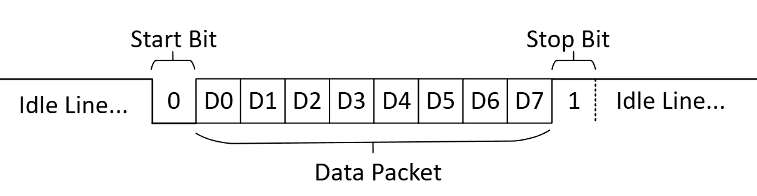
  - Fig. XXX, Common UART Packet Structure.
Universal Asynchronous Receiver Transmitter is a communications protocol allowing integrated systems to communicate serially. UART requires just two lines: power (commonly 3.3V or 5V, but other voltages are also used), and a shared ground.
There isn’t a universal standard for the packet structure of UART communication, but the following structure is by far the most common [AF]:
- The line is high when idle, allowing non-connection to be easily determined.
- The first stop bit is 0 (low).
- The stop bit is immediately followed by 8 data bits, occasionally the 8th bit is for parity checking (no standardised preference for odd or even). Data is sent with the LSB (least significant bit) first. Very occasionally the packet contains 9 bits of data, with the 9th acting as the parity bit.
- The stop bit is high, and most commonly there is only 1 (but occasionally there can be 2).
- The line returns high when idle
Baud rate
The speed of UART communication is measured in bits per second (referred to as Baud). 9600 Baud (9600 bits per second) is used by the Myriota chip and PIC16F877A by default, however many other speeds are available. As with most other types of communication, increasing baud increases data throughput at the cost of range, with the converse also true.
A baud rate of 9600, and packet structure as described above, that gives a theoretical maximum data throughput of 9600 / (1start bit + 8 data bits + 1 stop bit) = 960 characters per second. Although maximum effective range for UART communications depends on cable shielding, voltage, and interference, most manufacturers would seek to limit 9600 baud UART to 15m [AF]. This will be more than sufficient for communicating between the Myriota, PIC, and GNSS packages.
9600 Baud produces a time period of 104μs. To be able to pulse at this speed, most integrated circuits will need to divide the frequency of their oscillator many times. To achieve this for the PIC16F877A, the Frequency of oscillation is divided and placed on a free-running 8-bit timer [C]. The level of this division is controlled by the value in the SPBRG (Serial Port Baud Rate Generator) register.
Essentially, by considering the three things below, different baud rates can be selected and generated by the PIC:
- The frequency of the external crystal oscillator
- The dividing value in the SPBRG (Serial Port Baud Rate Generator) register
- High Speed or Low Speed UART (Controlled by the BRGH (Baud Rate Generator High) bit in TXSTA register)
The formula for baud rate generation is given by equations XXX and XXX, below [C]:
High-speed Baud: | Low-Speed Baud:
$$Baud rate= \frac{F_{OSC}}{64 ×(X+1)}$$ | $$Baud rate= \frac{F_{OSC}}{16 ×(X+1)}$$
  - Left: Equation XXX, Baud rate when calculated for high-speed baud. Where X is the value in the SPBRG register. [C]
  - Right: Equation XXX, Baud rate when calculated for low-speed baud. Where X is the value in the SPBRG register. [C]
High-speed baud most often provides higher tolerance timing signals due to the increased granularity of the clock, but low-speed baud may overcome its looser tolerance by being closer to the required Baud rate (for certain frequencies). [C]

CHAPTER 3 - DEVELOPMENT METHODOLOGY

Methodology:
This project has many unique features to consider when deciding on a development methodology:
- It’s easy to see how the project should be structured through development.
- The requirements and objectives are fairly well defined, with limited chance of scope creep.
- There are limited opportunities to work with operations teams or end users throughout nearly all of the development lifecycle.
- As an independent project, there is almost no teamwork involved, with only the possibility of advice from the project supervisor.
- Many of the tasks involve technologies or methods I am unfamiliar with, representing high risk.
- Due to other project’s requirements on my time, this project will be on a condensed timeline.

Given these factors, a hybrid development methodology has been chosen that will mix aspects of the waterfall and spiral methodologies. The project will follow the well-structured, sequential aspects of waterfall development, but will incorporate the risk-prioritisation of the spiral methodology.
The waterfall methodology fits my project well because the requirements and objectives are well defined, allowing for logical sequential planning. However, many of the tasks involve technologies or approaches I haven’t come across before. Naturally, this means many aspects of the project are high-risk, and the risk-prioritised spiral model (completing high-risk activities as soon as possible) will reduce the chance of non-delivery. For example, transmitting and receiving UART sentences between microcontrollers is a technically unfamiliar task, and the spiral methodology allows more time to understand the involved process, and fix any issues that crop up.
Agile development does not make sense for this project, as there is little risk of scope creep, and the project must be de-risked and delivered quickly. Agile development doesn’t provide as structured a plan, which can mean big risks go unnoticed until later on in development, leaving less time to find a solution.

Tools and Software
An appropriate selection of tools and software is essential to ensure the project is completed successfully in the allotted time and budget.

MPLab

  - Fig. A, Microchip’s MPLAD IDE. [A]
Code development and microcontroller programming will be done in Microchip’s MPLab IDE. Although I am more familiar with the Proteus simulation and programming software, MPLab is specifically developed by PIC’s manufacturers, and therefore has a better guarantee of future support and compatibility. It also benefits from native compatibility with the cheap PICKit 3 downloader, which can be used to program the device. Otherwise, trying to purchase a USB programmer on the already limited £250 budget would be difficult.

Picoscope

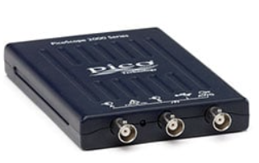
  - Figure. XXX, Picoscope 2000. [AG]
The ability to physically view signals is required to verify the operation of some of the key techniques in this project. This means that an oscilloscope-type device will be required for any advanced debugging. I have chosen to use a Picoscope 2000 to do this for two main reasons:
- Its high sample rate (1Gs/s) is high enough to view UART sentences at 9600 baud with high fidelity.
- I have experience using the device, and associated software.
Using the Picoscope will mean no time will need to be spent downloading, installing, and learning new software, allowing more time for development. Without the Picoscope, a benchtop oscilloscope would need to be borrowed, meaning reliance on other stakeholders to complete the project work.
The Picoscope also has the benefit of being highly portable, allowing it to be used whenever required in the office, lab, or at home should flexible working be required.

SH-U09C5 USB to TTL UART Converter
Project development was already underway when I began to run into problems sending and receiving UART sentences, and it became apparent that I needed a reliable method for reading and transmitting UART sentences for the purposes of debugging.
I chose the SH-U09C5 converter over similar devices for the following reasons:
- Since development was already underway, I needed a solution quickly, and the SH-U09C5 was available online with next day delivery.
- The converter comes with all the required cables, and a self-test jumper cable that allows you to test the device is working correctly (something essential to debug confidently).
- The device operates on 3V3 and 5V UART, meaning the Myriota package and PIC chip could both be tested with one device.
- The drivers for the device were available freely online with easy installation.
- The device was available at the low cost of £12, helping maintain an already struggling budget.

TeraTerm
TeraTerm is an Open Source terminal emulator for Windows that allows users to connect to devices through serial port, telnet and SSH connections [B].
TeraTerm was chosen over any alternatives because it’s simple to use, free, and compatible with the USB to Serial converter that was purchased.

WSL and Oracle Virtual Box
The Myriota dev kit required programming with Linux commands. Able to use only a windows laptop, there were two options available:
- WSL: Windows subsystem for Linux.
- A Linux virtual machine, emulating a Linux operating System on Windows.
Originally, WSL was selected as it seemed like the quickest way to get started on the development (saving several hours not needing to install a VM and set up that OS), but I soon found that it was not fully compatible with the Myriota device and was unable to program it due to complications involving USB passthrough privileges.
With WSL ineffective, a virtual machine would be required. Oracle Virtual Box was chosen for the following reasons:
- I have used it previously, meaning there was a higher chance of success, and less time required learning to use it.
- It is open source and freely available, keeping the project budget free for hardware.
- It is widely used by a large community, so plenty of tutorials and resources are available online.

KiCad
To design the PCB, KiCad was chosen for the following reasons:
- It is widely used across the electronic hardware design industry, and is straightforward.
- It is open source, and therefore freely available
- I have previous experience using the software, so no learning curve

Design Priorities
The main design priorities for the project are:
- Size and weight. This device is going to be carried in unfamiliar environments, and therefore very likely to be hand-carried. Limiting the size and weight of the device is important.
- Reliability. Any device designed for use in emergency environments is “failure critical” where the effects of failure may be significant disruption, damage, or loss of life. Naturally, reliability is essential.
- Environmental assurance. The device must be able to withstand difficult environments from snow to excessive heat, rough movement, heavy rain, and possibly submerging in water.
- Utility. Where possible, the device should be able to provide as many useful functions as possible.

CHAPTER 4 - DESIGN & IMPLEMENTATION

Design Overview

This design revolves around a PIC16F877A microcontroller coordinating input, process and output between an LCD Screen, Keyboard, GPS package, and Myriota dev kit.
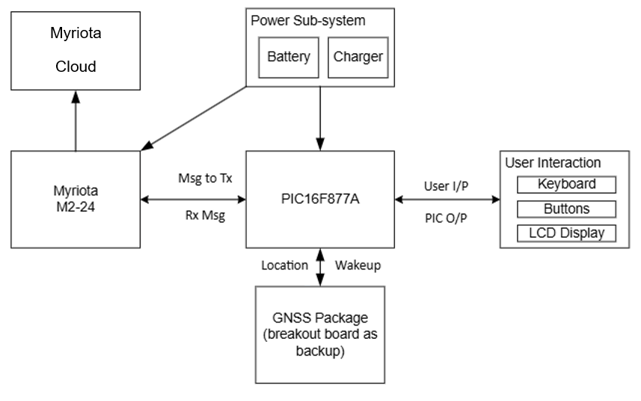
  - Fig. XXX, System Overview.
The PIC interacts with the peripherals in the following way:
- Myriota dev kit: The PIC wakes up the package by raising GPIO 0 high, then transmits the message to be transmitted via the UART port. The dev kit then schedules that message for transmission, and sends itself back to sleep.
- LCD Screen: The PIC transmits data for the LCD screen to show using a standard 4-bit parallel protocol. LCD.c and LCD.h take care of most of the ground work.
- Keyboard: The keyboard works through a multi-tap technique (similar to old phone keyboards where the same button must be pressed multiple times to select the right number). This raises one of the GPIO pins high, which is read by the pic and processed by the await_input function.
- GNSS Package: This package automatically transmits all of the required information via UART formatted in NMEA (National Maritime Electronics Association) sentences once per second. The PIC receives and processes these coordinates from the $GNGLL (Combined GNSS system, Geographic position of Longitude and Latitude [R]) sentence with the extract_coords and cords_to_str functions. The coordinates are converted from degrees and minutes to degrees (and subsequent fractions of a degree).

Key Justifications

Microcontroller
There is a myriad of different microcontrollers that would all be good choices for this project, with each bringing slight benefits of drawbacks. From the widely-used ATMega328P to the powerful PIC18, low-cost STM8, and all-rounder PIC16, each microcontroller is crafted for a slightly different use.

Name | ATmega328P [U] | PIC16F877A [V] | PIC18F4550 [W] | STM8S003F3P6 [X]
Photo | 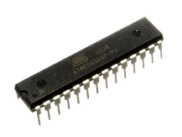 | 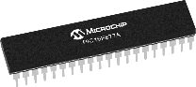 | 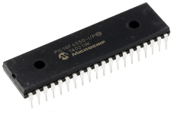 | 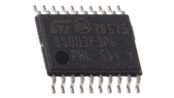
Advantages | -Huge community due to Arduino  -Available in THC package  -32kB flash  -2kB RAM  -Low cost | -Prior experience using this chip  -33 IO pins  -Available in THC package | -Available in THC package  -USB 2.0  -35 IO pins  -FOSC up to 48MHz  -32 kB flash | -Very low cost  -Very low power draw
Disadvantages | -Only 23 IO pins | -Lower amount of flash (14kB)  -Low RAM (368b)  -Costly | -Very costly  -Higher power consumption | -Not available in THC package  -Only 16 IO pins  -Lower amount of flash (8kB)  -Low RAM 1kB
Cost | Low | High | Very High | Very Low

Ultimately the choice of microcontroller selection came down to the following factors:
- I have prior experience with the PIC16, increasing chance of delivery
- The PIC16 has enough hardware to get the job done, without costs getting too high.
- The PIC16’s only significant disadvantage over the competition is lack of flash and RAM, but it is still sufficient to cover the needs of this project, and therefore isn’t a significant issue.

Myriota Connectivity

Connection Type | Myriota module | Myriota Dev Kit | Myriota Flex Sense
Photo | 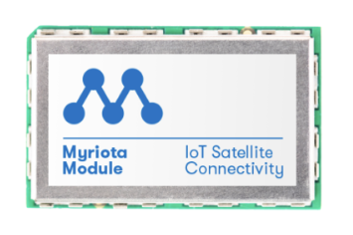 | 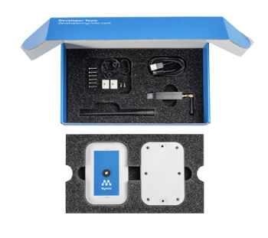 | 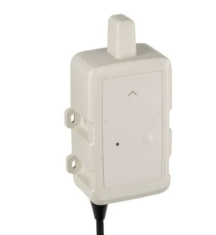
Advantages | -Lowest cost  -Designed for integration into PCBs  -Small size  -Lowest power consumption | -Easy integration with external sensors as required  -Provides plenty of flexibility  -Has GNSS already integrated | -Fastest solution to market  -Has GNSS already integrated
Disadvantages | -Requires Specialist soldering equipment | -Higher cost | -Provides least customisability
Cost | -Lowest cost | -High Cost | -High Cost

The selection of the Myriota dev kit is due to the following reasons:
- The dev kit provides the easiest flexibility, allowing for plenty of customisation, while keeping costs down.
- The specialist soldering tools required to fix the module to a PCB (pick and place machine, stencil printer, reflow oven).
- The dev kit comes with plenty of resources (developer area, hardware manager, and more) to enable easy integration of the Myriota connectivity.

GNSS Connectivity
Many options are available for GNSS connectivity:
Name | u-blox MAX-M10S [Y] | u-blox NEO-M9N [Z] | Sony CXD5603GF [AA]
Photo | 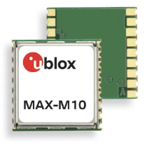 | 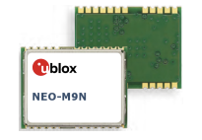 | 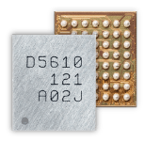
Advantages | -Connects to wide range of GNSS networks  -Affordable (£20 price point)  -Small 9.7 x 10.1mm package  -meter-level accuracy  -Moderate power use, 7mA (up to 50mA)  -Guaranteed compatibility with Myriota [AB] | -Connects to wide range of GNSS networks  -UART, SPI, I2C connectivity  -Small 10 x 16 mm space profile  -meter-level accuracy | -Connects to wide range of GNSS networks  -I2C and SPI output  -Low 0.7V supply voltage  -40mA max current draw (down to as low as 5mA while in consistent use)  -Small 3.1mm package  -meter-level accuracy
Disadvantages | -Single-Band GNSS only | -Higher power consumption (~30mA)  -Single frequency GNSS  -Package requires specialist equipment to solder | -Small voltage range  -Soldering requires specialist equipment  -Package requires specialist equipment to solder
Cost | Low cost (~£20) | Moderate cost (~£30) | High cost (~£50)

The U-Blox M10S series was selected due to its low cost and compatibility with the Myriota chip (although not necessary for use with the dev kit since GNSS is provided, ensuring compatibility is an important step for integrating the module with the PCB in the future).

LCD Screen

Name | 1602 Character LCD | ILI9341 2.8" TFT | Nextion NX4832T035
Photo | 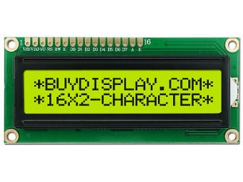 | 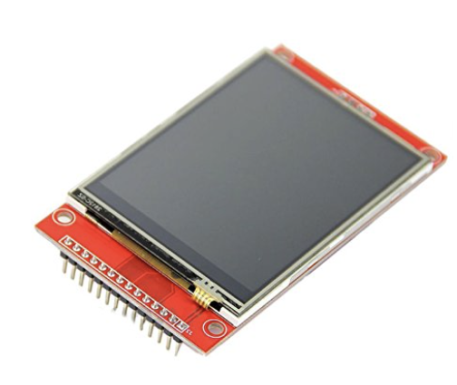 | 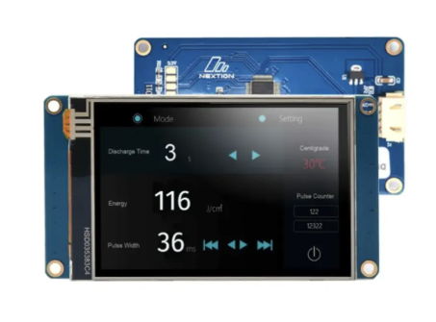
Advantages | -Simple to use  -Computationally cheap  -Small and lightweight  -Low power use (~30mA) | -Resistive Touch screen options available  -High customisability  -SPI and parallel protocols | -High customisability  -Capacitive touch
Drawbacks | -Low resolution  -Little customisation | -Hardware intensive to control | -High cost  -High power draw  -Physically Large
Price | Low cost (~£3) | Moderate cost (~£15) | High Cost (~£40)

This LCD 1602-character screen was chosen due to its low cost and low power consumption. It also represents the simplest display to integrate, improving chance of delivery. However, both the ILI9341 and Nextion NX4832T035 have sleeker UIs that would clearly be of benefit to any user, and would be worth reconsidering for any possible future generations should size or power requirements change.

Circuit Design
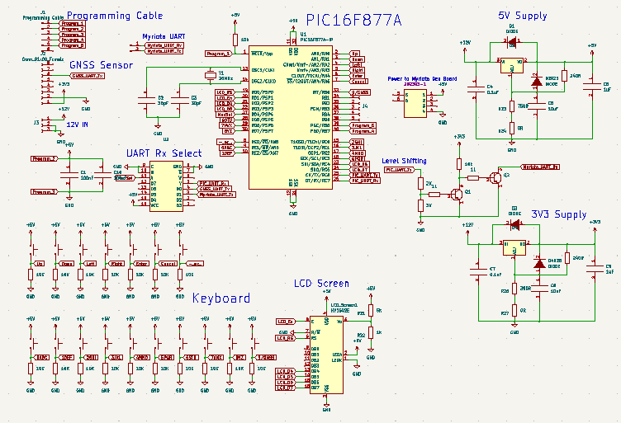
  - Fig. XXX, Circuit Design for the project.
PIC
In order to ensure normal operation when there is noise on the power line, 100nF filtering capacitors are required on each pair of VDD VSS pins. This filters out any parasitic signals on the line, ensuring a steady 5V supply to the chip.
A 20MHz crystal oscillator has been selected to maximise PIC performance. 30pF filtering capacitors are required to filter out parasitic signals, while still allowing the crystal oscillation to remain.
LCD Screen
The 1602 LCD Screen was connected to the PIC using 4 data lines (instead of 8), freeing up 4 GPIOs for other uses.
After some experimentation, a resistor divider was used to power V0, finding that R1 as 1K and R2 as 100R produced the best character back-light.
Keyboard
Each button of the keyboard has a pull-down resistor to ensure the voltage is not left floating when the button is open.
The buttons take up most of the GPIO pins on the pic, but an encoder IC was not used for the following reasons:
- It’s not strictly necessary. Almost all of the GPIOs are in use, but there are a few still free for future expansions.
- It increases latency. Rather than being able to check a button directly, the encoder must switch between several.
- The additional components that would be required will increase costs and take up more space on the board.
Power
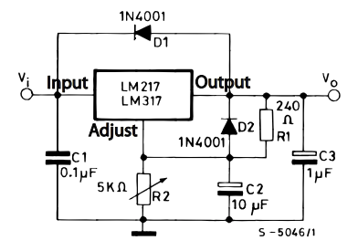
  - Fig. XXX, Example circuit for voltage regulator using the LM714 Linear regulator [AC].
Power enters the board from a 12V barrel connector, and dis stepped down to 5V and 3V3 with linear regulators. The dev board can be powered from the USB connector, which is fed 5V.
UART
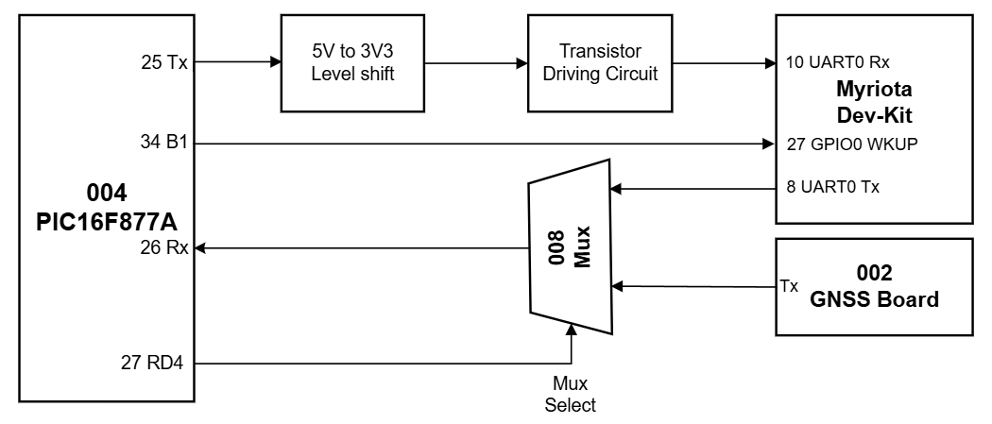
  - Fig. XXX, UART communication through the PCB.
Communication between the PIC16, GNSS board, and Myriota dev kit will be achieved with UART. The software on the PIC16 and Myriota dev kit employs the same UART standard as the GNSS chip, following common settings for most UART communications: 9600 baud, 8 data bits, and 1 stop bit.
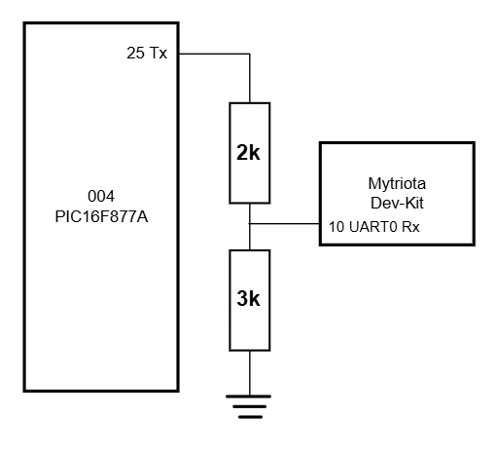
  - Fig. XXX, Level shifting UART with a potential divider
Since the PIC operates on 5V and the two other devices operate on 3V3, the level must be adapted with additional circuitry. Since the signals involved will be low power, a potential divider combination to step down from 5V to 3V3 will be sufficient for the PIC to talk to the other devices. A 3V3 signal is high enough to count as a logic 1 in 5V UART systems, meaning no additional components are required.
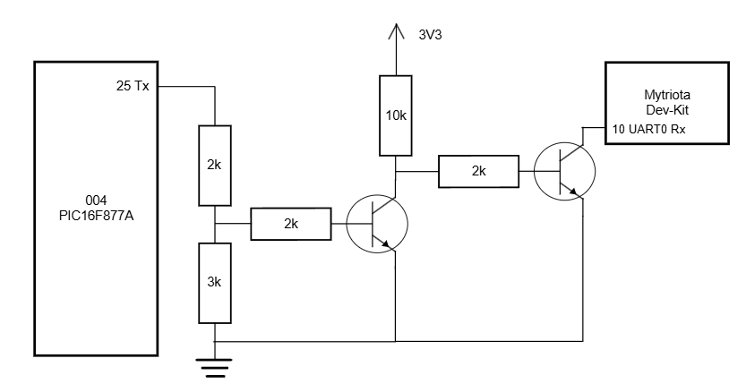
Figure. XXX, Level shifting and driving circuit for the Pic-Myriota UART communication.
The Rx pin for UART0 of the Myriota Dev kit has a strong pull-up resistor. The PIC cannot drive it low by itself, and will require a transistor to drive it. Using a transistor will allow it to pull the pin low. One transistor has the effect of inverting the output, so a second stage is required to correct this.
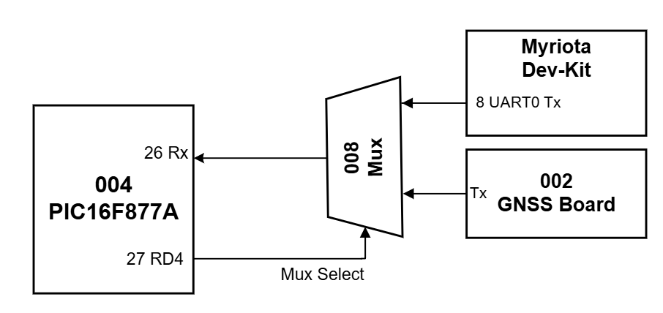
  - Figure. XXX, A multiplexer allowing the PIC to receive UART selectively from multiple sources.
The PIC needs to be able to receive UART character from both the Myriota module and GNSS board. However, the PIC16F877A only has one UART port, meaning that a multiplexer is required to allow the PIC to choose which source it wants to listen to. The PIC switches the source by raising or lowering the select line (connected to pin 27, RD4).

PCB Design
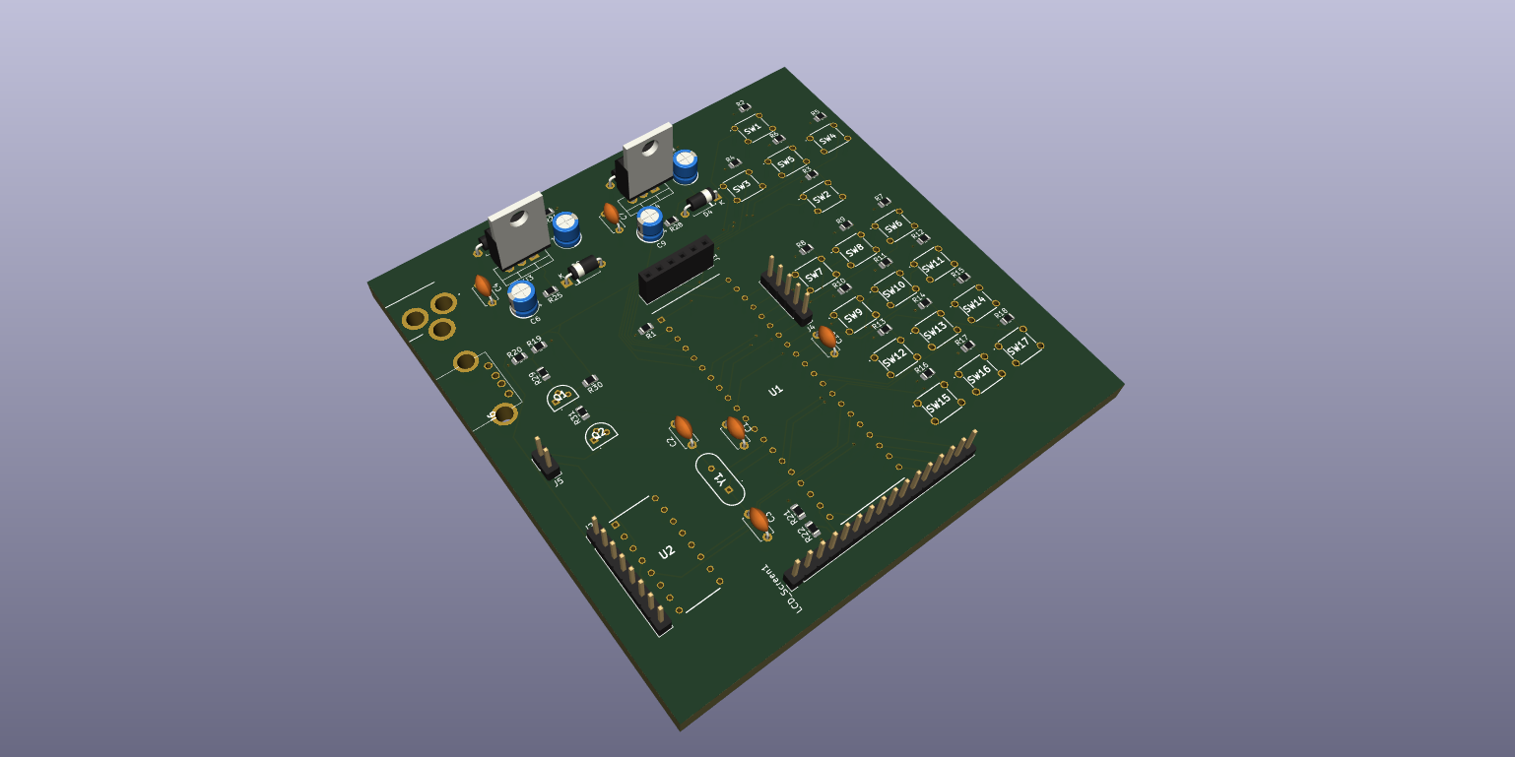
  - Fig. XXX, PCB for the project, designed using Kicad 6.0.
The PCB is a 4 layer board, including:
- Top Copper: Signal traces
- Middle 1: Ground plane
- Middle 2: Copper pours for 12V, 5V, and 3V3
- Bottom Copper: Any additional traces that didn’t fit on the top copper
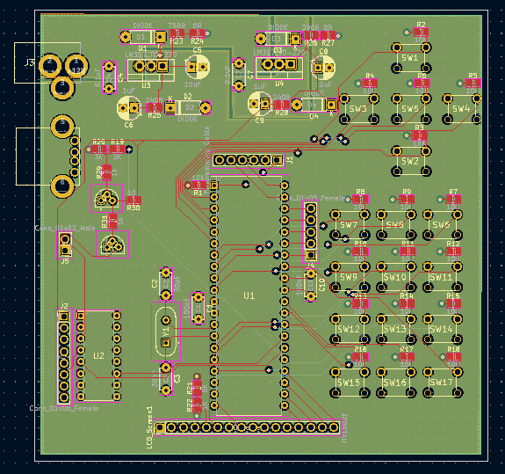
  - Figure. XXX, Completed PCB design.
Component Layout
Effective component placement was important. Through the design, components were arranged based on their connections, trying to reduce the length of traces as much as reasonably practical. Care was also taken to ensure that the following were placed facing outwards on the board to allow for easy connection: Barrel connector, USB connector, GNSS board, Myriota UART connections, and LCD screen header.
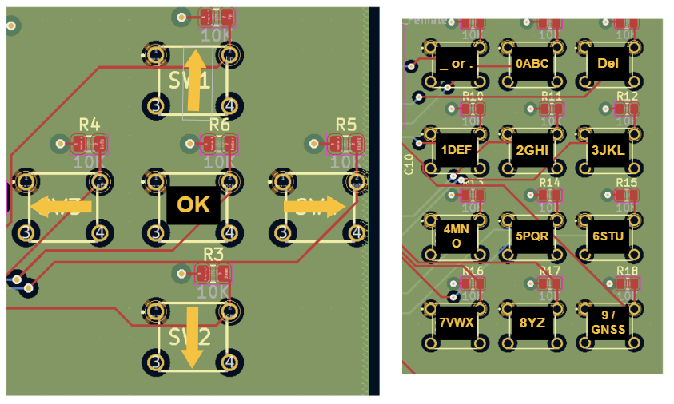
  - Figure. XXX, Layout of Buttons on PCB.
The buttons making up the keyboard were arranged in an appropriate pattern, as shown in the figure above.
Care was taken to try and squeeze the components into a 100mm square, leading to discounted manufacture prices with PCB houses such as JLC PCB.
UART traces were kept as small as reasonably practical to help improve performance, but with a comparatively low baud rate (9600), this likely wouldn’t be necessary and therefore components were primarily placed to reduce the length of the average trace.
Design Rule check
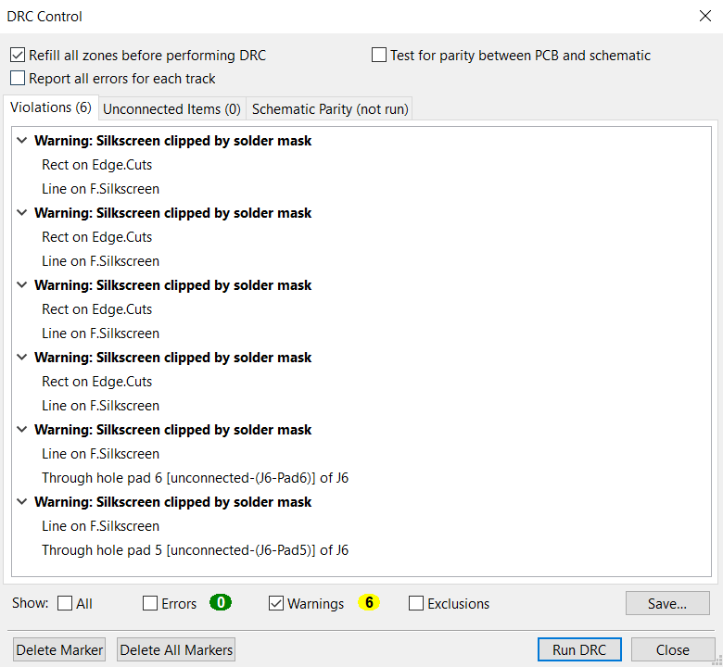
  - Figure. XXX, Design Rule Check completed for the PCB.
Ensuring the PCB is designed correctly before manufacture is essential. As such, a design rule check was conducted, finding that only a few minor warnings were generated (silkscreens overlapped that weren’t to the detriment of the design). With this completed, the PCB could confidently transition to manufacture.

Software
The software for this project can be grouped into three main areas:
- User interaction
- Retrieving Location
- UART communication between the Myriota and the PIC

User Interaction
Check Buttons:
The check_buttons function continually polls all of the GPIO pins connected to buttons. If the button is high, if waits for the button to be low again, ensuring a single button press isn’t counted multiple times.
At the end of the function, it waits for 50ms to combat any switch bounce that may be present.
Await input:
The await_input function is used by each screen to wait for the user to press a button, and action accordingly.
The function calls check_buttons and waits for a button to be high. If the button is a signle-press operation (such as the UP, DOWN, LEFT, RIGHT, or ENTER buttons), then a character is returned to indicate which one.
If the button is multi-tap (e.g. 2 presses is “A” and 3 presses is “B”), then the function waits for subsequent button presses, finally outputting the desired character when it has timed out.
Screens:
Each screen prints the title to the top line, and awaits the user’s input with await_input.
When the input is received, it is actioned accordingly:
- If the Input is a valid arrow button press, then the screen updates to the screen in the direction of the arrow. Invalid arrow presses (e.g. pressing down when there is no screen below) are ignored, and the input is awaited again.
- If in the TX_1 screen (to send a message), then characters are printed on the screen in order of press. The maximum message size if 20 characters, and the screen is 16 characters long, so the last 16 characters will be shown on screen. When the Enter button is pressed, the message is sent to the Myriota module with send_message.
In the case of the sensor screens (Latitude, Longitude, Time) then the most recent GNSS reading will be displayed on the screen (after processing). If the data is not valid, the screen will display “GNSS Not Found” across the bottom line.

Retrieving Location
Reading, processing, and displaying the Location, Time, and Data Validity from the GNSS board is a deceptively complex process, broken down with the following functions:
- get_location: listens to the GNSS board via the UART, and scans through all of the different NMEA sentences. It finds and extracts the $GNGLL sentence, providing the Latitude and Longitude in degrees and minutes, current time, and data validity.
- Extract_coords: this function takes the $GNGLL sentence string in input, and extracts the different sections. The longitude and latitude are converted to integers and decimalised (converting to degrees and fractions of degrees instead of degrees and minutes).
- Cords_to_str: this function takes the integer form of Latitude and Longitude and turns it into a string in the form “000.000000” so that it can be printed to the LCD screen.

UART Communication between PIC and Myriota
The communication between the PIC and Myriota package is UART with a 9600 Baud, 8 data bits, and one stop bit.
The code on the Myriota module was provided as part of the Myriota SDK, and works as follows:
- The PIC wakes the Myriota module by raising GPIO_0_WKUP high (connected to RB1)
- The Myriota module Initialises UART communication and transmits the string “READY\n”
- The PIC transmits the message to be sent, terminated by “\n”
- The Myriota module verifies the message is not too long, and schedules the message for transmission next time a satellite is overhead.
- If the message is too long, or the “\n” character is not received before it times out, then the Myriota module confirms this via UART. Otherwise it returns the “\nOKAY\n” string.
- The Myriota module goes back to sleep until the next time a satellite is overhead, when it transmits.
Please see Appendix B for more information.

Future Additions:
With the condensed timeline of this project, the full software wasn’t implemented in time, the following functions need to be added when development continues:
- Currently, only on character button from the keyboard is implemented (1ABC). Copying the code to work with all of the other buttons (2DEF, 3GHI, etc…) should be fairly straight forward.
- UART reception and transmission was completed for both the PIC and Myriota module when tested through a USB-serial adapter and TeraTerm. They successfully talked to eachother with individual characters, but I didn’t have enough time to make more complicated strings such as “\nOKAY\n” understood.
- The extract_coords function needs to be modified to work with negative values. Currently, extract_coords is extracting the longitude, latitude, time , and data status based on their position within the sentence, but a negative in either rof the coordinated will shift the position of all of the characters. Implementing would simply require searching for any minus symbols and employing logic accordingly.
- GNSS refresh: current, whenever a button is pressed, the GNSS reading is refreshed by listening to the GNSS board. However, these updates are only transmitted once a second, and result in a 1 second delay every time a button is pressed. Creating a new function to update the GNSS would allow it to be called only when necessary.

CHAPTER 5 – EVALUATION

Project Objectives and Design Priorities:
The objectives of the project were as follows:
- Establish a reliable communication link back to the Myriota cloud using the hardware designed during this project.
- Keep all hardware appropriate for a man-carried operation
- Test and validate successful message delivery to and from the Myriota cloud

None of these objectives were achieved in full, but the project did set up for future successful achievement with a little more development time. For example, sending messages to the Myriota cloud from the PIC was not achieved, but sending characters via UART to the Myriota module was, and sending messages from the Myriota module to the cloud was.

The design priorities for the project were:
- Size and weight
- Reliability
- Environmental Assurance
- Utility
The Size and weight design priority was achieved well, the PCB fits into a 100mm square, and the hole system weighs less than 1kg. This is easily man portable, even in difficult terrain. Reliability was also achieved. Although there was not enough time to thoroughly develop the system, it was working reliably on the breadboard.

Opportunities for Improvement:
The code would run faster if a dedicated “refresh_GNSS” function was implemented, meaning that the GNSS doesn’t need to be refreshed every time the user transitions to a new screen. This would make the program feel a lot less sluggish.

User Experience:
The UI of the project is very user-intuitive. The simple layout of buttons on a keyboard, and arrows on each screen indicating direction allows the user to navigate between receiving and transmitting messages, alongside viewing the time and current location in Latitude and Longitude.

CHAPTER 6 - CONCLUSIONS AND RECOMMENDATIONS

Achievements:
The following tasks were achieved through the project:
This project has seen the development of a proof-of-concept for communicating on the Myriota network. This includes a PCB that passed the design rule check, and a circuit that has been verified to work on a breadboard.
GPS position and time signals have been successfully received, and displayed to the screen with a fully intuitive UI.
Messages have been successfully sent to and received for the Myriota cloud.
The PIC microcontroller and Myriota package can successfully communicate individual characters using UART.
The project was unable to complete the following tasks:
- The PCB has not been constructed and tested. This will be essential moving forwards to confirm that the circuit operates as intended.
- A case has not been integrated into the design. This is an essential part of achieving the “Environmental Assurance” design priority. However, the small and low-power components used has ensured that any cases used can be small in size and lightweight, ensuring man-portability.
- No soldering of GNSS or Myriota package. Since the GNSS package and Myriota module both require specialist tools to solder onto a PCB (reflow oven, pick and place, etc…), this project has had to make do with a GNSS breakout board, and Myriota dev kit.

Through these tasks, the project has shown that a microcontroller-based distributed intelligence system is feasible for sending and receiving messages to the Myriota cloud, and therefore without localised infrastructure.
Although not complete, the project provides a useful concept demonstrator of what would be achievable if more development time was available.

Recommendations of future work:
If more development time becomes available, the following will all be useful areas to continue the research:
- Finishing the minimum viable product: Develop the software to include all button presses, and send UART strings between the PIC and Myriota module successfully.
- Mature into deployable solution: By providing an appropriately rugged case and manufacturing the PCB, the device will be useable in the environment it was intended for.
- Test in degraded Environment: It’s important to asses whether the solution actually is useful in a degraded electromagnetic environment. And determine that if not, the why not? How could it be improved and made more useful?

CHAPTER 7 – REFLECTION

Skills I learned
During the development of this project, there are many new skills that I have learned. I developed code for a PIC16F877A microcontroller using a brand-new compiler (XC8), with different syntax to the one I’d previously used (CCS for PIC). This was a first for me, although I have plenty of experience writing and simulating C code for PIC microcontrollers, I also had to implement it practically. Part of this was figuring out how to connect the programmer, ensuring the right crystal oscillator was used, and adding appropriate filtering capacitors to the PIC.

I taught myself how to develop and download code to the Myriota module. Of course, it was expected that I’d be learning to code a slightly different flavour of C, and how to use Myriota’s API, but there were many other unexpected skills developed too. This includes setting up a Linux (Ubuntu) virtual machine, downloading programs to the module through the Linux command line, and using the log utility file to clear the log when necessary.

Soft skills are just as essential to engineering projects as hard technical skills and I was pleased to discover these were also developed throughout the process. As I decided which development methodology to choose from, I had to calculate the trade-off between budget, time, risk, and quality. I also increased my proficiency formatting word documents, learning how to set up page numbers in different sections, ensuring they were presented professionally.

Technical troubleshooting is a difficult task, and one that gets easier with experience. Throughout this project I reinforced my understanding that 95% of the work involved is simply building an in-depth understanding of why an error is occurring, and fixing it is typically very easy after that. Additionally, I also observed is the importance of taking breaks; there were several points throughout this project where I’d be trying to understand an error for hours, which later became apparent after taking a 10-minute break and approaching it with fresh eyes.

It’s been refreshing to use a microcontroller and a PCB to design and implement a solution to a technical problem. Much of my previous experience with engineer projects requires a very quick turnaround, meaning that easier but less efficient tools need to be used. Code may need to run from a raspberry pi rather than an individual microcontroller, meaning it takes up more space, and draws more power. This increased power requires more batteries, increasing the space and weight further, and the case to store it all is larger and heavier still, producing a solution that works but isn’t optimised for the job. Now that I have more experience optimising designs for their unique problem, it’s more feasible to do this within a short turnaround.

Personal Impact
This project had a significant personal impact on me. I’ve found I’m more confident in the skills I have developed, and excited to take on more projects like this in the future.
It was very satisfying to take my technical skills to solve a problem; taking it from first idea to developed solution, spurring an interest in several new areas.
Specifically, I’ve come to appreciate microcontrollers, and the process of evaluating which one is best-suited for the given task, and then the development of the code to run on it.
Protecting critical national infrastructure is also something I’ve become really interested in, and it’s a way I can use my technical skills to help protect people all over the country from disasters such as flooding, cyber-attacks, and conflict.
A nice bonus from the project is now owning the tools and skill required to carry out further development with the PIC16 microcontroller line as a hobby.
This project has been a first for me in several areas, as already discussed, and I look forward to ensuring the next project continues stretching me to develop even more skills.

What I did well
There are several things that went well throughout this project. Primarily, this is the techniques employed to de-risk from an early stage:
- Spiral and waterfall development methodology: Triaging tasks early on based on technical risk, allowed problems to be noticed and completed quickly. For example, problems with UART reception and transmission led to the purchase of a USB-Serial adapter that was used to debug the problem. The delivery time for this to arrive wasn’t an issue because there were other tasks that could be completed in parallel.
- Building a Minimum Viable Product from isolated chunks: ensuring that each isolated part of the project was working first before combining together allowed for a relatively easy way to debug technical problems.
- Prioritising delivery: due to the short timeline and limited budget of this project, I ensured to prioritise a working solution that requires more development than a mature development that wasn’t working. This is evident in the lack of a PCB, but a working breadboard prototype.
Other things that also went well for the project included staying within budget, acquiring lots of useful tools for the future, and my selection of key components.

Different Next Time:
That being said there are also a few things I would change for next time:
- Allocating time further in advance. My time for this project was constrained because the three months before the deadline, I was needed for another project. The remaining three weeks I had for this didn’t provide me with enough time to provide a mature solution, which may have been possible if I’d started working on the project 6 months in advance.
- More funding would have been very helpful for the development, and there may have been other projects happy to contribute to the development. Next time I need to spend more time trying to increase the resources I have available. For example, with another £500 it would have been possible to purchase a standalone computer and run Linux on that, rather than try and run a virtual machine on windows.
- Collaboration with other engineers. Due to the nature of an independent project, this was naturally going to be constrained from the beginning. However, if I were to continue with development, or start another project, I would definitely benefit from the experience and skill of others.
- New software. As with all technical projects, there’s a constant balance between time, cost, risk, capability development, delivery, and so many other factors. Rather than trying to use Proteus for programming the PIC microcontroller, I taught myself to use MPLab IDE, developing my capability for the future. This time spent learning the new compiler syntax could have been used to improve delivery instead.

CHAPTER 8 – REFERENCES

References

Table of Figures
Figure Number: | Title:

CHAPTER 9 – BIBLIOGRAPHY

APPENDICES

Appendix A – Code on the PIC
//Student No. 2114210
//Jack Lonsdale
#include <xc.h>
#include <string.h>
#include <stdio.h>
#include "lcd.h"

// CONFIG
#pragma config FOSC = HS // High-Speed Oscillator
#pragma config WDTE = OFF // Watchdog Timer Enable
#pragma config PWRTE = OFF // Power-up Timer Enable
#pragma config BOREN = ON // Brown-out Reset Enable
#pragma config LVP = OFF // Low-Voltage Programming
#pragma config CPD = OFF // Data EEPROM Code Protection
#pragma config WRT = OFF // Flash Program Memory Write Enable
#pragma config CP = OFF // Flash Program Memory Code Protection

void coords_to_str(char* String, long Num);
char rx_screen();
char tx_screen();

volatile unsigned long MilliTime = 0;
//char NextScreen='A';

#define _XTAL_FREQ 20000000 // 20 MHz crystal

void __interrupt() ISR(void) {
if (T0IF) {
T0IF = 0; // Clear Timer0 overflow flag
MilliTime++; // Increment every ~1ms
TMR0 = 236; // Reload value for 1ms tick
}
}

void init_milli_timer() {
OPTION_REG = 0b00000111; // Prescaler 1:256, Timer0 source = internal
TMR0 = 236; // Preload value for 1ms overflow at 20MHz
T0IE = 1; // Enable Timer0 interrupt
GIE = 1; // Enable global interrupts
}

// --- UART Initialisation ---
void UART_Init() {
TRISC6 = 1; // TX as input (will be corrected by hardware later)
TRISC7 = 1; // RX as input

BRGH = 1; // High speed
SPBRG = 129; // Baud rate = 9600 for 20MHz

SYNC = 0; // Set to Asynchronous mode
SPEN = 1; // Enable UART communications

CREN = 1; // Receive continuously
TXEN = 1; // Enable Tx
}

// --- UART Receive ---
char UART_Read() {
//This is required to refresh UART communications in case of an overrun error (common in PIC16 chips)
if (OERR) { // Check if Overrun Error occurred
CREN = 0; // Disable receiver
CREN = 1; // Re-enable receiver
}
while (!RCIF); // Wait for data
return RCREG; //Return the character when received
}

// --- UART Transmit ---
void UART_Write(char data) {
while (!TXIF); // Wait for the transmit buffer to be empty
TXREG = data; // Transmit the character
}

//Write string to UART
void WriteString(const char* Sentence){
while(*Sentence){ //While the current character is not '\0' (null terminator))
UART_Write(*Sentence); //Transmit the character through UART
Sentence++;
}
}

void extract_string(char* StringIn,char* StringOut, int Start, int Stop){
int InCounter=0, OutCounter=0; //This function extracts a portion of a string form another string
while(InCounter<=Stop){ //Since StringOut is a buffer, no values need to be returned
if(InCounter>=Start){ //It's a shame this isn't a built in command for XC8
StringOut[OutCounter] = StringIn[InCounter];
OutCounter++;
}

InCounter++;
}
StringOut[OutCounter]='\0';
return;
}

void write_to_LCD(int Y, int X, char* Message){ //Simplifies the process of writing to the LCD screen
lcd_set_cursor(X, Y); //And cleans up the code by removing a line
lcd_string(Message);
}

char check_buttons(char Button){ //THis function goes through all of the GPIO pins that have buttons]
Button='0'; //connected and checks to see if they're high
if(PORTAbits.RA0 == 1){ //In future generations, the remaining buttons will be added
Button='1';
while(PORTAbits.RA0 == 1){}
}

else if(PORTAbits.RA1 == 1){ //If button is pressed
Button='2';
while(PORTAbits.RA1 == 1){} //Wait until button is released
}

else if(PORTAbits.RA2 == 1){
Button='3';
while(PORTAbits.RA2 == 1){}
}

else if(PORTAbits.RA3 == 1){
Button='4';
while(PORTAbits.RA3 == 1){}
}
else if(PORTAbits.RA4 == 1){
Button='5';
while(PORTAbits.RA4 == 1){}
}
else if(PORTAbits.RA5 == 1){
Button='6';
}

__delay_ms(50); //To combat switch bounce
return Button;
}

char await_input(){ //THis function takes an input from check_buttons
char Input = '0'; //And actions button presses appropriately
while(Input=='0'){ //It also handles multi-tap for the keyboard buttons
Input = check_buttons(Input); //As with previous function, the code for the 1ABC button
} //will be replicated for all other keyboard buttons in future generations
if(Input=='1'){
WriteString("\n\rUp");
return 'U';}

if(Input=='2'){
WriteString("\n\rDown");
return 'D';}

if(Input=='3'){
WriteString("\n\rLeft");
return 'L';}

if(Input=='4'){
WriteString("\n\rRight");
return 'R';}

if(Input=='5'){
WriteString("\n\rEnter");
return 'E';}

if(Input=='6'){
int ButtonPresses = 1; //Tracks how many times the same button was pressed
while(PORTAbits.RA5 == 1){} //Waits for the button to be released
int TimeReleased = MilliTime; //Records the time button was released
int TimeWaiting = 0;
while(TimeWaiting < 1000){
if(PORTAbits.RA5 == 1){
TimeReleased = MilliTime;
ButtonPresses++;
while(PORTAbits.RA5 == 1){};
}
TimeWaiting = MilliTime - TimeReleased;
}
int FinalChar = ButtonPresses % 4;
switch(FinalChar){
case 1:
return '1';
break;

case 2:
return 'A';
break;

case 3:
return 'B';
break;

case 0:
return 'C';
break;

}

return 'F'; //If there was no button pressed (should never happen in theory)

}

}
//---------------------------------------------------Screens Start------------------------------------------------------

char tx_screen(){ //Top level UI screen for transmitting a message
WriteString("\n\rTx Screen");
char Input = '/';
lcd_clear();
write_to_LCD(0,0,"< Tx Message >");
write_to_LCD(0,1,"V");

while((Input != 'L') && (Input != 'R')&& (Input != 'D')){
Input = await_input();
switch(Input){
case 'L':
return 'r'; //Go to Rx UI screen
break;
case 'R':
return 's'; //Go to Sensor UI screen
break;
case 'D':
return '0'; //Go to "Send a message" screen (Tx1))
break;
}
}
}

//When in the screen to send a message, this handles the updating of the bottom line, and add new characters to the string
void print_tx_message(char Character, char* MessageString){
char TempString[16] = "";
int Len = strlen(MessageString);
char LenStr[5]="";

if(Len<20){ //20 is maximum transmission size for Myriota Tx
MessageString[Len] = Character;
MessageString[Len+1] = '\0';
Len++;

if((Len>16)){
extract_string(MessageString, TempString, Len-16, Len-1);
write_to_LCD(0,1,TempString);
}
else{
write_to_LCD(0,1,MessageString);
}
}
}

void send_message(char* Message){ //Please see appendix C for the prototype code

write_to_LCD(0,1,"Sending.... ");

//wake up Myriota

//wait for Ready\n string

//Send message

//Toggle GPIO0

//Await "ok\n" string

}

char tx_1_screen(){ //The screen where the user enters the message to be transmitted
WriteString("\n\rSend Message Screen");

char Input = '/';
char MessageString[20] = "";

lcd_clear();
write_to_LCD(0,0,"^ Transmit Msg ");
write_to_LCD(0,1,"|");
while((Input != 'U')&&(Input != 'E')){
Input = await_input();

switch(Input){
case 'U':
return 't'; //GO to Tx UI screen
break;
case 'E':
send_message(MessageString); //Enter pressed, send the message
break;
case '1': //Add characters to the bar when pressed
case 'A':
case 'B':
case 'C':
print_tx_message(Input, MessageString);
break;
}
}
}

char rx_screen(){ //Top level UI screen for receiving messages
WriteString("\n\rRx Screen");
char Input = '/';
lcd_clear();
write_to_LCD(0,0," Rx Message >");
write_to_LCD(0,1,"v");

while((Input != 'R') && (Input != 'D')){
Input = await_input();

switch(Input){
case 'R':
return 't'; //Go to Tx UI Screen
break;
case 'D':
return '1'; //GO to "last messages" screen
break;
}
}
}

char rx_1_screen(){ //VIew the last received message
WriteString("\n\rView Previous Message Screen");
char Input = '/';
lcd_clear();
write_to_LCD(0,0,"^Receive message");
write_to_LCD(0,1,"No Messages... ");
while(Input != 'U'){
Input = await_input();

switch(Input){
case 'U':
return 'r'; //Go to Rx UI screen
break;
}
}
}

char sensor_screen(){ //Top level UI screen for sensors
WriteString("\n\rSensor Screen");
char Input = '/';
lcd_clear();
write_to_LCD(0,0,"< GNSS + Time ");
write_to_LCD(0,1,"v ");

while((Input != 'L') && (Input != 'D')){
Input = await_input();

switch(Input){
case 'L':
return 't'; //Go to Tx Screen next
break;
case 'D':
return '2'; //Go to Latitude screen next
break;
}
}
}

char sensor_1_screen(){ //Screen that displays latitude
WriteString("\n\rLatitude Screen");
char Input = '/';
write_to_LCD(0,0,"^ Latitude (deg)");

while((Input != 'U') && (Input != 'D')){
Input = await_input();

switch(Input){
case 'U':
return 's'; //Go to sensor screen next
break;
case 'D':
return '3'; //Go to Longitude screen next
break;
}
}
}

char sensor_2_screen(){ //Screen that displays longitude
WriteString("\n\rLongitude Screen");
char Input = '/';
//lcd_clear();
write_to_LCD(0,0,"^Longitude (deg)");
//write_to_LCD(0,1,"v 000.000000W");

while((Input != 'U') && (Input != 'D')){
Input = await_input();

switch(Input){
case 'U': //Go to Latitude screen next
return '2';
break;
case 'D':
return '4'; //Go to Time screen next
break;
}
}
}

char sensor_3_screen(){ //Screen that displays the time
WriteString("\n\rTime Screen");
char Input = '/';
write_to_LCD(0,0,"^ UTC Time ");

while(Input != 'U'){
Input = await_input();

switch(Input){
case 'U':
return '3'; //Go to Longitude screen next
break;
}
}
}
//---------------------------------------------------Screens End------------------------------------------------------

//---------------------------------------------------GNSS Start------------------------------------------------------------------

//This function reads the NMEA sentences from the GNSS sensor and extracts the $GNGLL sentence (later used to extract Latitude and Longitude))
void get_location(char* Message, int MaxLength){
//Initialising function
char receivedChar;
unsigned int Length;
Message[0] = '\0';
while(1){
receivedChar = UART_Read(); // Wait for character to be received

if(receivedChar=='$'){ //If the $ sign is present, a new sentence is about to begin
if(strncmp(Message,"$GNGLL",6)==0){ //If it is a $GNGLL (latitude and longitude) sentence (ignores all others)
Message[55]='\0'; //THe GNGLL sentence is 54 characters long
return;
}

Message[0] = '$'; //Empty the string and start again
Message[1] = '\0';
Length = 1;
}

else if(strlen(Message)>0 && Length < MaxLength-2){
Message[Length] = receivedChar; //Add the last received character to the string
Message[Length+1] = '\0'; //Remember kids: always null terminate!
Length++;
}
}
}

void extract_coords(char* NMEASentence, char* Latitude, char* Longitude, char* Time, char* DataStatus){
WriteString("\n\rextract_coords called");

char TempString[3]=""; //This function take in input the $GNGLL sentence from
//the get_location function, chops up the different
char TempLatitude[11]; //sections, and calculated decimalised Degrees
char TempLatDeg[3]; //(converts from degrees and minutes)
char TempLatMinutes[9];
char TempLongitude[12];
char TempLongDeg[4];
char TempLongMinutes[9];

//Extracting Latitude degrees and minutes from NMEA Sentence
extract_string(NMEASentence,TempLatitude,7,16);
extract_string(TempLatitude,TempLatDeg,0,1);
extract_string(TempLatitude,TempLatMinutes,2,9);

//Extracting Longitude degrees and minutes from NMEA Sentence
extract_string(NMEASentence,TempLongitude,20,30);
extract_string(TempLongitude,TempLongDeg,0,2);
extract_string(TempLongitude,TempLongMinutes,3,10);

//Extracting the time and data status
extract_string(NMEASentence,Time,34,39); //Data status tells you the validity of the data
extract_string(NMEASentence,DataStatus,44,44); // if ='A' then the data is valid

//Getting Latitude Degrees decimalised
long TempLatDegrees = (TempLatDeg[0]-'0')*10000000 + (TempLatDeg[1]-'0')*1000000; //COnverts the string latitude into an integer
long TempLatMin = (TempLatMinutes[0]-'0')*10000000 + (TempLatMinutes[1]-'0')*1000000
+(TempLatMinutes[3]-'0')*100000 + (TempLatMinutes[4]-'0')*10000
+(TempLatMinutes[5]-'0')*1000 + (TempLatMinutes[6]-'0')*100
+(TempLatMinutes[7]-'0')*10;

TempLatMin = TempLatMin/60;
TempLatDegrees = TempLatDegrees + TempLatMin; //Decimalises the coordinate (degrees, not degrees and minutes)

coords_to_str(Latitude, TempLatDegrees);

//Getting Longitude Degrees decimalised
long TempLongDegrees = ((TempLongDeg[0]-'0')*100000000 + (TempLongDeg[1]-'0')*10000000 + (TempLongDeg[2]-'0')*1000000); //Following the same process to calculate longitude, as above with latitude

long TempLongMin = ((TempLongMinutes[4]-'0')*1000);
TempLongMin = TempLongMin*10;
TempLongMin = TempLongMin + ((TempLongMinutes[0]-'0')*10000000)
+((TempLongMinutes[1]-'0')*1000000 + ((TempLongMinutes[3]-'0')*100000)
+ (TempLongMinutes[5]-'0')*1000 + (TempLongMinutes[6]-'0')*100
+ (TempLongMinutes[7]-'0')*10);

TempLongMin = TempLongMin/60;

TempLongDegrees = TempLongDegrees + TempLongMin;

coords_to_str(Longitude, TempLongDegrees); //This function converts the integers to strings so they can be printed on the screen

}

//THis function takes the integer form of Latitude or Longitude and converts it to a string so that it can be printed to the LCD screen
void coords_to_str(char* String, long Num){ //Take in input long int < 200000000 in form 000000000 and converts to string
int Counter=0;
if(Num >= 100000000){ //100s
String[0] = '1';
Num -= 100000000; //Works by continuous placeholder subtraction
}
else{String[0] = '0';}

while(Num>=10000000){ //10s
Counter += 1;
Num -= 10000000;
}
String[1] = Counter + '0';

Counter=0; //1s
while(Num>=1000000){
Counter += 1;
Num -= 1000000;
}
String[2] = Counter + '0';

String[3] = '.'; //Adding decimal point

Counter=0;
while(Num>=100000){ //0.1s
Counter += 1;
Num -= 100000;
}
String[4] = Counter + '0';

Counter=0;
while(Num>=10000){ //0.01s
Counter += 1;
Num -= 10000;
}
String[5] = Counter + '0';

Counter=0;
while(Num>=1000){ //0.001s
Counter += 1;
Num -= 1000;
}
String[6] = Counter + '0';

Counter=0;
while(Num>=100){ //0.0001s
Counter += 1;
Num -= 100;
}
String[7] = Counter + '0';

Counter=0;
while(Num>=10){ //0.00001s
Counter += 1;
Num -= 10;
}
String[8] = Counter + '0';

Counter=0;
while(Num>=1){ //0.000001s
Counter += 1;
Num -= 1;
}
String[9] = Counter + '0';

String[10] = '\0'; //"I pity the fool who doesn't null terminate" - B.A.Baracus (if he was an embedded software engineer)
}

//---------------------------------------------------GNSS End-------------------------------------------------------------------

void main() {
__delay_ms(2000); //Stops code re-executing many times in case of power fluctuations
lcd_init();
write_to_LCD(0,0,"Loading...");
init_milli_timer();
UART_Init();

ADCON1 = 0x06;
TRISA = 0x3F; //Sets A0-A5 as input

WriteString("\n\n\r----------Reset----------"); //Helpful in case of debugging

char NextScreen='r'; //Starts the program in the Rx UI screen
//NextScreen='r';

while(1){
char GNSSLocation[73]; //Larger than GNGLL sentences to allow for other sentences to be used in future
get_location(GNSSLocation, sizeof(GNSSLocation));
char Latitude[12]; //Placeholders for extract_coords
char Longitude[12];
char UTCTime[7];
char Hours[3];
char Minutes[3];
char Seconds[3];
char DataStatus[2];

extract_coords(GNSSLocation, Latitude, Longitude, UTCTime, DataStatus);

switch(NextScreen){

case 'r':
NextScreen = rx_screen(); //UI screen for Rx
break;
case 't':
NextScreen = tx_screen(); //UI screen for Tx
break;
case 's':
NextScreen = sensor_screen(); //Sensor UI screen
break;
case '1':
NextScreen = rx_1_screen(); //View last message received
break;
case '0':
NextScreen = tx_1_screen(); //Send a message
break;
case '2':
//Latitude
if(DataStatus[0]=='A'){
write_to_LCD(0,1,"v ");
write_to_LCD(5,1,Latitude);
write_to_LCD(15,1,"N");
}
else{
//Print No Signal
write_to_LCD(0,1," GNSS Not Found ");
}
NextScreen = sensor_1_screen();
break;

case '3':
//Longitude
if(DataStatus[0]=='A'){
write_to_LCD(0,1,"v ");
write_to_LCD(5,1,Longitude);
write_to_LCD(15,1,"W");
}
else{
//Print No Signal
write_to_LCD(0,1," GNSS Not Found ");
}
NextScreen = sensor_2_screen();
break;
case '4':
//Time
if(DataStatus[0]=='A'){
extract_string(UTCTime,Hours,0,1); //Breaks down the time into hours, minutes and seconds
WriteString("\n\rHours: "); //And prints to lower half of LCD screen
WriteString(Hours);
extract_string(UTCTime,Minutes,2,3);
WriteString("\n\rMinutes: ");
WriteString(Minutes);
extract_string(UTCTime,Seconds,4,5);
WriteString("\n\rSeconds: ");
WriteString(Seconds);
write_to_LCD(0,1," ");
write_to_LCD(4,1,Hours);
write_to_LCD(6,1,":");
write_to_LCD(7,1,Minutes);
write_to_LCD(9,1,":");
write_to_LCD(10,1,Seconds);
write_to_LCD(12,1," ");
}
else{
//Print No Signal
write_to_LCD(0,1," GNSS Not Found ");
}
NextScreen = sensor_3_screen();
break;
}
}

}

Appendix B – Code on the Myriota module
The following code was developed by Myriota Pty. Ltd, Australia, and was provided as part of the Myriota SDK example “UART” program

// Copyright (c) 2016-2020, Myriota Pty Ltd, All Rights Reserved
// SPDX-License-Identifier: BSD-3-Clause-Attribution
//
// This file is licensed under the BSD with attribution (the "License"); you
// may not use these files except in compliance with the License.
//
// You may obtain a copy of the License here:
// LICENSE-BSD-3-Clause-Attribution.txt and at
// https://spdx.org/licenses/BSD-3-Clause-Attribution.html
//
// See the License for the specific language governing permissions and
// limitations under the License.

// This example demonstrates uart interface communication between an external
// device and the Myriota Module. This also demonstrates a basic modem
// application. Operates as follows:
// 1. the external device wakes up the module by setting GPIO0 high,
// 2. waits for the "READY\n" string from the Myriota Module,
// 3. sends messsage string terminated by "\n",
// 4. sets GPIO0 low again.
// 5. The Myriota Module acknowledges reception with string "\nOK\n",
// 6. then schedules the message string for satellite transmission.

#include <string.h>
#include "myriota_user_api.h"

const static uint8_t GPIOPin = PIN_GPIO0_WKUP;
void *uart_handle = NULL;

#define READY_STRING "READY\n"
#define RECEIVE_TIMEOUT 10000 // [ms]
#define ACK_STRING "\nOK\n"

// The interface can be UART_0 or LEUART, depending the debug interface defined
// in BSP
#define UART_INTERFACE UART_0
#define UART_BAUDRATE 9600

// Read new line terminated string from UART with timeout
// Return number of bytes read or -1 on timeout or string is too long
int UARTReadStringWithTimeout(void *Handle, uint8_t *Rx, size_t MaxLength) {
UARTWrite(uart_handle, (uint8_t *)"\n\rRead Str called", strlen("\n\rRead Str called"));
const uint32_t start = TickGet();
int count = 0;
while (TickGet() - start < RECEIVE_TIMEOUT) {
uint8_t ch;
UARTWrite(uart_handle, (uint8_t *)"\n\rWhile check", strlen("\n\rWhile check"));
if (UARTRead(Handle, &ch, 1) == 1) {
UARTWrite(uart_handle, (uint8_t *)"\n\rChar received: ", strlen("\n\rChar received: "));
UARTWrite(uart_handle, &ch, 1);
if (ch == '\n') return count;
Rx[count] = ch;
count++;
if (count == MaxLength) return -1;
}
}
return -1;
}

static time_t UartComm() {
uart_handle = UARTInit(UART_INTERFACE, UART_BAUDRATE, 0);
if (uart_handle == NULL) {
UARTWrite(uart_handle, (uint8_t *)"\n\rFailed to init UART", 20); //Check point
return OnGPIOWakeup();
}
Sleep(0.1);
UARTWrite(uart_handle, (uint8_t *)READY_STRING, strlen(READY_STRING));
uint8_t Rx[MAX_MESSAGE_SIZE] = {0};
int len = UARTReadStringWithTimeout(uart_handle, Rx, MAX_MESSAGE_SIZE);
if (len <= 0) {
UARTWrite(uart_handle, (uint8_t *)"\n\rFailed to Rx msg", 20);
} else {
UARTWrite(uart_handle, (uint8_t *)Rx, len);
UARTWrite(uart_handle, (uint8_t *)ACK_STRING, strlen(ACK_STRING));
ScheduleMessage(Rx, len);
printf("Scheduled message: ");
for (int i = 0; i < len; i++) printf("%02x", Rx[i]);
printf("\n");
}

UARTDeinit(uart_handle);
return OnGPIOWakeup();
}

void AppInit() {
// Internally pull down the pin to make sure the pin is not floating
GPIOSetModeInput(GPIOPin, GPIO_PULL_DOWN);
ScheduleJob(UartComm, OnGPIOWakeup());
GPIOSetWakeupLevel(GPIOPin, GPIO_HIGH);
}

Appendix C – send_message function
void send_message(char* Message){
char ReceivedChar='0';
char ReceivedStr[6]="";
int Len = 0;
int Continue = 1;

//__delay_ms(5000); //For testing purposes, please remove if redundant
PORTBbits.RB1 = 1; //raise GPIO_0_Wkup high

//wait for "READY\n" string
while(Continue==1){
ReceivedChar = UART_Read();

if(ReceivedChar=='R' || ReceivedChar=='E' || ReceivedChar=='A' || ReceivedChar=='D' || ReceivedChar=='Y'){
ReceivedStr[Len] = ReceivedChar;
ReceivedStr[Len+1] = '\0'; //"I pity the fool who doesn't null terminate" - B.A. Baracus
Len++;
//UART_Write(ReceivedChar);
if(ReceivedChar=='Y'){
Continue = 0;
}
}

}
extract_string(ReceivedStr,ReceivedStr,(strlen(ReceivedStr)-6),(strlen(ReceivedStr)-2));

if((strcmp(ReceivedStr, "READY") == 0)){
//send message to Myriota via UART
WriteString("Message\n");
write_to_LCD(0,0,"READY received");
}

PORTBbits.RB1 = 0; //Set GPIO_0_WKUP low to tell Myriota message has finished

while(Continue==1){
ReceivedChar = UART_Read();
if(ReceivedChar == 'O'){
write_to_LCD(0,1,"Message Sent");

}
}

}

