Why is Coaching and Mentoring Important in
The Workplace?

A report By
Nargas Ahmadzai (2106756)
Module_ Coaching and Mentoring Skills for the Workplace
Module Code_ BMSW6105_BIRM
Lectures By_ Dennis Pepple

Table of contents

1. Introduction 4
1.1 Coaching 4
1.2 Mentoring 4
2. Why is Coaching and Mentoring Important in the Workplace? 6
3. Advantages and Disadvantages of the GROW Model 9
3.1 Advantages of the GROW model 10
3.2 Disadvantages and Limitations of the GROW Model 11
4. Reflection 11
4.1 Reflecting on the Coaching Session 11
4.2 Reflection on the Mentoring Session 14
5. References 17

Table of Figures

Figure 1 Difference between coaching and mentoring 5
Figure 2 9 Coaching Skills Every Effective Leader Needs 6
Figure 3 What Are The Disadvantages Of Coaching and Mentoring? 8
Figure 4 The GROW Model 9
Figure 5 Gibbs's Reflective Cycle 12
Figure 6 Looking Through the JOHARI Window 14

Introduction

Life is constantly full of challenges and confrontations. There are always questions to answer with agreement or disagreement. Therefore, genuine guidance and the appropriate support are key elements for successful and acceptable answers. This report is based on the importance of coaching and mentoring skills for the workplace. People often have concerns and doubts about their careers, performance, abilities, relationships, emotional intelligence, and lack of professional connections. It shows how an excellent coach can guide someone towards the right path and help them make sound decisions.
In the first section, the report aims to define coaching and mentoring and contrast the differences between both approaches. It utilises models and theories to explain and analyse coaching and mentoring more thoroughly. The second section reflects on the outcome of mentoring and coaching sessions as a part of the assignment using the useful tool of GIBBS’ Reflective Cycle.

1.1 Coaching
Based on several arguments by literature it is outlined that coaching is a one-to-one learning conversation and has always existed. Models and techniques have recently been used in the workplace environment. However, the question of which model or theory is more effective remains unsorted (Bresser and Wilson,2010).

The research outlines that coaching substantially increases the effectiveness of the connections between self-development, management development and organisational effectiveness. Coaching has different forms; each is a useful way to improve and develop an individual's skills and abilities and support for boosting performances (wales,2002).
Coaching is the process of providing individuals with a dedicated space for development, encouraging reflection and fostering new insights. This process serves as the groundwork for crafting new, alternative, or refined narratives of an individual's personal and professional life (Stelter,2007).

1.2 Mentoring
As mentioned, coaching is a method of developing skills to accomplish tasks, while mentoring is a method of enhancing individuals' capabilities to reach their goals.
Mentoring is nurturing potential and providing guidance and support to others within a relationship built on trust. This includes facilitating the realisation of goals and empowering individuals to achieve success. It is not just a task or process but a professional relationship where one person helps another grow beyond the usual manager-subordinate dynamic (Cranwell-Ward et al.,2004).

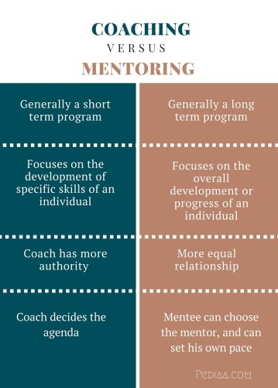

Figure 1 Difference between coaching and mentoring
Source: (Hasa, 2016)

Figure 1 portrays the contrasts between Coaching and mentoring. Coaching is a challenging job that requires the utmost focus and clarity to guide others in the right direction. Both approaches demand skills to enhance while carrying out their duties. Coaching skills are effective, and anyone can consciously enhance their coaching abilities.

Why is Coaching and Mentoring Important in the Workplace?

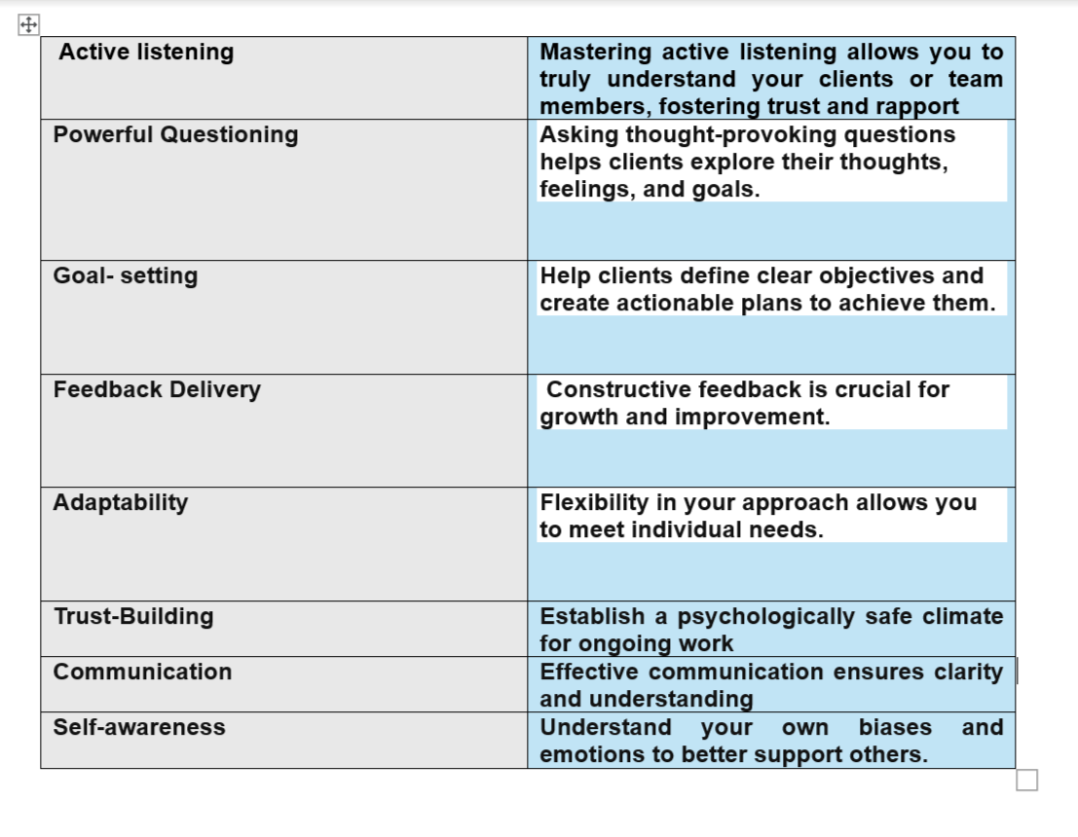
Figure 2 9 Coaching Skills Every Effective Leader Needs
Source: (Miles, 2022)

Previously the report defined coaching and mentoring and outlined the contrast between both approaches, the table above in Figure 2 shows some main skills for effective coaching. This section of the report explains the situations when these approaches are essential.
Effective coaching helps individuals succeed in the workplace. Like in sports, where coaches help athletes reach their full potential, workplace coaches guide employees to improve their skills, performance, and productivity, and meet expectations. Coaches aim to give employees the confidence of achievement. Research shows that coaching and mentoring employees of any organisation increases production and creates a return on the investment of 5.7 times the cost. Once the sports coach said’’ that you have to trouble the comfortable and comfort the troubled.’’ This means that managers of organisations should observe their employees regularly to identify the areas of coaching and mentoring for improvement and great performance, effective coaches do not answer employees instead they guide and encourage them to solve their problems themselves (Factorial, 2020).
Coaching and mentoring are not the same as therapy. They involve a supportive communication bond between two people to reflect on past experiences and seek future opportunities. The mentor personally develops this connection to build trust and confidence.
A constructive coaching and mentoring session involves exploring resistance and building trust between the coach and employees to help them adapt to changes and difficulties (Connor and Pakora,2017).
Coaching and mentoring are tailored to meet the needs and requirements of each individual, depending on their unique situation. What works for one person may not work for another because individuals have distinct personalities, values and problems. One piece of advice might be understandable for one person but not for another. Therefore, effective coaching and mentoring involve listening to and understanding the coachee and providing guidance and support. The coach and mentor act as facilitators.
They must listen to the client's story and create an environment where they feel confident and trusting enough to share their thoughts, doubts, and concerns. It is important for the coach and mentor not to act as instructors and to avoid imposing rigid instructions, as this could limit the session's effectiveness. The coaching session must be designed as an empty map where roads can be marked by the agreements of both coach and client to proceed step by step towards their desired destination (Connor and Pakora,2017).

However, coaching and mentoring have limitations mentioned in figure 3
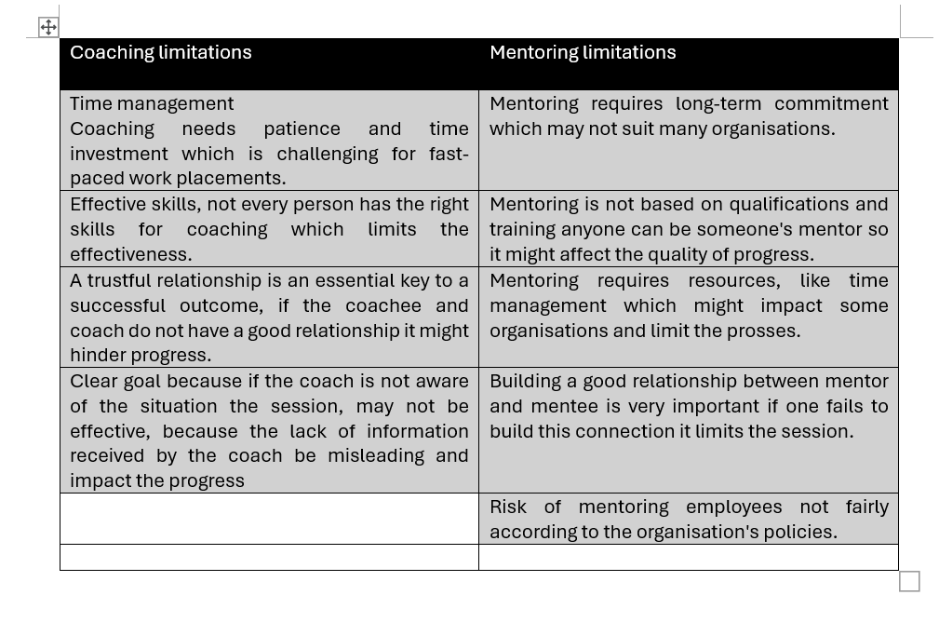
Figure 3 What Are the Disadvantages Of Coaching and Mentoring?
Source: (Lopez, 2022)

Many literature debates that coaching and mentoring are the same approaches with different names. However, it is outlined that coaching focuses on short-term specific goals while mentoring is a supportive connection for long-term tasks with broader viewpoints. Theories and models are introduced by literature to support their guidance and coaching such as the MMM model, GROW model, SMART model, and RAW model.
The report focuses on one of these effective coaching theories the GROW model framework, which can be applied in various settings. This framework promotes adaptability in establishing coaching cultures. When this culture becomes the standard, it enables people to work and live together more harmoniously and productively, for instance, The GROW model can be used in a team or group setting to clarify team goals. Group coaching is a powerful way to enhance teamwork, initiate team motivation towards common goals, and improve morale. It helps to get everyone on the same page, define roles, and establish personal responsibility towards team goals. It can be utilised by managers to develop employee growth potential. It allows the coachee to take the lead in the conversation and helps the manager better understand the employees’ personal goals (Miller,2020).

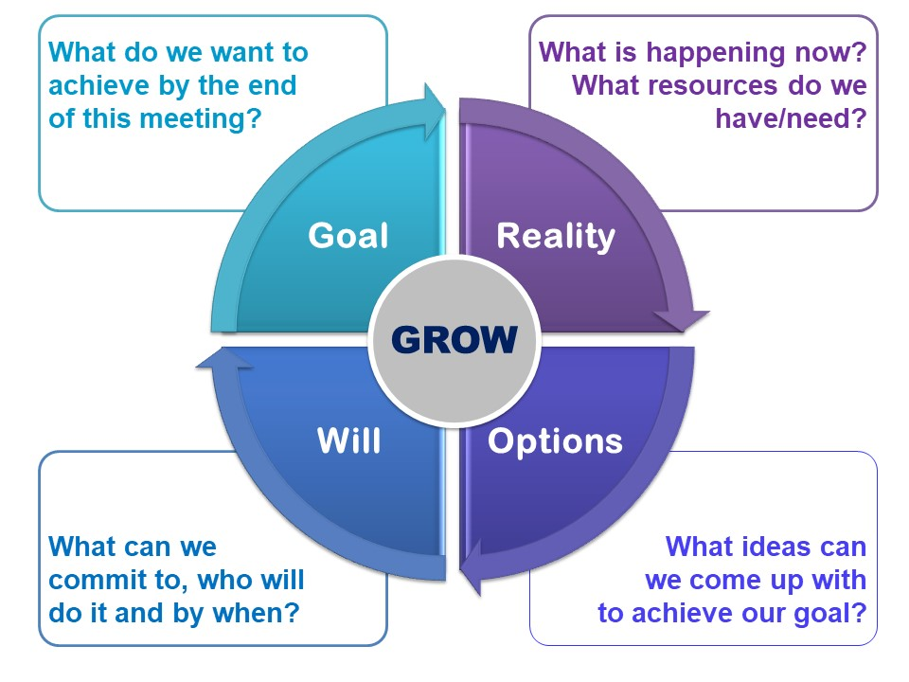
Figure 4 The GROW Model
Source: (Wilson,2020)

The GROW framework for coaching was developed in the 1980s by Sir John Whitmore and his colleagues at Performance Consultants International. In 1988, Whitmore authored the book "Coaching for Performance," which has been widely utilised for decades. He was seeking to develop a more effective approach to leadership in business (Miller,2020).
This theory helps to identify the client's goals and current situation. It suggests the next steps and available options, supporting individuals in progressing by recognising their strengths and weaknesses. This enables them to identify their abilities and the necessary actions to achieve their goals by choosing reliable options.

Advantages and Disadvantages of the GROW Model

Theories and frameworks play a crucial role in the research and explanation of challenges by providing structured models for understanding and addressing complex problems. Effective coaching and mentoring also rely on the use of the right framework. However, there are situations where these frameworks may not successfully achieve the intended goal. It is important to note that their application has both advantages and disadvantages. Alexander (2006) explained in his article that in the GROW model, the first step for coaching effectiveness is to build rapport and identify the topic the client wants to discuss. Sometimes, gaining a deep insight is necessary to achieve this.

The second step is for the coach to focus on reality and delve into the topic to gather more information while avoiding making judgments and assumptions. Clarifying the truth of the topic allows the coach to search for the availability of the correct options. Sometimes, a coach does not need to offer new options; instead, they can help bring out previous thoughts and encourage the coachee to consider if those thoughts are useful for achieving their goals. At the end of the session, the coach plans an action to help the coachee start working towards their goals. It is important to build a trustworthy connection and ask about available support, as well as any obstacles or barriers that need to be overcome. This model is very successful in organisations. Coaches and leaders value the GROW model because of its flexibility and successful results. It engages employees and managers to inspire great performance for instance, GOOGLE utilises the GROW model for coaching employees to increase productivity and build strong relationships.
However, the GROW model has pros and cons, some of which are mentioned in the report.

3.1 Advantages of the GROW model

It allows the coachee to take responsibility because coaching guides individuals in uncovering what is effective and what requires adjustment, fostering a greater level of self-awareness and accountability. Ultimately, this approach encourages individuals to take responsibility for implementing the actions they have determined for themselves. A proficient coach empowers individuals to develop the confidence and skills needed to address their challenges (Admin, 2022).

It improves engagement across teams and organisations. Coaching can have a transformative effect on entire organisations. By helping teams implement their solutions, employees are more engaged and by fostering a culture of coaching, focus on more strategic activities. Ultimately, everyone achieves more through self-directed learning and self-discovery, which in turn unlocks abilities and potential.
The GROW framework can be incorporated into various contexts such as conversations, video calls, meetings, and everyday leadership scenarios. Its application does not necessitate the allocation of specific time, sessions, or designated locations.

3.2 Disadvantages and Limitations of the GROW model

Goals need to be realistic because sometimes, the person being coached may have overly ambitious goals that they believe are attainable, when in fact they are not realistic. The GROW model's limitation when it comes to setting goals is that both the coach and the person being coached need to ensure that the goals set are realistic.
If the person being coached is uninterested, the GROW framework will not be effective because many employees lack motivation and interest during training and brainstorming sessions, making the entire exercise useless.
The last part of the GROW model involves establishing the will to get things done. Some people might skip this part, especially those who lack the interest and motivation to take action. In certain situations, people might refrain from taking action to uphold the current state of affairs and oversee organisational matters, even when it is not the most efficient course of action (Admin, 2022).

Reflection

4.1 Reflecting on the Coaching Session

Reflection is invaluable for learning and growth. Employing Gibbs's reflective cycle framework, I am contemplating my coaching session to extract insights and enhance my practice by learning from my mistakes. This framework was introduced by Graham Gibbs in 1988 to give a better structure to learn from past experiences (University of Cumbria, 2020).

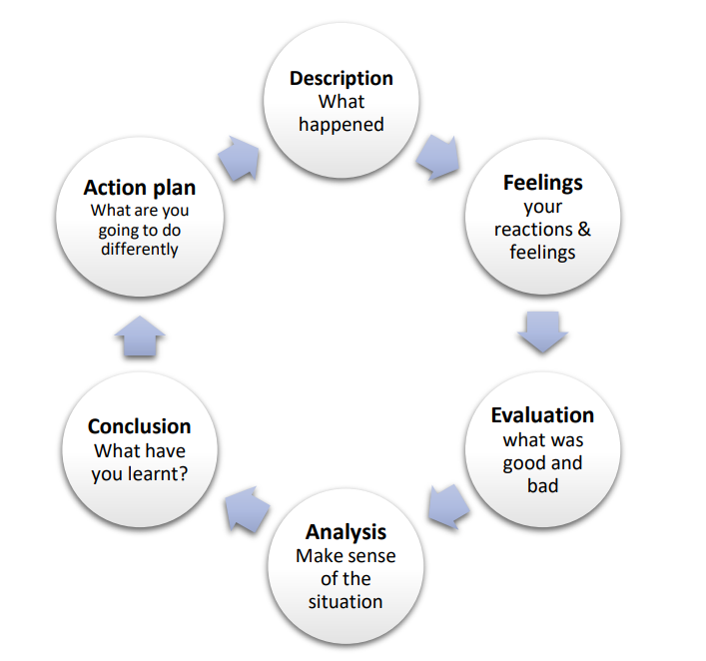

Figure 5 Gibbs's Reflective Cycle
Source: (University of Cumbria, 2020)

The six sections of this structure offer a brief analysis of past experiences. I am examining each section to analyse my coaching session and assess the session's outcome.
Description
One of my assignments for coaching and mentoring skills for the workplace model was to organise a coaching session with my classmate and present in front of the lecturer in the class. This involves a five-minute question and answer session followed by finalising with one clear action. The session required one to choose one of the four coaching and mentoring models given in the assignment brief.
- SMART
- MMM
- RAW
- Grow
I have chosen the GROW model with my classmate to structure my questions and offer one action for the next session.
Feelings
I was very excited about this assignment because it was a very clear and understandable task.
I felt like I was in a real scenario where I was coaching someone who needed my advice and guidance. However, the time limit was my only concern, and I tried my best to finish my task during a certain time.
Evaluation
The session was successful, and I received positive feedback. However, my lecturer suggested that I should have utilised the MMM model and included a specific action item for the next session. Although I managed the time well, I hurried through my questions and the conclusion to prevent any confusion. My friend answered my questions within the time limit, but I wish we had more time so I could delve into more detailed questions and conclude the session more comprehensively.
Analysis
As previously noted, I realise that I should have utilised the MMM model instead of the GROW model based on the feedback received. The MMM model is simpler to use. However, I ended up using the GROW model as I found more comprehensive materials to formulate my questions and to incorporate into my report.
Conclusion
This was a truly delightful experience. I gained insight into coaching knowledge and honed my time management skills. With more practice with my friend, the experience could have been even better. Moving forward, I recognised the need to improve my time management and focus on formulating a specific action plan for the coachee in the conclusion. Furthermore, I aim to deepen my understanding of coaching models to ensure that I can deliver sessions with more positive feedback in the future.
Action plan
In the future, I plan to have more practice sessions. So, I aim to thoroughly discuss each point with my partner to ensure clarity and manageability. I also intend to consult with my lecturer regarding the selection of theories to receive better feedback. According to Britton and Tesser (1991), time management skills are crucial for perfect practice, so I will work on improving time management to avoid rushing. This will involve practising within a specific time frame.

4.2 Reflection on the Mentoring Session

As I have explained in the previous reflection section, reflecting on the experience is the best way of learning and development. There are frameworks available to utilise for reflection and to gain valuable insight from the outcomes. I am reapplying the Gibbs reflective cycle for my reflection on the mentoring session to outline my experience from describing the situation and finalising it to the action plan for the next time.
The Gibbs reflective cycle has six sections to analyse the situation effectively by describing each pillar and portraying an action plan (University of Cumbria, 2020).

Description
My second assignment for Model (6105) coaching and mentoring skills for the workplace was structured as a ten-minute mentoring session for the same two people to ask questions related to the previous coaching session. It was a five-minute session per person to continue with the same goal outlined in the coaching session in the first assignment. I had the same classmate for a mentoring session. The session aimed to use the JOHARI window framework as a tool for asking questions and addressing a new step to achieve their goals.
The JOHARI window is the framework that can be used to encourage individuals to seek feedback and improve self-awareness and also understanding of others (Oliver and Duncan,2019).
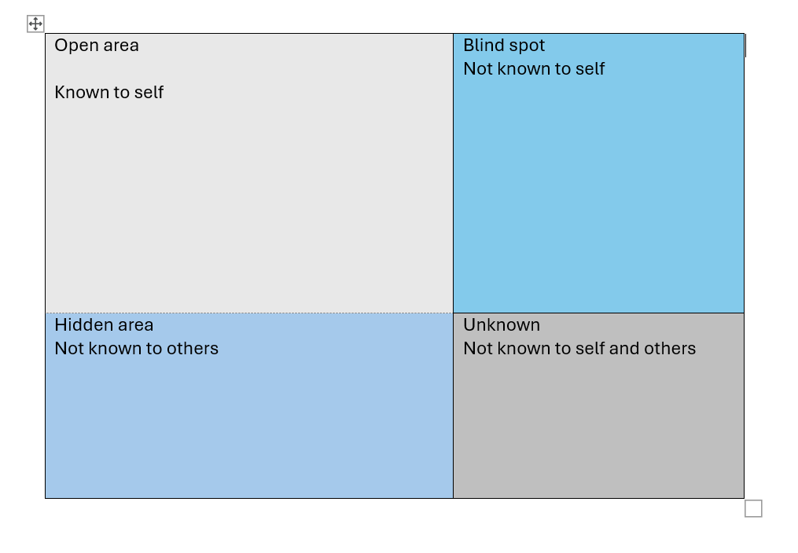
Figure 6 Looking Through the JOHARI Window
Source: (Oliver and Duncan,2019)

My aim for the mentoring session was to minimise the blind spot and enlarge the open area so my mentee could know something about her that she did not realise before.

Feelings
I think this is my favourite module because I enjoyed coaching and mentoring sessions. When I was preparing the questions, I went through different YouTube videos to expand my knowledge about these sessions. I felt very excited and professional during this session because it was different from other presentations I had in my previous assignments.
Evaluation
The mentoring session went very great. I have managed very well to ask my question in available time. I did not rush this time. I received good feedback, as the lecturer was impressed, and he mentioned that this session was better than the last session and we improved.

Analysis
The session was great the only thing that could be more helpful was more understanding of the JOHARI window. Because during the lessons we did not have much information or maybe activities related to the JOHARI window. When me and my classmate were arranging the questions for the session. We both had confusion about how to apply this framework considering the four areas and then connecting it back to the coaching sessions' action plan.
Conclusion

As I already expressed my feelings about this model it was one of my favourite models. I have learnt professionalism, teamwork and how to reflect on feedback. Learning about the JOHARI window was the interesting part because it taught me about the four areas that I have around me and how to decrease one to improve my self-awareness by asking for feedback.

Action plan
To improve my knowledge about the JOHARI window I plan to read more about this framework because I feel that knowing more about myself and the people around me will empower me to improve what I have and to choose the right things in future.

References

- Admin, S. (2022). GROW Coaching Model Pros and Cons. [online] upskillst pro. Available at: https://www.upskillist.pro/blog/grow-coaching-model-pros-and-cons [Accessed 12 Jun. 2024].
- Alexander, G., (2006). THE GROW COACHING MODEL EXPLAINED. Excellence in Coaching: The Industry Guide, p.61.
- Bresser, F. and Wilson, C., (2010). What is coaching? Excellence in coaching: The industry guide, 2, pp.9-20.
- Britton, B.K. and Tesser, A., 1991. Effects of time-management practices on college grades. Journal of Educational Psychology, 83(3), p.405.Effects of time-management practices on college grades. Journal of Educational Psychology, 83(3), p.405.
- ‌Connor, M. and Pokora, J., (2017). Coaching and mentoring at work: Developing effective practice: Developing effective practice. McGraw-Hill Education (UK).
- Cranwell-Ward, J., Bossons, P., Gover, S., Cranwell-Ward, J., Bossons, P. and Gover, S., (2004). What is Mentoring? (pp. 26-44). Palgrave Macmillan UK.
- ‌Factorial (2020) The Benefits of Coaching in the Workplace (with examples) - Factorial, Factorial Blog. Available at: https://factorialhr.com/blog/coaching-in-the-workplace/.
- Hasa (2016) Difference Between Coaching and Mentoring, Pediaa.com. Available at: https://pediaa.com/difference-between-coaching-and-mentoring/.
- Lopez, T. (2022) What are the disadvantages of coaching and mentoring, Bliss Tulle. Bliss Tulle. Available at: https://blisstulle.com/what-are-the-disadvantages-of-coaching-and-mentoring/ (Accessed: 16 July 2024).
- ‌Miles, M. (2022) 9 Coaching Skills Every Effective Leader Needs, www.betterup.com. Available at: https://www.betterup.com/blog/coaching-skills.
- Miller, K. (2020). What is the GROW Coaching Model? [online] PositivePsychology.com. Available at: https://positivepsychology.com/grow-coaching-model/#grow [Accessed 8 Jun. 2024].
- Oliver, S. and Duncan, S., (2019). Looking through the Johari window. Research for All, 3(1).
- Stelter, R., (2007). Coaching: A process of personal and social meaning-making. International Coaching Psychology Review, 2(2), pp.191-201.
- ‌University of Cumbria (2020). Gibbs’ reflective cycle. [online] University of Cumbria, University of Cumbria, pp.1–4. Available at: https://my.cumbria.ac.uk/media/MyCumbria/Documents/ReflectiveCycleGibbs.pdf.
- Wales, S., (2002). Why coaching? Journal of change management, 3(3), pp.275-282.
- Wilson, C. (2020). The GROW model. [online] Culture at Work. Available at: https://www.coachingcultureatwork.com/the-grow-model/ [Accessed 8 Jun. 2024].

