E-PORTOFOLIO REPORT

Evidence-Based Policing BMPL4001

Dumitru Vasile Gomoescu
Student number:2223227

Evidence-Based Policing and Decision Making
Table of Contents
Introduction 4
Main Body 5
Conclusion 9
References 10
Appendices 11

Introduction
The essay will outline the key theories of classical criminology, provide insights about models of evidence based policing and portray a real life implementation of chosen model. The essay will also evaluate the strategies as well as weakness of the “evidence based policing” and classical approach to criminology.

Main Body
According to classical theories, an individual indulges in a criminal activity and breaks the law with rational free thinking even after knowing the repercussions of their actions. In response to these actions, the classical theory of crime proposes that the society has to be proactive in enforcing punishments that fit the crime. The theories help in understanding as well as explaining the reasons behind any crime that is being committed. The Neoclassical theory defines crime as an action that is influenced by opportunities. The school of thoughts belonging to the neoclassical concept of crime has presented criminal behaviours as the direct consequence of circumstance that an individual has to face in a society (Hughes, 2022). It also proposes that crimes are committed with rational thinking and places crime outside the societal framework. According to rational choice theory criminal activity is seen as the result of a “rational decision making” process where the consequence and benefit that is associated with crime is consciously weighed by the criminal. A criminal indulging in a crime aims to participate in the activity if the benefits associated with the crime are greater than the costs involved (Gottfredson and Hirschi, 2022). The deterrence theory also has its roots with the classical theory and its proponents believe that people choose to adhere to the law or violate it based on the conscious calculation of the gains and consequences involved with the actions.
From a legal perspective, crimes are usually defined as the acts that are forbidden by the law which can bear punishments through imprisonments or fines. However, the criminologist’s theorists have come to the conclusion that for understanding crimes it is important to focus on the attributes that drive criminal behaviours rather than specific acts. The structural functionalism concepts have argued that deviant behaviours helps society to demarcate between acceptable and non-acceptable behaviours that affirm the cultural values and norms. The functionalist views have explained that crimes are the result of social structures and its presence is beneficial to society (Draca et al., 2019). Crime has often been seen as a direct opposite of altruism where the actions are broadly related with the individual’s motive of obtaining the resources of others through unethical means.
The conflict theorists have viewed deviant behaviours as being the direct consequence of material inequality that exists between the socio-economic groups. Criminality is often related with the behavioural definitions of crime and seen as a personality profile. Criminality has been viewed as a strategic behaviour of individuals that is often characterised by indifference to the sufferings of others, lower self-control and egoists thinking of self centeredness (Sen, 2019). The criminal behaviours are the products of systematic processes where there is direct involvement of the complex interaction in between the individual, societal as well as ecological factors. The ecological factors of crime involve the interactions that an individual has in a physical environment. The factors such as crowding, recreational opportunities, crowding, and geography affects the physical and emotional development of the people which affects the opportunities of crime. Societal factors that encompass heterogeneity of culture, beliefs and economic relations also influence criminal activities. However, societal and ecological factors may influence the crime motives but without individual intervention, a crime is not possible. Hence individual factors and motivations remain the central description that results in crime (Burt, 2020).
“Evidence Based Policing” is a contemporary form of criminology where use of rigorous scientific techniques, experiments and systematic reviews of search results are used for policy and decision making. The POP model (“Problem-oriented policing”) has been defined as an approach for tackling the crimes through the process of specific problem identification, analysis, development of responses and assessments of effects in relation to the responses. The model of POP is generally used as a tool for diagnosing or solving crime problems in the areas where there are comparatively higher crime levels known as “Hotpots” (Hinkle et al., 2020). A targeted approach for intervention is an approach in POP and can also be described in the context of the SARA (“Scanning, Analysis, Response and Assessment”) model. SARA models look for identifying as well as overcoming the root causes of crime by treating the crime symptoms. The scanning phase involves the identification of existing problems and prioritising them according to the risks involved. The analysis phase involves the use of data for analysing the problems that exist in society. Response is the phase where crimes are being addressed, laws are enforced and community partners work in coordination with each other for eliminating the problems in the community. The fourth phase of assessment is the phase where evaluation of the performance is done and POP is followed for revising the areas where more improvements are required (Pollock et al., 2021).
The theory of classical criminology explains that crimes are free will decisions which are made applying the principle of “pain and pleasure” and people involved in crime to maximise the pleasure and reduce the pain. The classical theories have portrayed the idea that inorder to reduce crimes it is important to instil a doubt or fear of the consequences through punishments. The underlying principle of all these methods such as POP, SARA and others is based on the idea of increasing the barriers to crime through policy framing and decision making. During the initial development of the POP concept, this model was a very responsive and incident driven policing where success was quite short lived. Instead of overcoming the root causes of the problem, the POP approach was just oriented in treating the symptoms of the crime. However, as highlighted by classical theories, there are various ecological, societal and individual factors that affect the actions of the people and their attitude towards indulging in a criminal action (Kermani and Seyyedzadeh Sani, 2019). Hence it is important to follow an approach that not only checks on regular crime symptoms but defenestrates the root of crime from the ground. Hence, a more comprehensive approach of the POP model was built upon through the use of the SARA model for addressing the problem and crime in the society. The framework follows a step-by-step for crime elimination and tries to reduce crime opportunities or increase crime barriers for effectively reducing the criminal activities.
In order to apply the idea of EBP and classical criminology, a case scenario is taken where a local convenience store wanted police to come and check on the drunks who would come to the store, hang on the sidewalks and indulge in fights. Going to the store and protecting the shop from thugs have become a daily routine for the local police. In this case, the local problem of the community is clearly identified as the store was being overrun by the addicts and responsible citizens were protecting business from the drunks. The local police were proactively showing up every time for driving away the drunks but people were not getting the best service from the local police department. In this case, it can be seen that following the approach of the POP model, although the local police were proactive in their jobs, their success was very short-lived (criminaljusticeknowhow, 2020). The SARA approach would require the local police department to identify the impact of the case very critically. They have to analyse if the consequences of the case were merely a matter of inconvenience to the local people or if there are other consequences such as the health, safety, happiness of community members which are at risk. Then a proper analysis of the problem is carried out where the declining sales records of the involved store, frequency of fights reports, average age of individuals, and socio economic status of the people involved in the society are analysed. In the response stage, the involved perpetrators in the crime who have long histories of arrests regarding trespassing, drug related crime could be arrested with the help of cooperation from the store owner. The police can conduct meetings with the store owners to eliminate the root cause of the inconvenience which is being caused. Then several response plans are created and the one which is most feasible is implemented. The final phase would evaluate the effectiveness of the response plan in getting the intended objective. In this way, a proper strategic framework that would help in taking not just proactive actions but a very broad and effective solution can be approached.
The classical criminology has been successful in reducing the crime rates and providing successful deterrents in controlling crimes. However, the main limitation of classical theories of crime is that it categorises all criminals as rational decision makers, assuming all people are equal and does not categorise accounts of individual dissimilarity (Huggins, 2022). Evidence based policing increases the effectiveness of the actions but the pragmatic application of the scientific investigations is very difficult and it can provide a false sense of security to the community.

Conclusion
The insights that have been provided in the essay comprise a wide range of perspectives regarding classical criminology from a variety of scholars. The essay has been able to explain the topic in a very critical, comprehensive and systematic way.

References
Burt, C.H., 2020. Self-control and crime: beyond Gottfredson & Hirschi's theory. Annual Review of Criminology, 3, pp.43-73.
criminaljusticeknowhow (2020) The S.A.R.A. model, Criminal Justice Know How. Available at: https://criminaljusticeknowhow.com/the-sara-model/ (Accessed: February 13, 2023).
Draca, M., Koutmeridis, T. and Machin, S., 2019. The changing returns to crime: do criminals respond to prices?. The Review of Economic Studies, 86(3), pp.1228-1257.
Gottfredson, M.R. and Hirschi, T., 2022. A general theory of crime. In A General Theory of Crime. Stanford University Press.
Hinkle, J.C., Weisburd, D., Telep, C.W. and Petersen, K., 2020. Problem‐oriented policing for reducing crime and disorder: An updated systematic review and meta‐analysis. Campbell systematic reviews, 16(2), p.e1089.
Huggins, C., 2022. Increasing Content Mastery in Criminology. Greater Faculties: A Review of Teaching and Learning, 3(1), p.6.Hughes, G., 2022. Crime, Violence and Modernity: Connecting Classical and Contemporary Practice in Sociological Criminology. Routledge.
Kermani, S. and Seyyedzadeh Sani, S.M., 2019. The Problem-Oriented Policing and Fear of Crime. Journal of Legal Research, 18(38), pp.79-106.
Pollock, W., Scott, S. and Moore, E., 2021. Using problem-oriented policing to address police problems through the study of body-worn camera footage. The Police Journal, 94(2), pp.166-183.
Sen, S., 2019. Crime and punishment.

Appendices
Appendix No1:
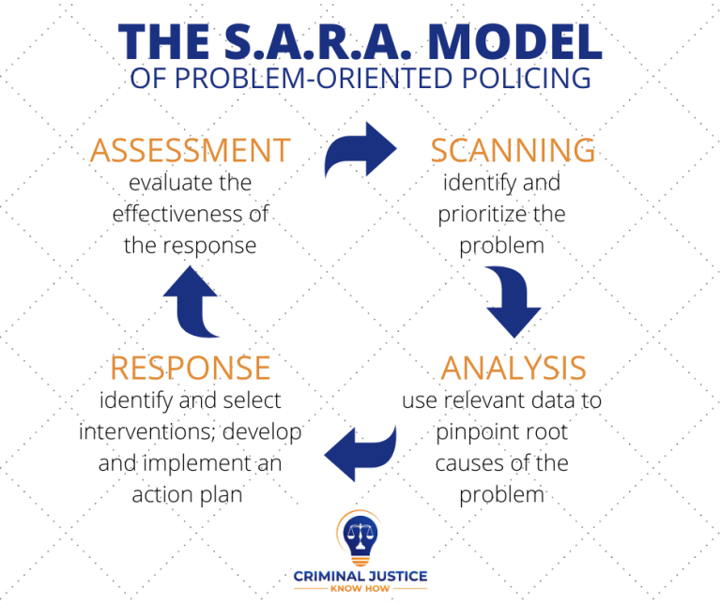
Image No1: “The SARA Model”
(Source: criminaljusticeknowhow, 2020)

