EMPLOYABILITY AND CAREER DEVELOPMENT
Portfolio of Written Tasks

Student Name | Yonatan Eskinder
Student ID | 2509538
Programme | Cert HE Business Skills for the Workplace
Module | Employability and Career Development
Module Code | LCLM4005
Lecturer / Module Lead | Dr Inderjit Grewal – London
Assignment Title | Portfolio of Written Tasks
Word Count | Approximately 1,500 words

Academic sources used in this portfolio: Cottrell (2021), Mullins and Christy (2016), and Northouse (2021). Employer evidence is taken from official Premier Inn/Whitbread and Travelodge career adverts (Whitbread Careers, 2026; Travelodge, 2026).

Task 1 – Select Job Adverts and Identify Key Skills
Figure 1. Job advert evidence – Premier Inn / Whitbread Careers
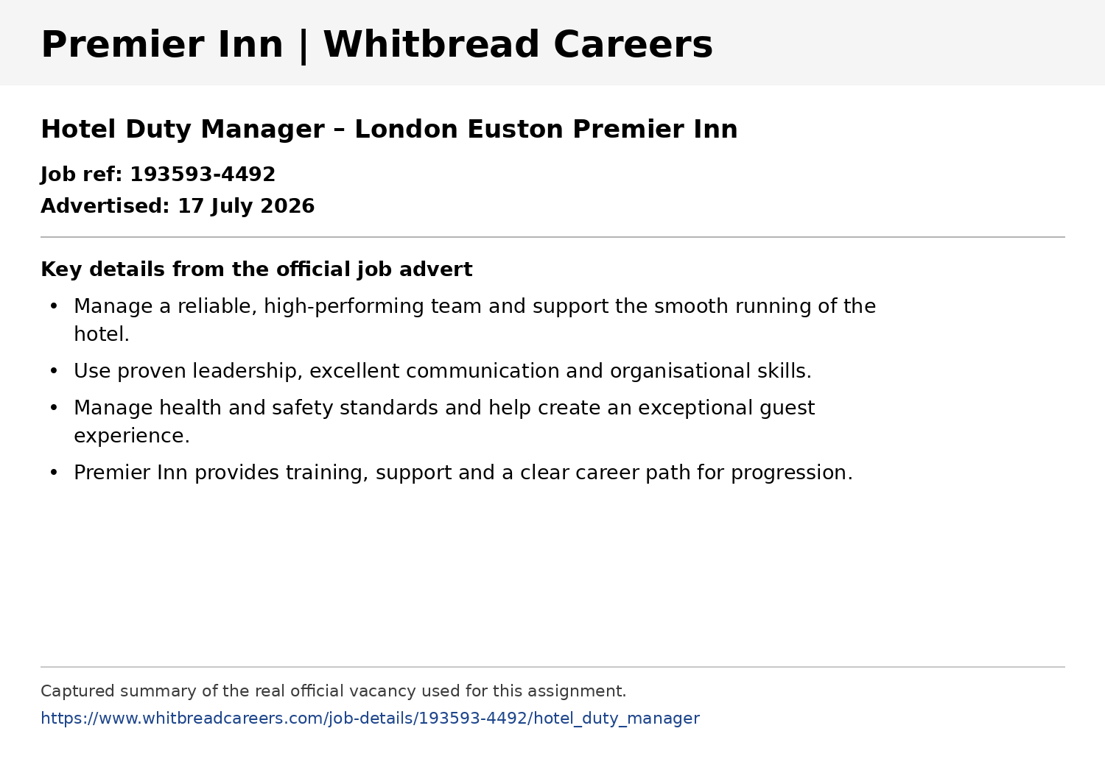
Source: Whitbread Careers (2026), Hotel Duty Manager, London Euston Premier Inn, advertised 17 July 2026. Accessed 13 August 2026.
Figure 2. Job advert evidence – Travelodge Careers
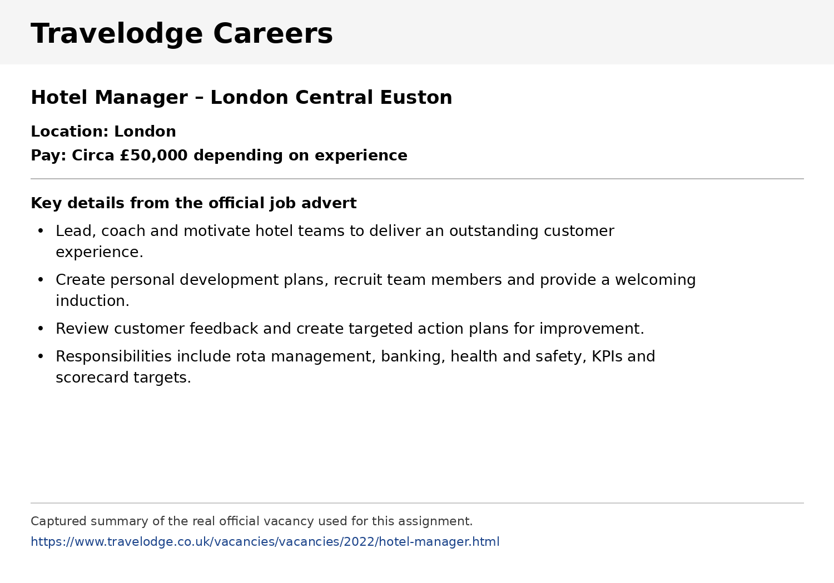
Source: Travelodge (2026), Hotel Manager, London Central Euston. Accessed 13 August 2026.
The two adverts show that hotel management requires both people-management skills and practical operational knowledge. The Premier Inn Duty Manager advert asks for proven leadership, excellent communication and organisational skills, responsibility for health and safety, and the ability to create an exceptional guest experience (Whitbread Careers, 2026). The Travelodge Hotel Manager advert similarly requires leadership, coaching, customer service, communication, rota management, health and safety, and an ability to work towards KPIs and scorecard targets (Travelodge, 2026).
The strongest common skills are leadership, communication, customer service, organisation and problem solving. Both employers expect a manager to guide other employees rather than only complete individual tasks. This supports Northouse’s (2021) view that leadership involves influencing people towards a shared goal. The adverts also show that managers need knowledge of hotel operations, safety procedures, team development and performance. Travelodge places additional emphasis on commercial areas such as KPIs, banking and customer-feedback action plans (Travelodge, 2026).
My present role as a Night Team Leader at Premier Inn gives me evidence of several of these skills. I allocate duties, support colleagues, respond to guest complaints, complete reports, carry out security and fire-safety checks and provide handovers to daytime management. For example, when the hotel is busy or short-staffed, I reorganise tasks according to urgency and support reception while still ensuring safety checks and the night audit are completed. This experience makes the Duty Manager role a realistic next career step.
One key skill I would use in my future role is leadership. As a Duty Manager, I would begin each shift by setting priorities, allocating responsibilities according to team members’ strengths and checking progress. If a guest complaint occurred during a busy check-in period, I could delegate routine tasks to colleagues while I dealt with the more serious issue. This would allow the whole team to contribute, reduce delays and maintain service standards. Mullins and Christy (2016) emphasise that effective management depends on coordinating people and resources, which is directly relevant to this type of hotel role.

Task 2 – Self-Assessment, SWOT Analysis and Evidence of Readiness
A SWOT analysis helps identify internal strengths and weaknesses together with external opportunities and threats. Reflective self-assessment is useful because it turns experience into specific development priorities rather than general intentions (Cottrell, 2021). My SWOT is based on my work as a Night Team Leader, my previous Night Receptionist experience and my current business studies.

Strengths
• Leadership and team supervision – I allocate duties and guide colleagues. Example: when a team member is absent, I redistribute the workload and support the busiest areas myself.
• Customer service – I stay professional and solution-focused. Example: when a guest has a booking problem, I listen, check the reservation and explain the available solution clearly.
• Calm decision-making under pressure – I can prioritise safety, guests and operational duties during busy night shifts.
• Communication and teamwork – I provide detailed handovers and work with reception, housekeeping and maintenance so important information is not lost.
• Health and safety awareness – I complete security patrols, fire-safety procedures and incident reports as part of overnight operations.

Weaknesses / Areas for Development
• Delegation – I sometimes try to solve too many problems myself because I want the work completed correctly. Example: during a busy shift I may take on a task that could be assigned to an experienced colleague.
• Commercial knowledge – I have less experience with hotel KPIs, labour costs, revenue and budgeting than with operational night duties.
• Formal performance conversations – I can support colleagues informally, but I need more confidence giving structured corrective feedback when standards are not met.
• Professional and academic writing – I am improving how I organise management ideas and evidence in a concise academic style.

Opportunities
• Progress internally from Night Team Leader to Duty Manager and later Hotel Manager.
• Shadow experienced Duty Managers and learn how they use occupancy, labour, revenue and guest-feedback information.
• Use my CertHE Business Skills for the Workplace to strengthen business and management knowledge.
• Take part in internal training and volunteer for team briefings, new-starter support and small improvement projects.

Threats
• Competition from applicants who already have Duty Manager or Assistant Hotel Manager experience.
• Staff shortages and high guest expectations can increase pressure in hospitality.
• Balancing university study with night work may reduce the time available for professional development.
• Hotel technology and operating systems change, so continuous learning is necessary.
My strongest evidence of readiness is my progression in hospitality. I moved from Night Receptionist into a Night Team Leader position and now take responsibility for the overnight operation. This includes allocating duties, making operational decisions, resolving guest issues and completing management handovers. For example, on a high-occupancy night I may have late arrivals, guest requests, security checks and the night audit competing for attention. I prioritise guest safety and urgent service needs, delegate suitable tasks and ensure the morning team receives a complete handover. This demonstrates organisation, leadership and decision-making, which are also required in the two adverts (Whitbread Careers, 2026; Travelodge, 2026).
Customer service is another area where I am ready for progression. A difficult guest may be tired or frustrated, particularly when a booking problem occurs late at night. My approach is to remain calm, listen without interrupting, verify the information and communicate what I can do. This demonstrates emotional control and problem solving rather than simply following a routine. It also supports the customer-focused expectations in both job adverts. Mullins and Christy (2016) explain that organisational effectiveness depends heavily on people and behaviour, which is particularly important in a service business where the guest directly experiences employee behaviour.
My communication skills are supported by daily workplace evidence. I communicate with guests, colleagues and managers and provide detailed handovers between night and day shifts. I also work across departments when rooms, maintenance or housekeeping issues affect guests. Academically, studying Business Skills for the Workplace is helping me improve written communication, research, reflection and understanding of management. These academic and workplace experiences together show that I am developing both practical and theoretical readiness for management.
However, my self-assessment also shows why I still need development. Delegation is the clearest example. Earlier in my career I often felt that doing a task myself was the quickest way to guarantee quality. As my responsibilities increased, I realised this can overload the leader and reduce opportunities for colleagues to develop. Northouse (2021) links leadership with influencing and supporting others towards shared objectives. I therefore need to continue moving from 'doing everything myself' towards setting clear expectations, trusting colleagues and checking results.
Commercial awareness is another important gap because the Travelodge advert specifically refers to KPIs, scorecard targets, banking and rota management (Travelodge, 2026). My current experience is stronger in guest service, safety and overnight operations. To become a rounded manager, I need to understand how staffing decisions, occupancy, customer feedback and costs affect hotel performance. I can develop this by shadowing managers, asking to review appropriate performance information and connecting workplace examples with my university learning.
Finally, I need more practice with formal feedback. For example, if a colleague repeatedly fails to complete a required task, a manager must address the issue clearly, fairly and professionally rather than avoiding the conversation or simply completing the task for them. I want to observe experienced managers, learn the correct company procedure and practise giving specific feedback that explains the standard, the gap and the agreed improvement. Cottrell (2021) emphasises that personal development is most effective when areas for improvement are identified and followed by planned action. My SWOT therefore shows both readiness for the next step and clear priorities for further development.

Task 3 – Employment Goals and Personal Development Plan
My short-term goal is to progress from Night Team Leader to Duty Manager within the next 6–12 months. This is important because it builds directly on the leadership, guest-service and operational responsibilities I already perform. My long-term goal is to progress into Hotel Manager level within approximately three to five years, with broader responsibility for people, commercial performance and the overall guest experience. These goals align with the career progression described by both employers and with my aim to build a long-term career in hospitality management (Whitbread Careers, 2026; Travelodge, 2026).
The weaknesses in my SWOT show what I must improve before and after promotion. For example, better delegation will help me lead through other people rather than trying to complete every task myself. Stronger commercial knowledge will help me understand KPIs and make decisions that support the whole hotel. I also need confidence in formal feedback so I can maintain standards while supporting colleagues fairly. Setting measurable actions makes development easier to review (Cottrell, 2021).
Weakness / Goal | Specific action + example | Timeline | Resources needed | How I will measure progress
Delegation | Delegate at least two suitable responsibilities on busy shifts. Example: assign a trained colleague to complete a routine operational task while I handle a guest escalation. | 8 weeks | Duty Manager feedback; shift plans; team support | Weekly reflection and manager feedback showing I delegate clearly and follow up rather than taking tasks back.
Commercial knowledge | Shadow a Duty Manager and learn how occupancy, rota costs, guest feedback and KPIs are reviewed. Example: discuss one weekly performance measure and what action it suggests. | 3 months | Duty/Hotel Manager; internal reports; university materials | I can explain key hotel KPIs and give one example of using performance information in a decision.
Formal feedback | Observe an experienced manager, then practise a structured feedback conversation using a specific behaviour, expected standard and agreed action. | 3 months | Manager coaching; company procedures | Manager confirms I can give clear, respectful and evidence-based feedback.
Career progression | Prepare for and apply for suitable Duty Manager opportunities after reviewing my progress against the two adverts. | 6–12 months | Updated CV; manager mentoring; internal vacancies | Complete readiness review, obtain manager feedback and submit suitable applications.
I will review this plan monthly and keep evidence such as feedback, examples of delegated tasks, notes from shadowing and university feedback. This will allow me to see whether my weaknesses are becoming strengths and whether I am ready to take the next management step (Cottrell, 2021).

Reference List
Cottrell, S. (2021) Skills for Success: Personal Development and Employability. 4th edn. London: Red Globe Press.
Mullins, L.J. and Christy, G. (2016) Management and Organisational Behaviour. 11th edn. Harlow: Pearson.
Northouse, P.G. (2021) Leadership: Theory and Practice. 9th edn. Thousand Oaks, CA: SAGE Publications.
Travelodge (2026) Hotel Manager – London Central Euston. Travelodge Careers. Available at: https://www.travelodge.co.uk/vacancies/vacancies/2022/hotel-manager.html (Accessed: 13 August 2026).
Whitbread Careers (2026) Hotel Duty Manager – London Euston Premier Inn, Job ref. 193593-4492. Available at: https://www.whitbreadcareers.com/job-details/193593-4492/hotel_duty_manager (Accessed: 13 August 2026).

