

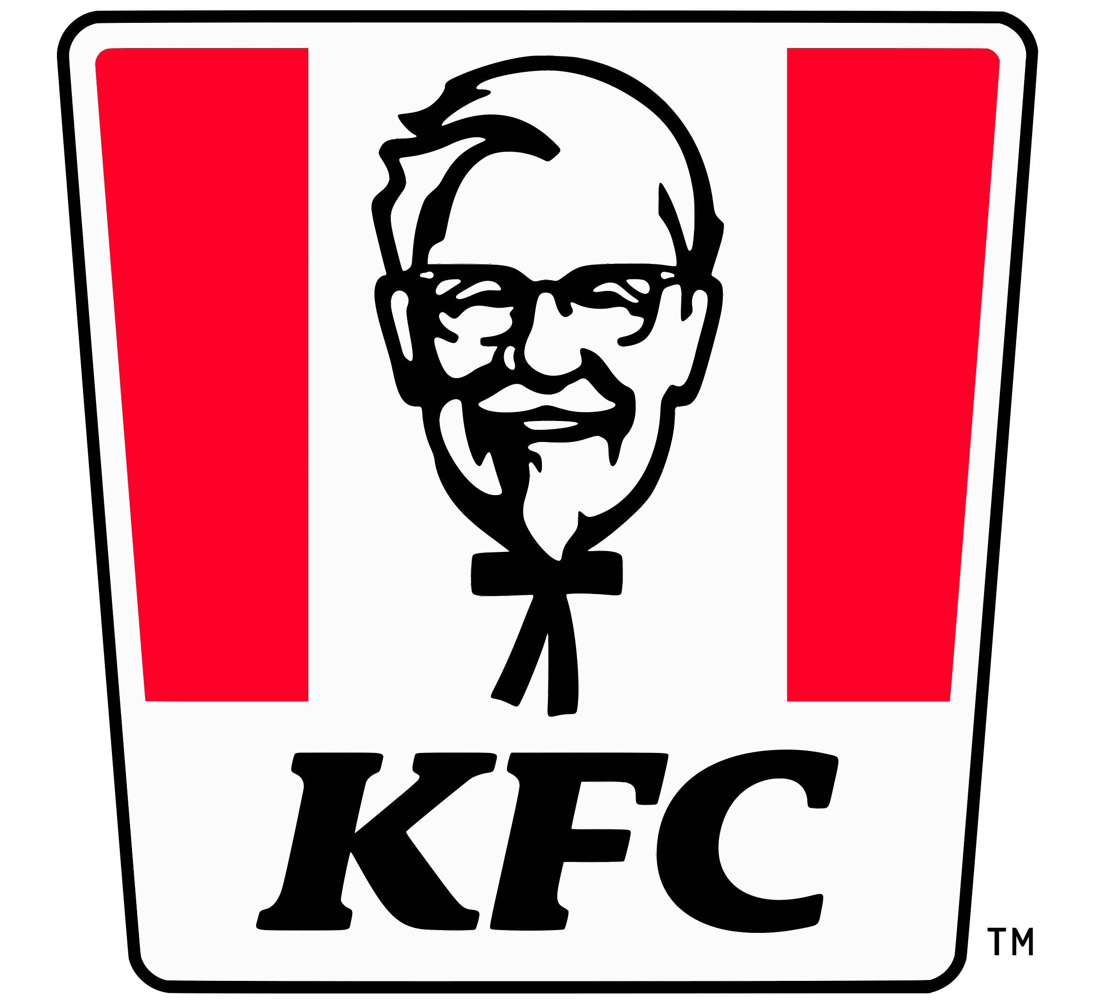
International Management (LCMB7006)

Student name: Alison Faucher
Student Number: 2236800
Lecturer: Tushara Balendran
Word count: 5000 - 6000

Table of Contents
- Introduction 4
1.1 Rationale 4
1.2 KFC Company Background 4
- The Macro Environment – KFC PESTLE Analysis for the UK and Trinidad and Tobago 4
2.1 Political 5
2.2 Economical 6
2.3 Social 7
2.4 Social – Cultural (Hofstede analysis) 8
i. Power Distance 8
ii. Individualism 9
iii. Masculinity 9
iv. Uncertainty Avoidance 10
v. Long Term Orientation 10
vi. Indulgence 11
2.5 Technical 11
2.6 Legal 12
2.7 Environmental 13
- Porter’s 5 Forces 14
3.1 Threat of New Entrants 15
3.2 Bargaining Power of Buyers 16
3.3 Threat of Substitutions 16
3.4 Bargaining Power of Suppliers 17
3.5 Rivalry Among Existing Competitors 17
- SWAT Analysis Of KFC 18
4.1 Strengths 19
4.2 Weakness 19
4.3 Opportunities 20
4.4 Threats 20
- STP Analysis (Segmentation, Targeting and Positioning) 21
5.1 Segmentation 22
5.2 Targeting 23
5.3 Position 23
- KFC Perceptual Map 24
- Marketing Mix Elements (7Ps) 24
7.1 Product (or Service) 25
7.2 Price 26
7.3 Promotion 26
7.4 Place 27
7.5 People 28
7.6 Packaging 28
7.7 Process/Physical Evidence 29
- Ansoff Matrix 30
8.1 Market Penetration 30
8.2 Product Development 31
8.3 Market Development 31
8.4 Diversification 32
- Recommendation 32
- Conclusion 32
- References 33
- Appendix 40

Introduction

1.1 Rationale
This report will detail how the international organisation Yum Brands, trading in differing continents, approaches their use of marketing for its KFC brand and its associated products. It will concentrate on how the marketing for each country is approached and the factors that influence their decision-making process and results.

1.2 KFC Company Background
Harland Sanders, born in Henryville Indiana, bought a roadside motel in Corbin, Kentucky when he was 40, where he began to serve his fried chicken to his guests. Nine years later he perfected his famous 11 herbs and spices recipe for his fired chicken that is still in use today.

In 1952, KFC opened their first Kentucky Fried Chicken franchise near Salt Lake City in Utah. Four years later, after selling his motel in Corbin, Harland Sanders travelled the USA creating additional franchises and increasing the awareness and visibility of his brand and products.

At the age of 74, Harland Sanders wanted to reduce his Level of work, as he was getting older with over 600 stores, he found it was getting overwhelming to manage, which resulted in him selling his interest in his company to investors for approximately $2m. He was kept on as the face of the company and his likeness can still be seen on products today. (KFC, 2023)

The Macro Environment – KFC PESTLE Analysis for the UK and Trinidad and Tobago
The idea behind the PESTLE Analysis was initially introduced by Frank Aguilar, a Harvard Business School professor. He released a book Scanning the Business Environment in 1967 that analysed the external factors that he believed would affect organisations and businesses. He concentrated on the Economic, Technical, Political and Social subject areas, which was known as ETPS. This analysis evolved from these original areas to include additional subject areas to what we know today as PESTLE; formed of Political, Economic, Social, Technological, Legal and Environmental. It is a popular analytical tool applied to investigate and examine the external factors that can, and do, effect a company, or business and is useful to gain an insight and inform the strategic decisions made by senior management. (Frue, 2017)
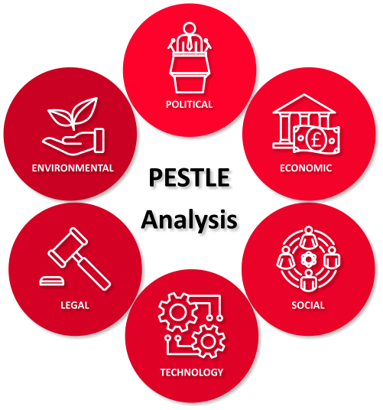
(Source created by learner, 2023)

2.1 Political
UK
KFC Changed its name from Kentucky Fried Chicken to KFC to distance itself from the unhealthy association to the word ‘Fried’.
KFC faced backlash after Niko Omilana released the video ‘The Behind the Bucket’ on YouTube, which documented their visit to a farm that sold chickens to KFC. Another documentary filmed by VFC, also uploaded onto their YouTube Channel, VFC, detailed the conditions of the chickens and their environment on the farm operated by meat company Moy Park, one of Europe’s leading poultry producers which prompted an investigation into the treatment of the animals. (The Guardian, 2022) In 2019 KFC Back in 2019 signed the Better Chicken Commitment and is calling on other companies to also sign up and is committed to work with NGO partners and suppliers. (KFC, 2023)
The Political factors for the UK have been both favourable and unfavourable for the following reasons:-
Favourable
In a world where people are becoming more conscious of what they consume, and with the connotation that the word Fried can conjure in the subconscious, the choice to move to the anacronym of KFC is a positive strategic move.

Unfavourable
The release of the YouTube videos detailing the documentary creators point of views and beliefs on the conditions that chickens are kept, prior to being sold as products on the menu of KFC, does have a negative impact on those that would have come into contact with it. Although the initial impact has been short lived, customers do know that KFC does have some attachments with the highlighted undesirable practices surrounding the rearing and storage of the chickens used in their products.

Trinidad and Tobago
Trinidad and Tobago has an ongoing trade agreement with The USA, its largest trading partner, the parent country of KFC, which allows KFC to operate their 60 restaurants in the country, including its first opening in 1973, a joint venture with Jaycees incorporated and Prestige Holdings Limited (PHL) in St. James. (KFC, 2023)
Favourable
KFC’s trade in Trinidad and Tobago has led it to become the top fast food restaurant chain with 60 restaurants in the country and successfully contributes to the country’s economy.

2.2 Economical
UK
KFC is one of the largest and popular fast food restaurants in the UK, (Statista, 2023) and as such contributes to the UK economy by employing local people and using locally sourced products from local suppliers (KFC, 2023).

Trinidad and Tobago
Trinidad and Tobago has a stable government in its 2nd term, which saw them through the Global COVID19 pandemic, and has a bilateral trading agreement in situ with the U.S., which saw in 2022, exports of $5.4 billion to the U.S. and imports $3.5 billion from the U.S. (U.S. Government, 2023) and with it 60 restaurants country wide with the late opening times, KFC has contributed to economic growth.
Favourable
KFC has been successfully trading in Trinidad and Tobago for 50 years and has successfully contributed to the country’s economy through the hiring of their staff with local population and selling their products to the nationals and tourists alike.

2.3 Social
UK
KFC is one of the leading fast food companies in the U.K. and is seen mainly as a take away restaurant, serving primarily chicken-based products including their barging buckets aimed at groups and families dining together. During the local and national implementation of the government lockdowns, due to the Global COVID19 Pandemic, KFC was among the essential companies, as it is in the food industry, was allowed to open which saw many customers ordering via a Drive-Thru, Mobile Ordering, and Delivery via the KFC app, among other food delivery apps during and up to their late night and in some cases 24hr opening times. (KFC, 2021)
Favourable
KFC’s bargain bucket products, aimed at the more familial and friendship social grouping and their use of Drive-Thru and online ordering with delivery option in addition to late night opening, has increased the ease of ordering their products while socialising.

Trinidad and Tobago
Trinidad and Tobago has access to its own gas and oil reserves and is the largest producer in the Caribbean (Trinidad and Tobago Government, 2023), but it is also very much dependent on tourism, being one of its main sources of income. This was made evident to the population during the countries lockdowns following the global outbreak of COVID19.
KFC opened it’s 60th franchise with are all situated in the tourist areas (KFC, 2023) throughout the country. Due to the tourist transient populations high recognition of the globally popular KFC brand, these areas therefor generate a higher income, with the global brand of KFC having a high Brand Recognition among the main group of tourists coming from the UK and USA.
As part of KFC’s 50th-anniversary celebrating their trading in Trinidad and Tobago, they donated $250,000 towards 50 tertiary-level bursaries for 25 deserving students. KFC wanted to give back to their customers and devised their bursary, aptly named the KFC Bucket Bursary, as a thank you to Trinbagonians for permitting their brand to be part of their lives since 1973. 25 students enrolled at the University of Trinidad and Tobago, were awarded the bursaries (Yum Brands, 2023) (Loop News, 2023)
Favourable
KFC is seen as a very popular fast food restaurant in Trinidad and Tobago with a highly recognisable brand internationally. As such its online presence is aimed at the more social aspect of eating with family and friends at home with delivery, or in store.
With their positive recognition of their loyal customers since they first started trading in 1973, KFC recognised the contribution their customers made to their success and created their own branded Bucket Bursary, for 25 university students.

2.4 Social – Cultural (Hofstede analysis)
Comparison of the UK against Trinidad & Tobago
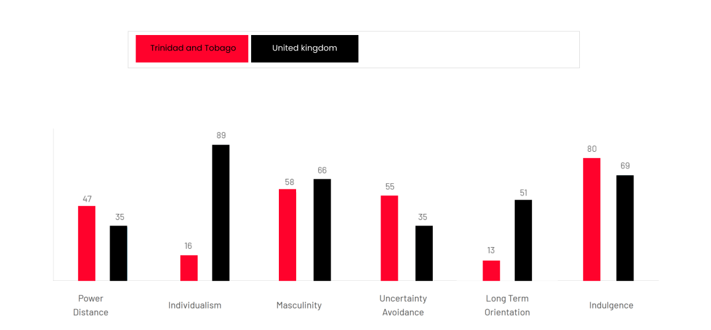
The Hofstede Cultural Analysis originated from the research of Geert Hofstede, who made claim that he had successfully uncovered the secrets of entire national cultures with the use of his analytical framework. He stated that he had successfully identified the main dimensions that pertain to the national culture of countries that are hierarchically ordered. The 6 areas that he believed that would demonstrate his country analysis are Power Distance, Individualism, Masculinity, Uncertainty Avoidance, Long Term Orientation and Indulgence. These however have been said to have been based on his biased views so may not be wholly accurate and also does not take into account the unmeasurable (McSweeney, 2002), as the altering economic and cultural landscape provided by forced migration such as wars.
Hofstede Analysis Comparison of the UK against Trinidad & Tobago

(hofstede insights, 2023)

i. Power Distance
UK
The UK‘s PDI (Power Distance Index) is 35, which is in the lower rankings. They are noted as being more factual with the societal belief, leaning to unequal balance between groups expressed within the cultural viewpoint depicting the inequalities.
Power Distance is defined as the level each individual and withing groupings require and accept that the distribution of power will be dispensed unequally, with the UK believing that this should be minimised. (hofstede insights, 2023)
Trinidad & Tobago
Trinidad and Tobago scores of 47, which is quite low in signifying that the aspects of the style: Being independent, hierarchy for convenience only, equal rights, superiors accessible, coaching leader, management facilitates and empowers are not relatively important.
Power is based on the experience of team members, and the employees need to be kept updated, with control being disliked while an informal attitude towards managers is undertaken with the use of their name and the communication between them is seen as direct and interactive. (hofstede insights, 2023)

ii. Individualism
UK
With a score of 89 the UK ranks within the highest level alongside other countries such as the US and Australia, which symbolises that the general UK population are highly individual and value their privacy. This is taught from an early age and throughout life to aim for their happiness via fulfilling their needs. (hofstede insights, 2023)
Trinidad and Tobago
Trinidad and Tobago ranks at 16 on the individualism spectrum, meaning that as a people they are, unlike the UK, more close-nit community where family and community at large is very important and influences the societal outlook that permeates at all levels and the individual misdeeds can be seen as a much larger offence reflecting on their family, friends and local community groups. (hofstede insights, 2023)

iii. Masculinity
UK
With a score of 66, the UK is seen as more masculine in nature and is generally more driven with goal aspiration and success oriented. The Scandinavian countries score on a more feminine level with Sweden scoring 5 and Denmark scoring 16 with the UK having a more pragmatic view to work where you live in order to work and in doing so gain an understanding that is performance ambition. (hofstede insights, 2023)

Trinidad and Tobago
As Trinidad and Tobago scores 58 they are seen as a more masculine society in nature, which is a view that is shared with the UK, being a more masculine oriented society. They both have the view that you live in order to work attitude that permeates through their society levels where managers are expected to be conclusive and assertive, with importance placed on equity, in all levels where conflicts are resolved through aggressive, decisive methods. (hofstede insights, 2023)

iv. Uncertainty Avoidance
UK
The UK’s score of 35 denotes a level where society has a low uncertainty avoidance tolerance leading to a comfortability not knowing what is ahead and to simply go with whatever happens and proceed with the changeable be it unavoidable or not. This though does not tend to alter their need to follow societal rules such as taking turns, being fair and queuing. They tend to not hold a specific need to be detail driven, but due to a high Masculinity score, the final product will be evident with a more individualised, creative and flexible approach as opposed to a more rigid method. (hofstede insights, 2023)
Trinidad and Tobago
Trinidad and Tobago’s uncertainty avoidance scores is higher than the UK by 20, indicating an intermediate score of 55 which is in the middle, so is neither swayed to being towards uncertainty avoidance or not, as the UK is, or rigidly against it, such as Germany which scored 65 and is more likely to avoid uncertainty in favour of having a clear understanding of what they need to do and knowing will happen in the near or distant future. (hofstede insights, 2023)

v. Long Term Orientation
UK
With a score of 51, the UK’s score is undeterminable due to it neither showing a preference towards or against a long term orientation, unlike Trinidad and Tobago, who has a very low score of 13 and Germany with a high score of 83. (hofstede insights, 2023)
Trinidad and Tobago
Trinidad and Tobago scored quite low with 13. This denotes a preference towards having a positive attitude towards the truth with a high regard for their traditions. (hofstede insights, 2023)

vi. Indulgence
UK
With a score towards the higher end of 69, it shows UK culture is seen as more indulgent resulting impulsiveness, strong desires and regard for enjoying themselves, having fun, a positive attitude, have a tendency towards optimism and tend to believe that they should be able to spend their money as they see fit. (hofstede insights, 2023)

Trinidad and Tobago
The culture of Trinidad and Tobago is considered as very Indulgent, with an even higher score than the UK’s 69 with one of 80. Society is believed to have a strong willingness to be impulsive and really enjoy their life and have fun as much as possible. They also demonstrate a positive attitude to life in general and be very optimistic with an attitude that they can and should spend money as they would want to. (hofstede insights, 2023)

2.5 Technical
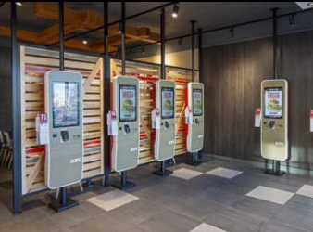
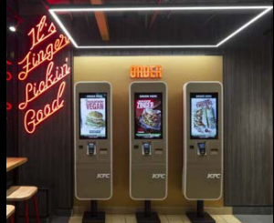
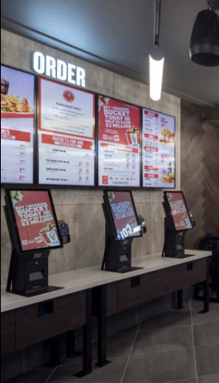
UK
(KFC, 2021)

KFC has introduced the ability for their customers to order their food via 3rd party food apps, such as Just Eat and Deliveroo, in-store ordering terminals, allowing the choice between collection and delivery as well as their Drive-throughs.
Favourable
KFC implementation and embracing of technology has allowed the customer to have alternate methods to purchase their orders, enabling them to have less in the way of delays with the aim of increasing customer satisfaction.
Trinidad and Tobago
Trinidad and Tobago does embrace technology, and being one of the richest countries in the Caribbean (Trinidad and Tobago Government, 2023), has strived to incorporate technology at all levels. KFC has an online order payment facility and also offers home delivery, delivery via its website and KFC app and restaurants with a drive-thru access, which increases their customer base and reach.
Favourable
KFC offers many of the technological opportunities for their customers in Trinidad and Tobago as it does in the UK such as online ordering and drive-thru’s to increase the customer service options and satisfaction.

2.6 Legal
UK
KFC faced backlash after Niko Omilana released the video ‘The Behind the Bucket’ on YouTube, and a documentary filmed by VFC, and they have been accused of misleading their customer their depiction of chicken farming after activists visits. (The Guardian, 2022)
Unfavourable
KFC customer may remember and be influenced by the YouTube documentaries and the visits by animal welfare activists.

Trinidad and Tobago
There was a Change.org petition started by My Lo, from Trinidad and Tobago, for KFC to be declared and essential an Essential Service during the early stages of the lockdown in Trinidad and Tobago. Unfortunately the petition only garnered 60 supporters and was not take seriously by the government (Lo, 2020)
Earlier this year the government published an announcement on their official website denouncing various accusations made via social media that oppose their beliefs and branded them as malicious falsehoods and implore them to cease the unfounded and bias posting. (Trinidad and Tobago Government, 2023)

Favourable
KFC offers many of the technological opportunities for their customers in Trinidad and Tobago as it does in the UK such as online ordering and drive-thru’s to increase the customer service options and satisfaction.

2.7 Environmental
UK
KFC has stated that it is committed to ‘Building Green’ by incorporating a range of environmental, energy and health alternatives that aim to improve their awareness and the utilisation of the requirements needed to focus and build on their 11 must-haves for all of their new build restaurants. (KFC, 2021)
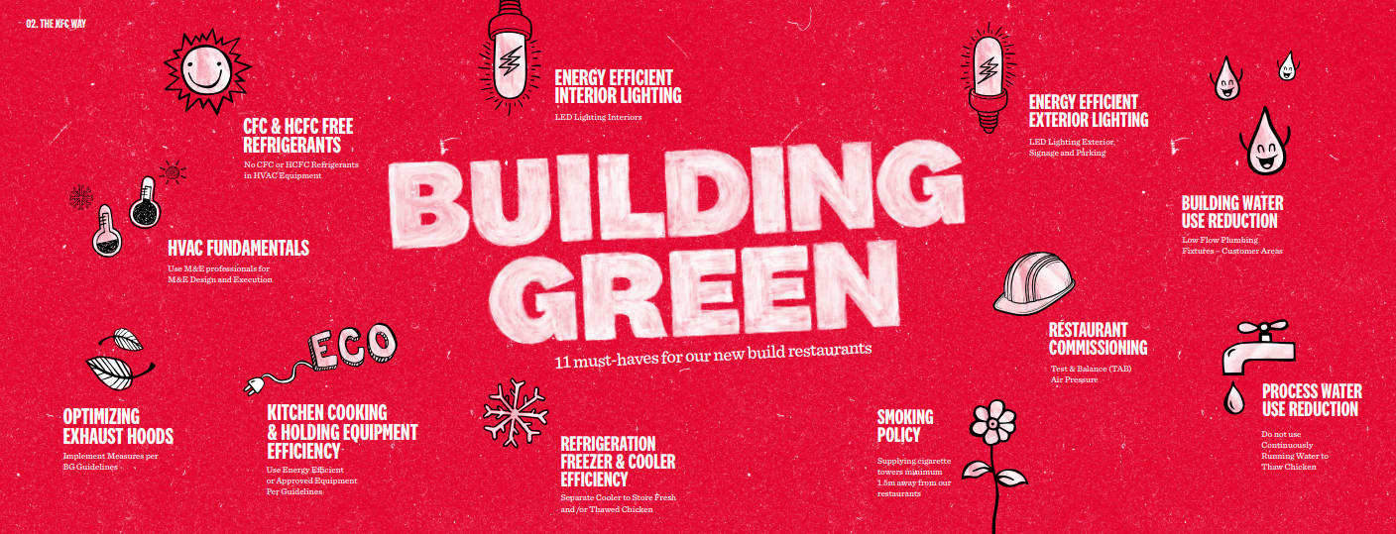
(KFC, 2021)

Favourable
KFC is aiming to become more environmentally aware with their Build Green initiative, for all future new build restaurants.
Trinidad and Tobago
On June 8, 2023, KFC customers we offered complimentary seedlings in a KFC branded cup, with the expectation that their customers would be inspired to become closer to nature and foster a sense of environmental responsibility. This was to coincide with the religious celebration of Corpus Christi with the hopes of inspiring a spiritual renewal and growth. (Loop News, 2023)
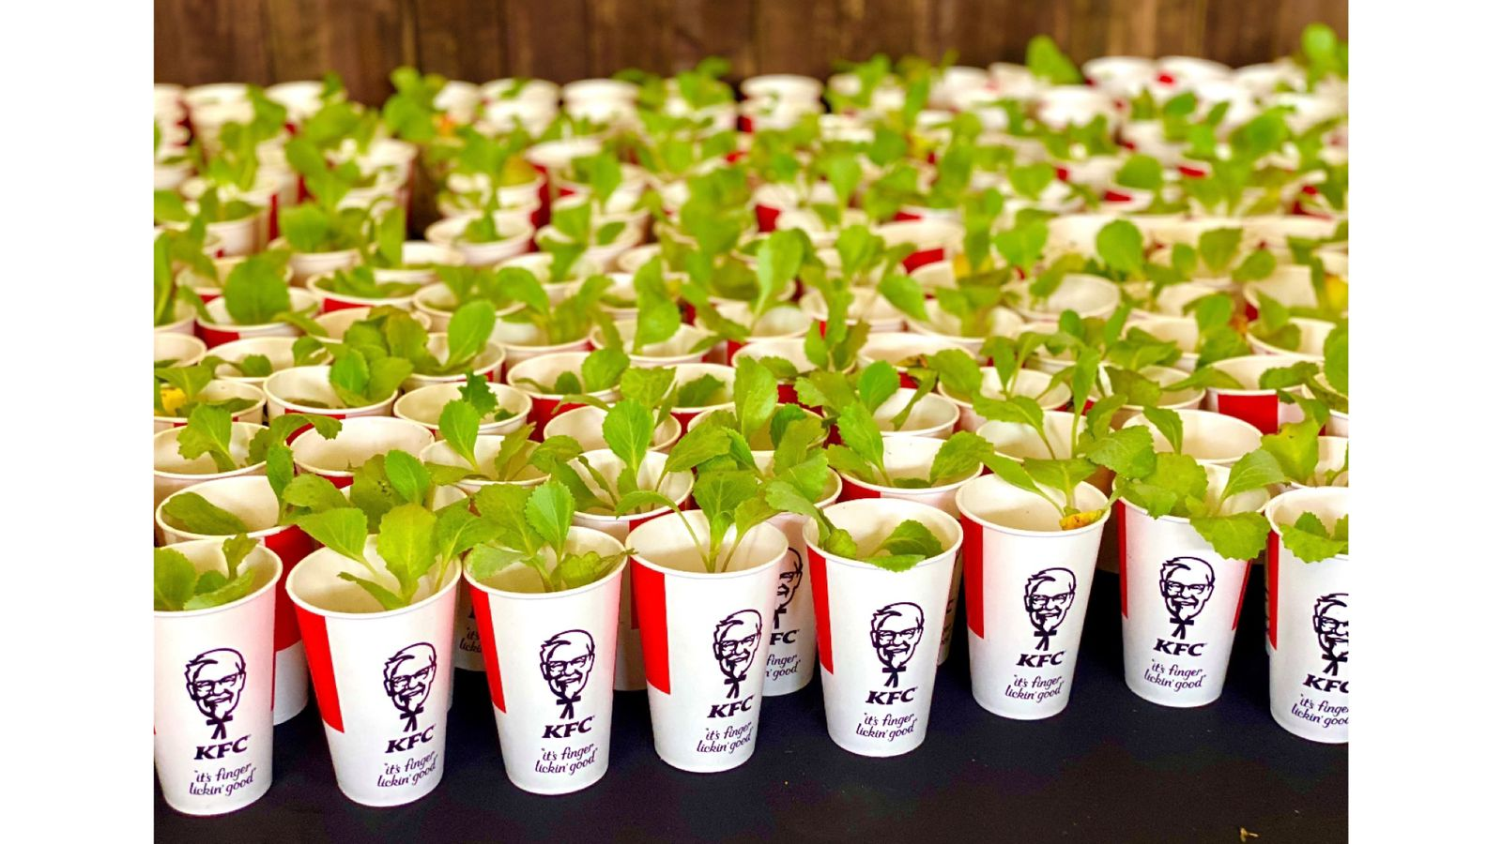

(Loop News, 2023)

Favourable
KFC’s offer of free seedings to their customer was a, a simple way to aid customers to become closer to nature and increase their respect for their environment,

Porter’s 5 Forces
The five forces analysis originated by (Porter, 2008) analysis is utilised to determine the preferable strategies that a company can utilise to identifies both the internal ‘strengths’, ‘weaknesses’ it possess and the external ‘opportunities’ and ‘threats’ that it has. (Gürel and Tat, 2017). Once they are recognised they can be incorporated in a strategic plan with pertinent strategies to reverse any identified ‘weaknesses and threats and increase opportunities and strengths.

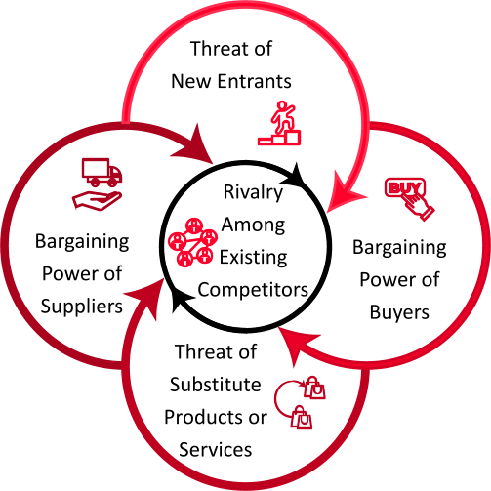
Porters 5 Forces
(Source created by learner, 2023)

3.1 Threat of New Entrants
UK
KFC has many competitors (see appendix 001) and as of the end of 2022 was joint 2nd with Costa on 59% behind Greggs on 67%. According to the research detailed in Statista, there is 7 other competitors between KFC and McDonalds on 53% via for similar customers in the fast food industry, so the threat is low. Although not all of their competitors are offering similar chicken products, they do offer valid competition for similar customers.

Trinidad and Tobago
With 60 restaurants, KFC is the largest fast food chain in Trinidad and Tobago, with McDonalds trailing behind with 4 nationwide (McDonalds, 2021). There are many localised independent and smaller chain national fast food restaurants, such as Subway with 45 restaurants (Subway, 2023) and Burger Kings with 14 restaurants (Burger King, 2023).

3.2 Bargaining Power of Buyers
UK
In the UK KFC’s bargaining power of buyers is medium, as there are many alternatives offering similar products at a much lower price such as Morley’s in London and other national and local fast food restaurants. KFC is the most recognisable fast food chain in the UK that primarily sell chicken-based products and have a loyal customer base, as was seen during the national lockdowns during the global COVID19 pandemic, but if customers can find similar products at a more competitive price they will be swayed and will purchase their chicken-based products from a KFC rival. This is evident from the level of smaller sized chicken chains such as Cottage Chicken and other independent restaurants selling chicken-based products.

Trinidad and Tobago
KFC’s bargaining power of its buyers is medium, as although there are alternatives to KFC products throughout the country, given their internationally recognisable brand and with the 50 years of established trading in 60 location as of 2023, they have a loyal customer base that seem to prefer KFC products, but also have customers that frequent their competitors if they deem the products on offer at a price that is not competitive with their rivals, thus placing the customers bargaining power at medium.

3.3 Threat of Substitutions
UK
In the UK KFC’s threat of substitutes is high, as there are many rivals offering different products such as pizzas from Pizza Hut and sausage rolls and sandwiches from Greggs.

Trinidad and Tobago
KFC’s threat of substitutes in Trinidad and Tobago is high, as there are many alternative products throughout the country such as doubles and dhalpuri from the local vendors.

3.4 Bargaining Power of Suppliers
UK
The bargaining power of suppliers is low, as there are different farm chicken suppliers throughout the UK, but there are only a hand fully of suppliers with KFC (The Guardian, 2022) that are locked into contracts, but many of the products have to

Trinidad and Tobago
KFC’s bargaining power of suppliers is low, as all of the franchise in Trinidad and Tobago are exclusively held by Prestige Holdings since its first franchise in 1973 (Prestige Holdings Limited, 2023) and they dictate which suppliers the franchisee uses.

3.5 Rivalry Among Existing Competitors
UK
The rivalry among competitors is high, as there is a large variety of competitors throughout the UK (see Appendix 001) as well as the local chain and individual fast food restaurants.

Trinidad and Tobago
Similar to the UK, the rivalry among competitors is high, as there is a varied selection of competitors throughout the country catering to both the local and tourist population serving a diverse array of fast food products.

SWAT Analysis Of KFC
The SWOT analysis is an analytical tool utilised to affirm the strengths, weaknesses, opportunities an threats that a company or organisation may face through brainstorming then the results can be incorporated in the final strategic planning process. (Boonyarat Phadermroda, 2019)
SWAT Analysis

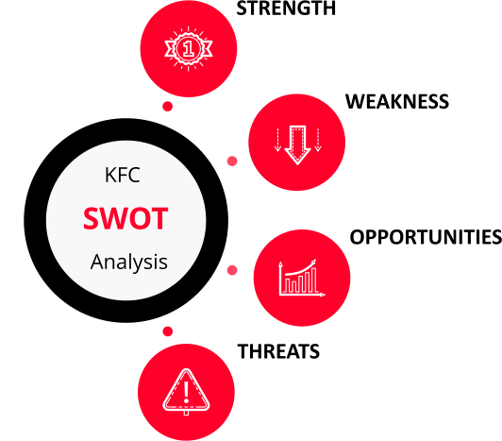
What does KFC, organisation, staff and services do well?
Are there any trends, areas of investment, or growth that KFC can take advantage of and turn into and strength?
What does KFC organisation, staff and services need to improve?

(Source created by learner, 2023)

Strengths
Trinidad and Tobago
KFC is one of the most internationally recognisable fast-food restaurants and is the largest fast food chain, with 60 restaurants in the throughout the country serving chicken based products coated in their famous 11 herbs and spices.
KFC has shown their gratitude to their loyal customers by creating a university bursary for 25 students.

UK
KFC is one of the most recognisable fast-food restaurants in the UK, with 963 restaurants in the UK and Ireland (KFC, 2023) serving chicken based products coated in their famous 11 herbs and spices.

  - Weakness
UK
KFC employees are not known for having the swiftest customer service and have had problems with their suppliers (Guardian, 2018) and have had their failures with their suppliers documented and published online (The Guardian, 2022) in online media newspapers and on YouTube and other platforms.

Trinidad and Tobago
KFC have a record for upsetting their customers and has had to publicly apologise for their condiment policy (Trinidad Guardian, 2022) and was extremely insensitive to their customer base when using the imagery of one of their chicken products to represent Emancipation Day (National File, 2020)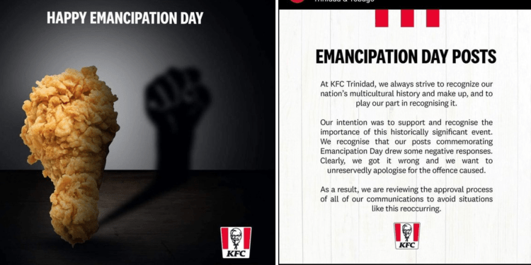

4.3 Opportunities
UK
KFC introduced their Vegan Burger in selected restaurants in 2019 which sold out in 4 days (Independent, 2019) and then nationwide in 2020. If KFC expand their limited vegan chicken range they can increase their customer base and impact their previous scandals concerning their chicken farm suppliers.

Trinidad and Tobago
The KFC menu in Trinidad and Tobago differs from the UK, with their addition of mash potato and American style biscuits, but they have a lot of scope to introduce vegan chicken products, as the currently do not have any on sale. (KFC, 2023)

4.4 Threats
Trinidad and Tobago
KFC in Trinidad and Tobago is relatively safe in its market position, but if an additionally popular US chicken chains such as Popeyes, starts trading in the country, and introduces a range of vegan chicken, it could seriously threaten KFC’s hold on the market, with many of their tourists hailing form the US.

UK
KFC can be made vulnerable to popular US chicken chains such as Popeyes, which has opened a popular restaurant in London that opened to weeks of ques containing customers willing to suffer long waits to purchase their fast food. If this popular US chicken-based fast-food restaurant expands throughout the UK and introduces a range of vegan chicken, it could seriously threaten KFC.

Similarities
In both the UK and Trinidad, KFC is the premier chicken-based fast food chain, with a high brand appeal and loyal customers. The importance to being seen as a green environmentally conscious organisation is paramount to KFC. Both countries have and offer franchises for their restaurants.

Differences
In Trinidad, KFC has a menu very much based on the US menu, offering products such as mash potato and American style biscuits, but unlike the UK they do not have any vegan chicken based products. Although KFC has face scandals in both countries, the scandals have been based on differing subjects, as in Trinidad and Tobago they have been based on their customers need views and identity, whereas In the UK KFC has faced scandals from their suppliers.

STP Analysis (Segmentation, Targeting and Positioning)
The STP analysis of KFC customers within the fast food sector focuses on the characteristics obtained through Segmentation, Targeting and Positioning (STP), to gain detailing specified information to influence their specific marketing and promotion for an identified demographic.

The use of STP analysis permits KFC to promote an increased market performance through the three key process to aid in identifying the most valued customers so that the redeveloped and redefined marketing strategies towards these identified targe customers their demographic, producing new brand, service and product awareness in order to increasing KFC’s value and market position (Linkedin, 2023).

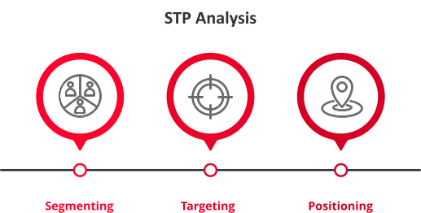

(Source created by learner, 2023)

5.1 Segmentation
Segmentation segregation of STP will usually consist on one, or more of the following areas
- Demographics - Who KFC Customers are?
- age
- gender
- highest education level
- location of home or work
- choice of profession
- income
- Psychographics - Why become a customer of KFC?
- priorities in life
- personality traits
- beliefs set
- life values
- Lifestyle traits - Reasons customers likely to purchase products
  - Social gatherings
  - entertainment choices
  - time constraints

- Behaviour – Voluntary actions undertaken by KFC customers
  - brand loyalty
  - recognition
  - shopping habits (HubSopt, 2021)

KFC should focus on the segmentation demographic group

UK
Young adults, families with low to middle income individuals and tourists with a need for a quick meal
Trinidad and Tobago
Middle income individuals and tourists with a need for a quick meal and wanting familiarity of a known and identifiable brand and their products

5.2 Targeting
Strategically identifying which segmented area of KFC customer demographic to focus on and target using specified questioning:
- Does the focused segmented section comprise of enough potential customers to justify targeting?
- How likely is the profit margin to increase with focused targeting?
- Is the focused targeted group easily differentiated from the other segmented sections?
- Can the ease of access to the focused target section be accessed simply?
- Does KFC have the ability and capability to direct their sales towards the focused target section and group?
- Has KFC made all efforts to make known and clarified that any and all social, legal, physical, or technological barriers that could prevent targeting been adequately addressed in all areas?
(HubSopt, 2021)

KFC should focus on the target demographic group

UK
Light to heavy social media users, families and the younger general public
Trinidad and Tobago
Light to heavy social media users, tourists and the younger general public

5.3 Position
The best market solution for KFC is to build on their present market position as one of the most recognised international fast food restaurants brands and increase their menu to incorporate the changing food purchasing of the general public, such as the fast growing vegan demographic to assist in reinforcing KFC’s a unique 11 herbs and spices selling point and preferential selling position, that will deliver the best financial returns from current customers and potential customers.
(mindtools.com)

KFC should focus maintaining their market position
UK
First class service with the a variety of products catered to both the young public and families
Trinidad and Tobago
First class service with the a variety of products catered to both the local public and tourists
Similarities
In the UK and Trinidad and Tobago KFC should focus on similar demographics such as the young adults and families.
Differences
As KFC is a is a popular internationally recognised brand tourists who like to frequent restaurants that they are familiar with KFC in Trinidad is situated in areas with high tourist traffic, while KFC’s in the UK are mainly situated on the main streets and close to public transport services.

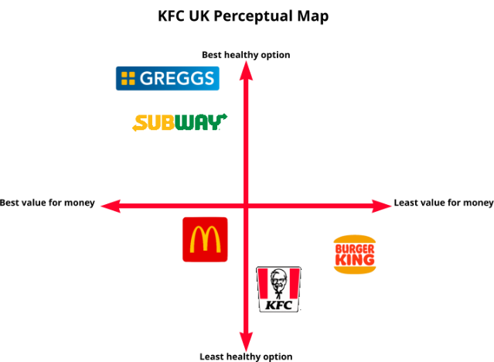
KFC Perceptual Map
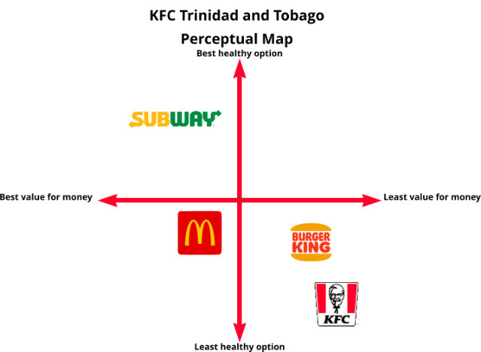

(Source created by learner, 2023)

Marketing Mix Elements (7Ps)
the marketing mix, or the 7Ps, are utilised applied when marketing strategies are need. The 7ps are Product, Price, Place, Promotion, People, Physical Evidence and Presentation, and Process which was a concept introduced by Neill Bordan in a Harvard Business School Journal over 70 years ago.
The organization must plan an appropriate marketing service mix for strategic marketing planning such as selling a product that fulfils consumer demand, selling a product at a reasonable price, and distributing the products to suit customer purchasing behaviour and provide convenience. (Nonthapot, 2019)

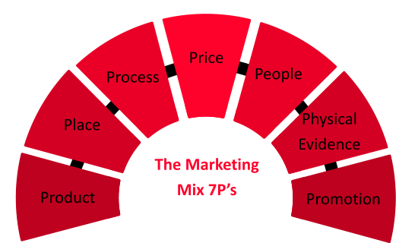
Neil Bordon introduced the concept of a mixed marketing strategy in ‘The Concept of the Marketing Mix’, an article published in the in the late 1950’s, although it has also been attributed to E. Jerome McCarthy in 1960 because he introduced it into education in 1960. (Yudelson, 1999)

(Source created by learner, 2023)

7.1 Product (or Service)
UK
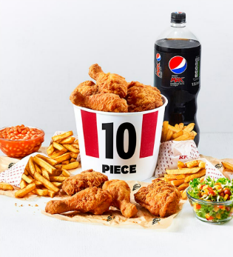
KFC has a range of chicken-based products ranging from their only vegan chicken option, to their personal and their multi-peron/group sharing boxes.
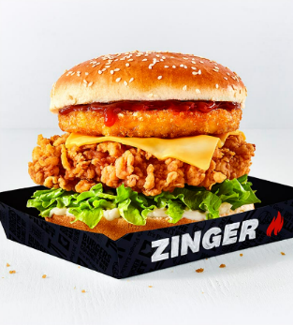
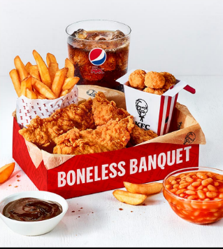
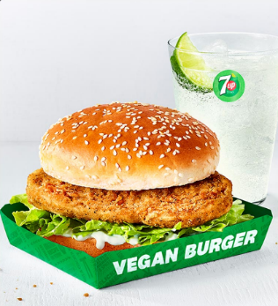

Trinidad and Tobago
KFC has a range of chicken-based products and sides ranging from their Two To Share bucket to masch potato and mac and cheese.

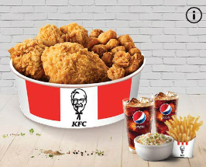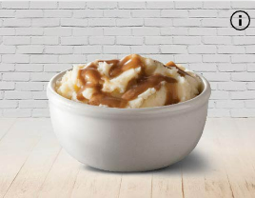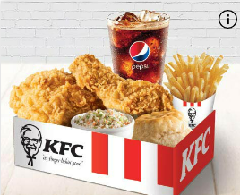
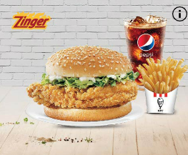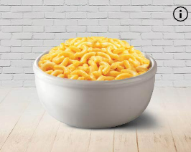

7.2 Price
UK
Their online prices range from £1.59 for a cookie to £39.99 party bucket with 14 pieces of chicken, 8 hot wings, 8 mini fillets, large popcorn chicken, 6 regular fries, 2 large sides and a 1.5lt bottle of drink.
Trinidad and Tobago
Trinidad and Tobago currency is the Trinidad and Tobago Dollar and their online prices range from $5 for an US biscuit to $189.99 Mega 12 bucket with 12 pieces of chicken, 6 regular fries, and 4 large sides.

7.3 Promotion
UK
The promotion methods used by KFC UK include online platforms including social media, KFC UK website, store and app promotions.
KFC could increase their customer base if they had promotions more regularly like their wrap of the day such as a weekly promotions and vouchers much like Mc Donalds do in the newspapers such as Metro.
- Pre-Purchase
The use of vouchers and limited promotions
- Purchase
The use of upselling at the purchase stage with the addition of reduced complimentary products and multi-purchase discount
- Post-Purchase
When a purchase is made via the app limited exclusive discounts and offers tailer to the customer purchase history

Trinidad and Tobago
KFC in Trinidad and Tobago utilise online platforms such as their website and store and app promotions.
By incorporating weekly altering meal or single or multi-item promotions and vouchers, they are more probable to increase their customer levels.
- Pre-Purchase
The use of vouchers and limited weekly product promotions
- Purchase
The use of upselling at the purchase stage with the addition of reduced complimentary products and multi-purchase discount and buy-one-get-one free offers
- Post-Purchase
When a purchase is made via the app limited exclusive discounts and offers tailer to the customer purchase history

7.4 Place
Market entry methods
UK
Franchise and KFC owned restaurants
Trinidad and Tobago
Solely franchised exclusively through Prestige Holdings since their initial franchise in 1973 (Prestige Holdings Limited, 2023)
Influences of method
UK
The ability to purchase a UK KFC franchise is obtained via the KFC website. Being one of the top fast food restaurants in the UK with an internationally recognised brand.
Trinidad and Tobago
Having an internationally recognised brand and being the most popular and largest fast food restaurant chain in Trinidad and Tobago, it is very likely that a new franchise would be able to benefit from the established restaurants popularity to power their customer base prior to opening a franchise when notifications and building, or refitting a store to adhere to the KFC uniformly branded requirements. As there is no alternative route to obtain a KFC franchise other than purchasing exclusively through Prestige Holdings since their initial franchise in 1973 (Prestige Holdings Limited, 2023) which is available through their website and the KFC website

7.5 People
UK
In the UK the customers that KFC are targeting are the young adults and families and those with busy lives with less time to cook a meal, or go to a traditional restaurant.
Trinidad and Tobago
The customers that KFC are targeting in Trinidad and Tobago are the tourists, young adults and families and those with busy lives with less time to cook a meal, or go to a traditional restaurant.

7.6 Packaging
UK
The packaging should all be recyclable and biodegradable to reflect their Green Build philosophy.
Trinidad and Tobago
The packaging should all biodegradable to reflect their back to nature and care for the environment philosophy.

7.7 Process/Physical Evidence
UK
Having more electronic ordering hubs available, such as on each table for the dine-in customers, would allow for queues and waiting time to be reduced.
Trinidad and Tobago
Attracting additional franchise restaurants spread more evenly throughout the country would aid in alleviating the levels of delivery and would also attract more local foot traffic and in store customers. Having electronic ordering hubs available for all customers o entry with the additional ordering hubs based on all tables for the dine-in customers, would allow for queues and waiting time to be reduced.

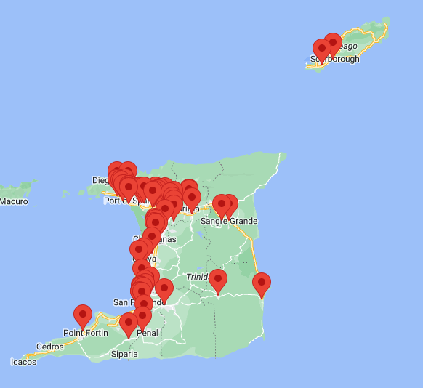
(KFC, 2023)

Advantages
UK and Trinidad and Tobago
Employing all of the elements withing the 7P’s Marketing Mix allows for a robust analogy of the collected data.
(Ivy, 1992)

Disadvantages
UK and Trinidad and Tobago
Employing all of the elements withing the 7P’s Marketing Mix allows for can collect too much data that may not be relevant to the necessary analytical data needed to crate the applicable strategic processes.
(Ivy, 1992)

Ansoff Matrix
The Ansoff Matrix is an analysing tool for business created and named after Harry Igor Ansoff, also known as the ‘father of strategic management’. It assist with the visually concept of where a business product strategy is within their market sector and if they need to venture into alternate areas to improve their future strategies detailing possible risks and areas where lateral growth is possible. (Adrian Bullock, et al 2019)
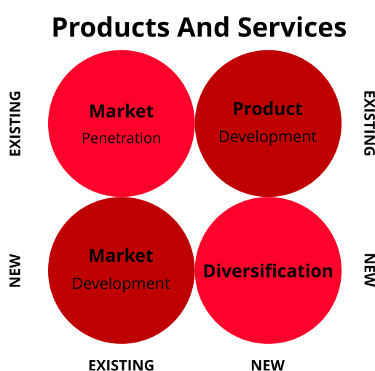
(Source created by learner, 2023)

8.1 Market Penetration
This penetrating market strategy concentrates on increasing the product level of sales for existing products as well as the market it exists in. This is the lowest-risk option. (Adrian Bullock, et al 2019)
UK
KFC could increase their sales of specific products through offering delas on specified days.
Trinidad and Tobago
KFC could increase their sales of specific products through offering delas when the option of delivery is chosen when making a purchase, as most of their restaurants are situated on the west coast of the country.

8.2 Product Development
The product development strategy focuses on establishing new products into an already existing market. This risk is deemed as higher, due to the level of financial investment that would be warranted to creating or modify any existing products. (Adrian Bullock, et al 2019)
UK
KFC have a single vegan product, The Vegan Burger, but they could add to their already established vegan line by offering additional products such as a Vegan Chicken Wrap.
Trinidad and Tobago
KFC could introduce a chicken wrap line using their seasoned chicken breast and mirror the fillings used in their corresponding chicken burgers, such as their Zinger Burger which could have a complimentary Zinger Wrap.

8.3 Market Development
The market development strategy the Ansoff Matrix is aimed at penetrating new markets with existing products in its range. This possibility of entering alternative countries to gain new customers. The risk is high as it is an untapped area for the company.(Adrian Bullock, et al 2019)
UK
Offering discount for a specific demographic, such as NHS workers or students would concentrate on a new specified marked especially if the discount was continuous and unlimited with the production if related ID.
Trinidad and Tobago
KFC could offer a mobile trucks, to sell where they have limited, or nor restaurants, such as the central and east coast of the county, gain access to the population that don’t travel regularly or frequently to areas already catering to their customers on the west coast of the country.

8.4 Diversification
The market development strategy the Ansoff Matrix is aimed at penetrating new markets with existing products in its range. This possibility of entering alternative countries to gain new customers. The risk is high as it is an untapped area for the company. (Adrian Bullock, et al 2019)

UK
The introduction of a new KFC product such as their own soft drinks would allow them to compete with the more popular soft drink companies.
Trinidad and Tobago
The introduction of a new KFC product such as their own soft drinks, using locally grown fruit, would allow them to compete with the more popular soft drink companies.

Recommendation
KFC must concentrate on increasing its product line to incorporate the increasing vegan diet if it is to expand its customer base through product expansion through the employment of product development the UK, while in Trinidad and Tobago as the west coast of the country has the majority of KFC’s fast food restaurants, utilising mobile stores to bring the restaurant to more rural areas and the less catered areas of the country through the use of market development.

Conclusion
With KFC being one of the most internationally recognisable fast food brands its product awareness and brand quality have assisted them with their customer base and country wide expansion through the franchise program. Having restaurants strategically developed with in the tourist areas in countries like Trinidad and Tobago which are considered an all year round tourist destination, allows KFC to benefit from their high brand recognition within the tourist demographic. While in the UK have their restaurants situated close to transportation alighting points allows them to benefit from the flow of the foot traffic. KFC should not however get complacent with their present position, as there are many alternatives available form their rivals, so implementing the recommendations for both the UK and Trinidad and Tobago will enforce the encouragement of additional customer to build their present customer base.

References
Adrian Bullock, C. J. ,. a. N. T., (2019. A Dictionary of Publishing. 2019 ed. s.l.:Oxford University Press.
Boonyarat Phadermroda, R. M. C. G. B. W., (2019) Importance-Performance Analysis based SWOT analysis. International journal of information management, 44(01), pp. 194-203.
Burger King, (2023). Facebook Burger King Trinidad and Tobago. (Online)
Available at: https://www.facebook.com/BurgerKingTrinidadTobago
(Accessed 21 08 202).
Frue, K., 2017. Who Invented PEST Analysis And Why It Matters. [Online]
Available at: https://pestleanalysis.com/who-invented-pest-analysis
(Accessed 31 July 2023).
Guardian, (2018). KFC returns to original supplier after chicken shortage fiasco. [Online]
Available at: https://www.theguardian.com/business/2018/mar/08/kfc-returns-to-original-supplier-after-chicken-shortage-fiasco
(Accessed 22 08 2023).
hofstede insights, (2023). Country Comparison Tool. [Online]
Available at: https://www.hofstede-insights.com/country-comparison-tool?countries=trinidad+and+tobago%2Cunited+kingdom
(Accessed 31 07 2023).
HubSopt,( 2021). The Marketer's Guide to Segmentation, Targeting, & Positioning (STP Marketing). (Online)
Available at: https://blog.hubspot.com/marketing/segmentation-targeting-positioning
(Accessed 04 08 2023).
Independent, (2019). KFC vegan burger sells out in first four days. [Online]
Available at: https://www.independent.co.uk/life-style/food-and-drink/kfc-vegan-burger-chicken-uk-imposter-london-sell-out-price-a8968561.html
(Accessed 10 08 2023).
Ivy, J., (1992). A new higher education marketing mix: the 7Ps for MBA marketing. The International Journal of Educational Management, 6(5), pp. 288-299..
KFC, (2023). Behind The Bucket. (Online) Available at: https://www.kfc.co.uk/behind-the-bucket/our-chicken (Accessed 09 09 2023)

KFC, (2021). COVID-19 UPDATES. (Online)
Available at: https://www.kfc.co.uk/covid-19-updates
(Accessed 21 08 2023).
KFC, (2021). Doing Restaurants The Right Way. [Online] Available at: https://brand-uk.assets.kfc.co.uk/2021-12/KFC%20Development%20Brochure.pdf
(Accessed 19 08 2023).
KFC, (2023). Doing Restaurants The right way. (Online) Available at: https://brand-uk.assets.kfc.co.uk/2021-12/KFC%20Development%20Brochure.pdf (Accessed 12 08 2023).
KFC, (2023). FIND A KFC Trinidad and Tobago. (Online) Available at: https://www.kfc.tt/find-a-kfc (Accessed 20 08 2023).
KFC, 2023. KFC. (Online) Available at: https://global.kfc.com/our-heritage/ (Accessed 06 August 2023).
KFC, (2023). KFC Trinidad and Tobago About. [Online] Available at: ttps://www.kfc.tt/about-us (Accessed 23 August 2023).
KFC, (2023). Trinidad KFC Menu. (Online) Available at: https://www.kfc.tt/menu/overview
(Accessed 07 08 2023).
Linkedin, (2023). How do you use segmentation, targeting, and positioning (STP) to tailor your marketing strategy?. (Online) Available at: https://www.linkedin.com/advice/0/how-do-you-use-segmentation-targeting-positioning (Accessed 17 08 2023).
Lo, M., (2020). Change.org. (Online) Available at: https://www.change.org/p/nemo-have-kfc-st-lucia-declared-an-essential-service (Accessed 04 08 2023).
Loop News, (2023). KFC donates $250,000 to tertiary level education. [Online]
Available at: https://tt.loopnews.com/content/kfc-donates-250000-tertiary-level-education
(Accessed 15 08 2023).
Loop News, (2023). KFC to distribute 5000 seedlings on Corpus Christi. [Online]
Available at: https://tt.loopnews.com/content/kfc-distribute-5000-seedlings-corpus-christi
(Accessed 15 08 2023).
McDonalds, (2021). Restaurants by Country. (Online)Available at: https://corporate.mcdonalds.com/content/dam/sites/corp/nfl/pdf/Restaurants%20by%20Country%202021.pdf (Accessed 20 08 2023).
McSweeney, B., (2002). Hofstede’s Model of National Cultural Differences and their Consequences: A Triumph of Faith - a Failure of Analysis. Human Relations, 01.55(01).
National File, (2020). KFC Tobago Uses ‘Racist’ Advert with Fried Chicken Symbolizing Black ‘Emancipation’. (Online) Available at: https://nationalfile.com/kfc-tobago-uses-racist-advert-with-fried-chicken-symbolizing-black-emancipation/ (Accessed 08 08 2023).
Nonthapot, S., (2019). The impact of economic factors on street food consumer choice in Nong Khai Municipality, Nong. Growing Science, (https://www.growingscience.com/msl/Vol9/msl_2019_195.pdf), p. 2337–2346.
Porter, M.E. (2008) “The five competitive forces that shape strategy.,” PubMed, 86(1), pp. 78–93, 137. Available at: https://pubmed.ncbi.nlm.nih.gov/18271320. (Accessed: 08 08 2023)
Prestige Holdings Limited, (2023). Prestige Holdings Limited A Restaurant Management Company. (Online) Available at: https://www.phl-tt.com/ (Accessed 19 08 2023).
Statista, (2023). Most popular dining brands in the United Kingdom (UK) as of the fourth quarter of 2022. (Online) Available at: https://www.statista.com/statistics/950444/most-popular-restaurant-brands-in-the-united-kingdom-uk/ (Accessed 18 08 2023).
The Guardian, (2022). The Guardian. (Online) Available at: https://www.theguardian.com/environment/2022/apr/12/kfc-faces-backlash-over-misleading-portrayal-of-chicken-farming-niko-omilana (Accessed 08 08 2023).
Trinidad and Tobago Government, (2023). Oil and Gas industry.(Online)
Available at: energy.gov.tt/our-business/oil-and-gas-industry/ (Accessed 20 08 2023).
Trinidad Guardian, (2022). KFC CEO: We got it wrong with condiment policy. [Online]
Available at: KFC CEO: We got it wrong with condiment policy (Accessed 18 08 202).
U.S. Government, (2023). U.S. Relations With Trinidad and Tobago. [Online]
Available at: state.gov/u-s-relations-with-trinidad-and-tobago/ (Accessed 18 Auguat 2023).
Yudelson, J., (1999). Adapting Mccarthy’s Four P’s for the Twenty-First Century. SAGE Jouranls, 21(1), pp. 60-67.
Yum Brands, (2023). Citizenship & Sustainability News. [Online] Available at: https://www.yum.com/wps/portal/yumbrands/Yumbrands/news/citizenship-sustainability-news/?mid=1226911 (Accessed 01 08 2023).

- Appendix
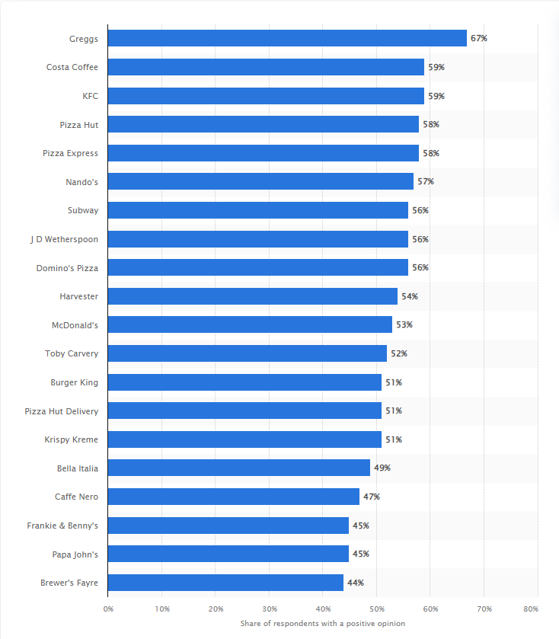
Appendix 001
Most popular dining brands in the United Kingdom (UK) as of the fourth quarter of 2022

(Statista, 2023)

