Citizenship of the digital competence framework

Numerous individuals often find themselves confused about the concept of digital competence, as well as the digital competence framework and its role in enhancing the development of children's digital literacy skills in Wales.
This framework is designed to not only aid students in their academic pursuits across various subjects but also to equip them with essential skills that will benefit them throughout their lives, even after they have left school to join the adult world. Our focus will be on evaluating whether the five progression steps outlined within each of the four components of the citizenship strand of the digital competence framework can effectively deliver the support and educational experiences we aspire for our children to gain during their digital learning journey.
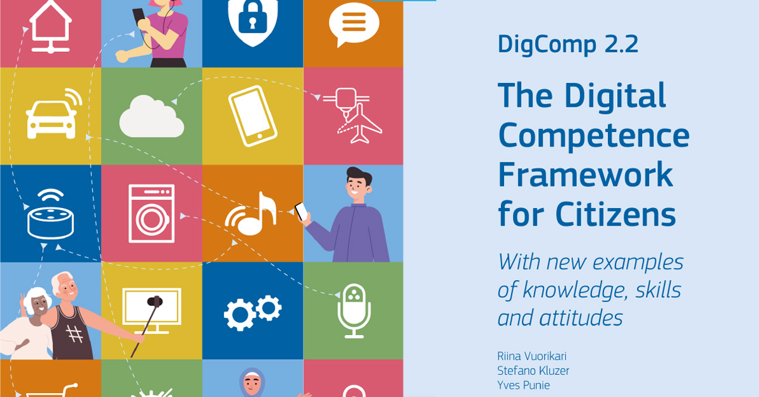
(Europeancommisson, 2022).
According to the digital competence framework our children will explore the concept of being a responsible digital citizen, actively contributing to the online community while thoughtfully assessing their role within it. They will be equipped to face both the benefits and challenges of digital citizenship, developing essential strategies and tools that empower them to navigate their journey as independent consumers and creators in the digital landscape (Hwb.gov, n.d).

Online behaviour and online bullying
The various strands of the digital competence framework are certainly valuable, but let's focus on the one that truly matters to us: the strand addressing online behaviour and online bullying. As parents, we all share a common concern—none of us want our children to experience bullying in any form, especially in the digital realm where it can be pervasive and damaging.
Below you will discover a concise overview of several key aspects that our children will explore at each stage of the digital competence framework, specifically within the online bully element of the citizenship strand section. This framework is designed to equip them with essential skills and knowledge that will empower them to navigate the digital world responsibly and effectively.
- Progression step 1: I can make decisions based on what I like and dislike.
- Progression step 2: I can identify different forms of bullying, including online bullying, and suggest strategies for dealing with it
- Progression step 3: I can understand the risks and legal consequences of sending intimate images and content/sexting
- progression step 4: I can understand the implications of online actions, including my digital footprint and the legal implications of sharing inappropriate material
- progression step 5: I can apply appropriate strategies to protect the rights, identity, privacy and emotional safety of both myself and others in online communities (Hwb.gov, n.d).

One crucial aspect of digital citizenship education involves guiding our children on appropriate online behaviour and addressing the issue of cyberbullying. The initial phase of developing this framework focuses on helping children understand their own emotions as well as those of others, fostering effective communication about feelings. However, the framework lacks specific guidelines regarding the appropriate age for implementing this foundational step. It is reasonable to speculate that this instruction is likely introduced during the early years of schooling, possibly around the foundation stage or key stage 1.
It would be beneficial for the government to provide clearer age-related milestones for children as they advance through each stage of this educational framework. Progression step number two is then teaching children how to identify all form of online bullying and strategies to deal with it. We as parents are truly heartened to learn about initiatives aimed at addressing bullying, as our concerns for our children's well-being often revolve around this issue. The fact that schools are taking proactive steps to identify bullies and provide strategies for coping is indeed commendable. However, it raises an important question about the inclusivity of these measures. The framework does not clarify whether these anti-bullying efforts apply universally to all students or if there are tailored approaches for those with additional learning needs. This is particularly crucial considering that, according to the Anti-Bullying Alliance, young people with disabilities face a significantly higher risk of being bullied, including in online environments (Ant-bullyingalliance, n.d).
It may be necessary to consider an alternative strategy when addressing the needs of children with additional learning requirements, particularly since some of these children face challenges in social interactions and communication skills.
As children progress through steps 3 to 5, it becomes evident that the framework is increasingly designed to cater to the needs of key stage 3 and 4 students, addressing more complex and mature subjects. This phase introduces critical discussions surrounding legal issues, racism, and sexual matters related to online behaviour, which are essential for fostering awareness among young individuals. It is unfortunate that topics such as racial abuse and sexting must be addressed, yet it is crucial for our children to be educated on these matters to ensure their safety and to prevent them from making potentially harmful mistakes in their online interactions. Implementing this digital framework is a significant advantage for parents, providing a sense of security; however, it also highlights the need for educators who may not fully grasp the intricacies of the digital landscape to effectively convey these important lessons to our children.
Numerous schools have certainly incorporated the digital competence framework into their policies, alongside a variety of other concepts related to online learning and safety. This integration reflects a growing recognition of the importance of equipping students with the necessary skills to navigate the digital landscape effectively and securely.
Curriculum Leads
Curriculum Leads will work with the online safety lead to develop a planned and coordinated online safety education programme. This will be provided through:
• a discrete programme
• the Digital Competence Framework
• personal and social education/sex and relationships education
• assemblies and pastoral programmes
• through relevant national initiatives and opportunities e.g. Safer Internet Day and Anti-bullying week (Bishopgore, 2022).
The digital competence framework serves its intended purpose effectively, yet it is not without its shortcomings. One significant issue is that educators may lack the latest knowledge and skills necessary to instruct students on recognising online dangers and understanding appropriate online behaviour. This gap can hinder the framework's overall effectiveness in preparing children to navigate the digital landscape safely and responsibly. The rapid expansion of the digital landscape is evident to everyone, as it increasingly intertwines with our social interactions, whether we are adults engaging on platforms like Facebook or younger individuals using Snapchat and TikTok. It is crucial to address online behaviour and the issue of cyberbullying, which are integral components of the citizenship aspect of the digital competence framework. This framework is essential for ensuring the safety of our children in the online realm until a more refined version is developed to better educate them about the potential risks associated with being online. Digital competence stands as one of the three essential cross-curricular elements in the Welsh curriculum, “digital competence are mandatory cross-curricular skills within Curriculum for Wales” (WelshGovernment, 2022). Thus highlighting its importance in fostering a safe and informed digital environment for the younger generation.

Ant-bullyingalliance, (n.d) Do children with SEND experience more bullying?
Available at https://anti-bullyingalliance.org.uk/tools-information/all-about-bullying/at-risk-groups/sen-disability/do-children-send-experience-more
(Accessed: 10th November 2024).

Bishopgore school, (2022), Online Safety Policy
Available at https://drive.google.com/file/d/1Dy-MRj7VEOc356Lc9LNFet_fgnQHT1Yv/view
(Accessed: 16th November 2024).

European Commision, (2022), Digital Competences Framework (DigComp 2.2) update published
Available at https://ec.europa.eu/social/main.jsp?langId=en&catId=89&newsId=10193&furtherNews=yes
(accessed: 16th November 2024).

Hwb.gov, (n.d) Digital competence framework
Available at https://hwb.gov.wales/api/storage/d26af733-abd1-4d33-92fe-4ea8eb1d928f/dcf40620.pdf
(Accessed: 10th November 2024).

Hwb.gov, (n.d) Digital competence framework
Available at https://hwb.gov.wales/api/storage/d26af733-abd1-4d33-92fe-4ea8eb1d928f/dcf40620.pdf
(Accessed: 10th November 2024).

Welsh Government, (2022, Cross-curricular skills frameworks
Available at https://hwb.gov.wales/curriculum-for-wales/cross-curricular-skills-frameworks
(Accessed: 16th November 2024).

Our Children and the Digital World
The rapid evolution of technology in recent years has been nothing short of astonishing. Innovations have emerged at an unprecedented speed, transforming the way we live, work, and communicate.


(Dunlop, 2017).

The emergence of artificial intelligence brings with it a mix of excitement and concern as I sincerely hope we are not witnessing the dawn of a future where A.I. dominates our lives. With each technological advancement surpassing the previous one at an astonishing rate, we must wonder if our children can absorb this overflow of information. We could question are they equipped to acquire the necessary digital skills while also ensuring their safety in an increasingly complex digital landscape?
As technology continues to evolve at a rapid pace, it is crucial that the children of Wales are not left behind. An Estyn inspector has noted that a key factor in schools that demonstrate effective practices is the presence of a strong digital leader (Estyn, 2017). These leaders play a vital role in driving and overseeing the development of digital skills throughout the school, ensuring that necessary actions are taken promptly. However, what happens to schools lacking effective digital leadership? While we may hope to see an increase in teachers equipped with digital leadership skills in the future, currently, this trend is primarily observed in high-performing schools. This is commendable, but we must also consider the needs of those schools that are struggling.



(Kamel,2021)
It's natural for us to want the best for our kids, and in today's world, being tech-savvy is becoming increasingly important for their future job prospects. We want them to learn how to navigate technology effectively, but it raises the question of when the right time is to start this learning process. Sure, kids can pick up on tech at a really young age, but do they have the maturity to grasp the potential risks that come with it? Plus, if we push them too hard too soon, could we risk overwhelming them and causing burnout? It's a tricky balance to strike as we guide them through this digital landscape.
Indeed, while technology presents significant risks and can be perilous when misused by individuals with harmful intentions, it is essential to recognise that it also holds immense potential for positive impact when wielded responsibly. In the past, acquiring knowledge often required a trip to the library, where one would sift through countless books to learn about subjects as diverse as North American mountain lions or Australian kangaroos.
However, with the advent of connectivism, accessing information has become remarkably efficient; now, a few clicks can lead you to a wealth of resources and insights, transforming the way we learn and interact with the world around us. This shift not only demonstrates knowledge but also empowers individuals to explore and understand complex topics with unprecedented ease.
In today's digital age, children have the incredible opportunity to explore a vast array of topics from every corner of the globe, which is essential for their growth and education. This access to diverse information not only broadens their horizons but also fosters critical thinking and curiosity, enabling them to engage with the world in meaningful ways. By encouraging our children to delve into various subjects, we equip them with the knowledge and skills necessary to navigate an increasingly complex society, ultimately shaping them into informed and well-rounded individuals.
Connectivism is an emerging educational theory that emphasizes the importance of integrating ideas, concepts, and knowledge in a practical way. It recognizes the significant role technology plays in learning and highlights how our ongoing connectivity provides us with various options to shape our educational experiences (WGU, 2021).

Estyn, (2017) Digital competence: Improving pupils’ digital skills
Available at https://estyn.gov.wales/blog/digital-competence-improving-pupils-digital-skills/
(Accessed: 8th November 2024).

Dunlop, C, (2017), 4 Rising Technology Trends You Need to Know About
Available at https://www.authoritylabs.com/4-rising-technology-trends-you-need-to-know-about/
(Accessed: 8th November 2024).
Snowden, J, (2020), My first month at Symatrix
Available at https://www.linkedin.com/pulse/my-first-month-symatrix-jonathan-snowden
(Accessed: 8th November 2024).
WGU, (2021) Connectivism Learning Theory
Available at https://www.wgu.edu/blog/connectivism-learning-theory2105.html
(Accessed: 16th November 2024).

The Teaching Assistants Digital Friend and Fiend
The position of a teaching assistant has allowed me to engage deeply with digital blended learning, particularly through the use of iPads in a secondary school setting. Over my decade-long experience, I have discovered that iPads serve as invaluable tools for students with disabilities and those who struggle with writing speed. By enabling these students to take notes directly from my device, we can maintain the flow of the lesson without unnecessary delays, allowing the teacher to continue without waiting for them to catch up. Additionally, the iPad facilitates my ability to document the progress of the students I support, noting their strengths and areas for improvement, which can then be shared with other teaching assistants who may also be working with the same pupil. 
(Morris, 2923)

However, I have encountered challenges with the longevity of these devices; after two years, they often begin to malfunction. I recall a specific incident where I emailed the head of house about a student's misbehaviour, only for the email to be delayed for two months, resulting in a miscommunication that left the student's mother unaware of the situation. Despite these setbacks, the benefits of using iPads to assist students in the classroom are significant, although the financial burden of replacing devices every two years for all 20 teaching assistants in our school is a concern that cannot be overlooked. “Apple has apologised after facing criticism for admitting it deliberately slows down some ageing iPhone models” (BBC, 2017).
Apple's acknowledgment of intentionally slowing down their iPhones raises concerns that they might be applying the same strategy to their iPads, potentially encouraging users to upgrade sooner than necessary. This suspicion resonates with my own experience, as my iPad became significantly less functional after just two years of use. It's disappointing, especially considering how valuable these devices are as educational tools that enhance learning for students in the classroom.

(GCF, n.d)
The financial strain became overwhelming as the iPads are no longer utilized in the school. My institution has now made a significant investment in Chromebooks and laptops, which I find to be a wonderful decision. I've observed that these devices tend to have a much longer lifespan compared to the iPads. Additionally, they provide valuable support for students with disabilities and those who struggle with writing speed, allowing them to work on the laptops with the guidance of a teaching assistant.
The school where I am employed is fortunate to still have the financial means to provide digital learning tools for students, especially considering that many institutions have struggled to recover from the setbacks caused by the COVID-19 lockdowns. During this time school were given a support grant but unfortunately This grant does not cover income that was self-generated and is now lost. When schools typically rely on private income to fund a service or operation, the loss of this revenue can put extra strain on their budgets (Government, 2020). This didn’t cover the private income schools would receive in normal times. I empathise with those schools that are currently navigating tight budgets, as they may need to operate on limited resources for a few years. While this timeframe may seem lengthy, it is relatively short in the broader context of educational development. However, if these schools do not allocate their budgets wisely—particularly in investing in reliable digital tools like laptops instead of less dependable options such as iPads—they risk making poor financial decisions that could lead to severe consequences, including the potential redundancy of teaching assistants. This outcome would be detrimental, especially for children with additional learning needs, who rely heavily on the support of these assistants. The absence of adequate support could hinder these students' progress in crucial areas of Maslow's hierarchy of needs (Maslow, 1943) such as self-esteem and belonging, as teaching assistants play a vital role in fostering a positive learning environment and helping children integrate with their peers.
Therefore, it can be seen, that finance is one of many barriers to prevent digital inclusion and learning other factors can be lack of qualified teachers or the lack of understanding of digital technology tools and unable to show children how to use them.
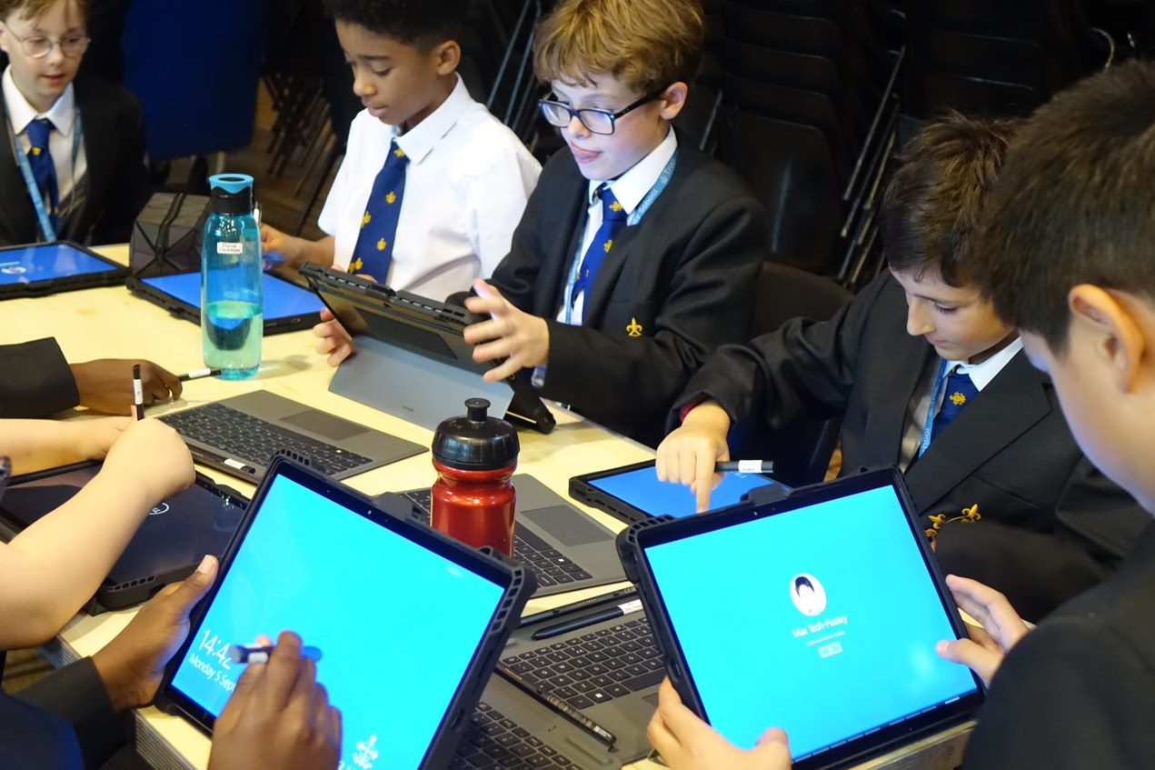
(Trinity, 2022)
My digital friend that significantly enhances the classroom experience and supports the students I assist is undoubtedly the laptop. I have observed that students genuinely appreciate using laptops, as they enable them to stay on par with their peers and prevent them from lagging behind. While it is true that laptops may come with a higher initial cost, they prove to be a worthwhile investment over time, especially when compared to iPads. Laptops are built to last and will continue to function effectively for many years, making them a more sustainable choice for educational purposes.

(Discrictdot, 2015).
So, with the laptop being my friend who do think is my ‘fiend’ of digital technology? that’s right you’ve got it, its the iPads, despite their initial affordability and appeal, they often fall short in terms of long-term reliability. As I have illustrated throughout this blog, these devices may begin with a strong performance, but they tend to encounter significant issues over time, leading to disruptions not only for myself and my colleagues but, more critically, for the students who rely on them. This unreliability makes iPads more of a hindrance than a help in the educational environment, and thus, they should be approached with caution and reconsidered for use in schools.
In summary, schools can effectively tackle the digital barriers discussed in this blog by making informed investments in their digital tools. Conducting thorough research on the products they choose to implement is crucial. By prioritising thoughtful selection over simply acquiring the latest technology trends, schools will benefit not only their staff but, most importantly, their students.

BBC, (2017), Apple apologises for slowing older iPhones down
Available at https://www.bbc.co.uk/news/technology-42508300
(Accessed: 27th November 2024).

Districtdot, (2015), Unfriend
Available at https://thedistinctdot.com/2015/05/14/unfriend/
(Accessed: 20th December 2024)
GCF Global, (n.d) Financial problem-solving strategies
Available at https://edu.gcfglobal.org/en/moneybasics/financial-problem-solving-strategies/1/#
(Accessed: 20th December 2024).

Available at https://edu.gcfglobal.org/en/moneybasics/financial-problem-solving-strategies/1/#

Government, (2020) School funding: exceptional costs associated with coronavirus (COVID-19) for the period from March to July 2020
Available at https://www.gov.uk/government/publications/coronavirus-covid-19-financial-support-for-schools/school-funding-exceptional-costs-associated-with-coronavirus-covid-19-for-the-period-march-to-july-2020
(Accessd:15th December 2024).

Maslow, A, (1943), A Theory of Human Motivation

Morris, E (2023), How Long Does an iPad Last?
Available at https://www.ur.co.uk/blogs/news/how-long-does-an-ipad-last
(Accessed: 14th December 2024).

Trinity, (2022) Launch of the Trinity Digital Learning Programme
Available at https://www.trinity-school.org/launch-of-the-trinity-digital-learning-programme/
(Accessed: 20th December 2024).

How COOL IS MINECRAFT IN SCHOOL?

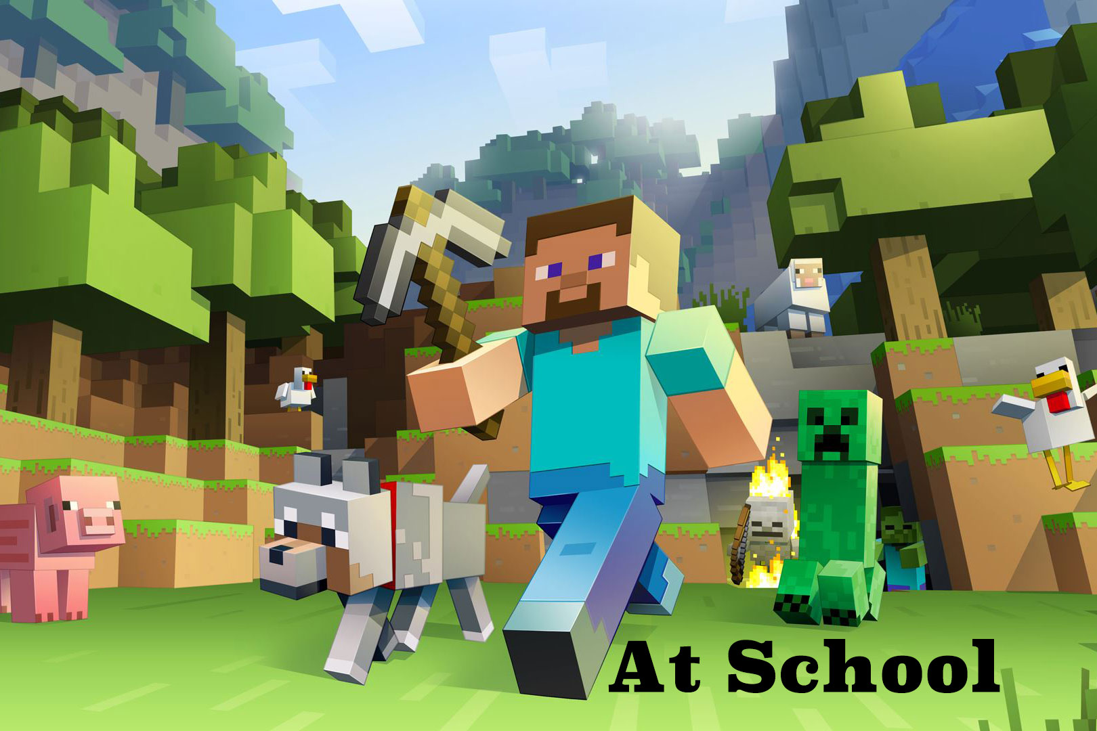
(Schudio,n.d)
How can a computer game serve as an educational tool in the classroom? Is it truly feasible? In my experience, and in many others, the computer game Minecraft has been effectively integrated into lessons for several years and continues to be utilised. In a secondary school environment, Minecraft can be an invaluable resource, particularly because the current generation of students have than likely been familiar with the game since childhood, making them adept at navigating its features. This familiarity not only enhances their engagement but also allows for innovative teaching methods that leverage the game's interactive and creative aspects.


(Skrebels, 2024)

Minecraft has established itself as one of the most successful games ever, particularly among younger audiences, and as it celebrates its 15th anniversary in 2024, it's no wonder that educational institutions are embracing its widespread appeal. Schools are increasingly recognizing the potential of this beloved game to engage students and enhance their learning experiences, increasing its popularity to create innovative educational opportunities that captivate children's imaginations while teaching essential skills.

Safeguarding
Throughout my experiences, I have come to realise that integrating Minecraft into educational activities can be incredibly advantageous and safe for children. The key to maintaining this safety lies in the effective use of parental controls. By utilising these controls, we can safeguard students from various potential dangers, which resonates with the second tier of Abraham Maslow's hierarchy of needs, highlighting the critical nature of personal security for all individuals. “Safety needs can be fulfilled by the family and society (e.g., police, schools, business, and medical care)” (Mcleod, 2024).
Children playing Minecraft at home may face certain risks, particularly if their parents are unfamiliar with how to utilize parental controls effectively. Additionally, some children might have parents who are indifferent to their online activities, which can further exacerbate the situation. However, based on my experience with Minecraft in coding classes, I believe that parental controls are unnecessary in this context. The version of Minecraft used in educational settings differs significantly from the one available on consoles like Xbox and PlayStation, as it does not connect to the broader Minecraft community online.

Helping behaviour and social community
According to Sean Arnold a stem coach and technology educator who has worked in New York City’s citywide special education District 75 since 2005. Students facing mobility or behavioural challenges can now explore these environments safely in a virtual setting before venturing into the real world. This experience has significantly aided students in feeling more connected to a world that can often seem distant from them (Arnold,n.d)
Minecraft is an incredibly enjoyable game that captivates players with its engaging gameplay, and this enjoyment can be connected to the theories of Lev Vygotsky. The immersive world of Minecraft allows players to explore, create, and collaborate, fostering a sense of community and learning that aligns with Vygotsky's ideas about social interaction and cognitive development. Through its open-ended nature, the game encourages creativity and problem-solving, making it not just a source of entertainment but also a valuable tool for personal growth and social engagement.
Contemporary educational theories emphasise the significance of play in the learning process, with Vygotsky highlighting the crucial role of social interaction and collaboration during play as key drivers of children's educational development. According to his perspective, children often emulate adults or more knowledgeable peers, and this interaction through play, shapes abilities that are still developing—skills that are on the verge of maturation and are currently in their formative stages.
Since its inception in 2009, Minecraft has become a staple in secondary schools, where students have not only played but also developed a deep appreciation for the game over the years. From my perspective, one of the most effective ways to engage children in learning is by making the experience enjoyable, and Minecraft excels in this regard. The game fosters curiosity and critical thinking, as players are often required to tackle various challenges that encourage them to explore the internet and conduct research to successfully complete their objectives. This blend of fun and educational value makes Minecraft a powerful tool for learning in a modern classroom setting.
In today's rapidly evolving landscape of technology and social media, children have unprecedented access to devices like mobile phones, making it essential for educators to adapt and embrace these advancements. It is crucial for teachers and teaching assistants to leverage technology to enhance the learning experience rather than be left behind.
Minecraft can be seen to captivate students' attention, which not only engages them but also addresses various learning needs, fostering skills in problem-solving, creativity, and research. This platform serves as an excellent resource for coding lessons, particularly for Primary and Key Stage Three students. However, its applicability for Key Stage Four, especially in relation to GCSE preparation, seems limited beyond coding exercises. Although using Minecraft in the initial phases of education helps students develop essential skills, its role in enhancing the more complex curriculum of Key Stage Four is still questionable. However, it is evident that Minecraft lays a strong groundwork for learners at Key Stage Three, equipping them with the necessary abilities they will require for their GCSE examinations. This highlights Minecraft's value as a digital resource in educational settings, as it can be integrated into school activities during coding and ICT classes. Additionally, students often engage with the game at home, drawn by its entertaining nature, unaware that they are simultaneously benefiting from its educational aspects. The sole drawback to this enjoyable home learning experience is the necessity for monitoring and the implementation of parental controls.

Arnold, S, (n.d) Minecraft and Accessible Play
Available at https://education.minecraft.net/en-us/blog/minecraft-and-accessible-play#:~:text=Students%20with%20mobility%20or%20behavioral,feel%20very%20separate%20to%20them.
(Accessed: 18th December 2024).
Mcleod, S, (2024), Maslow’s Hierarchy of Needs
Avaible at https://www.simplypsychology.org/maslow.html
(Accessed: 18th December 2024)
Schudo, (n.d) Minecraft at School
Avaible at https://www.schudio.com/minecraft-school/
(Accessed: 19th December 2024).

Skrebels, J, (2024), The Most Important Moments in Minecraft’s First 15 Years
Available at https://news.xbox.com/en-us/2024/05/17/minecraft-15-years-most-important-moments/
(Accessed: 17th December 2024).

