

ASSESSMENT TITLE
Component 1: Online Portfolio of Set Exercises

Name: Anderson Villanueva Suarez
Student ID: 2337296
Module Name: Changemakers: Creativity and Value Creation
Module code: BMHP5014_LON
Lecturer: Dr. Laila Surani

I acknowledge that this portfolio is mine, and I have use Microsoft Editor for Spelling and grammar

INTRODUCTION
The purpose of this online portfolio is to present a series of exercises and activities focused on the application of certain activities, such as practice, value creation, technology, and the most important, the leadership required as a future professional dedicated to health and social care sector
- Defining Key Concepts in Practice
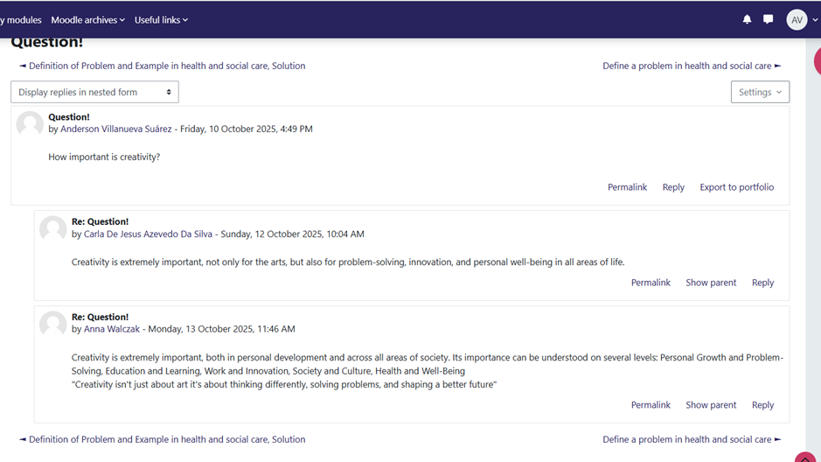
Innovation
Definition: Innovation is a multifaceted concept defined differently across disciplines differentiating it from related terms like invention and imitation. This diversity arises from the interdisciplinary nature of innovation management and the varying demands economic, social, and technology contexts (Lorenz, 2010).
Importance of innovation in Health and Social Care: Innovation in health and social sectors is essential for addressing structural and societal challenges, facilitating changes in social interactions, power dynamics, and health governance. It aims to provide creative solutions to improve accessibility and affordability of care, while enhancing population and financial coverage in line with universal coverage and the Sustainable Development Goas (Van et al,. 2020).
Example: Implementing a new digital system for managing patient records that enables various healthcare professionals to access information remotely, facilitating better coordination of care (NHS England, 2024).

Creativity
Definition: Creativity is a concept that is understood and examined from various sources angles, highlighting its intricacy and the challenges in achieving agreement. It is frequently characterised as the capacity to generate novel ideas, viewpoints, inventions, or artistic creations, suggesting the act of crafting something unique, discovering original answers (GOV.UK, 2023).
Importance of creativity in Health and Social Care: It is linked to improvements in the quality of patient care, improvements in nurses work and personal lives, and promotion of organizational performance
Example: A group of nurses who collaborate to design a new, cost-effective technique for patient mobility, shifting away from costly conventional equipment (Radzi et al., 2025).
Value Creation
Definition: Value creation results from innovation, which involves producing beneficial outcomes for individuals, organizations, or society
Importance in Health and Social Care: It offers a concrete measure of achievement, showing how new methods enhance patient well-being and boost the overall effectiveness of the care system
Example: The telemedicine platform minimizes patient travel time, increase their access to specialist, and reduce the organization cos for each consultation, thereby creating value (NHS England, 2025).
Change
Definition: Change refers to the act of modifying current structures, systems, or behaviours, often resulting from innovation
Importance in Health and Social Care: Healthcare settings are constantly evolving and necessary continuous adjustments to accommodate new evidence, patient requirements, and technological progress
Example: Implementing the telemedicine system demands a transformation in staff communication, scheduling of appointments, and an overall adjustment in the care delivery model to incorporate remote services (Chreim et al., 2012).

2. Mind map to solve problems in Health and Social Care
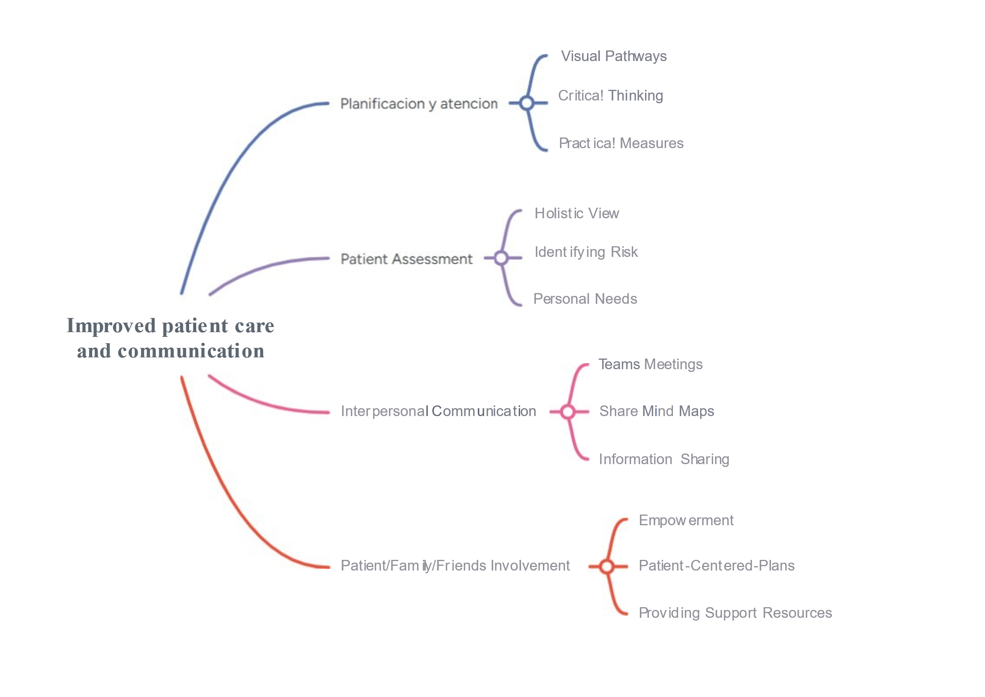3. Convergent and Divergent Thinking
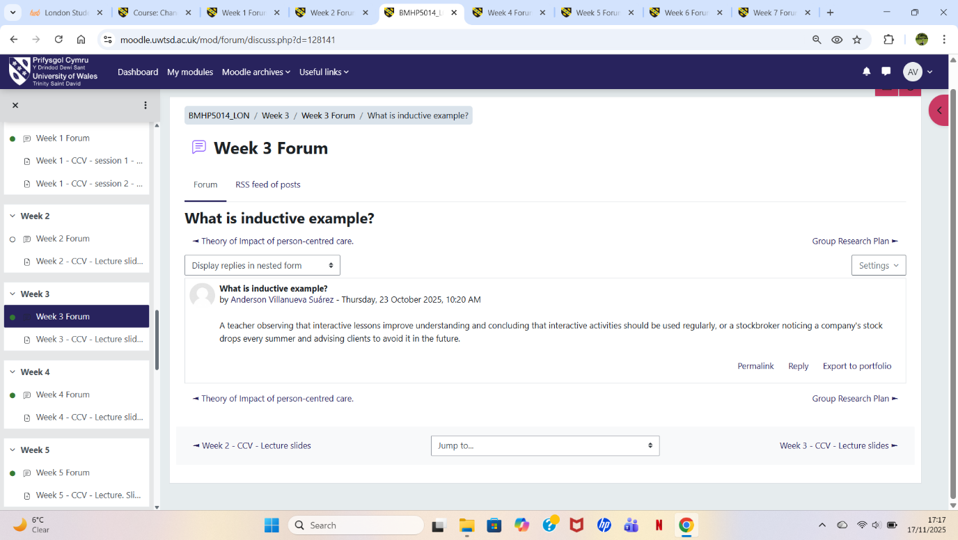
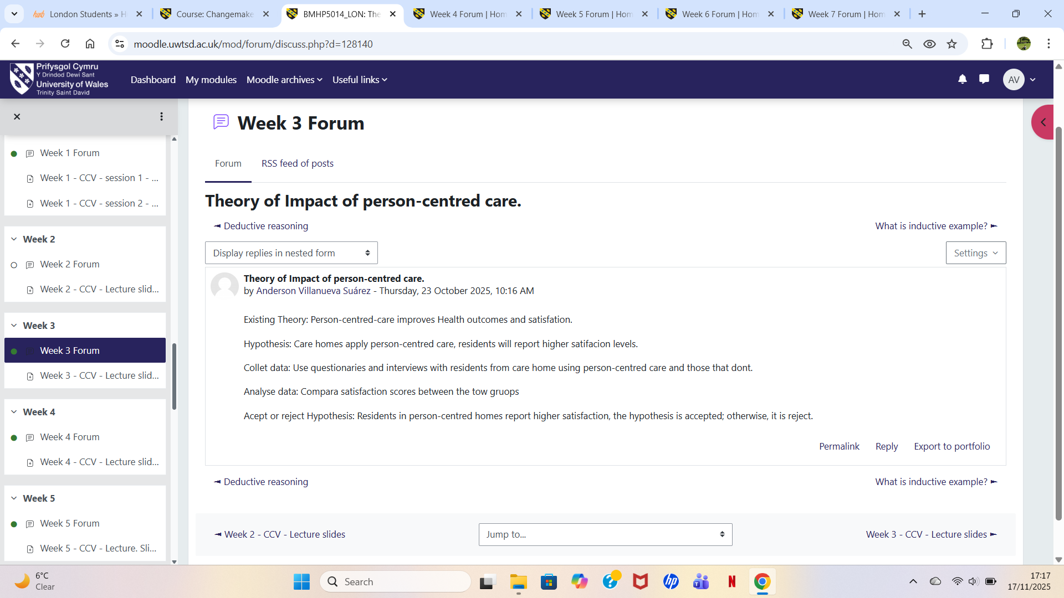

Convergent thinking is a mental process that combines and organizes information using logic and reasoning to address problems or challenges, in contrast to divergent thinking, which creates multiple inventive solutions. Both styles of thinking and reasoning work together and are essential for successful problem-solving (Hongdizi et al., 2023).
The group activity highlighted these thinking styles in the following manner, initially, we applied divergent methods to brainstorm ideas for a problem the needed a solution. For instance, in a real situation at our university, the printer was malfunctioning, divergent thinking prompted us to reach out to the IT department to see if anyone had a repair suggestion, also, propose that they look for a different photocopier supplier, or consider temporary printing solutions from home. After that, we shifted our focus to convergent techniques, assessing and selecting the best option as a team
Reflecting on these insights underscores the significance of fostering a positive team environment and collaboration, emphasizing the value and involvement of every team member. This experience has allowed me to appreciate the diverse perspectives of my collages, realizing that, even if I disagree with their suggestions, it is crucial to acknowledge and consider them, highlighting tolerance rather than enforcing my own viewpoint (Barker, 2022).

4. Case Study Analysis of a UK Innovation
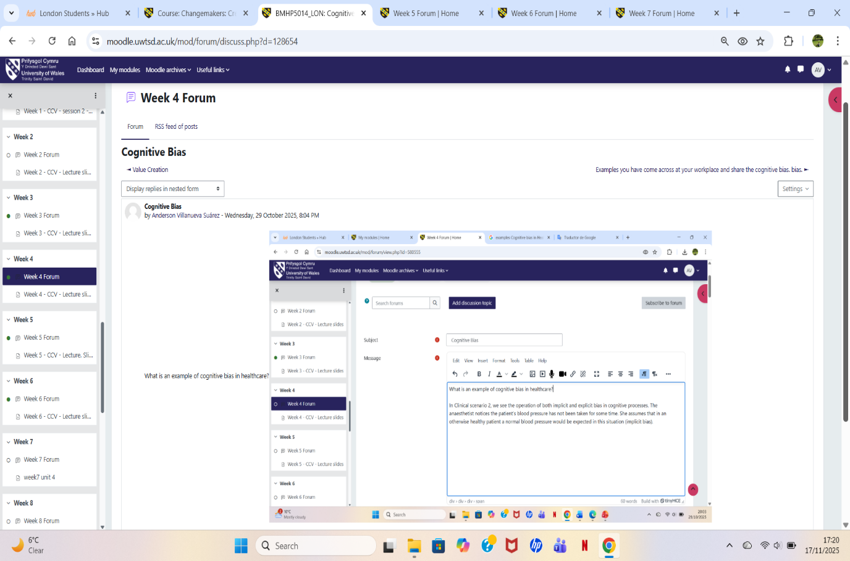
(NHS, 2024).
The NHS has creatively applied artificial intelligence in stroke treatment through the Brainnomix e-Stroke platform, which innovatively analyses brain scans and enhances inter-hospital communication (GOV.UK, 2022).
This innovation addresses the urgent need to minimize the time elapsed from stroke patients arrival at the hospital to the star of treatment. Delays can severely impact outcomes, leading to long-term disability or death. It also offers improvement in communication challenges that arise during patient transfers to hospital for specialized care (GOV.UK, 2022).
This AI platform generated immense value and innovation for patients, who achieved greater independence after a stroke, thereby improving their long-term quality of life and reducing the delay in receiving treatment. For staff, the platform generates value by instant AI-guided decision support, enabling healthcare professionals to make faster and more accurate treatment decisions, while also streamlining communication between hospital teams (GOV.UK, 2022).

5. Current problem in the UK Healthcare and Social services
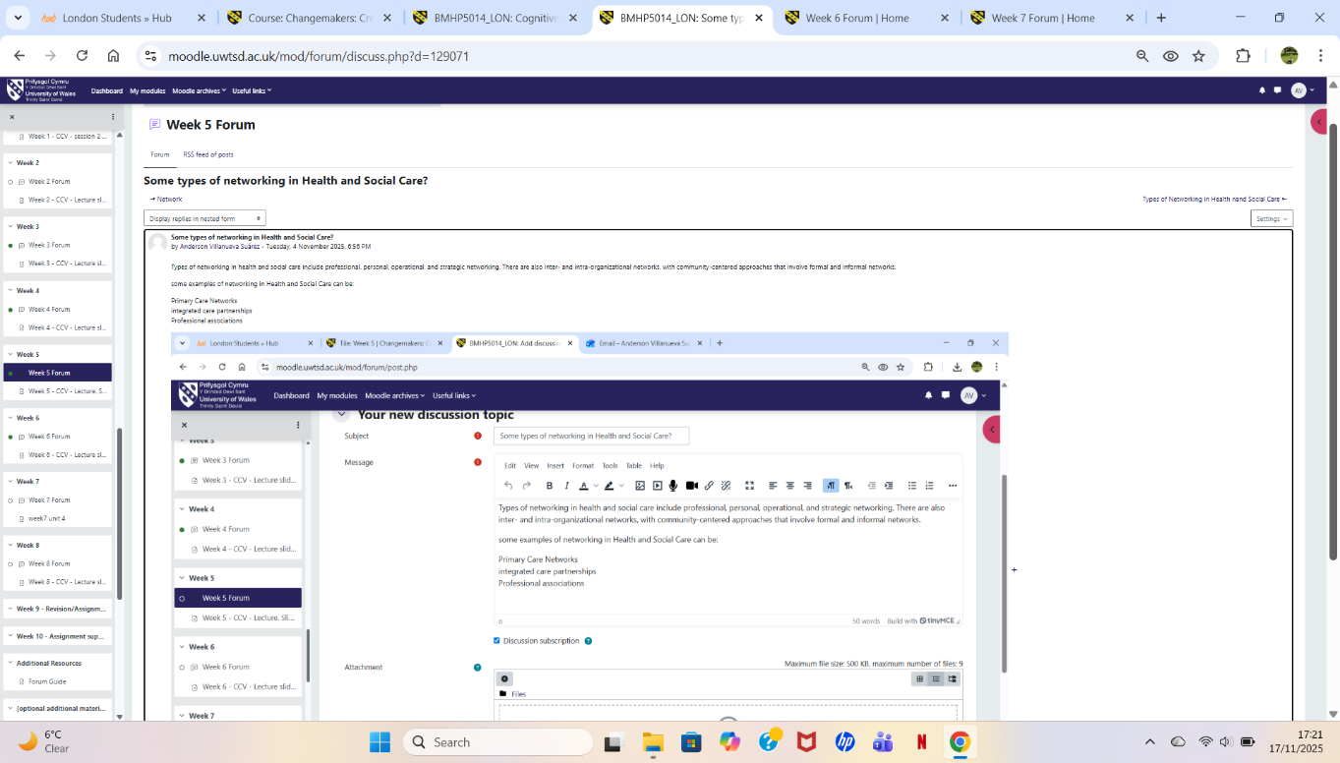
Burnout Syndrome: Burnout syndrome refers to a condition of emotional, physical, and mental fatigue resulting from prolonged and intense stress. It manifests through feelings of depletion, cynicism or disconnection from one’s work, and a diminished sense of effectiveness or achievement. Although it is not classified as mental health disorder, it is frequently associated with workplace stress and may result in anxiety, irritability, and physical issues such as headaches or difficulties with sleep (WHO, 2019).
Burnout syndrome in the UK, particularly among healthcare staff such as nurses, was significantly identified, mainly during the COVID-19 pandemic. One of the main findings was that during the second wave of the pandemic, the majority of nursing staff experienced very high levels of burnout, characterized by mental an emotional exhaustion. Burnout was strongly correlated with a lack of organizational support, resilience, and concern for patient safety. Another finding was a recommendation for nursing manager and staff leaders, focusing on developing better strategies to improve resilience, personal well-Being, and commitment within healthcare and social care organisations (Glasberg, et al., 2007).
Another important conclusion regarding this syndrome among healthcare professionals in the United Kingdon, consistent with the global trends, shows that professionals experiencing or exhibit higher rates than the general population, factors such as workload, night shifts, and exposure to biological hazards contribute to significantly to this risk (Abdulmohdi, 2024).
The study concluded that this syndrome manifested through emotional exhaustion, depersonalization, and reduce personal accomplishment, with physiological factor such as cortisol and melatonin also playing a role. In summary, burnout among UK healthcare staff is influence by a combination of individual, organizational, and social factor. Effective management and leadership are essential in recognizing and addressing burnout to enhance staff well-being (Abdulmohdi, 2024).

6. Benefits Digital Innovation in Health and Social Care
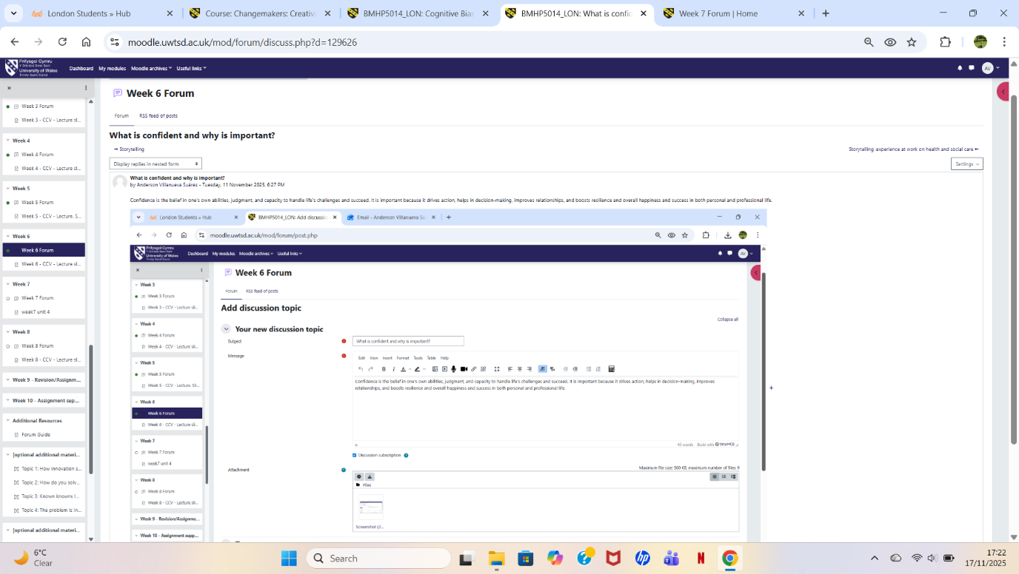
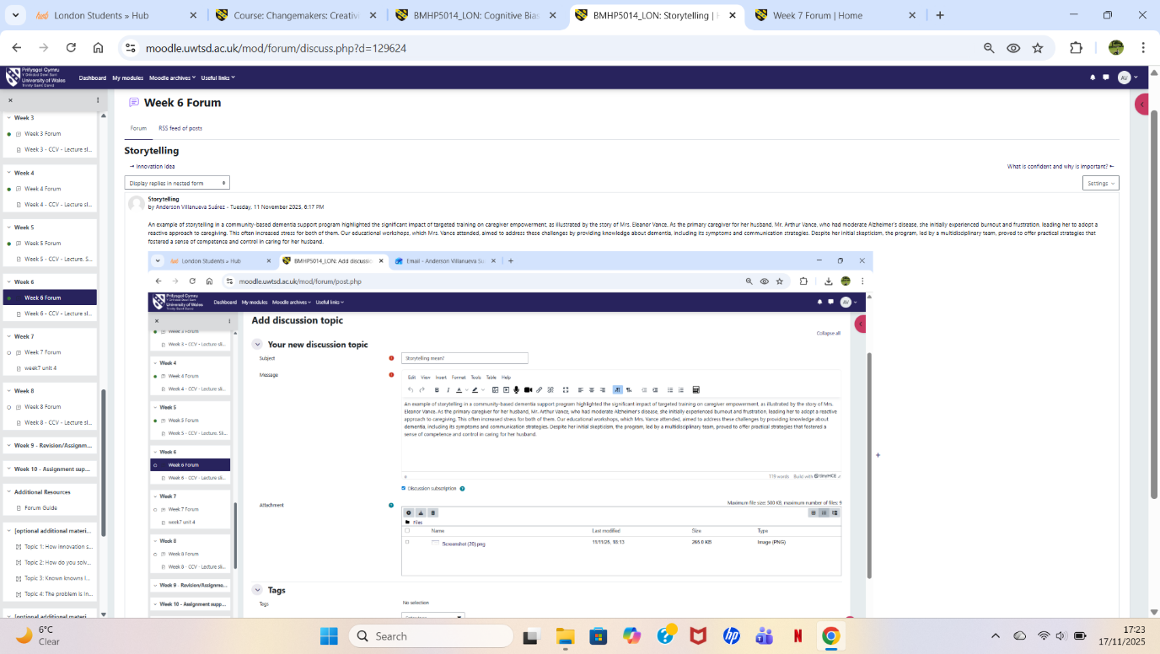
Continuous Glucose Monitors: A continuous glucose monitor (CGM) is a device for people with diabetes that monitors glucose levels day and night using a small sensor worn under the skin. The monitor wirelessly transmits data to a smartphone or reader, eliminating the need for frequent finger pricks and providing continuous monitoring (NHS, 2027).
This allows user to receive personalized care, view trends, obtain early diagnosis, receive customized alerts for high or low glucose levels, and share date with their healthcare team, reducing the need for frequent hospital visits and streamlining their treatment. CGMs can help user better understand how food, physical activity, and other factors affect their glucose levels (NHS, 2027).
An example of continuous glucose monitor (CGM) available in the UK is the Dexcom G6 and G7. These devices are currently widely used for diabetes management and are available through the British National Health Service (NHS), other examples include the FreeStyle libre 3 plus and the Dexcom ONE+ (Diabetes UK, 2025).


(Diabetes UK, 2025)

Communication and collaboration among healthcare professionals
Continuous glucose monitoring communication and collaboration among healthcare professionals by providing access to and continuous flow of information, a real time data rich picture of a patients glucose levels, enabling more informed and focused clinical discussions. Healthcare professionals treatment plans, helping patients better understand how their lifestyle affects their glucose levels. This transforms the dynamics of episodic and reactive care into a continuous and proactive model (NHS UK, 2024).
An example of this collaboration is the centralized data platform, which uses cloud-based platforms or integrated electronic health records (EHRs), this allows all members of the patients care team such as primary care physicians. Endocrinologist, diabetes educators, nutritionist, and pharmacists to access the same real-time glucose data and reports, eliminating reliance on incomplete or inadequate data (NICE, 2023).
Another important example of this type of collaboration is the specific interventions between different specialist; they collaborate and refine in a coordinated manner aspects of patients treatment plan, such as medication adjustments, dietary recommendations, or exercises regimens (NICE, 2023).

(NHS England, 2023).
Digital Technology and Support for Preventive Care
Currently, digital technology plays a crucial role in supporting preventive care a health promotion through various methods that improve disease prevention, patient engagement, and healthcare delivery. Digital health interventions have been implemented at all levels of prevention, (primary, secondary, tertiary, and quaternary) encompassing areas such as vaccination, screening, chronic disease management, and the prevention of unnecessary medical treatments or overmedicalization. These interventions can include health information technologies such as electronic health records, clinical decision support systems, telemedicine, and multi-technology platforms, all of which have demonstrated improvements in clinical outcomes and overall health performance (GOV.UK, 2018).
 (The healthcare insights, 2025).

A real-world example currently existing in the UK is the “Healthier You” program, a joint initiative of NHS England, Public Health England, and Diabetes Uk to provide evidence-based interventions to individuals identified as being at high risk of developing type 2 diabetes. While an in-person option exists, a digital modality was successfully implemented to broaden access and participation, particularly among the young people working-age population (NHS England, 2025).
7. The NHS Leadership Framework
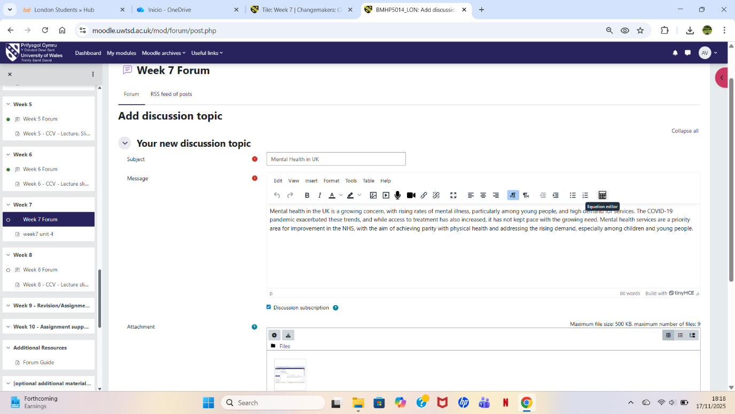
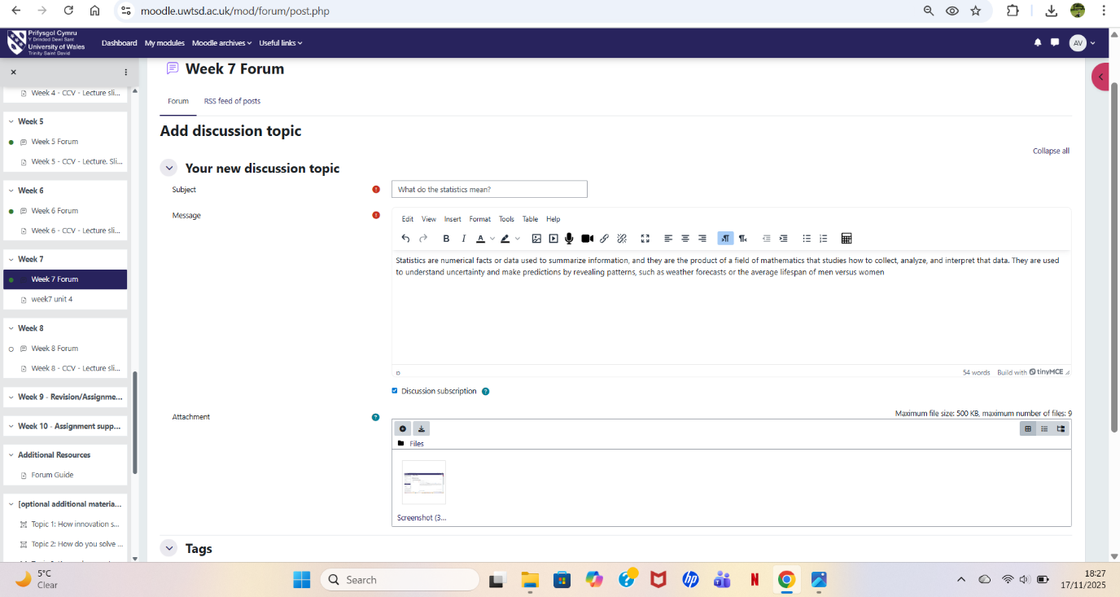
The NHS Leadership Framework outlines the standards and behaviours that characterise effective leadership in the healthcare and social care sectors. This framework is relevant to all personal, applying not just to those in formal management rules but to everyone in the healthcare organisation (NHS England, 2025).
It is essential elements involve establishing a clear vision, supporting employees, promoting a positive workplace culture, and ensuring high-quality patient care through well-defined objectives, supportive leadership, and strong teamwork. This framework is crucial for providing a share language for leadership development, enhancing patient care, and fostering a more engaged and efficient workforce (NHS England, 2025).
This framework is crucial because there is evidence linking effective leadership to positive healthcare outcomes, such a patient and staff satisfaction, as well as lower mortality rates. By standardizing expectations and promoting values like compassion and collaboration, it contributes to the development of leaders who can manage the complexities of the system and foster continuous improvement in healthcare (NHS England, 2024).
Leadership behaviour: Leading with empathy
An NHS leader must use empathy as a core skill to foster creativity and improve patient or service user care. At the same time, empathy also plays a fundamental role in compassionate leadership, which is increasingly important in healthcare settings. Compassionate leadership involves dimensions such as empathy openness, communication, and respect, which together contribute to creating an environment where staff feel supported and motivated. By integrating empathy, cooperation and interdisciplinary partnerships, leaders are better equipped to develop equitable solutions that improve health and overall care outcomes (GOV.UK, 2022).

REFERENCES

Abdulmohdi, N. (2024) ‘The relationships between nurses’ resilience, burnout, perceived organisational support and social support during the second wave of the COVID‐19 pandemic: A quantitative cross‐sectional survey’, Nursing open, 11(1), pp. e2036-n/a. Available at: https://doi.org/10.1002/nop2.2036.
Barker, A.K. (2022) ‘Developing teamwork skills in a course on ore deposits’, Mineralogia, 52(1), pp. 43–48. Available at: https://doi.org/10.2478/mipo-2021-0005.
Chreim, S., Williams, B.E. (Bernie) and Coller, K.E. (2012) ‘Radical change in healthcare organization’, Journal of health organization and management, 26(2), pp. 215–236. Available at: https://doi.org/10.1108/14777261211230781.
Diabetes UK. (2025) Can I get continuous glucose monitoring on the NHS? Available at: https://www.diabetes.org.uk/about-diabetes/looking-after-diabetes/technology/continuous-glucose-monitors/can-i-get-cgm-on-the-nhs#:~:text=blood%20sugar%20levels.-,Which%20continuous%20glucose%20monitor%20can%20people%20get%20on%20the%20NHS,those%20aged%20six%20and%20over. (Accessed on 22 November 2025).
Glasberg, A.-L., Norberg, A. and Söderberg, A. (2007) ‘Sources of burnout among healthcare employees as perceived by managers’, Journal of advanced nursing, 60(1), pp. 10–19. Available at: https://doi.org/10.1111/j.1365-2648.2007.04370.x.
GOV.UK (2022) Artificial intelligence revolutionising NHS stroke care. Available at: https://www.gov.uk/government/news/artificial-intelligence-revolutionising-nhs-stroke-care (Accessed on 28 October 2025).
GOV.UK (2022) Leadership for a collaborative and inclusive future. Available at: https://www.gov.uk/government/publications/health-and-social-care-review-leadership-for-a-collaborative-and-inclusive-future/leadership-for-a-collaborative-and-inclusive-future (Accessed on 28 November 2025).
GOV.UK (2018) The future of healthcare: our vision for digital, data and technology in health and care. Available at: https://www.gov.uk/government/publications/the-future-of-healthcare-our-vision-for-digital-data-and-technology-in-health-and-care/the-future-of-healthcare-our-vision-for-digital-data-and-technology-in-health-and-care (Accessed on 20 November 2025).
GOV.UK, (2023) UK Innovation Strategy: leading the future by creating it. Available at: https://www.gov.uk/government/publications/uk-innovation-strategy-leading-the-future-by-creating-it/uk-innovation-strategy-leading-the-future-by-creating-it-accessible-webpage (Accessed on 21 October 2025).
Hongdizi, J., Cui, Y.-X. and Zhou, X. (2023) ‘Influence of Analytic Processing on Divergent and Convergent Thinking Tasks: The Role of Rational and Experiential Thinking Styles’, Journal of intelligence, 11(2), p. 23. Available at: https://doi.org/10.3390/jintelligence11020023.
Lorenz, R. (2010) ‘What is innovation? Insights and perspectives on the term “innovation”’, International journal of technology intelligence and planning, 6(1), pp. 63–75. Available at: https://doi.org/10.1504/IJTIP.2010.033924.
NHS UK, (2024) Continuous glucose monitoring and hybrid closed loop for diabetes. Available at: https://www.nhs.uk/tests-and-treatments/cgm-and-hcl-for-diabetes/#:~:text=Continuous%20glucose%20monitors%20and%20hybrid,levels%20when%20you're%20asleep (Accessed on 20 November 2025).
NHS England, (2024) NHS leadership competency framework for board member Available at: https://www.england.nhs.uk/publication/nhs-leadership-competency-framework/ (Accessed on 27 November 2025).
NHS England, (2025) Management and leadership development. Available at: https://www.england.nhs.uk/long-read/management-and-leadership-development/ (Accessed on 24 November 2025).
NHS England, (2025) News Digital transformation. Available at: https://www.england.nhs.uk/2025/10/millions-more-online-consultation-submissions-by-patients-to-practices-in-september/ (Accessed on 21 November 2025).
NHS England, (2025) NHS Social Value Playbook. Available at: https://www.england.nhs.uk/long-read/nhs-social-value-playbook/ (Accessed on 22 November 2025).
NHS England, (2024) The Innovation Ecosystem Programme – how the UK can lead the way globally in health gains and life sciences powered growth. Available at: https://www.england.nhs.uk/long-read/the-innovation-ecosystem-programme/ (Accessed on 21 October 2025).
NICE, (2023) Type 2 diabetes in adults. Available at: https://www.nice.org.uk/guidance/qs209/chapter/Quality-statement-4-Continuous-glucose-monitoring-for-adults-who-use-insulin-and-need-help-monitoring-their-blood-glucose (Accessed on 21 November 2025).
Radzi S, Tan JS, Rajalingam P, Cleland J, Mogali SR (2025) ‘Developing and Testing a Framework for Learning Online Collaborative Creativity in Medical Education: Cross-Sectional Study’, JMIR formative research, 9, pp. e50912–e50912. Available at: https://doi.org/10.2196/50912.
Van Niekerk, L., Manderson, L. and Balabanova, D. (2021) ‘The application of social innovation in healthcare: a scoping review’, Infectious diseases of poverty, 10(1). Available at: https://doi.org/10.1186/s40249-021-00794-8.
World Health Organization, (2019) Burn-out an "occupational phenomenon": International Classification of Diseases. Available at: https://www.who.int/news/item/28-05-2019-burn-out-an-occupational-phenomenon-international-classification-of-diseases (Accessed on 17 November 2025)

