
name of the assignment
[Document subtitle]

[Date]
University of Wales Trinity Saint David

Front Page

Include relevant detail:
- Report Title
- Your Name
- Date
- Any other relevant details

Executive Summary

An executive summary should summarise the key points of the report. It should restate the purpose of the report, detail methodology (e.g. detailed research into CRM Strategies at M&S Food), highlight the major findings, conclusions and recommendations from the report
The purpose of this report is to analyse……..

DO THIS SECTION LAST!!!!!!
NOT INCLUDED IN WORD COUNT – this section should be ½ to 1 page in length for a 2000 word report.

DO NOT use any references in this section.

Table of Contents
Executive Summary 1
Introduction 3
Main Findings 4
Sub Headings can be included 4
Conclusion (average of 10% of word count) 5
References 6
UPDATE THE TABLE OF CONTENTS FREQUENTLY – CHECK IT HAS BEEN UPDATED PRIOR TO SUBMISSION

Introduction

The Introduction tells the reader what the report is about. It sets the project in its wider context, and provides the background information the reader needs to understand the report. The Introduction: introduces the topic of the report in context.

Introduce the concept of ‘Customer Relationship Management’ and why it is important for customer retention and loyalty. Evaluate the importance of customer relationships for business success.
Areas you could include in your discussion could be:
- Customer centrality
- Context to the UK grocery supermarket sector

Main Findings (Start on a new page)

Sub Headings can be included

Section 1

M&S Food – Organisation Overview
Provide a brief profile of ‘Marks & Spencer Food’, including critical discussion of:

- The company’s historical development and evolution
- Its current market position: market share, growth or decline trends, market performance (profit or loss status)
- The organisation’s mission statement and how it reflects its values.

Points to consider

- Keep the company history quite brief
- Add some critical discussion E.g. is the market performance good? Are M&S Food in a good financial position?
- Is the mission statement effective?
- Remember to use data (which must be referenced to its source) and references to support your discussion.
- You may find the M&S Annual Report useful, amongst other resources https://corporate.marksandspencer.com/sites/marksandspencer/files/2025-05/Marks-and-Spencer-Group-plc-Annual-Report-and-Financial-Statements-2025_INTERACTIVE_FINAL.pdf

Section 2 (Start each section on a new page)

Data and Customer Relationships
- Define sustainable customer marketing relationships and why is this important for business success (support with academic references)
- Define CRM and CRM Software Systems – critically discuss their importance in business success (use references to support)
- Critically describe how M&S collect, analyse and evaluate data to help build long term customer relationships. YOU MUST GIVE REAL EXAMPLES OF WHAT M&S ARE DOING AND HOW EFFECTIVE THIS IS
  - Where do M&S collect customer data?
  - How do they analyse this data?
  - How does this help M&S build strong customer relationships / retention / loyalty?
- Remember to give positive and negative points in your discussion – e.g. what problems can occur with CRM systems and data management etc

Section 3 (Start each section on a new page)

CRM Strategy Analysis
Use sub headings for each part of this section:
3.1 Segmentation, Targeting and Positioning
- Define STP (use a reference).
- How does this help develop customer loyalty – use examples of how M&S segment and target customers to illustrate your discussion
- You could use a positioning map if you want

3.2 The Marketing Mix (7Ps)
- Define Porter’s Generic Strategies and which strategy M&S Food follow
- Show how M&S use the 7ps – use a table such as the one below
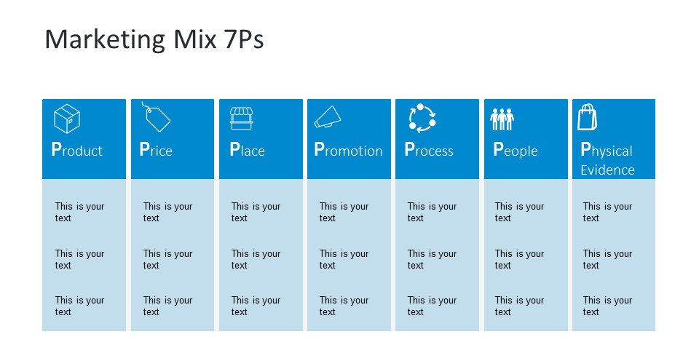
- Critically discuss how this enables M&S Food to meet customer needs and build customer relationships and loyalty.

3.3 The 4Cs of Customer Needs
- Define 4Cs Model briefly
- Analyse if M&S food are meeting customer needs effectively and how this affects customer relationships.
- Include critical comments – do competition meet customer needs more effectively?
Consumer wants and needs | How to M&S Food meet customer needs?
Cost to Satisfy | Do M&S Food provide value for money for customers?
Convenience to buy | Do M&S Food provide convenient solutions for customers?
Communication | How do M&S Food communicate through adverts, personalised messages etc? Does this build trust and loyalty?

3.4 Ethics and Sustainability
- Define Ethics and Sustainability & critically discuss its importance for customer relationships.
- Refer to Tripple Bottom Line
- Evaluate M&S Food’s policies(with examples) and critically discuss of these impact customer relationships. Looks at positive and negative points.

Conclusion (average of 10% of word count)

Draw a conclusion to the report summarising:

- The CRM practices that positively contribute to ‘M&S Food’s’ performance and sustainable customer relationships.
- Areas where ‘M&S Food’ could make improvements to strengthen long-term customer relationships and loyalty.

Reference List (Start on a new Page)

