

LOCATION: Swansea | LLEOLIAD: abertawe
LEVEL 6 | LEFEL 6
EXAMINATION PERIOD | CYFNOD ARHOLIADAU
May 2020 | MAI 2020

MODULE CODE: ACCA6018
COD Y MODWL: ACCA6018
WIDE AREA NETWORKS
TIME: 2 HOURS

Name : Matthew lee Cooze

Student ID : 1911017

Date & Time : 11/05/2020 10am-1pm

All file outputs at bottom of word document

This is an individual practical lab-test, held under examination conditions. You will be assigned three Switches and two Routers; you should configure these devices based on the given specifications.

This paper is marked out of 100.

Device IPv4 Address Tables;
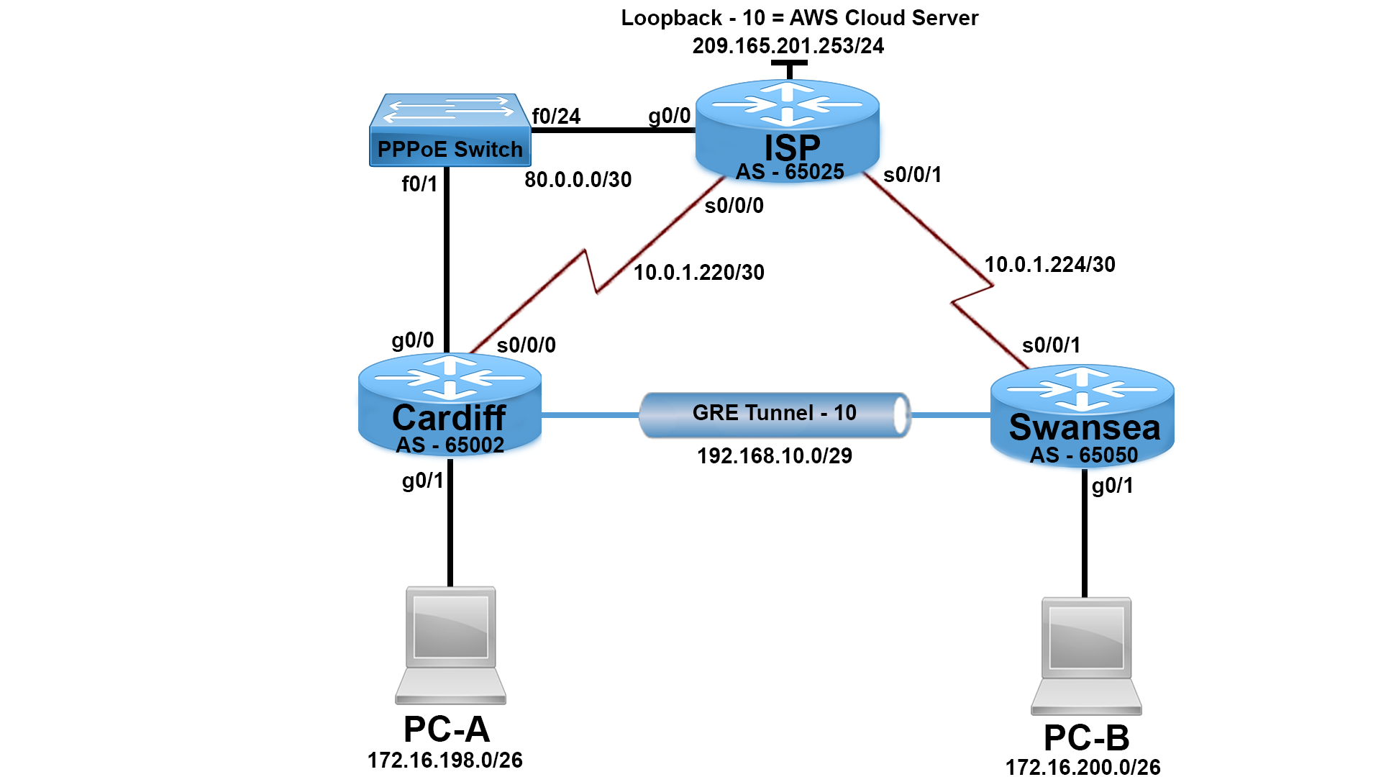

ISP
Interface | IP Address | CIDR
Loopback 10 | 209.165.201.253 | /24
G0/0 | PPPoE Enabled Global Group | -
G0/1 | Last Available Address (Refer to Topology) | /26
Virtual Template 1 | 80.0.0.1 | /30
S0/0/0 | First Available Address (Refer to Topology) | /30
s0/0/1 | First Available Address (Refer to Topology) | /30

Cardiff
Interface | IP Address | CIDR
G0/0 | PPPoE Enabled – Dialer Pool 1 | -
Dialer 1 | IP Address Negotiated – Last Available PPPoE Pool | -
Tunnel 10 | First Available Address (Refer to Topology) | /29
S0/0/0 | Last Available Address (Refer to Topology) | /30

Swansea
Interface | IP Address | CIDR
G0/1 | Last Available Address (Refer to Topology) | /26
Tunnel 10 | Fifth Available Address (Refer to Topology) | /29
S0/0/1 | Last Available Address (Refer to Topology) | /30
PC-A
Interface | IP Address | Default Gateway | DNS Server
NIC | DHCP | DHCP | 8.8.8.8
PC-B
Interface | IP Address | Default Gateway | DNS Server
NIC | DHCP | DHCP | 8.8.8.8

Task 1: - Topology Creation (5 marks)
Using Packet Tracer software create the topology shown above and complete all tasks below.
Task 2: - Basic Device Configuration (10 marks)
- Cable a network as per the topology diagram.
- Configure all devices with IP address shown in the above tables and network topology.
- Configure hostnames on each device.
- Disable DNS lookup on all routers.
- Configure domain name on all routers = wanexam2020.com
- Secure privilege executive login with level 5 encrypted password = class
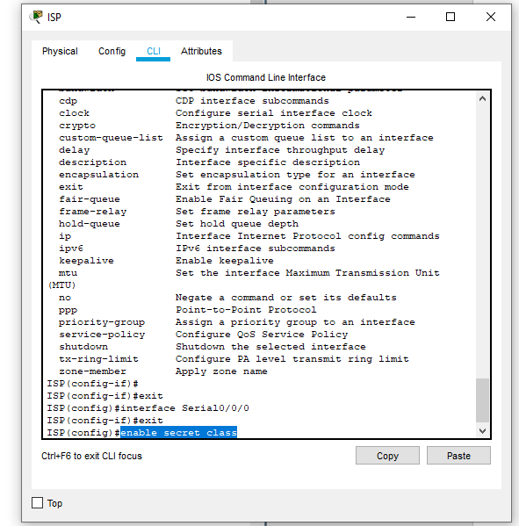

- Create local database of username and encrypted level 5 password for all routers; Username = admin Password = cisco
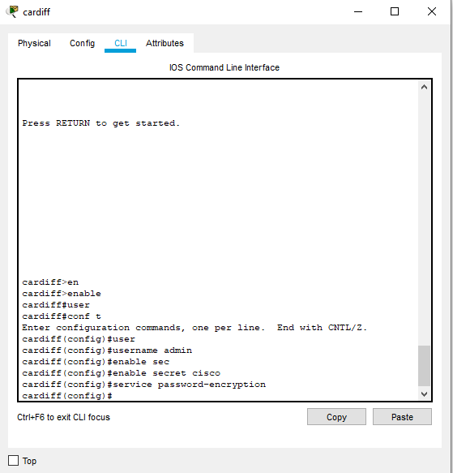
- Secure all router console lines with local authentication and enable synchronous logging.
- Secure all router virtual terminal lines with local authentication and disable telnet.
- After enabling SSH; create cryptographic keys with 1024 bit modules.

Task 3: - Cardiff and Swansea DHCP configurations (8 marks)
- Configure a DHCP pool on Cardiff router so PC-A receives its IP Address, Default Gateway and DNS Server configurations from the DHCP server. (4 Marks)
- Configure a DHCP pool on Swansea router so PC-B receives its IP Address, Default Gateway and DNS Server configurations from the DHCP server. (4 Marks)
Note: Refer to Network Topology and IP Address table for IP addressing and DNS address.

Task 4: - Configure Exterior Gateway Routing with BGP (25 Marks)
- Create a BGP instance on all routers utilizing the Autonomous System Numbers (ASN) that has been given within the network topology.
- Configure all routers with the network statements pertaining to each of their interface subnet addresses.
- Configure BGP neighbor addresses for each router where appropriate.

- Configure a default static route on ISP router with Lo10 as outgoing interface.

- Redistribute the default route within BGP process by adding the network statement: network 0.0.0.0 to the ISP BGP process.

- Verify all routes are on routing table.

Task: 5 - Point to Point Protocol (PPP) (7 Marks)

- Configure all serial links to utilize PPP encapsulation

- Configure Challenge Handshake Authentication Protocol (CHAP) on all routers using the password = wanexam2020

Task: 6 - Generic Routing Encapsulation (GRE) Tunnel (10 Marks)

- Configure a GRE tunnel link between Cardiff and Swansea routers using the IP address given within the IP table for the tunnel addresses. Use tunnel 10 as the GRE interface.

- Use the serial interfaces as the source for each tunnel respectively.

- Use the serial link IP address for the destination of the tunnel on Cardiff and Swansea routers.

- Use default tunnel mode for encapsulation.

Task: 7 - Network Address Translation (NAT) (5 Marks)

- Allow PC-A and PC-B subnet to utilize PAT.

- Configure Port Address Translation (PAT) on the ISP router using the Loopback 10 interface as the translated address.

- Configure NAT on the correct interfaces on the ISP router to start the NAT process.
Task: 8 - Test connectivity Pre ACL (15 marks)
From PC-A, ping PC-B and AWS Cloud Server and vice versa. Is it successful? _____no______
From any PC - B, ping Cardiff router tunnel 10 IP address. Is it Successful? ______no______

Task: 9 - Access Control Lists (ACL) (15 Marks)

Create an ACL to only allow the PC-B subnet to remote SSH into the Cardiff router. ( 3 Marks)
Create an ACL to prevent PC-B from ‘Pinging’ the AWS server and also prevent PC-B from using HTTP and DNS protocols within the AWS server. (7 Marks)
Verify only PC-B is able to SSH to Cardiff router. Try SSH from PC-B and PC-A, screenshot the output here. (5 Marks)

Submission Requirement
The packet tracer file should be saved as “studentname_id” and uploaded on Moodle. In addition to packet tracer file, you must also submit

- the output of show running-configuration command in a text file for all devices configured.
- This document with task 8 and task 9 completed

All documentation for your solution should be submitted electronically on Moodle.
It is your responsibility that you submit all the outputs and files correctly.

ISP
ISP#show running-config
Building configuration...

Current configuration : 2247 bytes
!
version 12.4
no service timestamps log datetime msec
no service timestamps debug datetime msec
service password-encryption
!
hostname ISP
!
!
!
enable secret 5 $1$mERr$hx5rVt7rPNoS4wqbXKX7m0
!
!
!
!
!
no ip cef
no ipv6 cef
!
!
!
username admin
!
!
!
!
!
!
no ip domain-lookup
!
!
spanning-tree mode pvst
!
!
!
!
!
interface Loopback10
ip address 209.165.201.253 255.255.255.0
!
interface Loopback12
ip address 210.165.201.252 255.255.255.0
!
interface FastEthernet0/0
ip address 80.0.0.253 255.255.255.0
duplex auto
speed auto
shutdown
!
interface FastEthernet0/1
no ip address
duplex auto
speed auto
shutdown
!
interface Serial0/0/0
ip address 10.0.1.1 255.0.0.0
encapsulation ppp
clock rate 2000000
shutdown
!
interface Serial0/0/1
ip address 10.0.1.3 255.255.255.0
shutdown
!
interface Serial0/1/0
no ip address
clock rate 2000000
shutdown
!
interface Serial0/1/1
no ip address
clock rate 2000000
shutdown
!
interface GigabitEthernet0/2/0
ip address 209.165.201.253 255.255.255.0
shutdown
!
interface GigabitEthernet0/3/0
no ip address
shutdown
!
interface FastEthernet1/0
shutdown
!
interface FastEthernet1/1
shutdown
!
interface FastEthernet1/2
shutdown
!
interface FastEthernet1/3
shutdown
!
interface FastEthernet1/4
shutdown
!
interface FastEthernet1/5
shutdown
!
interface FastEthernet1/6
shutdown
!
interface FastEthernet1/7
shutdown
!
interface FastEthernet1/8
shutdown
!
interface FastEthernet1/9
shutdown
!
interface FastEthernet1/10
shutdown
!
interface FastEthernet1/11
shutdown
!
interface FastEthernet1/12
shutdown
!
interface FastEthernet1/13
shutdown
!
interface FastEthernet1/14
shutdown
!
interface FastEthernet1/15
shutdown
!
interface Vlan1
no ip address
shutdown
!
ip classless
!
ip flow-export version 9
!
!
banner motd ^C authorised users only^C
!
!
!
!
line con 0
history size 15
exec-timeout 6 45
password 7 0822455D0A16
logging synchronous
login
!
line aux 0
!
line vty 0 4
exec-timeout 8 20
password 7 0822455D0A16
logging synchronous
login
history size 15
transport input ssh
privilege level 5
line vty 5 15
exec-timeout 8 20
password 7 0822455D0A16
logging synchronous
login
history size 15
transport input ssh
privilege level 5
!
!
!
end

ISP#

ISP#
ISP#show ip route
Codes: C - connected, S - static, I - IGRP, R - RIP, M - mobile, B - BGP
D - EIGRP, EX - EIGRP external, O - OSPF, IA - OSPF inter area
N1 - OSPF NSSA external type 1, N2 - OSPF NSSA external type 2
E1 - OSPF external type 1, E2 - OSPF external type 2, E - EGP
i - IS-IS, L1 - IS-IS level-1, L2 - IS-IS level-2, ia - IS-IS inter area
* - candidate default, U - per-user static route, o - ODR
P - periodic downloaded static route

Gateway of last resort is not set

C 209.165.201.0/24 is directly connected, Loopback10
C 210.165.201.0/24 is directly connected, Loopback12

Cardiff

cardiff#
%SYS-5-CONFIG_I: Configured from console by console
show running-config
Building configuration...

Current configuration : 2033 bytes
!
version 12.4
no service timestamps log datetime msec
no service timestamps debug datetime msec
service password-encryption
!
hostname cardiff
!
!
!
enable secret 5 $1$mERr$hx5rVt7rPNoS4wqbXKX7m0
!
!
!
!
!
no ip cef
no ipv6 cef
!
!
!
username admin
!
!
!
!
!
!
!
no ip domain-lookup
!
!
spanning-tree mode pvst
!
!
!
!
!
interface Tunnel1
ip address 50.50.50.1 255.255.255.0
mtu 1476
tunnel destination 192.168.10.1
!
!
interface FastEthernet0/0
no ip address
duplex auto
speed auto
shutdown
!
interface FastEthernet0/1
ip address 192.168.0.253 255.255.255.0
duplex auto
speed auto
shutdown
!
interface Serial0/0/0
ip address 10.0.1.2 255.0.0.0
encapsulation ppp
!
interface Serial0/0/1
no ip address
clock rate 2000000
shutdown
!
interface Serial0/1/0
no ip address
clock rate 2000000
shutdown
!
interface Serial0/1/1
no ip address
clock rate 2000000
shutdown
!
interface GigabitEthernet0/2/0
no ip address
shutdown
!
interface GigabitEthernet0/3/0
no ip address
shutdown
!
interface FastEthernet1/0
shutdown
!
interface FastEthernet1/1
shutdown
!
interface FastEthernet1/2
shutdown
!
interface FastEthernet1/3
shutdown
!
interface FastEthernet1/4
shutdown
!
interface FastEthernet1/5
!
interface FastEthernet1/6
shutdown
!
interface FastEthernet1/7
shutdown
!
interface FastEthernet1/8
shutdown
!
interface FastEthernet1/9
shutdown
!
interface FastEthernet1/10
shutdown
!
interface FastEthernet1/11
shutdown
!
interface FastEthernet1/12
shutdown
!
interface FastEthernet1/13
shutdown
!
interface FastEthernet1/14
shutdown
!
interface FastEthernet1/15
shutdown
!
interface Vlan1
no ip address
shutdown
!
ip classless
!
ip flow-export version 9
!
!
!
!
!
!
!
line con 0
!
line aux 0
!
line vty 0 4
exec-timeout 8 20
password 7 0822455D0A16
logging synchronous
login
history size 15
transport input ssh
privilege level 5
line vty 5 15
exec-timeout 8 20
password 7 0822455D0A16
logging synchronous
login
history size 15
transport input ssh
privilege level 5
!
!
!
end

cardiff#

cardiff#show ip route
Codes: C - connected, S - static, I - IGRP, R - RIP, M - mobile, B - BGP
D - EIGRP, EX - EIGRP external, O - OSPF, IA - OSPF inter area
N1 - OSPF NSSA external type 1, N2 - OSPF NSSA external type 2
E1 - OSPF external type 1, E2 - OSPF external type 2, E - EGP
i - IS-IS, L1 - IS-IS level-1, L2 - IS-IS level-2, ia - IS-IS inter area
* - candidate default, U - per-user static route, o - ODR
P - periodic downloaded static route

Gateway of last resort is not set

Swansea
%SYS-5-CONFIG_I: Configured from console by console
show running-config
Building configuration...

Current configuration : 2220 bytes
!
version 12.4
no service timestamps log datetime msec
no service timestamps debug datetime msec
service password-encryption
!
hostname swansea
!
!
!
enable secret 5 $1$mERr$hx5rVt7rPNoS4wqbXKX7m0
!
!
!
!
!
no ip cef
no ipv6 cef
!
!
!
vpdn enable
username admin
!
!
!
!
!
!
no ip domain-lookup
!
!
spanning-tree mode pvst
spanning-tree portfast bpduguard default
!
!
!
!
!
interface Tunnel1
ip address 192.168.10.1 255.255.255.0
mtu 1476
tunnel destination 192.168.10.0
!
!
interface FastEthernet0/0
no ip address
duplex auto
speed auto
shutdown
!
interface FastEthernet0/1
ip address 192.168.0.253 255.255.255.0
duplex auto
speed auto
shutdown
!
interface Serial0/0/0
ip address 10.0.1.4 255.255.255.0
clock rate 2000000
shutdown
!
interface Serial0/0/1
ip address 10.0.1.253 255.255.255.0
encapsulation ppp
clock rate 2000000
shutdown
!
interface Serial0/1/0
no ip address
clock rate 2000000
shutdown
!
interface Serial0/1/1
no ip address
clock rate 2000000
shutdown
!
interface GigabitEthernet0/2/0
no ip address
shutdown
!
interface GigabitEthernet0/3/0
no ip address
shutdown
!
interface FastEthernet1/0
shutdown
!
interface FastEthernet1/1
shutdown
!
interface FastEthernet1/2
shutdown
!
interface FastEthernet1/3
shutdown
!
interface FastEthernet1/4
shutdown
!
interface FastEthernet1/5
shutdown
!
interface FastEthernet1/6
shutdown
!
interface FastEthernet1/7
shutdown
!
interface FastEthernet1/8
shutdown
!
interface FastEthernet1/9
shutdown
!
interface FastEthernet1/10
shutdown
!
interface FastEthernet1/11
shutdown
!
interface FastEthernet1/12
shutdown
!
interface FastEthernet1/13
shutdown
!
interface FastEthernet1/14
shutdown
!
interface FastEthernet1/15
shutdown
!
interface Vlan1
no ip address
shutdown
!
router rip
!
ip classless
ip route 10.0.1.224 255.255.255.252 209.165.201.253
!
ip flow-export version 9
!
!
!
!
!
!
!
!
line con 0
!
line aux 0
!
line vty 0 4
exec-timeout 8 20
password 7 0822455D0A16
logging synchronous
login
history size 15
transport input ssh
privilege level 5
line vty 5 15
exec-timeout 8 20
password 7 0822455D0A16
logging synchronous
login
history size 15
transport input ssh
privilege level 5
!
!
!
end

swansea# show ip route
Codes: C - connected, S - static, I - IGRP, R - RIP, M - mobile, B - BGP
D - EIGRP, EX - EIGRP external, O - OSPF, IA - OSPF inter area
N1 - OSPF NSSA external type 1, N2 - OSPF NSSA external type 2
E1 - OSPF external type 1, E2 - OSPF external type 2, E - EGP
i - IS-IS, L1 - IS-IS level-1, L2 - IS-IS level-2, ia - IS-IS inter area
* - candidate default, U - per-user static route, o - ODR
P - periodic downloaded static route

Gateway of last resort is not set

swansea#

