Student Name: Vadym Kozlov
Student Number: 1703901
Module Code: EMPL4008
PROBLEM SOLVING
Module Tutor: Syed Muhammad Hammad

Table of Contents
Introduction…………………………………………………………………………………3
Part 1: Skills for tackling the problem successfully…………………………………….4
  - The analysis of the problem…………………………………………………………...5

  - Critical thinking, analysing the key steps of critical thinking……………………….6
Part 2: Understanding organisational analysis and communication skills…………….8
2.1 Identifying the key influencing factors to the organisation………………………….8
2.2 Brief letter to the line manager about the impacts of PEST………………………...9
Part 3: Working with others and understanding employees’ behaviour………………10
Part 4: Data analysis skills and information communication technology…………….11
Bibliography………………………………………………………………………………...12
References………………………………………………………………………………….12
Web Links…………………………………………………………………………………...12

Introduction:
Business Dictionary (2017) describes the problem solving as the technique of reaching the solution by going step by step through the details of an actual problem arisen. In this assignment the author will attempt to analyse the problem solving as the whole process applied within one selected organisation.

Part 1: Skills for tackling the problem successfully
  - The analysis of the problem:
To start analysing the problem solving as the process the author have chosen the organisation where this will be done. The choice was the company where he worked himself as a private hire driver – Abbey Cars UK Group. The reason for that choice was that the author knew this company for 4 years and he was involved in the company activity, also encountered numerous problems arising within the company from time to time. Firstly, let the author introduce the company.
Abbey Cars began as the family business in 1968. Today it’s one of the biggest London’s private hire operator, which has coverage of the whole Grater London and South-East Anglia, including areas such as Dulwich, Dagenham, Feltham, Pinner, Hammersmith, Heathrow and London City airports. Currently it employs nearly 5,000 drivers on the full and part – time basis.
Abbey Cars providing excellent quality of services in the following areas:
- Minicab – they offer access to their large fleet of 5 door vehicles based in around Greater London and the South – East.
- Chauffeur Service – is the most exclusive of the services and provides the range of roomy luxury saloons vehicles all equipped with air – conditioning and satellite navigation.
- Airport Transfers – arranging airport and ferry transfers for any of London’s main airports and docks all year round.
- Tours – lets you see some of the famous landmarks in the UK, accompanied by skilled multilingual guides if required.
- Coaches and Minibuses for any occasion – large variety of air – conditioned minibuses and 49+ coaches are available.
- Overseas Transport – in the past few years the company has expanded greatly and now offers comfortable transportation in the major European cities, North America and Asia.
- PCO Training and Testing – help and assistance with topographical assessment.
After short introduction of the Abbey Cars the author will attempt to analyse some examples of the problems which could be arising within the company from time to time. According to Holistic Software Development (2017) any problem at work while running the business can be assessed by its complexity, therefore they can be identified as simple, complicated and complex.
Simple problem is a well understood issue, and the solution to it is obvious to everyone involved in this problem. It can be resolved straight away, rapidly using quick and effective management. In case of Abbey Cars some drivers were complaining of not being paid enough for their shifts. The manager reacted quickly, summoned the drivers who were not happy to the office one by one and personally adjusted their shift arrangements, so they can work split hours to suite their needs and at the same time to cover busiest periods of time in the office by having extra workforce available. In this problem was sorted at the stage of being simple and it resulted in satisfaction between staff and management, plus the increase of the company profit.
Complicated problem requires lots of analysing, investigation and critical thinking to be. Writing the computer program is complicated, so as the engine building, lots of skills and time is required, but the result predictable.
Complex problem is often the case when simple problem due to lack attention becomes complex. The author identified three stages of that process:
- Inability to define the actual cause of the problem.
- Panicking.
- Ready to leave the problem without solution being offered.
The diagram below shows that complex problem cannot have simple solution.
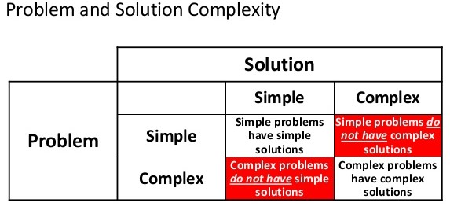
Source: (McSweeney, 2014)

The author now will attempt to analyse the simple problem becoming the complex one in the case of Abbey Cars. In one of the branches of Abbey Cars the night shift controller was not properly assessing and checking some of the drivers coming for the shift, because they were his friends and relatives. Basically, they were reporting for duty even still being at home, or even sitting in the pub. After one of the airport pick ups the passenger smelled the alcohol coming from the driver and accused him of being drunk while on duty. The driver from the other side accused the passenger of being rude and aggressive and left her on the M4 motorway in the middle of nowhere. Passenger called the office and reported it to the night shift manager – controller, she also called police. The night controller though did not report the incident further to upper management and tried to cover it up. Only when the police contacted PCO Head Office and Transport for London, the inspectors came to the branch to investigate.
In this case in the author’s opinion the simple problem such as lack of communication between different levels of management and the employees due to ignorance and negligence from one of the sides became the complex one, involving many other sides such as customers, police, PCO office and Transport for London. That required a set of complex solutions, such as internal investigation, police investigation, PCO office and Transport for London investigation. At the end 4 employees and the controller were dismissed, the company also had to pay heavy fine, apologise to the customer and restructure the management operations in that branch.

  - Critical thinking, analysing the key steps of critical thinking:
Barry K. Beyer (1995) states that critical thinking means “making clear, reasoned judgments”. Ability to think clearly and rationally about what can be done in certain situation can be called critical thinking. Critical thinking is the crucial part of the problem solving.
In this part of the assignment the author will attempt to analyse the key steps of critical thinking and how in his opinion it will help to identify the problem at working place. The diagram below describes 6 key steps of the critical thinking according to Elmansy (2017):
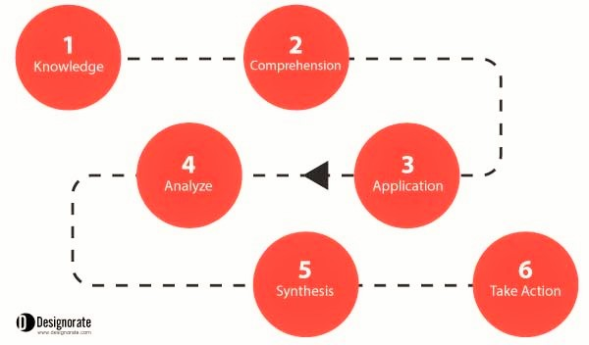

Source: (Elmansy, www.designorate.com, 2017)

The author now will briefly explain all the 6 steps of the critical thinking:
- Knowledge – identifying the actual problem: what is the problem and what needs to be done to resolve it?
- Comprehension – understanding the situation and all the facts about it. Using the research methods available and applicable in such case the relevant data must be collected.
- Application – the continuation of the previous stage with the provisional analyses being involved. The links between information gathered and resources to be required must built to proceed to the step 4.
- Analyse – upon the collection of the required information and the linkages being built between in the main problem the actual analysis can be started. This will include identifying the situation, the strong and weak points and the challenges which can be faced while resolving the problem.
- Synthesis – this stage is the decision-making stage. After full analysis was completed and all the relevant information was taken into the consideration the decision should be finalised. Also, the initial ways to start performing the decision into action should be identified. SWAT analysis is very useful tool which can be used at this stage.
- Take Action – the transformation of the critical thinking results into action steps. In the case of multiply solutions needed, they must be evaluated and prioritized accordingly.
In the case of Abbey Cars, the complex problem with lack of communication between levels of management and employees could have been avoided if one of the managers was able to implement those 6 crucial steps at the stage when problem was only the simple one.

Part 2: Understanding organisational analysis and communication skills
2.1 Identifying the key influencing factors to the organisation:
In this part of the assignment the author will attempt to analyse the key influencing factors applicable to the business activity of Abbey Cars and their impact on the organisation in total. Diagram below names the key influencing factors.
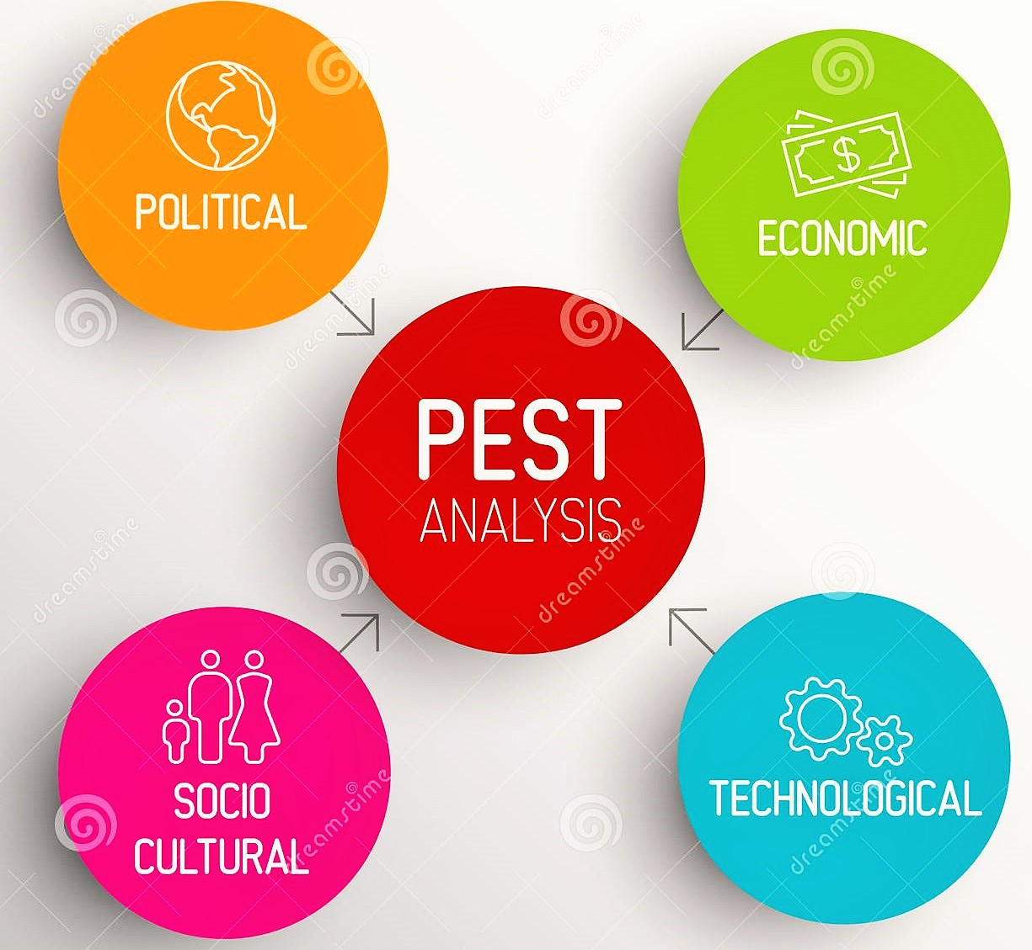
Source: (Dreamstime.com, 2017)
According to Post (2017) the components of PEST could be briefly described as:
- Political – government policy and statements can be influential on organization's success, productivity and profitability. Factors that must be considered are incorporate assessment rules, copyright, property and employment law requirements and political security.

- Economic - this factor analyses the outside financial issues that can be influential to organization’s wellbeing. Things to consider are incorporate financial development, trade and stock exchange vulnerability, credit accessibility and unemployment policies.
- Socio - Cultural – examines demographic and cultural aspects of the company’s market. This factor helps the business to assess customers’ needs and to understand what makes them to buy the company’s products.
- Technological – this factor analyses the technology impact on the company’s ability to deliver products and services to the market. Issues such as the influence of the internet and information technology changes should also be considered in this factor.
2.1 Brief letter to the line manager about the impacts of PEST:
Recently the author wrote a letter to his branch manager Mr Wahid Assam regarding his concerns over the impact of PEST factor on the company’s business activity:
“Dear Sir,
In this letter I would like to raise some concerns regarding the impact of political, economic, social and technological factors on the company’s business activity which You may find useful for the future reference.
First, the political factor. Two main areas of concern: Brexit and all related issues which coming along with it. Some drivers from Europe, especially from Bulgaria, Romania and Poland already unsure whether they will stay in the UK after Brexit will come to force. The second area of concern is some government regulations regarding the obtaining or renewing the PCO licence. The introduction of English Knowledge Assessment already put some drivers off desire to continue work in the future. These two areas can drastically reduce the workforce numbers within the company, so some solution needs to be found very soon. Secondly, the economic factors such as falling exchange rate of the pound and already started reduction in some businesses in Central London because of the Brexit will be affecting the company’s profitability. Third, the social factor is already changing the company’s whole image. New customers from different countries and cultural areas are bringing some changes to the company activity, such as growing demand for bilingual speaking drivers, especially from Europe, China and Asia. And the last factor is technological. Fast changes in the information technology areas, evolution of the internet and need for fast, constant upgrading of the gadgets and devices used for work within the company are putting huge pressure on IT department, which will have to be restructured soon.
I sincerely hope that those notes will be helpful for You Sir on order to manage Your branch more effectively.”

Part 3: Working with others and understanding employees’ behaviour
Staffieri (2006) point out that managing employees can sometimes be more time-spending than any other function and costlier if not done properly. To do this more effectively and less time-consuming the manager must identify which type of behaviour each employee is displaying. In this part of the assignment the author will attempt to analyse two main types of the employee behaviour and what techniques can be used by the management to influence those types of behaviour. According to Management Study Guide (2017) two main types of employee’s behaviour can be identified as: task performers (positive behaviour) and counter-productive work behaviour (negative behaviour). Task performers take their work very seriously, always focused on meeting deadlines and achieving targets on time. They work in close coordination with clients and customers, they also involved in training of newcomers. The management influence on such individuals can be motivation (including financial) to go further and do more, acknowledgment of their value to the company and setting them up as an example of perfect employee. Individuals with negative work behaviour are potentially harming their organization. Such individuals talking bad of their organization they also abuse fellow workers and pass inappropriate comments around. They are often involved in doing unproductive tasks which can spoil the entire work culture. Individuals with bad work behaviour are often involved in thefts, leaking confidential information, data tampering and corruption. Such individuals need to be dealt with patience, all the grievances must have addressed in private. They must have encouraged to get rid of their negative habits through training and counselling. Throwing them out of organisation is not the solution, every possibility of keeping them as valuable workers must be used.

Part 4: Data analysis skills and information communication technology
The introduction of satellite dispatching technology in Abbey Cars 8 years ago has changed the whole process of taking orders and allocating drivers to their jobs. The table below is showing the advantages and disadvantages of using the information technology in minicab business:
Advantages | Disadvantages
Increases production. | Implementation expenses: high costs of installing and upgrading.
Improves communication between drivers and customers, drivers and controllers. | Job elimination: reduces number of controllers, management and call centres.
Improves data storage and file management. | Security breaches: risks of data loss and corruption. Vulnerability to hackers or viruses.
Improves financial management.
Cuts costs in fleet operation.

Table based on source: (Ramey, 2012)

Bibliography:
Cottrell, S. The Study Skills Handbook (2nd edition). Hampshire: Palgrave MacMillan, 2003.
Pears, R. & Shields, G. Cite Them Right. Basingstoke: Palgrave MacMillan, 2011.

References:
Business Dictionary, (2017). Problem Solving. WebFinance Inc. Web Research.
Holistic Software Development, (2017). Simple, Complicated and Complex. Holistic Software Ltd. Web Research.
McSweeney, A. (2014). Complexity and Solution Architecture. Linkedin. Web Research.
Beyer, B., K. (1995). Critical Thinking. Phi Delta Kappa Educational Foundation. Web Research.
Elmansy, R. (2017). 6 Steps for Effective Critical Thinking. Designorate. Web Research.
Post, J. (2017). What Is a PEST Analysis? Purch. Web Research.
Staffieri, N. (2006). Managing the Four Employees Behaviours. SuperVision. Burlington. Vol. 62, Iss. 12, pp 3-5.
Management Study Guide, (2017). Types of Employment Behaviour. MSG. Web Research.
Ramey, K. (2012). Advantages and Disadvantages of Information Technology. Use of Technology. Web Research.

Web Links:
http://www.businessdictionary.com/definition/problem-solving/
https://abbeycarsuk.co.uk/
http://www.designorate.com/steps-effective-critical-thinking/

