Jonah Lewis
P149954
BMSP4005 DISTINCTIVENESS AND REGENERATION

MODULE LEVEL 4
ASSIGNMENT – Past, Present and Future Fortunes of Blaenafon ‘The Iron Town’
Contents
Part A 2
1. Introduction 2
2. Historical Development 2
2.1. Blaenafon’s Industrial Timeline 2
3. Changing Fortunes – the Rise and Fall of Blaenafon’s Fortunes. 3
3.1. Population Explosion 3
3.2. Commercial Development 3
3.3. Residential Expansion 4
4. Existing Assets, Structures and Economic Character 7
5. Key Stakeholders and Interest Groups 9
6. Local/ Regional Development Strategies 10
Blaenafon Heritage and Regeneration Strategy 1997 10
Blaenavon World Heritage Site Management Plan 2011 – 2016 10
CADW – Heritage Tourism Project 2009 10
The Forgotten Landscapes Project 2010 – 2015 10
Blaenavon Town Centre Conservation Area Appraisal & Management Plan (2017 – 2022). 10
Part B 10
Conclusion & Future Economic Opportunities. 10
Business Opportunity 1 – ‘Blaenafon Weekenders ’ 11
Business Opportunity 2 – Up Market Camping 11
Business Opportunity 3 – Renewable Energy 12
References to APA Standard: 14

Part A

Introduction
In this essay, we will travel through the ages from the birth of Blaenafon as a sleepy hamlet, through its formative years as a growing industrial hub in South Wales. To the peak of its powers as a leader in the iron, steel and coal industries in the area. Following on through to its decline with the closure of the main commercial enterprises in the early half of the 20th Century.
The second half of the essay we will review the current situation in Blaenafon and the surrounding area. What is being done and what can be done to turn around the fortunes of this once great iron town.

Historical Development

Blaenafon’s Industrial Timeline
In the late 18th century, Blaenafon was merely a handful of farmsteads scattered over the Coity and Blorenge mountains, with the main occupation being sheep farming and agriculture. The terrain was undulating Welsh hillside. Blaenafon and the surrounding area were known to be mineral rich. Iron ore foraging and forestation of timber to supply the forge at Pontypool dated as far back as 1675.
In 1787 three English entrepreneurs – Hill, Hopkins and Pratt leased approx. 4,800 hectares of land from the Earl of Abergavenny. All the necessary materials (ores, clay, coal and limestone) were available within the leased area known locally as Lord Abergavenny Hills and the idea was to build a state of the art ironworks locally to utilise the minerals.
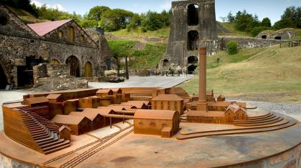
Ironworking was the first of three major industries to be set up in Blaenafon. Initial investment for the new venture was £40,000 (a small fortune in that day and age). It had three furnaces (later expanded to six) and employed 300 when it opened in 1789. Even at its on-set, it was the second largest ironworks in Wales. Production peaked in 1812 when it produced 14,000 tons of pig iron. The whole infrastructure comprised of the main forge in Blaenafon, Garn Ddyrrus and Govilon forges, Pwll Du tunnel, quarries at Tyla and Pwll-du, reservoirs and a network of tram lines inter connecting them and to the canal wharf at Llanfoist.
The ironworks began its decline in 1840 due to lack of demand. In addition, the globalisation of the de-phosphorisation (Bessemer) process actually developed in Blaenafon by Gilchrist Thomas, decreased demand even further.
However, this was not the end for the town as a new steelworks had been constructed at Forgeside in 1860 to take advantage of the newly built Blaenafon – Pontypool railway line, offering quicker and cheaper transport. Sadly this signalled the end of Garn-Ddyrys Forge and the tramline to the Brecknock – Montgomery canal at Llanfoist became obsolete. Although in decline, the Ironworks continued to produce iron ingots for the steelworks before its final closure in 1904. The Steelworks continued production of steel due to the high demand during the Victorian era but declined sharply towards the end of the 19th century. During the WWI (1914-18) it was still manufacturing shell steel for armaments. It finally closed its doors in 1938.
Over 5000 were employed between the two industries at their peaks of production.
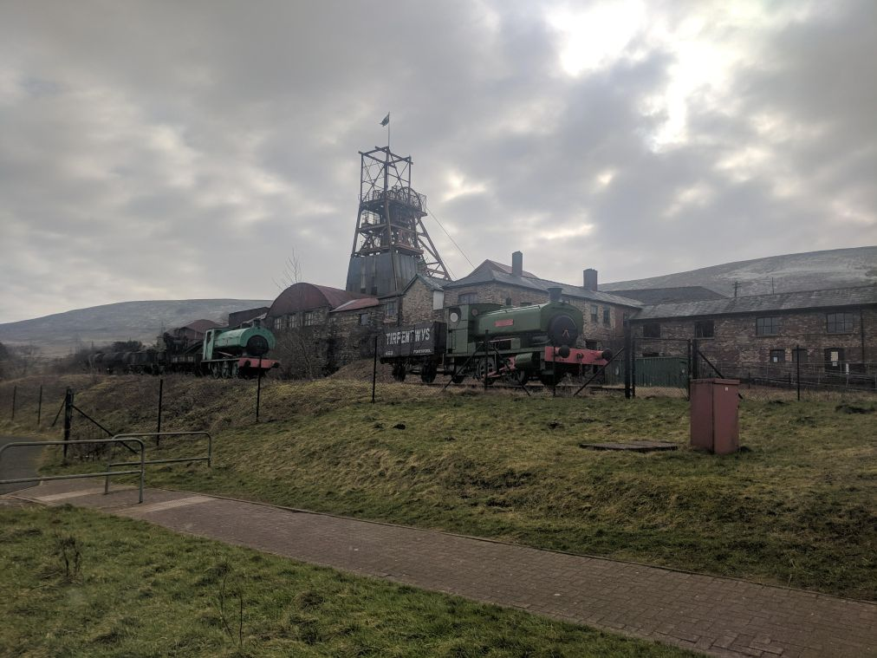
The third and final industry to benefit Blaenafon was coal mining at Big Pit. The original shaft was deepened to 300ft in 1880. Originally, the coal provided the ‘steam’ power at the ironworks and later at the steelworks. However, in the early 20th century there was a great demand for the high quality anthracite coal worldwide, required for the new industrial age. At its height, Big Pit employed 1,399 and produced 250,000 tons of coal yearly.
However, the mining industry in Wales was already in decline in the 1920’s. Big Pit continued to be the major employer in Blaenafon until it finally closed in 1980 with a loss of 250 jobs. Thus ended the industrialised era for the town.

Changing Fortunes – the Rise and Fall of Blaenafon’s Fortunes.

Population Explosion
The opening of the Ironworks created job opportunities as the industry grew to keep up with the increase in production. Skilled workers were required and were imported from England by the Iron Masters. Unskilled labour from all over the UK also migrated towards the source of this new enterprise. Resulting in Blaenafon’s population exploding from 1000 in 1800 to over 5000 in 1830. This continued to grow steadily and peaked at 12,500 in 1921
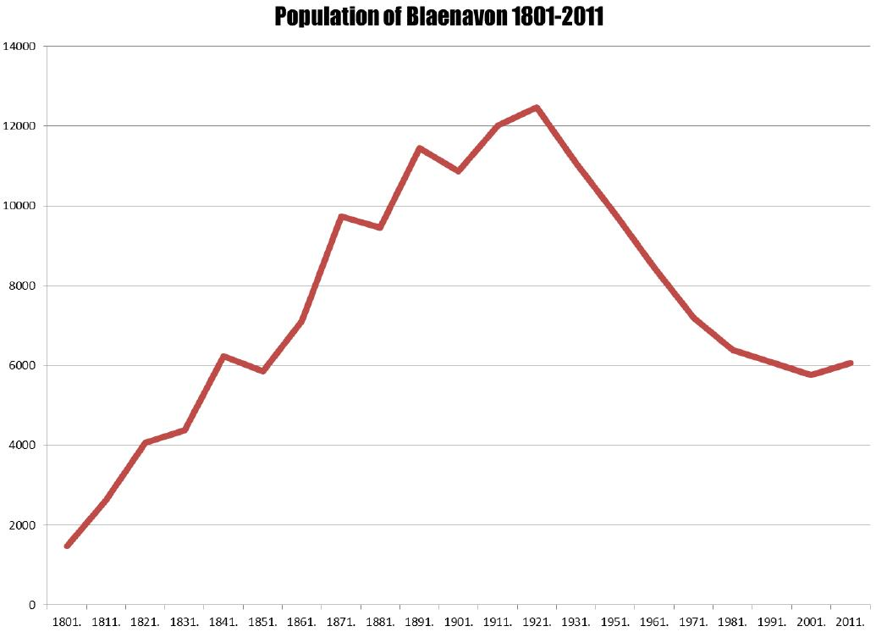

Commercial Development
Where there is a growth in industry, a growth in commerce naturally follows. However, there were only a handful of shops and public houses serving the town by the time John Griffith Williams arrived from Brecon in 1830 to seek his fortune. A draper by trade, he proceeded to develop his business interests in the town. By 1860 he had supplied Blaenafon with its first hotel (The Red Lion), a brewery, a reservoir, pottery, waterworks, gas works and The Coliseum Hall (sadly now demolished). In addition, he was influential in setting up the regular market situated in Market St. More importantly, he persuaded the parochial highways committee to approve the creation of Broad Street, which became a thriving commercial area. In the 1880’s this street alone had ten grocer shops, seven drapers, three watchmakers and two fishmongers.

Residential Expansion
Urban growth came as Blaenafon’s industry flourished. The characteristic of its growth pattern can only be described as chaotic. Buildings were constructed on any available land and followed existing trackways and railways, This can be seen as the town radiated eastwards away from the Ironworks within the valley, as shown in the maps of Blaenafon (below) taken some 60 years apart. The town continued to steadily expand from the early 1800 through to the turn of the 20th century.
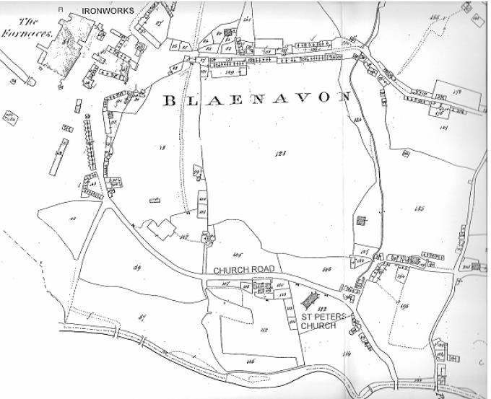 | 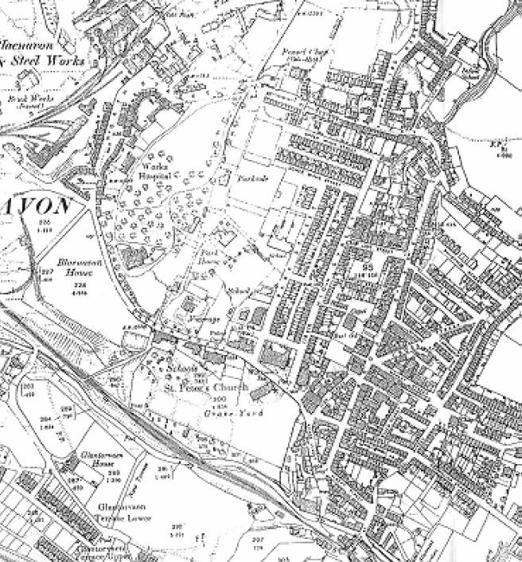
1844 | 1901

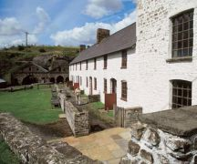
Residences were constructed by the iron company to house the imported workers including Engine Row and Stack Square (pictured left). By mid to late 18th century new residential areas sprang up eastwards surrounding the flourishing commercial area of Broad St and Market Street.

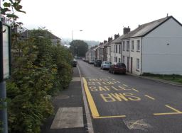
Terrace houses were built up to accommodate the workers in High St, Park St. Upper and Lower Waun St.
Upper Waun St.

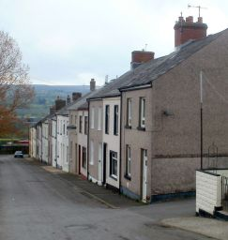
In the 1860’s the satellite village of Forgeside was built to accommodate the workers of the new steelworks. Fine examples of typical workers house still remain.
C Row Forgeside built 1860

At one time the town boasted eighteen churches and chapels, with both Welsh and English services to cater for the influx of imported workers. In 1860 61% of the town’s population were Welsh speaking. There were also over fifty public houses to host the working men at the end of their shifts.
The town began its decline at the turn of the 20th century. A number of factors contributing to its slide namely:
- World War I and the turmoil of its economic aftermath as Britain struggled to pay, greatly affected the economy.
- The Great Depression of the 1930’s. Triggered by the US stock market crash in 1929. World trade slumped and the value of Britain’s exports halved as a result. Unemployment in the region was 20% of the work force.
- Downturn in demand for steel and coal led to short time and redundancies at both the steelworks and the mines.
- Closure of firstly the ironworks in 1904 and then the steelworks followed in 1938 left only one surviving industry – Big Pit and its surrounding collieries.
- However nationalisation of the coal fields in 1947 led to a streamlining of operations and further cuts in requirements.
The loss of the ironworks and steelworks, plus the downturn in mining affected the town greatly. Many left the area in search of work resulting in general long term population decline from the 1920’s. The town lost over 1000 inhabitants every decade until the 1980’s when it levelled out as it effectively had minimal working population left to lose. (refer to the population graph in Section 3.1)
Miner’s strikes from the late 1960’s through to the stand-off with the Conservative government in 1973/4 had an adverse effect causing an already strained National Coal Board to leak more money. More cuts were inevitable
The final hammer blow came in 1980 with the closure of Big Pit. This was the last nail in the industrial coffin for Blaenafon. The town fell into decline and neglect. Local businesses closed due to lack of trade, shop fronts were boarded up and buildings fell into disrepair due to lack of maintenance.
With lack of investments or injection of funds the town went into a period of decline.
From the 2011 UK Census Data:
It was found that over 7.1% of males and 4.3% of females are currently unemployed. This is well above the national average of 4.6%.
Also the median age of the area is 41 years. This indicates that the area primarily consists of the older generation. There is little enterprise to entice younger elements and families to the area. It was also noted that a high percentage actually travelled outside to work. Thus Blaenafon is classified as a dormitory town.

Existing Assets, Structures and Economic Character
Blaenafon has been described as the finest remaining example of an Irontown in the UK. There are a number of fine architectural structures within the town which can be attributed to its wealth and successful industrial past. There are now 26 listed buildings within the conservation area and one Ancient Monument. Being a conservation zone all new and existing dwelling upgrades have to follow strict planning regulations.
The majority of the town was built from the mid 1850’s through to the turn of the century and much remains intact to this present day. Religion was always at the forefront of the South Wales Industrial revolution. The churches and chapels formed a meeting point. And gave the chance for schooling to the younger element. At one point there 18 churches and chapels sadly only 8 remain.
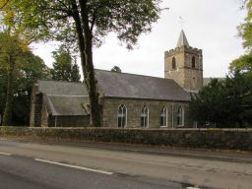
St. Peters was built by the Ironmasters in 1804 – the cast iron pillars and steel façade are testament to the skillset present at that time. This was the first church constructed by company owners for the workers to worship in South Wales.

Other fine examples which remain are:
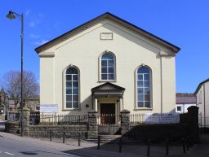
Horeb Chapel in Ivor Street built in 1823 and rebuilt in 1862

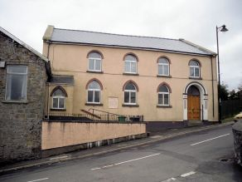
Bethlehem Chapel located in Broad Street – Opened on Christmas day 1820

:
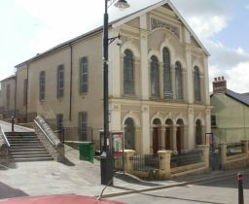
English Baptist Chapel. Located at the bottom of Broad St. Originally built in 1844 then re-built in 1888 in an Italian fresco style.

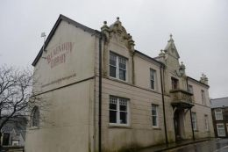
Former Borough Council Offices which were saved and turned into private offices

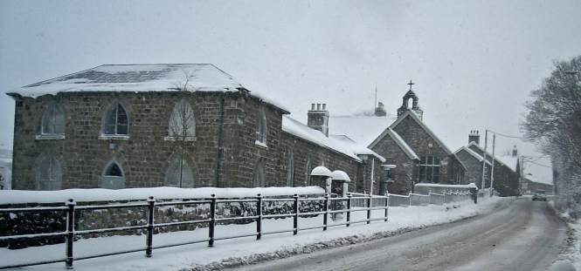
St. Peters School – built in 1816. Founded by Sarah Hopkins in in memory of her late brother.

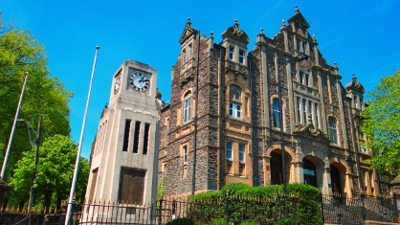
Finally the Working Men’s Hall – funded by contributions from the local workforce. Built in 1894 and arguably one of the finest surviving architectural examples of its kind in Britain.

Key Stakeholders and Interest Groups
To manage the World Heritage Site is a major responsibility and could not be taken on by a single entity the task and risks would be too great. Thus the Blaenafon World Heritage Site Partnership was formed in 1999 to implement a Heritage and Regeneration Strategy, which would both conserve the historic assets of the Blaenafon Industrial Landscape and contribute to its continued economic and social revival.
It was inscripted in Dec 2000 and since then various partners have continually worked together promoting and protecting the conservation area. Its prime objective is to protect the cultural landscape for future generations. It’s intended to promote cultural tourism, a chance to educate the younger generation and change their current perception of the area and highlight their heritage.
Currently led by Torfaen County Borough Council. Other stakeholders are listed below:
Visit Wales - Tourism | Monmouthshire County Council
Royal Commission on the Ancient and Historical Monuments of Wales | Brecon Beacons National Park Authority National Museum Wales
Blaenau Gwent County Borough Council Countryside Council for Wales | Blaenavon Town Council
Welsh Assembly Government | Cadw
British Waterways Board | National Trust (NGO)
.
However the most important partner in this venture is not listed – it is the Blaenafon community in general. As it is they who have the most to benefit and also the most to lose.
Even before the Well-being of Future Generations (Wales) Act 2015, there was a high focus on engaging with the community.
There is ongoing consultation with the Blaenafon Traders and Tourism Association, the Community Heritage Museum, the Pontypool and Blaenafon Railway Company, the World Heritage Day Committee and the Govilon Heritage Group.

Local/ Regional Development Strategies
Attempts at regeneration of Blaenafon and the surrounding region have been ongoing since the 1960’s with little to no success.
With UNESCO status in Dec 2000 circumstances took a turn for the better. The UNESCO World Heritage Committee however stated that “all World Heritage Sites must have an appropriate management system in place which should specify how the ‘Outstanding Universal Value’ (OUV), authenticity and integrity of the site should be maintained”.
A number of programs have been run since 2000 namely:

Blaenafon Heritage and Regeneration Strategy 1997
This management team was set up in 1997 to provide an integrated strategic vision, action and management plan to discuss and apply for funding via the Heritage lottery Funding (HLF) and other financial programs. This study led to the nomination of the areas for special consideration which it achieved when UNESCO granted World Heritage Status. A 10 year plan was then put in place to regenerate the area whilst still ensuring the original industrial heritage remained intact.

Blaenavon World Heritage Site Management Plan 2011 – 2016
Followed on from the initial 10 year plan which commenced in Jan 2001. Aim was to continue regeneration for the area and build on the achievements of the first. Thus ensuring Blaenafon continued to be at the forefront of heritage led regeneration projects.

CADW – Heritage Tourism Project 2009
The aim of this project was to open up Wales’ heritage to appeal to audiences on both the national and international arenas. Initial investment at the Blaenafon Ironworks led to a 14.2% increase in visitors

The Forgotten Landscapes Project 2010 – 2015
Received £1.6 million from HLF to ensure the upkeep of the relict landscape of the surrounding area.

Blaenavon Town Centre Conservation Area Appraisal & Management Plan (2017 – 2022).
The Blaenavon Town Centre Conservation Area Appraisal & Management Plan (BTCCAAMP) is reviewed every five years and at present includes 26 listed buildings and one Scheduled Ancient Monument.
The updated plan will run between 2017 and 2022 and will allow the council to apply for stage two funding from the HLF, which is an estimated £2million

Part B

Conclusion & Future Economic Opportunities.
Blaenafon is in a better place than it was 20 years ago. With upgrades and refurbishments ongoing throughout the region since achieving its UNESCO status. However this is still work in progress. There is more to be done.
When assessing the current recovery plan it is obvious the main revenue will be through tourism. Whether it be historic, eco or cultural as the way to improve Blaenafon’s social and economic fortunes. Additional funding by the Government and the Welsh Assembly in 2019 hope to attract another 250,000 to the Heads of the Valleys area in general.
The Ironworks, Big Pit and Blaenafon’s historical town and architecture attracted over 190,000 tourists in 2016. As a tourist industry the idea is to ensure their experience is an enjoyable one. Then there is every chance tourists will return and also recommend to friends. This is turn increases future visitation and increases the end revenue.
Looking at the current Blaenafon calendar there are already events scheduled in for the spring, summer and autumn. Carnivals, country fetes, etc. But these are just day trips. Most visit Big Pit or the Ironworks, currently few visit the town itself – they come during the day and at night the town is empty. The idea is once the tourists are in the region is to try and keep them there. This has a knock on effect as there will be a need for accommodation, food and fare. Where unfortunately Blaenafon is lacking in both. You can’t honestly see people spending a week of their summer vacation in Blaenafon – but a long weekend? That has possibilities.

Business Opportunity 1 – ‘Blaenafon Weekenders ’
At least once a month from Easter through to Sept have an event which spans both Saturday and Sunday. It needs precise planning and needs to be advertised and subscribed to well in advance.
You need 6 – 7 events per season. Each one if successful could bring thousands of pounds of additional revenue into the town. Every event will need meticulous preparation and planning. But the extra effort will reap massive rewards. This however cannot be done on a voluntary basis and would need a small dedicated paid team.
It has to work around sports and recreation – as these have the best chance to maximise attendance. Examples would be a ‘Valley Rugby 7’s and 10’s’. They can be hosted at both Blaenafon and Forgeside grounds. Add to the spice and offer a decent amount of prize money (funded by local businesses) and wait for the applications to roll in. Current successful examples are the Aberaeron 7’s, Heineken Amsterdam 7’s’, Kelso Borders 7’s
Blaenafon Biathlon or 10K – quality rural countryside to choose your routes. Make it a weekend event by offering a Juniors Biathlon on the Sunday. Possibly look at setting the Blorenge 5K Mountain Challenge for another weekend’s competition.
Pop Concert – The current events schedule does not take into account todays trends (A dart night with the aging Bobby George and partner is not likely to draw in the younger crowds!) This is the most complex to organise but has the greatest profit margins. Some thought would need to go into the organisation of this. Possibly start on a Friday evening and go through to Sunday afternoon.
Other sports to be considered – Mountain biking, half marathon.
It’s all about bringing in the punters. So you have to look at current trends which attract competitors and even more so spectators.

Business Opportunity 2 – Up Market Camping
This goes hand in hand with Business Opportunity 1.
There’s currently insufficient accommodation within Blaenafon. Your choices are limited to The Lion or the Queen Victoria. After that you have to travel outside the town. To draw the crowds and make the most of their revenue they have to able to stay in or close to the facilities.
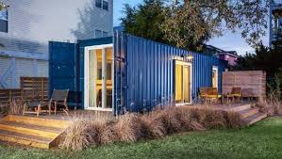
It’s a big gamble to invest in B&B’s, hotels or restaurants if the long term enterprise plan cannot be guaranteed. However if there was an ‘alternative’ campsite set up to accommodate the weekend traveller (initially) Then the capitol required is less. To offset the ‘camping stigma’ you could set the scene with luxury portakabins (http://www.bunkabin.co.uk/ or http://www.portakabin.co.uk/living-accommodation.html)
Or for the more extrovert go ‘glamping’ with https://www.exclusivetents.com/
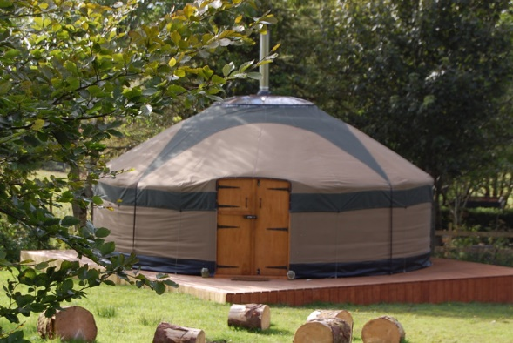
Initially these units (both cabins and yurts) could be hired in and make a small percentage profit on the hire cost. Numbers required will come from advance bookings. So planning must be meticulous. The camp site would need to be set up with sanitation and mains power. There would be a cost to build the main site to allow for camp office, club house, maintenance deport, security cameras, etc. Each pitch should come with a minimum of electric and water. Make sure there is adequate sanitation and shower facilities available.
Both the above would be of benefit to the town. As the hostelries, restaurants, cafes and shops in general would see a significant boost in trade. If the location it too far to walk then run a camp bus to ferry passengers to and from of the town.

Business Opportunity 3 – Renewable Energy
This, although originally set to cover off the free energy to the campsite. Can actually be utilised for any requirement both locally on other venture and farther afield. Again there will be an initial outlay. But it’s for the equipment and battery systems only. Apart from minimal maintenance these should pay for themselves in a relatively short space of time.
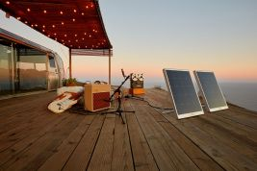
With the campsite to make it more eco-friendly each unit could be provided with their own solar panels – https://solpad.com.
These units are portable but can be set into a main frame if required.

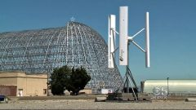
The site could further supplement its power requirements by using a mini wind turbine refer to https://semtive.com/ This can be set up within the campsite to make it more self sufficient. The Valleys are always pretty windy even on a summer’s day. So why not harness the power.

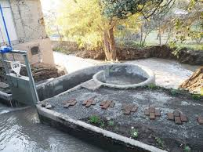
Finally there’s the chance to harness the hydro power of the area. If the campsite is located near any fast flowing torrent then why not tap into this as an additional source of free energy. This solution again can be utilised anywhere there is water – but this is a permanent solution whereas the other can be moved to alternative venues if required. Turbulent in Belgium have devised a mini hydro that can be installed next to a water course with the minimum of effort and the main stream source is not deviated but becomes part of the hydro system. http://www.turbulent.be/

(Words 3490)

References to APA Standard:

I live here (No date); Statistics for Blaenavon

https://www.ilivehere.co.uk/statistics-blaenavon-torfaen-4029.html

[Accessed 4th April 2018]

Welsh Government (8th August 201) - Well-being of Future Generations (Wales) Act 2015

Available at:
http://gov.wales/topics/people-and-communities/people/future-generations-act/?lang=en

[Accessed 4th April 2018]

Mills J. (20th July 2015) –Blaenavon World Heritage Site gets thousands in grant funding. South Wales Argus

Available at:
http://www.southwalesargus.co.uk/news/13464831.Blaenavon_World_Heritage_Site_gets_thousands_in_grant_funding/

[Accessed 4th April 2018]

Visit Blaenavon (No Date) – Blaenavon World Heritage Site / Regeneration

Available at:
http://www.visitblaenavon.co.uk/en/WorldHeritageSite/LookingAfterBlaenavon/Regeneration.aspx

[Accessed 6th April 2018]

Blaenavon WHS Management Plan – Executive Summary.pdf (April 2011)

http://www.visitblaenavon.co.uk/en/Publications/WorldHeritageSite/LookingAfterBlaenavon/BlaenavonWHSManagementPlanExecutiveSummary.pdf

[Accessed 6th April 2018]

Free Press Reporter (17th October 2017) Proposal for £2million fund to help develop Blaenavon's town centre – Free Press

Available at:

http://www.freepressseries.co.uk/news/15601703.Proposal_for___2million_fund_to_help_develop_Blaenavon__39_s_town_centre_must_consider_the_financial_limitations_with_conservation_area_boundary_change/

[Accessed 6th April 2018]

Visit Blaenavon (No Date): Blaenafon World Heritage Site – Documents

Available at: http://www.visitblaenavon.co.uk/en/WorldHeritageSite/LookingAfterBlaenavon/Documents.aspx

[Accessed 6th April 2018]

Blaenafon Renewal Area Newsletter.pdf (February 2009)

Available at: https://www.torfaen.gov.uk/en/Related-Documents/Housing-Improvement-Grants/Blaenavon-Renewal-Area-Newsletter.pdf

[Accessed 6th April 2018]

Visit Blaenavon (September 1998) Blaenafon Heritage Regeneration Study.pdf

Available at:
http://www.visitblaenavon.co.uk/en/Publications/WorldHeritageSite/LookingAfterBlaenavon/BlaenavonHeritageandRegenerationStudy1998.pdf
[Accessed 6th April 2018]

Blaenavon Ironworks (No Date)
Available at: http://cadw.gov.wales/daysout/blaenavonironworks/?lang=en
[Accessed 09 Feb 2018]

The Blaenavon Ironmasters (No Date)
Available at: http://www.visitblaenavon.co.uk/en/Publications/Blaenavon-Story/The-Blaenavon-Ironmasters.pdf
[Accessed 09 Feb 2018]

Blaenavon Historical Processes, Themes and Background (No Date)
Available at: http://www.ggat.org.uk/cadw/historic_landscape/blaenavon/english/Blaenavon_Features.htm
[Accessed 10 Feb 2018]

Blaenavon Town Centre Conservation Area Appraisal and Management Plan 2017 – 2022 (No Date)
Available at: https://www.torfaen.gov.uk/en/Related-Documents/Forward-Planning/Blaenavon-Conservation-Area-Appraisal-and-Management-Plan.pdf
[Accessed 10 Feb 2018]

Industrial Wales and Monmouthshire – Blaenavon Town (No Date)
Available at: http://www.industrialgwent.co.uk/a51-blaenavon/index.htm
[Accessed 10 Feb 2018]

Big Pit: A Brief History (No Date)
Available at: http://www.visitblaenavon.co.uk/en/Publications/Blaenavon-Story/Big-Pit.pdf
[Accessed 11 Feb 2018]

Blaenavon Industrial Landscape (No Date)
Available at: http://whc.unesco.org/en/list/984
[Accessed 12 Feb 2018]

Blaenavon Industrial Landscape (No Date)
Available at: https://worldheritageuk.org/about/ourworldheritagesites/wales/blaenavon-industrial-landscape/
[Accessed 12 Feb 2018]

