university of wales trinity saint david
Motivation in leadership and management
Managing Organisations
Rachel Griffiths 1808557
3/4/2019

Table of contents

Abstract……………………………………………………………………………………2
Introduction………………………………………………………………………………..2
Main body …………………………………………………………………………………3-7
Conclusion…………………………………………………………………………………7
Recommendations…………………………………………………………………………7
Reference list ………………………………………………………………………………8

Abstract
The purpose of report is to evaluate a contemporary theme in health management and its impact on organisational structure and culture in supporting leadership and management and how new realities and change to The National Health Service organisation affects the motivation of its employees. It will look at the roles of good management and leadership in supporting an organisation and relate to theories. At present the NHS are under stress to deliver care to the growing population and are looking to change and restructure in order to meet these demands.

Introduction
A contemporary theme within health management is change, this along with new realities continuously being raised from ongoing health research means healthcare organisations need to implement initiatives that aim to improve delivery of care. According to the Health secretary Andrew Lansley, the NHS is a standard setting of excellence with its design and performance, however, in some areas it lacks values and principles. Similarly, Aylward (2011) stated that they “strive for a world class healthcare service by scrutinising the relevance of health issues and ideas and finding ways in which it can be improved” (Great Britain, The Bevan Commission, 2011). Over the past 60 years, the structure of the NHS has seen a dramatic change due to the economic situation (NHS England, 2019). Such a rise in financial and political pressures raises question as to whether it can continue to function in meeting its demands. These demands and pressures have an effect on the management of the NHS because the health boards of the organisations need to come together to promote best practice. Such changes and new realities puts pressure on management because they need to be skilled and knowledgeable in how to implement changes in the organisation with the support of subordinates (Hewison and Griffiths, 20014). Failure in managing changes efficiently and effectively will result in employees feeling fearful which can lead to a breakdown of relationships and a lack of motivation. This can have a negative effect on an organisation because managers cannot achieve their goals without participation from all of the team. Consequently, improved outcomes are a result of effective changes made with the participation of all members within an organisation, this is why good management is very important.
.

Main Body
Heinzberg (1959) theory of motivation suggests that there are a range factors within an organisation that provide job satisfaction for employers and also factors that cause dissatisfaction. For employees to be satisfied with their job there are a set of hygiene factors and they are essential for existence of motivation in the workplace. These factors include appropriate pay and being equal to others with the same role, work flexibility, break entitlements, holidays, and working conditions that need to be clean, hygienic, and safe. Motivation factors meet the employee’s psychological needs by persuading employees to complete goals, this is done by appraisals and recognition of the work they have accomplished. Workers need to have a purpose and a sense of achievement to feel relevant to the organisation and, also, need to have the opportunity to grow and advance within the organisation. Subsequently, motivation is clearly affected by the impact of organisational structure and workplace conditions.
Organizational culture raises the fundamental assumptions and principles shared by members of an organisation (Schein, 1985). According to Beerel (2009), these assumptions and beliefs function consciously and unconsciously and depict the organizations view of itself and its environment. Ultimately, they are learned reactions of the challenges for survival internally and externally. An organization’s culture not only advances from its founding leader’s beliefs and practices but its experiences of the environment which has been moulded by countless leaders over time. These particular beliefs, assumptions and practices become implanted within an organisation’s culture, therefore appearing as the norm (ibid).
Corroborating norms and customs provides an organisation with certainty and assures associates that everything is somewhat under control, this is why new realities and changes heighten anxiety within an organisation, but it is not always negative anxiety. To overcome this, the leader must be innovative and be creative as he, or she, will need to break down current practice by aiming to contain control of the purpose and empower subordinates by sharing the vision and assuring them the outcome is for the greater good (ibid). Therefore, change involves altering organisational culture, along with the beliefs and practices that go with it and this alteration of culture may require the interruption of existing systems.
In this way management and leadership are closely related. Management can be defined as the process of planning and controlling things or people so that there is a productive outcome of work. Likewise, leadership is the action of motivating people to act in ways so that goals can be achieved (Hannagan, 2009) Undoubtedly, the motivation of employees is closely linked to management and leadership processes.
Management and leadership are applicable to all types of organisations. Managers of different organisations apply or use different managerial or leadership techniques or methods, therefore they can either help their organisation by knowledge diffusion and sharing of practices or they may hinder development by the use of poor strategies. Management can, therefore, be beneficial to employees or have a negative impact. (Bresen et al, 2017).

Mintzberg (1990) stated that managers have a duty to lead the team, resolve any conflicts, and negotiate new contracts within the company, and externally, as well as regularly attending board meetings. Roles of managers can be further subdivided into categories such as interpersonal, informational and decisional (Caramela, s. 2018).

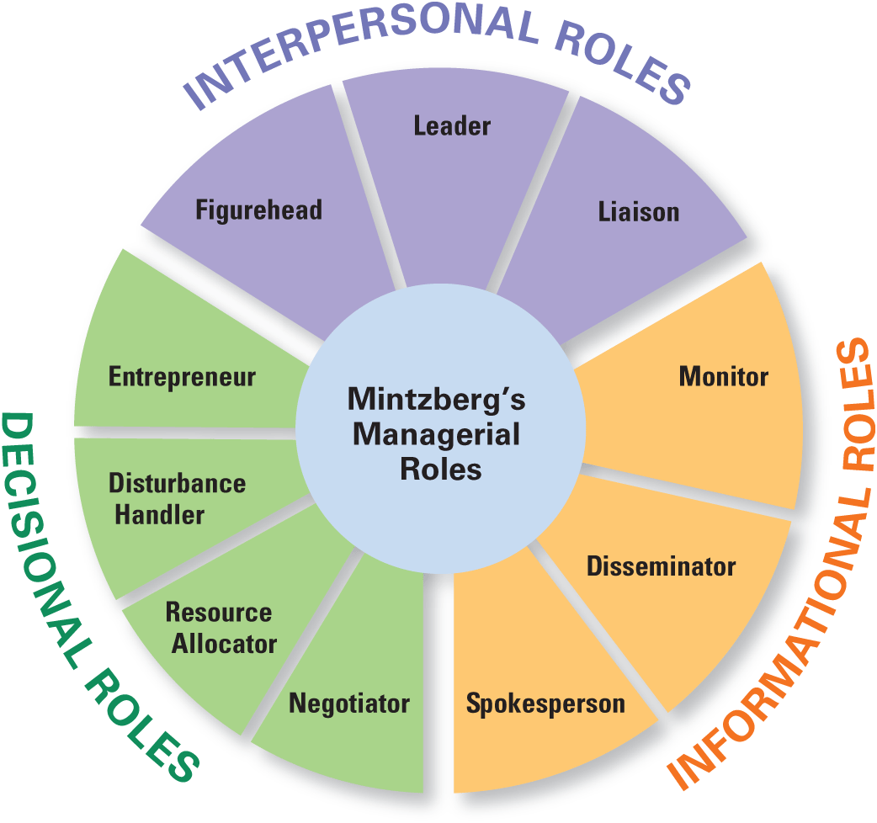
Mintzbergs managerial roles
To date the Health Care sector and health organisations such as the NHS are currently experiencing major pressure to change and restructure. The financial struggles are developing an economic crisis and there is a greater demand for better quality of service from the public, which puts pressure on health care professionals (Bresen et al, 2017).
Leadership and management is important because it secures the organisation without it, an organisation could collapse, especially in a large organisation such as the NHS, also the way in which an organisation is structured is just as important (Dickson, 2007).
Subsequently Hannagan (2008) notes that organisation structure is important as it designates work roles within departments and presents a system of hierarchy and authority structure. Similarly, Mintzberg (1990) identified 5 popular organisational structures: simple, divisional, machine bureaucracy, professional bureaucracy, adhocracy. Within the National Health Service they follow a divisional structure whereby work is delegated among divisions of health boards where each health board is responsible for its division and focuses on their needs and functions (Caramella, 2018). In addition, Mintzberg (1990) noted that there needs to be 6 basic parts to an organisation;
- A Strategic Apex- Senior management.
- A middle line where the strategic apex seniors link with members within the operating core that handle operational processes.
- A techno structure who are the analysts of various sorts.
- Support staff who offers support and other services to the organisation.
- Ideology of the companies norms and values.

Below is an example of the national health boards governance and framework and how it’s structured.
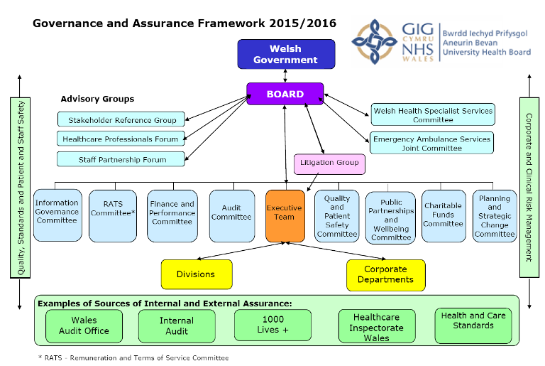
NHS governance framework (NHS,2015).

It is not only Mintzberg (1990) who stated that every manager needs to practice and master interpersonal, informational and decision making roles but House (1996) path goal theory of leadership stipulates that leaders must clarify the path to direct subordinates, they need to attempt to overcome any obstacles preventing the goal being attained and reward others by showing appreciation and gratitude for their role. A leader will need to have self-confidence in implementing change whilst empowering its co-workers and creating a vision to work towards. A good leader will have good relationships through communicating and listening which will develop respect and this will result in participation and a positive outcome for change (Caramella, 2018).
Berrel (2009) states that effective leaders recognise new realities and present issues as they always have a systemic impact. Therefore, leaders are required to be proficient at system thinking in order to communicate to others. As a leader, good communication is necessary when altering current systems as employees need a voice and direction for any successful changes (Alimo-metcalfe, 2001).
Dickson (2009) states that “the NHS system is facing challenges with lack of funding and resources, a high expenditure on agency staff and being understaffed in some areas”. He also noted the political perspective, Conservatives have set in place proposals that aim to change and provide patients a greater choice and control over their care by giving them options. Fundamentally, the Conservatives aim to implement changes to the system whereby new incentives are to be introduced and they want to prioritise better provision of access to primary care services at nights and weekends, and to attempt to re-engage staff at a local level. Although the NHS supports change and are continuously trying to achieve better outcomes, the Conservatives are still dedicated to the present organisation structure (Dickson, 2007). In this respect, change may be hindered by political reluctance to implement new organisational structures.
Challenges within the NHS would be inevitable as health care delivery is dependent on how much funding is available and the way in which it is structured and administered. Therefore, it is essential for health organisations to master combining clinical and managerial skills, productivity, and effective healthcare (Hyde et al, 2016). So, the organisational change being undertaken in the NHS will require effective management of finances and human resources.
Similarly, Soni and Bailey (2019) wrote a report for the NHS future forum that stresses that NHS and partner organisations should be working in new innovative ways to improve public health within their communities. However, it has been reported that, due to the demand on the NHS, there is not sufficient time to regenerate a new system but instead the NHS must look at what currently works well and modify it to their healthcare provision. Fundamentally, they found that the vicinities in the NHS that worked most effectively shared the common code of partnership which provided better health for the public, and did so by partnership with the government, voluntary and community organisations and by promotion. It seems apparent that partnership within a large organisation is beneficial to organisational effectiveness and motivation and that large scale change is more difficult.

A common challenge organisations face is that employees have a tendency to resist change (Hannagan, 2008) and this can have a negative impact in an organisation as employees will lack motivation. Within a large organisation like the NHS if some employees aren’t cooperating then it puts pressure on other members of the organisation who might feel they are not be valued, but overloaded with work due to other members not doing their part. Therefore, managers and leaders are required to change these attitudes and behaviours within an organisation as it is not productive and could led to poor outcomes. It is evident that any form of change within an organisation can cause fear amongst employees, so good leadership and management skills can empower and motivate employees to achieve the goals that are required for change.
Conclusion
In summary, it is evident that leadership and management has significant importance within an organisation as it provides a culture and structure that creates a unit whereby all its members have delegated roles. Organisations have to continuously change to suit their needs, and change involves altering organisational culture, along with the beliefs and practices that go with it. This alteration of culture may also require the interruption of existing systems. This can only be achieved by the participation of subordinates, which can be a challenge as change can cause anxiety within the workforce and, then, result in a lack of motivation. This indicates that the motivation of employees is not only closely linked to management and leadership processes, but also with workplace conditions. These constant changes within the NHS organisation will require good management and managers will need to help motivate employees to complete goals by providing targets, showing appreciation and respect and, also, sharing the vision of how this change is for the greater good.
Recommendations
Hospitals need to offer additional hours to existing staff and increase the salary for covering absent colleagues instead of paying out for agency staff which are paid almost double, if not triple, as opposed to contracted employees. Pay increases for overtime will be incentives to work overtime. Most employees will not work overtime just to earn their general wage, especially when they are already working full time hours. By cutting back agency staff and giving extra money to current employees, managers would save money in the long term.
Government policies need to be considered as they have an effect on health. For instance, the rise of unemployment affects the health of the individual mentally and physically as these people are more inclined to suffer with stress and social isolation which then increases the use of prescription of drugs which adds to costs.
There needs to be something in place where the public can give their views on how they rate the quality of the NHS and how it is run and state what issues they have. In doing so, this will drive forward improvements and without public feedback improvements cannot be made.

Reference list
Alimo-Metcalfe, B. and Lawler, J. (2001), "Leadership development in UK companies at the beginning of the twenty-first century. Lessons for the NHS?", Journal of Management in Medicine, Vol. 15 No. 5, pp. 387-404.
Aylward, M (2011) “ Back to bevan seminar: Are Bevans principles still applicable to the NHS?”. The Bevan Commission.
Beerel, A (2009) Leadership and change management. London: SAGE publications.
Caramella , S (2018). The management theory of henry mitzberg. Available at https://www.business.com/articles/management-theory-of-henry-mintzberg-basics/ (Accessed on 27/3/2019).
Carr, S (2009) Leadership for health improvement; implementation and evaluation. Journal of health organisation and management: Bradford vol23, issue 2.
Dickson, N (2009) the kings fund: The new political reality facing NHS. Available at: https://www.kingsfund.org.uk/blog/2010/09/white-paper-challenge-gps-plugging-knowledge-and-skills-gaps (Accessed on 30/03/19).
Ham, C., Clark, J., Spurgeon, P., Dickinson, H. and Armit, K. (2011), “Doctors who become chief executives in the NHS: from keen amateurs to skilled professionals”, Journal of the Royal Society of Medicine, No. 140, pp. 113-9.
Hannagan, T (2008) Management concepts and practices. 5th ed. Essex: Pearson Education.
Hewison, A. and Griffiths, M. (2004) “Leadership development in health care; a word of caution”. Journal of Health Organization and Management, Vol. 18 No. 6, pp. 464-73.
House, R.J. (1971) A path goal theory of leader effectiveness. Administrative science quarterly..
House, R.J and Mitchell, T.R (1974). Path goal theory of leadership. Contemporary business.
Mintzbergs managerial roles image (2019) Available at: https://content.openclass.com/eps/pearson-reader/api/item/93e3b7b0-d68f-11e5-95f5-cd3b5082a19b/1/file/robbins_decenzo_coulter-fomecaa-10e_v5a/OPS/images/EX_01_005.png ( Accessed on23/03/2019).
NHS England (2019) About NHS England. Available at: https://www.england.nhs.uk/ourwork/tsd/data-info/info-stand/background/ (Accessed on 30/04/19).
NHS Wales (2015). Governance and assurance framework. Available at: www.wales.nhs.uk/sitesplus/gallery/866/Governance_and_Assurance_Framework_2015_2016.png ( accessed on 30/04/19).

