Leadership and management, theory and practice
Assessment 1

Student name: Carolina Cioinac
Student number: 1921599
Module code: LCBB6003
Module Lecturer: Dr Charles Nwaogwugwu

Contents
Introduction 2
About the chosen organisation 3
The theories and models of Leadership and management 4
An application of these theories and models 6
Contemporary leadership and management development issues 8
A reflection of my own experience of leadership and areas for my own development 10
Conclusion 12
References 13
Appendix 15

Introduction
Leadership and management play an important role in the organization that focuses on improving the strategic planning and managerial objectives of the company. The discussion will focus on the specific experience of leadership within the organization Walmart evaluating the role of leadership and the overall experience working as a leader in different areas like management, volunteer work, training, working in a group and leisure activities. The experience will be evaluated throughout the assignment where it will evaluate the leadership process and use the relevant theories like the Great Man Theory of Leadership and Human Relations Theory. The data from the survey and Interview both primary and secondary will be used here. The discussion will further focus on developing the skills and knowledge based on the experience and reflect on producing a leadership development plan concentrating on the areas where the Improvement of the skills and knowledge is required.

About the chosen organisation
Walmart is an American multinational retail corporation. It operates over 11,000 stores in 30 different countries including e-commerce websites. About 2.4 million employees are associated with the company throughout the world. It is also known as supercentres including grocery stores and discount department stores (Walmart, 2022). The headquarters of the company is situated in Bentonville, Arkansas. Sam Walton is the founder of the company. Walmart has generated $565.7 billion and the company has achieved the highest position according to its revenue. Through innovation, the company is developing an effective experience for customers both in online and offline stores. In order to value its customers and community around the world the company is creating opportunities in different ways.

Figure 1: Featuring the company
(Source: Walmart, 2022)

The theories and models of Leadership and management
Great man leadership theory
Great man leadership theory is based on great leaders who are born with efficient attributes to help to differentiate them from others. The traits that are presented in these types of people are responsible for their authority, power and positions in the organisation (Kamales and Knorr, 2019). The business leaders and managers of Walmart for operating the business in the community use the charismatic leadership style. The leaders at Walmart are interested to achieve goals and achieve a complete advantage through human resources, as they are one of the important stakeholders. The aim of the leadership style that is used by Walmart managers and business leaders is to emphasise the importance of their employees through the leadership process (Shaturaev and Bekimbetova, 2021). The company uses two types of leadership such as democratic and participative leadership. The leaders of the organisation are focusing on the continuous process that includes development and learning. The leaders of this organisation conduct a voluntary program for its employees. The organisation follows great man leadership theory, which helps them to understand the strength and weaknesses of its employees by managing their behaviours (Adler and Laasch, 2020). These types of leaders have different personality traits such as social aptitude, communication skills in confidence that help to bring a positive change to the organisation through this voluntary program. According to the figure 2, the effectiveness of leadership helps the organisation to retain its employees.
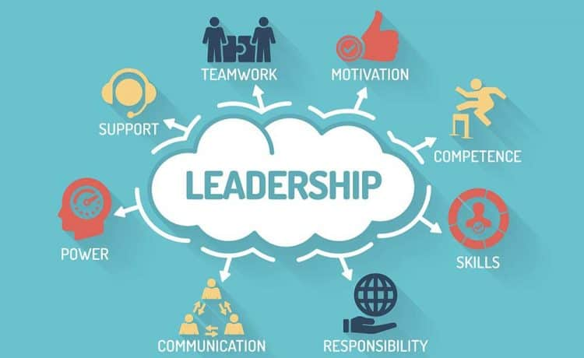
Figure 2: Effectiveness of leadership
(Source: Adler and Laasch, 2020)
Human relations theory
Human relations theory is an important part of organisational thought that focuses on influencing employee productivity, employee satisfaction and informal workplace organisations. The theory has three different elements, which are used by Walmart for enhancing employee relations (Gjøsæter et al., 2021). It is important for the organisation's impact on the employees' productivity by increasing their job satisfaction and motivation. For maintaining and developing a positive work environment by encouraging productivity and retaining employees’ human relations are important for Walmart. By focusing on this management approach, the organisation effectively develops a workplace culture in which their employees can work with motivation. In order to create human relations skills such as handling conflict and strong communication can help to create better relationships with the employees. It is important for managers and leaders to manage human relations during voluntary events regarding the continuous development and learning programs for employees (Sandybayev, 2019). During the event, the managers should follow effective communication, negotiation, multitasking, and conflict resolution for maintaining human relations with the employees. According to the figure 3, the effectiveness of management helps the organisation to maintain its employee’s behaviour.

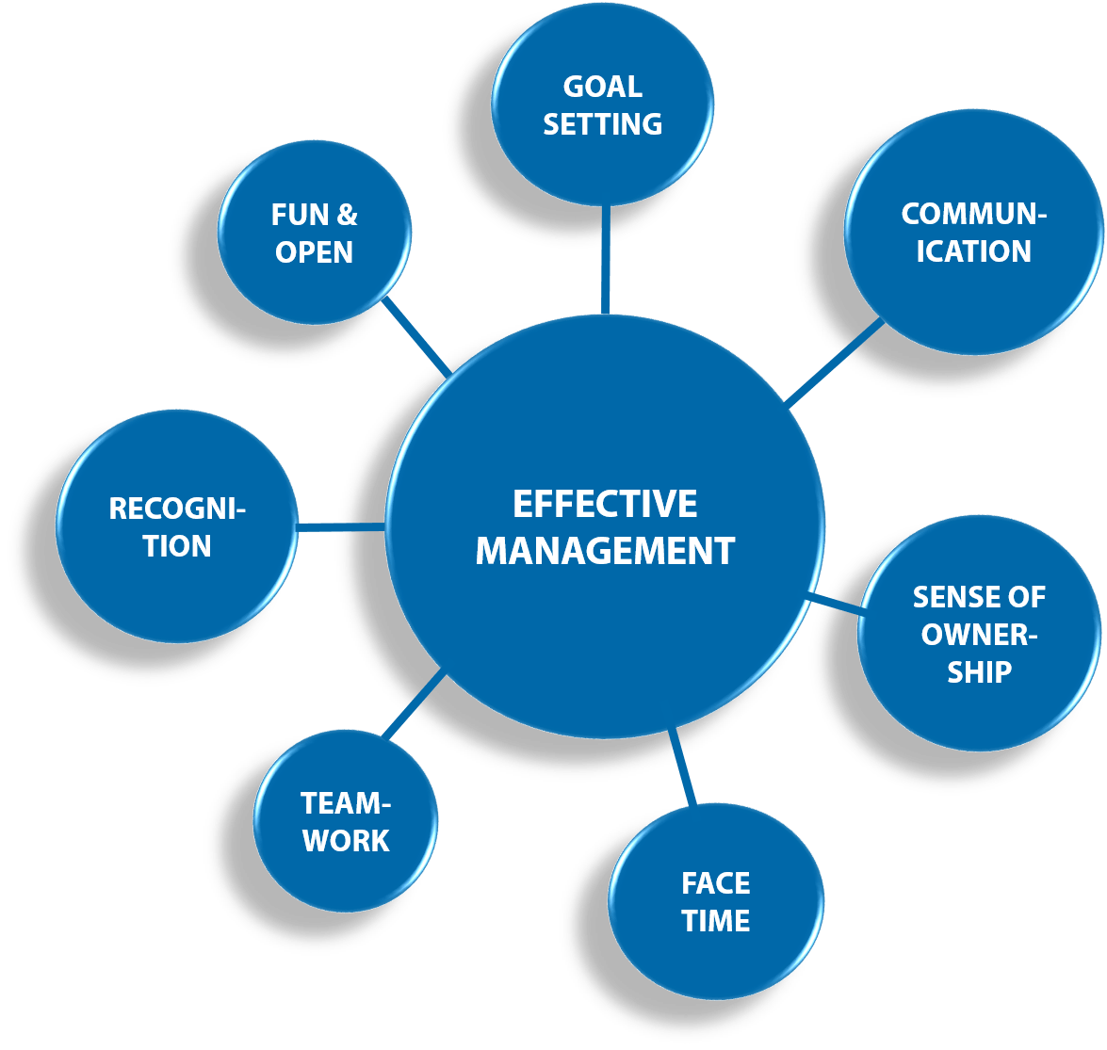
Figure 3: Effectiveness of management
(Source: Sandybayev, 2019)

An application of these theories and models
Implementation of great man leadership theory
With the help of great man leadership theory, Walmart trains their leaders as an asset of their organisation. These types of leaders have the necessary attributes, which are responsible for developing authority and power in the workplace. According to this leadership style, the managers and leaders of the company amplify the success of the team by inspiring and motivating (Oberer and Erkollar, 2018). In order to ensure success in the workplace the leaders communicate goals and objectives transparently with the team members. According to this theory, the leaders and managers of Walmart use different types of leadership styles such as charismatic, democratic and participative leadership. With this type of leadership style, understanding the different approaches can help leaders to be more effective by comprehending the requirements of their employees. It helped them to identify the different behaviours of employees. With these effective types of leadership styles, the company can achieve their vision by encouraging the employees. Charismatic, democratic and participative leaders have excellent communication, creativity, honesty and confidence, which helps to retain employees (Schoemaker et al., 2018). It helps the organisation to lower the turnover rates of employees by increasing job satisfaction. Effective leaders focus on developing their emotional intelligence by accepting feedback from employees.
Implementation of human relations theory
In order to establish a workforce, which can be effective for achieving organisational objectives, effectively the human relations theory should be used. Walmart can implement human relations theory sorry among the employees, which can help them to create the best outcomes to impact the attitude of others (Asbari et al., 2021). With the help of employee productivity and motivation, the organisation can increase positive social bonds in the workplace. Human relations have to improve working situations such as positive treatment, empowerment, and participation, which can lead Walmart to increase the productivity of its employees. With the help of human relations theory, the organisation can treat their employees in an effective way by increasing motivation. It helps to promote positive group values and relationships among the employees by interacting effectively. Positive human relation plays a great role in motivating employees to establish informal rules within the workplace. In order to enhance employee performance, the working conditions need to be safe and conducive (Abbas, 2018). Working conditions and social benefits promote employee productivity it helps to impact employee compensation and benefits.

Contemporary leadership and management development issues
Focusing on the business operations of Walmart, the contemporary leadership and management issues will be identified from the survey on the employees of the company. It will also focus on developing primary and secondary research to identify the common leadership challenges and issues faced by the leaders of Walmart with aligning their own experience in participating in the voluntary role of leadership and management (Tien, 2019). The challenges of leadership and management development issues are as follows,
Issue 1: Gender Issue
Focusing on the business operations of the Global Company the leaders of the organisation faced issues regarding the biological basis of the role of a leader. The traditional styles of leadership are continuously changing by the implementation of new exercises on practices in the field of leadership (Moldoveanu and Narayandas, 2019). According to the primary research, the researchers identified that female leaders follow the participated styles and males are comfortable with democratic leadership. However, it might not be applicable in all of the situations that are created big issues in the field of leadership.
Issue 2: impact of the current popularity of empowerment affecting the ways of managing or leading a team
Empowerment always put the employees motivated in managing their roles and responsibility, but it sometimes affects the different managerial practices including lack of training, equality and quality maintenance of the programs.
Issue 3: Cultural Differences
The cultural differences created various challenges in leadership and management because the different cultural conditions created various conflicts among the employees. The leaders might face challenges who have adopted the autocratic style because they are not comfortable with the power of distance (Kamales and Knorr, 2019). The leaders face challenges in managing people due to a lack of skills and knowledge about handling the cultural gaps.

Figure 4: Cultural differences in an organisation
(Source: Kamales and Knorr, 2019)

A reflection of my own experience of leadership and areas for my own development
Focusing on the reflection to develop discussion on my own experience of leadership and the areas of my own development I will focus on my voluntary participation in the organisation Walmart in a leading role of leadership and Management in a project. I was appointed by my professor to lead a role in Walmart managing a team and developing performance with managerial skills. Focusing on the reflection on my experience of leadership and the areas of my own development, I will gather data aligning with the primary and secondary research.
My experience
Focusing on evaluating my experience at Walmart I can say that I actively participated as a team leader in the organisation for performing a group activity of project management. I was focused on managing a team where I was improving motivation and productivity between the two members so that they can attribute their best efforts to organisational contribution. Focusing on the volunteer work my leadership experiences emphasized the importance of employee motivation in the organisation with continuous learning and development process. I get to know that the leaders of the organisation needed to be efficient enough that they motivate the employees to participate in voluntary programming.
I have experienced that conducting voluntary programs will be effective following the great man theory to identify the strength and weaknesses of the individual employees and manage the behaviours and activities of the individuals. I have also experienced the different attributes of leadership focusing on personality of them including communication skills, aptitude and confidence among each employee. I have conducted a survey amount the employee's understanding of their areas of knowledge and preferences for my leadership style and the way of managing the voluntary program.
I have to know that the organisation's development needed to be focused on employee satisfaction and the development of positive work to make them more motivated towards giving their best performance. Interviewing the employees, I have collected data regarding different elements that are used in Walmart for increasing job satisfaction and motivation. Working in Walmart I have experienced the improvement of work culture that helps in motivating the employees which I get to know by applying human relations theory. Suggestions of the theory reflected on developing strong practices in handling conflict through effective communication have helped me interact better with the employees.
Areas of my own development
Reflecting on the areas of my own development, I can say that I need to be more focused on improving my communication because during the participation in-group discussions I was feeling nervous and fumbled to talk fluently. However, my confidence to overcome any kind of situation helped me in boosting my capabilities. It enabled me to demonstrate the authority to deal with interpersonal conflicts. As I have focused on the three types of leadership styles democratic, charismatic leadership and participated leadership style against knowledge about the continuous learning process implementation in improving the weaknesses by applying the strengths. I need to be more focused on improving my confidence in managerial areas so that I can deliberately perform challenging task and hold workloads without getting nervous.
Focusing on the areas of my own development, I think making smart decisions and becoming adaptable are the good qualities of mine that have helped me in adopting the leadership skills working at Walmart.

Conclusion
The discussion has reflected on evaluating leadership and management that place an important role in the organisation managing the different activities and making the organisation productive and motivated. The discussion has focused on the business organisations of Walmart with the evaluation of the different practices based on leadership discussing experience based on the specific situations. The evaluation of the situation has implemented the different leadership styles and models of leadership specifically the great man theory and human relations theory to evaluate the different attributes of leadership implementing the role in the real context. Based on the primary and secondary research the assessment has included the discussion in identifying and valuation the impact of leadership in Walmart. The leadership development plan has presented in the appendix focusing on the different objectives and areas of learning for own development.

References
Abbas, S.A., (2018). Extrovert followership and its impact on agreeable leadership. Abbas, SA (2018). Extrovert Followership and its Impact on Agreeable Leadership. International Journal of Educational Leadership and Management, 6(2), pp.154-179.
Adler, N.J. and Laasch, O., (2020). Responsible leadership and management: Key distinctions and shared concerns. In Research Handbook of Responsible Management (pp. 100-112). Edward Elgar Publishing.
Asbari, M., Hidayat, D.D. and Purwanto, A., (2021). Managing employee performance: From leadership to readiness for change. International Journal of Social and Management Studies, 2(1), pp.74-85.
Gjøsæter, Å.S., Kyvik, Ø., Nesse, J.G. and Årethun, T., (2021). Business models as framework for sustainable value-creation: strategic and operative leadership challenges. International Journal of Innovation and Sustainable Development, 15(1), pp.50-74.
Kamales, N. and Knorr, H., (2019). Leaders with managing cultural diversity and communication. Asia Pacific Journal of Religions and Cultures, 3(1), pp.63-72.
Moldoveanu, M. and Narayandas, D., (2019). The future of leadership development. Harvard business review, 97(2), pp.40-48.
Oberer, B. and Erkollar, A., (2018). Leadership 4.0: Digital leaders in the age of industry 4.0. International journal of organizational leadership.
Sandybayev, A., (2019). Impact of effective entrepreneurial leadership style on organizational performance: Critical review. International Journal of Economics and Management, 1(1), pp.47-55.
Schoemaker, P.J., Heaton, S. and Teece, D., (2018). Innovation, dynamic capabilities, and leadership. California management review, 61(1), pp.15-42.
Shaturaev, J. and Bekimbetova, G., (2021). THE DIFFERENCE BETWEEN EDUCATIONAL MANAGEMENT AND EDUCATIONAL LEADERSHIP AND THE IMPORTANCE OF EDUCATIONAL RESPONSIBILITY. InterConf.
Tien, N.H., (2019). International economics, business and management strategy. Dehli: Academic Publications.
Walmart.com. (2022) Save money. live better. Available at: https://www.walmart.com/ (Accessed: December 19, 2022).

Appendix
Objectives | What leadership activities do I need to undertake to accomplish my objectives? | Where will I develop my leadership to achieve my leadership objectives? | Target Date
Effective Communication | I will focus on daily practising my communication publicly including in a group project or a debate. Communicating clearly will help me in improving my interpersonal skills so that I can be capable of managing the employees with positive qualities of my leadership abilities. | In the organisation | Within the next 2 months
Time Management | Reflecting on the start of the project I need to be focused on scheduling all of the tasks with maintaining the timescale for the individuals. | Workplace | Within 1-month
Problem solving | Focusing on improving the problem-solving skills I need to be more focused on improving my decision-making abilities so that I can easily manage conflicts. I need to be more focused on overcoming the challenges including my leadership abilities and making smart decisions. | In the workplace | Within the next 3 months
Figure 1: Leadership development plan

