Tutorial exercises and associated cases Answers
Exercise one
Task 1: Developing your self-awareness
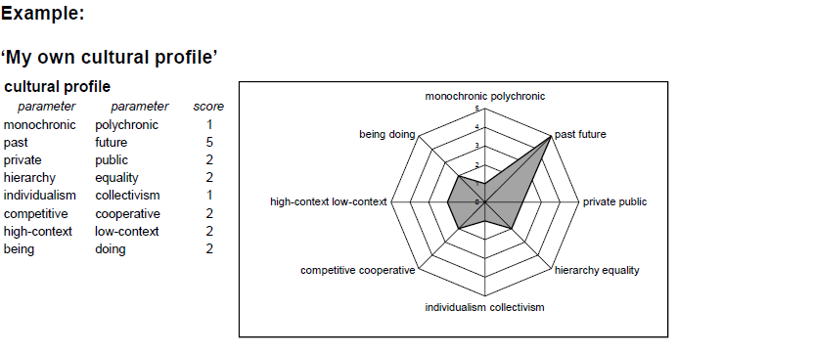
Task 2: Developing cross-cultural understanding
1 & 2
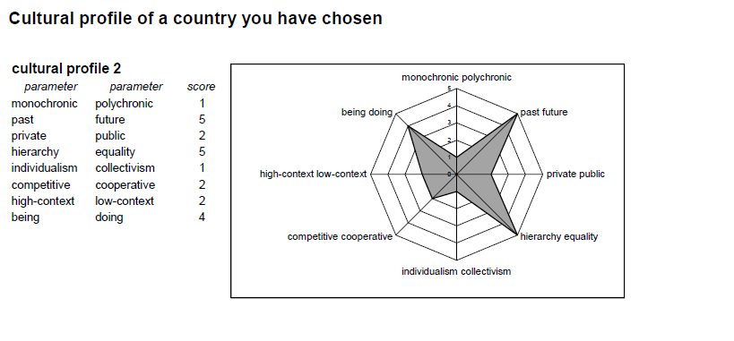
- Compare the two profiles and determine the differences and similarities in the
parameters.

- What are the differences and the similarities between which parameters?

If you compare the cultural profiles of the example you can identify only two parameters which score really differently: Power (Hierarchy/ Equality) and Action (Doing/Being). The other parameter scores are the same or similar.

- Define what you believe are the critical issues when representatives of the two cultures profiled work together?
- What are the critical issues when representatives of the two cultures profiled work together?

If you are going to do business with people in the country concerned, you will need to pay
attention only to the critical cultural differences. In this example, there are two parameters
which can cause problems: Hierarchy/Equality and Doing/Being. Therefore, you need to adapt your management skills (planning, organising, staffing, directing/leading, controlling) by taking into account these two cultural variables.

