

Student name: Ana Maria Dias da Silva
Student ID: 2439686

Module name: Introduction to Health and SociaL Care
Module code: LCHS4003_LON
Lecturer name: Ping Wu
Content page

Cover Page …………………………………………………………... 1
Element 1: Research poster- Ambulance Services …………… 3
Element 2: Essay- Origins and Structure of the NHS ………… 4-5
References …………………………………………………………… 6

Explanation of the Chosen Healthcare Service
Ambulance services are part of the NHS and respond to 999 emergencies.
Paramedics treat patients at the scene and safely take them to hospital. They help with heart attacks, strokes, accidents, breathing problems, and mental-health crises.
The aim is to save lives quickly and provide free emergency care for everyone.
References (Harvard Styles)
NHS Digital (2024) Ambulance statistics, England.
NHS England (2025) Ambulance Response Time Data.
College of Paramedics (2024) UK Paramedic Workforce Report.
WHO (2022) Emergency Medical Systems in Europe.
Current Functioning of the Service
Today, ambulance services operate 24/7 and use 999 call centres.
Calls are prioritised by urgency:

- Category 1: life-threatening (target 7-9 mins)
- Category 2: urgent (target -18 mins)
NHS (2024): 10+ million calls/year.
Average Category 1 response: 8.7 mins.

Brief History of the Service
Ambulance services began in the 1800s with horse-drawn carriages.St John amabulance started organised first aid in 1877.
In 1948, the NHS made ambulance care free for eveyone. Training improved over time and paramedics now provide advanced care before hospital.
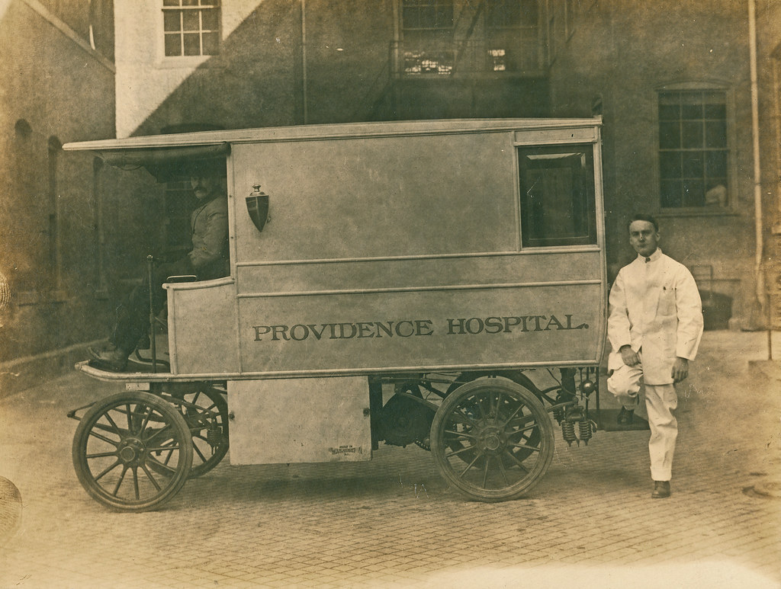
Two Challenges Faced by the Service
- Delays and long waiting times
High demand and hospital delays make ambulance response slower
- Staff stress and burnout
Paramedics face long shifts and emotional pressure. College of Paramedics (2024): 30%+ staff report burnout


Conclusion
Ambulance services are essential and save lives every day.
To improve care, the NHS needs more staff, faster hospital handovers, and better support for paramedics.
This will help emergency teams respond quicker and protect patient safety.

Ambulance Services in the NHS
Ana Silva, Introduction to Health and Social Care, 2439686@student.uwtsd.ac.uk

The Origins and Structure of the National Health Service (NHS)

The National Health Service (NHS) is one of the most significant social reforms in British history. It was created to ensure that healthcare was available to everyone, regardless of wealth or social status. The NHS officially began on 5 of July 1948, and its introduction transformed public access to medical care. Before this date, healthcare in the UK relied on a combination of private payments, charity support, and limited insurance schemes. Many working-class families could not afford a doctor, which contributed to poor health outcomes and inequality across the country (NHS) England, 2023).
The idea for a universal health system developed during the Second World War. The war highlighted the need for strong social support systems and demonstrated the importance of public health. In 1942, William Beveridge published the Beveridge Report, which identified disease as one of the “five giants” that society needed to address (Beveridge, 1942). His report influenced the government to create a welfare state, including free healthcare. Aneurin Bevan, the Minister of health, led the establishment of the NHS. Bevan argued that healthcare should be based on clinical need, not ability to pay. This principal became the foundation of the NHS and remains central today (NHS, 2024).
The NHS was created with three core principles:
- It meets the needs of everyone.
- It is free ate the point of delivery.
- It is based on the clinical need, nit ability to pay (NHS England, 2023)
These values aim to reduce health inequalities and ensure fairness is access to healthcare. The NHS was funded mainly through taxation, meaning that everyone contributed, and everyone could benefit.
Over time, the NHS structure has changed. Today, the NHS operates differently across the four nations of the UK: England, Scotland, Wales, and Northern Ireland. Devolution allows each nation to make decisions based on local needs. In England, the NHS is organised into integrated Care Systems (ICS), which were introduced to improve coordination between hospitals, primary care, community services, and social care (Department of Health and Social Care, 2023). General practitioners (GPs) remain the first point of contact for most patients, while hospitals provide specialist treatment. Public health programmes, including vaccination campaigns and health education, are also key elements of the system (Public Health England, 2021).
Although the NHS continues to provide essential care to millions, it faces significant challenges. Increasing demand, an ageing population, chronic illnesses, and rising mental-health needs place pressure on services. In addition, the NHS is experiencing staff shortages, affecting both clinical and support roles. NHS Digital (2024) reports high rates of staff vacancies and burnout, which impacts patient access and waiting times. Funding pressures also create difficulties, with many services struggling to meet targets, particularly in emergency elective care. Some critics argue that outsourcing and private involvement may threaten the principle of universal access (Pollock, 2022), while others emphasize the need for technological innovation and investment in prevention to maintain sustainability (King’s Fund, 2024).
Despite these challenges, the NHS remains a fundamental part of British society. It continues to be valued for its commitment to equality and public service. Protecting the NHS means ensuring that it can adapt to future needs, invest in staff, and improve efficiency while maintaining its founding principles.
In conclusion, the NHS was founded to provide fair and equal access to healthcare for everyone in the UK. Influenced by post-war reform and guided by principles of university and fairness it transformed the health system. Although the NHS faces pressures, it remains essential, and ongoing improvements in workforce planning, funding, and integrated care will be key to securing its future.

References

Beveridge, W. (1942) Social Insurance and Allied Services. London: HMS.
Department of Health and Social Care (2023) Health and Care System Reform. Available at: https://www.gov.uk (Accessed: 31 October 2025)
King’s Fund (2024) The Future Of the NHS. Available at: https://www.kingsfund.org.uk (Accessed: 31 October 2025)
NHS (2024) NHS Constitution for England. Available at: https://www.gov.uk/government/publications/nhs-constitution-for-england (Accessed: 31 October 2025)
NHS Digital (2024) NHS Workforce Statistics. Available at: https://digital.nhs.uk/data-and-information/publications (Accessed: 31 October 2025)
NHS England (2023) History of the NHS. Available at: https://www.england.nhs.uk (Accessed: 31 October 2025)
Pollock, A. (2022) HNS Privatisation and Policy. Available at: https://www.bmj.com (Accessed: 31 October 2025)
Public Health England (2021) COVID-19 response and public framework. Available at: https://www.gov.uk (Accessed: 31 October 2025)

