Data Center Technologies
Marius-Catalin Bobitiu
Data Centre Technologies
Cloud Computing
University of Wales Trinity Saint David London
1813436@student.uwtsd.ac.uk

Abstract— A data center can be thought of as a facility whose responsibility is to manage large amounts of data. The data center is logically composed of application software, software infrastructure (system software), and hardware infrastructure [1].
Hardware infrastructure refers to physical components such as servers, storage systems, network components, power supplies, cooling systems, and everything else necessary to allow data center operations. In contrast, software infrastructure refers to the software that runs on the hardware infrastructure, which includes low-level programs (such as operating systems) that communicate with the hardware. Many data center services, such as data security, backup, and virtualization, are also provided by the software architecture to serve huge volumes of data. Furthermore, the software architecture includes management functionalities that allow IT personnel to control not just data but also hardware resources. The application software that offers services to end users is the data center's top layer. Depending on the circumstances, application software may differ. Databases, email services, Web browsers, and business programs such as ERP and billing systems are examples of these applications [1].
The general rule of thumb for the flexibility and scalability of data center facilities is designed. The rule incorporates numerous essential concepts, including site selection, building selection, floor layout, electrical system design, mechanical design, and modular concept., allowing data center installations to be changed and adjusted when necessary, and to minimize transformations and changes to the basic building system [2].
This research provides precise suggestions for attaining high levels of flexibility and scalability in data centers. These best practices are related to site selection, building selection, and design and construction principles for key facility systems.

Introduction
The key to long-term sustainability in a data center installation is to think of it as a container for equipment and activities, as well as an interconnected system in which each component must be flexible and adaptable.
Speed, economy, flexibility, and scale are increasingly crucial to winning the race to satisfy the increased connection and processing needs of the Internet of Things (IoT) and big data. The data center offers the necessary information to help businesses make better decisions. They've gone a long way from merely keeping the lights turned on. Yet despite changes in the value and function of data centers, most people's design methods have not changed. Historically, every construction has been started from scratch. Although each data center project has unique requirements, they also have a lot in common, and there are many benefits to using these common points.
This article offers a technique for planning data center projects that improves both the quality and speed with which the results are produced This structured planning method defines the steps to be performed as well as the key decisions that each stage creates. By following this approach and making it clear to all stakeholders, project managers may increase transparency, make stakeholders feel like their time is being used more efficiently, and create support for the project [3].
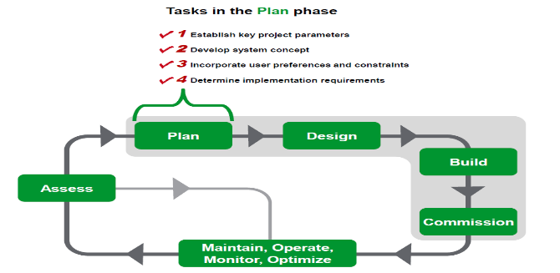
Figure 1. Planning phase of a Data Center

As illustrated in [3, Fig. 1] planning takes place in the context of the data center life cycle. The "planning" phase is divided into four main tasks in the system planning sequence. The planning sequence outlined in this whitepaper determines the design requirements for the detailed engineering design of the physical infrastructure of the data center (which powers, cools, locates, and protects the IT system.) This planning sequence is independent of IT planning and assumes that another IT planning process is running in parallel or has already taken place.

I.1 Data Center Density

Data centre density is a term used in industry and refers to the amount of electricity and servers consumed per square foot of space plus the load on the cooling system. The size of a data centre is used to determine the amount of data it can handle, but density is one of the main factors in visualizing data centre capacity. Data centre administrators can do something to improve user performance without requiring more physical space. High-density data centres are the future of data management.

High-density Data Center vs Low-density Data Center
The density of the data centre is calculated based on the kilowatts consumed by each enclosure. To increase density and meet resource requirements, data centres must increase the power consumption of each enclosure or increase the power consumption per square foot. Based on these numbers, data centres can be considered high or low density.
As mentioned above, data centre density can be increased by increasing power consumption per enclosure or increasing power consumption per square foot. For data centres that are considered high density, the average power per square foot of the enclosure is approximately 10 kW or 150 kW. The density of data centre racks continues to increase. The following is a breakdown of the different densities of the data centres. A data centre with an average of 4kW racks or cabinets is considered low density. A data centre with racks or cabinets with an average power consumption between 5kW and 8kW is considered medium density. If the racks or cabinets in the data centre consume 8kW to 15kW, it is considered high density. Data centres over 16 kW are considered extreme density.
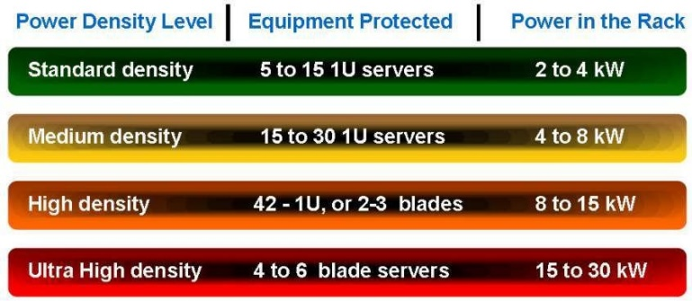
Figure 2. Density to power level of servers [4]

I.2 Rack Units and Layout
Most businesses keep track of their assets, and Each server rack device has its own model, SKU, and serial number. On the rack management spreadsheet, these three pieces of information, as well as the description, installation date, and service date, may be entered. Power Consumption as well as Heat Dissipation, PDU (Power Distribution Unit) and UPS (Uninterruptible Power Supply) connections are also suggested columns. This file is then kept up to date by adding, deleting, and/or maintaining the equipment. The spreadsheet should cover the full server room installation, including each rack and cabinet.
Heat may and will collect in server racks, and using controlled techniques allows you to discover possible "hot spots," which can then be validated using a thermal imaging camera or managed by the most basic level of ambient temperature monitoring. Understanding the power load and heat dissipation may help you correctly design the room air conditioner and regulate the airflow in the rack. To increase total cooling and ventilation, fan trays and top covers can be employed.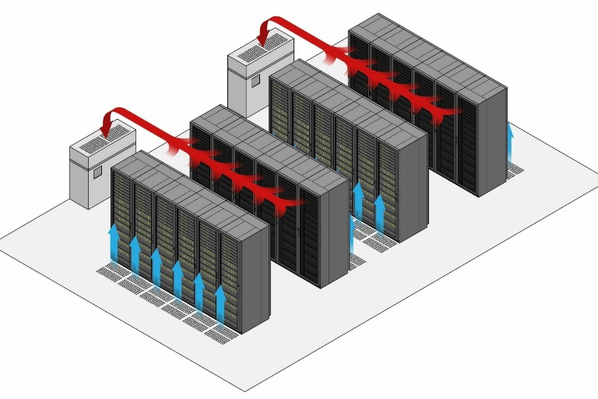
Figure 3. Rack layout with cooling systems [5]
An example of a rack layout is illustrated in [5, Fig. 3], which shows a data centre with a good airflow management. The blue arrows represent the cold isles, which cools the equipment keeping them at a good, functional temperature, while the red arrows represent the hot air released by all the components. To keep the airflow going, and the temperature at a low level, a cooling system needs to be installed to bring the hot aisle to a lower temperature. The more "free space" in the server rack, the more room for airflow. You can leave a vertical space between the server and the IT equipment to help cool down. Thermal equipment, such as UPS batteries, can be positioned near the server rack's bottom, and hot air rises. Heavier equipment should also be stored towards the bottom of the rack. Ideally, the equipment should be logically structured to allow for easy management and access to plugs, sockets, and ports, whether for power or networking. It is best to place yourself at the upper middle of the rack..

Data Centre Architectures
The data center has the processing power, storage, and software required to support the enterprise's operations. IT architecture relies heavily on data center infrastructure, and all information originates or is supplied through IT architecture. Proper data center infrastructure design planning is essential, and performance, resilience, and scalability must all be carefully considered
.
II.1 Fat-Tree Architecture

Al-Fares et al. [6] introduced Fat-tree, as shown in Figure 2, which allows for the use of low-cost commodity network components in the design The network's switching components are all the same. Furthermore, some routes to the destination host will always consume all available bandwidth. Furthermore, as demonstrated in Table 2, the Fat-tree network is less expensive than the conventional network. 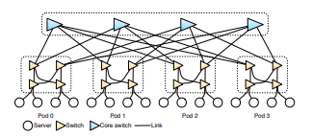
Figure 4. Fat-tree design [6]

II.2 BCube, MDCube
BCube [7] is a container based on a Modular Data Centre (MDC) design. The MDC consists of thousands of servers, which are connected to each other via switches, and then these servers are packed into a 20- or 40-foot container. MDC provides shorter implementation time, lower manufacturing and cooling costs, and higher power and system density. Leading companies in this field already offer shipping container-based products, such as HP, Microsoft, and Sun.
MDCube [8] is a framework that builds a container-based super data center. The container in MDCube follows the BCube design, connecting thousands of servers in the container. In other words, MDCube is a design that uses BCube-based containers as building blocks to implement a big data center.
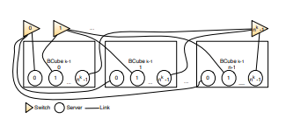
Figure 5. BCube design [7]
Figure 5 illustrates the server-centric design of BCube [7], using only commercial rack switches (COTS) and basic servers. Each server has a limited number of network ports that are linked to a micro switch. The server is in charge of routing intelligence.

II.3 VL2 Architecture

Greenberg et al. [9] VL2 was introduced, a network design that employs Valiant Load Balancing (VLB) for traffic propagation, address resolution for large server groups, and flat addressing to prevent resource fragmentation Route diversity is provided by the real topography. Overall, VL2 is intended to alleviate many present difficulties by offering agility and generating the illusion of a single Layer 2 switch throughout the data center by establishing a virtual layer. Additionally, VL2 eliminates the need for oversubscribed links on the network through network design.
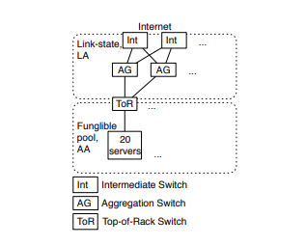
Figure 6. VL2 design [9]

Scalability
The data center is indeed very important to the business because it is the foundation for keeping the business running. The more users use the company website or Internet, the more files will need to be saved and backed up. So, they need a bigger data center, which means they need to upgrade. Literally, data center scalability is the ability of computers, or the data centers themselves to continue to perform well when upgrades and changes are made to capacity and size. If the data center can be improved to be bigger, it will definitely perform better.
Some companies need to maintain their data centers well to save money and profits. When they upgrade their data center, they need a good scale to determine how much they need to improve. If the company overbuilds resources, it will waste resources. However, some of them still overbuild it sometimes because of the need to address peak demand; however, it is difficult to predict when it will happen and what to do when you have additional capabilities. As we all know, this is difficult for the company to control. Therefore, they need to make the data center scalable, thereby improving the scalability of the data center itself [10].

III.1 Benefits of Scalability
Cloud computing has radically transformed the nature of IT infrastructure over the last decade, and many businesses have abandoned internal solutions and shifted their operations entirely to the cloud. Cloud computing delivers tremendous scalability benefits for many smaller companies, allowing them to easily modify their IT system to match their present demands and focus on developing their business rather than continually updating their infrastructure [11].
Whether a business completely discards physical equipment or places its servers in a colocation data center, cloud computing provides many benefits in terms of scalability.

Storage
It is critical for a developing business to have enough storage capacity to meet these needs, from maintaining vital files and hosting applications to appropriately storing sensitive customer data. Although a highly driven start-up may not require more than a few terabytes of data storage, it may soon find itself straining to handle greater workloads and assets after a string of victories. Rather of managing an ever-expanding collection of hard drives, organizations may use cloud computing to extend their data storage plans to fulfill availability needs without incurring capital expenditures to build physical infrastructure [11].

Versatility
Businesses and sectors may change extremely quickly in today's market. The best IT solution for a year might become obsolete in a matter of years, making it difficult for the company to react to changing consumer demands. Organizations may substantially alter their infrastructure and workloads to match today's demands using cloud computing, rather than being confined to major equipment and assets in the past. To solve current difficulties and concerns, the private network can be rebuilt as a hybrid cloud or multi-cloud deployment. This is especially crucial for expanding businesses, which confront new obstacles and even legal obligations as they go upward [11].

Power
From Having enough storage capacity to satisfy these demands is crucial for a growing organization, from keeping important files and hosting programs to properly storing sensitive client data. Although a highly driven start-up may not require more than a few terabytes of data storage, it may quickly find itself straining to handle larger workloads and assets following a run of triumphs. Rather of managing an ever-expanding collection of hard drives, businesses may utilize cloud computing to scale their data storage plans to match their availability requirements without incurring capital costs expenditures to expand physical infrastructure [11].

Time
For IT staff, managing IT infrastructure may be time consuming and difficult. Because of the ongoing requirement to debug network issues and manage the various assets of local solutions, less time is spent building creative solutions that can revolutionize goods and services. Rather than developing internal alternatives, consider using cloud computing and hosting data center computing solutions, the company focuses its technical resources on driving innovation rather than solving problems. As the business grows and the IT infrastructure becomes more complex, this is crucial [11].

Savings
Moving to the cloud to meet your computing needs can save growing businesses not only Not only in terms of equipment, but also of power, cooling, and staff. The flexibility to scale up or down cloud resources based on current demand eliminates the majority of the risks associated with rapid expansion. Due to fixed IT infrastructure expenditures, a bad quarter or two will not instantly result in a loss. Many apps can even function more cost-effectively in the cloud and are frequently simply transferred via promotion and migration techniques [11].

Security
Data centers are complicated, and in order to secure them, security components must be examined independently while also adhering to a complete security policy. Physical security and software security are two types of security. Physical security encompasses a wide variety of procedures and techniques designed to keep outsiders out. Virtual security or software can prevent cybercriminals from bypassing firewalls, cracking passwords, or entering the network through other vulnerabilities.

IV.1 Physical security
The most obvious safety features of data center buildings are associated with design and layout The building itself can be constructed as a one-time or multi-purpose unit, with the latter functioning as a common area for non-data center companies. Data center facilities are frequently located distant from major thoroughfares in order to provide a buffer zone of greenery and collision barriers. The availability of data center facilities is quite restricted. Most lack external windows and have a limited number of entrance options. Building security staff watch suspicious activity through the lenses of surveillance cameras positioned in the perimeter. Visitors can get entry to the building by scanning a personal identification verification (PIV) card and entering a personal password. Access can also be granted through employee credential readers and biometric devices such as fingerprint readers, iris scanners, and face recognition.

IV.2 Software Security
SIEM (Security Information and Event Management) solutions give a real-time picture of the data center's security status. SIEM aids in the visibility and control of all entry and alarm system material, as well as sensors on the perimeter fence.
Creating a security zone on the network is one approach to add a layer of protection to the data center. The administrator has the option of dividing the network into three sections: a very flexible test area, a research area with a slightly strict environment, and a production region with only permitted production equipment.
Certain tools may be used before deploying apps and code to check them for susceptible vulnerabilities and then offer indicators and corrective functions. You may use the scanner to check for buffer overflows and other vulnerabilities in the code. Because malware may be disguised in legal communications, insight into the flow of data is essential as cloud computing grows.

Fault Tolerance
Fault tolerance is one of the hot topics among IT professionals today, but few outside the IT department have a good understanding of the term's true meaning, especially in the context of the data center. Over time, fault tolerance has become increasingly important, and it is worth taking the time to understand what this term means and how a good level of fault tolerance knowledge can lead to a more reliable system for your entire business.
The term fault tolerance is often used to describe data centers. As a reliable indicator of quality and reliability standards, a fault-tolerant data center is a data center without a single point of failure. The facility is specially constructed to avoid this point of failure and is equipped with a number of technologies that significantly improve the fault tolerance of the entire facility [12].
A high level of fault tolerance can have a real impact on data center reliability, but this is not the only factor that companies should consider. Data center downtime can also be avoided by avoiding failures. Continuous monitoring of system use, good training practices, and meticulous maintenance work together to help prevent any failures, thus minimizing downtime [12].

Energy Consuming and Management
The energy [13] consumption of data center space is 100 to 200 times greater than that of standard office space. Because the power consumption is so large, they are the main target of energy-saving design measures, which can save money and reduce power consumption. However, the main features of data center loads have pushed several design objectives, most notably dependability and high-power density capacity, well beyond energy efficiency. In general, shorter design cycles leave insufficient opportunity to properly analyze effective design options or consider upfront and life cycle costs.
Rack servers are frequently the leading source of energy waste, accounting for the majority of the IT power load in a typical data center. The server takes up the majority of the space and is in charge of the whole operation. Most servers run at 20% or less usage most of the time, but they nevertheless consume entire power. Significant upgrades have recently been made to the internal cooling system and server processing equipment to save wasted energy. When purchasing a new server, it is suggested that variable-speed fans be used instead of typical constant-speed fans with inbuilt cooling components. When operating, variable speed fans can offer enough cooling, while running slower, thus consuming less power [13].
By integrating redundancy in the IT system, energy can be further saved. Instead of giving power to each server, consider using one power source per server rack. A rack-mounted integrated power supply will run at a greater load factor (perhaps 70%) for a given amount of redundancy than a single server power supply (20 percent to 25 percent ). This increase in power supply load factor greatly increases power supply efficiency (see Figure 1 on the power supply in the next section). Other IT resources, such as the central processing unit (CPU), disk drives, and memory, can also be shared to save power consumption. Another long-term method for enhancing hardware energy efficiency is the combination of short-term load shifting and accelerating and decreasing resources based on demand.

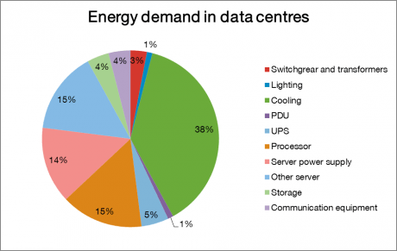
Figure 7. Energy demand in a typical data center [14]

Recommendations

Monsoon architecture
In Greenberg et al. [15] A model called Monsoon was proposed, which is a "cloud" mesh design that employs simple switches to save expenses and enable for powerful growth to 100,000 servers. Monsoon boosts performance by employing Valiant Load Balancing (VLB). Figure 3 depicts a high-level overview of the Monsoon architecture. Monsoon focuses on layer 2 of the architecture, which is split into Ethernet layer 2 and IP layer 3. Cost reductions, elimination of server fragmentation (all applications may share a wide flat address space), and avoidance of interference with IP-layer operations are just a few of the Layer 2 advantages.
According to [15], Monsoon requires customizable control plane software, MAC-in-MAC tunnels, and 16K MAC inputs on Layer 2 switches. Furthermore, the top-of-rack switch must support 20 servers through 1 Gbps connections to two 10 Gbps uplinks. The top switch should be equipped with 144 10Gbps ports. At level 2, this design enables for over 100,000 servers to have no oversubscription connections. Load balancers (LB) can be created using standard servers rather than costly specialized hardware. Through Equal Cost Multipath, IP layer 3 is responsible for equitably distributing Internet requests to access routers (AR) (ECMP). According to Greenberg et al. [15], the server's network stack needs to replace ARP is used in conjunction with the Monsoon Agent and Wrapper, a novel Mac virtual interface that wraps Ethernet packets. The Monsoon network stack relies on the directory service for route information. There are several approaches to implementing directory services. The gateway server, which works in tandem with the access router, is another service required by the Monsoon architecture (AR). Ingress Server is required for VLB Monsoon payload distribution and encapsulation.

Conclusion
Although the initial investment in the data center is high, in the long run, it is actually not that expensive. The data center has a great influence focusing on economic growth and organizational efficiency Given the substantial investment in data centers.
Organizations must plan their data centers effectively, assess their available budget, and generally detect difficulties, including outages. Organizations must anticipate their current long-term business requirements and integrate them into their IT strategy. When trying to build a sustainable and scalable data center, the fourth tier of the data center should use chosen as the standard.

Bibliography

[1] | S. Huang, "Brief Introduction of Data Center Technologies," Code Project, 12 April 2017. [Online]. Available: https://www.codeproject.com/Articles/1181824/Brief-Introduction-of-Data-Center-Technologies. [Accessed 11 August 2021].
[2] | M. A. Bell, "Use Best Practices to Design Data Center Facilities," Gartner, Stamford, 2015.
[3] | N. Rasmussen, "Data Center Projects: System planning.," Schneider Electric’s Data Center Science Center, Le Creusot, 2017.
[4] | Anonymous, "Modernizing Vintage Data Centers To Big Data Centers," Bomara Associates, 01 01 2018. [Online]. Available: https://www.bomara.com/powerware/wp_vintage_data_centers.htm. [Accessed 15 August 2021].
[5] | B. Kleyman, "Helping your Data Center Breathe easier with good airflow management," UpSite, 15 June 2016. [Online]. Available: https://www.upsite.com/blog/helping-your-data-center-breath-easier-with-good-air-flow-management/. [Accessed 16 August 2021].
[6] | A. L. a. A. V. M. Al-Fares, "A scalable, commodity data center network architecture," SIG-COMM Comput, Commun. Rev., vol. 38(4), pp. 63-74, 2008.
[7] | G. L. D. L. H. W. X. Z. Y. S. C. T. Y. Z. a. S. L. C. Guo, "BCube: a high performance, server-centric network architecture for modular data centers," in SIGCOMM '09: Proceedings of the ACM SIGCOMM 2009 conference on Data Communication, New York, NY, USA, 2009.
[8] | G. L. D. L. C. G. a. Y. Z. H. Wu, "Mdcube: a high performance network structure for modular data centre interconnection," CoNEXT '09: Proceedings of the 5th international conference on Emerging networking experiments and technologies, pp. 25-36, 2009.
[9] | J. R. H. N. J. S. K. C. K. P. L. D. A. M. P. P. a. S. S. A. Greenberg, "VL2: a scalable and flexible data center network," SIGCOMM '09: Proceedings of the ACM SIGCOMM 2009 conference on Data communication, pp. 51-62, 2009.
[10] | D. C. Management, "What is Data Center Scalability?," Nex Data Center, 22 February 2017. [Online]. Available: https://www.nexdatacenter.com/what-is-data-center-scalability/. [Accessed 20 August 2021].
[11] | T. Banta, "5 benefits of Scalability in Cloud Computing," VXCNGE, 19 February 2019. [Online]. Available: https://www.vxchnge.com/blog/cloud-computing-scalability-benefits. [Accessed 20 August 2021].
[12] | Anonymous, "What Makes a Data Center Fault Tolerant?," TRG Data Centers, 3 January 2018. [Online]. Available: https://www.trgdatacenters.com/resource/what-makes-a-data-center-fault-tolerant/. [Accessed 20 August 2021].
[13] | O. VanGeet, "FEMP Best Practices Guide for Energy-Efficient Data Center Design," Best Practices Guide for Energy-Efficient Data Center Design, pp. 5-9, 04 March 2011.
[14] | Anonymous, "Data Centers," 25 September 2019. [Online]. Available: https://encyclopedia.smartencyclopedia.eu/content/data-center/. [Accessed 20 August 2021].
[15] | P. L. D. A. M. P. P. a. S. S. A. Greenber, "Towards a next generation data center architecture: scalability and commoditization.," PRESTO '08: Proceedings of the ACM workshop on Programmable routers for extensible services of tomorrow, no. NY, USA, 2008, pp. 57-62, 2008.

