

Student name: Violeta Pinderova
Student ID: 2247133

Module name: Empowering the Older Person
Module code: BMHP6027_LON
Lecturer’s name: Laila Surani

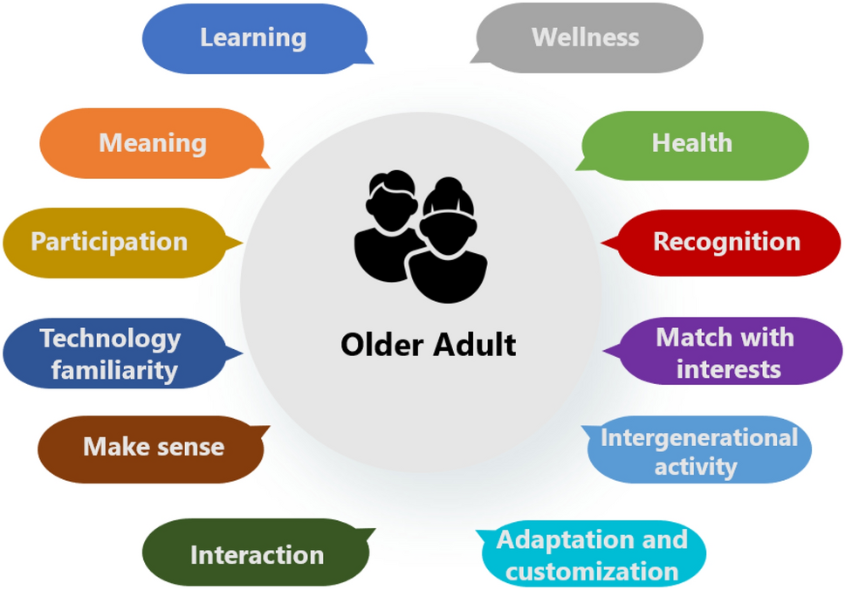  (Cardona et al. 2024) |  | Challenges in Empowering and Supporting Older people:  - Age discrimination  - Loss of independence  - Social isolation longlines.  - Digital exclusions  - Financial insecurities  - Health inequalities  - Cultural and language barriers (ONS, 2023). |  |   (Mahmood, et al. 2021)
Evaluating the Care and Support Needs of Older People.  Supporting older adults to live well and independently is a key part of promoting dignity and wellbeing in later life. The need for person-centred, coordinated care is only increasing as the population ages (NHS England, 2022). The focus of this poster will be on three primary issues: chronic illness, decreased mobility, and social isolation as well as the theories like Rogers and Maslow’s. These are some of the complex problems that older persons commonly face (Manthorpe and Iliffe, 2021).  Empowerment and Support Needs of Older People.  Care needs that include maintaining:  - dignity and respect,  - physical health,  - person centred care,  - emotional wellbeing,  - social inclusion  - cultural needs (Victor and Sullivan, 2022). |  |  |  | Integrated Health and Social Care  - collaboration across community services, hospitals, social workers, and general practitioners.  - smooth and well-coordinated support in social and medical settings (IPPR, 2021).  Digital Inclusion  - offer training and accessible technology for older adults (DHSC, 2021).  Independent Living  - Enable older adults to live safely and confidently at home (Marmot et al., 2020).  Conclusion  An integrated, person-centred approach is necessary to meet the care and support needs of older adults. Elderly people can preserve their dignity and quality of life by encouraging independence, expanding access to integrated care, and bolstering their mental and physical health. Maintaining high levels of care requires regular service evaluation, community interaction, and ongoing staff training.
Theories and Policies
Theories that emphasise the significance of attending to not only physical health but also psychological and social wellness include:
- Maslow's Hierarchy of Needs (Maslow, 1943)
- Person-Centred Care approach (Rogers, 1951).
When planning care, these viewpoints help practitioners take into account each patient's values, interests, and objectives:
- The NHS Long Term Plan (2019)
- Care Act (2014)
By ensuring that support services encourage "ageing in place," these frameworks allow people to live in their communities in a safe manner (WHO, 2021).
Recommendations:
Person-Centred Care
- Involve older people in all care decisions.
- Respect individual preferences, values, and culture.
- Promote dignity and choice.

References

Care Act 2014. (2014) c.23. London: The Stationery Office.

Cardona, J.S., Lopez, J.A., Vela, F.L.G. et al. (2024) ‘Meaningful learning: motivations of older adults in serious games’, Universal Access in the Information Society, 23, pp.

Department of Health and Social Care (DHSC). (2021) People at the Heart of Care: Adult Social Care Reform White Paper. London: DHSC.

Hendry, A., et al. (2024). Frailty. Available: https://link.springer.com/chapter/10.1007/978-3-031-57361-3_31. (Accessed: 14 October 2025).

Institute for Public Policy Research (IPPR). (2021) Care Fit for Carers: Ensuring the UK Has the Social Care Workforce It Needs. London: IPPR.

Mahmood, A. Patille, R., & Chyrva, P.R. (2021) ‘How to empower older adults to become digital citizens in our tech-dependent world’, Ageing in the Right Place. Available at: https://www.sfu.ca/airp/news-events/op-ed/How-to-empower-older-adults-to-become-digital-citizens-in-our-tech-dependent-world.html. (Accessed: 15 October 2025).

Manthorpe, J. and Iliffe, S. (2021) ‘Older people’s care and support: A review of current issues’, British Journal of Social Work, 51(5), pp. 1825–1839.
Marmot, M. et al. (2020) Health Equity in England: The Marmot Review 10 Years On. London: Institute of Health Equity.
Maslow, A.H. (1943) ‘A theory of human motivation’, Psychological Review, 50(4), pp. 370–396.
NHS England (2022). Integrated care systems: Improving care for older people. London: NHS England.
NHS England. (2019) The NHS Long Term Plan. London: NHS England. Available at: https://www.longtermplan.nhs.uk (Accessed: 27 October 2025).
ONS (2023) Loneliness and Social Isolation in Older Adults. London: ONS.
Rogers, C.R. (1951) Client-centred therapy: Its current practice, implications, and theory. Boston: Houghton Mifflin.
World Health Organisation (2021) Decade of Healthy Ageing: Baseline Report. Geneva: World Health Organisation.
Victor, C.R., and Sullivan, M.P. (2022) ‘Loneliness and ageing: Implications for health and social care policy’, Ageing and Society, 42(2), pp. 305–323.

