Living with care: The older person

COMPONENT 2 – WRITTEN REPORT
BMHP6009
Shefali Begum (1918219)
Lecturer – Joanne Davies
EXECUTIVE SUMMARY
From this report, it has been found that the issue of diabetes and diabetes is high for the elderly generations and massive instances of healthcare issues have been observed among the old age people in the UK. The huge burden on old age people is creating a burden on the healthcare staff in the UK. In this report, a thorough critical discussion has been portrayed about the health and social care needs for the age-old people in the UK. The theory of needs has been applied to elderly people to determine better structural relevance of healthcare in the UK. The issues have been majorly developed in recent years regarding the change of NHS and lack of social care for the elderly people present in the UK. The UK government proposed changes in law because of increasing older abuse incidents in the UK.
Table of Contents
1. Introduction 4
2. Definition of old age 4
3. Discuss the reason for changing the number of older people 5
4. Critically evaluate the task of identifying, assessing and outlining the health and social care needs of an elderly individual 6
5. Findings 7
5.1 Introduction to the context of health and social care needs among elderly generations 7
5.2 Identification of any concerns elderly generations are experiencing 9
6. Feasible solutions and interventions to support health and social care needs for elderly generations. 11
7. Conclusion 12
References 13
Bibliography 17

1. Introduction
The elderly population is growing all over the world and similarly, in the UK, the number of elderly people is growing over the years who are aged over 65. The purpose of the report is to identify the reason behind expanding and critically evaluating the health and social care needs of an elderly individual. In addition to that, this report will identify any concerns the old people are experiencing in the context of their health, social or emotional. Along with this, the report will examine the current health and social care provisions in the UK that impact an increasing number of older people.

2. Definition of old age
The definition of old age reflects the 60 or 65 years of age or older individuals according to the statistical and public administrative purposes. As per the views of Menezes et al. (2023), it has been identified that enabling older people to take part in the communities in old age is the basic sense of engagement, fulfilment and citizenship. For instance, in FY 2022, 19.17% of people were under 65 years old (Statista, 2024).
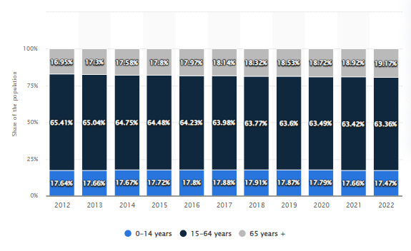
Figure 1: Rate of old age people in the UK
(Source: Statista, 2024)
On the other hand, as argued by Fuseini et al. (2023), it can be stated that old age is the normal development level of life which has been involved with the physical and psychological comorbidities which can lead towards the deterioration of the mental and physical function. Apart from this, it has been found that healthcare organisation face significant threats in terms of the psychosocial and physical well-being of the elderly which has a significant impact on the well-being of the society as well. For instance, it has been identified that in the financial year 2021, the age particular death rate for males 90 or more stood at 231.6 per one thousand population and 209.9 for females (Statista, 2023a). Based on this, it can be stated that increasing age is one of the major concerns for increasing the mortality rate of the UK among old age people.

3. Discuss the reason for changing the number of older people
In this context, it has been identified that the major reason for changing the ageing of the world's population is due to the decreasing rate of fertility rates and rising rate of life expectancy (Studysmarter, 2024).
Disrupt the trends of society: The amount of individuals aged 65 years or more older in the global platform has been increasing in a significant way which has been surging from 761 million in FY 2021 to 1.6 billion in FY 2050 (UN, 2024). Therefore, it can be stated that ageing among the population is one of the global trends which is the inevitable outcome of the demographic transition. Hence, it can be depicted that the trend towards longer lives and smaller families has been taking place in the nations along with the youthful populations. Also, it has been found that in the fiscal year 2021, 1 in 10 individuals in the global platform came under the 65 or more than this (UN, 2024). Also, it has been predicted that by 2050, the age group will be accountable for 1 in 6 people which can disrupt the well-being of the solicitor in a significant way (UN, 2024).
Decrease in fertility rate: As fertility rate declines year by year then the amount of the younger people will decrease in an effective way. Therefore, it has a significant impact on society. When the amount or proportion of working age adults then the share of the old age will be increased effectively. For instance, it has been found that in FY 2050, 2.35 number of children per woman which will be decline at 2.15 number of children per woman (O'Neill, 2024). Based on this, it can be stated that the decline the fertility rate is one of the manor cause for decreasing the population rate in the global platform and raise the older age people.
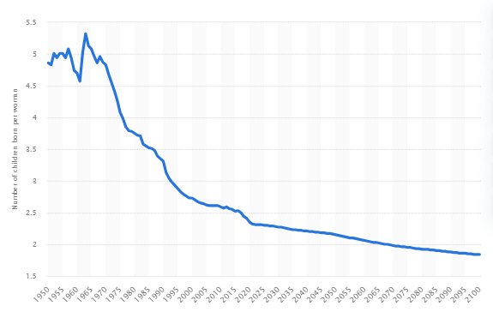
Figure 2: Rate of fertility per woman
(Source: O'Neill, 2024)

4. Critically evaluate the task of identifying, assessing and outlining the health and social care needs of an elderly individual
In 2021-2022, there are nearly 1,5 million requisitions for support made by the age-old people of around 65 years to the local authorities, which is up from around 1.3 million as of 2015-2016 (Schlepper and Dodsworth, 2023). It seems to be a modest upsurge of around 4.5% in comparison to the rising number of older people in the British population while considering the ageing population showing a 3% (approx.) drop in the rate of requests. However, over the years the average weekly cost of care homes across the UK stood at nearly £675 for care homes devoid of nursing and nearly £950 for care homes along with nursing (Statista, 2023c). Furthermore, over half of the people across the UK affirmed that their health deterioration is being subjected to the cost of living crisis (Gregory, 2022). It implies that families have chosen to forego essentials vital for living healthy lives. Hence the need for cost-effective health and social care is on the rise in this phase while the cost of living crisis is accelerating.
The older people in the UK are waiting for too long to acquire social care and they are being subjected to a serious shortfall of staff and money. A new analysis conducted by a charity in the UK indicated that nearly 80% of the people across England died in 2021-2022 being kept waiting for care (Ageuk, 2023). As opined by Sinha et al. (2022), inadequate resources and poor infrastructure in low-income neighbourhoods have been critical factors that serve as barriers to health and social care. The author further added that housing insecurity, travel costs and the role of public transportation serve as physical impediments to accessing health and social. It can be directly implied that access to essential health and social care is the need of the hour. Further, several people across England are liable to endure chronic pain, unmet health and social support needs and anxiety being owed to the deteriorating shortage of care home beds as well as social care staff (Batty, 2023). From these facts, it can be directly implicated that the significant drop in terms of the amount of care and support provided to older people across Great Britain is unswervingly piling intense pressure on caregivers and families.
Concerning the UK’s health and social care for older people it has been found that the pressure is escalated by leaving the NHS in constant crisis, which in turn is contributing to ambulance queues outside. Hence, health and social care support in the UK for the British people is confronted with the urgent need to enhance availability with precision. Moreover, around 12% of people aged more than 50 years equates to around 2.5 million people having unmet social and health care needs increasing to 15% in their 70s and progressively to around 20% in their 80s (Batty, 2023). It can be implied that the primary cause as well as subsequent delays in health and social care for older people in their discharging is the growing and huge shortfall in the social care and NHS staff, which has become substantially worse than ever before commencement of the COVID-19 pandemic crisis. The overall scenario of health and social care in the UK convincingly emulates the need for extra support from organisations and the UK government alike.

5. Findings

5.1 Introduction to the context of health and social care needs among elderly generations
In recent times, the growth rate of elderly people in the UK has been the main reason for increasing the need for health and social care as the physical and emotional needs for healthcare are increasing. By 2046, the rise of the elderly population is expected to grow by 24.7% in the UK (Clark, 2024). The health and social care needs of the elderly people have been influenced by a variety of reasons that have affected the UK population. This is due to the increased life expectancy rate in the UK as the decline in fertility has been the main concern. Between 2015 to 2020 the number of people over 65 people has increased by 12% with the amount of 1.1 million people and 18% of people over the age of 85 (UK Parliament, 2024).
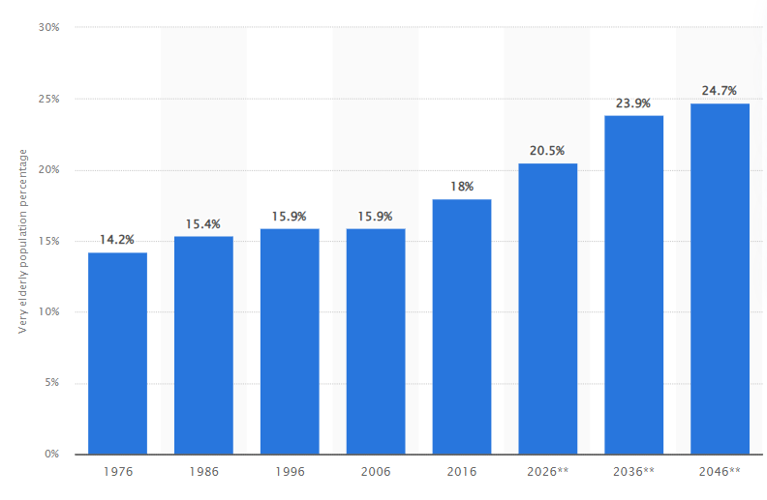
Figure : Population Growth of Elderly People in the UK
(Source: Clark, 2024)
As per the views of Abdi et al. (2019), the development of health and social care issues in the healthcare industry is promoted by chronic conditions that increase unmet care needs in terms of physical and mental health development. The NHS is unable to provide better health care due to the lack of equipment and service aspects. The lack of home services from the NHS affects nearly 900,000 older people yearly as they regularly seek hospital treatment for unmet needs in health conditions (The Guardian, 2023a). Another issue faced by elderly people is the development of chronic conditions due to the lack of effective healthcare solutions. Among 20% of the people aged over 65 years have 3 or more chronic conditions that create high-level health concerns (Elflein, 2022). Delayed discharge has been determined as one of the main issues in healthcare as well. An average of 13,440 patients daily have remained in the hospital, which is 30% more than the previous year as of 2022 (UK Parliament, 2022). Additionally, the social care issues that are faced by the elderly people underlie the increased cost of living and the healthcare cost creating obstruction towards the development of healthy lives. After the COVID-19 pandemic, the increase in social care needs has affected the process of livelihood of adults and older people. This resulted in the increase of the 2.6 million people looking for social care needs by 21% over the 80s (The Guardian, 2023b). These are the main issues faced by the elder people in the UK in terms of social and health care needs.
In an aspect of this, The “Human Needs Theory” refer to the development of the needs in a hierarchical way to ensure the better management of the human needs for lifestyle satisfaction. In terms of this, there are mainly five needs that are considered namely, “physiological, safety, love and belonging, self-esteem and self-actualisation” needs. As stated by Vogel et al. (2021), meeting human needs helps to neglect the catastrophic effects of the lifestyle and society aspect through the development of the structural aspect in the socio-economic aspect. This particular theory can be implemented in terms of the need among the elderly people regarding the social and health care needs in the UK to develop a better understnadng a structural relevance of NHS to ensure better development.

5.2 Identification of any concerns elderly generations are experiencing
The elderly generation in the UK is going through time while managing health and social care needs. For instance, a shortage in care is resulting in lowering the well-being of elderly generations and at the same time more instances of health issues such as chronic pain and anxiety are observed among the people in the UK (The Guardian, 2023). A huge instance of unmet care needs has been observed due to the shortage of social care staff and care home beds in the UK. In this context, A&E charity departments have mentioned the huge burden on the NHS (The Guardian, 2023b). A decline in the services of care homes has resulted in building huge pressure on elderly citizens and their families as well. To be more precise, 12% of people belonging to the age group of 50s which is equivalent ot 2.6 million people 15% of the people belonging to the age group of 70s and 21% of people in their 80s have complained about unmet social care needs (The Guardian, 2023b). This reflects that the rise in the health care issues among the elderly generation in the UK is resulting in hindering social and health care services. For example, instances of cancer, dementia, obesity and diabetes have increased among the elderly generations in the UK. To be precise there are rates of diabetes and obesity will increase by 33% and 34% respectively by 2050 [Refer to Bibliography 1]. Thus, this can help in establishing comparison between the health issues in the UK. For example, the issues of diabetes and dementia is highly observed among the elderly generations. However, the issues relating to obesity is observed from people from all age groups. This confirms that the issues of dementia and diabetes is a common phenomenon among the people belonging to elderly generations.
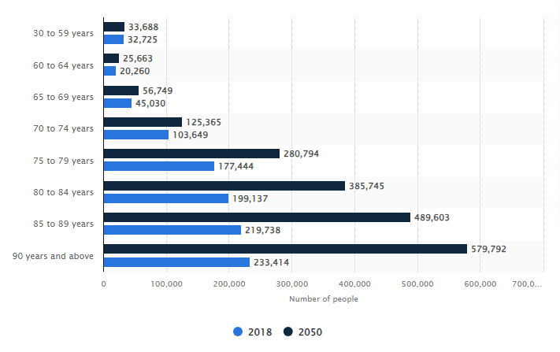
Figure: Rise in Dementia instances among the people in the UK
(Source: Statista, 2023b)
From the figure above, it can be seen that the issues of dementia will tend to rise in future. For instance, the total number of dementia instances for the age group of 90 years and above will be 597,792 individuals by 2050 and 489,603 individuals for the age group of 85 to 89 years (Statista, 2023b). This justifies that the issues relating to dementia are more prevalent among the elderly generations in the UK and this might result in issues of overburdening on the existing social care staff in the UK. This will hinder the existing policies related to health and social care in the UK as well. From the official website of the NHS UK, it can be seen that there are multiple policies such as Standards of business conduct policy, NHS England standing orders, NHS England and NHS Improvement schemes of delegation Integrated care boards: counter fraud statutory guidance, Health and safety policy and Managing to safeguard allegations against staff: policy and procedure (NHS, 2024). Thus the policies included in the NHS help in managing the case or instance of an individual and at the same time help in improving the health conditions of citizens. For example, the health and Safety policies help in ensuring that health, safety and care are included in the paramount of work for the NHS staff (NHS, 2024). Thus, this ensures that the patients in the UK, especially the elderly generation get the best and highest-quality facilities in the UK. Therefore, it can be summed up that the issues of dementia and other diseases such as diabetes are highly observed in the elderly generations and this is exerting huge pressure on the healthcare staff and lowering the quality of services rendered in the UK.

6. Feasible solutions and interventions to support health and social care needs for elderly generations.
There are some reasons that are responsible for the changes in legislation for protecting older people and providing their own rights in the UK. There are some laws in the UK that protect older people that are “The Care Act, 2014”, “The Equality Act 2010” and section 43 of the Care Act 2014 (BCP Council, 2024). According to the report of BMJ, the Ministry of Justice and the Law Commission are to modernise the legislation for older people since one in six older people face abuse, specifically those who suffer from dementia (BMJ, 2024). Regarding this context, the “Crime Survey for England and Wales (CSEW)” projected that over 200,000 adults aged 60-74 years experienced domestic abuse (Parliament, 2024). Furthermore, older people faced physical abuse including violence, although in the UK, financial and physical abuse is recorded as the most common form of harm involving manipulation of older people to get assets through wills, marriage and abuse of lasting power of attorney (BMJ, 2024). Regarding this context, the UK government proposed to bring changes to the law substantially increasing the financial abuse of older people. Due to these reasons, the UK government was forced to bring changes in legislation to prevent the older people in the UK communities.
There are several solutions to support the health and social care needs of older people in the UK. For example, the UK government can make laws for the older people in order to support them after facing domestic abuse. In this case, the government can take care of them by supporting them in the context of social care. Along with this, the government can act against their heirs and decide to provide shelter for older people. Moreover, the government can encourage communication with family, caregivers and friends to prevent cases of elder people abuse in the UK. In this case, private NGOs can stand up against this and promote the domestic abusiveness of older people. Furthermore, other healthcare organisations can promote positive health programs that encourage older people to be more aware of their resources and nurture their cognitive, physical and social qualities. In the context of supporting health needs, the government and private caregiving institutions can develop personalised care plans for elderly people who suffer from dementia since these types of elderly people are mostly abused in the UK. In addition to that, the government can make different types of housing in the communities of the UK such as care homes and supported living services to offer health treatment and temporary shelter for those people. Furthermore, NGOs and other companies can campaign against this and build awareness among the generations not to abuse them in this way. In this way, the government and other health care institutions can reduce the percentage of older people abused in the UK.

7. Conclusion
While drawing the inferences, it is earnest to mention that the health and social care offerings are subjected to face serve criticalities in terms of delivering proper care to age-old people. In such a stance, it is crucial to focus on strategic interventions, which will contribute to serving the age-old people in a better way. Though the increasing amount of the elderly population is becoming a threat for the population, recent advancement of the need assessment criteria for this population is becoming a wide impact of mitigating the existing social issue. On the other hand, application of the sustainable conception and effective legislation for this population is performing a valuable dimension of the business.

References
Abdi, S., Spann, A., Borilovic, J., de Witte, L. and Hawley, M., 2019. Understanding the care and support needs of older people: a scoping review and categorisation using the WHO international classification of functioning, disability and health framework (ICF). BMC geriatrics, 19, pp.1-15.
Ageuk, 2023. Older people are often waiting far too long for the social care they need. Available at: https://www.ageuk.org.uk/latest-press/older-people-are-often-waiting-far-too-long-for-the-social-care-they-need/ (Accessed: 17 March 2024).
Batty, D., 2023. England’s worsening care shortages leave older people struggling – Age UK. Available at: https://www.theguardian.com/society/2023/feb/17/england-care-shortages-older-people-age-uk-report# (Accessed: 17 March 2024).
BCP Council, 2024. The Care Act (2014). Available at: https://www.bcpcouncil.gov.uk/adult-social-care-and-health/about-adult-social-care-services/the-care-act-2014. (Accessed: 18 March 2024)
BMJ, 2024. Proposed changes to UK law risk increasing financial abuse of older people, warn experts. Available at: https://www.bmj.com/company/newsroom/proposed-changes-to-uk-law-risk-increasing-financial-abuse-of-older-people-warn-experts/ (Accessed: 18 March 2024).
Clark, D. 2024. Elderly population distribution of the United Kingdom (UK) 1976-2046. Available at: https://www.statista.com/statistics/743332/elderly-population-of-united-kingdom-uk/(Accessed: 10 March 2024)
Elflein, J. 2022. Percentage of elderly with chronic conditions as of 2021, by country. Available at: https://www.statista.com/statistics/807007/percentage-of-seniors-with-chronic-health-conditions-by-country/(Accessed: 11 March 2024)
Fuseini, A.G., Rawson, H., Ley, L. and Kerr, D., 2023. Patient dignity and dignified care: A qualitative description of hospitalised older adults perspectives. Journal of Clinical Nursing, 32(7-8), pp.1286-1302.
Gregory, A., 2022. Half of Britons say cost of living crisis has made health worse, poll finds. Available at: https://www.theguardian.com/business/2022/may/17/cost-of-living-crisis-health-worse-poll-britons (Accessed: 17 March 2024).
Menezes, D., Woolrych, R., Sixsmith, J., Makita, M., Smith, H., Fisher, J., Garcia-Ferrari, S., Lawthom, R., Henderson, J. and Murray, M., 2023. ‘You really do become invisible’: examining older adults’ right to the city in the United Kingdom. Ageing & Society, 43(11), pp.2477-2496.
NHS, 2024. Our policies and procedures. Available at: https://www.england.nhs.uk/contact-us/pub-scheme/pol-proc/ (Accessed: 19 March 2024).
O'Neill, A. 2024. Total fertility rate from 1950 to 2021, with projections until 2100. Available at: https://www.statista.com/statistics/805064/fertility-rate-worldwide/ (Accessed: 14 March 2024).
Parliament, 2024. Domestic abuse of older people. Available at: https://lordslibrary.parliament.uk/domestic-abuse-of-older-people/ (Accessed: 18 March 2024)
Schlepper, L., and Dodsworth, E., 2023. The decline of publicly funded social care for older adults. Available at: https://www.nuffieldtrust.org.uk/resource/the-decline-of-publicly-funded-social-care-for-older-adults (Accessed: 15 March 2024).
Sinha, A., Bavishi, A., Hibler, E.A., Yang, E.H., Parashar, S., Okwuosa, T., DeCara, J.M., Brown, S.A., Guha, A., Sadler, D. and Khan, S.S., 2022. Interconnected clinical and social risk factors in breast cancer and heart failure. Frontiers in Cardiovascular Medicine, 9, p.847975.
Statista, 2023a. Age-specific death rate per 1,000 population in the United Kingdom in 2021, by gender. Available at: https://www.statista.com/statistics/1125118/death-rate-united-kingdom-uk-by-age/ (Accessed: 11 March 2024)
Statista, 2023b. Number of people living with dementia in the United Kingdom (UK) in 2018 and forecast for 2050. Available at: https://www.statista.com/statistics/1289608/prevalence-of-dementia-in-the-united-kingdom/ (Accessed: 17 March 2024)
Statista, 2023c. Residential care in the UK - statistics & facts. Available at: https://www.statista.com/topics/7908/residential-care-in-the-uk/#topicOverview (Accessed: 17 March 2024).
Statista, 2024. United Kingdom: Age distribution from 2012 to 2022. Available at: https://www.statista.com/statistics/270370/age-distribution-in-the-united-kingdom/ (Accessed: 10 March 2024)
Studysmarter, 2024. The Ageing Population. Available at: https://www.studysmarter.co.uk/explanations/social-studies/families-and-households/the-ageing-population/ (Accessed: 12 March 2024)
The Guardian, 2023a. Lack of NHS home care ‘forces 855,000 older people into English hospitals each year’. Available at: https://www.theguardian.com/society/2023/jul/11/900000-older-people-ae-lack-of-nhs-care-at-home(Accessed: 11 March 2024)
The Guardian, 2023b. England’s worsening care shortages leave older people struggling – Age UK. Available at: https://www.theguardian.com/society/2023/feb/17/england-care-shortages-older-people-age-uk-report (Accessed: 17 March 2024)
UK Parliament, 2024. Challenges of an ageing population. Available at: https://www.parliament.uk/business/publications/research/key-issues-parliament-2015/social-change/ageing-population/(Accessed: 11 March 2024)
UN, 2024. WORLD SOCIAL REPORT 2023:LEAVING NO ONE BEHIND IN AN AGEING WORLD. Available at: https://www.un.org/development/desa/dspd/wp-content/uploads/sites/22/2023/01/WSR_2023_Chapter_Key_Messages.pdf (Accessed: 13 March 2024)
Vogel, J., Steinberger, J.K., O'Neill, D.W., Lamb, W.F. and Krishnakumar, J., 2021. Socio-economic conditions for satisfying human needs at low energy use: An international analysis of social provisioning. Global Environmental Change, 69, p.102287.

Bibliography
Bolton, 2022. How Does The Ageing Population Affect Social Care. Available at: https://www.bolton.ac.uk/blogs/how-does-the-ageing-population-affect-social-care (Accessed: 19 March 2024).

