
Hilton National UK
Financial Management


University of Wales Trinity Saint David

Student's Name: Konstantinos Soulintzis (1908247)

Course: Finance
Professor's Name: Marie Pitson
University: University of Wales TSD
City (State): London

Executive Summary
The report analyzes the Hilton Hotels and Resorts (HH&R), a global hotel brand with a strong presence in the UK and Ireland. Analysis using financial ratios reveals that the HH&R performs exceptionally regarding liquidity and gearing ratios; however, concerns exist about profitability ratios from 2018 to 2019. HH&R profitability ratios have fallen drastically, especially the return on total assets and return on shareholders' equity (ROE) – a clear indication that the organization can face challenges in future years to generate additional financial resources through equity finance. However, currently, HH&R depends higher on equity finance in 2019 than in 2018 – a reflection of low financial risk and reduction in interest payments. Even though the net profit margin also decreases because of higher expenses and low revenues in 2019. Hence, the suitable option for HH&R is to look for expansion opportunities by increasing capital expenditures to compete with competitors, and this approach also helps to generate more cash inflows. However, the preferable source for capital expenditure is internal financial resources rather than dependence on debt finance.

Table of Contents
Executive Summary 1
1. Introduction 3
2. Main Findings 3
2.1. Financial Analysis 4
2.2. Financial Analysis Trends 5
2.2.1. Profitability 5
2.2.2. Liquidity 6
2.2.3. Gearing 7
3. Knowledge from Ratio Analysis 8
4. Benefits and Limitations of Ratio Analysis 9
5. Conclusion 11
Bibliography 12
Appendixes 13
Appendix A: Income Statements of Hilton Hotels from 2018 to 2019 13
Appendix B: Balance Sheets of Hilton Hotels from 2018 to 2019 14

Hilton National UK

1. Introduction
Globalization trend provides vital opportunities to multinational companies; however, it also increases the competition, leading to a competitive business environment. Hence, organizations find it challenging to compete and accomplish sustainable competitive advantage. Organizations need to identify and develop innovative strategies based on the internal financial analysis – an effective way to evaluate the company's strengths and weaknesses from the financial perspective. The current report presents a detailed financial analysis of Hilton Hotels and Resorts (HH&R). As an accountant for the HH&R, the report is developed for the CEO (Chief Executive Officer) to present a financial analysis using profitability, liquidity, and gearing ratios. The report also provides significant information regarding the applications of financial findings to HH&R, its financial management strategies, and its performance in the hotel industry. Additionally, the financial analysis provides vital information to HH&R to make relevant decisions concerning capital expenditures, expansion strategies, and improvement policies and procedures. Discussing the benefits and limitations of ratio analysis in the hotel industry can help the CEO of HH&R accomplish sustainable financial performance in the hotel and tourism industry.

2. Main Findings
Financial analysis of the HH&R is conducted with the use of profitability, liquidity, and gearing ratios. HH&R income statements and balance sheets for 2018 and 2019 are mentioned in the appendixes (See Appendix A and B).

2.1. Financial Analysis
Table 1: Profitability Ratios of HH&R from 2018 to 2019
All figures are 000's |  | HH&R
 | Formulas | 2018 | 2019
Profitability Ratios
a. Return on Total Assets | Net Income/ Total Assets | £8150 / £13,430 =  60.7% | £6521 / £14,650 =  44.51%
b. Return on Stockholder’s Equity (ROE) | Net Income/ Total Equity | £8150 / (£3591 - £1689)  = 428% | £6521 / (£6288 - £1841)  = 146.6%
c. Net Profit Margin | Net Income/ Total Revenue | £8150 / £14,000  = 58.21% | £6521 / 13,000  = 50.16%
d. Gross Profit Margin | Gross Profit / Total Revenue | £13,550 / £14,000 = 96.79% | £12,150 / £13,000 = 93.46%

Table 2: Liquidity Ratios of HH&R from 2018 to 2019
All figures are 000's |  | HH&R
 | Formulas | 2018 | 2019
Liquidity Ratios
a. Current Ratio | Total Current Assets/ Total Current Liabilities | £1980 / £1539  = 1.29 | £2185 / £1696  = 1.28
b. Net working capital | Total Current Assets - Total Current Liabilities | £1980 - £1539 = £441 | £2185 - £1696 = £489

Table 3: Gearing Ratios of HH&R from 2018 to 2019
All figures are 000's |  | HH&R
 | Formulas | 2018 | 2019
Gearing Ratios
a. Debt to Assets | Total Debt/ Total Assets | £1689/£13,430 = 0.126 | £1841/£14,650= 0.126
b. Debt to Equity | Total Debt/ Total Equity | £1689/(£3591 - £1689) = 0.888 | £1841/ (£6288 - £1841)= 0.4140
c. Long-term Debt to Equity | Total Long-term Debt/ Total Equity | £150/(£3591 - £1689) = 0.079 | £145 / (£6288 - £1841) = 0.326
d. Total Debt to Total Capital Employed | Total Debt / (Total Debt + Total Equity) | £1689/ (£1689 + {£3591 - £1689}) = 0.470 or 47% | £1841/ (£1841 + {£6288 – £1841}) = 0.293 or 29.3%
e. Total Equity to Total Capital Employed | Total Equity / (Total Debt + Total Equity) | (£3591 - £1689) / (£1689 + {£3591 - £1689}) = 0.530 or 53% | (£6288 - £1841) / (£1841 + {£6288 - £1841}) = 0.707 or 70.7%

2.2. Financial Analysis Trends

2.2.1. Profitability
Figure 1: Profitability Ratios of HH&R from 2018 to 2019
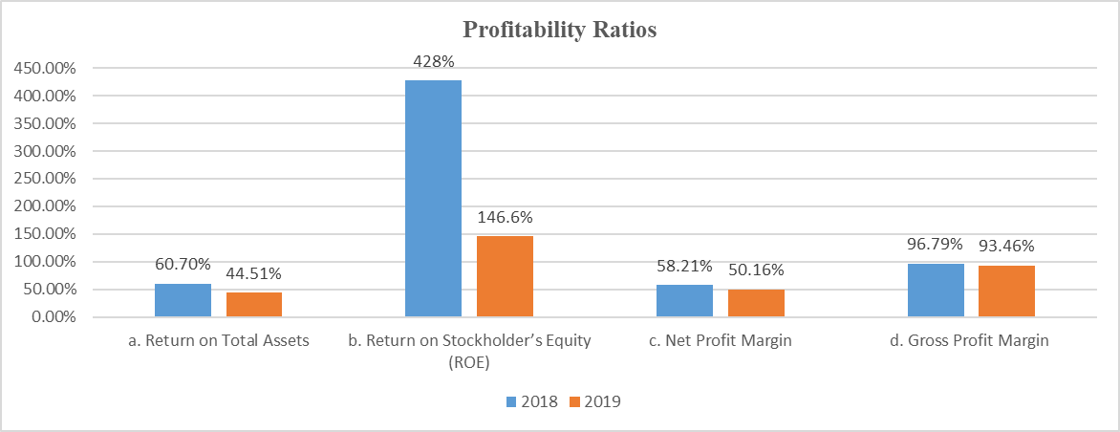
Figure 1 reflects that the HH&R is performing well regarding the profitability ratios in 2018 – a clear indication that the hotel brand can accomplish a market leader position in the UK and Ireland hotel industry. However, there is a clear reduction in profitability in 2019 in comparison to 2018.
Return on total assets has fallen from 60.70% in 2018 to 44.51% in 2019 – a reflection of a reduction in HH&R's ability to utilize assets for generating revenues.
There is a slight reduction in the net profit margin from 58.21% in 2018 to 50.16% in 2019. The gross profit margin had fallen from 96.79% to 93.46% in 2019. Hence, it is easy to establish that the HH&R faces the challenges of a rise in expenses and a reduction in revenues.
The greatest concern is the return on stakeholders' equity (ROE) because it had fallen from 428% in 2018 to 146.6% in 2019. It reflects that the HH&R is not effectively using the shareholders' equity to generate revenues. This situation discourages the shareholders from providing additional funds to the organization because it fails to meet the shareholders' required rate of return. Lafont, Romero, Palacios, and Ruiz (2020) suggest that the total shareholder return is an exceptional indicator because it considers the share price and, most importantly, the overall return achievable by the investor on the provided funds. Therefore, shareholders' return of HH&R may not encourages the investors with objectives of high returns, and the organization may have to depend on the debt finance to meet the working capital and capital expenditures requirements.

2.2.2. Liquidity
Figure 2: Current Ratio of HH&R from 2018 to 2019
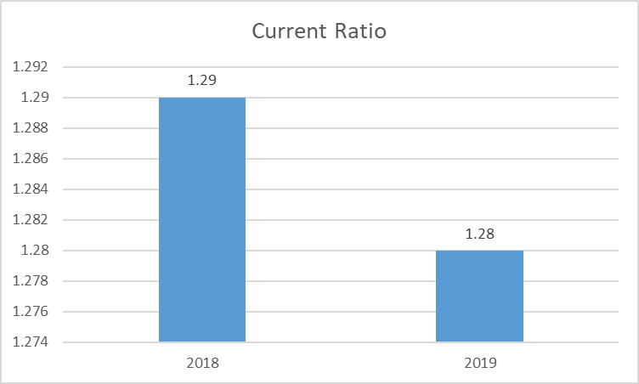
Figure 2 reflects a slight decrease in the current ratio from 1.29 in 2018 to 1.28 in 2019 – a reflection that the HH&R may not face the liquidity challenge in the short term because enough resources are available to meet the short-term obligations.

2.2.3. Gearing
Figure 3: Gearing Ratios of Hilton Hotels from 2018 to 2019
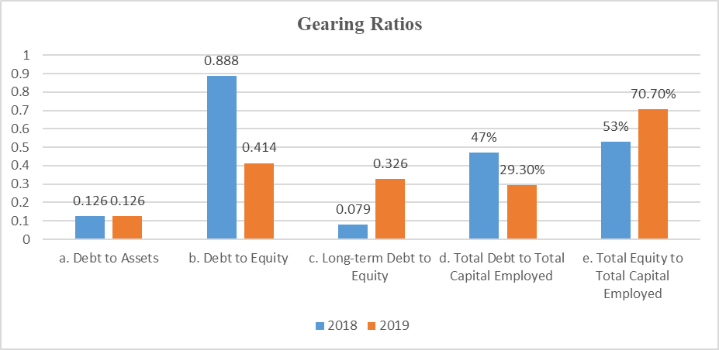
The gearing ratios comparison in figure 3 shows; the company dependence from 2018 to 2019 has fallen on the debt finance. The justification is that the debt to equity ratio fallen from 0.888 in 2018 to 0.414 in 2019. HH&R successfully generates more funds through equity finance due to the higher ROE in 2018; however, things might change in the future because the organization is unsuccessful in generating higher ROE. The higher the debt, the higher is the financial risk. Interest payments of debt finance decrease the net profit margin; therefore, the low amount of earnings is available to distribute to shareholders in dividends. Nazir, Azam, and Khalid (2021) recommend that short-term and long-term debt negatively impact the company's financial performance, especially regarding profitability. Therefore, HH&R successfully turns around the situation in the time period 2018-2019 because of the higher ROE. However, it is also important to mention that the shareholders' required rate of return is higher than the debtholders rate of return; therefore, HH&R needs to improve its financial performance to continue to meet the shareholders' expectations.

3. Knowledge from Ratio Analysis
The hotel and resort industry is highly competitive, where companies need to continuously introduce new innovative strategies to attract customers and maintain their market position. As per an estimate, the UK hotels' industry expects to decrease at a CAGR (Compounded Annual Growth Rate) of 21.5 % from 2016 to 2021 (IBISWorld 2021). Therefore, one thing is crystal clear that the HH&R performance is not different from industry trends. Lu and Tabari (2019) suggest that Airbnb in the UK creates a high impact on the consumers' behaviour of the hotel industry; therefore, leading to a situation where hotels need to revaluate their strategies to survive and compete in the sharing economy.
In the perspective of all these research findings, HH&R needs to develop a solid plan of action to improve its profitability ratios because currently, the organization's liquidity position is stable and less dependent on debt finance. The future shows some concerns because of the reduction in the ROE, an indication that HH&R will depend more on debt finance. Net Working Capital had risen from £441,000 in 2018 to £ £489,000 in 2019 (See Table 2). Therefore, the matter is that HH&R is investing high financial resources in the company to increase its current assets – an effective strategy to meet the working capital requirements. However, this situation can potentially lead to an unstable condition if HH&R decides to depend more on debt finance than equity finance. The most exceptional indicator for HH&R regarding the gearing ratio is that the debt to assets ratio remains the same at 0.126 in 2018 and 2019, respectively. It reflects that the management maintains the policy of using less debt finance to support the assets. A good strategy in the short-term and long-term, especially in the hotel industry, enables the HH&R to earn high profits by keeping the interest costs as low as possible.

4. Benefits and Limitations of Ratio Analysis
The benefits of ratio analysis for the HH&R are exceptional because the organizations in the hotel industry usually have large capital expenditures to meet the industry trends and customers' expectations. Therefore, the use of capital budgeting techniques like Net Present Value (NPV), Internal Rate of Return (IRR), and Payback Period (PP) is common because it provides relevant data for efficient decision-making. Without capital expenditures, hotels can expect a decrease in cash inflows.
Figure 4: Capital Investment in the Tourism and Travel by Country in 2019
Source: (Statista, 2021)
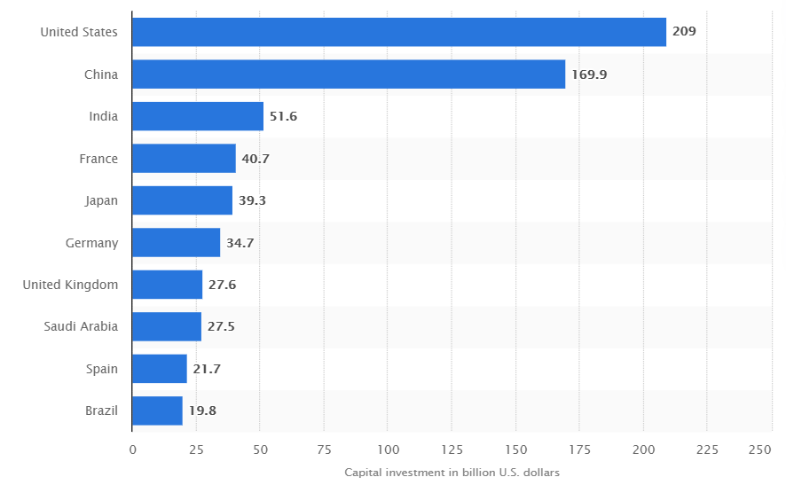
Figure 4 shows that only the US and China account for a total capital investment of $209 billion and $169.9 billion in 2019, respectively (Statista, 2021). Therefore, if HH&R has to maintain a sustainable performance, then continuous capital investment is vital. Hence, ratio analysis is one single tool that can help in identifying trends to examine the current financial performance and forecast the future results, helps in determining how effectively the hotel uses its internal resources and external finances to generate revenues, and most importantly, help in examining the liquidity and solvency situation. HH&R can use the ratio analysis findings to identify how much funding is essential for capital investment and generable from the equity and debt finance, or whether the internal resources are enough to meet the expectations. The current ratio analysis reflects that the HH&R company may have to depend on the debt finance in the future years because investors may not provide additional funds because of the continuously decreasing ROE.
There are some limitations to ratio analysis – a worth investigating because it can decrease the organization's capabilities to maximize the benefits from the decision-making. Ratio analysis is a quantitative tool; therefore, ignoring the qualitative factors in making decisions in real-time can lead to less productive results. However, the HH&R management can opt for damage control strategies by investing in improving their in-house data capabilities. Only quantitative analysis is also useful to some extent; however, the compulsion is to invest in technological tools like data analytics and artificial intelligence (AI). Lee, Kwon, and Back (2021) identify that the hospitality industry's AI and big data analytics can potentially play an important role in improving decision-making by extracting patterns and new information, leading to a more improved overall financial performance. Another limitation is that the ratio analysis is on the historical data; therefore, HH&R can expect that the forecasted results may generate some variances compared to actual results, leading to ineffective decision-making. Lastly, there are also concerns about the information in the financial statements because the management may change the accounting policies to benefit certain areas, leading to undervalued or overvalued figures. Hence, complete dependence on ratio analysis for decision-making in the hotel industry may not be a suitable option.

5. Conclusion
The analysis reveals that the HH&R can perform exceptionally in terms of liquidity and gearing ratios; however, concerns exist regarding profitability ratios in the period from 2018-2019. The net profit margin and gross profit margin have fallen slightly, but the biggest concern is the return on total assets and returns on shareholders' equity (ROE).
Return on total assets ratio has fallen from 60.7% in 2018 to 44.51% in 2019, and additionally, ROE had fallen from 428% in 2018 to 146.6% in 2019 – an indication that the investors in the future years may not provide additional funds in the form of equity finance. However, from 2018 to 2019, HH&R successfully increased their dependence on equity finance to support the activities, such as; the debt to equity ratio has fallen from 0.888 in 2018 to 0.4140 in 2019, respectively. Therefore, it is clear that the HH&R faced less financial risk in 2018-2019; however, this could have led to better net profit margins, but it decreased because of the low revenues.
A reduction in revenues from 2018 to 2019 reflects that the HH&R's ability to meet the shareholders' rate of returns will negatively impact future years. However, HH&R is not moving against the industry trends because different reports suggest that the complete industry is facing intense competition, especially from the new players like Airbnb, and thus, it becomes difficult to accomplish projected results. Hence, two important challenges for the HH&R are; how the hotel can maintain its profit margins while increasing the dependence on debt finance in future years and how capital expenditures can help attract new customers from different segments of the society. Therefore, the most suitable option for the HH&R is to diversify its portfolio to compete with competitors like Airbnb and develop new policies to utilize internal cash resources for capital expenditures rather than dependent on external sources.

Bibliography
IBISWorld, 2021. IBISWorld - Industry Market Research, Reports, and Statistics. [online] Ibisworld.com. Available at: <https://www.ibisworld.com/united-kingdom/market-research-reports/hotels-industry/> [Accessed 23 September 2021].
Lafont, J., Romero, J., Palacios, M. and Ruiz, F., 2020. Shareholder return and value creation at listed infrastructure companies in different economic contexts. Economic Research-Ekonomska Istraživanja, 34(1), pp.2194-2209.
Lee, M., Kwon, W. and Back, K., 2021. Artificial intelligence for hospitality big data analytics: developing a prediction model of restaurant review helpfulness for customer decision-making. International Journal of Contemporary Hospitality Management, 33(6), pp.2117-2136.
Lu, L. and Tabari, S., 2019. Impact of Airbnb on Customers' Behavior In the UK Hotel Industry. Tourism Analysis, 24(1), pp.13-26.
Nazir, A., Azam, M. and Khalid, M., 2021. Debt financing and firm performance: empirical evidence from the Pakistan Stock Exchange. Asian Journal of Accounting Research, 6(3), pp.324-334.
Statista, 2021. Capital investment in travel and tourism in leading countries 2019 | Statista. [online] Statista. Available at: <https://www.statista.com/statistics/1093456/capital-investment-travel-and-tourism/> [Accessed 23 September 2021].

Appendixes

Appendix A: Income Statements of Hilton Hotels from 2018 to 2019
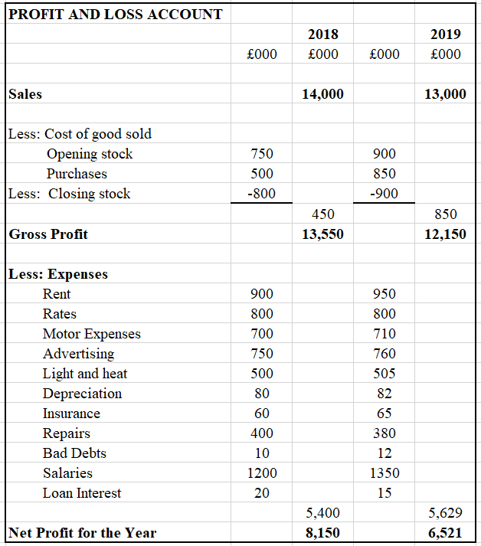

Appendix B: Balance Sheets of Hilton Hotels from 2018 to 2019


