

Module name: International Marketing: Principles and Practices
Module Code: LCMB7026
Student name: Kush Jani
Student ID: 2504341
Lecturer name: Dr Tushara Balendran
Submission date : 24 April

Table of Contents
Introduction 3
Section 1 3
Background information about the company 3
Comparative analysis with PESTLE 3
Comparative analysis with STP & Marketing Mix 8
STP comparison 8
Marketing mix comparison 12
Directional development strategy 14
Ethical issues 17
Recommendations 18
Section 2 20
Conclusion 23
References 24

Introduction
As globalisation is gaining prominence along with the rapid growth of technologies, it has become mandatory for brands to ensure international presence in order to grow. This report will look into the case of Zara. The report will critically compare the markets of Spain and the US using tools like PESTLE, STP, 7Ps marketing mix, directional developmental strategy and others. It will identify the gaps and make recommendations accordingly. The next part of the assessment will conduct a reflective account using Gibbs’s reflective cycle to look into my experience of completing this report while preparing an action plan to improve my activities in future.

Section 1

Background information about the company
Zara is a Spanish retailer that Amancio Ortega Gaona and Rosalía Mera Goyenechea established in 1975. It stands out for offering an impressive range of clothing, bags, accessories, beauty products, fragrances, and others (Zara.com, n.d.a). Its owner, INDITEX, is generating annual revenue of €9.8 billion (INDITEX, 2025). The mission of the company is to ensure that customers receive their requirements at the right time, while the vision is to become the global leader in sustainable fashion (Boardmix, 2026). The company entered the US market through New York in 1989 (INDITEX, n.d.c). This way, it expanded.

Comparative analysis with PESTLE
The macroenvironment plays a significant role when it comes to the attractiveness of a market for business development. It refers to the external environment and the associated factors that may affect companies (Stocker and Erdélyi, 2024). The PESTLE framework helps to evaluate political, economic, social, technological, legal and environmental elements (Uztürk and Büyüközkan, 2023). Here is a detailed analysis to compare the US and Spain considering Zara’s operations:
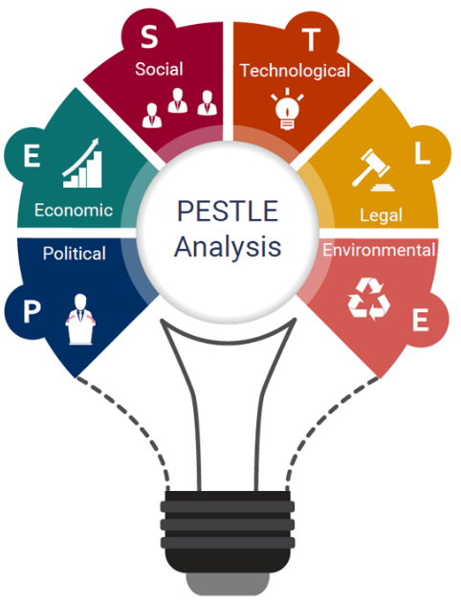
Figure 1: PESTLE tool
(Source: IBISWorld, 2020)
- Political factors
Politically, both the US and Spain are not quite stable. As of 2026, Spain’s political stability index is 0.00, which is not impressive (The Global Economy, 2026a). In the US context, the stability index is -0.10, which is even more alarming (The Global Economy (2026b). This means that companies like Zara have a hard time operating in these markets considering their poor political conditions, the US being in an even more unfavourable state.
Besides, the US and Spain trade relations are also quite inconsistent. This is evident as tariff is likely to increase under new laws in the US (BBVA Research, 2025). Political tensions can also be seen in both markets. For instance, the US political parties are dealing with severe polarisation (Stirling, 2025). On the other hand, Spain is dealing with trade wars (Francaviglia, 2025). This shows problems for Zara in both markets, which is a similarity.
- Economic factors
There are signs of economic growth in both countries. The US is currently generating GDP of $30.62 trillion, and leading in the list of global countries. On the other hand, Spain is at the 12th position, with GDP of $1.89 trillion (Worldometer, n.d.). The GNP of the US is $26 trillion, while Spain’s GNP is only $1 trillion (MacroTrends, 2026). This shows that the US market is more favourable, as profit and sales of companies are likely to be higher in this market than Spain.
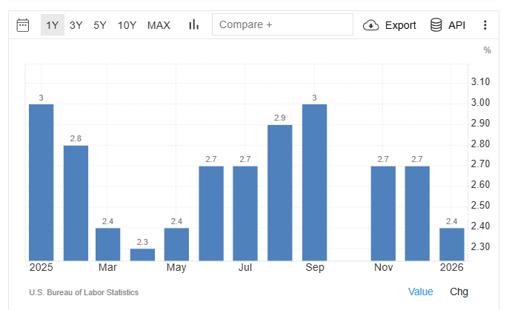
Figure 2: US inflation rate
(Source: Trading Economics, 2026a)
However, inflation rate is increasing in both countries. In the US context, the inflation has increased to 2.4% (Trading Economics, 2026a). Spain’s inflation rate is at 2.3% (Trading Economics, 2026b). This makes Spain a slightly more favourable market, while both countries are facing increasing prices.
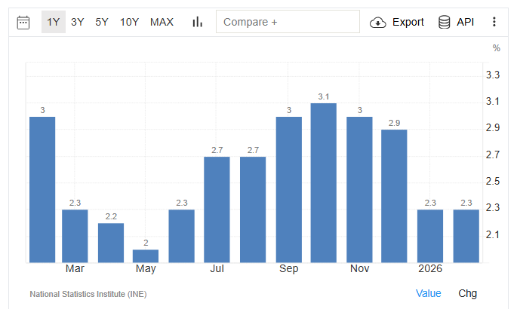
Figure 3: Spain inflation
(Source: Trading Economics, 2026b)
Taxing is also high in both markets. As of 2026, corporate tax rate starts from 21% (PwC, 2025a). On the other hand, Spain’s corporate tax rate starts from 25% (PwC, 2025b). While the US is more of a favourable market here, the tax rates are quite high in both markets, which is a similarity.
- Social factors
Both countries are growing population-wise. The US has a large population of 349 million, while Spain has a population of 47 million (Worldometers, n.d.). This gives an upper hand to the US, as Zara will be able to build a bigger market here.
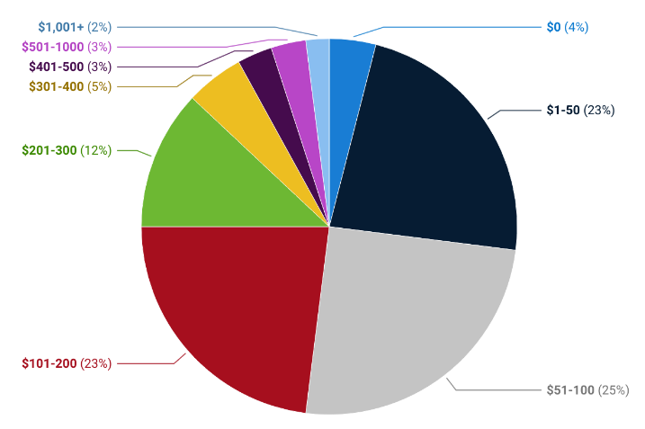
Figure 4: US spending on clothing
(Source: Elad, 2024)
Consumer behaviour is also positive in both markets. For instance, US consumers spend between $51 and $100 monthly on clothing and apparel (Elad, 2024). On the other hand, Spanish households are spending €20.7 billion annually on clothing (Rocco, 2025). This shows that Zara is likely to make profit from both markets, which is a similarity.
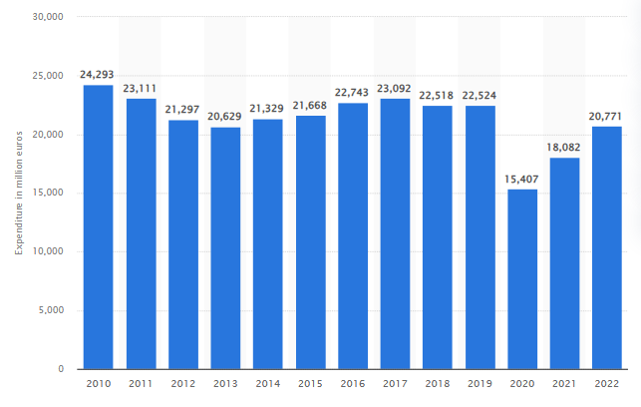
Figure 5: Spanish spending on clothing
(Source: Rocco, 2025)
- Cultural factors
Hofstede’s dimensions of culture can be considered here. These include power distance, individualism/collectivism, masculinity/femininity, and others (Jan et al., 2024). The advantage of this model is that it helps to get an actionable framework on culture, but the disadvantage is that outcomes can be outdated with inaccurate generalisation. As the following figure shows, the US has limited power distance, while Spain is more into formal power. Moreover, uncertainty avoidance is higher in Spain, which means the US is more open to risk-taking (The Culture Factor, 2026). Individualism and long-term orientation are some similarities in cultures of both countries. Based on the analysis, the Spanish culture is more favourable for Zara as it meets its original approach.
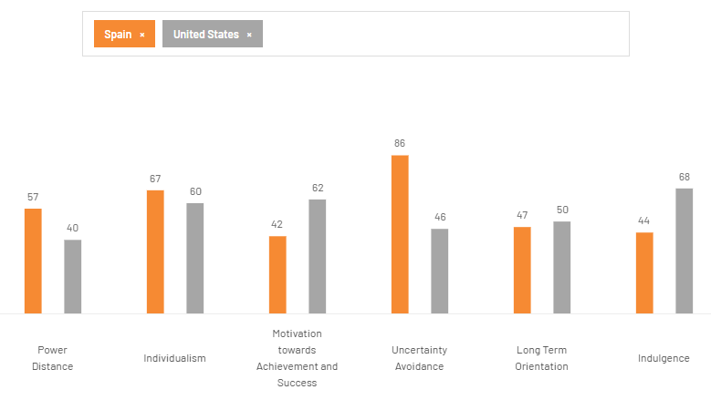
Figure 6: Cultural comparison of Spain and the US
(Source: The Culture Factor, 2026)
Culturally, the US has a focus on high-end luxury brands (Koolteee, 2025). Spain also follows latest fashion trends, with a focus on street fashion (Vamos Academy, 2023). This suggests that the Spain comes closer to match Zara’s product line.
- Technological factors
Both the US and Spain are growing technologically. This is evident as the technology revenue has reached over $1 trillion as of 2024 in the US context (Soltani, 2025). In Spain, on the other hand, the tech revenue has increased to $395.28 billion (GlobalData, 2024). This shows that the US is more favourable. Ecommerce is growing in the fashion sector, while emerging technologies like AI, AR and VR are also being used for customised services, recommendations and digital trial rooms (Akramet al., 2022). Zara will be able to utilise these in both markets, which is a similarity.
However, cyber crime cases are also increasing in both markets. In the US, the FBI has registered over 859,532 complaints of cyber attacks (FBI, 2025). On the other hand, Spain has also registered about 472,125 cases (GiCP, 2026). While Spain is more favourable with lower number of cases, cybersecurity risks continue for Zara if it does not have a strong strategy.
- Legal factors
Legally, both countries have some strong laws and regulations regarding business management. Fair Labor Standards Act (FLSA) of the US sets standards on wages, working hours, and dismissal clauses (DOL, n.d.). Similarly, in Spain, the Workers’ Statute determines the standards of working hours and wages (Mariscal Abogados, 2026). This suggests that both countries can be unfavourable for Zara with changing laws.
Apart from that, regulations are also changing frequently in both markets. For instance, the New York Fashion Sustainability and Social Accountability Act was recently developed in the US to enhance sustainability standards of fashion brands (The Fashion Act, n.d.). Spain is also about to introduce the Extended Producer Responsibility (EPR) law in this field to enhance social responsibilities of fashion brands (Staxxer, 2022). Being a fast fashion brand, these laws can be challenging for Zara to follow, which is a similarity.
- Environmental factors
Finally, the environmental factors can be considered. Both the countries are struggling with their environmental conditions. The US is mainly dealing with severe pollution, wastage and disasters like wildfire (Igini, 2025). On the other hand, Spain is also dealing with climate-related issues, wastage, greenhouse gas emissions, and so on (EEA, 2025). In recent times, fast fashion brands are facing backlash for polluting the environment. This makes it challenging for Zara to maintain a goodwill in both the markets, as it can be considered as a contributing factor to their environmental challenges. Hence, it will have to improve its sustainability strategies in both countries with the similarities.

Comparative analysis with STP & Marketing Mix

STP comparison
Segmentation
The first requirement for marketing strategy is to segment the customers. The process helps to build multiple groups to segment the customers to be able to identify a suitable target market for the brand (Tabianan et al., 2022). In this scenario, Zara may have different segments across the US and Spain. As the following table suggests, the segments will have different conditions and needs across the two markets:
Demographic Segment
Young broad middle class segment (Spain)
- Age: 18-25 years
- Location: Spain
- Income:€10,000-€15,000
Upper middle class segment (US)
- Age: 18-25 years
- Location: The US
- Income: $20,000-$25,000
Psychographic Segment
General fashion lovers (Spain)
- Age: 20-30 years
- Location: Spain
- Income: €15,000-€25,000
- Values and lifestyle: Fashion lovers and regular buyers
European fast fashion enthusiasts (US)
- Age: 22-35 years
- Location: The US
- Income: $22,000-$30,000
- Values and lifestyle: Regular buyers of European-style fashion items
Behavioural Segment
Habitual buyers of latest trends (Spain)
- Age: 18-30 years
- Location: Spain
- Income:€20,000-€25,000
Latest fashion item collectors (US)
- Age: 18-24 years
- Location: The US
- Income: $18,000-$22,000
(Source: Carmely, 2023; Martin Roll, 2021)
Targeting
The stage of targeting comes next. It helps to target the segment that suits the interests of the brand more closely. This stage makes it easier for the marketing team to create content catering their interests and pain points (Alijoyoet al., 2025). Based on the above analysis, here are the chosen target markets for Zara in both markets and their comparison:
Target market | Priority | Pain points
Young broad middle class segment (Spain) | Primary target market in Spain | They need to find latest fashion items under budget.
Latest fashion item collectors (US) | Primary target market in the US | They look for latest clothing and accessories following latest fashion trends.
Habitual buyers of latest trends (Spain) | Secondary target market in Spain | They are habituated to make purchases from latest fashion trends.
Upper middle class segment (US) | Secondary target market in the US | They need to find good-quality clothing under a good brand name.
Table 2: Target market comparison
(Source: Carmely, 2023; Martin Roll, 2021)
Zara follows a differentiated targeting strategy. For instance, its marketing content focuses on changing styles and trends. This meets the aims of fashion lovers. On the other hand, its marketing content also highlights pricing and quality (Martin Roll, 2021). This helps to target customers who look out for fashion products under budget.
Positioning
The step of positioning comes next. Once the brand identifies its target market and their pain points, it can successfully understand the right way to position the brand considering quality and price (Kalamand Kalam, 2020). Zara usually positions itself as an affordable brand that regularly offers latest fashion and apparel products. Here is a perceptual map for Spain:

High Quality
Low Quality
High Price
Low Price
Figure 7: Positioning map for Spain
As this map suggests, Zara positions itself as a high quality but low price brand in Spain. Its biggest competitors include Mango, Bershka and Pull & Bear (Harshita, 2025). Among others, Zara stands out for offering highly affordable fashion items and accessories under budget. On the other hand, in the US context, the perceptual map is as follows:

High Quality
Low Quality
High Price
Low Price
Figure 8: Positioning map for the US
In contrast to the Spain context, Zara positions itself in the high quality and high price segment in the US. Here, its biggest competitors include H&M, Shein, and Forever21 (Owler, 2026). This shows two different positioning strategies. In Spain, Zara positions itself in the high quality and low price segment. On the other hand, in the US, it is in the high quality and high price segment. Thus, it has different marketing strategies in both markets.

Marketing mix comparison
The marketing mix can be an essential requirement for brands to make the right choices for marketing. It focuses on four main elements to understand the approaches of the brand in gaining awareness of the products from customers (Ho et al., 2022). Here is a detailed analysis of the marketing mix strategies that Zara will develop in both markets:
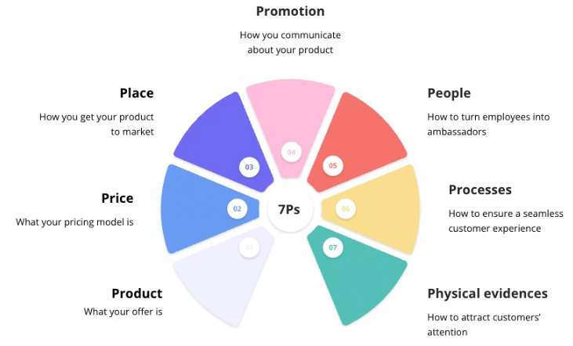
Figure 9: 7Ps marketing mix
(Source: Augusti, 2026)
- Product
The primary product range of Zara includes its wide range of clothing, bags, accessories, beauty products, fragrances, and others (Zara.com, n.d.). These are being offered in both markets. Spain’s culture is connects closely with Zara, which allows it to follow the differentiation strategy. This refers to the idea of expanding product range and features (Caravaggio et al., 2022). As the company has warehouses in Spain, the product depth and line fillings are higher in this market, which helps it to focus on range and quality. However, in the US context, Zara is more likely to focus on sales. This means that the adaptation strategy is followed in Spain, while standardisation is maintained in the US context.
Product depth and width can be considered. Product depth helps to evaluate the number of versions and variations that companies have in a single product line, while product width looks into the total number of distinct product lines (Kotler and Keller, 2015). In Spain, Zara’s product breadth is large. It offers clothing, footwear, accessories, beauty products, fragrances and other for men, women and children (Zara.com, n.d.c). On the other hand, in the US context, the focus is mainly on clothing and accessories, while beauty products and fragrances are occasionally available. This shows a larger breadth in Spain.
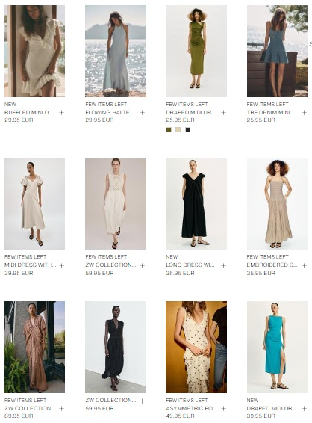
Figure 10: Product variations in women’s clothing
(Source: Zara.com, n.d.c)
On the other hand, the depth is again more significant in Spain, but the US collection is also large. There are multiple options for clothing, including different types of fabrics, colour options, style variations, and so on in Spain (Zara.com, n.d.c). In the US context, the number of SKUs is limited per category. Size availability is also lower as compared to that of Spain (Goldstone, 2026). This shows the difference in product depth and breadth in two markets.
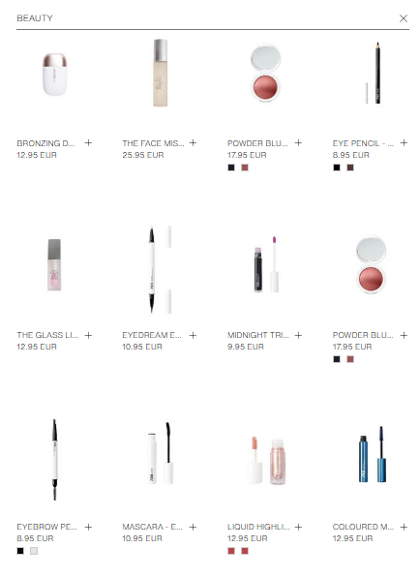
Figure 11: Product variations in beauty
(Source: Zara.com, n.d.c)
- Pricing
In the Spain context, Zara maintains its usual brand position of affordable fashion products. On the other hand, in the US context, the price increases considering the distance from its original warehouses, exchange rates and tariffs (Mateos, 2025). Here, Zara maintains cost-based pricing strategy in Spain. This strategy believes in setting prices based on expenses (Thielen et al., 2022). On the other hand, profit-based pricing focuses on analysing consumer willingness (Xu et al., 2022). In the US context, the profit-based pricing strategy is followed considering consumer needs. This means that prices are lower in Spain, as it is the host country and products are easily accessible from here.
- Place
Zara offers its products across both its website and the physical outlets. Here, Spain has an upper hand as the warehouses are located here. When it comes to the US, Zara follows a centralised distribution model. There are about 98 Zara stores across the US, while Spain has over 547 stores (Forbes, 2026). Store density is much higher in Spain.

Figure 12: Zara's biggest store in de España, Spain
(Source: Malasa, 2023)
This suggests that Spain has an upper hand regarding offline stores. However, Zara’s ecommerce website offers uniform services across the US and Spain.

Figure 13: Zara's expanded store in LA, the US
(Source: Lopez, 2025)
- Promotion
For promoting its store and products, Zara usually follows the non-traditional digital marketing strategy. Spain is a high-context culture with indirect communication and a focus on body language, while the US is a low-context culture with direct communication (RVF International, 2026). In Spain, it invests in store experience, visual merchandising, and frequent product drops to test the products and their reception (Martin Roll, 2021). The Integrated Marketing Communication helps to coordinate multiple tools like advertising, public relations, social media, and direct marketing for promotions (Rehman et al., 2022). Direct marketing and public relationships are prioritised in Spain. On the other hand, in the US context, digital and social media marketing are more common. It also uses influencer marketing in this market (White, 2024). This means that Zara primarily uses social media and advertising strategies in the US, while in Spain it has a more detailed strategy with store experience and visual merchandising.
- People
Zara has a strong people strategy. As of now, it operates with over 170,000 employees (PitchBook, 2026). Zara’s owner INDITEX maintains a strict human rights policy that is binding upon all employees in different markets (INDITEX, 2016). Moreover, diversity and inclusion policies are also commonly followed in different markets (INDITEX, 2024). Spanish employees are more likely to have unions and are more likely to open up (Reuters, 2023). On the other hand, the US employees are expected to show agility and flexibility.
- Process
The process strategy remains similar for Zara in both the US and Spain contexts. Vertical integration is seen in Zara in the Spanish context, as its warehouses and networks are well-developed (Jonwal, 2025). This strategy refers to having in-house teams for supply chain and production (Chambolleand Guignard, 2025). However, this is not seen in the US context, as products are mostly exported. There are centralised distribution centres of Zara across Spain that are used for both domestic and global deliveries (Sinha, 2024). This shows that the process is more streamlined in Spain.
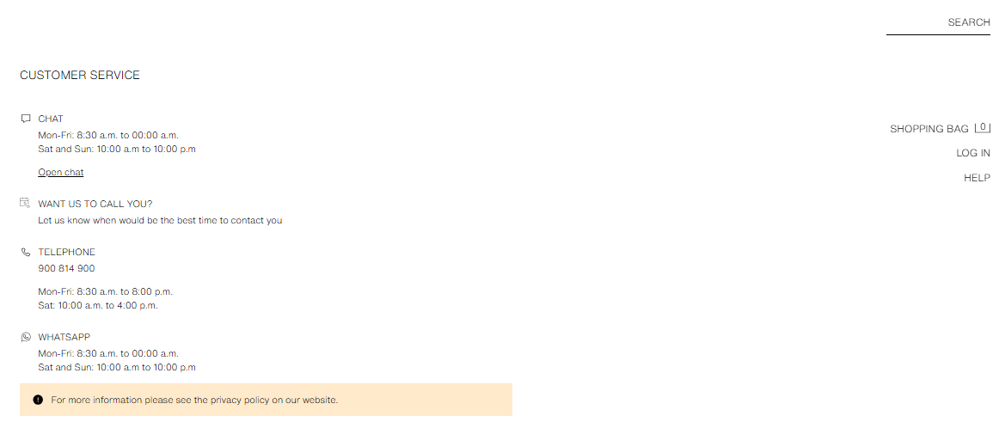
Figure 14: Spain's customer service
(Source: Zara.com, n.d.d)
The customer complaint processes can also be compared here. Spanish consumers have a legal right to request official complaint forms (Zara, 2023). This is a unique system that is not available for the US consumers. While both countries offer helpline, in-store and email support for returns and complaints, Spain’s customer service offers callback and WhatsApp options, which are not available in the US (Zara.com, n.d.d; Zara.com, n.d.e). This again shows the difference.
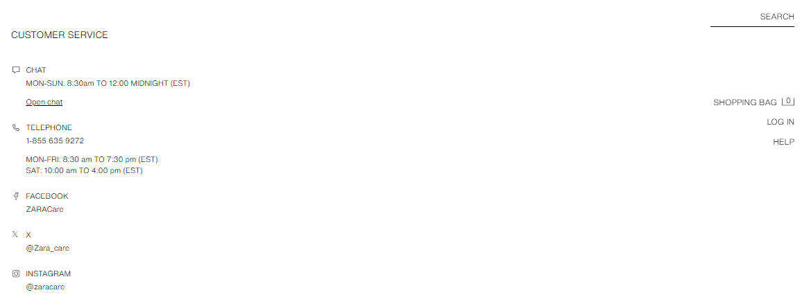
Figure 15: Customer service in the US
(Source: Zara.com, n.d.e)
- Physical evidence
Zara stands out for its minimalistic store designs and luxury-adjacent locations. In Spain, the company has stores in high-traffic shopping streets including Madrid and Barcelona. Similarly, it is also targeting such streets in the US, like Fifth Avenue and NYC. The RFID technology is used globally to ensure accuracy with inventory (INDITEX, 2014). This is used in both markets.
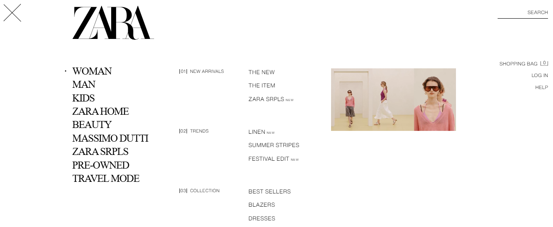
Figure 16: Zara's US website options
(Source: Zara.com, n.d.f)
Apart from that, the loyalty program is also operational globally (Espin, 2026). This suggests limited difference in the physical evidence aspect of Zara. The official websites in both markets help navigate across products and different options. The only difference is that Massimo Dutti brand extension option is only available in the US (Zara.com, n.d.c; Zara.com, n.d.f). Both websites offer similar options and services for consumer convenience.
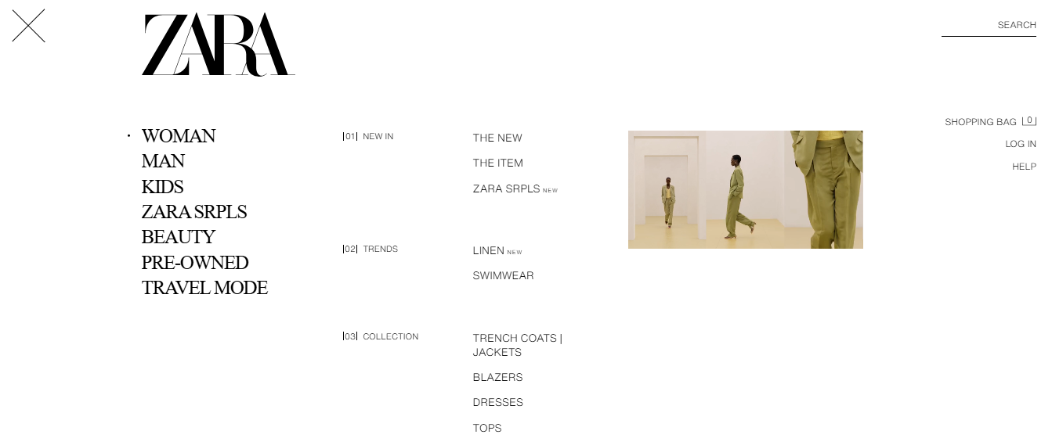
Figure 17: Zara's Spain website options
(Source: Zara.com, n.d.c)

Directional development strategy
As Zara already has a well-established business in Spain, a directional development strategy of the company can be analysed in the US context. In simple terms, such a strategy provides a clear roadmap to brand development, positioning and growth (Sayedand Dayan, 2024). While Zara enter the US in 1989, brand development is still at the surface level. Hence, a strong directional development strategy will be beneficial for the company. Zara’s original mission of prioritising customers and focusing on innovative fashion is also relevant in the US context (INDITEX, n.d.a). This is mainly because the centralised logistics and inventory systems are being followed globally.
The purpose of Zara’s entry in the US was to gain international brand appeal and profitability growth. A recent report shows that INDITEX, the owner of Zara, is expecting massive sales growth and profitability. The brand reported 10.6% sales growth by the end of 2025, shares growth by 7% reaching sales of up to $11.41 billion (Reid, 2025). Here, about 18.6% of the sales are coming from the US market (Rocco, 2025). This shows that the level of sales is growing in this market and is becoming important for Zara’s future.
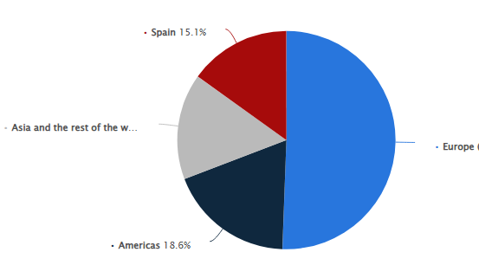
Figure 18: Sales share globally
(Source: Rocco, 2025)
As mentioned previously, Zara’s branding is slightly different in the US context than that of Spain. Here, the pricing increases with exchange rates and tariffs (Mateos, 2025). As a result, it targets citizens who are from upper middle class segment and are open to high-quality products at higher rates due to their interest for latest fashion trends. Most women and girls in the US spend about $545 on average annually on clothing items, which reduces to $326 for boys and men (Newbery, 2022). Gen Alpha and Gen Z teens are spending on fashion but relying mostly on parents (Mintel, 2025). This makes this segment less suitable for Zara’s target market.
The demand for luxury and upscale fashion is also growing in the US. Here, again, Gen Z and Millennial have a higher potential. A recent survey suggests that 40% of luxury buyers feel satisfied with the pricing based on the quality of products (Mintel, 2026). Another study shows that 16.7% of US citizens aged 18-34 years are likely to increase fashion expenses (Canaves, 2025). This gives an upper hand to Zara’s growth in the US. Keeping this in mind, it has been planning on expanding the operations to see improvement in sales and profit.
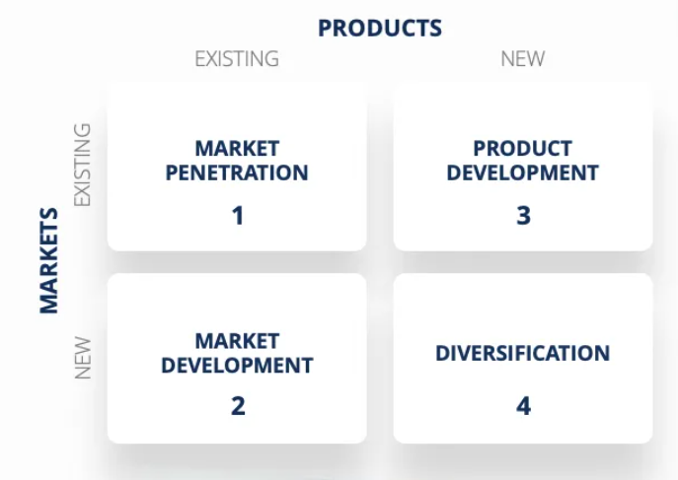
Source: (Peterdy, 2025)

Here, Ansoff matrix can be applied for a better understanding. This model looks into growth strategies like market penetration, product development, market development and diversification (Puytet al., 2024). After entering the US, Zara’s main focus has been on market penetration. This is mainly because of the growing competition in the US market (Owler, 2026). Instead of expanding the product range, the company believes in simply expanding the brand values and awareness across the US, gaining more consumer attention and enhancing sales.
Zara’s owner INDITEX is making efforts to see expansion in the brand value within the US market. For instance, it has chosen The Forum Shops at Caesars Palace on the Las Vegas Strip for a new flagship store (Europa Press, 2025). This investment is aimed at enhancing Zara’s brand value while positioning a store in a high-traffic shopping area for luxury fashion. Moreover, this also meets the 100-Store milestone of the company and makes its brand known among other luxury brands in the same retail section, such as Sephora, Gucci, Apple, Coach, and others (Martinez, 2025). This suggests that the directional strategy of Zara in the US focuses on steady expansion with a centralised operational angle.
Furthermore, Zara is also trying to show its efforts with circular economy. It has developed a platform that enables citizens to repair and resell products or donate them. While Zara positions itself as a high-end brand, this new platform in the US enables it to meet the sustainability needs of the US citizens (Apparel Resources News-Desk, 2024). This way, the company constantly tries to explore the needs of the US citizens and meet them with effective strategies and decisions.

Ethical issues
There are some ethical issues with Zara’s marketing mix. A major issue is related to its fast fashion brand value, which is more prominent in Spain. While Zara is now pivoting towards sustainable and high-end fashion, it has faced allegations of environmental pollution in the past.
- Unethical marketing practices
A study from 2025 shows a lack of ethics in the process element of Zara’s marketing mix. Its owner, the INDITEX Group, has scored in the Ethical Consumer’s climate category. There is a lack of transparency as the company does not openly admit its actions to reduce supply chain emissions. Moreover, the company flies over 100 tonnes of clothing items through a Spanish airport annually (Ethical Consumer, 2025). This further complicates with the allegations of forced labour and violation of human rights. There are allegations of the brand paying wages to suppliers below the cost of production (Ethical Consumer, 2025). This again violates the people element of Zara’s marketing mix.
Besides, a study from 2021 shows that Zara indulged in forced labour in some of its supply chains located mostly in China and Brazil. Modern slavery standards are seen as workers are expected to work 16 hours a day to cope with fast fashion approach of the company (ImpACT International, 2021). This clearly shows an ethical gap in the people element of Zara’s marketing mix. Moreover, as mentioned previously, Zara has an in-house supply chain in Spain and maintains low prices while meeting changing consumer needs quickly (Wolff, 2025). As a result, environmental pollution increases, as the company regularly manufactures a large quantity of garments to keep the prices low and cope with the changing trends.
- Ethical marketing practices
On the other hand, some ethical marketing practices can also be seen in Zara’s marketing mix. For instance, it has developed Join Life program, which aims to set environmental, health, and safety standards for its products. This program started in the host country Spain, but is currently operational globally. Zara uses sustainable raw materials and focuses on repair, resale, and donation for better circular economy using this program (Zara.com, n.d.b). This helps the company to maintain ethical standards in the product and process elements of its marketing mix.
Apart from that, the owner INDITEX Group has also worked on certain sustainability efforts. For instance, it has worked on lower-impact linen and polyester while reducing water consumption in supply chain. It is also aiming to improve biodiversity with their activities and operations (INDITEX, n.d.b). This is another ethical example within its marketing mix in the aspects of product, people and process. The company is trying to improve the quality of supply chain and final outcomes with more sustainable efforts.
Based on its recent efforts and strategies, it seems that Zara has invested in sustainability initiatives. For instance, it has set targets on eliminating plastic waste and renewable energy. However, the annual reports or sustainability results do not openly disclose the efforts. There is only 11% traceability in the transparency index report (Live Frankly Team, 2024). This can also be an ethical problem, particularly in the process element of the company in its marketing mix.

Recommendations
Zara is a highly successful international brand known for its wide range of fashion and apparels. However, it is struggling to ensure top-notch international marketing strategies considering the rising competition and ethical issues. Here are some strategies that Zara can follow to improve its international operations and marketing strategies in future:
- R&D and localisation
Primarily, Zara needs to invest in R&D to understand the conditions of the international markets and their needs. For instance, in the US, premium and luxury fashion is in demand (Mintel, 2026). Here, regular research into the changing market conditions can be done with the help of focus groups and predictive models (Bulchand-Gidumalet al., 2024). With this information, Zara will be able to focus on localisation. It can integrate the specific customer needs in each market, including the US.
- Digital transformation
Zara is already working on integrating technologies to ensure more digital operations. This needs to be improved further to make the company more agile and innovative for the international markets. For instance, artificial intelligence (AI) helps with customised recommendations, while augmented reality (AR) can be used for virtual trial rooms (Akramet al., 2022). Zara needs to invest in these technologies to improve its physical evidence and enhance traffic for its official website. It can also meet different consumer needs.
- Sustainability and transparency
Zara’s current sustainability policy needs improvement, as there are several issues with its ethical positioning. In recent times, transparency is a major requirement for brands to avoid allegations of greenwashing (Alyahiaet al., 2024). For addressing this, Zara needs to change its policy and increase integration of audit results, initiatives and outcomes. This will help the company to show its efforts and initiatives to reduce environmental impact. Moreover, it should also be stricter with the code of conduct and human rights policies when dealing with the suppliers.
- Influencer partnerships
There is also a need to improve digital marketing strategies with strong influencer collaborations. This helps brands to do paid partnerships with social media influencers and gain better brand awareness (Thomaset al., 2024). While Zara already follows such marketing strategies, this needs to improve in future. It needs to be more active with international influencers, particularly those in the US and other markets. This will help Zara to gain stronger brand awareness in these markets while improving social media presence.

Section 2
Section 2: Reflective Account — Gibbs' Reflective Cycle
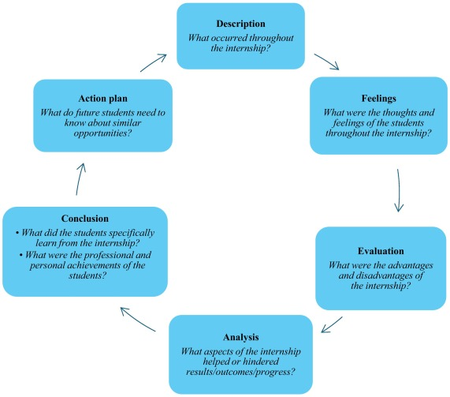
Image 1. Gibbs Reflective cycle. Source (Ocampo et al., 2025)

A reflective analysis is essential for learning more about an experience and gain insights from the same. In this section, I will reflect upon my process of completing the previous section, whereby I prepared a report on Zara while comparing its operations in Spain and the US. Gibbs’ reflective cycle is a popular model for conducting a reflection. It focuses on six stages for conducting a reflection (Ahmadpouret al., 2025). Here is a detailed analysis of my process and experience of completing the report:
- Description
The purpose of the report was to explore the operations of Zara in its home country, Spain, and a host country, the US. It started with a PESTLE comparison to look into the external conditions in both countries. Then, it conducted a deep STP and marketing mix analysis to compare the strategies of the company in the two markets. Moreover, the ethical issues of the country were also considered while exploring its directional development strategy in the US. The process was quite challenging, as I had to conduct in-depth research into Zara and the market conditions in both markets. Moreover, I also had to consider the weekly lecture materials to integrate them in my work.
The final part of the report required recommendations for the brand to improve its international marketing strategies. For this, again, I had to conduct research while considering the current drawbacks and challenges seen within Zara. The process helped me understand more about Zara and international operations.
- Feelings
I felt quite nervous initially, as the requirements of the first part of the assessment seemed quite complex and challenging. While I have worked on such reports, this assessment was much more comprehensive. However, my confidence started to grow as I looked into the details of the requirements and interacted with my peers and tutors to discuss the same. Now that I have completed it, I feel much more confident about international business and operations.
- Evaluation
The process of completing this report was positive for various reasons. Firstly, I feel that my research skills were impressive. I could dig deep into the operations of Zara to compare its activities in Spain and the US. Secondly, I was also able to utilise my critical thinking skills. This skill helps to take a critical approach into analysing different concepts considering various outcomes (Angelelliet al., 2023). This helped me to explore the current situations and conditions in both countries and compare Zara’s operations.
Apart from that, I also feel that I was capable of maintaining an effective format to present the details in this assessment. For instance, I used relevant figures, statistics and illustrations like perceptual maps. I also divided the details into relevant headings and subheadings to make the data more readable and easy to comprehend. All these made the experience easier and better for me to complete this assessment.
However, there were some aspects that made the process negative. A major challenge came from lack of time management. This skill is essential to manage time while having a clear timeline for different tasks and duties (van Sluijsand Matzat, 2024). I struggled to manage time between classes and lectures for this assessment, which made it slightly challenging for me to meet the deadline. Apart from that, I also had a hard time identifying recommendations. While I could show critical thinking, my creative and innovative thinking may not have been satisfactory.
- Analysis
The experience went well mainly because of my perseverance and hard work. While I was scared and nervous, I took the initiative to conduct research and discuss my ideas. It is important to critically evaluate information gathered through research to be able to integrate them into a piece of work for better analysis (Heimet al., 2022). I was able to do this after taking help from my tutors and peers. Moreover, I also feel satisfied with my ability to plan the content, which was again possible because of my focus on the requirements and critical thinking.
On the other hand, the negative experience came from my lack of confidence. I was quite nervous and sceptical about the report, which made it difficult for me to prepare a wireframe and divide words accordingly. This, along with classes, made it difficult for me to follow a fixed routine for the assessment. As a result, I struggled with the deadline. Furthermore, creativity is essential to think in a unique and innovative manner considering digital development (Cojocariuand Boghian, 2024). However, I did not have this skill, which made it challenging for me to think recommendations for Zara. Furthermore, my knowledge of cultures is also limited. Thus, when using Hofstede’s theory, I had to conduct major external research to understand the concepts. This again took away some time.
- Conclusion
This reflective study helped me to explore my experience of completing this assessment. The process of completing it was challenging. However, it worked through the difficulties and tried to push my capabilities. It helped me learn more about international marketing and operations. Moreover, I have more understanding of my current drawbacks. I can now work on my areas of improvement.
- Action plan
Here is an action plan that I will work on in future to address the skills that I need to improve in future:
Skills | Resources | Actions | Timeline
Time management | Timelines, routines, timers | I will use Eisenhower matrix to divide time for my activities and duties. I will also keep timers to make sure that I complete my tasks on time. | 3 months
Creative thinking | Books, videos, reflection | I will read books and theories on creative thinking. I will also watch relevant videos to pick up the right tips and approaches to be able to think creatively. | 3 months
Confidence and leadership | Courses, course fee, reflection | I will enrol in relevant courses to gain more confidence. I will also try to take more leadership initiatives in team tasks to be more decisive and confident. | 6 months
Table 3: My action plan

Conclusion
It can be observed that Zara has successfully built a strong brand internationally. As this report explored, the company has a strong presence in its home country Spain, while it is making efforts to grow in the US market. Externally, there are opportunities in both markets, with US having an upper hand economically. Zara positions itself as a more high-end brand in the US, while it is an affordable fast fashion brand in Spain. The marketing mix differences also suggest that the brand is focusing on profitability in the US context, while it gets to experiment in Spain. There are some ethical challenges as Zara indulges in fast fashion approaches resulting in environmental challenges. The report recommended Zara to understand the market conditions, invest in technologies and improve sustainability.
The reflective section further looked into my experience of completing this report. Using Gibbs’ reflective cycle, I found that I was capable of conducting effective research and critically analyse the data, while my time management needs improvement.

References
Ahmadpour, N., Shariati, A. and Moghadam, M.P. (2025) ‘Effect of narrative writing based on Gibbs’ reflective model on the empathy and communication skills of nursing students’, BMC Medical Education, 25(1), pp.1-9.https://doi.org/10.1186/s12909-024-06593-7
Akram, S.V., Malik, P.K., Singh, R., Gehlot, A., Juyal, A., Ghafoor, K.Z. and Shrestha, S. (2022) ‘Implementation of digitalized technologies for fashion industry 4.0: Opportunities and challenges’, Scientific Programming, 2022(1), pp.1-17.https://doi.org/10.1155/2022/7523246
Akram, S.V., Malik, P.K., Singh, R., Gehlot, A., Juyal, A., Ghafoor, K.Z. and Shrestha, S. (2022) ‘Implementation of digitalized technologies for fashion industry 4.0: Opportunities and challenges’, Scientific Programming, 2022(1), pp.1-17.https://doi.org/10.1155/2022/7523246
Alijoyo, F.A., Aziz, T.S.A., Omer, N., Yusuf, N., Kumar, M.D., Ramesh, A.V.N., Ulmas, Z. and El-Ebiary, Y.A.B. (2025) ‘Personalized marketing: Leveraging AI for culturally aware segmentation and targeting’, Alexandria Engineering Journal, 119, pp.8-21.https://doi.org/10.1016/j.aej.2025.01.074
Alyahia, M., Azazz, A.M., Fayyad, S., Elshaer, I.A. and Mohammad, A.A. (2024) ‘Greenwashing behavior in hotels industry: The role of green transparency and green authenticity’, Sustainability, 16(3), pp.1-20.https://doi.org/10.3390/su16031050
Angelelli, C.V., de Campos Ribeiro, G.M., Severino, M.R., Johnstone, E., Borzenkova, G. and da Silva, D.C.O. (2023) ‘Developing critical thinking skills through gamification’, Thinking Skills and Creativity, 49, pp.1-13.https://doi.org/10.1016/j.tsc.2023.101354
Apparel Resources News-Desk (2024) Zara brings repair and resell services across the USA: Sustainability News USA, Apparel Resources. Available at: https://apparelresources.com/business-news/sustainability/zara-brings-repair-resell-services-across-usa/(Accessed: 5 March 2026).
Augusti, A. (2026) Marketing Mix: definition and how to use it [4Ps to 7Ps], DinMo. DinMo. Available at: https://www.dinmo.com/marketing-strategy/marketing-mix/ (Accessed: 6 April 2026).
BBVA Research (2025) Spain: Spain – U.S. trade relations in the face of possible tariff increases, Spain | Spain – U.S. trade relations in the face of possible tariff increases | BBVA Research. Available at: https://www.bbvaresearch.com/en/publicaciones/spain-spain-us-trade-relations-in-the-face-of-possible-tariff-increases/ (Accessed: 26 February 2026).
Boardmix (2026) Zara Mission and Vision Statement Analysis. Available at: https://boardmix.com/analysis/zara-mission-and-vision-statement-analysis/ (Accessed: 6 April 2026).
Bulchand-Gidumal, J., William Secin, E., O’Connor, P. and Buhalis, D. (2024) ‘Artificial intelligence’s impact on hospitality and tourism marketing: exploring key themes and addressing challenges’, Current Issues in Tourism, 27(14), pp.2345-2362.https://doi.org/10.1080/13683500.2023.2229480
Canaves, S. (2025) US Luxury Consumers and Their Path to Purchase, EMARKETER. EMARKETER. Available at: https://www.emarketer.com/content/us-luxury-consumers-their-path-purchase(Accessed: 5 March 2026).
Caravaggio, A., Gori, L. and Sodini, M. (2022) ‘Monopolistic dynamics with endogenous product differentiation’, Mathematics, 10(3), pp.1-15.https://doi.org/10.3390/math10030302
Carmely, M. (2023) Zara Target Market: Brand Analysis & Marketing Strategy, Start.io - A Sell-side Omnichannel Advertising Platform. Available at: https://www.start.io/blog/who-is-zaras-target-market-zara-brand-analysis-customer-segmentation-marketing-strategy-competitors/ (Accessed: 18 April 2026).
Chambolle, C. and Guignard, M. (2025) ‘Buyer power and the effect of vertical integration on innovation’, Journal of Economics & Management Strategy, pp.1-17. https://doi.org/10.1111/jems.70002
Cojocariu, V.M. and Boghian, I. (2024) ‘A literature review on digital creativity in higher education—toward a conceptual model’, Education Sciences, 14(11), p.1-18.https://doi.org/10.3390/educsci14111189
Cybersecurity and Privacy Protection Research Group [GiCP] (2026) Spain’s Situation in the Cyberspace Domain, SafeHorizon Project. Available at: https://www.project-safehorizon.eu/spains-situation-in-the-cyberspace-domain/(Accessed: 2 March 2026).
DOL (n.d.) Wages and the Fair Labor Standards Act. Available at: https://www.dol.gov/agencies/whd/flsa(Accessed: 2 March 2026).
EEA (2025) Spain. Country profiles | Europe’s environment 2025 (EEA). Available at: https://www.eea.europa.eu/en/europe-environment-2025/countries/spain?activeTab=6a7adbb6-0f71-49f2-99d0-034ed587d856(Accessed: 2 March 2026).
Elad, B. (2024) Money Spent On Clothes Statistics 2024 By Demographics, Generation And Monthly Amount Spent, Enterprise Apps Today. Available at: https://www.enterpriseappstoday.com/stats/money-spent-on-clothes-statistics.html(Accessed: 2 March 2026).
Espin, V. (2026) ZARA Loyalty Program Campaign - Vanessa Espin, Behance. Available at: https://www.behance.net/gallery/75151781/ZARA-Loyalty-Program-Campaign(Accessed: 5 March 2026).
Ethical Consumer (2025) How ethical is Zara S.A? Ethical Consumer. Available at: https://www.ethicalconsumer.org/company-profile/zara-sa(Accessed: 5 March 2026).
Europa Press (2025)Inditex boosts US presence with Zara flagship at Caesars Palace in Las Vegas. Available at: https://ww.fashionnetwork.com/news/Inditex-boosts-us-presence-with-zara-flagship-at-caesars-palace-in-las-vegas,1773094.html(Accessed: 5 March 2026).
FBI (2025)FBI Releases Annual Internet Crime Report. Available at: https://www.fbi.gov/news/press-releases/fbi-releases-annual-internet-crime-report(Accessed: 2 March 2026).
Forbes (2026)Zara.Available at: https://www.forbes.com/companies/zara/(Accessed: 2 March 2026).
Francaviglia, G. (2025) Political turmoil in Spain as Europe faces US trade wars and global conflict, 360. Available at: https://360info.org/political-turmoil-in-spain-as-europe-faces-us-trade-wars-and-global-conflict/(Accessed: 2 March 2026).
GlobalData(2024) Spain ICT Market Size and Forecast (by IT Solution Area, Size Band and Vertical) to 2028. Available at: https://www.globaldata.com/store/report/spain-ict-market-analysis/(Accessed: 2 March 2026).
Goldstone, P. (2026) These are the Zara Shopping Hacks you Need to Know. Marie Claire. Available at: https://www.marieclaire.co.uk/news/fashion-news/zara-shopping-hacks-479843 (Accessed: 11 April 2026).
Harshita (2025) Top 10 Fast Fashion Clothing Brands in Spain. Hula Global.Available at: https://hulaglobal.com/blog/spain/top-10-fast-fashion-clothing-brands-in-spain/(Accessed: 2 March 2026).
Heim, A.B., Walsh, C., Esparza, D., Smith, M.K. and Holmes, N.G. (2022) ‘What influences students’ abilities to critically evaluate scientific investigations?’, PLoS One, 17(8), pp.1-16.https://doi.org/10.1371/journal.pone.0273337
Ho, C.I., Liu, Y. and Chen, M.C. (2022) ‘Factors influencing watching and purchase intentions on live streaming platforms: From a 7Ps marketing mix perspective’, Information, 13(5), pp.1-19.https://doi.org/10.3390/info13050239
IBISWorld (2020) How to Conduct a PESTLE Analysis, IBISWorld Industry Reports. Available at: https://www.ibisworld.com/blog/3-step-pestle-analysis/99/1127/ (Accessed: 6 April 2026).
Igini, M. (2025) Top 6 Environmental Issues the US Is Facing, Earth.Org. Available at: https://earth.org/top-environmental-issues-us/(Accessed: 2 March 2026).
ImpACT International (2021) Fast fashion at a human cost - Zara fashion retailer chooses sales over ethics. Available at: https://impactpolicies.org/news/226/fast-fashion-at-a-human-cost-zara-fashion-retailer-chooses-sales-over-ethics(Accessed: 5 March 2026).
INDITEX (2014) Inditex deploys RFID technology in its stores. INDITEX. Available at: https://www.inditex.com/itxcomweb/bb/en/press/news-detail/7f71fd36-94ec-45fa-a2e6-6837b63f2903/inditex-deploys-rfid-technology-in-its-stores(Accessed: 5 March 2026).
INDITEX (2016) POLICY ON HUMAN RIGHTS. INDUSTRIA DE DISEÑO TEXTIL, S.A. (INDITEX, S.A.). Available at: https://www.inditex.com/itxcomweb/api/media/7e50ddce-a4de-4d51-9ab0-f7c248d23656/inditex_policy_on_human_rights.pdf?t=1655306506255(Accessed: 5 March 2026).
INDITEX (2024) Our people. Inditex Group Annual Report 2023. Available at: https://static.inditex.com/annual_report_2023/en/Social.pdf(Accessed: 5 March 2026).
INDITEX (2025) Interim Nine Months 2025 Results. INDITEX. Available at: https://www.inditex.com/itxcomweb/al/en/press/news-detail/464b3454-3676-469e-8106-2078e38e3435/interim-nine-months-2025-results(Accessed: 6 March 2026).
INDITEX (n.d.a) Our Approach. INDITEX. Available at: https://www.inditex.com/itxcomweb/es/en/group/our-approach(Accessed: 5 March 2026).
INDITEX (n.d.b) Sustainability. INDITEX. Available at: https://www.inditex.com/itxcomweb/es/en/sustainability(Accessed: 7 March 2026).
INDITEX (n.d.c) History. Available at: https://www.inditex.com/itxcomweb/bf/en/group/history (Accessed: 6 April 2026).
Jan, J., Alshare, K.A. and Lane, P.L. (2024) ‘Hofstede’s cultural dimensions in technology acceptance models: a meta-analysis’, Universal Access in the Information Society, 23(2), pp.717-741.https://doi.org/10.1007/s10209-022-00930-7
Jonwal, S.(2025)Zara Case Study: The Fast Fashion Giant’s Winning Strategy. Young Urban Project. Available at: https://www.youngurbanproject.com/zara-case-study/(Accessed: 5 March 2026).
Kalam, K.K. and Kalam, K.K. (2020) ‘Market segmentation, targeting and positioning strategy adaptation for the global business of Vodafone Telecommunication Company’, International Journal of Research and Innovation in Social Science, 4(6), pp.427-430.https://www.researchgate.net/profile/Khaled-Kalam-2/publication/342881199_Market_Segmentation_Targeting_and_Positioning_Strategy_Adaptation_for_the_Global_Business_of_Vodafone_Telecommunication_Company/links/5f0b33114585155050a04318/Market-Segmentation-Targeting-and-Positioning-Strategy-Adaptation-for-the-Global-Business-of-Vodafone-Telecommunication-Company.pdf
Koolteee(2025)What Makes America Fashion Culture Unique Globally?. Medium. Available at: https://koolteee.medium.com/what-makes-america-fashion-culture-unique-globally-59a6fe1d8508(Accessed: 2 March 2026).
Kotler, P. and Keller, K.L. (2015) Marketing Management. 15th Edition–Global. https://gnindia.dronacharya.info/MBA/1stSem/Downloads/MarketingManagement/Books/Marketing-Management-text-book-1.pdf
Live Frankly Team (2024) How sustainable is Zara?: Sustainable fashion, Live Frankly. Available at: https://livefrankly.co.uk/sustainable-fashion/how-sustainable-is-zara-and-can-i-shop-there-with-a-clean-conscience/(Accessed: 5 March 2026).
Lopez, R. A. (2025) Zara expands globally with new flagship in Los Angeles and store reopening in Turin. Fashion Network. Available at: https://ww.fashionnetwork.com/news/Zara-expands-globally-with-new-flagship-in-los-angeles-and-store-reopening-in-turin,1738029.html (Accessed: 11 April 2026).
MacroTrends (2026) GNP by Country. Available at: https://www.macrotrends.net/global-metrics/countries/ranking/gnp-gross-national-product (Accessed: 6 April 2026).
Malasa (2023) Zara, Plaza de España. Available at: https://www.grupomalasa.com/en/proyectos/zara-plaza-de-espana/ (Accessed: 11 April 2026).
Mariscal Abogados (2026) Adaptation of Companies in Spain to the New Working Hours. Legal Services Spain. Available at: https://www.mariscal-abogados.com/what-is-the-workers-statute/(Accessed: 2 March 2026).
Martin Roll (2021) The Secret of Zara’s Success: A Culture of Customer Co-creation. Martin Roll. Available at: https://martinroll.com/resources/articles/strategy/the-secret-of-zaras-success-a-culture-of-customer-co-creation/(Accessed: 5 March 2026).
Martinez, J. (2025) 100-Store milestone in the United States: Zara opens flagship store in Los Angeles, FashionUnited. FashionUnited. Available at: https://fashionunited.uk/news/retail/100-store-milestone-in-the-united-states-zara-opens-flagship-store-in-los-angeles/2025060682073(Accessed: 5 March 2026).
Mateos, M. (2025) Is Zara cheaper in Spain than us? - Herradura Coffee & Fruit Farm, Herradura Coffee Farm. Available at: https://fincadecafe.com/en/2024/01/12/is-zara-cheaper-in-spain-than-us/(Accessed: 5 March 2026).
Mintel (2025) US Gen Alpha and Gen Z Fashion Consumer Report 2025. Mintel Store. Available at: https://store.mintel.com/report/us-gen-alpha-gen-z-fashion-market-report(Accessed: 5 March 2026).
Mintel(2026) US Luxury Consumer: 2025. Mintel Store. Available at: https://store.mintel.com/report/us-luxury-consumer-market-report(Accessed: 5 March 2026).
Newbery, E. (2022) The Average American Spends This Much on Clothes Every Year, Nasdaq. Available at: https://www.nasdaq.com/articles/the-average-american-spends-this-much-on-clothes-every-year(Accessed: 5 March 2026).
Owler (2026)ZARA Competitors or Alternatives.Available at: https://www.owler.com/company/zara/competitors(Accessed: 2 March 2026).
PitchBook (2026)Zara Overview. Available at: https://pitchbook.com/profiles/company/226464-22#overview(Accessed: 5 March 2026).
Puyt, R.W., Antoniou, P.H. and Caputo, A. (2024) ‘The Ansoff archive: Revisiting Ansoff's legacy and the holistic approach to strategic management’, Strategic Change, 33(6), pp.513-518.https://doi.org/10.1002/jsc.2600
PwC (2025a) United States. Corporate - Taxes on corporate income. Available at: https://taxsummaries.pwc.com/united-states/corporate/taxes-on-corporate-income(Accessed: 2 March 2026).
PwC (2025b) Spain. Corporate - Taxes on corporate income. Available at: https://taxsummaries.pwc.com/spain/corporate/taxes-on-corporate-income(Accessed: 2 March 2026).
Rehman, S.U., Gulzar, R. and Aslam, W. (2022) ‘Developing the integrated marketing communication (imc) through social media (sm): the modern marketing communication approach’, Sage Open, 12(2), pp.1-23. https://doi.org/10.1177/21582440221099936
Reid, H. (2025)Zara owner Inditex beats forecasts with strong start to winter. Reuters. Available at: https://www.reuters.com/business/retail-consumer/zara-owner-inditex-reports-strong-start-winter-sales-2025-12-03/(Accessed: 5 March 2026).
Reuters (2023)Unions want Zara owner Inditex to extend pay rises to all shopworkers in Spain. Available at: https://www.reuters.com/business/retail-consumer/unions-want-zara-owner-inditex-extend-pay-rises-all-shopworkers-spain-2023-01-19/(Accessed: 5 March 2026).
Rocco, B. (2025) Inditex Group: global sales share by region 2024, Statista. Available at: https://www.statista.com/statistics/456398/global-sales-share-inditex-group-by-region/(Accessed: 5 March 2026).
Rocco, B. (2025) Spain: apparel household expenditure 2022, Statista. Available at: https://www.statista.com/statistics/419905/clothing-consumption-expenditure-spain/?srsltid=AfmBOooqk3HScLhTuZ1iV_ve2U7_VFoRNQeqi_po2Y9G8Um-ULXrNDUX(Accessed: 2 March 2026).
RVF International (2026) Cultural Differences Living In Spain vs. The U.S., RVF International. Available at: https://rvfinternational.com/cultural-differences-between-living-in-spain-and-the-united-states/(Accessed: 5 March 2026).
Sayed, S. and Dayan, M. (2024) ‘The impact of managerial autonomy and founding-team marketing capabilities on the relationship between ambidexterity and innovation performance’, Journal of Open Innovation: Technology, Market, and Complexity, 10(1), pp.1-12.https://doi.org/10.1016/j.joitmc.2024.100238
Sinha, A.(2024) Unravelling Zara’s Supply Chain Success. Medium. Available at: https://medium.com/@akku03sinha/unravelling-zaras-supply-chain-success-8f70005a4f4f(Accessed: 5 March 2026).
Soltani, E. (2025) Global Revenue Share of U.S. Big Tech (2024), Voronoi. Available at: https://www.voronoiapp.com/technology/-Global-Revenue-Share-of-US-Big-Tech-2024-4763(Accessed: 2 March 2026).
Staxxer (2022) EPR guide for Spain. Available at: https://staxxer.com/guides/epr-guide-for-spain/(Accessed: 2 March 2026).
Stirling, D. (2025) The ‘Great Divide’: Understanding US Political Polarization, Syracuse University Today. Available at: https://news.syr.edu/2025/10/23/the-great-divide-understanding-us-political-polarization/(Accessed: 2 March 2026).
Stocker, M. and Erdélyi, Á. (2024) ‘The influence of perceived macro environment on the competitiveness of internationalized medium-sized and large enterprises’, Administrative Sciences, 14(6), pp.1-16. https://doi.org/10.3390/admsci14060116
Tabianan, K., Velu, S. and Ravi, V. (2022) ‘K-means clustering approach for intelligent customer segmentation using customer purchase behavior data’, Sustainability, 14(12), pp.1-15.https://doi.org/10.3390/su14127243
The Culture Factor (2026) Country comparison tool. The Culture Factor Group. Available at: https://www.theculturefactor.com/country-comparison-tool?countries=spain%2Cunited%2Bstates (Accessed: 10 March 2026).
The Fashion Act (n.d.) Home. Available at:https://www.thefashionact.org/(Accessed: 2 March 2026).
The Global Economy (2026a) Spain Political stability - data, chart, TheGlobalEconomy.com. Available at: https://www.theglobaleconomy.com/Spain/wb_political_stability/ (Accessed: 26 February 2026).
The Global Economy (2026b) USA Political stability - data, chart, TheGlobalEconomy.com. Available at: https://www.theglobaleconomy.com/USA/wb_political_stability/ (Accessed: 26 February 2026).
Thielen, F.W., Heine, R.J., van den Berg, S., Ten Ham, R.M. and Uyl-de Groot, C.A. (2022) ‘Towards sustainability and affordability of expensive cell and gene therapies? Applying a cost-based pricing model to estimate prices for Libmeldy and Zolgensma’, Cytotherapy, 24(12), pp.1245-1258.https://doi.org/10.1016/j.jcyt.2022.09.002
Thomas, V.L., Fowler, K. and Taheran, F. (2024) ‘How social media influencer collaborations are perceived by consumers’, Psychology & Marketing, 41(1), pp.168-183.https://doi.org/10.1002/mar.21918
Trading Economics (2026a) United States Inflation Rate. Available at: https://tradingeconomics.com/united-states/inflation-cpi (Accessed: 26 February 2026).
Trading Economics (2026b) Spain Inflation Rate. Available at: https://tradingeconomics.com/spain/inflation-cpi (Accessed: 26 February 2026).
Uztürk, D. and Büyüközkan, G. (2023) ‘Strategic analysis for advancing smart agriculture with the analytic SWOT/PESTLE framework: A case for Turkey’, Agriculture, 13(12), pp.1-25.https://doi.org/10.3390/agriculture13122275
Vamos Academy (2023) Spanish Influence on Global Fashion: A Stylish Discourse, Vamos Academy. Available at: https://vamospanish.com/discover/the-influence-of-spanish-on-global-fashion-a-stylish-discourse/(Accessed: 2 March 2026).
van Sluijs, M. and Matzat, U. (2024) ‘Predicting time‐management skills from learning analytics’, Journal of Computer Assisted Learning, 40(2), pp.525-537.https://doi.org/10.1111/jcal.12893
White, A. (2024) Zara’s Social Media Marketing Strategy in 5 Lessons. Brafton. Available at: https://www.brafton.com/blog/social-media/zara-social-media-marketing-strategy/ (Accessed: 6 April 2026).
Wolff, A. (2025) Zara and Sustainability: The High Cost of Low Prices, FG Conscious Fashion. FG Conscious Fashion. Available at: https://thefashionglobe.com/zara-can-never-be-sustainable/(Accessed: 5 March 2026).
Worldometer(n.d.) GDP by Country (2025).Worldometer. Available at: https://www.worldometers.info/gdp/gdp-by-country/ (Accessed: 26 February 2026).
Worldometers(n.d.) Population by Country (2026).Worldometer. Available at: https://www.worldometers.info/world-population/population-by-country/(Accessed: 2 March 2026).
Xu, S., Tang, H., Lin, Z. and Lu, J. (2022) ‘Pricing and sales-effort analysis of dual-channel supply chain with channel preference, cross-channel return and free riding behavior based on revenue-sharing contract’, International Journal of Production Economics, 249, pp.1-20.https://doi.org/10.1016/j.ijpe.2022.108506
Zara (2023) CONDITIONS OF PURCHASE AND USE. Available at: https://static.zara.net/static/pdfs/IC/terms-and-conditions/terms-and-conditions-en_IC-20230201.pdf (Accessed: 11 April 2026).
Zara.com (n.d.) ZARA International: New Collection Online, ZARA Official Website. Available at: https://www.zara.com/ww/(Accessed: 26 February 2026).
Zara.com (n.d.b) Join Life / Biodiversity & ecosystems: ZARA India, Join Life / Biodiversity & ecosystems | ZARA India. Available at: https://www.zara.com/in/en/sustainability-biodiversity-ecosystems-mkt4894.html(Accessed: 6 March 2026).
Zara.com (n.d.c) ZARA Spain: Home. Available at: https://www.zara.com/es/en/ (Accessed: 11 April 2026).
Zara.com (n.d.d) Customer service, Customer service - ZARA Spain. Available at: https://www.zara.com/es/en/contact (Accessed: 11 April 2026).
Zara.com (n.d.e) Customer service, Customer service - ZARA United States. Available at: https://www.zara.com/us/en/contact (Accessed: 11 April 2026).
Zara.com (n.d.f) ZARA United States: New Collection Online, ZARA Official Website. Available at: https://www.zara.com/us/ (Accessed: 11 April 2026).

