“The Coca Cola Company”

Danielle Tooze
1812486

developing workplace critical thinking
Power Point presentation
BMSW5101

Introduction

While studying the Leadership and Management Skills in the Workplace course, I have been asked by my tutor Shehla, to present a group presentation, with three fellow students, my group includes Samantha Davis, Corey Jones and Shumon Shahid.

In this group presentation the organisations we have decided to use these two organisations, Coke Cola and Cadburys.

I will be conducting my research on the organisation, Coca Cola and finding valuable evidence of how this company has made a positive impact on third world countries.
Today I will be using the Toulmin Model to interpret the research that’s been found.

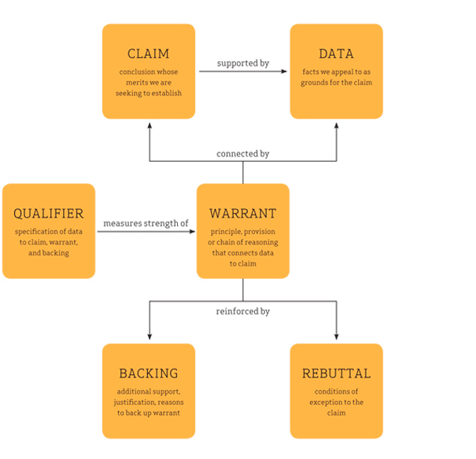
(Lumen,2011)

Presentation notes

The article I have chosen:

“COCA-COLA: DRINKING THE WORLD DRY”
(War on Want,2020)

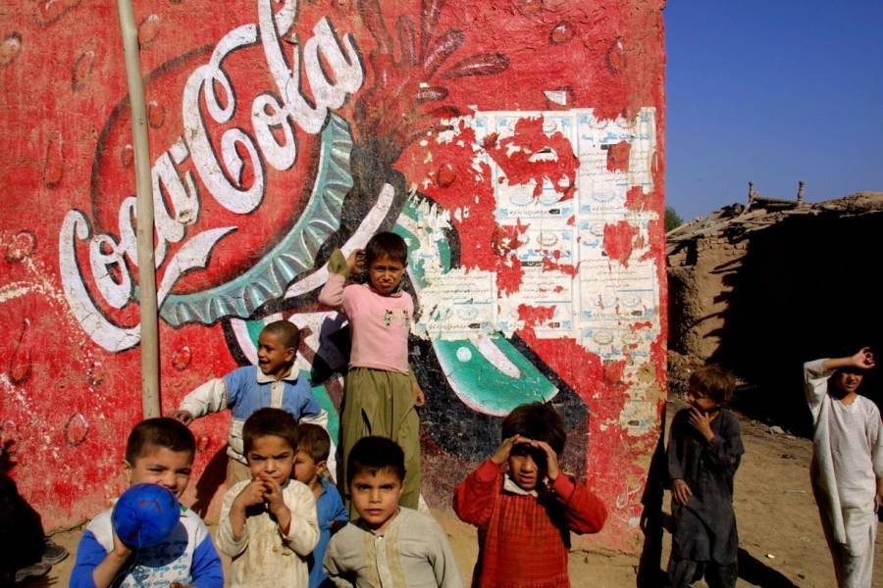
(ATI,2018)

Coca Cola Values

To create value and make a difference (The Coca-Cola Company,2017)

Values:

“Leadership: The courage to shape a better future”
(Coca-Cola Company,2017)

Coca Cola is having a positive impact on the world. By shaping a better future, for third world countries, with sustainable water resources and enhancing productive uses of water.

Claim:

“COCA-COLA : DRINKING THE WORLD DRY”
(War on Want,2020)

The Coca-Cola Company (TCCC) believes that by partnering up with the, U.S Agency for International Development (USAID), they can address community water needs around the world. In order to do this, they have created sustainable water resources, including water sheds and Eco Systems that supplies continuous clean water. Which is having a positive impact on countries such as Africa, Asia and the Middle east.

Beliefs:

Coca Cola company believe, they have met the global goal, to return all water they use, and produce more water to help third world countries.

Data:

According to War on Want – Fighting Global Poverty, an article read “COCA-COLA : DRINKING THE WORLD DRY” (War on Want,2020)

The Coca Cola Company is the most recognisable, non-alcoholic brand in the world, the company states, it has very high ethical standards and helps third world countries, but research shows that they are taking water, from the poorest of countries, leaving farmers land dry and unable to feed they’re crops.
Coca Cola admits, that without water they would have no business, as the main ingredient in their soft drinks is water.

Warrant and backing and qualifier:

The Coca Cola Company is creating change in the world, with helping third world countries tackle the water crisis, in recent years, Coca Cola has helped over 70 countries creating sustainable water resources, this company has partnered up with U.S Agency for International Development (USAID), and invested 33 billion pounds since 2005, to help countries such as Africa, Asia and Middle East.
Coca cola states “There is no resource more precious to human life and the health of our global ecosystems and economies than water.” (The Coca Cola Company,2017)
Coca Cola believe they are overcoming obstacles, to protect to protect water for all.
Water is key in growing and providing natural ingredients for the drinks they sell, without water there would be no brand.

Rebuttal:

Billions of people around the world, only know about the drinks Coca Cola sell and don’t see the positive impact this company has had on third world countries, that are struggling with sustainable resources, such as water. Coca Cola has helped a lot of these people to create a positive and struggle free future.

My thoughts and beliefs:

Are as follows, I believe that The Coca Cola Company are doing all they can for third world countries, I agree with The Coca Cola Company that they genuinely want to make a difference. They have invested £33 billion pounds, to create sustainable water resources including water sheds, and Eco Systems for long lasting effects. The company is also returning all water they use plus more back to countries to help create a good future for the people. When I think of Coca Cola, I automatically think of the drinks they sell, I never once thought, they are trying to create better futures for third world countries, so they can have sustainable clean water for the future. In the future when I think of Coca Cola, I will remember how Coca Cola, has changed the lives of people in third world countries and continue to do so.


(business wire inc,2020)

Reference list

Lumen (2011) Toulmin’s Argument Model.
https://courses.lumenlearning.com/ivy-tech-engl112/chapter/toulmins-argument-model/
(accessed on 20/02/20)

Drinking the world dry (2020) War on the world news.
https://warontheworld.co.uk/media/coca-cola-drinking-world-dry-
(accessed on the 20/02/20)

All that’s interesting (2019) Richard Stockman 2019.
https://allthatsintersting.co.uk/coca-cola-history
(accessed on 17/02/20)

The coca cola company (2017) Mission, vision and values
https://www.coca-cola.co.uk/about-us/mission-vision-and-values
(accessed on 18/02/20)

Business wire Inc (2020) Coca-Cola is the first fortune 500 Company to Replenish All the Water It Uses Globally.
https://www.businesswire.com/nes/home/20160829005174/en/Coca-Cola-Fortune-500-Company-Replenish-Water-Globally
(accessed on 22/02/20)

