ACADEMIC AND EMPLOYABILITY SKILLS ASSIGNMENT

PREPARED BY
MARCO VINICIO MARTINEZ GARCES

May 2019
Table of contents
SECTION I:
Introduction about the author
Powerpoint presentation
Points for a good powerpoint.
- Opening
- Speaking
- Questions
- Behavior
- Conclusion
SECTION II:
Skills evaluation
Self-evaluation
SECTION III:
Long- and short-term goals
Personal development plan
SECTION IV:
Protect your data
Time management and organization.
SECTION V:
Conclusion
SECTION VI:
Appendix

SECTION I
Introduction about the author.
The author was born in 1994 in Ecuador. When he was one year his family decided to move to Spain. When he was twelve years, they moved from the center of Madrid to the south of Madrid a city calls Fuenlabrada. After this, he started the high school one of the most important periods on the life of every people. After four obligatory days at the high school, he graduated at natural science baccalaureate. When he finished this he needed to decide the university to go or which course he would like to do, but unfortunately, his family didn't have enough money for a university so he started to work and after a year working he could pay his first year of a computing degreed. He passed successfully the first year of a degreed on applications web development. But after the first year, he arrived at a point where he didn't know which way it's correct or what he wanted to be in the future, so he decided to take a GAP year on London to think about his future and improve his English in the way of decided his future. After one year in London, he decided that he needed a study to be better in the future and has a good job, so he decided to start university in London. This experience gave him more mature, experience about life and found the right way for him.
Powerpoint presentation about myself and my experience on GAP year.
A continuation you will see a resume of the author powerpoint used to describes his self and his experience on a GAP year.

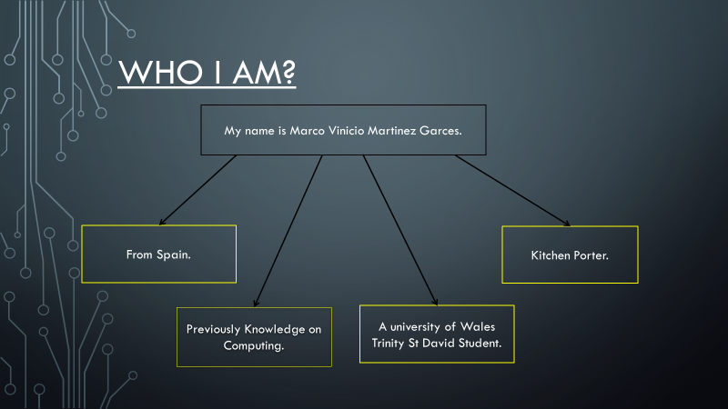

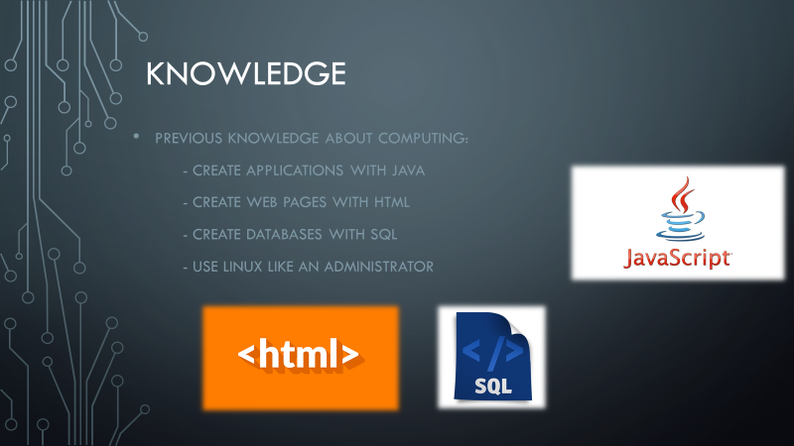

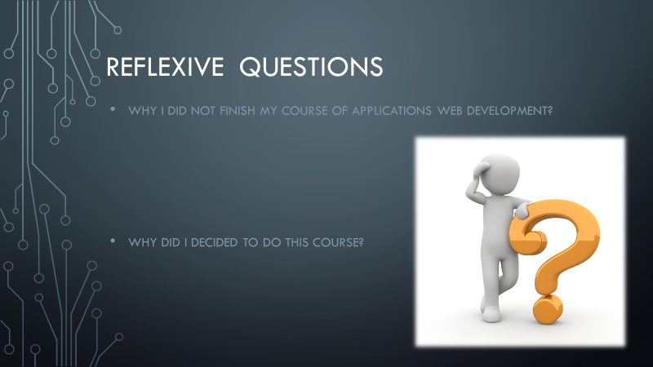

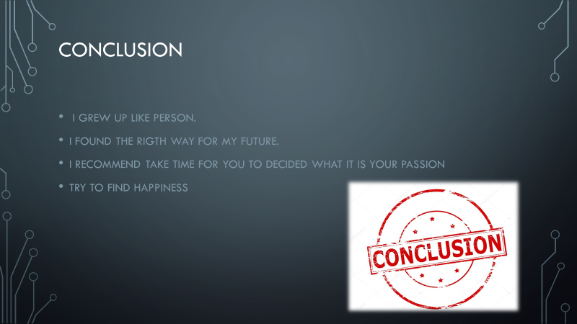

Points for a good powerpoint.
On this part, you will see a couple of points that will be helpful for you to develop a good powerpoint.
- Opening:
At the start of a power point, you should start with a little opening to capture the attention of the audience. Then once you have the attention of the audience you need to introduce briefly the topic that you are going to expose.
- Speaking:
One of the most important points to know about a presentation is how you speak. This means that you are natural, clear and not too loud. Then you need to put emphasis on the most important information and you need to do pauses to let that your audience understand the information and do not make your presentation boring.
- Questions:
You need to save the time of your presentation at the end for questions. So, for this part, you need to have a good understanding of the topic that you are going to speak, and you will be able to answer the questions.
- Behavior:
This point talks about your behavior with the audience. This means you need to have enthusiasm but not excessive. You need to do that your audience become embroiled having eye contact with the audience, use humor to keep the attention of them and control the timing to do some pauses to take a breath by asking the audience.

- Conclusion:
Once you finish your power point you must do a conclusion about the topic. At this point, you can give the keys concepts, the main idea of your presentation and give a brief opinion about the topic of your presentation.

SECTION II
Skills Evaluation.
At some point on the life some people need to do an exam of his self and think about which skills do you have, what skills are necessary for have a successful future and compare both lists to find the skills that you need to acquire or work to improve. So, in this part, you could see a couple of examples of skills that you need to have for has a successful future at studies or work. The list down here will describe the skills based on my experience.
- Communication skill.
- Writing skill.
- Understanding skill.
- Work under pressure.
Communication Skill.
Communication is one of the most important skills that you need to have if you want to have good communication in a study environment or work environment. The communication is not only speaking with the rest of people, but it is also speaking and connect with the people throw this. But communication is not only verbal communication, but you also need to know that maybe the body language is more important than the verbal language. So, when you will want to start a conversation with someone you need a good verbal language and body language.
Writing skill.
Writing like communication is one of the most important skill in a study environment and work environment. Because as you can see does not matter in which environment you are you need to have a good writing skill for doing assignments, working groups, and exams at the school or report and presentations in the work. This one can be improved with the reading of different books and acquiring vocabulary.
Understanding skill.
This skill sometimes can be confused with reading skill. This both are not the same the reading skill is the ability to read and the understanding skill is the capacity to understanding what you read or what you heard. This skill will help you in the school to learn because throw the understanding you can acquire the knowledge. But respect the work environment this skill will help you to do a good report and presentation about a topic.

Work under pressure.
This skill refers to be able to work even if you have to much pressure. This means e.g. your must do a presentation on your work in one week and your boss every day reminds you that you must do a good presentation, this is a constant pressure for you. So, you need to have the capacity to work with this pressure and do a good presentation. But for another hand at the study environment at the end of every term you have exam and assignments to submit, so at this point, you are under pressure so you need to be able to work under pressure to finish your assignments and pass your exams. One way to improve this skill is through meditation and knowing how to control your time.
Self-evaluation.
For evaluating yourself nowadays you have so much tool on the internet to evaluate yourself. This tool can help you to see what your strengths and weaknesses are. So, for this example, we will use the next page to do the test.
https://www.mindtools.com/pages/article/get-started.htm
On this link, you will find a page with a test that will help you to know more about yourself. This test has 15 statements where you must tick the option closer of your thought. The four options that you have available are Not at all, Rarely, Sometimes, Often and Very Often. After doing this test the page will return you a global result of your test and a result for every apart which one is Leadership and Management, Problem Solving and Decision Making, Communication Skills, Time Management, Personal Mastery with a brief explanation about your result. On my case my result was.
Total result: 47
Leadership and Management: 11 of 15.
Problem Solving and Decision Making: 8 of 15.
Communication Skills: 8 of 15.
Time Management: 13 of 20.
Personal Mastery: 7 of 10.
Leadership and Management:
This skill is necessary in case you will be the team leader because for good teamwork is necessarily have a good leader. But leadership and Management are not the same. So for another hand, the management is a good skill in the life of someone because this can help you to have good management respect the time for your personal life and for doing your work at a time and like this does not have too much pressure at the end. In may case my punctuation was 11 of 15 this means that I need to still work on this skill, but I am on the right way.

Problem-solving and decision making:
This skill refers to the capacity for solving a problem and make a decision. This means that you need to have enough capacity of analyzing the situation or the topic that you are going to work in and after you should be able to study all the decisions possible about this topic and take the best one for you or if in the case that you are a team leader the best options for your team. So, as you can see this skill have a little importance respect the last two before mentioned. On my case the result was 8 of 15, this means that I still have a long way to achieve a good problem-solving skill.
Communication skills:
For this skill, I can refer you to the point before where you read about the skill evaluation where you could find the communication skill. So here I will write about my result which one was 8 of 15. This result for me it is something that makes me see that I need to work on my communication skill in person because since I was a teenager, I am a shy person so this point for me is something difficult to achieve. But I learned some tips to improve my communication like, try to speak more with people that you have around in a common environment like work or class and after that try to have a conversation with stranger people and the most important learn to be confident with myself.
Time Management:
This skill is very important to work or study. Because with good control of this one you will be able to achieve good notes at the work or good critics about your work. This skill is based on the spear the time for your work or studies and your personal life in my opinion because you need to have a good balance between both to have a good personal life. My result was 13 of 20. This makes me see that my time management is making good progress. Some tips to improve this skill could be found your priorities about your work, do timetables for your day and have a good order of your responsibilities.
Personal Mastery:
This skill is not the most important respect of the study or work environment. this is maybe the most important skill for yourself. Because this skill works in the capacity to manage and lead yourself. On the way to develop this skill, you must learn to be positive and learn how to deal with negative thinking, also improve your self-confidence. When you improve your personal mastery, you will be able to in the future has success in your personal career. On my case, my result was 7 of 10.

SECTION III
Long term and short-term goals
After doing a self-evaluation you need to make a list of your goals in a long and short term.
To do this you need to ask your self what do you think you need to develop? what areas do you need to improve? So after this, you need to do a list with all the skills that you need to develop or improve and after creating the list you must divide into short term and long-term goals.
At the following list you can see, and examples of goals based on me.
Long term:
- Finish the university successfully.
- Found a good job on computing.
- Become more confident.
- Travel around the world.
Short term:
For me, these goals I would like to achieve in one year.
- Finish my first year at the university.
- Improve my communication skill.
- Improve my English.
- Learn to programme on python.
- Learn how to manage my time better.

Personal development plan.
After doing the list now, you can create your personal development plan to help you to achieve these goals. On this table, I will speak about how to improve the skills that I mentioned in section II.
Goals | Action steps
Communication Skill | - Speak more with my classmates and workmates.  - See films in English.
Writing Skill | - Read more books to improve my vocabulary.  - Do a list with the words that I do not understand and research the meaning.
Understanding Skill | - Research about the topics that I need.  - Manage my time to read and have time to do a good job.
Work under pressure | - Learn about meditation and practices.  - After a long time, working found some time for myself or my hobbies.  - Practices yoga.

SECTION IV
On this section, you will find some information about how to protect your data and how to manage your time.
Protect your data.
The protection of your data is one of the most important things for students or workers. Because as student or worker you have important data for your assignments in the case of students and for presentations in the case of workers. Many of users we do not care about the data we just save on our computers and we leave it there but or computers can be a victim of many threats like the next ones:
- Accidents like your computer broke or you throw water on it.
- Vandalism someone can steal your computer
- Computer viruses and malware.
- Hacking.
Now you will find some of the security procedures that I use to save my data.
- Use an external memory to do a copy of the security of all your data and save there.
- Do a copy in the cloud applications like one drive, Dropbox, mega or google drive. Then you have a copy on the internet and physical.
- Install a good antivirus at your computer to prevent hacker attacks and have a good firewall.
- Be careful when you are on the internet and do not give personal details to prevents hacker attacks in the future.

Time management and organization.
This both skills are something important to reduce the stress and to archive good mark at your exams or assignments. In my case like a student I must apply some tips to improve these skills because in my case these skills were weak.
- Create a timetable to divide the time available of each day to have time to study or do assignments and time for my hobbies like going to the gym. Because I think that each day you need to find a balance between the responsibilities and your hobbies, like this you reduce the stress and you can let that your brain rest correctly.
- Take notes at class and when I arrive at home review the notes took it at class and dedicate time for each module.
- Organize the notes by modules at my computer and do research by my side to understand better what I saw at class.
- Organize your workplace. Like this, at the time you can focus on your study and forget about distractions.

SECTION V
Conclusion.
On my conclusion, the module of Academic and Employability Skills is very helpful at the start of each course because gives to new students the skills for confronting and pass the first year of university. In my case, this module help throws every lecture to learn how to improve my self-knowing my strengths and weakness and how to face it. Teaching me how to do a proper powerpoint, how to do good research about the topic that I need to acquire knowledge and be able to pass my exams. For another hand, this module shows me some tips to improve my organization and time management this was very helpful to do my assignments and pass my exams.

SECTION VI
Appendix.
Test Your Skills and Find the Resources That Will Help You Most
https://www.mindtools.com/pages/article/get-started.htm

PERSONAL DEVELOPMENT PLAN

 | Short-Term Time Frame | Mid-Term Time Frame | Long-Term Time Frame
 | What do I want to | What do I want to | What do I want to
 | accomplish in the next | accomplish in the next | accomplish in the next
 | three to six months? | six months to two years? | two to three years?
Section 1 - My Goals
What are my overall goals | Improve my communication skill | Improve my English | Become more confident
that I want to accomplish
in this time period? |  | Learn how to manage my time better | Travel around the world
Example: become a |  |  | Finish the university
Student Affairs Officer;
learn computer graphics
Section 2 - Skills and
Knowledge to be
Learned
What specifically do I need | Be more open to people. | See more English programs. | Gain more confidence on myself.
to learn? What project do I |  |  | Learn to save money for trips.
need to work on? |  | Learn more vocabulary.
Example: Student advising; |  | Do timetables. | Do my best to finish the university successfully.
Banner; Dreamweaver; |  | Learn to do priorities.
develop a procedures
manual
Section 3 - Next Steps
How am I going to acquire
the skills and knowledge?
How am I going to do this |  | Seeing my favourites series or film on English | Going to the gym to fill comfortable with my body to gain confidence.
project? | Starting to speak more whit people at class. | Buying book on English. | Taking little of money apart of each month to different trips.
Example: take |  | Create timetables for every week.
Dreamweaver class; do an
informational interview; set
up a project outline

 |  |  |  | Short-Term Time Frame |  | Mid-Term Time Frame |  | Long-Term Time Frame
 |  |  |  | What do I want to |  | What do I want to |  | What do I want to
 |  |  |  | accomplish in the next |  | accomplish in the next |  | accomplish in the next
 |  |  |  | three to six months? |  | six months to two years? |  | two to three years?
 | Section 4 - Resources
 | What resources do I need?
 | Example: free time; funding
 | Section 5 - Time Schedule
 | What is my time schedule?
 | When will I start?
 | When do I expect to finish?
 | Section 6 - Completion |  |  | □__________ |  | □__________ |  | □__________
 | When have I completed each |  |  | □__________ |  | □__________ |  | □__________
 | When have I completed each |  |  | Date |  | Date |  | Date
 | step? |  |  | Date |  | Date |  | Date
 |  |  |  | □__________ |  | □__________ |  | □__________
 |  |  |  | Date |  | Date |  | Date
 |  |  |  | □__________ |  | □__________ |  | □__________
 |  |  |  | Date |  | Date |  | Date

