
Gareth Francis (1707331)
1707331@student.uwtsd.ac.uk
Motavation and organisation change - report
Module Code – M5X01176

Executive Summary
The context within this report followed the journey of Wall Colmonoy’s change management innovation with its motivation of change and the people in charge of the innovation. The innovation was moving from the traditional Wax Trees assembly to Polystyrene Tree assembly as part of their investment casting. The organisation looked at implementing the innovation by using Lewin’s force field analysis to gain the understanding of the innovation and to establish whether the modification was commercially and practically viable. The use of Lewin’s force field analysis showed that the use of a scoring system for the forces of one to five, one being a weak force and five being a strong force. This was then tabulated with a favourable force versus the restraining force with the totals being the deciding figure of implantation of change. There’s also a look at motivational theories to motivate the organisation and their people to understand the chain and getting the effectiveness and benefits of all interested parties. The organisation looked a Maslow’s hierarchy of needs, this was to understand the employee’s requirement of motivations, such as Physiological, Safety, Love, Esteem and Self-Actualisation.

Contents Page
Table of Contents
Executive Summary 1
Contents Page 2
Introduction 3
Investment Casting History 4
Investment Casting Process 4
Wax Tree Innovation 5
Lewin’s Force Field Analysis 6
Motivation for Change 10
Conclusion 12
Reference List 13

Introduction
The context in this report looks at a potential innovation at Wall Colmonoy Limited. The innovation the company were reviewing was that of changing methodology and material of their Investment Casting process. Wall Colmonoy Limited currently use Wax trees which are commonly used in the Investment Casting industry, however, due increasing fluctuation in costings due to the changes in Oil pricing daily and due to only having one single sourced supplier for the Wax Trees, an alternative product was needed. A project team within the Castings department was initiated with a view of using Polystyrene Trees for future assembly within the Investment Castings process. The project team looked to base their decision on whether to change from Wax Trees to Polystyrene Trees by using Lewin’s Force field Analysis.
Wall Colmonoy Limited are an internationally renowned company with six sites in North America and one located in Wales, Europe. Wall Colmonoy have four different types of business units, Alloy Products, Castings, Precision Components and Aerobraze all of which supply products in to the aerospace, automotive, glass, oil & gas, mining, energy and other industrial sectors. (Wall Colmonoy, 2019)

Investment Casting History
Investment casting process has been evident since 5000 BC which was used for applications such as the art and jewellery industries. (Singh, 2016) In modern years it’s been used in foundries worldwide to produce many different types of components for many different industries, such as the food industries, Oil and Gas and the Glass industries. (Wall Colmonoy, 2019) The use of Investment Casting is commonly used due to it being able to manufacture intricate parts, blends, internal features, and varying thicknesses with an excellent surface finish and negligible metallurgical limitations. This can be produced precisely in any shape or sizes which produces parts with minimum porosity or other defects. (Investcastinc.com, 2019)

Investment Casting Process
During a typical process of Investment Casting there is eight key stages to achieve the end goal of any individual casting component ready for use in appropriate application. This is illustrated via a process map of each key stages as seen in Figure 1.
Figure 1 (Source – Investment Casting.org).

The process begins with a wax pattern injection whereby a fabrication of a pattern of similar geometrical shape of the finished cast part is manufactured. Once this is produced it’s assembled to a sprue to form an assembly on the Wax Tree. The next step is then to dip the entire wax assembly in to a ceramic slurry which is known as a shell building, then sent for dewaxing which consists of a during of drying, this process is vital for the integrity of the casting. Post dewaxing the Wax Tree has molten metal poured in to its mould, this is the creation of the Casting. Once the casting is cooled the mould shell is knockout, thus allowing the cut-off of the gates and runners from the Wax tree. This is now the completion of the individual casting, of which is ready for sale. (Investmentcasting.org, 2019)

Wax Tree Innovation
Wall Colmonoy instigated a complete review for a potential innovation of moving against the conventional Wax Tree investment castings process by looking at using a polystyrene based tree. The motivation and reasoning for change was strategical, thus being down to cost and single source supplier for their Wax Trees. In most manufacturing companies worldwide, the main objective is to reduce cost. As discussed by Michael Evans and Peter Duff in an article for Forbes, the rule of business is “simple”, control costs, increase revenues and maximise profits. (Evans and Duff, 2019) Secondly with Wall Colmonoy only have one single source supplier for their Wax Trees, this was deemed as major business risk with their supply chain management. Wall Colmonoy are extremely reliant on their single source supplier therefore any delay or manufacturing issues arisen by the supplier could result in major implications for Wall Colmonoy, such as being unable to manufacture their own product. This was emphasised in 2011 when a Tsunami hit Japan causing major disruptions on the Apple iPad 2, as 25% of the hardware were manufactured in Japan thus being a single source to Apple. (Revilla, E and Maria, J.S., 2017). To weigh up the Pros and Cons of the new potential introduction of Polystyrene Trees, there was a comparison study conducted between the current and alternative process. The process used was the Lewin’s Force Field Analysis.

Lewin’s Force Field Analysis
Lewin’s Force field analysis was developed by Kurt Lewin (Lewin K. 1951) in his Field Theory in Social Science book from 1951 which was introduced when he was working as a social psychologist. This model has now been adopted in to the business world which is commonly used in modern day organisations when decision making, in planning or implementing any change management. Lewin force field analysis is also a powerful tool to visualise the pros and cons of any potential changes. (Ifm.eng.cam.ac.uk, 2019) To visualise the desired change, Kurt Lewin created a table which started with the organisations proposed change, in the case of Wall Colmonoy, Polystyrene Trees. Following this, the organisation needs to identify the potential constrains for the desired change, this is split in to the favourable forces and resistant forces either side of the proposed change column. This proposed change is deemed as an equilibrium to driving forces for change. (Change Management Coach, 2019) After putting the favourable and resistance forces in to the separate columns there’s then a requirement to score the representative forces from of one to five the numbers which was used by Wall Colmonoy. A score of one is considered as a Weak Force for change and five considered as a Strong Force for change (ToolsHero, 2019). In the below table the findings of Lewin’s Force Field Analysis provided by Wall Colmonoy.

Force | Favourable Forces | Directional Change | Desired Change | Directional Change | Resistance Forces | Force
4 | Cost Saving / Tree | > | Polystyrene Trees | < | Identification of Trees | 1
5 | Lighter Trees | > | Polystyrene Trees | < | Removal of Polystyrene | 5
4 | Easy Storage | > | Polystyrene Trees | < | Residual on Screws | 4
4 | Reliable Supplier | > | Polystyrene Trees | < | Operations Added – Post Processing | 4
4 | Tree Quality | > | Polystyrene Trees | < | Reclamation Costs | 3
3 | No Ash Content | > | Polystyrene Trees | < | Screwing in Bars – Cost | 1
5 | Cost Fluctuation – Less than Wax | > | Polystyrene Trees | < | Rigidity in Slurry Tank – Torque | 2
4 | More Robust – Less Brittle | > | Polystyrene Trees | < | Not Environmentally Friendly | 2
 |  |  | Polystyrene Trees | < | Tooling Costs | 1
 |  |  | Polystyrene Trees | < | Potential Damage to Autoclave | 5
 |  |  | Polystyrene Trees | < | Filtration from Top - Effectiveness | 4
 |  |  | Polystyrene Trees | < | Increased Risk of Contamination | 2
 |  |  | Polystyrene Trees | < | Removing Screws – Post Dewaxing | 5
 |  |  | Polystyrene Trees | < | 6 Bar Tree – customer Does Not Permit | 5
Total Favourable Force = 33 |  | 1 = Weak Force 5 = Strong Force |  |  | Total Resistance Force = 44
Figure 2 (Source – Wall Colmonoy)

On completion of the above table, the number of favourable forces were totalled along with the total of resistance forces. This was found to be thirty-three in the favourable force and forty-four in resistance force. On submitting the findings of the Lewin’s force fiend analysis to Wall Colmonoy senior management team, it was evident that proposed change was not a beneficial process change. The evidence resulted in Wall Colmonoy keeping their current process of Wax Tree rather than move to Polystyrene Trees. However, the Polystyrene Trees innovation could still have worked if Wall Colmonoy had considered potentially looked at reducing the resistance forces against the desired change. For example, reviewing the high number of the resistance forces and looking at whether a potential modification within the current process, or even to add an additional process. In the below table, please see the identified process changes created to drive the resistance forces number downwards where possible.
Force | Favourable Forces | Directional Change | Desired Change | Directional Change | Resistance Forces | Force | Modification Action | Force
4 | Cost Saving / Tree | > | Polystyrene Trees | < | Identification of Trees | 1 | Not Applicable | 1
5 | Lighter Trees | > | Polystyrene Trees | < | Removal of Polystyrene | 5 | Not Applicable | 5
4 | Easy Storage | > | Polystyrene Trees | < | Residual on Screws | 4 | Burn off – Limonene | 0
4 | Reliable Supplier | > | Polystyrene Trees | < | Operations Added – Post Processing | 4 | Not Applicable | 4
4 | Tree Quality | > | Polystyrene Trees | < | Reclamation Costs | 3 | Modification of process | 2
3 | No Ash Content | > | Polystyrene Trees | < | Screwing in Bars – Cost | 1 | Not Applicable | 1
5 | Cost Fluctuation – Less than Wax | > | Polystyrene Trees | < | Rigidity in Slurry Tank – Torque | 2 | Introduction of Robotic Programme | 0
4 | More Robust – Less Brittle | > | Polystyrene Trees | < | Not Environmentally Friendly | 2 | Not Applicable | 2
 |  |  | Polystyrene Trees | < | Tooling Costs | 1 | Not Applicable | 1
 |  |  | Polystyrene Trees | < | Potential Damage to Autoclave | 5 | Modification of Autoclave – New Component | 3
 |  |  | Polystyrene Trees | < | Filtration from Top - Effectiveness | 4 | Modification of Filtration System | 2
 |  |  | Polystyrene Trees | < | Increased Risk of Contamination | 2 | Not Applicable | 2
 |  |  | Polystyrene Trees | < | Removing Screws – Post Dewaxing | 5 | Remove screw prior to de-wax | 2
 |  |  | Polystyrene Trees | < | 6 Bar Tree – customer Does Not Permit | 5 | Make trees in house on C-Frame using virgin Wax | 3
Total Favourable Force = 33 |  | 1 = Weak Force 5 = Strong Force |  |  | Total Resistance Force = 44 |  | Total Resistance Force Post Modification = 28
Figure 3 (Source – Modified Table from Wall Colmonoy)

The table complied on page eight show that by doing some modification actions to the process that can improve and decrease the resistance forces. With the modification the total of resistance forces has been reduced to twenty-eight from forty-four a reduction of sixteen resistance forces. This can now be realistic change to Wall Colmonoy.
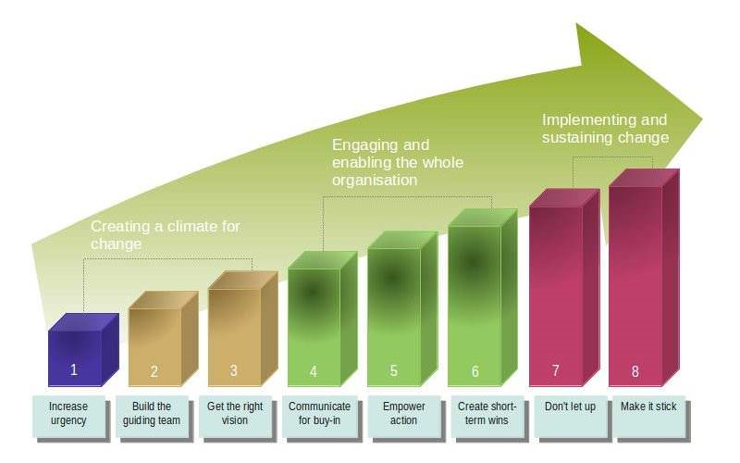
Wall Colmonoy had used the Lewin’s force field analysis model to decide on whether to implement an innovation. There are however many other models that could have been more beneficial such the Kotter’s eight step change model. This model has eight key steps to implementing an innovation or organisational change, from one to eight in the following sequence including the three sub categories. Increase urgency, build a team, understand the desired change with the categorised as “climate for change”. Communicate for buy in, empower action, create short term win which is classed as “engaging and the enabling the whole organisation. Don’t let up and make it stick, is “doing stage, implementing and sustaining the change”

Figure 4 (Source – Leadershipthoughts.com)

Motivation for Change
To adopt any change management within an organisation, there’s a requirement and need to change behaviour and to motivate individuals. Organisations can look to adapt many types of motivational theories which as Maslow’s hierarchy of needs model, Herzberg two factor theory, Alderfer’s modified need hierarchy model for example. (Mullins L, 2016) During this research journey, it was identified as that many organisations identify using Maslow’s hierarchy of needs model to motivate individuals. Abraham Maslow created this theory back in 1943 when studying the individual development and motivation of human. (Mcleod, 2019)He divided the concept in to order of five key components. Physiological, Safety, Love, Esteem and Self-Actualisation. (Managementstudyguide.com, 2019)
- Physiologic needs – This is the needs of the body, such as satisfying the normal function of hunger, thirst, need for oxygen and sleep.
- Safety needs – Freedom of pain or threat of physical attacks and protection from danger.
- Love needs – Social activities, affection, and sense of belonging.
- Esteem needs – Satisfying ego, self-respect, respect of others.
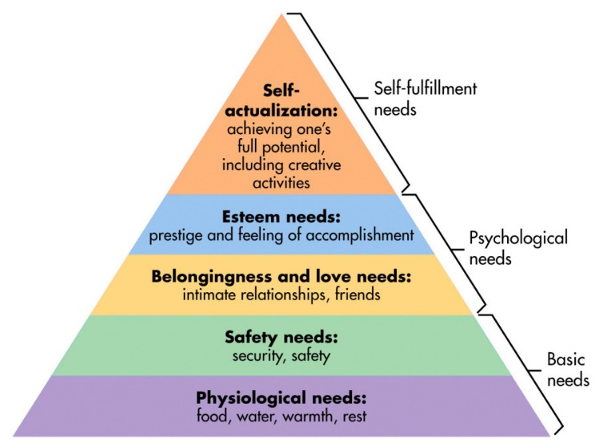
- Self-Actualisation needs – This is when the lower need has been satisfied and no longer act as a motivator. (Mullins L, 2016)

Figure 5 (Source - https://www.simplypsychology.org)

Abraham Maslow said that only 2% of human achieved the Self-Actualisation needs and has listed the likes of Ghandi, Mother Theresa, Einstein and himself as a few people to achieve the self-actualisation needs. During his creation of hierarchy needs, Maslow did not intend to use this model as part of the business world hence using as part of understanding the human concept. (BBC News, 2019) There is however, some doubt and criticism of the theory due its limitation but is still used as key theory in organisations worldwide. (Mullins L 2016)
Additionally as highlighted on page ten there are other types of motivation theories. In the case of Alderfer’s modified need hierarchy model, it is based on the similar concept to Maslow’s theory however is condensed in to three key concept, Existence needs, Relatedness needs and Growth needs which is commonly knowns as ERG theory. (Mullins L, 2016)

Conclusion
In conclusion of the report it follows the journey of the used of many change management theories to motivational changes used by senior management at Wall Colmonoy. During the management change process for the potential innovation of using Polystyrene Trees instead of the conventional use of Wax Tree the organisation used key tool, Lewin’s force field analysis. Using this tool gave a prospectus of the positive force against the negative forces, with a one (weak) to five (strong) scoring system. By using this type of scoring system, it gave senior management the ammunition to determine whether the innovation was a “good” or a “bad innovation”. Wall Colmonoy management team were so motivated to implement the innovation that when resistance forces was greater than the positive forces, it forced a decision to look at alternative methods to reduce the resistance forces. Project team were then tasked to identify new processes or adaptation of the existing process to reduce the resistance forces. On completion of these task it was evident that the innovation was able to implement as it resistance forces was reduced by fourteen. The motivation of organisation and its people is also a key factor in any change management to understand its employee’s especially extracting the best possible performance of them. Organisation use motivation theories such as Maslow’s hierarchy of needs to understand five key components, Physiological, Safety, Love, Esteem and Self-Actualisation.

Reference List
Bimac.com. (2019). Available at: http://bimac.com/assets/pdfs/investment-casting-process.pdf [Accessed 6 Apr. 2019].
BBC News. (2019). The pretty pyramid that beguiled business. Available at: https://www.bbc.co.uk/news/magazine-23902918 [Accessed 12 Apr. 2019]
Change Management Coach. (2019). Lewin's Force Field Analysis Explained. Available at: https://www.change-management-coach.com/force-field-analysis.html [Accessed 7 Apr. 2019].
Evans, M. and Duff, P. (2019). Want To Reduce Business Costs? Here Are 10 Areas To Start With. Forbes.com. Available at: https://www.forbes.com/sites/allbusiness/2014/09/30/want-to-reduce-business-costs-here-are-10-areas-to-start-with/#32e8544e4a7b [Accessed 8 Apr. 2019].
Investmentcasting.org. (2019). Available at: https://www.investmentcasting.org/uploads/8/1/9/8/81988734/the_investment_casting_process_-_website.pdf [Accessed 6 Apr. 2019].
Ifm.eng.cam.ac.uk. (2019). Force field Analysis. Available at: https://www.ifm.eng.cam.ac.uk/research/dstools/force-field-analysis/ [Accessed 8 Apr. 2019].
Investcastinc.com. (2019). The History of Investment Casting – Early & Modern Casting Process & Techniques — Invest Cast Inc. Available at: https://www.investcastinc.com/history-of-investment-casting/ [Accessed 6 Apr. 2019].
Lewin K. (1951) 'Field Theory in Social Science', Harper and Row, New York
Moneycrashers.com. (2019). 14 Ways to Reduce Materials & Cost of Goods Sold in Your Business. Available at: https://www.moneycrashers.com/reduce-materials-cost-goods-sold/ [Accessed 7 Apr. 2019].
Managementstudyguide.com. (2019). Maslows Hierarchy of Needs Theory. Available at: https://www.managementstudyguide.com/maslows-hierarchy-needs-theory.htm [Accessed 10 Apr. 2019].
Mcleod, S. (2019). Maslow's Hierarchy of Needs. Simply Psychology. Available at: https://www.simplypsychology.org/maslow.html [Accessed 12 Apr. 2019].
Managementstudyguide.com. (2019). Supply Chain Management - Definition and importance of its strategies. Available at: https://www.managementstudyguide.com/supply-chain-management-definition.htm [Accessed 8 Apr. 2019].
Mullins L. (2016) ‘Management & Organizational Behavior’, Pearson, London. pp. 231.
Mullins L. (2016) ‘Management & Organizational Behavior’, Pearson, London. pp. 229.
Mullins L. (2016) ‘Management & Organizational Behavior’, Pearson, London. pp. 228.
REVILLA, E. and MARIA, J.S., 2017. The impact of risk management on the frequency of supply chain disruptions. International Journal of Operations & Production Management, 37(5), pp. 557-576. agement, 37(5), pp. 557-576.
Singh, S. (2016). Investment Castings. Reasearch Gate.
ToolsHero. (2019). Force Field Analysis by Kurt Lewin, a decision making tool | ToolsHero. Available at: https://www.toolshero.com/decision-making/force-field-analysis/ [Accessed 7 Apr. 2019].
Wall Colmonoy. (2019). Delivering the Highest Quality Performance – Wall Colmonoy. Available at: https://www.wallcolmonoy.com/company-profile/who-we-are/ [Accessed 6 Apr. 2019].
Wall Colmonoy. (2019). Precision Components: Industries. Available at: https://www.wallcolmonoy.com/products-capabilities/precision-components/industries/ [Accessed 6 Apr. 2019].

